Building Block Configuration Guide  SAP Fiori apps rapid-deployment solution  Document Version: 1.0 – 2015-01-26 | Customer
Deployment of SAP Fiori Fact Sheet (MF3)

Typographic Conventions
Type Style | Description
Example | Words or characters quoted from the screen. These include field names, screen titles, pushbuttons labels, menu names, menu paths, and menu options.  Textual cross-references to other documents.
Example | Emphasized words or expressions.
EXAMPLE | Technical names of system objects. These include report names, program names, transaction codes, table names, and key concepts of a programming language when they are surrounded by body text, for example, SELECT and INCLUDE.
Example | Output on the screen. This includes file and directory names and their paths, messages, names of variables and parameters, source text, and names of installation, upgrade and database tools.
Example | Exact user entry. These are words or characters that you enter in the system exactly as they appear in the documentation.
<Example> | Variable user entry. Angle brackets indicate that you replace these words and characters with appropriate entries to make entries in the system.
EXAMPLE | Keys on the keyboard, for example, F2 or ENTER.

Document History
Version | Date | Change
1.0 | 2015-01-26 | Version 1
Table of Contents
1 Purpose 5
2 Generic Configuration for Fact Sheet 6
2.1 Create Required Search Connectors 6
2.1.1 Find the Required Software Component 6
2.1.2 Backend System: Check Import Log of Software Component 8
2.1.3 Find the required search connectors 9
2.1.4 Backend System: Create Search Connectors 10
2.1.5 Backend System: Schedule Indexing 12
2.1.6 Backend System: Test Embedded Search 12
2.2 Activating Required Services 13
2.2.1 Find Required Services 14
2.2.2 Gateway System: Activate the required ODATA services 15
2.2.3 Gateway System: Activate the required UI services 17
2.3 Backend System: Assign Required Roles 18
2.4 Verification of a Fact Sheet 19
3 Troubleshooting 21
3.1 FAQ Note 21

Purpose
The purpose of this document is to describe the steps required to manually enable a specific Fact Sheet end-to-end. The procedure is the same, only with different individual values for different Fact Sheet.

This document uses Fact Sheet Customer as example to work through the whole procedure.

Generic Configuration for Fact Sheet
Prerequisites
All the Fact Sheet related procedures in SAP Fiori Technical Foundation Configuration guide (EE0) should have been implemented.

Create Required Search Connectors
Different from Transactional or Analytical apps, Fact Sheet normally is accessed via Fiori Search, where search term is entered and in the returned result list, individual Fact Sheet link will be shown.

Therefore Fiori Search needs to be enabled first. In order to do so, search models, or search connectors need to be activated, which contain search pattern to react upon the search term.

One Fact Sheet would need several inter-related search connectors being activated and indexed. Fiori supports navigation across several Fact Sheets, thus the search connectors could also relate to each other. It is recommended that all required search connectors should be activated in one batch.

Each Support Package provides additional Search Model updates, which need to be imported into the system first, as described in EE0 Fiori Technical Foundation Configuration

Many procedures are through system jobs, and time-consuming. Sometimes error during job run would cause rollback and cancellation of the job.

Find the Required Software Component
Use
Search connectors are categorized by Software Components, and further classified with Application Components. Therefore it is necessary to find the corresponding Software Component or Application Component of the Fact Sheets that are to be used, such information is to be specified later in the configuration procedures.
Procedure
- Access the activity using the following navigation option:

Link | http://www.sap.com/fiori-apps-library

- At the left side enter the Fact Sheet that you want to use, for example. Customer.
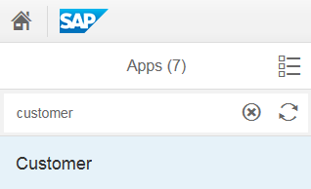
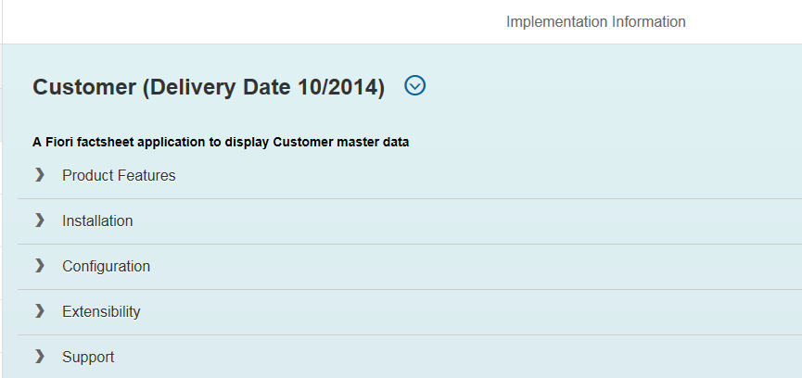
- Click the found entry Customer, at the right side the detail will be shown.

- Click Configuration, the node will expand with more detail. Scroll down to the Search Connector section. The Software Component and Application Components are shown.
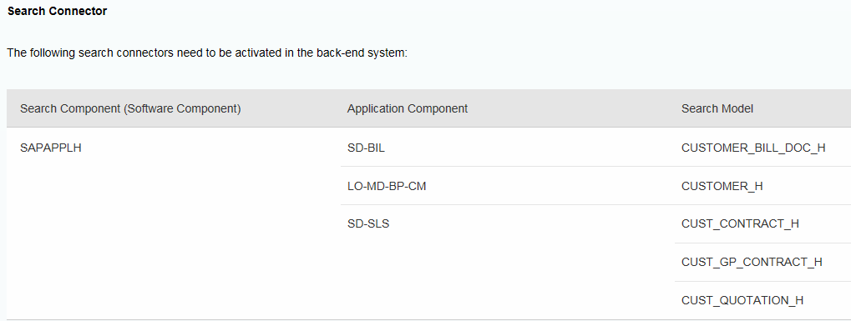

Backend System: Check Import Log of Software Component
Use
Each support package level delivers lots of model updates, which need to be imported into the system. Search connectors can only be created, when there is no model update issue.
Procedure
- Access the activity using the following navigation option:

Transaction Code | ESH_COCKPIT

- A Web browser window will come up, if it asks for credential, login using the Administrator user account,for example:for example the Fiori_adm user that was created in EE0 Fiori Technical Foundation Configuration.

- The screen Connector Administration Cockpit is shown. Click the link Modeler.
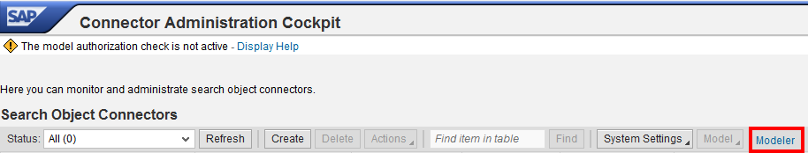
- In the screen Modeler for Search and Analytics, a hierarchy of existing software components and application components is shown. Choose the one you want to use, for example. SAPAPPLH, then choose Actions -> Import log (Transport). System would automatically trigger a background job to do model update, by the time that this screen is called.
- The model update job name is ESH_IEF_IMP_OM_UPDATE_CONTENT<your client>, you can use SM37 to check the detail. Make sure that the job finished with green light.
- After the job execution, the import log would have been updated by the model updates. To check the import status, repeat step 3 and 4 above. If import is successful, a success message is displayed. Otherwise error messages will be shown in a table, and the model update job will be triggered again.

Note
Alternatively, to check import status without triggering the model update job, use SE16 to open table ESH_OM_IE_IMPLOG, set the import status to ERROR, and then see how many entries are available.

Find the required search connectors
Use
Each Fact Sheet is supported by several inter-related search connectors. The relationship in between can be found in the Fiori Apps Reference Library
Procedure
- Access the activity using the following navigation options:
Link | http://www.sap.com/fiori-apps-library

- At the left side enter the Fact Sheet that you want to use, for example. Customer.
- Click the found entry Customer, at the right side the detail will be shown.
- Click Configuration, the node will expand with more detail. Scroll down to the Search Connector section. Now the required search connectors for Fact Sheet Customer are shown.
Note
Cross navigation is available among Fact Sheets, or between Fact Sheet and other apps. Search connectors are often inter-related. One connector with issue would also deactivate all related connectors.

In order to provide a stable and complete search entity foundation, it is recommended to activate all the required search connectors together in one step.

Backend System: Create Search Connectors
Use
Embedded search is based on active and consistent search connectors. In order to enable the search functionality, search connectors need to be created in advance.
Procedure
- Access the activity using the following navigation option:

Transaction Code | ESH_COCKPIT

- Click Create, then choose the software component you want to use, for example. SAPAPPLH, a list of available search connectors is shown below, those that were already created would be grey-out. Choose the search connectors you want to activate, for example. the ones you found in previous step, then choose Create Connector.

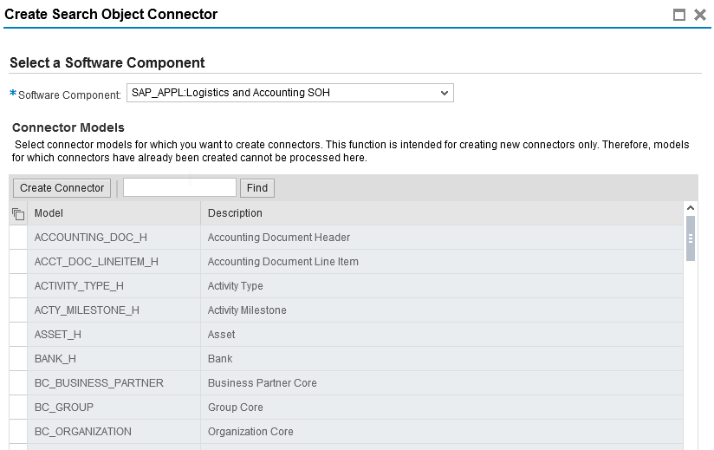
- A background job will be triggered to create the search connectors. It might run for hours, depending on the number of search connectors. The job name is ESH_<your client>_C_<unique code>.
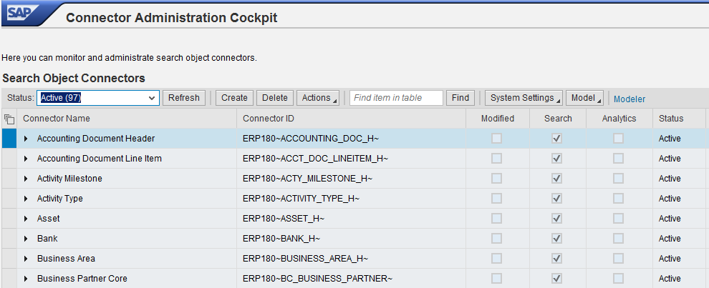
- Wait till the job finished or terminated, if it is terminated, check the job log to see what the error message is and start trouble-shooting. If job finished in success, go to ESH_COCKPIT again and the newly created search connectors should have the following status: Status Active and Search is flagged.

Backend System: Schedule Indexing
Use
Some search connectors are created with Status Prepared instead of Active. For these search connectors, schedule indexing is required.
Procedure
- Access the activity using the following navigation option:

Transaction Code | ESH_COCKPIT

- Select those search connectors with Status Prepared. Choose Action -> Schedule Indexing.
- In the pop-up window, select Start Immediately, then choose OK.
- A background job is triggered. Job name is ESH<your client>IX_<system id + client>_<unique code>.
- If the job finished in success, the search connector status should change to Active.

Backend System: Test Embedded Search
Use
Before going into Fiori LaunchPad, the embedded search can be tested via Web Dynpro user interface. This is to confirm the search is working properly.
Procedure
- Access the activity using the following navigation options:

Transaction Code | ESH_SEARCH

- Specify the search term, for example. Customer, and then choose Search.
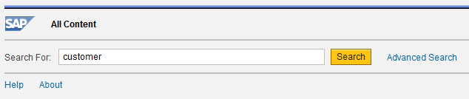
- A list of search result will be shown, pay attention to the entity type in the right end, for example. Customer.
- Select one entry with the required entity type, for example. Customer, and choose Details.
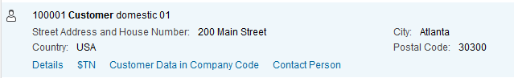
- The detailed information is shown at the right side.
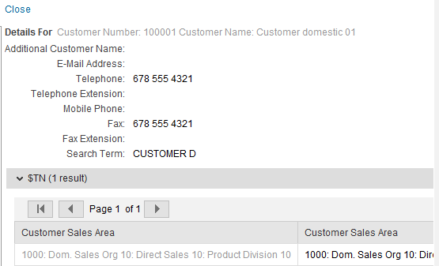

Activating Required Services

Find Required Services
Use
A Fact Sheet needs two kinds of services, one is the UI service to display the layout, and the other is ODATA service to feed the data. The exact service name can be found in Fiori Apps Reference Library.
Procedure
- Access the activity using the following navigation options:
Link | http://www.sap.com/fiori-apps-library

- At the left side enter the Fact Sheet that you want to use, for example. Customer.
- Click the found entry Customer, at the right side the detail will be shown.
- Click Configuration, the node will expand with more detail.
- The UI service is called UI5 application as below
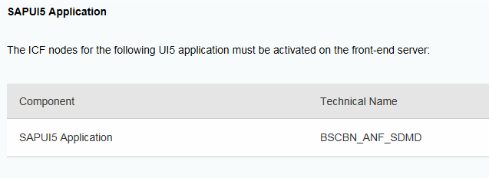
- The ODATA service is as below. Pay attention to the authorization role as well, the role will be assigned later.
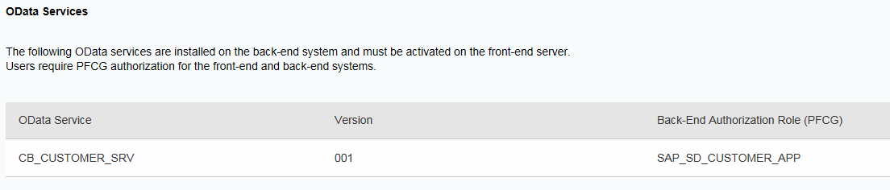

Gateway System: Activate the required ODATA services
Use
ODATA service is activated on the Front-end server, using RFC destination to call the backend server in order to fetch data. The system alias that was created before to connect Front-end server and backend server will be used in this step.
Procedure
- In the Front-end server, access the activity using the following navigation options:

Transaction Code | /n/IWFND/MAINT_SERVICE
- By default, the ODATA service was not yet activated, it has to be added first, click

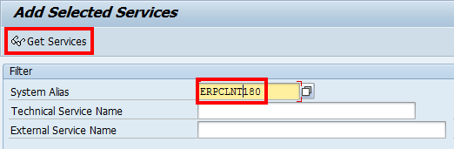
- In next screen, specify the correct system alias for the backend server, for example. ERPCLNT180, then choose Get Services, a list of services that are available will be shown.

- Find the one that is required, for example. CB_CUSTOMER_SRV
- Click the service, a pop-up screen Add Service is shown. Give a package to the newly added service, for example. local object, then choose
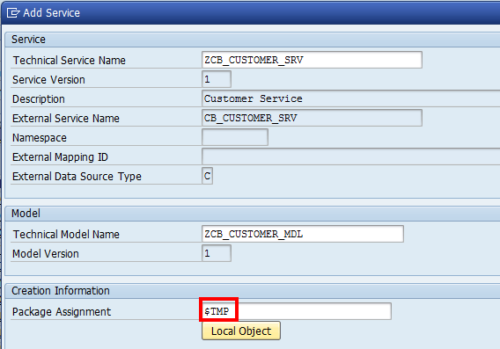

- Confirm the information message if any. Go back to the previous screen by choosing

- Find the service that was just added, for example. CB_CUSTOMER_SRV, and click it. The system alias and ICF node will be shown below. Make sure that the ICF node has green light on, if not, activate the ICF node by choosing

Gateway System: Activate the required UI services
Use
Fact Sheet UI is delivered in the form of BSP application, using UI5. Several Fact Sheet share the same UI service, for example. for the same module like MM.
Procedure
- In the Front-end server, access the activity using the following navigation options:

Transaction Code | SICF

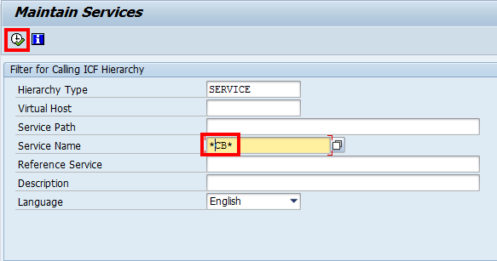
- In Maintain Services screen, put *CB* as search term for service name, then choose Execute.

- In the found list, find the required UI service, for example. bscbn_anf_sdmd , and make sure it is already activated. If not, right-click on the node and choose Activate.

- Also make sure that the service path is sap -> bc -> bsp -> sap
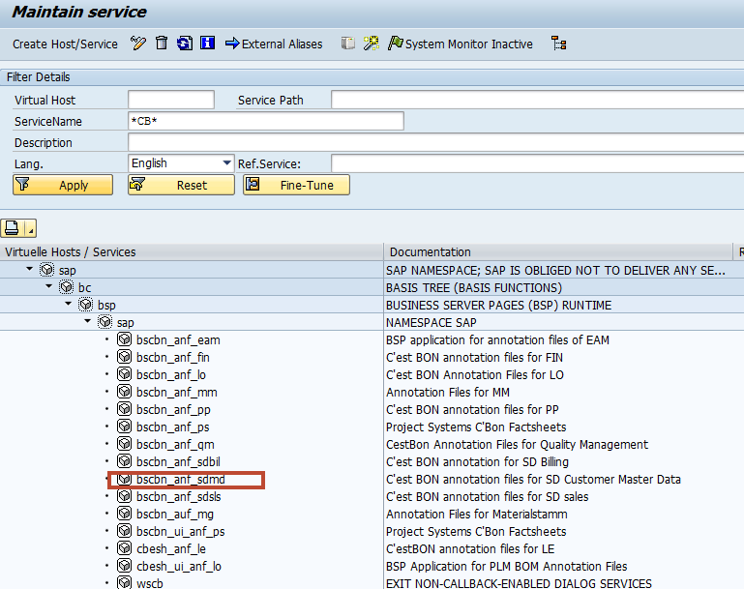

Backend System: Assign Required Roles
Use
This authorization is to be performed on the backend server.
Procedure
- Access the activity using the following navigation options:

Transaction Code | SU01

- Specify the user name and choose Change.
- In Maintain User screen, choose tab Role. Add the required role for example. SAP_SD_CUSTOMER_APP into the list.
- Save the user master data.

Verification of a Fact Sheet
Use
This is the procedure to verify if a Fact Sheet can be searched and displayed smoothly.
Procedure
- Access the Launchpad using a browser, for example. Chrome.

URL | https://<host>:<port>//sap/bc/ui5_ui5/ui2/ushell/shells/abap/FioriLaunchpad.html

- Login via credential, for example. Fiori_adm and the corresponding password, and then find the search icon in the right top corner.

- Click it, a search field will be shown, specify the search term, for example. Customer and press enter.
- The search result list will be shown, choose a customer object, for example. Customer domestic 01
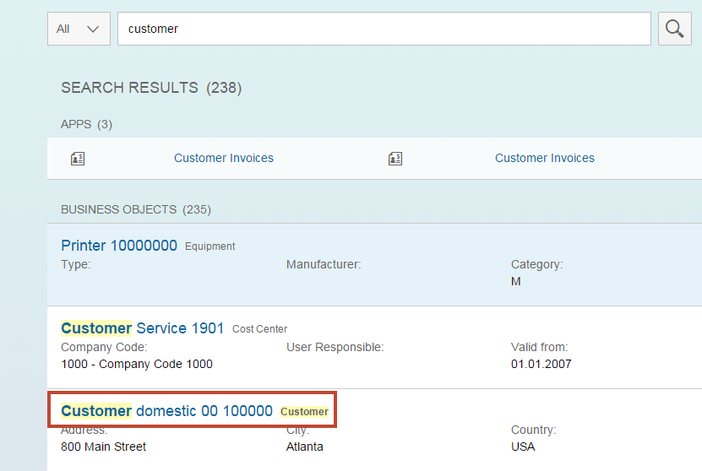
- The Customer Fact Sheet will be shown.
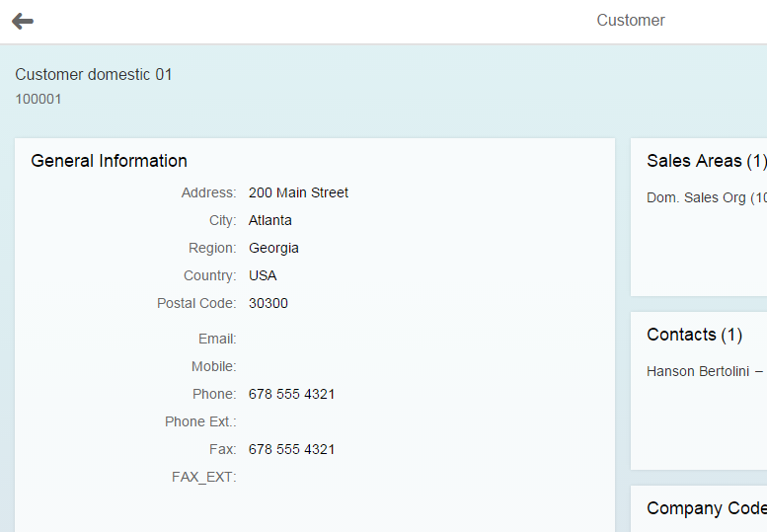

Troubleshooting

FAQ Note
SAP Note 1874091 - SNOTE: Frequently asked Questions (program based transport) provides very useful information when it comes to various import errors.

It is recommended to read this note before checking import log, or in case there's import errors shown in the log.

www.sap.com/contactsap
© 2015 SAP SE or an SAP affiliate company. All rights reserved.
No part of this publication may be reproduced or transmitted in any form or for any purpose without the express permission of SAP SE or an SAP affiliate company.
The information contained herein may be changed without prior notice. Some software products marketed by SAP SE and its distributors contain proprietary software components of other software vendors. National product specifications may vary.
These materials are provided by SAP SE or an SAP affiliate company for informational purposes only, without representation or warranty of any kind, and SAP or its affiliated companies shall not be liable for errors or omissions with respect to the materials. The only warranties for SAP or SAP affiliate company products and services are those that are set forth in the express warranty statements accompanying such products and services, if any. Nothing herein should be construed as constituting an additional warranty.
SAP and other SAP products and services mentioned herein as well as their respective logos are trademarks or registered trademarks of SAP SE (or an SAP affiliate company) in Germany and other countries. All other product and service names mentioned are the trademarks of their respective companies. Please see www.sap.com/corporate-en/legal/copyright/index.epx for additional trademark information and notices.
Material Number:

