Building Block Configuration Guide  SAP Fiori apps rapid-deployment solution  Document Version: 1.0 – 2015-07-06 | Customer
Theme Designer for SAP Fiori (MF4)

Typographic Conventions
Type Style | Description
Example | Words or characters quoted from the screen. These include field names, screen titles, pushbuttons labels, menu names, menu paths, and menu options.  Textual cross-references to other documents.
Example | Emphasized words or expressions.
EXAMPLE | Technical names of system objects. These include report names, program names, transaction codes, table names, and key concepts of a programming language when they are surrounded by body text, for example, SELECT and INCLUDE.
Example | Output on the screen. This includes file and directory names and their paths, messages, names of variables and parameters, source text, and names of installation, upgrade and database tools.
Example | Exact user entry. These are words or characters that you enter in the system exactly as they appear in the documentation.
<Example> | Variable user entry. Angle brackets indicate that you replace these words and characters with appropriate entries to make entries in the system.
EXAMPLE | Keys on the keyboard, for example, F2 or ENTER.

Document History
Version | Date | Change
1.0 | 2015-07-06 | First version.
Table of Contents
1 Purpose 5
2 Designing Custom Themes 6
2.1 Prerequisites 6
2.2 Access the Theme Designer 6
2.3 Selecting a Base Theme and Preview 7
2.4 Customizing a Theme 8
2.4.1 Saving a Theme 8
2.4.2 Preview a Theme 9
2.4.3 Editing Modes 10
2.4.4 Build a Theme 13
2.5 Customer Theme Maintenance 14
2.5.1 Deriving the URL Using the Customer Theme Maintenance 14
2.5.2 Deleting a Theme 15
2.5.3 Download a Theme 16
2.5.4 Upload a Theme 16
3 Example 18
3.1 Customizing the SAP Blue Crystal Theme 18

Purpose
The purpose of this document is to describe the general steps required to manually access the Theme Designer and use all its functionalities. With the Theme Designer for SAP Fiori, you can change the visual appearance of the SAP Fiori applications by modifying one of the theme templates provided by SAP. You can, for example, change the color scheme (background and text colors) or add your company’s logo,

Caution
The system landscape must have already been installed. Check the prerequisites carefully.

Designing Custom Themes

Prerequisites
To use the Theme Designer, several prerequisites must be met.
 | Activity
SAP Notes | - Check the SAP Note 1852401 'UI Theme Designer for SAP NetWeaver AS ABAP (main SAP Note) 'UI Theme Designer for SAP NetWeaver AS ABAP (main SAP Note)
Prerequisite | - Activate the services:  - /sap/public/bc/themes  - /sap/bc/theming
Authorization Objects | - For write access to the Theme Designer (create, update, delete themes), you must be assigned to the relevant authorization object:  - Authorization object: /UI5/THEME  - ACTVT (Activity): 02 (Change)  - /UI5/THMID (Theme Id): * = all themes  - Administrators can assign the relevant authorization objects to specific users using transaction Role Maintenance (PFCG).
Client | - Since themes are client-specific, the client you use to start the UI Theme Designer must be the same as the client of the theme repository. In addition, both need to run on the same server.
Supported Browsers | - Use one of the following browsers to run the Theme Designer:  - Google Chrome  - Mozilla Firefox  - Microsoft Internet Explorer 9

Access the Theme Designer
Use
In this step, you access the Theme Designer.
Procedure
- Open your SAP Logon application.
- Connect to the system using your ID and Password.
- Access the Theme Designer using the following transaction:
Transaction Code | /UI5/THEME_DESIGNER
Result
The UI of the Theme Designer is opened in your pre-defined browser.

Selecting a Base Theme and Preview
Use
In this step, you select an existing theme to be the base of your customization and an application for the preview, being the application optional.
Procedure
- In the Theme Designer, choose one of the themes available.

Note
The SAP Blue Crystal theme is the recommended theme for SAP Fiori applications.
- Choose Open.
- In the Add Target Content dialog box, choose an application as a sample for the preview. Use the following values:
Field Name | Entry Value
Link to Application | <Relative URL of your Launchpad>  Example  Use a relative link as link to the application, for example: /sap/bc/ui5_ui5/ui2/ushell/shells/abap/FioriLaunchpad.html  Note  Since the wave 2 Fiori apps can only be accessed via the Launchpad, no direct URL to a certain app can be set. However – the theming is valid then for all apps being accessed via the launchpad and navigation within the launchpad is possible in Theme Designer either.
Name of Application | <Name of your application>  Example  Fiori Launchpad
- Choose Add.

Note
You can add more than one application choosing .
Result
The preview of the selected application is displayed and the list of applications appears in the Preview area.

Customizing a Theme

Saving a Theme
Use
In this step, you save the selected base theme (i.e. Custom Blue Crystal) to your own theme that you can change to your needs.
Procedure
You have opened a Theme as described in the previous step.
- Select Theme -> Save in menu.
- Enter a ThemeID and Title.
- Choose OK.
- A success dialog is displayed. Choose OK.
Result
The theme has been saved. You can access it and perform changes later as follows:
- Open the Theme Designer.
- Choose the theme you want to edit from the list.
- Choose Open.

Preview a Theme
Use
You can customize your theme and see a preview of the customizations applied to the chosen application/ applications.
Procedure
- In the Target Pages pane, choose the application for which you want to see the preview.
- Select an app from the Fiori Launchpad to navigate into a Fiori app.
- Select the drop-down in the top of the Preview Pane and change the value from Desktop to Phone or Tablet.
Note
Your preview options depend on choosing an application for the preview. If you have chosen an application for the preview, you can see the customizations applied to the chosen application. Otherwise, you can only see the preview in a generic way, independent of the application to which you apply the theme, using the UI5 Control Previews.
Result
The preview of the selected application is displayed.

Editing Modes
Depending on the customization, you can choose three different editing modes: Quick, Expert, and CSS (Cascading Styles Sheets).

Quick Theming
Use
In this step, you can change color, font, add, and customize a background image in your theme.
Procedure
Proceed as follows to change colors or font:
- Choose the square next to each available parameter:
Parameter Name
Background Color
Base Color
Brand Color
Highlight Color
…
- Select the color.
- Choose OK.

Note
You can also insert the name or the code of the color (for example, grey or #808080) in the text box.
Proceed as follows to add/change the background image:
- Choose the square next to the text box right below the Background Image section.
- Choose to select an image

Note
Alternatively, you can drag and drop the image.
- Choose OK.
Proceed as follows to change the image background color:
- Choose the square next to the parameter.
- Select the color.
- Choose OK.
Proceed as follows to add/change the logo image:
Choose the square next to the Logo text box in the pane.
- Choose to select an image.

- Choose OK.
Result
The customizations are displayed in the preview.

Expert Theming
Use
In this step, you can change the color, font, add, and customize a background image in your theme in a more advanced way than in Quick Theming.
Procedure
- Choose the Expert tab.
Proceed as follows to change colors or font:
- Choose the square next to each available parameter:
Parameter Name
sapBackgroundColor
sapBaseColor
sapBrandColor
sapHighlightColor
sapLinkColor
…
- Select the color.
- Choose OK.

Note
You can also insert the name or the code of the color (for example grey or #808080) in the text box.
Proceed as follows to change the background image:
- Choose the square next to the text box with the label sapUIGlobalBackgroundImage.
- Choose to select an image.

Note
Alternatively, you can drag and drop the image.
- Choose OK.
Proceed as follows to change the image opacity:
- Select the parameter sapUIGlobalBackgoundImageOpacity. Enter a value between 0 and 1.
Note
Value 1: the background image is not visible any more
Value 0: the background image is fully visible

- Select the parameter sapUIGlobalBackgoundRepeat. Insert true or false in the text box to choose if the image is repeated or not.
Proceed as follows to change the image background color:
- Choose the square next to the parameter sapUiGlobalBackgroundColor.
- Select the color.
- Choose OK.
Proceed as follows to add/change the logo image:
- Choose the square in front of the text box with the label sapUiGlobalLogo.
- Choose to select an image.
- Choose OK.

Note
You can filter the displayed parameters choosing one of the items available in Filters.
You can also filter by tag choosing in View Options.
Result
The customizations are displayed in the preview.

Adding Custom CSS
Use
In this step, you can customize your theme adding CSS code.
Procedure
- Choose the CSS tab.
- Insert the CSS code in the input field.
Result
The CSS code you change is reflected in the preview in real time.

Build a Theme
Use
In this step, you publish (build) the customized theme on the server.
Procedure
There is more than option available to publish the theme:
- Open a theme as described in the previous sections.
- From the menu, choose Theme -> Save and Build…
- A success dialog is displayed. Choose OK.
Another option to build the theme perform steps as follows:
- Open the Theme Designer.
- Choose the theme you want to build from the list.
- Choose button Rebuild.
- A success dialog is displayed. Choose OK.
Result
The theme has been built (published) on the server. You can run an application with the customized theme.

Customer Theme Maintenance

Deriving the URL Using the Customer Theme Maintenance
Use
In this step, it is described how to maintain the customer themes and how to assemble the URL so the specific themes can be used.
Procedure
- Access the Tool for Customer Themes Maintenance using the following transaction:
Transaction Code | /n/UI5/THEME_TOOL
- You have now accessed the Tool for Customer Themes Maintenance.
- Select the Info area of your theme :
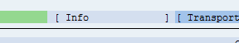

- Select Choose (F2) button. The details of the urls are displayed.
- The complete URL for calling the theme is assembled as follows:
Field Name | Entry Value
URL | <Full URL of your application>?sap-theme=<theme ID>@<theme-root>  (For example, http://<App servername>:<App Port>/sap/bc/ui5_ui5/ui2/ushell/shells/abap/FioriLaunchpad.html?sap-theme=joh@https%3a%2f%2fdewdfgwp01089.wdf.sap.corp%3a44300%2fsap%2fpublic%2fbc%2fthemes%2f~client-120
Result
You can find the urls for your theme in SAP Gateway system.

Deleting a Theme
Use
In this step, it is described how to delete a customer theme.
Procedure
There are multiple ways to delete theme.
Option 1:
- Open the theme designer.
- Select a theme.
- Choose Delete.
Option 2:
- Access the Tool for Customer Themes Maintenance using the following transaction:
Transaction Code | /n/UI5/THEME_TOOL
- You have now accessed the Tool for Customer Themes Maintenance.
- Double-click the red Delete area. The following pop-up shows up:
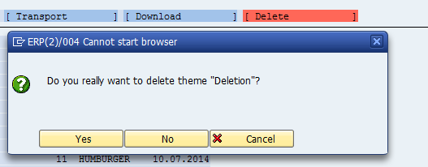

- Confirm with Yes to delete your theme.
Result
You have deleted a customer theme.

Download a Theme
Use
In this step, it is described how to download a customer theme.
Procedure
- Access the Tool for Customer Themes Maintenance using the following transaction:
Transaction Code | /n/UI5/THEME_TOOL
- You have now accessed the Tool for Customer Themes Maintenance.
- Double-click the Download area.
- A Save as dialog shows up. Select a folder on your hard or network drive and give the file a name. Confirm with Save.
Result
You have downloaded a customer theme.

Upload a Theme
Use
In this step, it is described how to upload a customer theme.
Procedure
- Access the Tool for Customer Themes Maintenance using the following transaction:
Transaction Code | /n/UI5/THEME_TOOL
- You have now accessed the Tool for Customer Themes Maintenance.
- Double-click the Upload area.
- An Open dialog shows up. Select a folder on your hard or network drive. Choose with Open.
- The theme is uploaded into your system.
Result
You have uploaded a customer theme.

Example

Customizing the SAP Blue Crystal Theme
Procedure
- Open your SAP Logon application.
- Connect to the system using your ID and password.
- Access the Theme Designer using the following transaction (see fig. 1):
Transaction Code | /UI5/THEME_DESIGNER

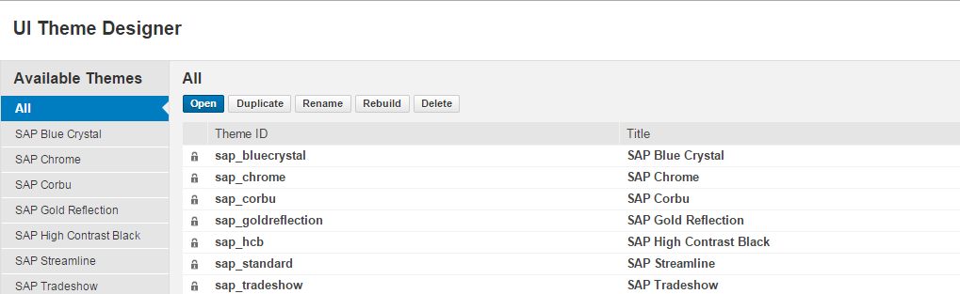
- In the UI Theme Designer choose the SAP Blue Crystal theme and choose Open.

- In the Add Target Content pane, enter the link to the SAP Fiori Launchpad and a name. Choose Add.

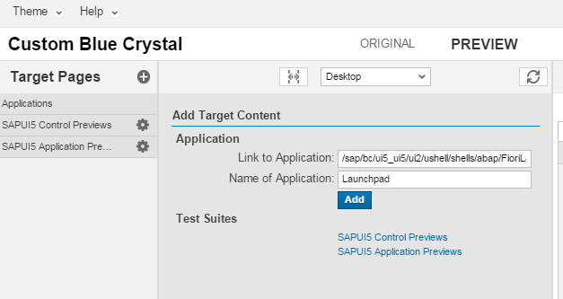

- Select Theme → Save in order to create and save your own theme. Enter the values for Theme ID and Title and confirm the dialog.
- In the Quick theming pane on the right, change the background color to any desired color.

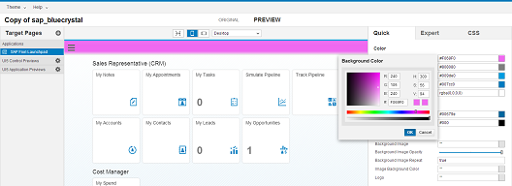

- Since not all changes affect the Launchpad, choose an app that is accessible via the Launchpad.

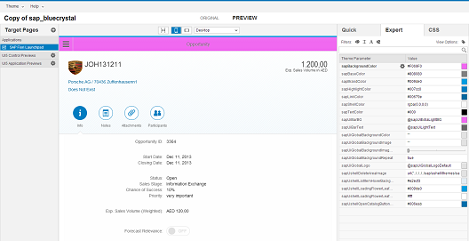

- In the Expert theming pane on the right, change the base color to red entering the following value:
Field Name | Entry Value
sapBaseColor | Red

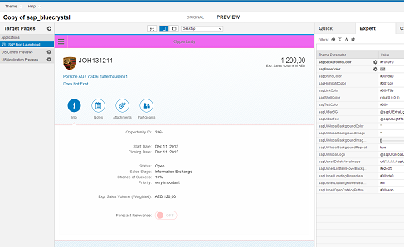

- Select the square next to the sapUIGlobalBackgroundImage text box.
- Add a background image by choosing .

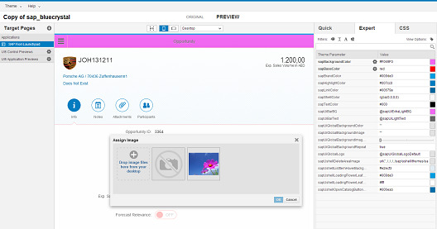

- Choose OK.

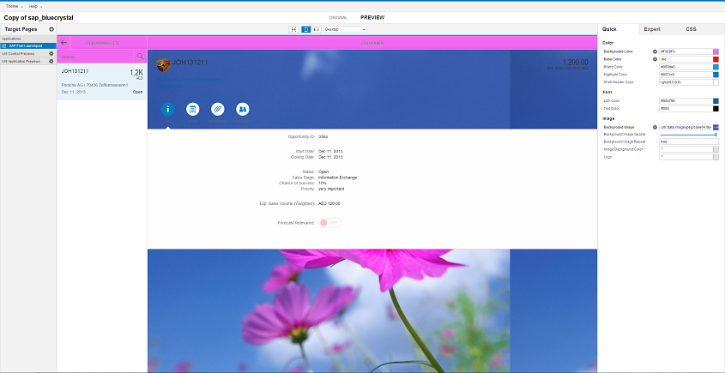

- Save and build the theme, choose Theme → Save & Build… and confirm the dialog.
- To access the SAP Fiori Launchpad, in the address field of your browser insert the URL as described in chapter ‘Deriving the URL Using the Customer Theme Maintenance’.

Example
Field Name | Entry Value
URL | http://<App servername>:<App Port>/sap/bc/ui5_ui5/ui2/ushell/shells/abap/FioriLaunchpad.html?sap-theme=Fiori_themedesigner@https%3a%2f%2fdewdfgwp01089.wdf.sap.corp%3a44300%2fsap%2fpublic%2fbc%2fthemes%2f~client-120

Caution
The URL must have the form <Full URL of your application>?sap-theme=<theme ID>@<theme root>.

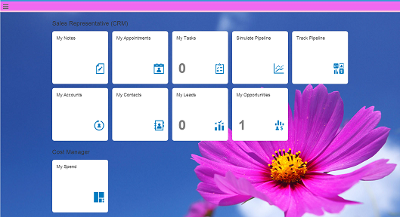

www.sap.com/contactsap
© 2015 SAP SE or an SAP affiliate company. All rights reserved.
No part of this publication may be reproduced or transmitted in any form or for any purpose without the express permission of SAP SE or an SAP affiliate company.
The information contained herein may be changed without prior notice. Some software products marketed by SAP SE and its distributors contain proprietary software components of other software vendors. National product specifications may vary.
These materials are provided by SAP SE or an SAP affiliate company for informational purposes only, without representation or warranty of any kind, and SAP or its affiliated companies shall not be liable for errors or omissions with respect to the materials. The only warranties for SAP or SAP affiliate company products and services are those that are set forth in the express warranty statements accompanying such products and services, if any. Nothing herein should be construed as constituting an additional warranty.
SAP and other SAP products and services mentioned herein as well as their respective logos are trademarks or registered trademarks of SAP SE (or an SAP affiliate company) in Germany and other countries. All other product and service names mentioned are the trademarks of their respective companies. Please see www.sap.com/corporate-en/legal/copyright/index.epx for additional trademark information and notices.
Material Number:

