Comparison of Multi-threading between C++ and Rust (OpenMP vs Rayon/Crossbeam)

Authors:

Nishal Ancelette Pereira <[napereir@andrew.cmu.edu](mailto:napereir@andrew.cmu.edu)>

Supradeep Rangarajan <[strangar@andrew.cmu.edu](mailto:strangar@andrew.cmu.edu)>

Summary

At this point, we have compared and performed preliminary analysis on the multithreading performance on a simple load imbalance workload (Mandelbrot) utilizing two multithreading libraries, Rayon and Crossbeam, which are implemented specifically for Rust to that of OpenMP implementation for C++.

Background

What is Rust?

Rayon

Rayon is a data-parallelism library for Rust. It is extremely lightweight and makes it easy to convert a sequential computation into a parallel one. It also guarantees data-race freedom.

Rayon uses the technique of “work stealing” that is very similar to what is employed by the Cilk abstraction for C/C++, hence very suitable for “divide and conquer” type of workload. Rayon when compared to Cilk is much easier to use and is being actively maintained by the developer community.

Advantages of Rust + Rayon

OpenMP

Motivation for the project

OpenMP extension to C++ provides a very easy, straightforward way of parallelism.

How Rayon works?

What Rayon provides as features?

Approach

To compare

Rust - Rayon

Benchmarks

Re-optimization

Change original implementation

Results

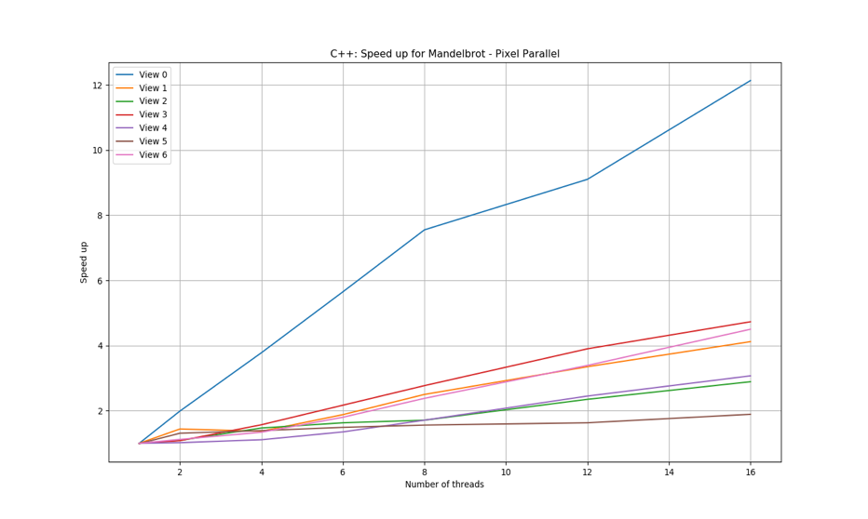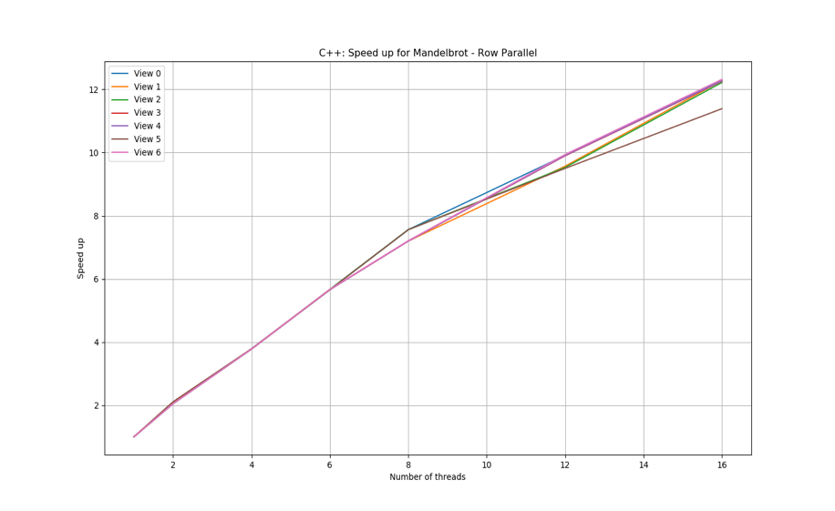

Figure 1: Speedup obtained on different views of Mandelbrot implemented using OpenMP for C++ for (a) Threads running parallel over the pixels (b) Threads running parallel over rows of the image

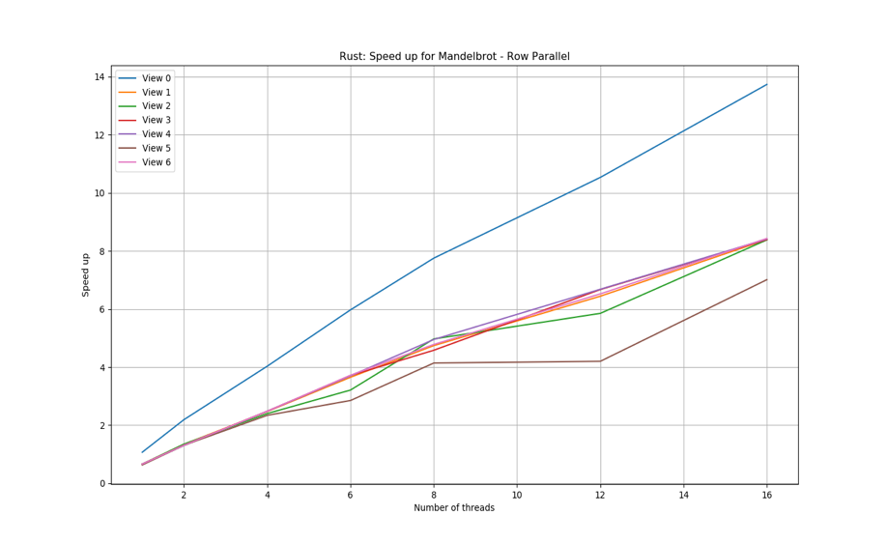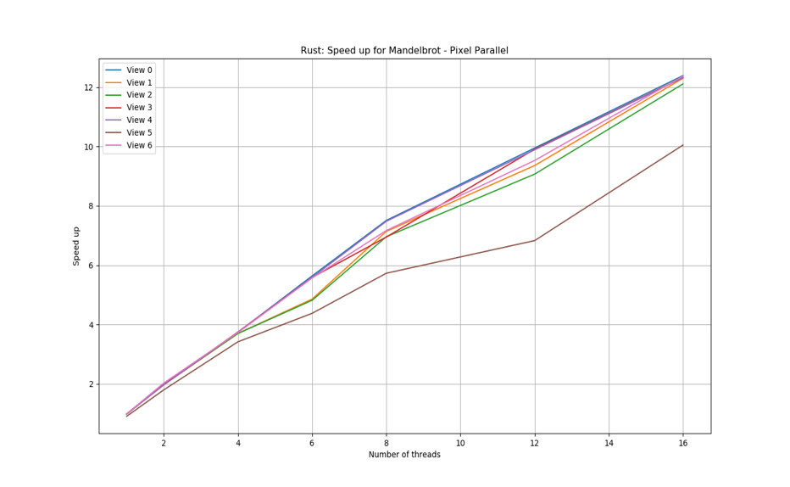

Figure 2: Speedup obtained on different views of Mandelbrot implemented using Rayon in Rust for (a) Threads running parallel over the pixels (b) Threads running parallel over rows of the image

Figure 1 and Figure 2 show the speedup that was obtained on different views of Mandelbrot for threads ranging from 2 to 16 for both C++ and Rust implementations. It is evident that Rust does not perform all that poorly in comparison to C++ version of Multithreading. The speedup obtained for Multithreaded version of Rust with threads running parallel over the rows of the image scales very similar to C++ version of Mandelbrot with threads running parallel over the pixels. Although the speedup obtained with Rust is a more non-linear when compared to C++. After some analysis we found that this is due to the dynamic scheduling in Rust. The threads in Rust steal work from other thread when their load is idle. Since the problem of parallelizing Mandelbrot is embarrassing parallel, we do not observe the benefits that Rust provides in making the functionality of code data-race safe.

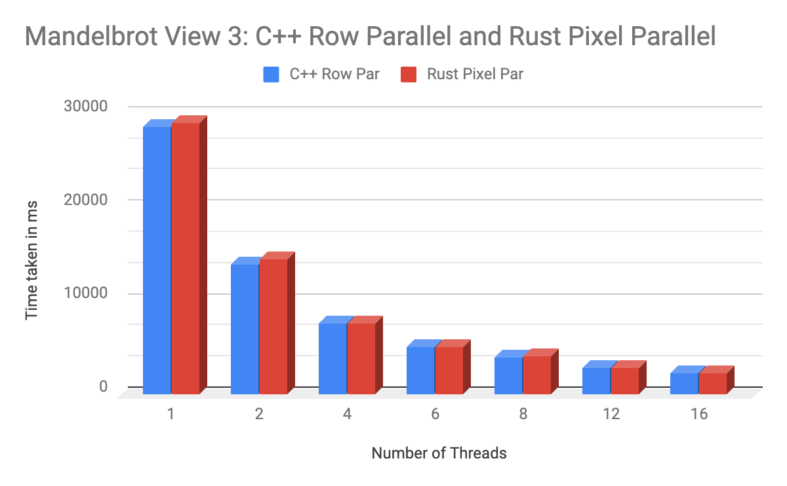

Figure 3: Comparison of time taken by multithreaded version of C++ and Rust Code for Mandelbrot

Figure 3 further iterates the points highlighted in figure 1 and figure 2. The time taken by the Rust implementation of Mandelbrot code lies within 1% of the time taken by C++ implementation.

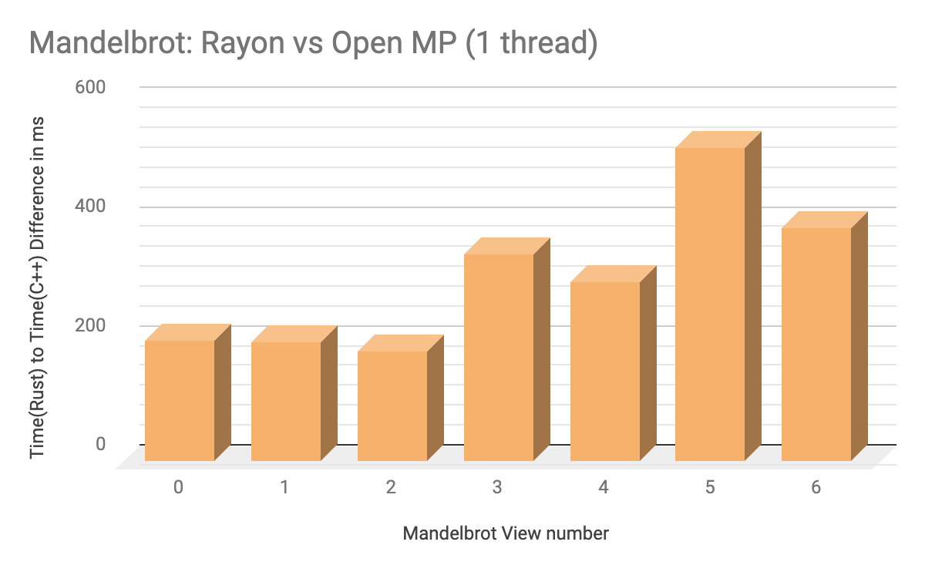

Figure 4: Difference in time taken by single threaded version of Mandelbrot in Rust and C++

Figure 4 analyzes the overhead introduced in spawning a single thread in both Rust and C++. From the timing information showed in the graph, it is observed that for a single threaded version of Mandelbrot, Rust takes more time than the C++ version (Indicated by the positive bar graphs) across all views of the image. This result shows that Rust introduces significant overhead to the boilerplate code.

References

[1] Feature Request: OpenMP/TBB like Parallel For Loops, [*https://github.com/rust-lang/rfcs/issues/859*](https://github.com/rust-lang/rfcs/issues/859)

[2] Rayon, [*https://github.com/rayon-rs/rayon*](https://github.com/rayon-rs/rayon)

Division of Work

We alternated between writing and recording data of each of the benchmarks for each language. Hence, equal work was performed by both the project members.