BIOS 560R Advanced Statistical Computing
Fall 2012
Steve Qin
9/6/2012
MCMC convergence diagnostics

################ Copied from Prof. Hal Stern’s website, slightly modified.
#
# Enclosed is a function called gandr.conv (and others called by it)
# This function takes two inputs:
# n x m matrix of posterior draws for a single parameter of interest
# (n = number of iterations per chain; m = number of chains)
# n1 = number of iterations to ignore as transient
# (defaults to 0.5*n if no number supplied)
# Output contains 3 pieces:
# 1. an approximate posterior 2.5,50,97.5% points (t-approximation)
# 2. quantiles obtained by treating (n - n1) x m matrix as samples
# from posterior
# 3. Gelman and Rubin's convergence measure R and an upper confidence
# limit for R (values near 1, say less than 1.1 are desirable)
#
gandr.conv<-function(r, n1 = nrow(r)/2) {
#
# r: matrix of simulated sequences
# n1: length of initial transient to ignore (default = 0.5)
#
alpha <- 0.05 # 95% intervals
m <- ncol(r)
x <- r[(n1 + 1):nrow(r), ] # part of simulated sequences to process
n <- nrow(x) # We compute the following statistics:
#
# xdot: vector of sequence means
# s2: vector of sequence sample variances (dividing by n-1)
# W = mean(s2): within MS
# B = n*var(xdot): between MS.
# muhat = mean(xdot): grand mean; unbiased under strong stationarity
# varW = var(s2)/m: estimated sampling var of W
# varB = B^2 * 2/(m+1): estimated sampling var of B
# covWB = (n/m)*(cov(s2,xdot^2) - 2*muhat*cov(s^2,xdot)):
# estimated sampling cov(W,B)
# sig2hat = ((n-1)/n))*W + (1/n)*B: estimate of sig2; unbiased under
# strong stationarity
# quantiles: emipirical quantiles from last half of simulated sequences
#
xdot <- as.vector(col.means(x))
s2 <- as.vector(col.vars(x))
W <- mean(s2)
B <- n * var(xdot)
muhat <- mean(xdot)
varW <- var(s2)/m
varB <- (B^2 * 2)/(m - 1)
covWB <- (n/m) * (cov(s2, xdot^2) - 2 * muhat * cov(s2, xdot))
sig2hat <- ((n - 1) * W + B)/n
quantiles <- quantile(as.vector(x), probs = c(0.025, 0.25, 0.5,
0.75, 0.975))
if(W > 1e-08) {
#
# non-degenerate case
# Posterior interval post.range combines all uncertainties
# in a t interval with center muhat, scale sqrt(postvar),
# and postvar.df degrees of freedom.
#
# postvar = sig2hat + B/(mn): variance for the posterior interval
# The B/(mn) term is there because of the
# sampling variance of muhat.
# varpostvar: estimated sampling variance of postvar
#
postvar <- sig2hat + B/(m * n)
varpostvar <- (((n - 1)^2) * varW + (1 + 1/m)^2 * varB +
2 * (n - 1) * (1 + 1/m) * covWB)/n^2
post.df <- chisqdf(postvar, varpostvar)
post.range <- muhat +
sqrt(postvar) * qt(1-alpha/2, post.df) * c(-1,0,1)
#
# Estimated potential scale reduction (that would be achieved by
# continuing simulations forever) has two components: an estimate and
# an approx. 97.5% upper bound.
#
# confshrink = sqrt(postvar/W),
# multiplied by sqrt(df/(df-2)) as an adjustment for the
# width of the t-interval with df degrees of freedom.
#
# postvar/W = (n-1)/n + (1+1/m)(1/n)(B/W); we approximate the sampling dist.
# of (B/W) by an F distribution, with degrees of freedom estimated
# from the approximate chi-squared sampling dists for B and W. (The
# F approximation assumes that the sampling dists of B and W are independent;
# if they are positively correlated, the approximation is conservative.)
#
varlo.df <- chisqdf(W, varW)
confshrink.range <- sqrt((c(postvar/W, (n - 1)/n + (1 + 1/m) * (1/n) * (B/W) * qf(0.975, m - 1, varlo.df))
* post.df)/(post.df - 2))
list(post = post.range, quantiles = quantiles,
confshrink = confshrink.range)
}
else {
#
# degenerate case: all entries in "data matrix" are identical
#
list(post = muhat * c(1, 1, 1), quantiles = quantiles,
confshrink = c(1, 1)) }
}
#
# some functions needed by the above
#
col.vars<-function(mat) {
means <- col.means(mat)
col.means(mat * mat) - means * means }

col.means<-function(mat) {
ones <- matrix(1, nrow = 1, ncol = nrow(mat))
ones %*% mat/nrow(mat) }

cov<-function(a, b) {
m <- length(a)
((mean((a - mean(a)) * (b - mean(b)))) * m)/(m - 1) }

chisqdf<-function(A, varA) {
2 * (A^2/varA) }
#
#
######################## end of function gandr.conv and its subfunctions.

#Example:

# Gibbs Sampler
# bi-variate normal
#
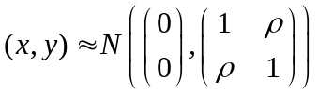

gibbs.binorm <- function(rho,n,x0,y0) {
# rho is corr coefficient of the bivariate normal distribution.
# n is the length of the chain
# x0 and y0 are the initial values for (x,y)
x <- rep(0,n)
y <- rep(0,n)

# initialize
x[1] <- x0
y[1] <- y0

# start chain
for(i in 1:n) {
x[i+1] <- rnorm(1,rho*y[i],1-rho^2)
y[i+1] <- rnorm(1,rho*x[i+1],1-rho^2)
}
return(cbind(x,y))
}

#
# multiple chains
#
chain1 <- gibbs.binorm(0.9,1000,10,10)
chain2 <- gibbs.binorm(0.9,1000,-10,-10)

# trace plot
par(mfrow=c(1,2))
plot(chain1[1:50,1],type="l",ylim=c(-10,10),col=1)
points(chain2[1:50,1],type="l",col=2)

plot(chain1[1:50,2],type="l",ylim=c(-10,10),col=1)
points(chain2[1:50,2],type="l",col=2)

par(mfrow=c(1,2))
plot(chain1[1:500,1],type="l",ylim=c(-10,10),col=1)
points(chain2[1:500,1],type="l",col=2)

plot(chain1[1:500,2],type="l",ylim=c(-10,10),col=1)
points(chain2[1:500,2],type="l",col=2)

The first 50 iterations:
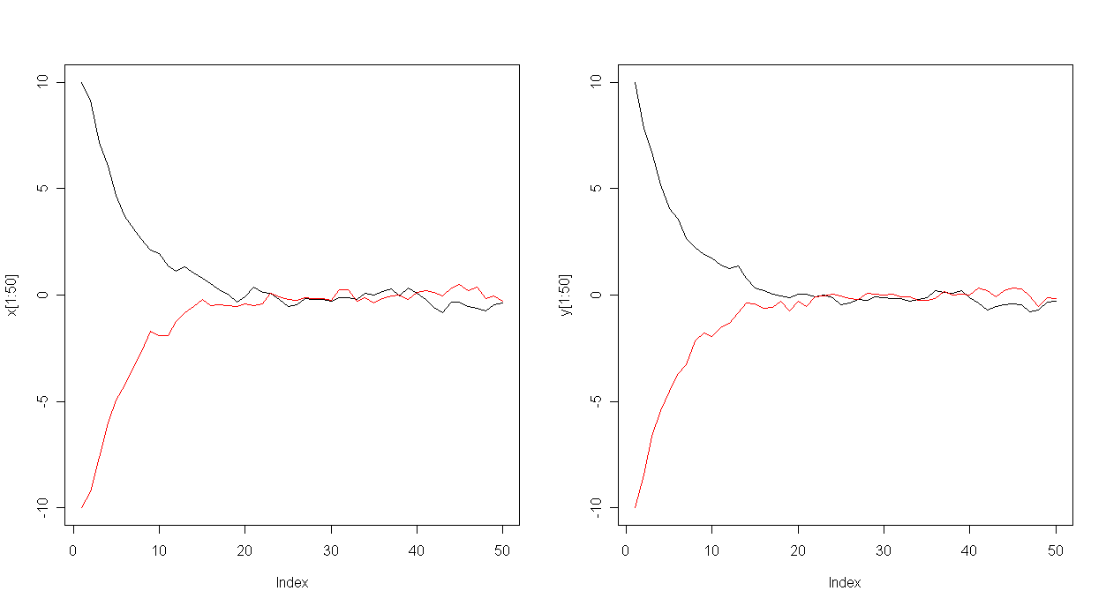
The first 500 iterations:
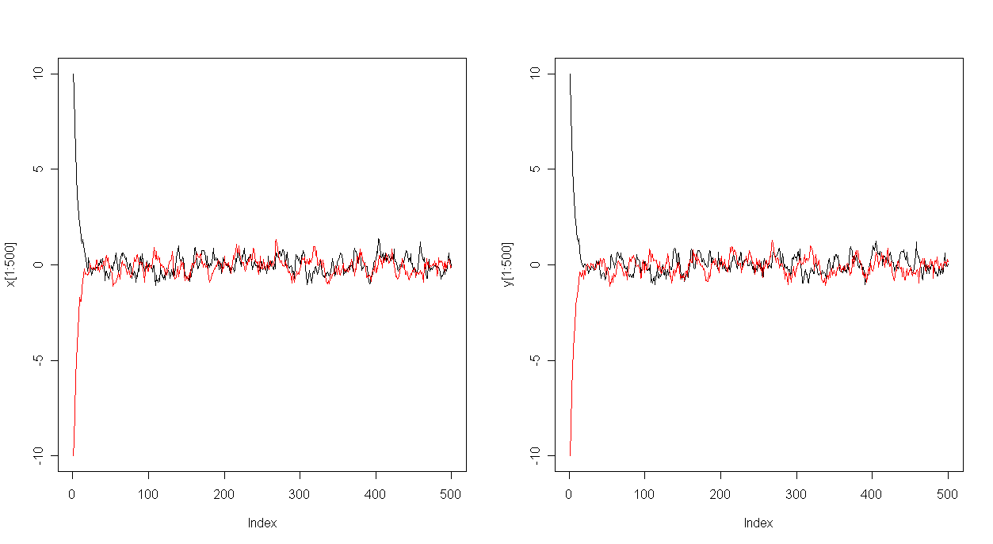
#
# convergence diagnostics using Rhat (Gelman et al. P297)
#
r <- cbind(chain1[1:50,1],chain2[1:50,1])
gandr.conv(r)

r <- cbind(chain1[1:500,1],chain2[1:500,1])
gandr.conv(r)

result: 1:50

$post
[1] -0.8849393 -0.1249011 0.6351371

$quantiles
2.5% 25% 50% 75% 97.5%
-0.71253039 -0.27389635 -0.16134125 0.08492607 0.35363964

$confshrink
[1] 1.453220 2.355414

result: 1:500

$post
[1] -0.90204110 -0.03037303 0.84129503

$quantiles
2.5% 25% 50% 75% 97.5%
-0.83945081 -0.34066484 -0.04824586 0.25813121 0.83794661

$confshrink
[1] 1.027877 1.126500

Example:

# Metropolis
# bi-variate normal
#
metro.binorm <- function(rho,n,x0,y0) {
x <- rep(0,n)
y <- rep(0,n)
# initialize
x[1] <- x0
y[1] <- y0
# tuning parameter
s0 <- 0.5 # maximum step size in random walk proposal function
# start chain
for( i in 1:n) {
s <- s0*runif(1)
theta<-2*3.1415926*runif(1)
xnew <- x[i] + s*cos(theta) # random walk
ynew <- y[i] + s*sin(theta) # random walk
r <- exp(-((xnew^2-2*rho*xnew*ynew+ynew^2)-(x[i]^2- 2*rho*x[i]*y[i]+y[i]^2))/(2*(1-rho^2))) # acceptance ratio
test <- runif(1)
if(test < r ) # accept proposed moved.
{
x[i+1] <- xnew
y[i+1] <- ynew
}
else # reject proposed move, stay put.
{
x[i+1] <- x[i]
y[i+1] <- y[i]
}
}
return(cbind(x,y))
}# end of metro.binorm

#
# multiple chains
#
chain1 <- metro.binorm(0.9,1000,5,5)
chain2 <- metro.binorm(0.9,1000,-5,-5)
chain3 <- metro.binorm(0.9,1000,-5,5)

# combined scatter plot
par(mfrow=c(1,1))
plot(chain1[,1],chain1[,2],type="l",xlim=c(-5,5), ylim=c(-5,5),col=1)
points(chain2[,1],chain2[,2],type="l",col=2)
points(chain3[,1],chain3[,2],type="l",col=3)

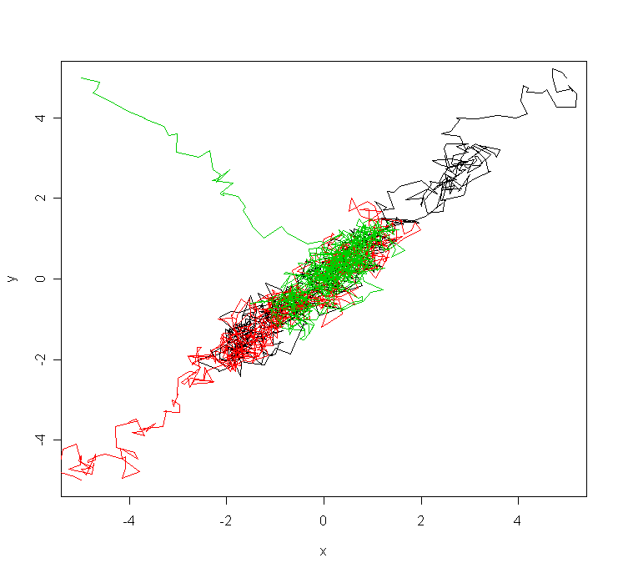
#
# convergence diagnostics using Rhat (Gelman et al. P297)
#
r <- cbind(chain1[1:100,1],chain2[1:100,1],chain3[1:100,1])
gandr.conv(r)

r <- cbind(chain1[,1],chain2[,1],chain3[,1])
gandr.conv(r)

r <- cbind(chain1[1:100,2],chain2[1:100,2],chain3[1:100,2])
gandr.conv(r)

r <- cbind(chain1[,2],chain2[,2],chain3[,2])
gandr.conv(r)

