**A program for primary school students to practice calculating**

**(pseudocode)**

The beginning four lines define four header file.

The five row define a global file.

The 6-11 rows define a structure Student;

The 12、 13 rows is declare two functions: CheckID and Exam;

In function main require input student ID and take the ID in the string s[6];

Use function CheckID check student id whether is correct or not, if the input is not correct, the function will return “0” and then require to enter again, if it’s correct ,the function will return “1” and jump out of the while loop ;

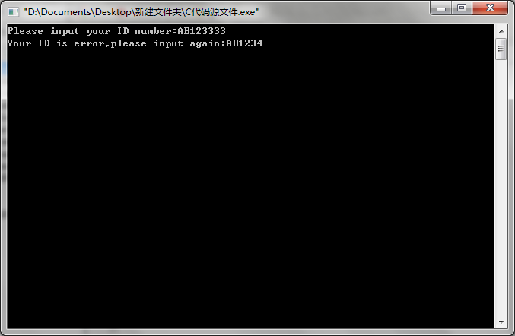

After successfully entered student id, shows three options, if input 3 directly exit;

If input 1,the program will start to keep time, and will be with three random number: m, a, b;

m=0,1,2,3 are on behalf of plus ,subtract, multiply, divide;

a, b are two numbers which will be using for operating;

Enter function Exam to give a test, according to the value of m to choose an operation;

Give ten tests by while loop , and pay attention to the rules of operation, if it break the rules, the program will deassign a, b random, till the value of a, b meet the requirements.;

After every test the switch can judge the answers, if it is correct, the score will be plus 10 and print out “Correct”, if it is wrong, the program will print out “Error” . And every time after giving a test, put the right answer and student answer in the two arrays: c1[10] and c2[10], and compute the time of the student using on ten tests;

Put the student ID, the score and time in the record.txt as a structure;

Final print out the score, time, the right answers and the student answers on the screen;

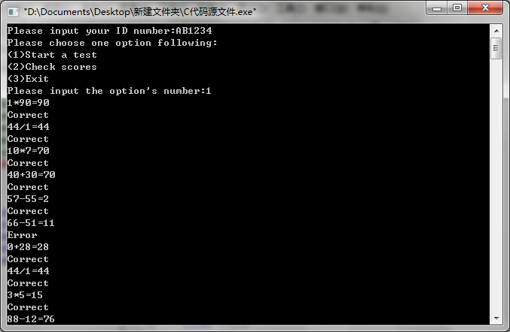

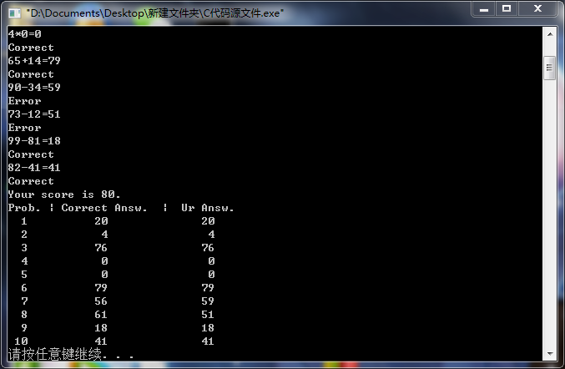

If input 2,the program will according to the student’s ID to scan the grade in the past the student do and output them on the screen.

