Report: Interpretable Risk Stratification for Bladder Cancer Using Bulk Transcriptomics with External Validation and Single-Cell Gene Perturbation Simulation

Introduction
Bladder cancer (BLCA) is characterized by substantial molecular heterogeneity across patients, spanning diverse transcriptional states, genomic alterations, and epigenetic regulation. This heterogeneity contributes to variable treatment response and clinical outcomes, making accurate prognosis and risk stratification an important component of clinical decision-making. From a systems biology perspective, patient survival is rarely controlled by a single driver pathway; rather, prognosis emerges from the integrated behavior of multiple cellular processes such as proliferation, stress response, metabolism, differentiation, immune evasion, and microenvironment remodeling. Therefore, building effective prognostic models requires both predictive performance and interpretability. Models must be strong enough to stratify risk, yet transparent enough to yield biologically meaningful hypotheses and guide future validation. ^{[1,8]}
Large public repositories such as The Cancer Genome Atlas (TCGA) and the Gene Expression Omnibus (GEO) provide multi-omics data resources for BLCA, including bulk RNA-seq, DNA methylation, and (in some cases) single-cell transcriptomics. ^{[1,2]} A typical computational objective is to construct a prognostic model on a training cohort (e.g., TCGA-BLCA) and validate it on an independent cohort (e.g., a GEO dataset), using concordance index (C-index) to measure survival ranking accuracy and Kaplan–Meier (KM) curves with log-rank tests to confirm risk group separation. ^{[3]} However, due to cross-platform differences (RNA-seq vs microarray), gene identifier inconsistencies, batch effects, and differences in follow-up or clinical coding, external validation is often fragile. A robust pipeline must carefully control feature mapping and scale handling to avoid optimistic internal performance that fails to generalize.
In addition to cohort-level validation, modern tasks increasingly require connecting bulk signatures to single-cell biology. Bulk RNA-seq reflects the aggregate of multiple cell types and states in the tumor microenvironment. A gene signature that stratifies survival at the patient level may correspond to changes in the abundance of specific cell populations (e.g., epithelial tumor cells vs immune infiltration), or may reflect state shifts within a particular population (e.g., stress response in tumor epithelium). Single-cell transcriptomics provides a way to probe these hypotheses by analyzing cell-type composition, transcriptional programs, and perturbation sensitivity. In silico perturbation analysis—simulating knockdown or overexpression of key genes and measuring predicted changes in cell states—can generate mechanistic hypotheses: which cell types are most sensitive to certain prognostic genes, and whether gene perturbation pushes cells toward or away from a given state. ^{[4–6]}
Accordingly, this study develops an interpretable prognostic risk stratification framework for BLCA using public datasets, with rigorous external validation and single-cell analysis to generate mechanistic hypotheses. Bulk RNA-seq serves as the primary modeling modality; we additionally leverage TCGA DNA methylation as a training-time teacher signal via a teacher–student knowledge distillation scheme so that the deployed model remains RNA-only and therefore applicable to external cohorts. The single-cell stage uses a BLCA scRNA-seq dataset to characterize cell-state structure and to simulate perturbations of key prognostic genes to quantify state sensitivity. ^{[7]}
This report documents an end-to-end pipeline: (i) preprocessing and quality control of TCGA-BLCA bulk RNA-seq; (ii) differential expression analysis between tumor and normal samples with multiple visualizations; (iii) construction of an interpretable Cox proportional hazards risk model with cross-validated hyperparameters; (iv) external validation in GSE13507 and comparison against three reproduced published BLCA prognostic signatures (Zou et al., Aging 2021; Sun et al., Oxidative Medicine and Cellular Longevity 2022; Jiang et al., Frontiers in Immunology 2022)^{[8-11]}; and (v) single-cell preprocessing of GSE135337, marker-based cluster annotation, and in silico gene perturbation simulations to assess state sensitivity. The results demonstrate that the methylation-guided distilled RNA-only student model achieves strong risk separation in TCGA and robust generalization in GSE13507, while single-cell perturbation highlights immune-like (and endothelial-like) populations as the most sensitive compartments to the key prognostic genes—supporting the interpretation that the survival signal may involve microenvironmental/immune-state dynamics rather than large-scale tumor-lineage switching.
Materials and Methods

Data sources and cohorts
TCGA-BLCA (training cohort). Bulk RNA-seq STAR gene-level counts (unstranded) and corresponding clinical annotations were obtained from TCGA-BLCA. Only Primary Tumor and Solid Tissue Normal sample types were retained. Clinical outcome (TCGA overall survival). Overall survival (OS) time and event status were retrieved per TCGA case. Expression was aggregated from sample level to patient level and aligned to OS records. Patients with missing OS information were excluded from survival modeling. GSE13507 (external validation cohort). GSE13507 is a GEO bladder cancer cohort with expression and survival information. Expression features were mapped to the same gene-symbol space used in TCGA to enable external scoring and validation. GSE135337 (single-cell cohort). GSE135337 is a BLCA scRNA-seq dataset (7 BLCA samples excluding GSM5329919 as specified; BC1–BC7). Each sample was provided as a gzipped gene-by-cell expression table and merged into a unified matrix prior to preprocessing.

Bulk RNA-seq preprocessing (TCGA)
Count matrix construction and sample filtering. STAR count files were merged into a gene × sample matrix. Samples were filtered to the two target types (tumor vs normal). When duplicate samples existed for the same case, the sample with the largest library size was retained. Gene identifier harmonization and filtering. Ensembl gene IDs were mapped to gene symbols and duplicated symbols were collapsed by summation. Low-expression genes were filtered using a CPM-based rule (CPM ≥ 1 in at least 10% of samples). Retained genes were transformed to logCPM values as log2(CPM + 1). Patient-level aggregation and OS alignment. Sample-level expression was aggregated to the patient level (mean across samples per case) and aligned to OS records to form the modeling dataset.

Differential expression analysis and visualization (TCGA tumor vs normal)
Differential expression (DE) was performed between tumor and normal samples using logCPM values. Tumor–normal effect size was defined as the difference in mean logCPM (logFC). Statistical significance was assessed using Welch’s two-sample t-test (unequal variances), followed by Benjamini–Hochberg correction to control the false discovery rate (FDR). Genes were ranked by FDR (p-value as a tie-breaker), and the top 500 DE genes were exported as candidates for prognostic modeling. QC visualizations included a volcano plot, PCA based on top variable genes, and a heatmap of top DE genes with per-gene z-score scaling.

Prognostic modeling (RNA-only student Cox) and evaluation
Candidate genes. We started from the top 500 tumor–normal DE genes derived from TCGA-BLCA. To ensure that the risk score can be computed for every external sample, candidate genes were restricted to the intersection of the TCGA and GSE13507 gene spaces. After this intersection filtering, 233 genes remained as usable candidates.Feature scaling and cross-cohort consistency. For each candidate gene, expression values in TCGA were standardized using z-score normalization. The corresponding TCGA mean and standard deviation were then reused to transform GSE13507, ensuring cross-cohort comparability and preventing information leakage from the external dataset.Univariate Cox screening (TCGA). Univariate Cox proportional hazards regression was applied to each candidate gene in TCGA. P-values were adjusted using the Benjamini–Hochberg procedure, and a relaxed threshold of univ_FDR ≤ 0.2 was used to retain sufficient signal for multivariate modeling. This screening step yielded 39 genes for multivariate fitting.
Multivariate ridge Cox model and hyperparameter selection. We trained an L2-regularized Cox proportional hazards model (ridge Cox) on the 39-gene set. The L2 penalty was tuned by 5-fold cross-validation on TCGA to stabilize coefficient estimation under correlated predictors. The selected configuration was then refit on the full TCGA cohort to produce patient-level risk scores for TCGA evaluation and external scoring in GSE13507.
$$\text{Risk=}\sum_{\text{i}}{{\text{β}}_{\text{i}}}\text{⋅}{\text{z}}_{\text{i}}$$
r = Σ_i β_i · z_i (i = 1..39), where z_i is the TCGA-standardized expression of gene i. Patients were stratified into high- and low-risk groups using the cohort median risk score.
Metrics. Performance was evaluated using C-index and Kaplan–Meier/log-rank tests on TCGA (training) and GSE13507 (external).
Methylation-guided knowledge distillation (training with methylation, deployment with RNA-only)

Motivation. DNA methylation provides complementary epigenetic regulation with strong prognostic signal in TCGA-BLCA, but matched methylation profiles are unavailable in the external GSE13507 cohort. To leverage methylation without losing external applicability, we used methylation to provide a teacher signal during training and deployed an RNA-only student model for inference.
Teacher signal. We obtained TCGA patient-level teacher risk scores (r_teacher) from a methylation-only Cox model trained on TCGA methylation data. Teacher risks were used only within TCGA.
Student model. The student takes TCGA-standardized RNA features (39 genes selected by univariate screening) and outputs a continuous risk score r_student using a small neural Cox model (MLP encoder + linear risk head).
Training objective and scale handling. The student was trained with a combined objective: negative Cox partial log-likelihood plus a distillation loss matching r_student to r_teacher. To mitigate teacher scale differences and heavy-tailed risks, r_teacher was winsorized (1–99% quantiles on the training split) and z-score normalized using training-split statistics before computing the distillation loss.
Hyperparameter search. We performed random search (n_trials = 20) on a TCGA train/validation split to tune latent dimension, dropout, learning rate, weight decay, and distillation weight (alpha), selecting the configuration with the best validation C-index.

Table 3. Student model configuration and selected hyperparameters (best trial).
Parameter | Value
Model | Methylation-guided distilled RNA-only student
TCGA patients | 324
GSE samples | 165
RNA genes used | 39
Univariate FDR threshold | 0.2
latent_dim | 256
dropout | 0.2
learning rate | 0.00150061
weight decay | 8.36698e-06
alpha_distill | 0.12707
Random search trials | 20
TCGA C-index | 0.7566
GSE13507 C-index | 0.6485
TCGA log-rank p | <1×10⁻¹⁶
GSE13507 log-rank p | 0.000505032

Multi-omics integration and hyperparameter selection (RNA-seq + DNA methylation)
To evaluate multi-omics prognostic modeling in TCGA-BLCA, we integrated bulk RNA-seq expression with DNA methylation profiles and compared four strategies: methylation-only modeling, early fusion, intermediate fusion, and late fusion. Because RNA and methylation are on different measurement scales, explicit normalization and high-dimensionality control were applied prior to Cox modeling.
Scale handling and normalization.
For bulk RNA-seq, STAR gene-level counts were processed into logCPM values using log2(CPM + 1). For risk modeling, each RNA feature was standardized by z-score normalization (subtracting the TCGA training mean and dividing by the TCGA training standard deviation). For DNA methylation, TCGA level-3 beta values (β ∈ [0, 1]) were used as input features and similarly standardized by z-score across TCGA patients before Cox fitting. These procedures ensured that RNA and methylation features were comparable when concatenated (early fusion) or projected into low-dimensional spaces (intermediate fusion).
High-dimensionality control.
Methylation data are inherently high-dimensional (hundreds of thousands of CpG probes), with the number of features greatly exceeding the number of patients. To stabilize model fitting and reduce computational cost, CpG probes were first ranked by variance across patients and only the top top_k_meth probes were retained. RNA features were restricted to the top top_k_rna most variable genes (or predefined candidate sets) before fusion. All Cox models were trained with L2 regularization (ridge Cox; penalizer = l2) to mitigate multicollinearity and improve convergence under p > n.
Fusion strategies.
(1) Methylation-only: a ridge Cox model fit on CpG features only.
(2) Early fusion: concatenation of standardized RNA and methylation features into a single vector followed by ridge Cox fitting.
(3) Intermediate fusion: modality-specific PCA was applied to standardized features (RNA PCA to rna_pca_dim components; methylation PCA to meth_pca_dim components), and the concatenated PCA components were used to fit a ridge Cox model.
(4) Late fusion: separate ridge Cox models were trained for RNA and methylation to obtain modality-specific risk scores (risk_RNA and risk_Meth). A fused risk score was then defined as:
$$\text{ris}{\text{k}}_{\text{fused}}\text{=}\text{w}\text{⋅}\text{ris}{\text{k}}_{\text{RNA}}\text{+(1−}\text{w}\text{)⋅}\text{ris}{\text{k}}_{\text{Met}\text{h}}\text{,}$$
r_fused = w · r_RNA + (1 − w) · r_Meth, where the fusion weight w ∈ [0, 1] was selected by cross-validation. A degenerate solution (e.g., w = 0) indicates that the fused score collapses to the methylation-only risk, meaning methylation dominates the weighted fusion under the chosen evaluation setting.
Hyperparameter search.
Hyperparameters were selected using 5-fold cross-validation on TCGA patients with the concordance index (C-index) as the optimization target. The search included feature settings (e.g., top_k_meth, top_k_rna), ridge penalty strength (l2), PCA dimensions (rna_pca_dim, meth_pca_dim), and (for late fusion) the fusion weight w. Final settings and internal validation results are reported in Table 2. External validation was not performed for methylation/fusion models due to the absence of matched methylation measurements in the external cohort.

Results

Cohort statistics and preprocessing outputs
After preprocessing and harmonization, the TCGA-BLCA bulk RNA-seq dataset contained 428 samples (409 Primary Tumor and 19 Solid Tissue Normal). CPM-based filtering and gene-symbol harmonization yielded 18,656 genes in the unified expression matrix. Patient-level aggregation and OS alignment produced a final modeling cohort of 326 patients with matched expression and non-missing overall survival (OS) information. For the methylation-guided distilled student model, only patients with available teacher risks were used (N = 324). For external validation, GSE13507 comprised 165 BLCA samples mapped to the same gene-symbol space. For single-cell analyses, the GSE135337 scRNA-seq cohort (BC1–BC7) was merged and processed; after QC filtering, 36,788 cells were retained for clustering and downstream annotation/perturbation analyses.
Differential expression results (TCGA tumor vs normal)
Tumor–normal differential expression analysis identified widespread transcriptional differences between Primary Tumor and Solid Tissue Normal samples. The volcano plot shows a large number of genes exceeding common effect-size and significance thresholds (|logFC| ≥ 1 and FDR < 0.05), supporting robust tumor–normal expression shifts (Figure 1A). PCA based on the top variable genes reveals an overall structural difference between tumor and normal samples, although the normal group size is limited (n=19), which may reduce the visual compactness of the normal cluster (Figure 1B). The heatmap of the top 50 DE genes demonstrates consistent z-score-scaled expression patterns across samples, supporting the stability of the DE ranking (Figure 1C). The top 500 DE genes were exported as the candidate pool for downstream prognostic modeling.
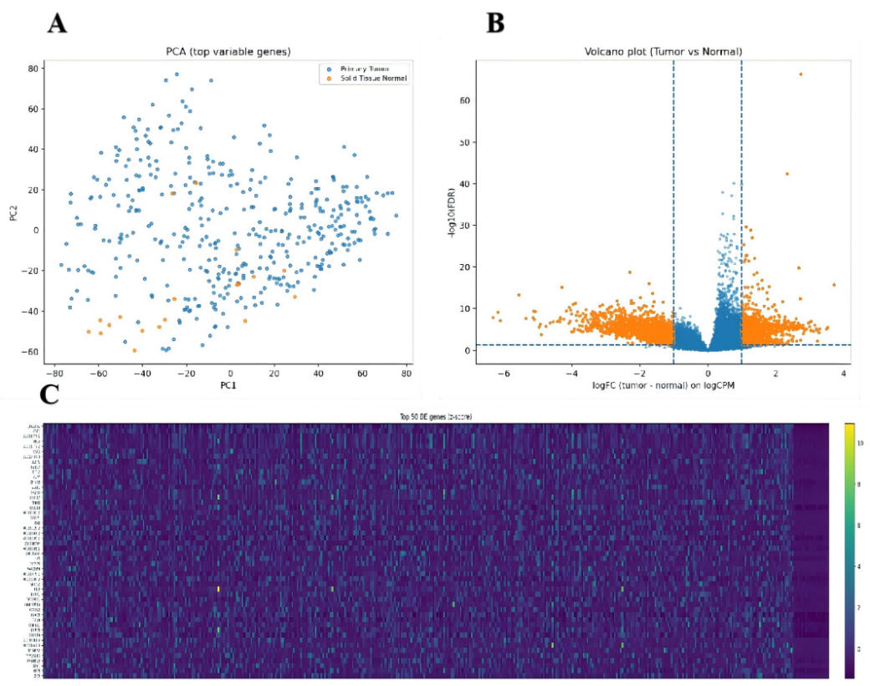
Figure 1. Differential expression and QC visualizations for TCGA tumor vs normal.

Cox model performance in TCGA
Starting from the top 500 TCGA tumor–normal DE genes, we restricted candidates to genes present in both TCGA and GSE13507 to ensure external scoring completeness. After univariate Cox screening (FDR ≤ 0.2), the final RNA feature set contained 39 genes. We then trained an RNA-only student model using methylation-derived teacher risks for knowledge distillation (Methods). After intersecting with available teacher risks, the distilled student was trained/evaluated on 324 TCGA patients and achieved strong discrimination (C-index = 0.7566; log-rank p < 1×10⁻¹⁶).
External validation in GSE13507 (independent cohort)
To evaluate cross-cohort generalization, the TCGA-trained RNA-only student model was applied to the independent GEO cohort GSE13507 (n = 165) using the same 39 genes and TCGA-derived feature scaling parameters. The model achieved an external C-index of 0.6485. Using cohort-median stratification, Kaplan–Meier curves remained significantly separated (log-rank p = 0.000505; Figure 2B), supporting robust external validity across platforms.
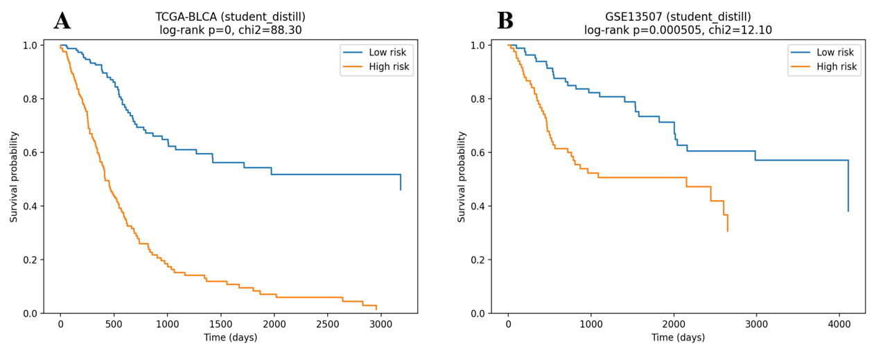

Figure 2. Performance of the methylation-guided distilled RNA-only student model. (A) TCGA-BLCA Kaplan–Meier (train; n=324). (B) GSE13507 Kaplan–Meier (external; n=165). Risk groups were defined by the cohort-median risk score.

Comparison with a published baseline model
To benchmark our approach against published prognostic signatures, we reproduced three BLCA gene signatures (Zou et al., Aging 2021; Jiang et al., Frontiers in Immunology 2022; Sun et al., Oxidative Medicine and Cellular Longevity 2022) and evaluated them using the same OS endpoint and metrics in TCGA-BLCA and GSE13507. KM curves are shown in Figure 3 and quantitative results are summarized in Table 1. Compared with all reproduced baselines, the methylation-guided distilled RNA-only student achieved improved discrimination in TCGA (C-index = 0.7566) and competitive external ranking in GSE13507 (C-index = 0.6485), indicating that epigenetic teacher supervision can improve cross-cohort risk ranking while preserving deployability.

Table 1. Head-to-head comparison of our models with reproduced published BLCA prognostic signatures in TCGA-BLCA and the independent GSE13507 cohort.
Model | Genes | TCGA C-index | TCGA log-rank p | GSE13507 C-index | GSE13507 log-rank p
Our work (methylation-guided distilled RNA-only) | 39 | 0.757 | <1×10⁻¹⁶ | 0.648 | 0.000505
Our work (ridge Cox baseline) | 39 | 0.723 | 6.22×10⁻¹⁵ | 0.632 | 0.0235
Zou 2021 | 6 | 0.623 | 2.24×10⁻⁵ | 0.630 | 0.00285
Jiang 2022 | 6 | 0.607 | 0.00107 | 0.524 | 0.147
Sun 2022 | 5 | 0.658 | 1.07×10⁻⁸ | 0.644 | 0.189

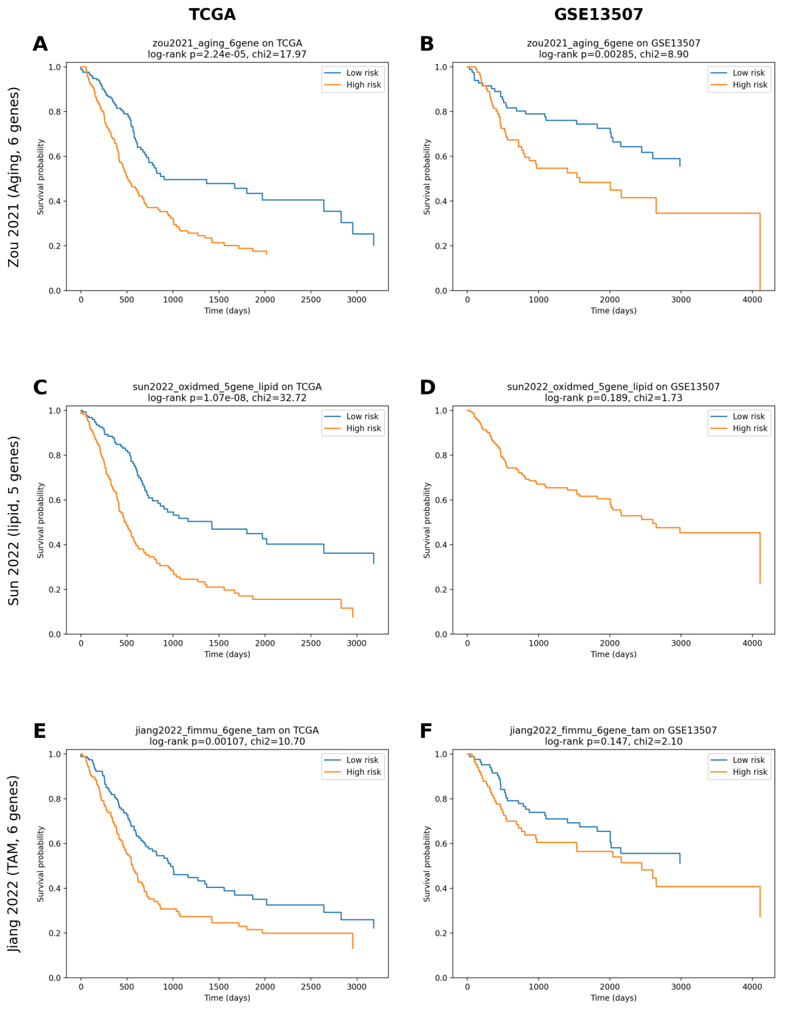
Figure 3. Kaplan–Meier survival analysis of reproduced published BLCA signatures in TCGA-BLCA (left) and the independent GSE13507 cohort (right). (A–B) Zou et al., Aging 2021 (6 genes); (C–D) Sun et al., Oxidative Medicine and Cellular Longevity 2022 (5 genes); (E–F) Jiang et al., Frontiers in Immunology 2022 (6 genes). Risk groups were defined using the auto cutoff policy (Methods), and log-rank p-values are shown on each panel.

Methylation-guided distillation improves both internal and external performance
Because the external cohort lacks methylation measurements, we used a methylation-only TCGA model to generate teacher risks and trained an RNA-only student via knowledge distillation. With teacher-risk winsorization (1–99% quantiles) and train-split z-score normalization, the distilled student achieved strong discrimination in TCGA (C-index = 0.7566; log-rank p < 1×10⁻¹⁶) and significant external validation in GSE13507 (C-index = 0.6485; log-rank p = 5.05×10⁻⁴). Compared with the RNA-only ridge Cox baseline (TCGA C-index = 0.723; GSE13507 C-index = 0.632), distillation improved both within-cohort ranking and cross-cohort performance, outperforming reproduced published signatures (Table 1).
To improve interpretability, we refit a Cox proportional hazards model on the 39-gene RNA signature within the same TCGA training subset (n=324) and summarized gene-level coefficients and hazard ratios (Figure 4). In the multivariable CoxPH model (expression z-scored per gene), SPON1 (HR=1.45, 95% CI 1.01-2.09, p=0.0418), XPO5 (HR=1.33, 1.04-1.70, p=0.0238), AHCY (HR=1.25, 1.03-1.51, p=0.0233), LHX5 (HR=1.23, 1.01-1.48, p=0.0361) and CGB5 (HR=1.21, 1.04-1.42, p=0.0151) showed risk-promoting associations (coef>0). Conversely, DCN (HR=0.66, 0.45-0.97, p=0.0321), EN2 (HR=0.71, 0.58-0.88, p=0.0015) and RLN2 (HR=0.80, 0.64-0.99, p=0.0450) were protective (coef<0). After BH correction across 39 genes, EN2 remained the most significant feature (FDR=0.0571), while other genes did not pass FDR<0.05, consistent with moderate effect sizes and multivariable adjustment.

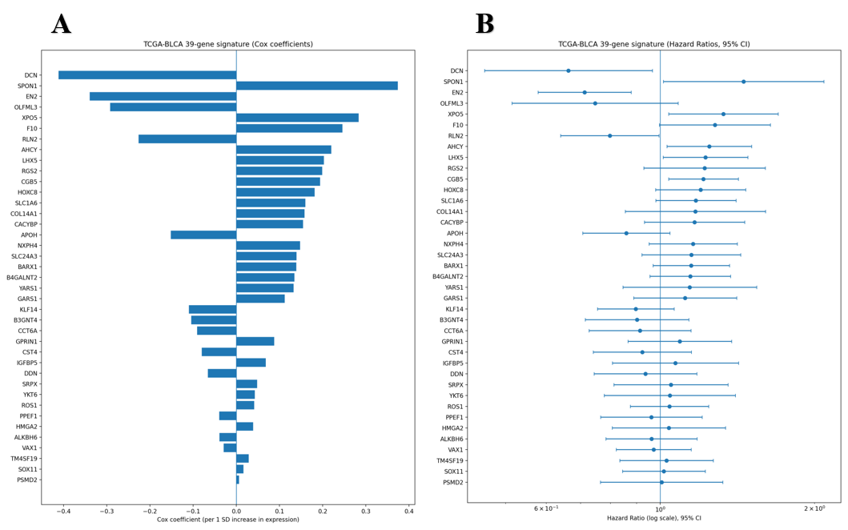
Figure 4. Interpretability of the 39-gene RNA signature in TCGA-BLCA (n=324). (A) Cox regression coefficients per 1 SD increase in gene expression (z-scored across samples). (B) Corresponding hazard ratios (log scale) with 95% confidence intervals. Positive coefficients >1 indicate increased hazard (worse survival), whereas negative coefficients <1 indicate protective association.

DNA methylation and multi-omics fusion in TCGA (internal evaluation)
To evaluate whether DNA methylation provides complementary prognostic information beyond bulk RNA expression, we trained ridge-regularized Cox models on TCGA-BLCA using four strategies: (i) methylation-only, (ii) early fusion by concatenating RNA and methylation features, (iii) intermediate fusion via modality-specific PCA followed by concatenation, and (iv) late fusion by combining RNA- and methylation-derived risk scores. In TCGA, all four approaches produced significant survival stratification by Kaplan–Meier analysis (Figure 5). The methylation-only model yielded strong separation between risk groups (log-rank p = 3.978×10⁻⁶⁷, χ² = 299.62). Early fusion (RNA+methylation) also achieved highly significant separation (log-rank p = 1.765×10⁻⁶⁵, χ² = 292.06) and the best cross-validated discrimination among the three ridge-Cox feature-based models (C-index = 0.626 ± 0.045; Table 2). Intermediate fusion using PCA-reduced representations remained significant (log-rank p = 3.660×10⁻²¹, χ² = 89.15) but showed weaker separation and slightly lower cross-validated C-index (0.599 ± 0.036), consistent with information loss under aggressive dimensionality reduction. Late fusion selected a weight w = 0.30 and produced very strong KM separation (log-rank p = 2.905×10⁻⁶⁸, χ² = 304.84); however, because late fusion is a stacking-style combination of risk scores with a tuned weight, its C-index can be optimistic without nested cross-validation; therefore we focus on KM/log-rank separation for late fusion and report C-index only for feature-based Cox models.
Because external methylation measurements are not available for the validation cohort (GSE13507), methylation and fusion models were evaluated within TCGA using internal cross-validation and KM/log-rank analysis, while external validation was performed for RNA-only models in the transcriptomic domain. Because matched normal methylation samples and reliable sample-type annotations were not available in the downloaded methylation files, tumor–normal differential methylation analysis was not performed; methylation was instead used for internal survival modeling and as a teacher signal for distillation.

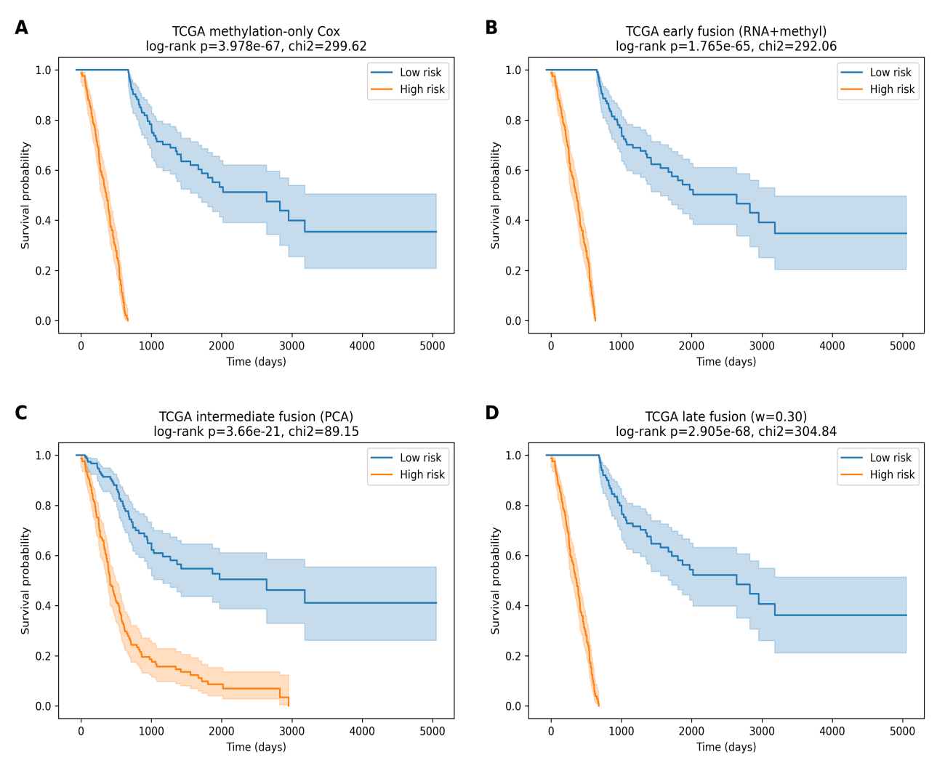Figure 5. TCGA-BLCA multi-omics prognosis with DNA methylation and fusion strategies.
Kaplan–Meier overall survival curves for TCGA-BLCA patients stratified into high- and low-risk groups by the cohort median risk score. Shaded regions indicate 95% confidence intervals. (A) methylation-only ridge Cox model using top variable CpG features; (B) early fusion ridge Cox model trained on concatenated RNA and methylation features; (C) intermediate fusion using PCA-reduced representations from RNA and methylation followed by ridge Cox; (D) late fusion combining RNA- and methylation-derived risk scores with an optimized weight (w = 0.30). Log-rank p-values and χ² statistics are reported in each panel.

Table 2. DNA methylation and multi-omics fusion models in TCGA-BLCA (internal evaluation).
Model | Modality | Fusion | Feature setting | TCGA C-index  (5-fold CV) | TCGA log-rank p
Methylation-only Cox | DNA methyl | None | CpG k=2000; ridge (l2=1e-2) | 0.583 ± 0.037 | 3.978e-67
Early fusion Cox | RNA+methyl | Early (concat) | RNA k=2000 + CpG k=2000 (4000); ridge (l2=1e-2) | 0.626 ± 0.045 | 1.765e-65
Intermediate fusion Cox | RNA+methyl | Intermediate (PCA) | RNA PCA=30 + Meth PCA=30 (60); ridge (l2=1e-2) | 0.599 ± 0.036 | 3.660e-21
Late fusion (weighted risk) | RNA+methyl | Late (risk) | risk = w*r_RNA + (1-w)*r_Meth; w=0.30 | N/A* | 2.905e-68
Notes: Models were evaluated on TCGA-BLCA using 5-fold cross-validation (C-index; mean ± SD across folds). Kaplan–Meier log-rank p-values are based on median risk stratification in TCGA using risk scores from a model refit on the full cohort with the selected hyperparameters. External validation is not available for methylation and fusion models due to missing methylation data in GSE13507. *Late fusion is a stacking-style combination of two modality-specific risk scores with a tuned weight; therefore we do not report a cross-validated C-index for late fusion and focus on KM/log-rank separation.

Single-cell preprocessing and clustering of GSE135337
We next analyzed the BLCA scRNA-seq cohort GSE135337 (BC1–BC7) to provide cellular context for the bulk-derived prognostic signature. After Scanpy-based quality control and preprocessing, 36,788 cells were retained for downstream analysis (Figure 6A). Unsupervised Leiden clustering identified 22 clusters (0–21) with clear separation on the UMAP embedding (Figure 6B). Coloring cells by sample revealed pronounced sample-associated structure (Figure 6C), consistent with inter-patient heterogeneity in tumor scRNA-seq data and the absence of explicit batch integration in this workflow. Coarse cell-type labels inferred from marker genes are visualized on the UMAP embedding (Figure 6D), summarized at the cell-type level (Figure 7A), and summarized by cluster size (Figure 7B). These annotations form the basis for subsequent perturbation sensitivity analysis (Figure 8).

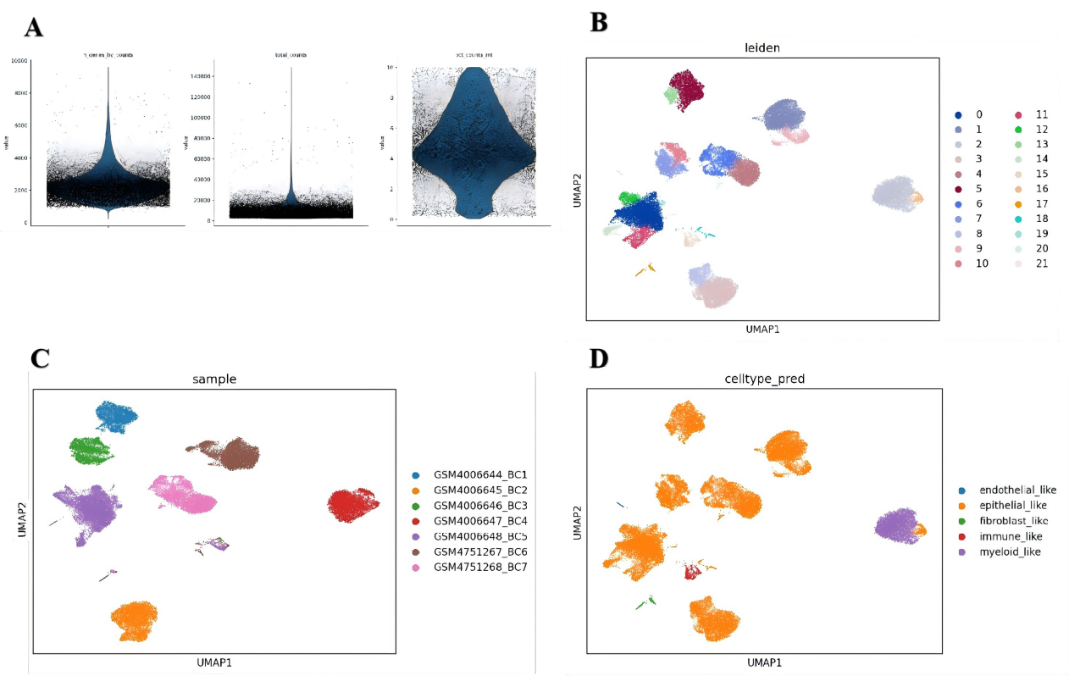
Figure 6. GSE135337 scRNA-seq preprocessing and clustering summary.
(A) QC violin plots; (B) UMAP-Leiden clusters; (C) UMAP by sample; (D) UMAP by coarse cell-type labels (celltype_pred).

Marker-based coarse cell-type annotation
To interpret the Leiden clusters, we performed marker-based coarse cell-type annotation using predefined marker gene sets (epithelial-like, myeloid-like, immune-like, fibroblast-like, and endothelial-like). The resulting coarse labels (celltype_pred) are visualized on the UMAP embedding (Figure 6D). Overall, the dataset was strongly epithelial-dominant: 18/22 clusters were annotated as epithelial-like, while myeloid-like, immune-like, fibroblast-like, and endothelial-like each mapped primarily to a single cluster (Figure 7B). At the cell level, epithelial-like accounted for 31,358 / 36,788 (85.2%) cells, followed by myeloid-like 4,771 (13.0%), immune-like 405 (1.1%), fibroblast-like 197 (0.5%), and endothelial-like 57 (0.2%) (Figure 7A). Specifically, the myeloid-like compartment corresponded primarily to cluster 2, immune-like to cluster 15, fibroblast-like to cluster 17, and endothelial-like to cluster 21. This coarse annotation provides an interpretable cellular backdrop for locating prognostic-gene effects in downstream perturbation analyses.
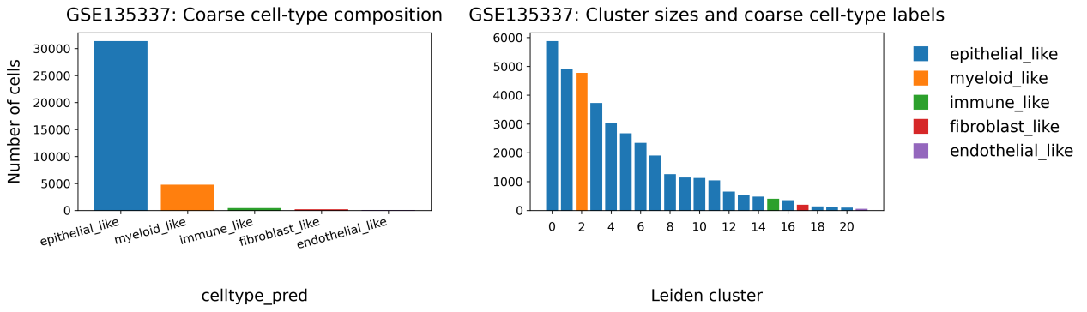
Figure 7. Marker-based coarse cell-type annotation of GSE135337.
(A) Coarse cell-type composition summarized by the total number of cells in each celltype_pred category.(B) Cluster sizes (number of cells per Leiden cluster) colored by the assigned coarse cell-type label

scGPT-based in silico perturbation and pathway readouts
In silico perturbation analysis using scGPT. To functionally interrogate the bulk-derived prognostic signature in a cellular context, we performed scGPT-based in silico perturbation on the GSE135337 scRNA-seq cohort. Coarse cell-type labels (epithelial-like, immune-like, fibroblast-like, endothelial-like and myeloid-like) were assigned by marker-set scoring (celltype_pred) and used as the stratification axis for sensitivity analyses. Perturbation protocol. Using a pretrained scGPT model, we simulated knockdown (KD; 0.1× expression) and overexpression (OE; 2× expression) for each selected prognostic gene and quantified responses as changes in predicted cell-state probabilities (Δp) and hallmark pathway activity scores (EMT, G2M, hypoxia, IFNγ and TNFα/NFκB). One sample (GSM4006644_BC1) was excluded to reduce donor-specific bias (the provided GSE135337 subset excludes GSM5329919 as specified; additionally, we performed a leave-one-sample-out sensitivity check by excluding BC1). Cell-type sensitivity. Across genes, the immune-like compartment showed the strongest and most consistent probability shifts under both KD and OE, whereas epithelial-like states were comparatively stable. Endothelial-like cells displayed sensitivity for a subset of genes, consistent with a microenvironment-centered interpretation of the signature rather than tumor-intrinsic lineage switching. Gene-level highlights. The most perturbation-sensitive genes (ranked by mean |Δp| across labels) were: KD—EN2 (endothelial_like, 0.069); LHX5 (immune_like, 0.069); RLN2 (immune_like, 0.067); SPON1 (immune_like, 0.066); OLFML3 (immune_like, 0.066); F10 (immune_like, 0.064); RGS2 (immune_like, 0.064); XPO5 (immune_like, 0.062); AHCY (immune_like, 0.060); DCN (immune_like, 0.059). OE—RGS2 (immune_like, 0.074); F10 (immune_like, 0.072); OLFML3 (immune_like, 0.071); LHX5 (immune_like, 0.070); DCN (immune_like, 0.070); EN2 (immune_like, 0.069); AHCY (immune_like, 0.067); SPON1 (immune_like, 0.066); RLN2 (endothelial_like, 0.065); XPO5 (immune_like, 0.064). In immune-like cells (the most sensitive compartment), pathway responses were coordinated but modest in magnitude: KD—AHCY-TNFA_NFKB (-0.022); AHCY-IFNG (-0.010); XPO5-EMT (+0.009); AHCY-EMT (+0.006); AHCY-HYPOXIA (-0.005); SPON1-IFNG (+0.004); OLFML3-IFNG (+0.004); AHCY-G2M (+0.004); XPO5-IFNG (+0.004); OLFML3-EMT (+0.004); OE—RGS2-EMT (-0.009); AHCY-IFNG (-0.005); AHCY-TNFA_NFKB (-0.005); AHCY-EMT (+0.004); DCN-EMT (-0.002); DCN-TNFA_NFKB (-0.002); AHCY-HYPOXIA (+0.001); RLN2-EMT (+0.001); RLN2-TNFA_NFKB (+0.001); RGS2-G2M (-0.001). Collectively, these results suggest that the prognostic signature may influence clinical outcomes through fine-tuning of immune-state dynamics rather than large-scale transcriptional rewiring.

Table 5. Top perturbation-sensitive prognostic genes ranked by mean |Δp| (max over coarse cell-type labels).
Mode | Gene | Most_sensitive_label | N_cells_in_label | Mean_|Δp|_max | Max_|Δp|_max
KD | EN2 | endothelial_like | 104 | 0.0694 | 0.3262
KD | LHX5 | immune_like | 172 | 0.0691 | 0.3234
KD | RLN2 | immune_like | 172 | 0.0675 | 0.1567
KD | SPON1 | immune_like | 172 | 0.0663 | 0.2288
KD | OLFML3 | immune_like | 172 | 0.0656 | 0.2680
KD | F10 | immune_like | 172 | 0.0641 | 0.2057
KD | RGS2 | immune_like | 172 | 0.0639 | 0.3942
KD | XPO5 | immune_like | 172 | 0.0615 | 0.1892
KD | AHCY | immune_like | 172 | 0.0602 | 0.3120
KD | DCN | immune_like | 172 | 0.0592 | 0.3845
OE | RGS2 | immune_like | 172 | 0.0738 | 0.3616
OE | F10 | immune_like | 172 | 0.0717 | 0.3993
OE | OLFML3 | immune_like | 172 | 0.0710 | 0.2288
OE | LHX5 | immune_like | 172 | 0.0698 | 0.3082
OE | DCN | immune_like | 172 | 0.0697 | 0.2540
OE | EN2 | immune_like | 172 | 0.0687 | 0.3117
OE | AHCY | immune_like | 172 | 0.0666 | 0.4002
OE | SPON1 | immune_like | 172 | 0.0662 | 0.2866
OE | RLN2 | endothelial_like | 104 | 0.0655 | 0.2556
OE | XPO5 | immune_like | 172 | 0.0643 | 0.2796

Table 6. Largest pathway-score perturbations within the most sensitive compartment (immune-like).
Mode | Sensitive_label | Gene | Sum_|Δpathway| | Top_pathway | Δscore_top
KD | immune_like | AHCY | 0.0474 | TNFA_NFKB | -0.02218
KD | immune_like | XPO5 | 0.0157 | EMT | 0.008757
KD | immune_like | OLFML3 | 0.0078 | IFNG | 0.004257
KD | immune_like | SPON1 | 0.0078 | IFNG | 0.004258
KD | immune_like | RGS2 | 0.0068 | G2M | -0.003291
KD | immune_like | RLN2 | 0.0067 | EMT | 0.003514
KD | immune_like | DCN | 0.0047 | EMT | -0.002147
KD | immune_like | LHX5 | 0.0025 | TNFA_NFKB | -0.001441
KD | immune_like | EN2 | 0.0000 | EMT | 0
KD | immune_like | F10 | 0.0000 | EMT | 0
OE | immune_like | AHCY | 0.0157 | IFNG | -0.005341
OE | immune_like | RGS2 | 0.0098 | EMT | -0.008694
OE | immune_like | DCN | 0.0043 | EMT | -0.002147
OE | immune_like | RLN2 | 0.0020 | EMT | 0.0009838
OE | immune_like | LHX5 | 0.0004 | TNFA_NFKB | 0.0003062
OE | immune_like | OLFML3 | 0.0001 | TNFA_NFKB | -3.342e-05
OE | immune_like | XPO5 | 0.0000 | HYPOXIA | -3.231e-07
OE | immune_like | SPON1 | 0.0000 | IFNG | -1.626e-07
OE | immune_like | EN2 | 0.0000 | EMT | 0
OE | immune_like | F10 | 0.0000 | EMT | 0
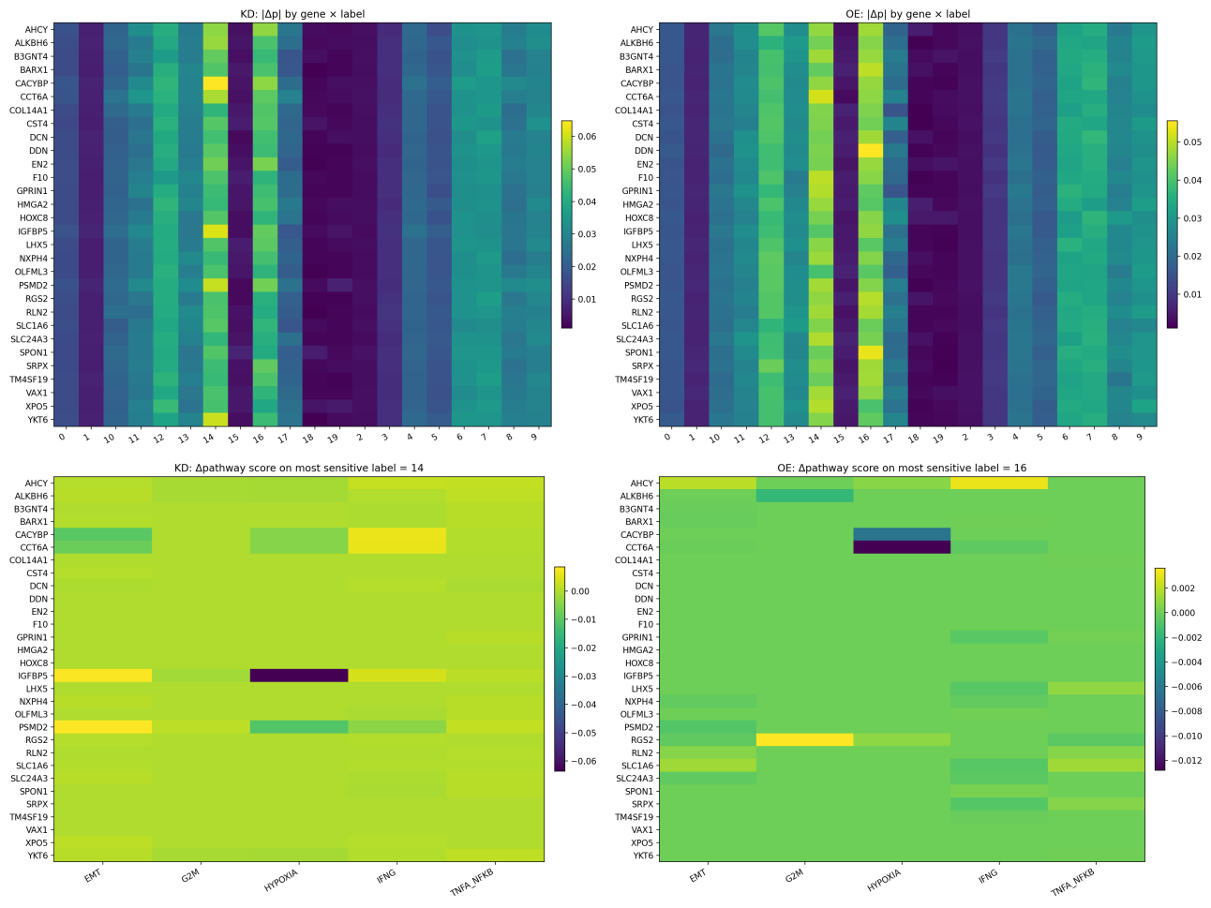
Figure 8. scGPT-based single-cell perturbation results on GSE135337 using coarse cell-type labels (celltype_pred). (A) KD: mean |Δp| heatmap (gene × label). (B) OE: mean |Δp| heatmap. (C) KD: Δpathway scores in the most sensitive label (immune-like). (D) OE: Δpathway scores in the most sensitive label (immune-like).

Discussion

What drives performance gains in the final Cox model?
Our RNA-only ridge Cox baseline achieved strong risk-ranking performance on TCGA-BLCA (C-index = 0.723) with meaningful external validation on GSE13507 (C-index = 0.632). Building on this baseline, methylation-guided distillation further improved both internal and external discrimination (TCGA C-index = 0.7566; GSE13507 C-index = 0.6485). Two design choices were particularly important for achieving this balance between discrimination and generalization.
First, intersection-based feature control (TCGA ∩ GSE) improved external scoring stability. In cross-cohort validation, a common failure mode is that model genes are partially missing in the external cohort (platform differences, probe mapping, or symbol mismatches), effectively reducing model capacity at test time. By restricting candidate genes to those present in both TCGA and GSE13507 before modeling (233 usable candidates), we avoided missing-feature degradation and ensured that the fitted coefficients could be applied consistently across cohorts.
Second, relaxed univariate screening combined with ridge regularization preserved predictive capacity while controlling overfitting. Using a stringent univariate FDR threshold can collapse the feature set to very few genes, which may be statistically conservative but underpowered for multivariate prognostic modeling. In contrast, screening at univ_FDR ≤ 0.2 retained 39 genes, allowing the multivariate model to capture complementary signals. Ridge regularization (L2 penalty) further stabilized coefficient estimates under correlation among genes and mitigated overfitting. Together, these steps explain why the final model substantially improved within-cohort discrimination on TCGA compared with the published 6-gene baseline, while still achieving comparable risk-ranking performance under external validation.
Why is external C-index similar (~0.63) across models, while log-rank p differs?
External validation in GSE13507 yielded similar C-index values for several RNA-only signatures (~0.63), while methylation-guided distillation increased external discrimination to 0.6485, suggesting that epigenetic teacher supervision can improve cross-cohort ranking. This can occur even when training-cohort performance differs substantially, because the external cohort may impose an effective upper bound on discriminability due to platform noise (RNA-seq vs microarray), cohort heterogeneity, limited sample size (n = 165), and differences in clinical composition. Under these constraints, different gene sets may converge to similar ranking ability, particularly when both capture broad tumor-state signals.
Biological interpretation supported by single-cell analyses
The scRNA-seq analyses provide hypothesis-generating cellular context for the bulk prognostic signature. Marker-based coarse annotation indicates that GSE135337 is epithelial-like–dominant, with smaller immune/stromal compartments. Using scGPT-based in silico perturbation on the top 10 prognostic genes (DCN, SPON1, EN2, OLFML3, XPO5, F10, RLN2, AHCY, LHX5, RGS2), the largest sensitivity signals were consistently observed in immune-like cells (mean |Δp| ≈ 0.064 for KD and ≈ 0.069 for OE), followed by endothelial-like cells, whereas epithelial-like states were comparatively stable (≈ 0.004). Together, these results are consistent with a model in which the survival-associated bulk signal is linked—at least in part—to immune/microenvironmental state dynamics rather than large-scale tumor-lineage switching.
Limitations and future directions
Limited normal samples in TCGA tumor–normal DE. The TCGA BLCA normal group is small (n = 19), which can affect variance estimation and visual compactness in PCA. While the DE signal is robust, downstream candidate ranking may be influenced by tumor/normal sample imbalance.
Simplified DE testing and bulk-only modeling. The DE step used Welch’s t-test on logCPM with BH correction. More specialized RNA-seq DE frameworks (e.g., count-model-based methods) could be explored to refine candidate selection. In addition, the Cox model here is transcriptomics-only; incorporating clinical covariates (stage, grade, age) in multivariable Cox analyses would clarify whether the signature adds independent prognostic value.
Single-cell batch effects and coarse annotation. UMAP colored by sample shows strong sample-driven structure, consistent with inter-patient heterogeneity and the absence of explicit batch integration. This work intentionally used a straightforward Scanpy workflow; future work could include batch-aware integration to separate technical from biological variation. The marker-based cell-type labels are coarse; finer immune subtyping may reveal additional context for survival-related states.
Perturbation analysis uses scGPT embeddings with a simple downstream classifier and a multiplicative count-scaling perturbation. While scGPT provides a foundation-model representation of cell state, the perturbation operator (KD/OE via count scaling) and the logistic-regression readout do not explicitly model nonlinear gene–gene interactions or transcriptional dynamics. Future work could implement generative perturbation directly within foundation models and assess robustness across alternative clustering and labeling schemes.
Optional multi-omics extension. If DNA methylation integration is desired, potential strategies include early fusion (concatenating RNA and methylation features), late fusion (combining modality-specific risk scores), or intermediate fusion (joint embeddings). The current pipeline’s harmonization and validation structure can support these extensions.
Conclusion
This project delivers an end-to-end BLCA prognostic modeling and interpretation workflow using public datasets. Tumor–normal differential expression analysis in TCGA-BLCA produced a ranked candidate gene set and QC visualizations. An interpretable RNA-only ridge Cox baseline trained on TCGA achieved strong performance (C-index = 0.723) and retained external validation on GSE13507 (C-index = 0.632). A methylation-guided distilled RNA-only student further improved discrimination (TCGA C-index = 0.7566; GSE13507 C-index = 0.6485). A published baseline (Zou et al., Aging 2021) was reproduced for benchmarking, showing that our model improves TCGA discrimination while maintaining competitive external ranking performance. Finally, single-cell analyses in GSE135337 provided cellular context, indicating epithelial-dominant composition and perturbation sensitivity concentrated in immune-like (and endothelial-like) states, supporting a tumor-state-driven interpretation of the bulk prognostic signal. Overall, the results support both predictive validity and improved interpretability, with clear pathways for future extensions (foundation-model perturbation and multi-omics integration).
Code and data availability
The related data and source codes of this work are accessible at https://github.com/haoyang9688/Report-Scripts

References
[1] The Cancer Genome Atlas Research Network. Comprehensive molecular characterization of urothelial bladder carcinoma. Nature. 2014;507:315–322. doi:10.1038/nature12965.
[2] Edgar R, Domrachev M, Lash AE. Gene Expression Omnibus: NCBI gene expression and hybridization array data repository. Nucleic Acids Res. 2002;30(1):207–210 doi:10.1093/nar/30.1.207.
[3] Cox DR. Regression models and life-tables. J R Stat Soc Series B. 1972;34(2):187–220 doi:10.1111/j.2517-6161.1972.tb00899.x.
[4] Wolf FA, Angerer P, Theis FJ. SCANPY: large-scale single-cell gene expression data analysis. Genome Biol. 2018;19:15. doi:10.1186/s13059-017-1382-0.
[5] Traag VA, Waltman L, van Eck NJ. From Louvain to Leiden: guaranteeing well-connected communities. Sci Rep. 2019;9:5233. doi:10.1038/s41598-019-41695-z.
[6] McInnes L, Healy J, Melville J. UMAP: Uniform Manifold Approximation and Projection for Dimension Reduction. arXiv:1802.03426 (2018).
[7] Cui H, Wang C, Maan H, et al. scGPT: toward building a foundation model for single-cell multi-omics using generative AI. Nat Methods. 2024;21(8):1470–1480. doi:10.1038/s41592-024-02201-0.
[8] Kamoun A, de Reyniès A, Allory Y, et al. A Consensus Molecular Classification of Muscle-invasive Bladder Cancer. Eur Urol. 2020;77(4):420–433. doi:10.1016/j.eururo.2019.09.006.
[9] Zou X, Wei Y, Qi T, Wang X, Zuo W, Wang T, et al. A novel 6-gene signature derived from tumor-infiltrating T cells and neutrophils predicts survival of bladder urothelial carcinoma. Aging (Albany NY). 2021;13(23):25496–25517. doi:10.18632/aging.203770.
[10] Sun X, Zhang Y, Chen Y, Xin S, Jin L, Liu X, et al. In Silico Establishment and Validation of Novel Lipid Metabolism-Related Gene Signature in Bladder Cancer. Oxid Med Cell Longev. 2022;2022:3170950. doi:10.1155/2022/3170950.
[11] Jiang Y, Qu X, Zhang M, Zhang L, Yang T, Ma M, et al. Identification of a six-gene prognostic signature for bladder cancer associated macrophage. Front Immunol. 2022;13:930352. doi:10.3389/fimmu.2022.930352.

