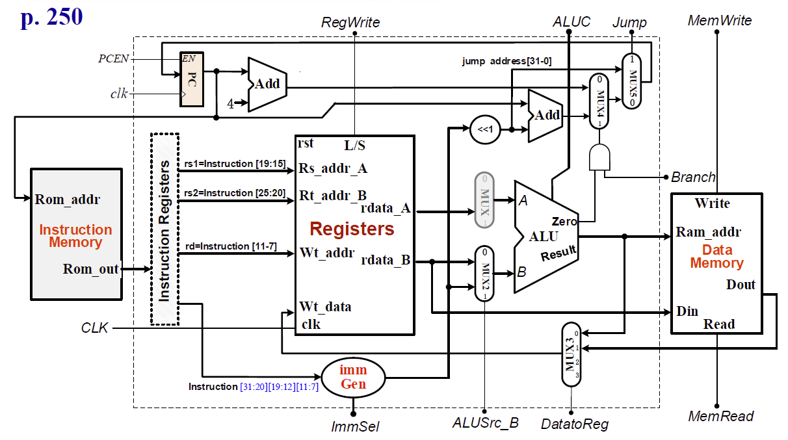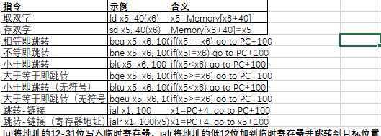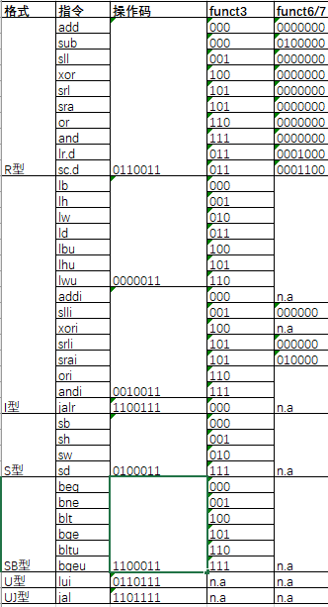

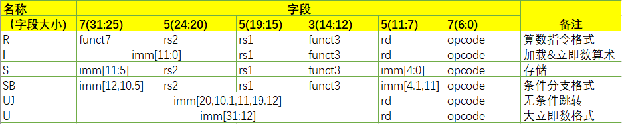

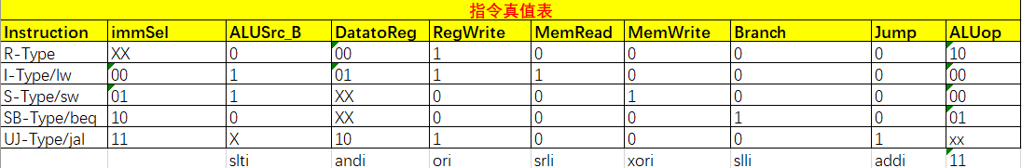

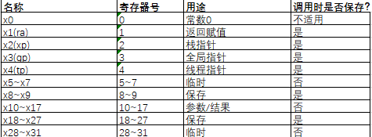

|  |  |
| --- | --- |
| **fib:**  **beq x10, x10, done**  **addi x5, x0, 1**  **beq x10, x5, done**  **addi x2, x2, -16**  **sd x1, 0(x2)**  **sd x10, 8(x2)**  **addi x10, x10, -1**  **jal x1, fib** | **ld x5, 8(x2)**  **sd x10, 8(x2)**  **addi x10, x5, -2**  **jal x1, fib**  **ld x5, 8(x2)**  **add x10, x10, x5**  **ld x1, 0(x2)**  **addi x2, x2, 16**  **done: jalr x0, x1** |

