# Git

## 配置

### 用户信息

$ git config --global user.name "John Doe"

$ git config --global user.email johndoe@example.com

### 文本编辑器（默认为vim）

$ git config --global core.editor emacs

### 检查配置信息

$ git config --list

user.name=John Doe

user.email=johndoe@example.com

color.status=auto

color.branch=auto

color.interactive=auto

color.diff=auto

...

你可以通过输入 git config <key>： 来检查 Git 的某一项配置

$ git config user.name

John Doe

## 本地操作

### 添加文件（本地）

haoyong@Lenovo-HY MINGW32 /

$ git init git_basics (本地创建一个初始化仓库)

Initialized empty Git repository in F:/github/Git/git_basics/.git/

haoyong@Lenovo-HY MINGW32 /

$ cd git_basics/ (进入工作区)

haoyong@Lenovo-HY MINGW32 /git_basics (master)

$ touch a (新建一个文件a)

haoyong@Lenovo-HY MINGW32 /git_basics (master)

$ touch b

haoyong@Lenovo-HY MINGW32 /git_basics (master)

$ git add a b (将文件ab添加进暂存区)

haoyong@Lenovo-HY MINGW32 /git_basics (master)

$ git status (查看工作状态)

On branch master

Initial commit

Changes to be committed:

(use "git rm --cached <file>..." to unstage)

new file: a

new file: b

haoyong@Lenovo-HY MINGW32 /git_basics (master)

$ git commit -m "init commit" (提交到历史区并重命名)

[master (root-commit) b9d666c] init commit

2 files changed, 0 insertions(+), 0 deletions(-)

create mode 100644 a

create mode 100644 b

### 修改文件（本地）

haoyong@Lenovo-HY MINGW32 /git_basics (master)

$ vim a (编辑文件a)

haoyong@Lenovo-HY MINGW32 /git_basics (master)

$ git status (查看当前工作状态 此时为修改状态)

On branch master

Changes not staged for commit:

(use "git add <file>..." to update what will be committed)

(use "git checkout -- <file>..." to discard changes in working directory)

modified: a

no changes added to commit (use "git add" and/or "git commit -a")

haoyong@Lenovo-HY MINGW32 /git_basics (master)

$ git add a (添加进暂存区)

warning: LF will be replaced by CRLF in a.

The file will have its original line endings in your working directory.

haoyong@Lenovo-HY MINGW32 /git_basics (master)

$ git status

warning: LF will be replaced by CRLF in a.

The file will have its original line endings in your working directory.

On branch master

Changes to be committed:

(use "git reset HEAD <file>..." to unstage)

modified: a

haoyong@Lenovo-HY MINGW32 /git_basics (master)

$ git commit -m "modify a"

[master warning: LF will be replaced by CRLF in a.

The file will have its original line endings in your working directory.

5c255fe] modify a

warning: LF will be replaced by CRLF in a.

The file will have its original line endings in your working directory.

1 file changed, 1 insertion(+)

### 删除工作区文件（本地）

haoyong@Lenovo-HY MINGW32 /git_basics (master)

$ git rm a

rm 'a'

haoyong@Lenovo-HY MINGW32 /git_basics (master)

$ ls

b

haoyong@Lenovo-HY MINGW32 /git_basics (master)

$ git status

On branch master

Changes to be committed:

(use "git reset HEAD <file>..." to unstage)

deleted: a

### 恢复工作区文件（本地）

haoyong@Lenovo-HY MINGW32 /git_basics (master)

$ git reset HEAD a

Unstaged changes after reset:

D a

haoyong@Lenovo-HY MINGW32 /git_basics (master)

$ ls

b

haoyong@Lenovo-HY MINGW32 /git_basics (master)

$ git checkout a

haoyong@Lenovo-HY MINGW32 /git_basics (master)

$ ls

a b

### 修改工作区文件名（本地）

haoyong@Lenovo-HY MINGW32 /newinit (master)

$ git mv a c

haoyong@Lenovo-HY MINGW32 /newinit (master)

$ git status

On branch master

Changes to be committed:

(use "git reset HEAD <file>..." to unstage)

renamed: a -> c

### 忽略工作区中的文件（本地）

haoyong@Lenovo-HY MINGW32 /

$ cd newbasic/

haoyong@Lenovo-HY MINGW32 /newbasic (master)

$ touch a.o

haoyong@Lenovo-HY MINGW32 /newbasic (master)

$ touch b.o

haoyong@Lenovo-HY MINGW32 /newbasic (master)

$ touch c

haoyong@Lenovo-HY MINGW32 /newbasic (master)

$ git status

On branch master

Initial commit

Untracked files:

(use "git add <file>..." to include in what will be committed)

a.o

b.o

c

nothing added to commit but untracked files present (use "git add" to track)

haoyong@Lenovo-HY MINGW32 /newbasic (master)

$ vim .gitignore (忽略工作区中的指定格式文件)

haoyong@Lenovo-HY MINGW32 /newbasic (master)

$ git status

On branch master

Initial commit

Untracked files:

(use "git add <file>..." to include in what will be committed)

.gitignore

c

nothing added to commit but untracked files present (use "git add" to track)

haoyong@Lenovo-HY MINGW32 /newbasic (master)

$ git add .gitignore

warning: LF will be replaced by CRLF in .gitignore.

The file will have its original line endings in your working directory.

haoyong@Lenovo-HY MINGW32 /newbasic (master)

$ git commit -m "add ignore"

[master (root-commit) 4ef53d3] add ignore

warning: LF will be replaced by CRLF in .gitignore.

The file will have its original line endings in your working directory.

1 file changed, 1 insertion(+)

create mode 100644 .gitignore

## 分支

### 创建分支与合并（合并提交）

haoyong@Lenovo-HY MINGW32 /

$ git init merge

Initialized empty Git repository in F:/github/Git/merge/.git/

haoyong@Lenovo-HY MINGW32 /

$ cd merge/

haoyong@Lenovo-HY MINGW32 /merge (master)

$ touch master.txt

haoyong@Lenovo-HY MINGW32 /merge (master)

$ git add master.txt

haoyong@Lenovo-HY MINGW32 /merge (master)

$ git commit -m "on master"

[master (root-commit) b7eabf0] on master

1 file changed, 0 insertions(+), 0 deletions(-)

create mode 100644 master.txt

haoyong@Lenovo-HY MINGW32 /merge (master)

$ git branch testone (创建分支)

haoyong@Lenovo-HY MINGW32 /merge (master)

$ git checkout testone (切换到分支上)

Switched to branch 'testone'

haoyong@Lenovo-HY MINGW32 /merge (testone)

$ touch testone.txt

haoyong@Lenovo-HY MINGW32 /merge (testone)

$ git add testone.txt

haoyong@Lenovo-HY MINGW32 /merge (testone)

$ git commit -m "one testone"

[testone b6be78f] one testone

1 file changed, 0 insertions(+), 0 deletions(-)

create mode 100644 testone.txt

haoyong@Lenovo-HY MINGW32 /merge (testone)

$ git checkout master (切回到master上)

Switched to branch 'master'

haoyong@Lenovo-HY MINGW32 /merge (master)

$ ls

master.txt

haoyong@Lenovo-HY MINGW32 /merge (master)

$ git merge testone (合并分支进行的操作)

Updating b7eabf0..b6be78f

Fast-forward

testone.txt | 0

1 file changed, 0 insertions(+), 0 deletions(-)

create mode 100644 testone.txt

haoyong@Lenovo-HY MINGW32 /merge (master)

$ ls

master.txt testone.txt

### 创建分支（分支提交）

haoyong@LAPTOP-71SJUFE0 MINGW32 ~/Desktop/新建文件夹

$ git clone https://github.com/haoyong4039/gitdemo.git

Cloning into 'gitdemo'...

remote: Counting objects: 32, done.

remote: Total 32 (delta 0), reused 0 (delta 0), pack-reused 32

Unpacking objects: 100% (32/32), done.

Checking connectivity... done.

haoyong@LAPTOP-71SJUFE0 MINGW32 ~/Desktop/新建文件夹

$ cd gitdemo/

haoyong@LAPTOP-71SJUFE0 MINGW32 ~/Desktop/新建文件夹/gitdemo (master)

$ git checkout -b feature

Switched to a new branch 'feature'

haoyong@LAPTOP-71SJUFE0 MINGW32 ~/Desktop/新建文件夹/gitdemo (feature)

$ vim test.txt

haoyong@LAPTOP-71SJUFE0 MINGW32 ~/Desktop/新建文件夹/gitdemo (feature)

$ git add test.txt

haoyong@LAPTOP-71SJUFE0 MINGW32 ~/Desktop/新建文件夹/gitdemo (feature)

$ git commit -m "add some feature tests"

[feature 2ea3a18] add some feature tests

1 file changed, 1 insertion(+)

haoyong@LAPTOP-71SJUFE0 MINGW32 ~/Desktop/新建文件夹/gitdemo (feature)

$ git push origin feature

Counting objects: 3, done.

Delta compression using up to 4 threads.

Compressing objects: 100% (3/3), done.

Writing objects: 100% (3/3), 304 bytes | 0 bytes/s, done.

Total 3 (delta 2), reused 0 (delta 0)

remote: Resolving deltas: 100% (2/2), completed with 2 local objects.

To https://github.com/haoyong4039/gitdemo.git

* [new branch] feature -> feature

## 单仓库操作

### 获取Git仓库已更新信息

haoyong@Lenovo-HY MINGW32 /

$ git clone https://github.com/haoyong4039/gitdemo.git

Cloning into 'gitdemo'...

remote: Counting objects: 12, done.

remote: Compressing objects: 100% (7/7), done.

remote: Total 12 (delta 2), reused 2 (delta 0), pack-reused 0

Unpacking objects: 100% (12/12), done.

Checking connectivity... done.

haoyong@Lenovo-HY MINGW32 /

$ cd gitdemo/

haoyong@Lenovo-HY MINGW32 /gitdemo (master)

$ git fetch （更新Git服务器中最新信息）

remote: Counting objects: 3, done.

remote: Compressing objects: 100% (2/2), done.

remote: Total 3 (delta 1), reused 0 (delta 0), pack-reused 0

Unpacking objects: 100% (3/3), done.

From https://github.com/haoyong4039/gitdemo

064d3b9..8f67690 master -> origin/master

haoyong@Lenovo-HY MINGW32 /gitdemo (master)

$ git log --oneline --decorate --graph --all

* 8f67690 (origin/master, origin/HEAD) Create test.txt

* 064d3b9 (HEAD -> master) Update newhello.txt

* c16ecfc Create newhello.txt

* b726dcf add hello

* e0c2cdc Initial commit

haoyong@Lenovo-HY MINGW32 /gitdemo (master)

$ git merge origin/master

Updating 064d3b9..8f67690

Fast-forward

test.txt | 1 +

1 file changed, 1 insertion(+)

create mode 100644 test.txt

haoyong@Lenovo-HY MINGW32 /gitdemo (master)

$ git log --oneline --decorate --graph --all

* 8f67690 (HEAD -> master, origin/master, origin/HEAD) Create test.txt

* 064d3b9 Update newhello.txt

* c16ecfc Create newhello.txt

* b726dcf add hello

* e0c2cdc Initial commit

### 将已更新信息推送至Git仓库(Git仓库已有更新)

haoyong@Lenovo-HY MINGW32 /gitdemo (master)

$ vim test.txt

haoyong@Lenovo-HY MINGW32 /gitdemo (master)

$ git add test.txt

haoyong@Lenovo-HY MINGW32 /gitdemo (master)

$ git commit -m "add some local texts in test.txt"

[master 16fb640] add some local texts in test.txt

1 file changed, 1 insertion(+)

haoyong@Lenovo-HY MINGW32 /gitdemo (master)

$ git pull (获取最新数据)

remote: Counting objects: 3, done.

remote: Compressing objects: 100% (2/2), done.

remote: Total 3 (delta 1), reused 0 (delta 0), pack-reused 0

Unpacking objects: 100% (3/3), done.

From https://github.com/haoyong4039/gitdemo

8f67690..3034e40 master -> origin/master

Auto-merging test.txt

CONFLICT (content): Merge conflict in test.txt

Automatic merge failed; fix conflicts and then commit the result.

haoyong@Lenovo-HY MINGW32 /gitdemo (master|MERGING)

$ vim test.txt

haoyong@Lenovo-HY MINGW32 /gitdemo (master|MERGING)

$ git add test.txt

haoyong@Lenovo-HY MINGW32 /gitdemo (master|MERGING)

$ git commit

[master 66785e9] Merge branch 'master' of https://github.com/haoyong4039/gitdemo

haoyong@Lenovo-HY MINGW32 /gitdemo (master)

$ git push

Counting objects: 6, done.

Delta compression using up to 4 threads.

Compressing objects: 100% (5/5), done.

Writing objects: 100% (6/6), 606 bytes | 0 bytes/s, done.

Total 6 (delta 2), reused 0 (delta 0)

remote: Resolving deltas: 100% (2/2), completed with 1 local objects.

To https://github.com/haoyong4039/gitdemo.git

3034e40..66785e9 master -> master

### 将已更新信息推送至Git仓库(Git仓库未有更新)

haoyong@Lenovo-HY MINGW32 /

$ git clone https://github.com/haoyong4039/gitdemo.git

Cloning into 'gitdemo'...

remote: Counting objects: 24, done.

remote: Compressing objects: 100% (14/14), done.

remote: Total 24 (delta 6), reused 9 (delta 2), pack-reused 0

Unpacking objects: 100% (24/24), done.

Checking connectivity... done.

haoyong@Lenovo-HY MINGW32 /

$ cd gitdemo/

haoyong@Lenovo-HY MINGW32 /gitdemo (master)

$ vim test.txt

haoyong@Lenovo-HY MINGW32 /gitdemo (master)

$ git add test.txt

haoyong@Lenovo-HY MINGW32 /gitdemo (master)

$ git commit -m "add local text in test.txt"

[master 6772631] add local text in test.txt

1 file changed, 1 insertion(+)

haoyong@Lenovo-HY MINGW32 /gitdemo (master)

$ git pull

Already up-to-date.

haoyong@Lenovo-HY MINGW32 /gitdemo (master)

$ git push

Counting objects: 3, done.

Delta compression using up to 4 threads.

Compressing objects: 100% (3/3), done.

Writing objects: 100% (3/3), 300 bytes | 0 bytes/s, done.

Total 3 (delta 1), reused 0 (delta 0)

remote: Resolving deltas: 100% (1/1), completed with 1 local objects.

To https://github.com/haoyong4039/gitdemo.git

66785e9..6772631 master -> master

### 添加文件到Git仓库

haoyong@Lenovo-HY MINGW32 /

$ git clone https://github.com/haoyong4039/gitdemo.git

Cloning into 'gitdemo'...

remote: Counting objects: 27, done.

remote: Compressing objects: 100% (17/17), done.

remote: Total 27 (delta 8), reused 10 (delta 2), pack-reused 0

Unpacking objects: 100% (27/27), done.

Checking connectivity... done.

haoyong@Lenovo-HY MINGW32 /

$ cd gitdemo/

haoyong@Lenovo-HY MINGW32 /gitdemo (master)

$ touch add.txt

haoyong@Lenovo-HY MINGW32 /gitdemo (master)

$ git add add.txt

haoyong@Lenovo-HY MINGW32 /gitdemo (master)

$ git commit -m "add local txt to Git"

[master 79c7bc8] add local txt to Git

1 file changed, 0 insertions(+), 0 deletions(-)

create mode 100644 add.txt

haoyong@Lenovo-HY MINGW32 /gitdemo (master)

$ git push

Counting objects: 3, done.

Delta compression using up to 4 threads.

Compressing objects: 100% (2/2), done.

Writing objects: 100% (3/3), 269 bytes | 0 bytes/s, done.

Total 3 (delta 1), reused 0 (delta 0)

remote: Resolving deltas: 100% (1/1), completed with 1 local objects.

To https://github.com/haoyong4039/gitdemo.git

6772631..79c7bc8 master -> master

### 删除Git仓库中的文件

haoyong@Lenovo-HY MINGW32 /

$ git clone https://github.com/haoyong4039/gitdemo.git

Cloning into 'gitdemo'...

remote: Counting objects: 27, done.

remote: Compressing objects: 100% (17/17), done.

remote: Total 27 (delta 8), reused 10 (delta 2), pack-reused 0

Unpacking objects: 100% (27/27), done.

Checking connectivity... done.

haoyong@Lenovo-HY MINGW32 /

$ cd gitdemo/

haoyong@Lenovo-HY MINGW32 /gitdemo (master)

$ git rm newhello.txt

rm 'newhello.txt'

haoyong@Lenovo-HY MINGW32 /gitdemo (master)

$ git commit -m "delete local txt"

[master a5fe612] delete local txt

1 file changed, 1 deletion(-)

delete mode 100644 newhello.txt

haoyong@Lenovo-HY MINGW32 /gitdemo (master)

$ git push

Counting objects: 2, done.

Delta compression using up to 4 threads.

Compressing objects: 100% (2/2), done.

Writing objects: 100% (2/2), 222 bytes | 0 bytes/s, done.

Total 2 (delta 1), reused 0 (delta 0)

remote: Resolving deltas: 100% (1/1), completed with 1 local objects.

To https://github.com/haoyong4039/gitdemo.git

79c7bc8..a5fe612 master -> master

## 多仓库操作

### Remote && pull request

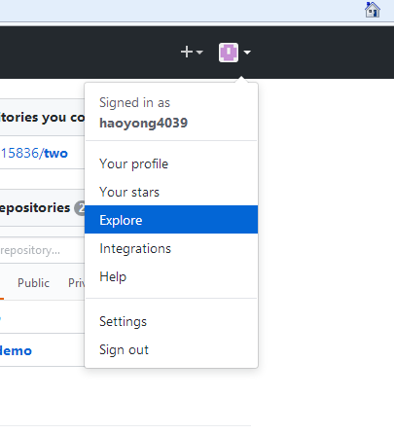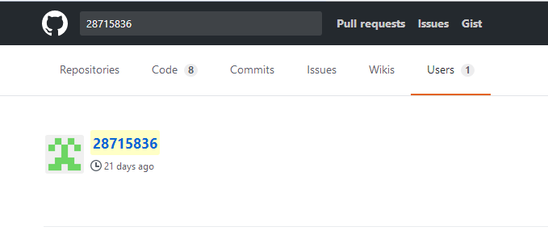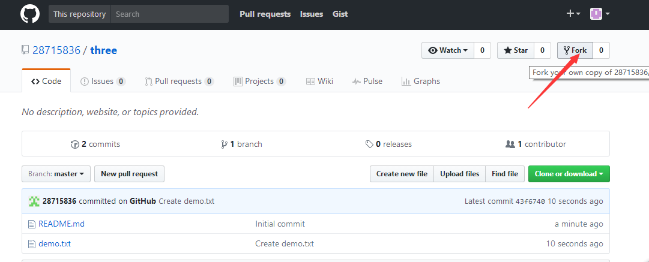

haoyong@LAPTOP-71SJUFE0 MINGW32 ~/Desktop/新建文件夹 (3)

$ git clone https://github.com/haoyong4039/three.git

Cloning into 'three'...

remote: Counting objects: 6, done.

remote: Compressing objects: 100% (3/3), done.

remote: Total 6 (delta 0), reused 6 (delta 0), pack-reused 0

Unpacking objects: 100% (6/6), done.

Checking connectivity... done.

haoyong@LAPTOP-71SJUFE0 MINGW32 ~/Desktop/新建文件夹 (3)

$ cd three

haoyong@LAPTOP-71SJUFE0 MINGW32 ~/Desktop/新建文件夹 (3)/three (master)

$ git checkout -b fenzhi (一般切换到分支进行操作)

Switched to a new branch 'fenzhi'

haoyong@LAPTOP-71SJUFE0 MINGW32 ~/Desktop/新建文件夹 (3)/three (fenzhi)

$ vim demo.txt

haoyong@LAPTOP-71SJUFE0 MINGW32 ~/Desktop/新建文件夹 (3)/three (fenzhi)

$ git add demo.txt

haoyong@LAPTOP-71SJUFE0 MINGW32 ~/Desktop/新建文件夹 (3)/three (fenzhi)

$ git commit -m "ahhhhhh"

[fenzhi c833e0e] ahhhhhh

1 file changed, 1 insertion(+), 1 deletion(-)

haoyong@LAPTOP-71SJUFE0 MINGW32 ~/Desktop/新建文件夹 (3)/three (fenzhi)

$ git push origin fenzhi (已分支方式进行提交)

Counting objects: 3, done.

Delta compression using up to 4 threads.

Compressing objects: 100% (2/2), done.

Writing objects: 100% (3/3), 270 bytes | 0 bytes/s, done.

Total 3 (delta 0), reused 0 (delta 0)

To https://github.com/haoyong4039/three.git

* [new branch] fenzhi -> fenzhi

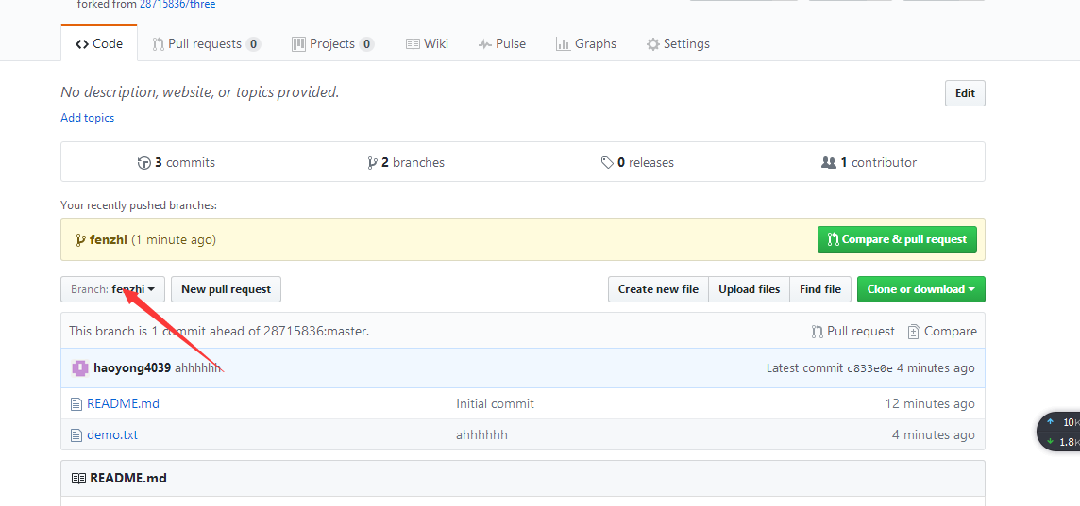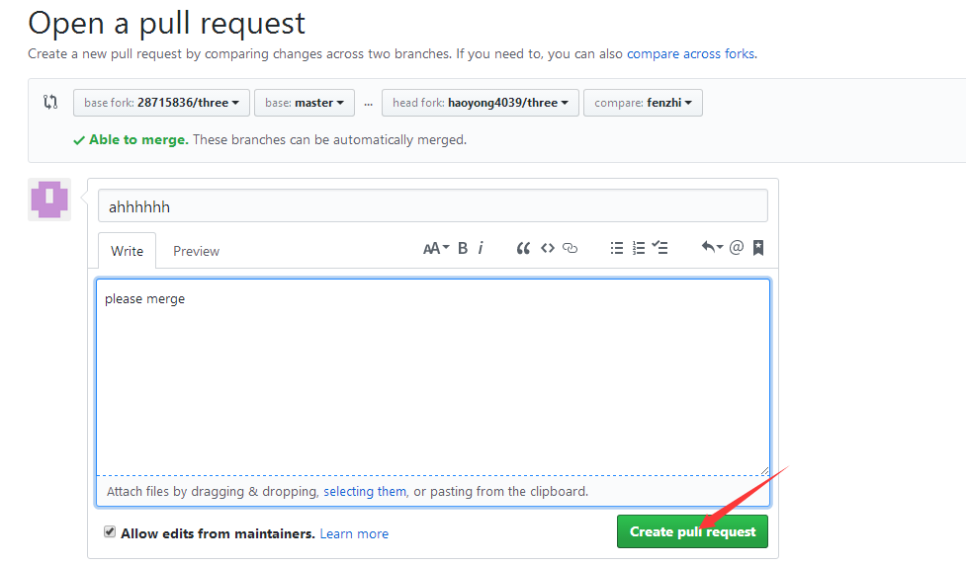

haoyong@LAPTOP-71SJUFE0 MINGW32 ~/Desktop/新建文件夹 (3)/three (fenzhi)

$ git remote add upstream https://github.com/28715836/three.git

(获取three进行同步更新合并)

haoyong@LAPTOP-71SJUFE0 MINGW32 ~/Desktop/新建文件夹 (3)/three (fenzhi)

$ git remote -v

origin https://github.com/haoyong4039/three.git (fetch)

origin https://github.com/haoyong4039/three.git (push)

upstream https://github.com/28715836/three.git (fetch)

upstream https://github.com/28715836/three.git (push)

haoyong@LAPTOP-71SJUFE0 MINGW32 ~/Desktop/新建文件夹 (3)/three (fenzhi)

$ git checkout master

Switched to branch 'master'

Your branch is up-to-date with 'origin/master'.

haoyong@LAPTOP-71SJUFE0 MINGW32 ~/Desktop/新建文件夹 (3)/three (master)

$ git fetch upstream

remote: Counting objects: 4, done.

remote: Compressing objects: 100% (3/3), done.

remote: Total 4 (delta 0), reused 4 (delta 0), pack-reused 0

Unpacking objects: 100% (4/4), done.

From https://github.com/28715836/three

* [new branch] master -> upstream/master

haoyong@LAPTOP-71SJUFE0 MINGW32 ~/Desktop/新建文件夹 (3)/three (master)

$ git merge upstream/master

Updating 43f6740..891736c

Fast-forward

demo.txt | 3 ++-

1 file changed, 2 insertions(+), 1 deletion(-)

haoyong@LAPTOP-71SJUFE0 MINGW32 ~/Desktop/新建文件夹 (2)/two (master)

$ git remote rename upstream uptrm (重命名)

haoyong@LAPTOP-71SJUFE0 MINGW32 ~/Desktop/新建文件夹 (2)/two (master)

$ git remote

origin

uptrm

haoyong@LAPTOP-71SJUFE0 MINGW32 ~/Desktop/新建文件夹 (2)/two (master)

$ git remote rm uptrm

## Another git push

haoyong@LAPTOP-71SJUFE0 MINGW32 ~/Desktop/新建文件夹 (3)

$ mvn archetype:generate -DarchetypeGroupId=org.apache.maven.archetypes -DarchetypeArtifactId=maven-archetype-webapp -DgroupId=com.mycompany.app -DartifactId=my-webapp

(创建一个简单的maven项目)

haoyong@LAPTOP-71SJUFE0 MINGW32 ~/Desktop/新建文件夹 (3)

$ cd my-webapp

(进入该项目目录下)

haoyong@LAPTOP-71SJUFE0 MINGW32 ~/Desktop/新建文件夹 (3)/my-webapp

$ git init

(初始化一个本地仓库)

haoyong@LAPTOP-71SJUFE0 MINGW32 ~/Desktop/新建文件夹 (3)/my-webapp (master)

$ git add .

(将与.git同一目录下的所有文件添加进暂存区)

haoyong@LAPTOP-71SJUFE0 MINGW32 ~/Desktop/新建文件夹 (3)/my-webapp (master)

$ git commit -m "commit"

(进行提交)

haoyong@LAPTOP-71SJUFE0 MINGW32 ~/Desktop/新建文件夹 (3)/my-webapp (master)

$ git remote add origin <https://github.com/haoyong4039/GitHubTwo.git>

(获取一个远程仓库并取名为origin)

haoyong@LAPTOP-71SJUFE0 MINGW32 ~/Desktop/新建文件夹 (3)/my-webapp (master)

$ git remote -v

(查看远程仓库)

origin https://github.com/haoyong4039/GitHubTwo.git (fetch)

origin https://github.com/haoyong4039/GitHubTwo.git (push)

haoyong@LAPTOP-71SJUFE0 MINGW32 ~/Desktop/新建文件夹 (3)/my-webapp (master)

$ git pull origin master

(检查远程仓库更新并合并 等价于

$ git fetch origin

$ git merge origin/master

)

haoyong@LAPTOP-71SJUFE0 MINGW32 ~/Desktop/新建文件夹 (3)/my-webapp (master)

$ git push origin master

(将项目推送到远程仓库)

Counting objects: 3, done.

Delta compression using up to 4 threads.

Compressing objects: 100% (3/3), done.

Writing objects: 100% (3/3), 462 bytes | 0 bytes/s, done.

Total 3 (delta 0), reused 0 (delta 0)

To https://github.com/haoyong4039/GitHubTwo.git

39be5b3..c783de4 master -> master