

## UNIVERSITI TEKNOLOGI MALAYSIA, JOHOR BAHRU FACULTY OF COMPUTING

**SEMESTER II - 2014/2015 SCSV1223 – WEB PROGRAMMING**

PROJECT REPORT – USER MANUAL

## MEMBER:

* HAO YUNTING **(**X18CS3002)
* ZHANG JIAWANG (X18CS3003)
* DING LU (X18CS3001)
* CHEN RUOFAN (X18CS3004)

## SECTION: 08

**LECTURER:** MADAM NOR ANITA FAIROS BINTI ISMAIL

# Table of Contents

1.0 Project Overview (Website Purpose) 2

2.0 Tools & Technology 2

3.0 Modules 2

4.0 Functionality 4

* 1. Database and Tables 6
  2. Database Design with Entity Relationship Diagram (ERD) 7
  3. User Manual 8
  4. Staff 9
  5. Manager 11
  6. Admin 12

7.0 Conclusion 15

# 1.0 Project Overview (Website Purpose)

Leave Application Management System can provide users with more convenient and more complete leave services. Users can fill out the leave slips online to see if they are approved, and do not need to go to the office to apply. At the same time, the manager can also approve the fake bars online to check the status of all the fake bars.

There are three modules of the System:

1. Staffs (User)
2. Managers (Manager)
3. Administrators (Admin)

# 2.0 Tools & Technology

* HTML: For webpage layout.
* CSS: To design the webpage.
* PHP: To ensure our webpages give content that is more dynamic and to connect to the database.
* MySQL: To be used with PHP.
* JavaScript: For calendar, confirmation.

# 3.0 Modules

* Admin
* Administrators can view the personal information of all employees, sort by each type of information, and view administrator information.
* Administrators also can view the information and application status of all the fake bars.
* Administrators can modify employees information.
* Manager
* Managers can view the application and approve or reject the employee's leave slip.
* Manager can modify personal information.
* Manager can view the names and departments of all staff members who are on leave, sort by name or department, and view all leave information for each employee.
* User
* Users can modify personal information.
* Users can fill in the leave slip and apply for leave.
* Users can view the application results.

# Functionality

* *Admins*
  + 1. Login account
    2. View all users' personal information
    3. Modify employee information
    4. Delete, add new user information
    5. View all fake application status
    6. Sort fake application in ascending and descending order
* *Managers*

1. Login account
2. Modify Personal Information
3. View all pending strips
4. Approving or rejecting employee leave
5. View the names and departments of all employees
6. View all leave information for each employee

* *Users*

1. Register an account
2. Login account
3. Edit personal information
4. Fill in the leave and submit
5. View application results

## Name and Password for Project Testing

Example of user from the database:

|  |  |  |  |
| --- | --- | --- | --- |
| No. | Name | Password | UserType |
| 1 | [hao](mailto:rs@yahoo.com) | 00000 | Admin |
| 2 | zhang | 88888 | Staff |
| 3 | ding | 12345 | Manager |
| 4 | chen | 11111 | Staff |
| 5 | gu | 22222 | Manager |

## Extra Functions in this Project

* Password Encrypting
* Lists can be arranged in both positive and reverse order
* Using session (passing value between page)
* Many tables are used to ease the flow of our system
* Lists can be arranged in both positive and reverse order

# 5.0 Database and Tables

There is a total of three tables used in the database for this project.

**Database Name:** db_zj

## Table:

1. Name: **Application**

For: To store all leave applications.

Relate Table: staff,department

1. Name: **Staff**

For: To store staffs,admins and managers’ information.

Relate Table: department,application

1. Name: **Department**

For: To store information about staffs’ department.

Relate Table: staff,application

# 5.1 Database Design with Entity Relationship Diagram (ERD)

|  |  |
| --- | --- |
| Application | |
| Id | Int(4) |
| Username | Varchar(100) |
| Department | Varchar(50) |
| Begintime | Varchar(15) |
| Days | Varchar(2) |
| Reason | Varchar(100) |
| Applytime | Varchar(20) |
| Status | Varchar(1) |
| checker | Varchar(50) |

|  |  |
| --- | --- |
| Staff | |
| Id | Int(4) |
| Name | Varchar(100) |
| Password | Varchar(50) |
| Level | Varchar(1) |
| Department | Varchar(50) |

**Symbol:**

*In red -> Primary Key  
*Blue -> Foreign Key

|  |  |
| --- | --- |
| Department | |
| Id | Int(4) |
| Name | Varchar(100) |

# 6.0 User Manual

Note: Login Page

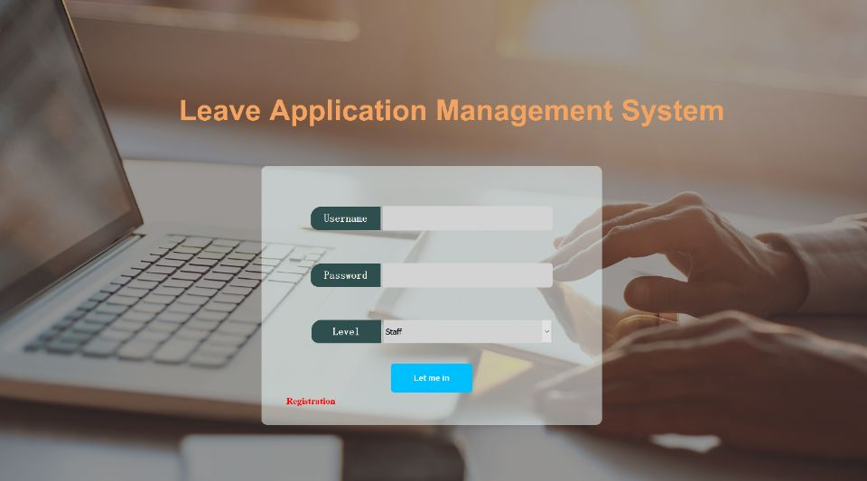

3

Note:

 insert information.

 login button

 Registration button(if not have account)

1

2

Note: Registration Page:

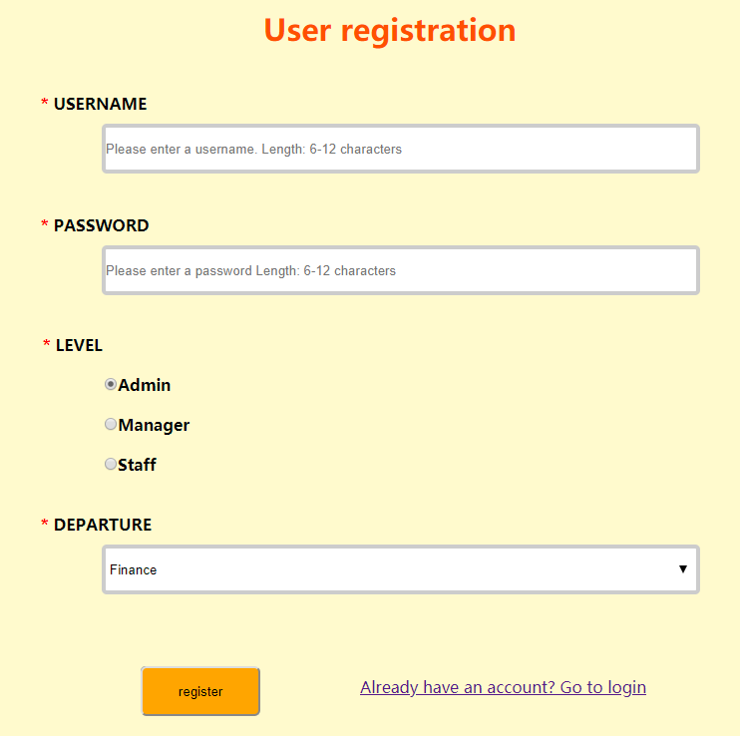

Note:

 insert information

 button – registar a new account

2

1

Note: database view – table staff

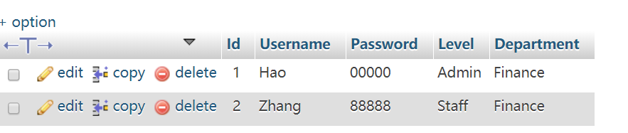

Note:

Insert information in database – table ‘staff ’

Note: Modify Personal Information

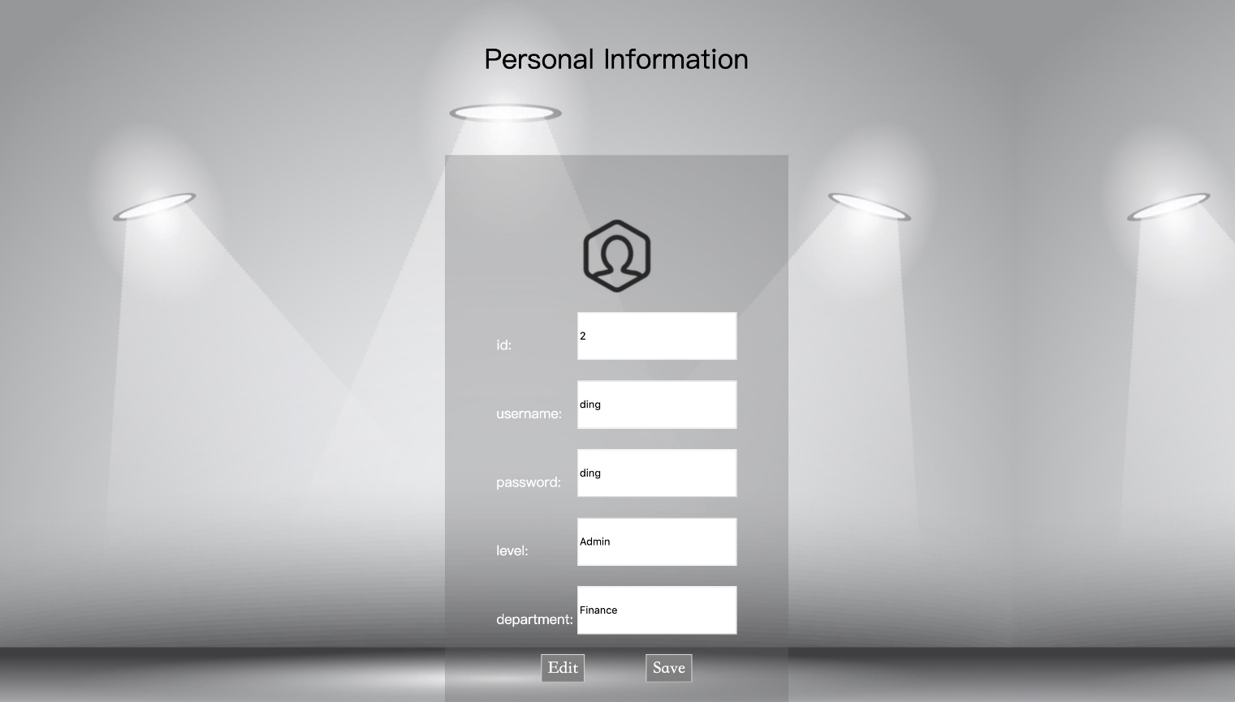

Note:

insert information

 button – edit and save (update database )

1

2

# 6.1 Staff

Note: Staff Main Page

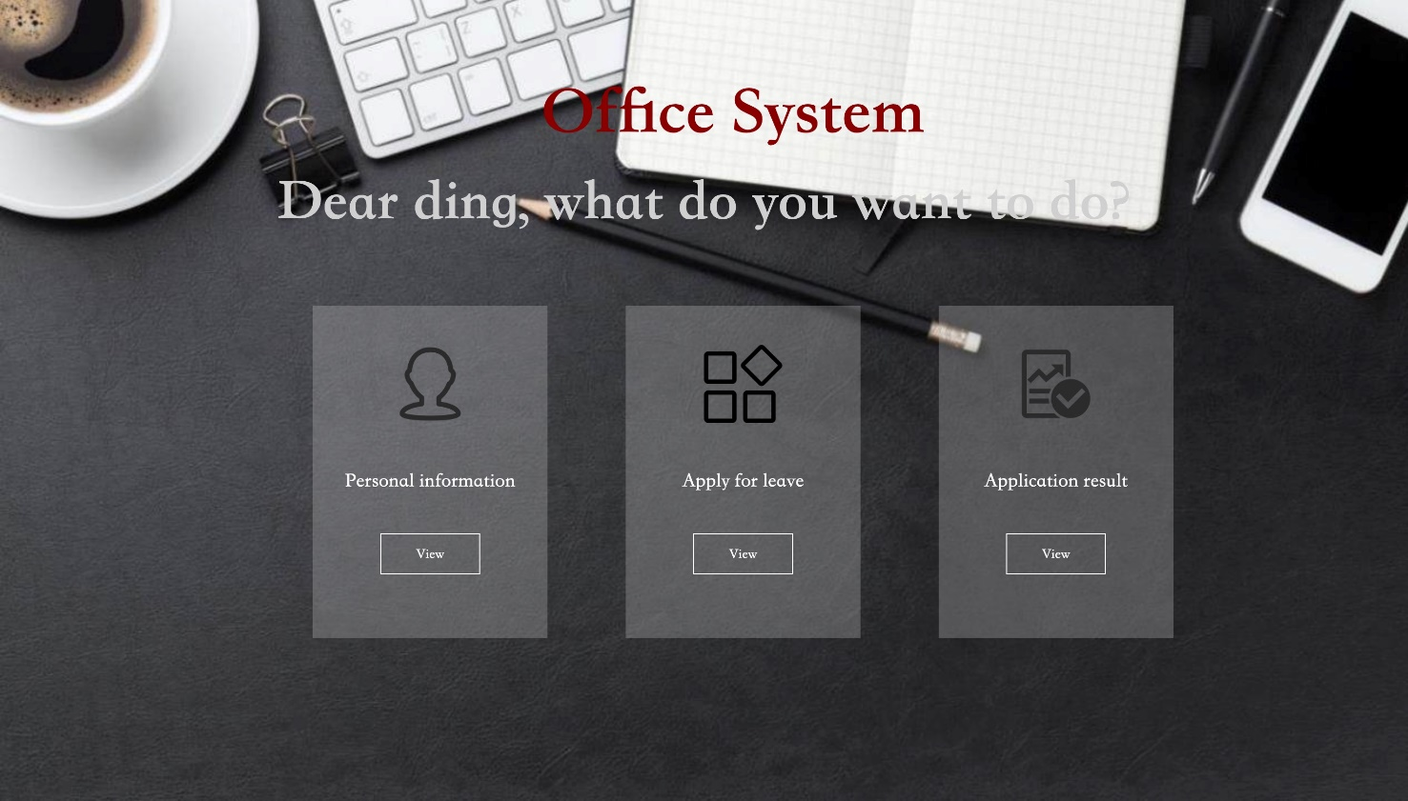

3

2

1

Note:

button - write a leave note

 button - check result

button – change personal information

Note: Staff write a leave application

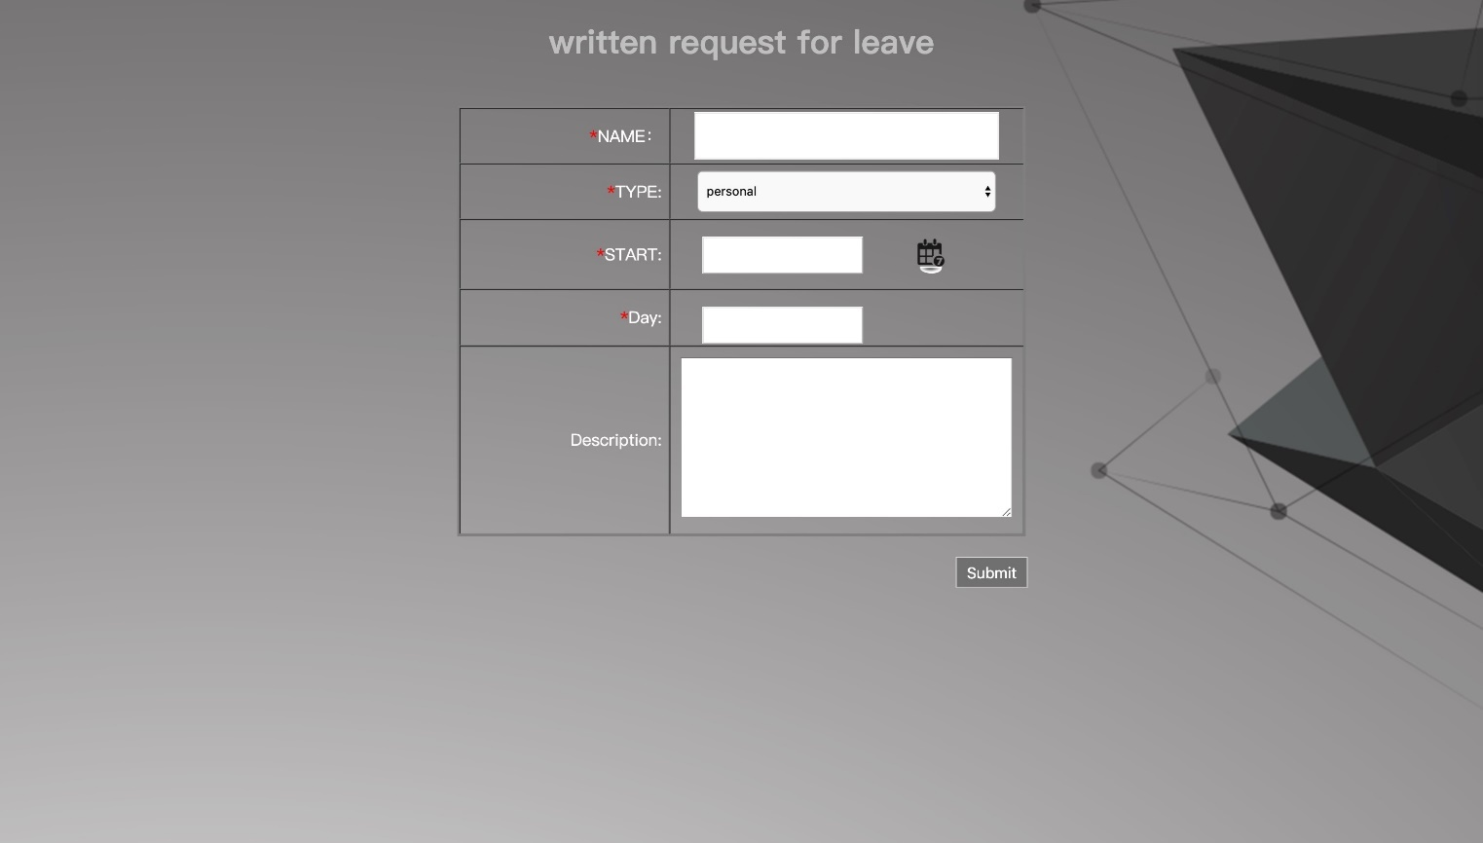

Note:

write your leave details

button – submit the information

2

1

Note:database - insert a leave application in table ‘application’

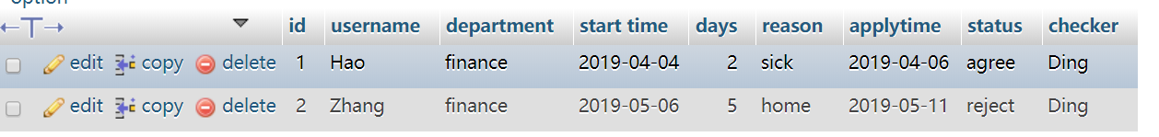

Note: View leave status

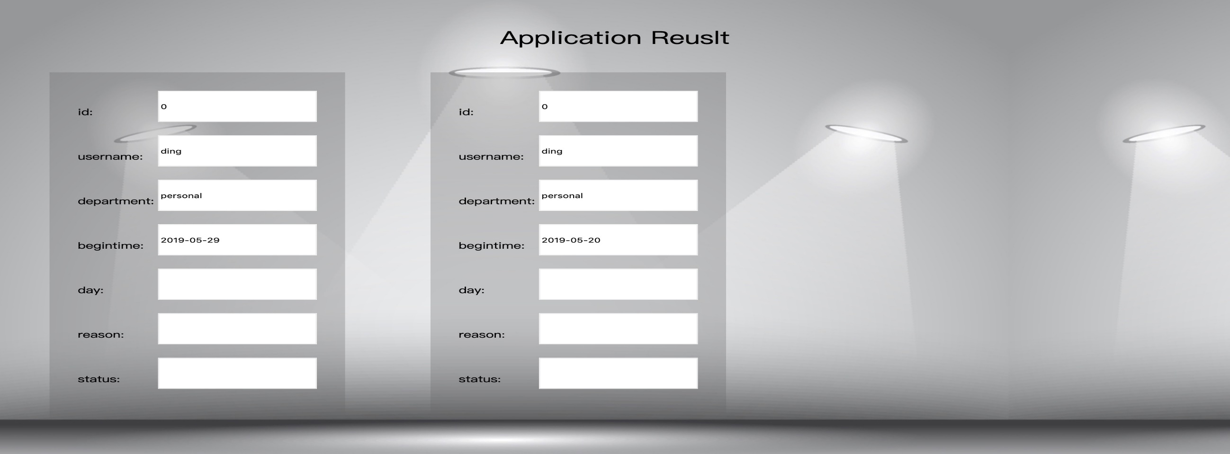

Note:

The information and status you can view.

# 6.2 Manager

Note: Manager Main Page

Note:

button - approve the staff’s leave application.

 button – view all applications.

button – change personal information.

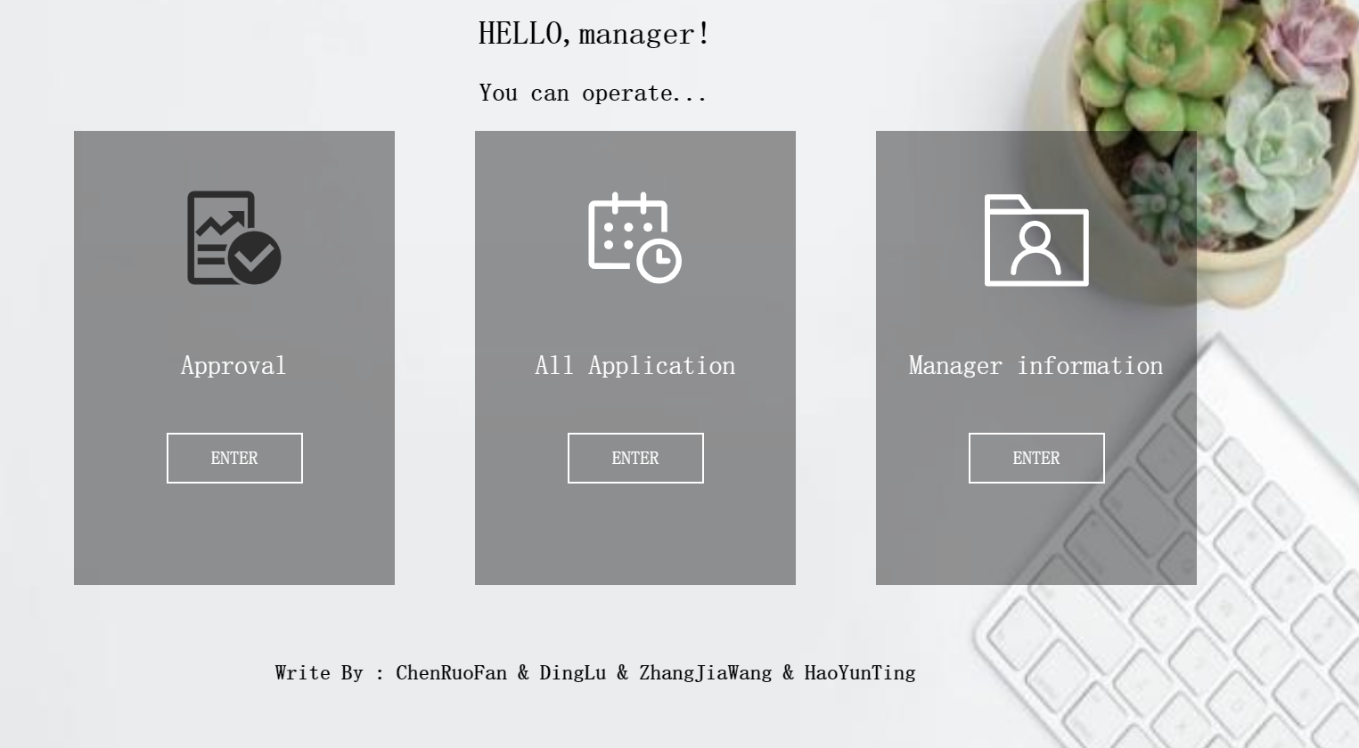

3

2

1

Note: Approval application

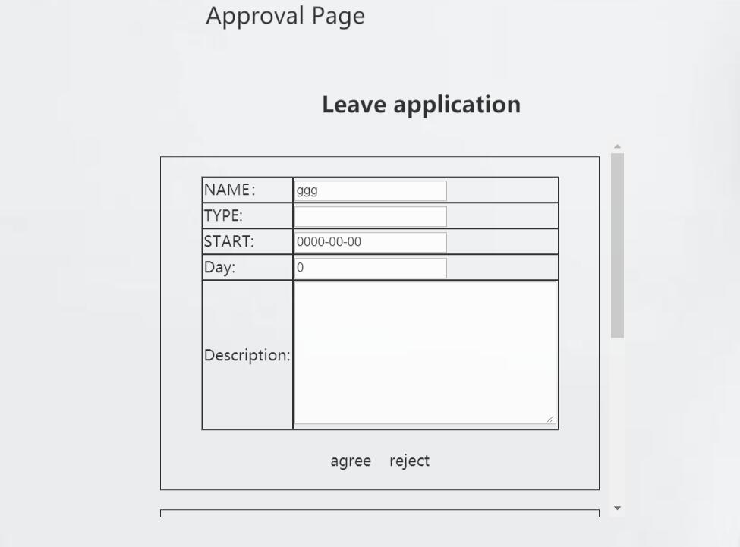

3

Note:

Staff’s leave application

 button – manager judge.(agree or reject)

slide it can see all be processed applications.

2

1

Note: database – update status in table ‘application’



Note: see all applications

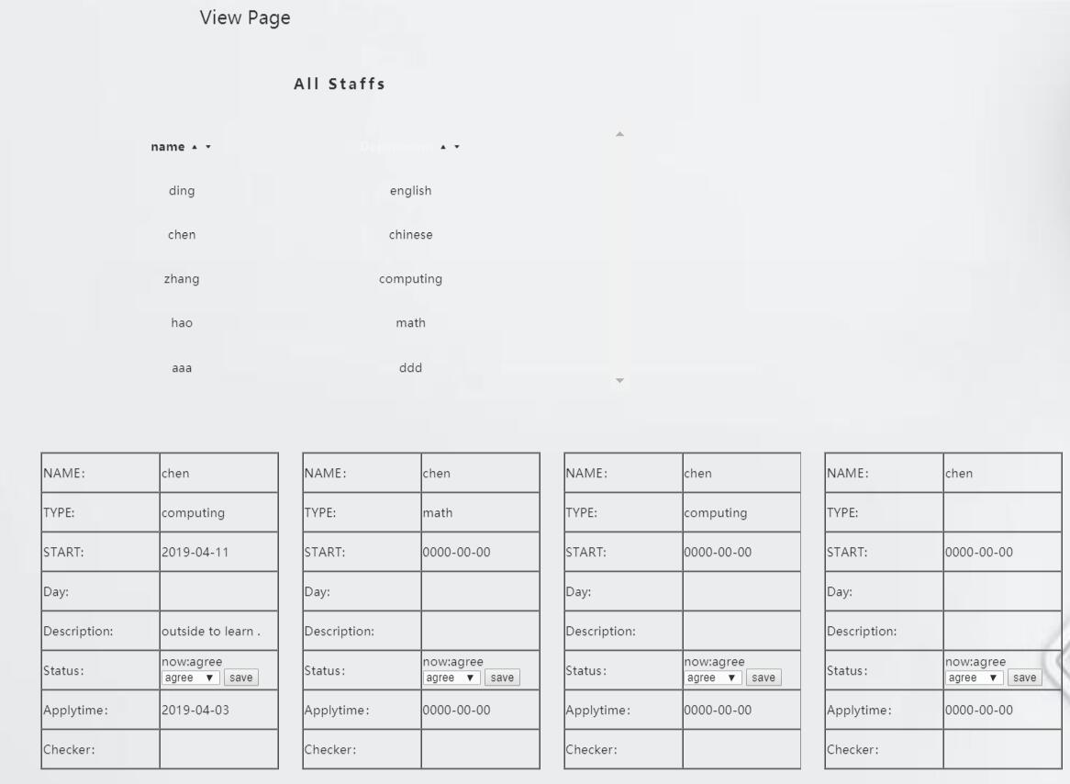

Note:

 list – all staffs’ nameand department.

 sort - Ascending and descending by name and department.

 in part 1,click one person’ name, there will be list his history applications.

 manager can change the status.

4

3

1

2

Note: database – update status in table ‘application’



# 6.3 Admin

Note: Admin Main Page

Note:

button – staffs’ information(can edit)

button – all applications(can edit)

button – logout

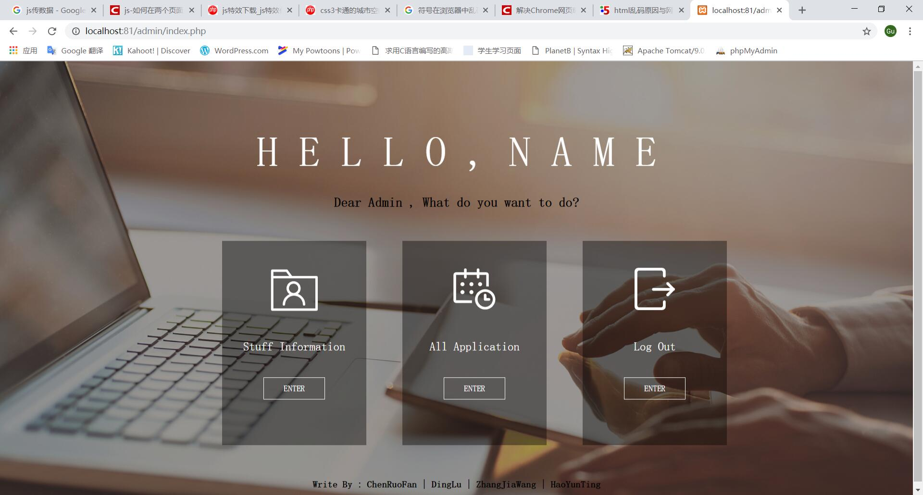

1

2

3

Note: sort,edit,delete – all staffs

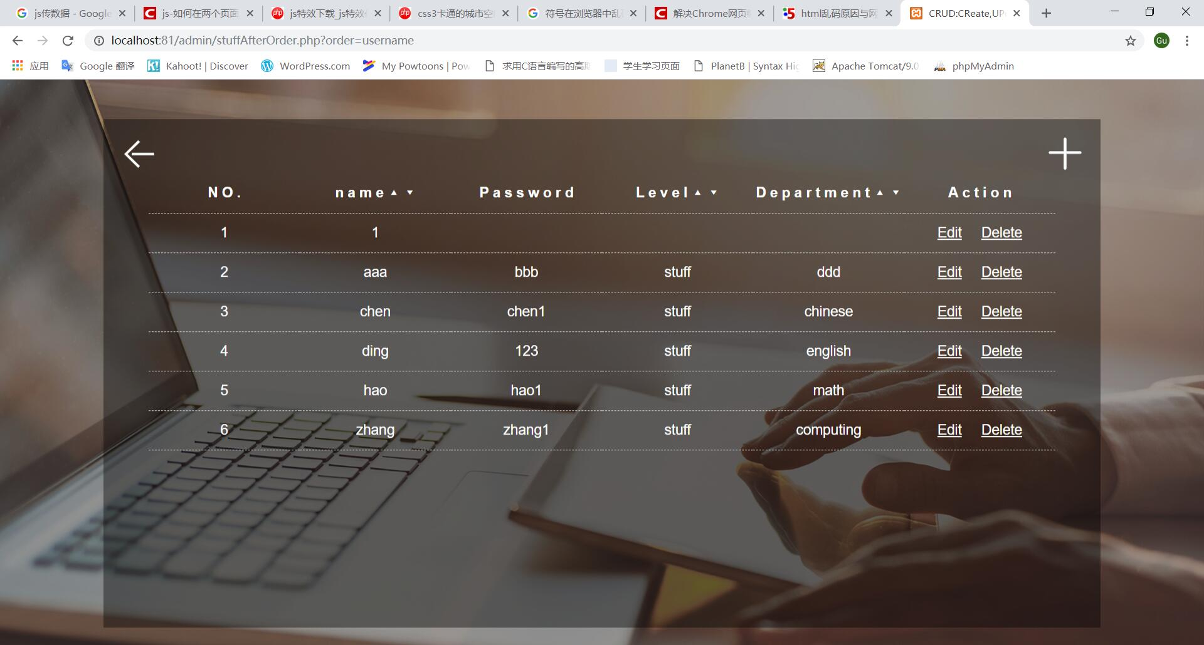

3

2

1

Note:

 sort staff’s information - Ascending and descending by name, password, level, department.

 button – edit and delete the staff’s information

 sort result - staffs’ information.

Note: sort of leaving application

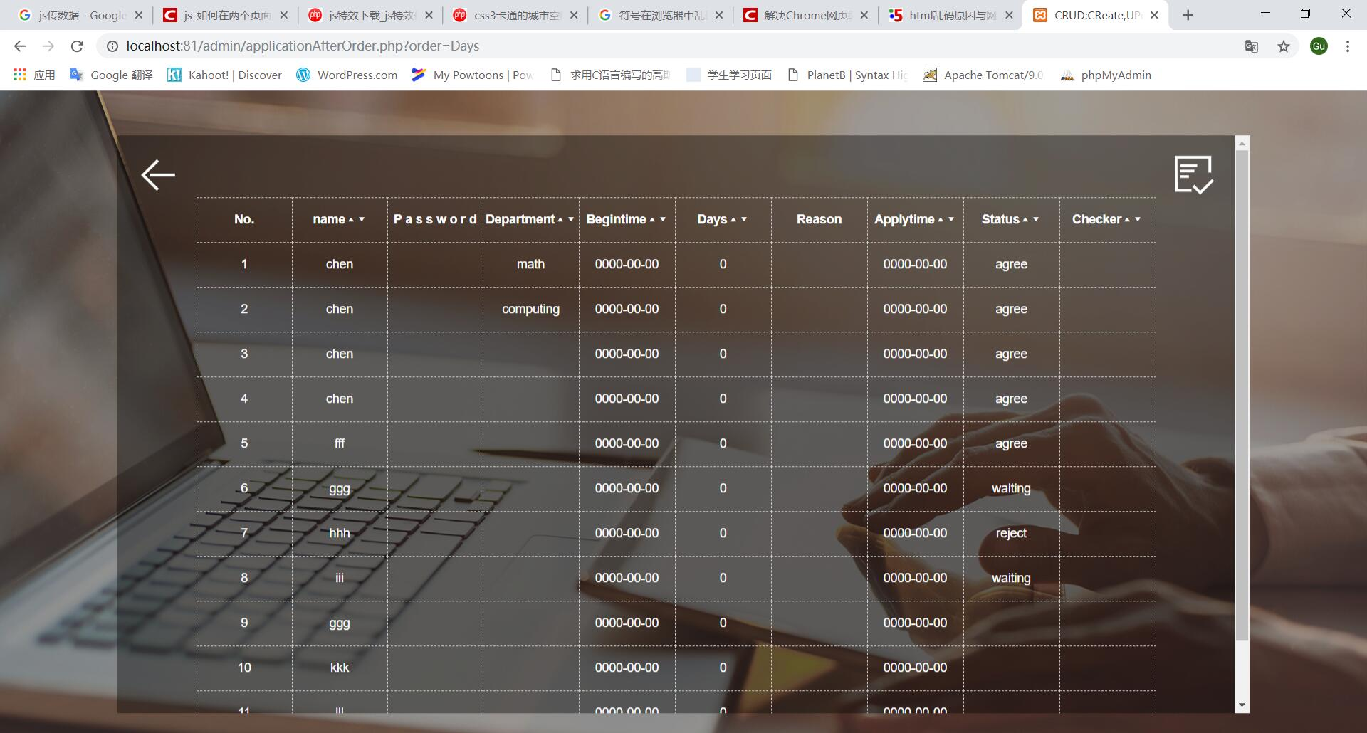

2

1

Note:

 sort leave notes- Ascending and descending by name, password, department, begintime, days, reason, applytime, status and checker.

the sort result – all leave application information.

Note: Add new staff

Note:

 insert account information.

button – save it in database.

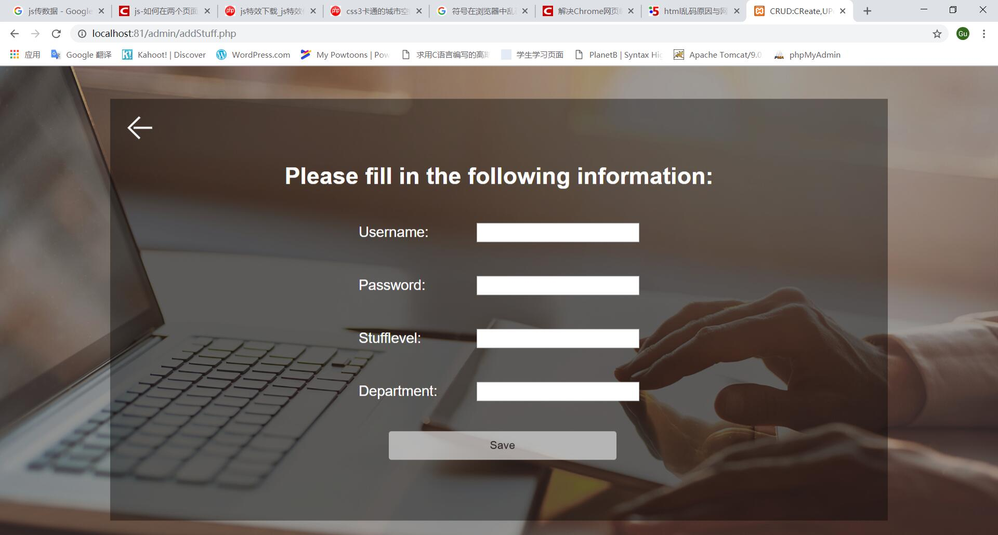

2

1

Note:database – update,insert staffs’ information



# 7.0 Conclusion

In short, Leave Application Management System can make the user's leave more convenient, the specific content of the leave is also clearly visible, you can also see the historical leave record, you can help the managers to count the leave information and view information. The admin can also handle the effective information of staffs and managers, and view all the information of both parties. It is convenient for them to improve work efficiency and save time.