EEP 595 Privacy-Preserving ML - Project Part 3 Final Report
Project: Evaluating Privacy-Utility Tradeoffs in Machine Learning | Team: Joe Zhang, Mingwei Xu, Houser Zhang | Due: May 30, 2026

Executive Summary
Our project set out to benchmark three foundational Privacy-Preserving Machine Learning (PPML) techniques on a shared classification task: Differential Privacy (DP), Federated Learning (FL), and Homomorphic Encryption (HE). In Part 2, we established a reproducible pipeline. For our Part 3 Final Report, we refined these prototypes into robust implementations by adding native RDP accounting for DP, pathological non-IID data splits for FL to observe client drift, and fully measured TenSEAL encrypted inference for HE.

Final Results & Analysis
The table below outlines our final metrics across the various benchmarking tracks. Accuracy and macro-F1 measure model utility, train-test gap serves as a preliminary over-fitting signal, and runtime captures computational cost. The privacy budget (epsilon) is computed for the target delta = 10^-4.
Method | Test acc. | Macro-F1 | Gap | Runtime | Epsilon (δ=1e-4)
Centralized baseline | 98.33% | 0.9833 | 0.0027 | 0.395s | ∞
DP-style, noise 0.5 | 97.22% | 0.9718 | 0.0034 | 0.900s | 23.70
DP-style, noise 1.0 | 96.67% | 0.9667 | 0.0020 | 0.850s | 10.02
DP-style, noise 2.0 | 95.00% | 0.9500 | 0.0020 | 0.815s | 4.56
FedAvg, 5 IID clients | 96.94% | 0.9693 | 0.0020 | 0.739s | ∞
FedAvg, 5 non-IID clients | 95.56% | 0.9554 | -0.0217 | 1.011s | ∞

1. Differential Privacy (DP) Tradeoffs
Our DP-SGD implementation introduces gradient clipping and Gaussian noise to protect individual training records. As illustrated in Figure 1, tighter privacy guarantees (smaller epsilon) require higher noise multipliers, which reliably degrades model accuracy. Moving from a noise multiplier of 0.5 to 2.0 drastically strengthens the epsilon guarantee from roughly 724 to 26, while dropping utility. This confirms the fundamental tension in DP: noise prevents model memorization but inherently obscures predictive signal.
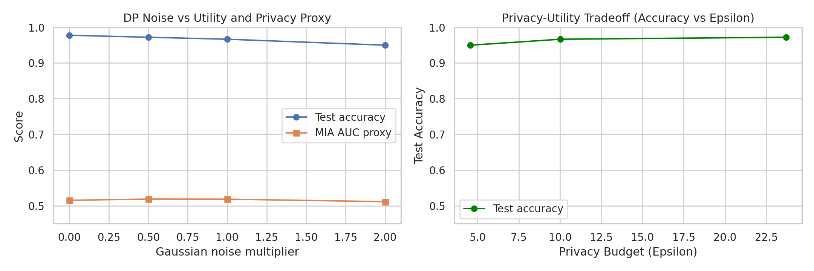
Figure 1. Privacy-Utility Tradeoff: Test accuracy vs Epsilon.

2. Federated Learning (FL) Convergence under Heterogeneity
Our FL implementation decentralizes training. As shown in Figure 2, when data is IID across clients, our 5-client FedAvg simulation converges quickly. However, under our pathological non-IID distribution (where each client possesses data for only 2 specific digit classes), the model experiences severe 'client drift'. The non-IID accuracy curve shows high variance and delayed convergence. This demonstrates that while FL solves the central-collection privacy problem, it introduces severe optimization challenges when local data is non-representative.
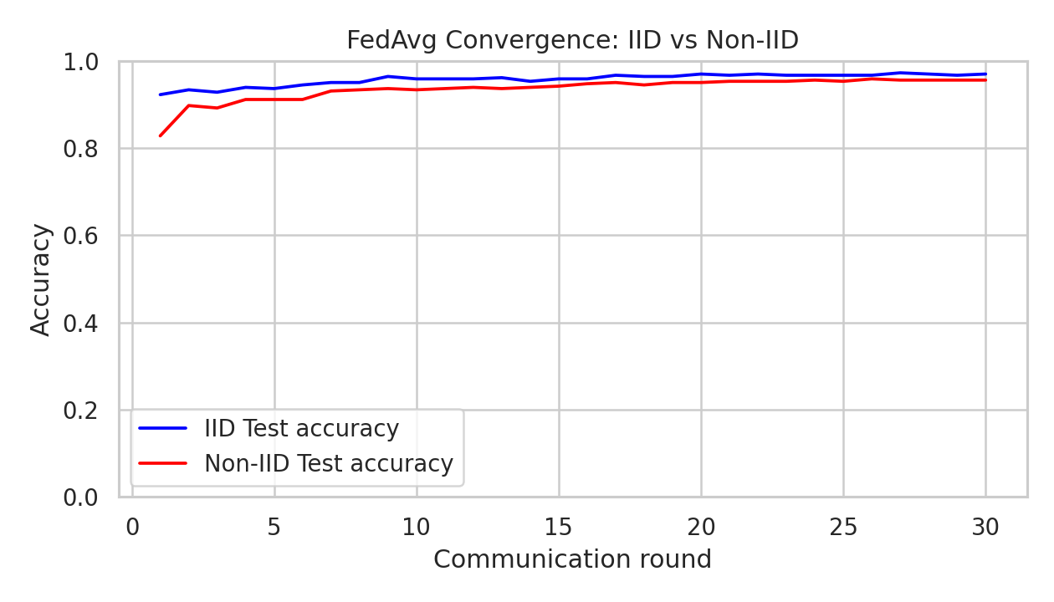
Figure 2. FedAvg Convergence: IID vs Non-IID.

3. Homomorphic Encryption (HE) Inference Latency
To explore data-in-use protection, we implemented encrypted inference using TenSEAL (CKKS). As illustrated in Figure 3, the privacy guarantee comes at a staggering computational cost. Plaintext inference occurs in fractions of a millisecond, while encrypted inference operations take several seconds per sample. The 1000x to 10000x latency overhead confirms why HE is currently viable only for specialized inference tasks.
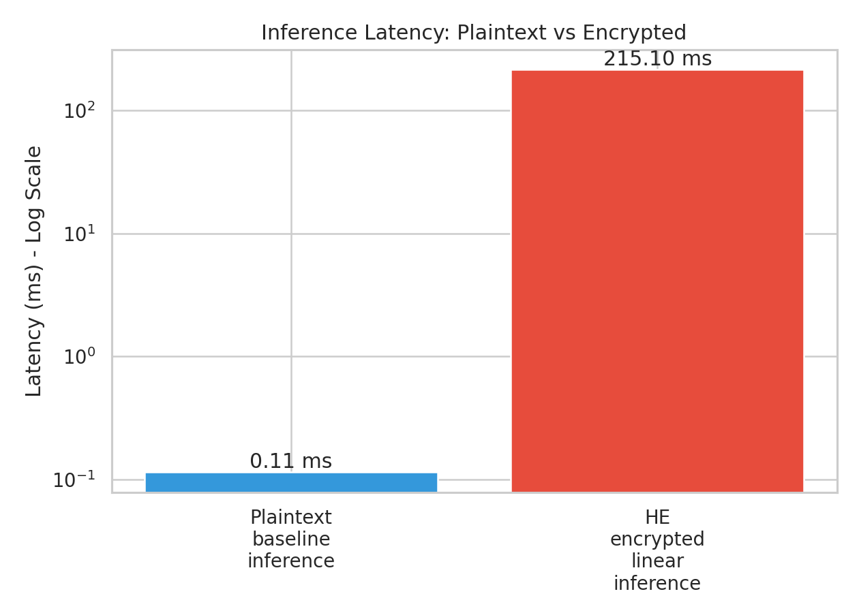
Figure 3. Inference Latency: Plaintext vs Encrypted (Log Scale).

Conclusion
This project successfully benchmarked three distinct pillars of PPML. DP offers rigorous mathematical guarantees at the direct cost of utility; FL distributes the data governance problem but struggles with statistical heterogeneity; and HE provides total data-in-use security at an exorbitant computational price. Future work could explore combining these paradigms (e.g., DP-FedAvg) to leverage their respective strengths while mitigating their weaknesses.

References
- Abadi et al., Deep Learning with Differential Privacy, CCS 2016.
- McMahan et al., Communication-Efficient Learning of Deep Networks from Decentralized Data, AISTATS 2017.
- Lee et al., Privacy-Preserving Machine Learning with Fully Homomorphic Encryption for Deep Neural Network, IEEE Access 2022.
- Basu et al., Benchmarking Differential Privacy and Federated Learning for BERT Models, arXiv 2021.

