**Exercise Report-1**

For

**INF 4140/9140 -Numerical Analysis**

**Hao, Zhao**

**Department of Geoscience & Department of Informatics, University of Oslo**

Feb 15, 2016

Exercise 4.1.1:

The interpolation problem in *Pn* leads to a linear system *V’c* = *f* , where *V* is a Vandermonde matrix. Write down the expression for the element *vij :*

----------------------------------------------------------------------------------------------------------------------------------

Answer:

$$The Candermonde matrix: Vn= \left[\begin{matrix}1 & 1 & …. 1 \\ X1 & X2 & …. Xn \\ . & . & \\ {X1}^{n-1} & {X2}^{n-1} & {……Xn}^{n-1}\end{matrix}\right]$$

Exercise 4.1.3:

What is meant by a triangle family q1(x), q2(x), . . . , qn(x) of polynomials? Are all

such families a basis for Pn?

----------------------------------------------------------------------------------------------------------------------------------

Answer:

A triangle family of polynomials means a sequence of polynomials form a triangular matrix S.

q1(x) = S11,

q2(x) = S12 + S22x,

q3(x) = S13 + S23x + S33x^2

. . .

qn(x) = S1n + S2nx + S3n x^2+· · ·+Snn.x^n-1

for any j , Pj (x) = xj−1 can be expressed recursively and uniquely as

linear combinations of q1(x), . . . , qj (x) by inverse transformation. Thus every triangle family is a basis for Pm.

----------------------------------------------------------------------------------------------------------------------------------

Exercise 4.1.5:

What good effects can be achieved by using over determination in polynomial interpolation?

----------------------------------------------------------------------------------------------------------------------------------

Answer:

The over determination in polynomial interpolation can be used to (1) reduce the effect of random or irregular errors in the values of function. (2) give the polynomial a smoother behavior between the grid points.

**Problems and Computer Exercises**

Exercise 4.1.1 (a):

----------------------------------------------------------------------------------------------------------------------------------

Plots Display:

Remarks:

For the display purpose, the 0 in difference has been replaced with the 1e-20 to avoid the ‘infinite’ in the logarithm display.

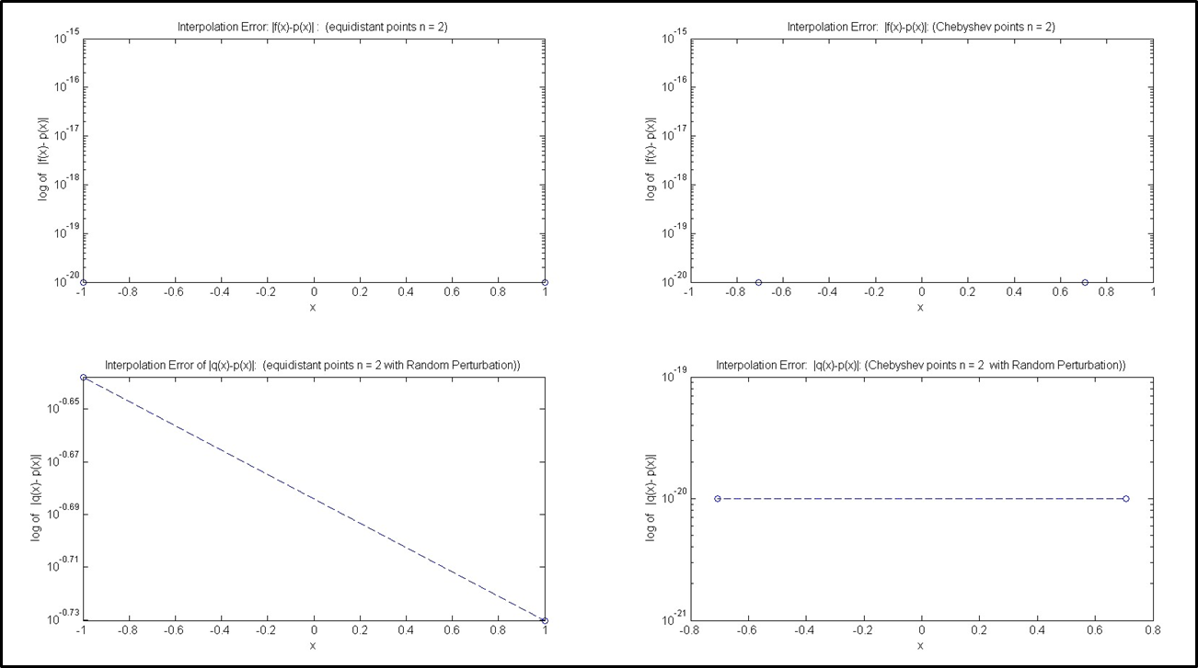

**Figure1.** Interpolation of function, with equidistant points and Chebyshev points, n =2

**Top-Left**: |f(x)-p(x)|: (equidistant points). **Top-right**: |f(x)-p(x)|: (Chebyshev points).

**Bot-Left**: |q(x)-p(x)|: (equidistant points). **Bot-right**: |q(x)-p(x)|: (Chebyshev points).

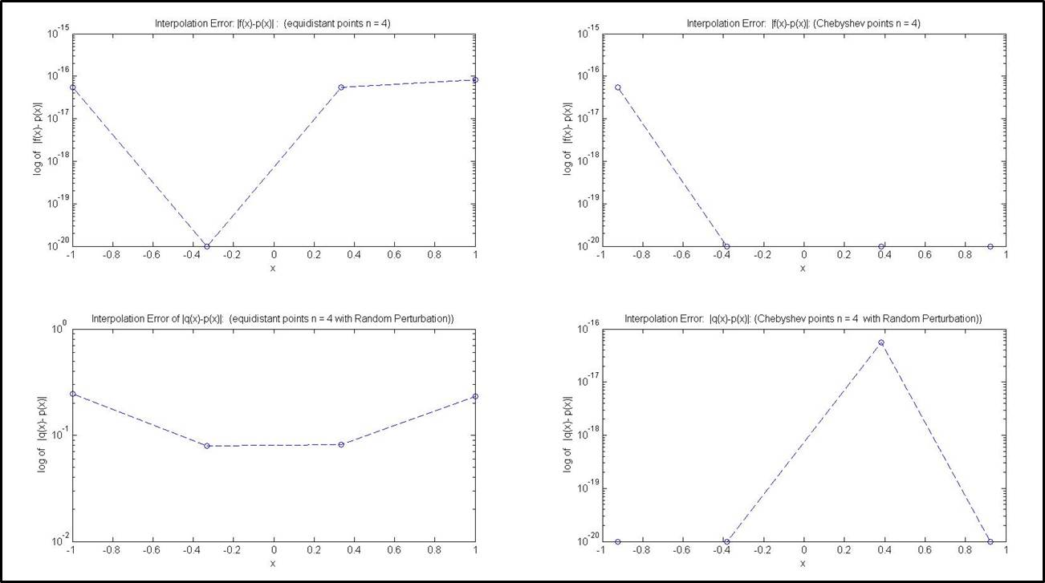

**Figure2.** Interpolation of function, with equidistant points and Chebyshev points, n =4

**Top-Left**: |f(x)-p(x)|: (equidistant points). **Top-right**: |f(x)-p(x)|: (Chebyshev points).

**Bot-Left**: |q(x)-p(x)|: (equidistant points). **Bot-right**: |q(x)-p(x)|: (Chebyshev points).

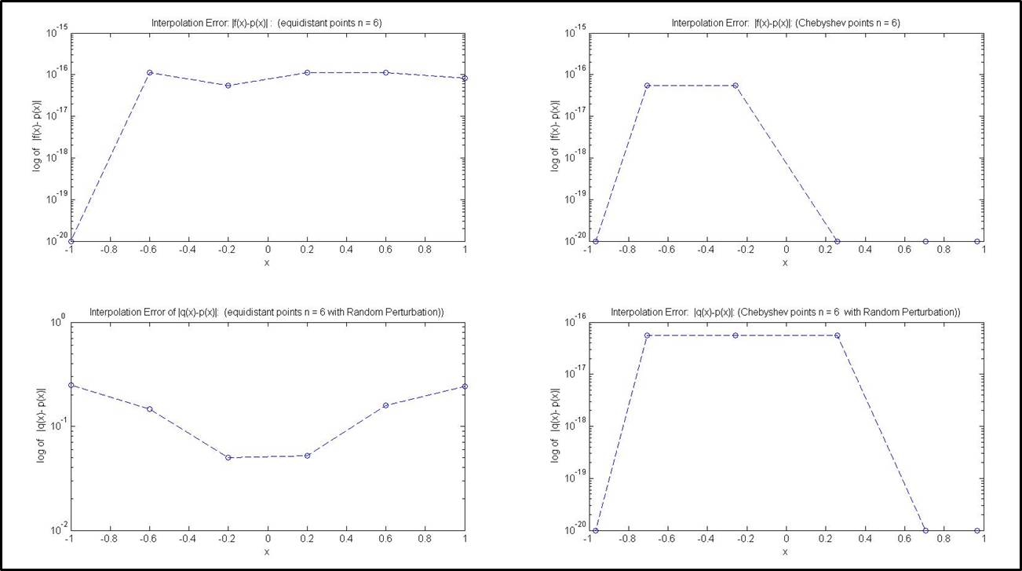

**Figure3.** Interpolation of function, with equidistant points and Chebyshev points, n =6

**Top-Left**: |f(x)-p(x)|: (equidistant points). **Top-right**: |f(x)-p(x)|: (Chebyshev points).

**Bot-Left**: |q(x)-p(x)|: (equidistant points). **Bot-right**: |q(x)-p(x)|: (Chebyshev points).

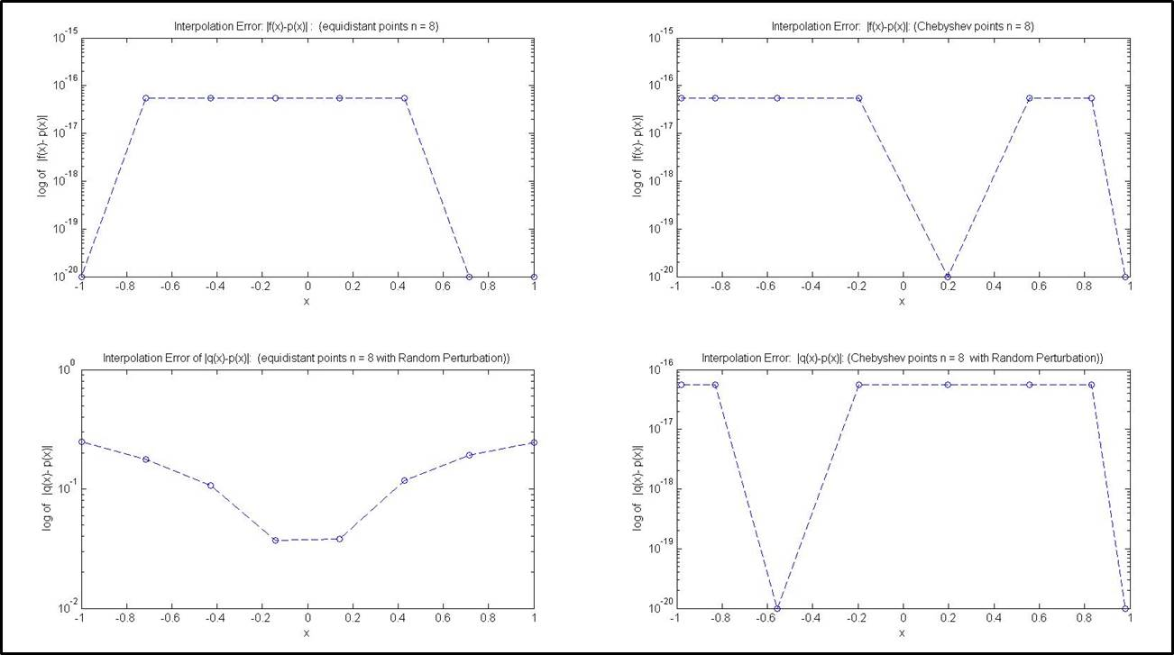

**Figure4.** Interpolation of function, with equidistant points and Chebyshev points, n =8

**Top-Left**: |f(x)-p(x)|: (equidistant points). **Top-right**: |f(x)-p(x)|: (Chebyshev points).

**Bot-Left**: |q(x)-p(x)|: (equidistant points). **Bot-right**: |q(x)-p(x)|: (Chebyshev points).

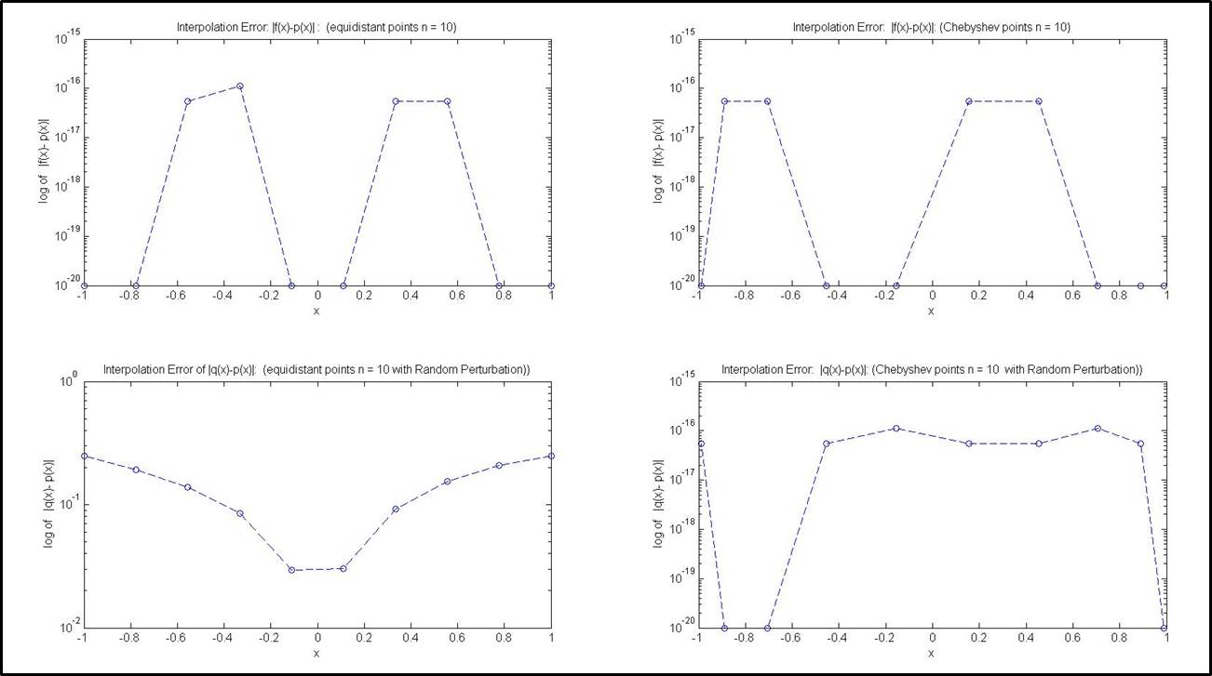

**Figure5.** Interpolation of function, with equidistant points and Chebyshev points, n =10

**Top-Left**: |f(x)-p(x)|: (equidistant points). **Top-right**: |f(x)-p(x)|: (Chebyshev points).

**Bot-Left**: |q(x)-p(x)|: (equidistant points). **Bot-right**: |q(x)-p(x)|: (Chebyshev points).

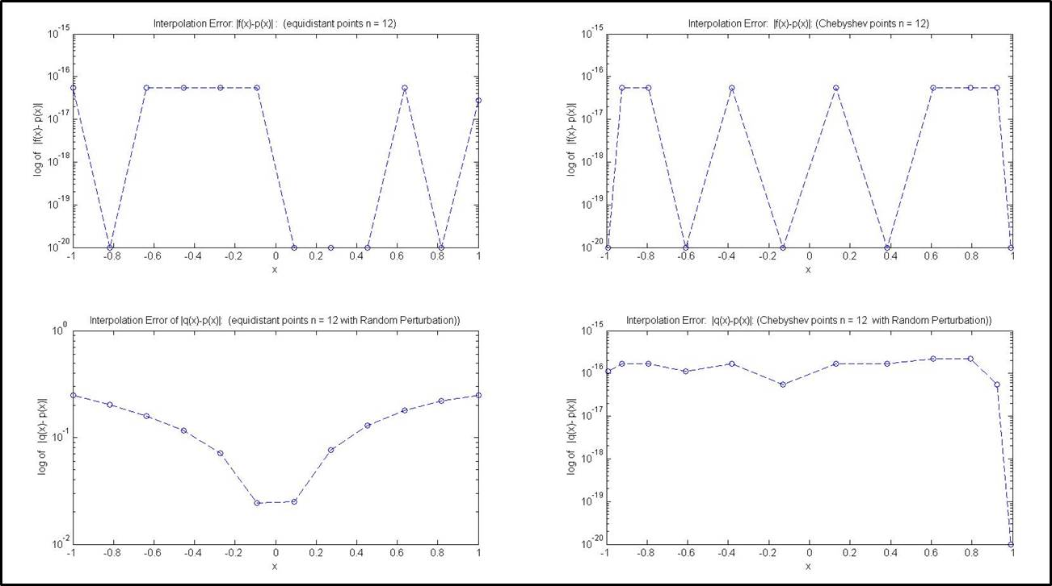

**Figure6.** Interpolation of function, with equidistant points and Chebyshev points, n =12

**Top-Left**: |f(x)-p(x)|: (equidistant points). **Top-right**: |f(x)-p(x)|: (Chebyshev points).

**Bot-Left**: |q(x)-p(x)|: (equidistant points). **Bot-right**: |q(x)-p(x)|: (Chebyshev points).

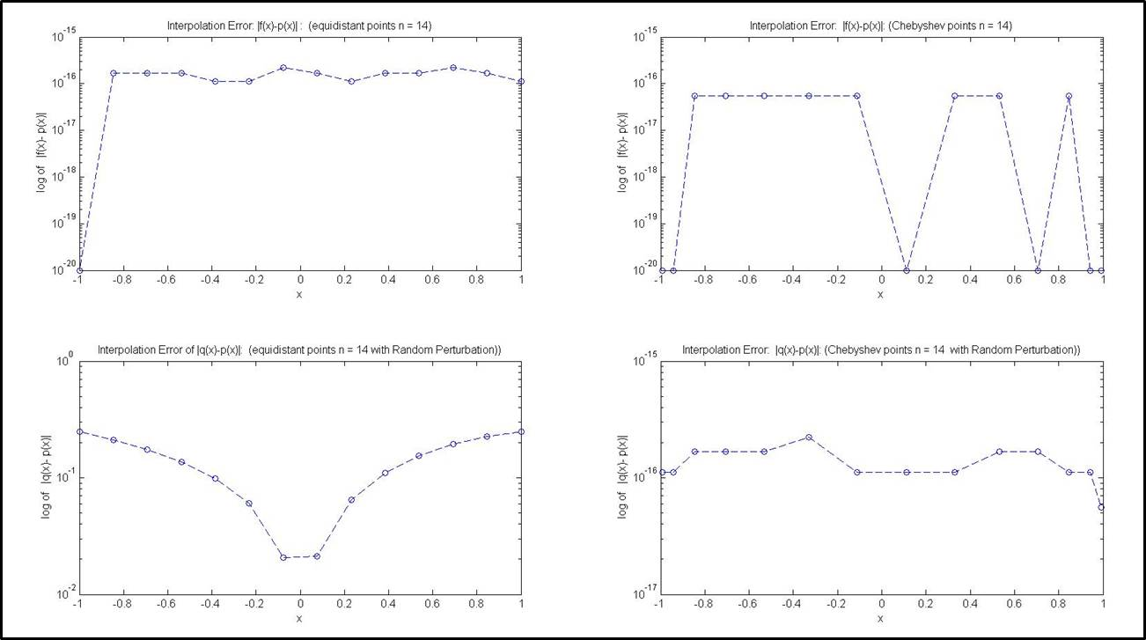

**Figure7.** Interpolation of function, with equidistant points and Chebyshev points, n =14

**Top-Left**: |f(x)-p(x)|: (equidistant points). **Top-right**: |f(x)-p(x)|: (Chebyshev points).

**Bot-Left**: |q(x)-p(x)|: (equidistant points). **Bot-right**: |q(x)-p(x)|: (Chebyshev points).

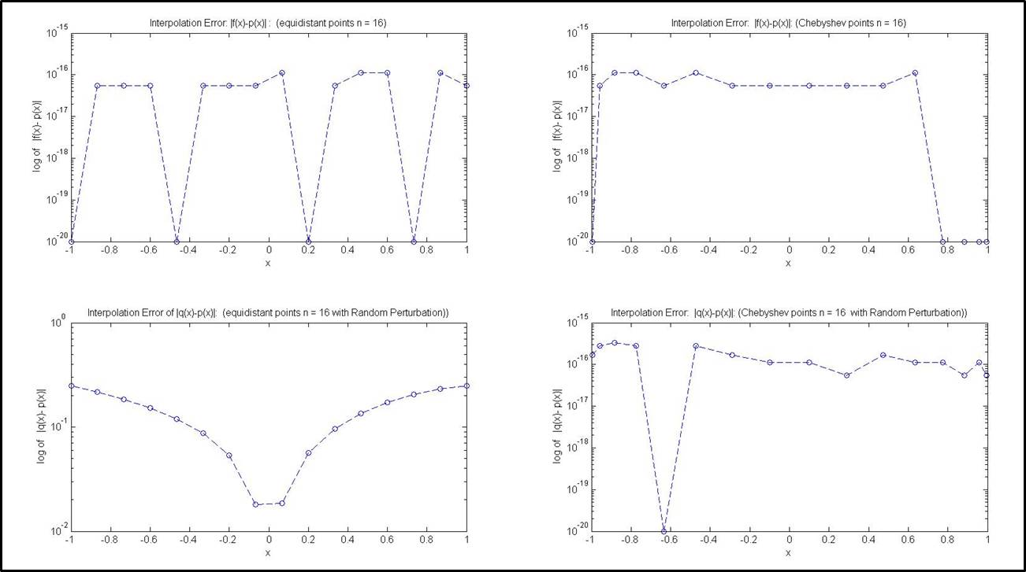

**Figure8.** Interpolation of function, with equidistant points and Chebyshev points, n =16

**Top-Left**: |f(x)-p(x)|: (equidistant points). **Top-right**: |f(x)-p(x)|: (Chebyshev points).

**Bot-Left**: |q(x)-p(x)|: (equidistant points). **Bot-right**: |q(x)-p(x)|: (Chebyshev points).

Exercise 4.1.1 (b):

----------------------------------------------------------------------------------------------------------------------------------

Plots Display:

Remarks:

The random function y = sin(x*pi), x =[-1,1] is used for this test.

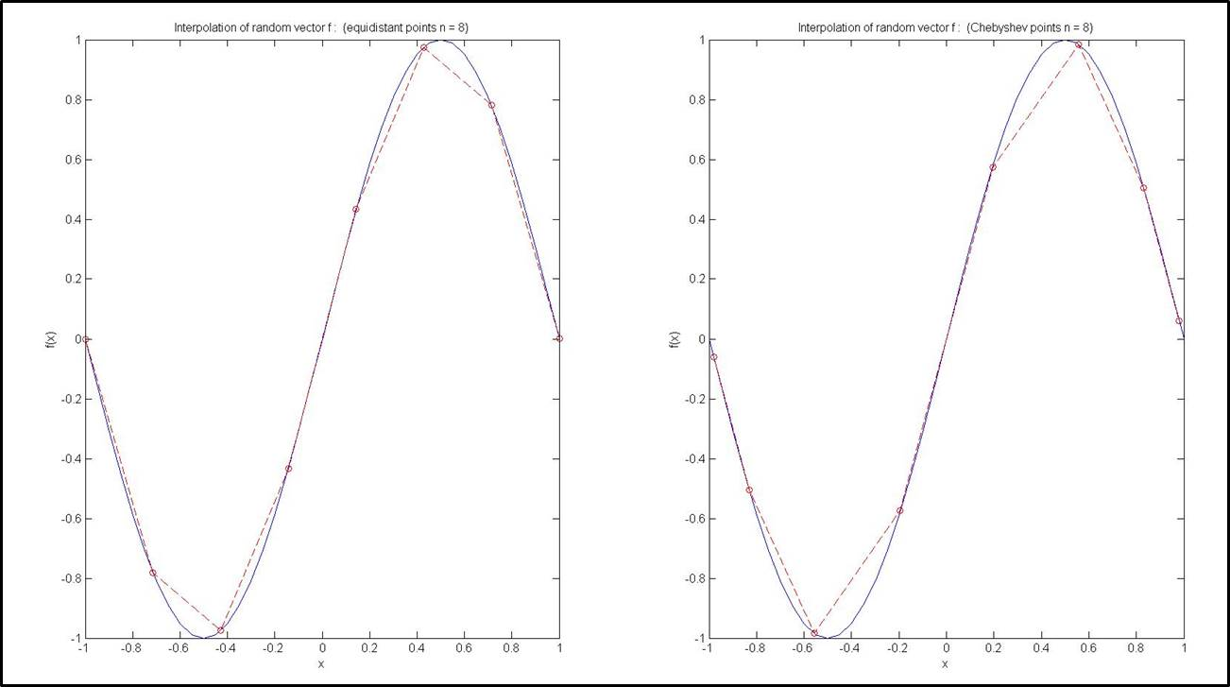

**Figure9.** Interpolation of random function, with equidistant points and Chebyshev points, n =8

**Left**: Display of f(x) and P(x) (equidistant points). **Right**: Display of f(x) and P(x) (Chebyshev points).

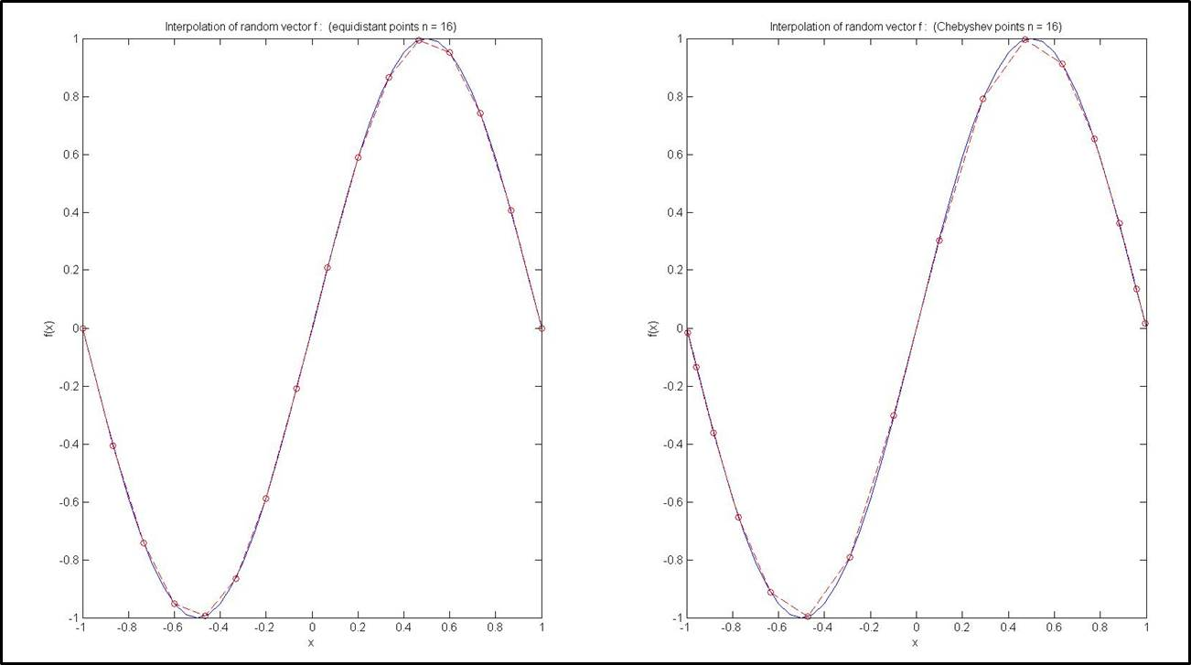

**Figure10.** Interpolation of random function, with equidistant points and Chebyshev points, n =16

**Left**: Display of f(x) and P(x) (equidistant points). **Right**: Display of f(x) and P(x) (Chebyshev points)