**Exercise Report-1**

For

**INF 4140/9140 -Numerical Analysis**

**Hao, Zhao**

**Department of Geoscience & Department of Informatics, University of Oslo**

Feb 15, 2016

Exercise 4.1.1:

The interpolation problem in *Pn* leads to a linear system *V’c* = *f* , where *V* is a Vandermonde matrix. Write down the expression for the element *vij :*

----------------------------------------------------------------------------------------------------------------------------------

Answer:

$$The Candermonde matrix: Vn= \left[\begin{matrix}1 & 1 & …. 1 \\ X1 & X2 & …. Xn \\ . & . & \\ {X1}^{n-1} & {X2}^{n-1} & {……Xn}^{n-1}\end{matrix}\right]$$

Exercise 4.1.3:

What is meant by a triangle family q1(x), q2(x), . . . , qn(x) of polynomials? Are all

such families a basis for Pn?

----------------------------------------------------------------------------------------------------------------------------------

Answer:

A triangle family of polynomials means a sequence of polynomials form a triangular matrix S.

q1(x) = S11,

q2(x) = S12 + S22x,

q3(x) = S13 + S23x + S33x^2

. . .

qn(x) = S1n + S2nx + S3n x^2+· · ·+Snn.x^n-1

for any j , Pj (x) = xj−1 can be expressed recursively and uniquely as

linear combinations of q1(x), . . . , qj (x) by inverse transformation. Thus every triangle family is a basis for Pm.

----------------------------------------------------------------------------------------------------------------------------------

Exercise 4.1.5:

What good effects can be achieved by using over determination in polynomial interpolation?

----------------------------------------------------------------------------------------------------------------------------------

Answer:

The over determination in polynomial interpolation can be used to (1) reduce the effect of random or irregular errors in the values of function. (2) give the polynomial a smoother behavior between the grid points.

**Problems and Computer Exercises**

Exercise 4.1.1 (a-1):

----------------------------------------------------------------------------------------------------------------------------------

Plots Display:

Remarks:

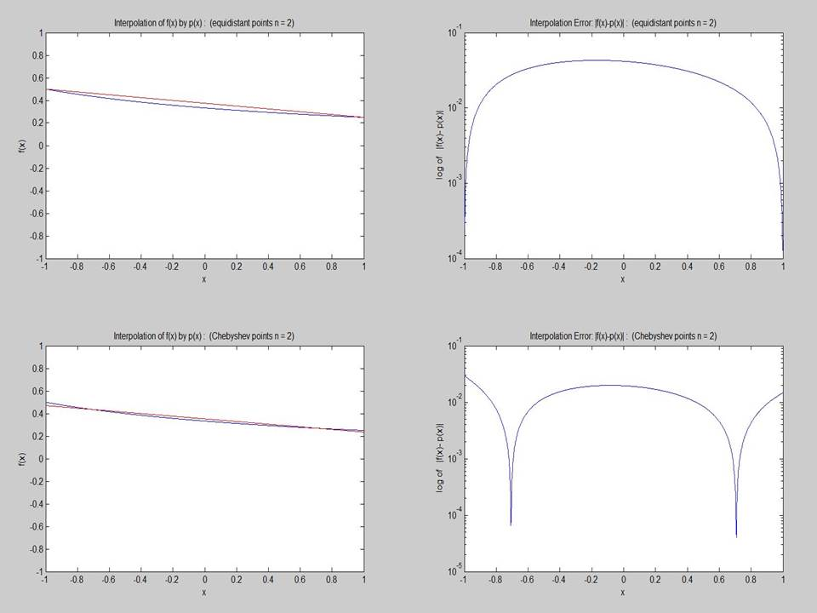

**Figure1.** Interpolation of function, with equidistant points and Chebyshev points, n =2

**Top-Left**: comparison of f(x) and p(x), (equidistant points). **Top-right**: |f(x)-p(x)|: (equidistant points).

**Bot-Left**: comparison of f(x) and p(x), (Chebyshev points). **Bot-right**: |f(x)-p(x)|: (Chebyshev points).

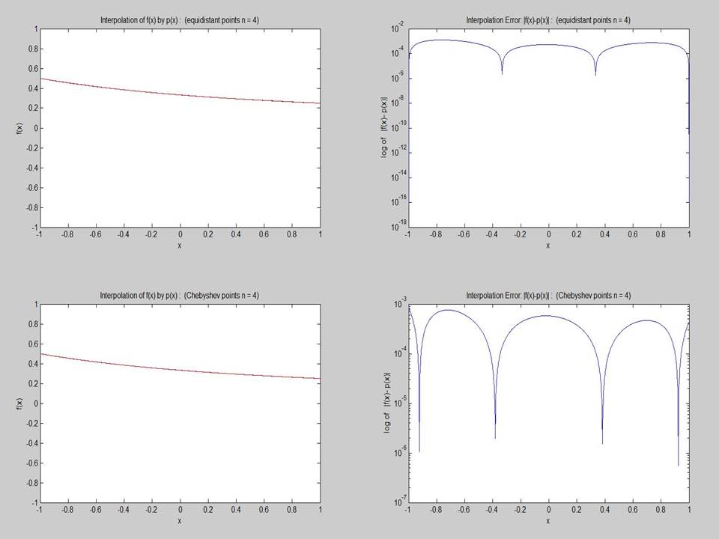

**Figure2.** Interpolation of function, with equidistant points and Chebyshev points, n =4

**Top-Left**: comparison of f(x) and p(x), (equidistant points). **Top-right**: |f(x)-p(x)|: (equidistant points).

**Bot-Left**: comparison of f(x) and p(x), (Chebyshev points). **Bot-right**: |f(x)-p(x)|: (Chebyshev points).

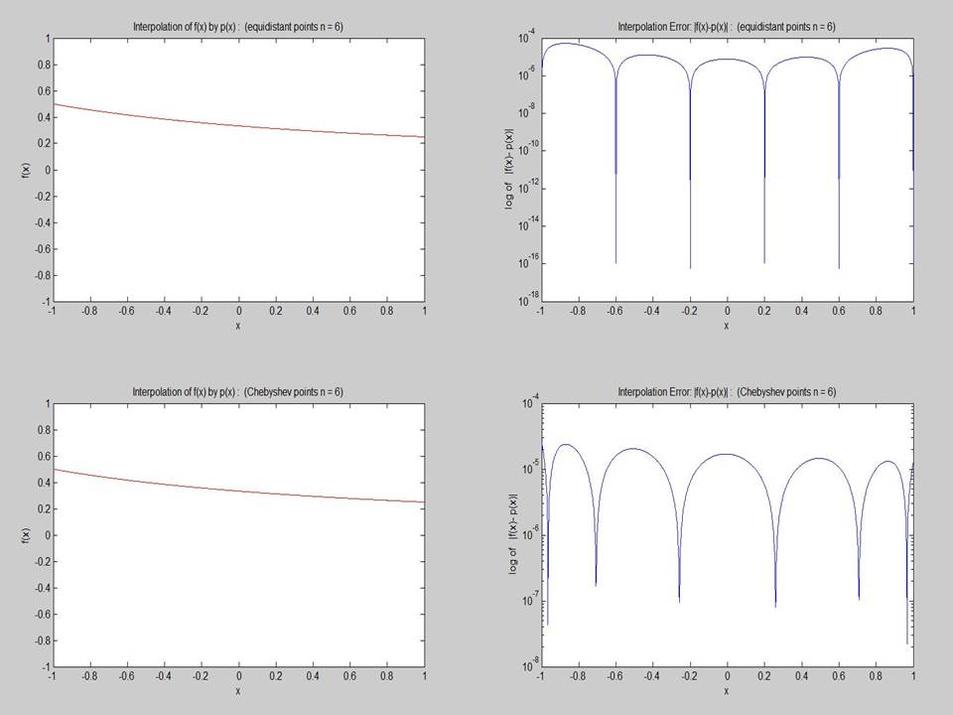

**Figure3.** Interpolation of function, with equidistant points and Chebyshev points, n =6

**Top-Left**: comparison of f(x) and p(x), (equidistant points). **Top-right**: |f(x)-p(x)|: (equidistant points).

**Bot-Left**: comparison of f(x) and p(x), (Chebyshev points). **Bot-right**: |f(x)-p(x)|: (Chebyshev points).

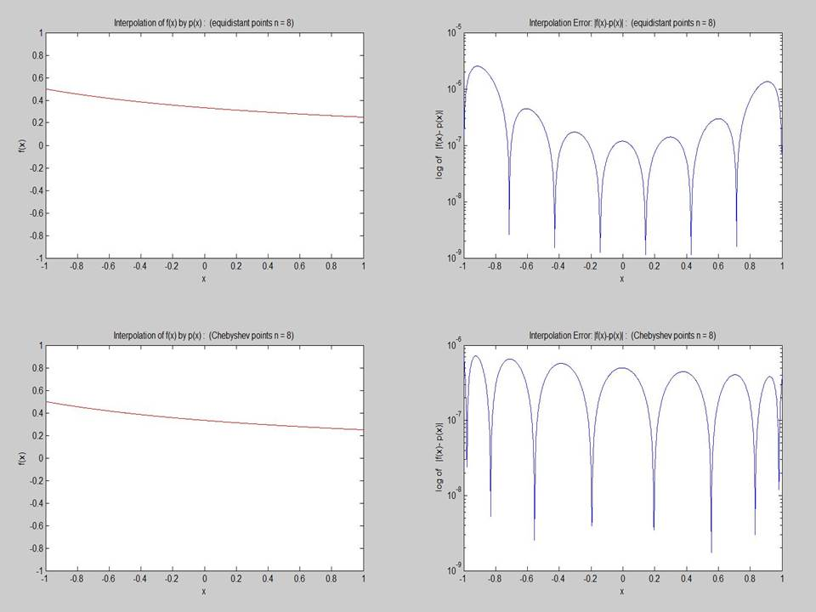

**Figure4.** Interpolation of function, with equidistant points and Chebyshev points, n =8

**Top-Left**: comparison of f(x) and p(x), (equidistant points). **Top-right**: |f(x)-p(x)|: (equidistant points).

**Bot-Left**: comparison of f(x) and p(x), (Chebyshev points). **Bot-right**: |f(x)-p(x)|: (Chebyshev points).

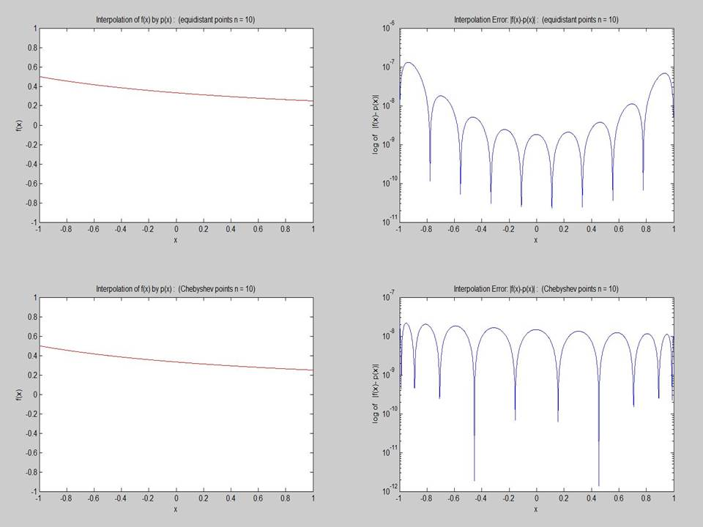

**Figure5.** Interpolation of function, with equidistant points and Chebyshev points, n =10

**Top-Left**: comparison of f(x) and p(x), (equidistant points). **Top-right**: |f(x)-p(x)|: (equidistant points).

**Bot-Left**: comparison of f(x) and p(x), (Chebyshev points). **Bot-right**: |f(x)-p(x)|: (Chebyshev points).

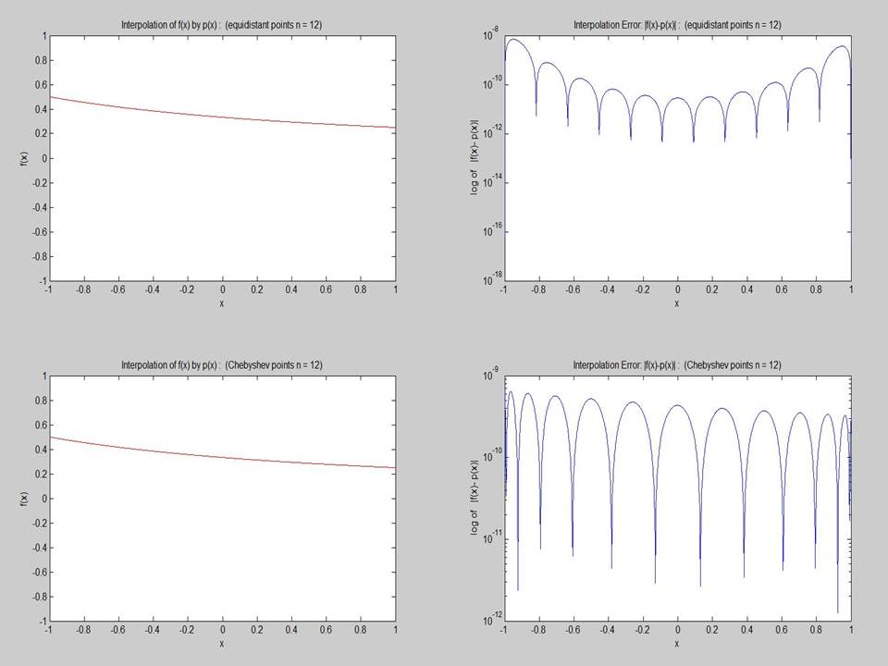

**Figure6.** Interpolation of function, with equidistant points and Chebyshev points, n =12

**Top-Left**: comparison of f(x) and p(x), (equidistant points). **Top-right**: |f(x)-p(x)|: (equidistant points).

**Bot-Left**: comparison of f(x) and p(x), (Chebyshev points). **Bot-right**: |f(x)-p(x)|: (Chebyshev points).

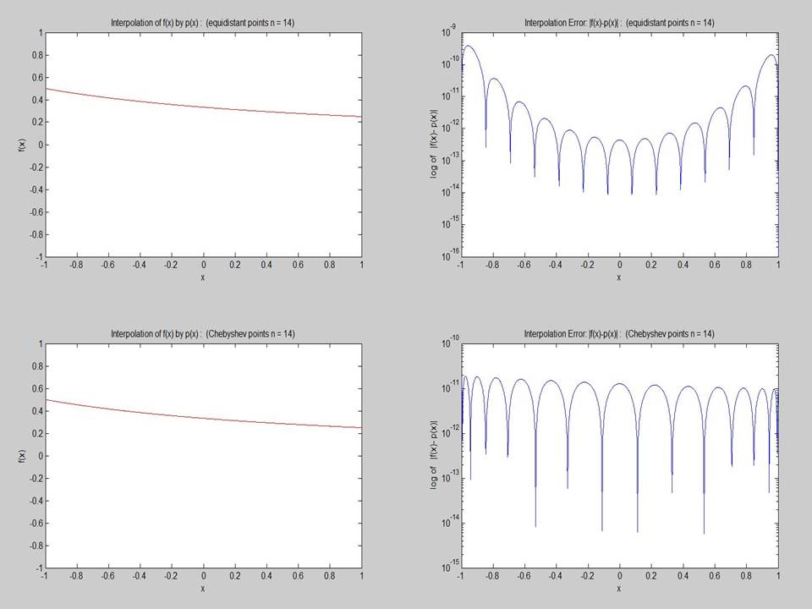

**Figure7.** Interpolation of function, with equidistant points and Chebyshev points, n =14

**Top-Left**: comparison of f(x) and p(x), (equidistant points). **Top-right**: |f(x)-p(x)|: (equidistant points).

**Bot-Left**: comparison of f(x) and p(x), (Chebyshev points). **Bot-right**: |f(x)-p(x)|: (Chebyshev points).

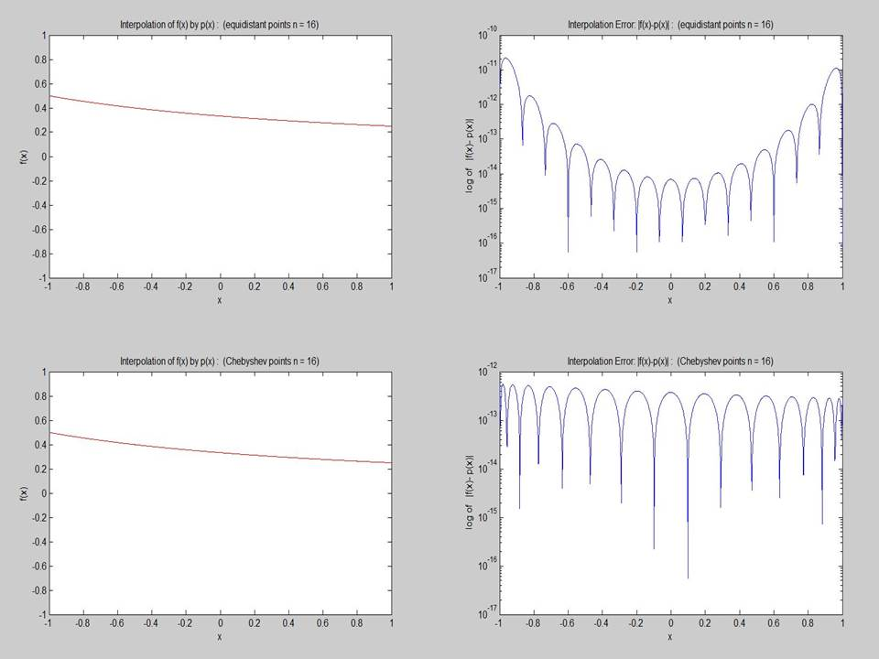

**Figure8.** Interpolation of function, with equidistant points and Chebyshev points, n =16

**Top-Left**: comparison of f(x) and p(x), (equidistant points). **Top-right**: |f(x)-p(x)|: (equidistant points).

**Bot-Left**: comparison of f(x) and p(x), (Chebyshev points). **Bot-right**: |f(x)-p(x)|: (Chebyshev points).

Exercise 4.1.1 (a-2):

----------------------------------------------------------------------------------------------------------------------------------

Plots Display:

Remarks:

To illustrate the error generated by the random perturbation, a random perturbation value is added on the original function, and the polynomial coefficient for the perturbed function are generated, and the corresponding numerical solution is regenerated as q(x), which is compared with the unperturbed solution p(x) as below.

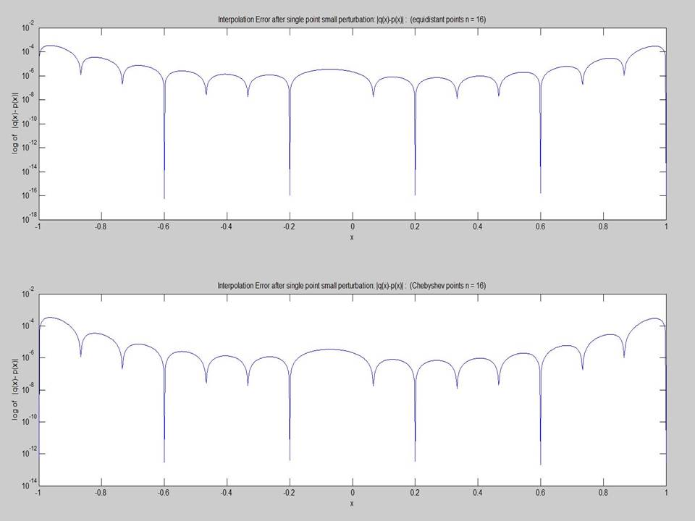

**Figure9.** Error generated by function with random Perturbation, n =16

**Top**: |q(x)-p(x)|: (equidistant points).

**Bot**: |q(x)-p(x)|: (Chebyshev points).

Exercise 4.1.1 (b):

----------------------------------------------------------------------------------------------------------------------------------

Plots Display:

Remarks:

The normal distribution random series with mean 0 and standard deviation 1 is choose for the comparison of interpolation with equidistance and Chebyshev points with x =[-1,1].

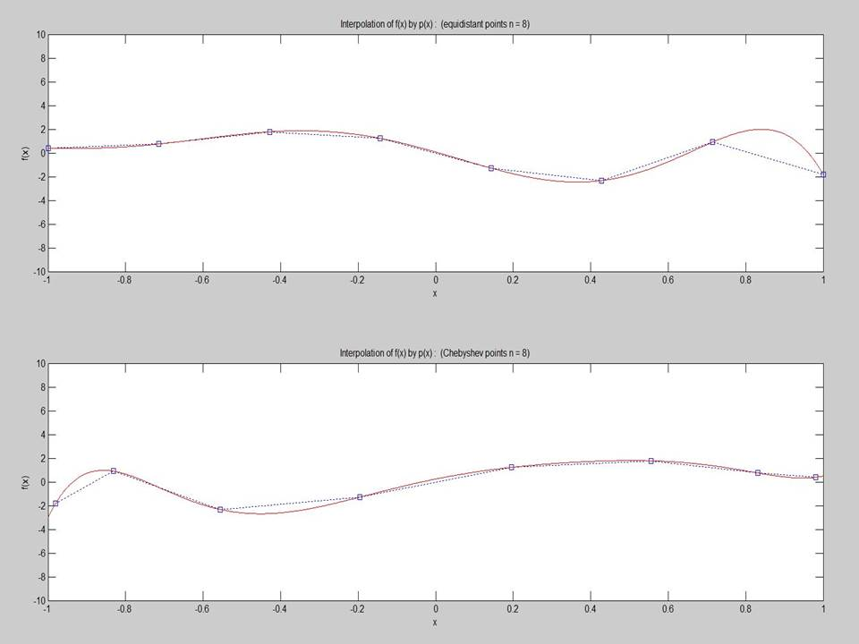

**Figure9.** Interpolation of random function, with equidistant points and Chebyshev points, n =8

**Left**: Display of f(x) and P(x) (equidistant points). **Right**: Display of f(x) and P(x) (Chebyshev points).

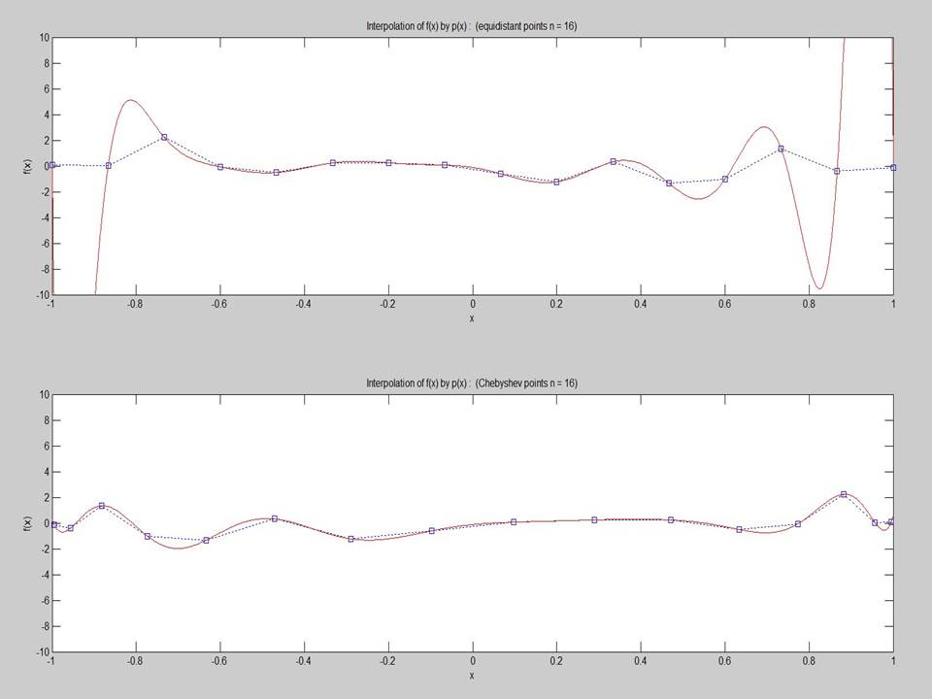

**Figure10.** Interpolation of random function, with equidistant points and Chebyshev points, n =16

**Left**: Display of f(x) and P(x) (equidistant points). **Right**: Display of f(x) and P(x) (Chebyshev points)