**Exercise Report-3**

For

**INF 4140/9140 -Numerical Analysis**

**Hao, Zhao**

**Department of Geoscience & Department of Informatics, University of Oslo**

May 9, 2016

----------------------------------------------------------------------------------------------------------------------------------

**Exercise 5.1.3:**

What is the advantage of including a weight function w(x) > 0 in some quadrature rules?

----------------------------------------------------------------------------------------------------------------------------------

Answer:

The advantage of including a weight function w(x) in some quadrature rules is to better handle the problem of the quadrature rules caused by the singularity function. For example, the integrand will become infinite at some point if the integrand has a singularity, or the integration interval is chosen close to infinite. In both these cases it will be advantageous to use the below weighted quadrature rule:

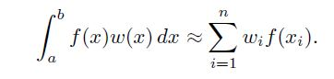

(1)

Where w(x) is the weight function that incorporates the singularity so that f(x) can be well approximated by a polynomial. And the limits (a,b) of integration are then allowed to be infinite.

----------------------------------------------------------------------------------------------------------------------------------

**Exercise 5.3.1:**

**5.3.1:**

What increase in order of accuracy can normally be achieved by a judicious choice of the nodes in a quadrature formula?

----------------------------------------------------------------------------------------------------------------------------------

Answer:

The order of accuracy of quadrature rules could be improved by a careful choice of nodes.

This is approved by the Theorem 5.1.3 in the course book, where it mentioned as below:

*Let k be an integer such that 0 ≤ k ≤ n. Consider the integral and an interpolator quadrature rule*

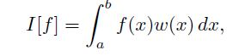

(2)

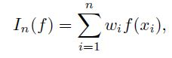

(3)

*By using n nodes to define the node polynomial as below:*

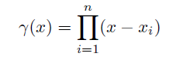

(4)

*Then the quadrature rule $I\left[f\right]≈I_{n}[f]$ will have the degree of exactness equal to d = n+ x -1, if all polynomials $p∈P_{k}$, the node polynomial satisfies:*

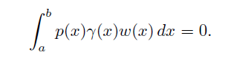

(5)

So based on above theorem, if the nodes are carefully chosen for the quadrature rule, the order of accuracy of the quadrature rule then will be improved. The Gaussian type of quadrature rules are the examples, which will have the maximum possible order 2n-1 by choosing the ‘Gaussian nodes’ and corresponding weights for the numerical integration calculation.

----------------------------------------------------------------------------------------------------------------------------------

**Exercise 5.3.8:**

1. Compute an approximate value of

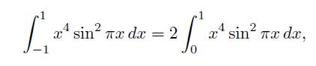

(6)

Using a five point Gauss–Legendre quadrature rule on [0, 1] for the weight function w(x) = 1. For nodes and weights see Table 5.3.1 or use the Matlab function legendre(n) given in Example 5.3.4. (The true value of the integral is 0.11407 77897 39689.)

----------------------------------------------------------------------------------------------------------------------------------

Answer:

Based on the Gauss–Legendre quadrature rule, we first transform the integration interval from [0 1] to interval [-1 1] by coordinate transformation.

$$x=\frac{b+a}{2}+\frac{b-a}{2}t$$

Considering a=0 and b=1, thus we will have

$$x=\frac{t+1}{2}$$

by replace the integration variable ‘x’ by ‘t’, the integration is converted to:

$$I[n]=\frac{1}{16}\int_{-1}^{1}{f\left(t\right)dt}$$

where $$f(t)={\left(t+1\right)}^{4}\sin^{2}(\frac{t+1}{2})π$$

Then for n = 5, by using Gauss–Legendre quadrature rule, we can find the corresponding gaussian nodes and associate weights:

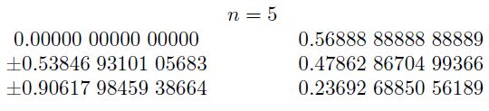

(Nodes Location) (Weight)

So the integration result could be estimated as:

$$I\left[n\right]=\frac{1}{16}\int_{-1}^{1}{f\left(t\right)dt}= \frac{1}{16} \sum_{i=1}^{5}{w_{i}*f\left(t_{i}\right)=0.114058}$$

(The corresponding Matlab code is also attached for reference)