  - 电机混控

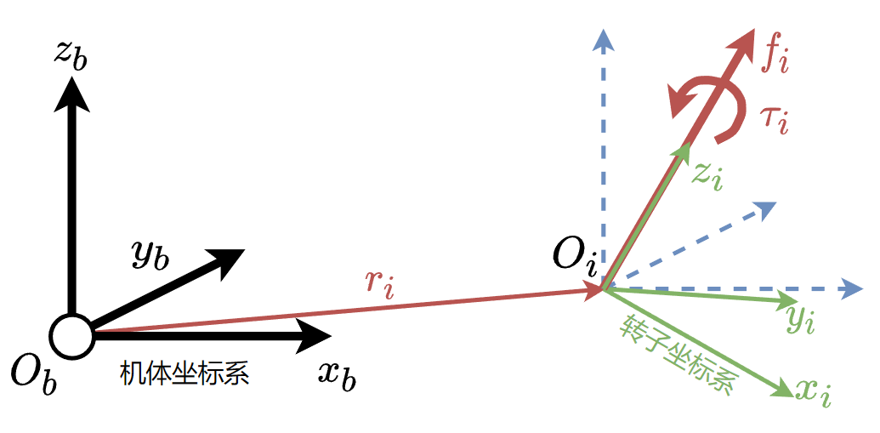
无人机每个旋翼提供的升力和反作用力矩如图所示。定义第i个螺旋桨的转子坐标系为$R_{i}$，转子坐标系的z轴与电机轴重合。记第i个螺旋桨提供的升力和反作用力矩分别$f_{i}$和$τ_{i}$，对于逆时针(CCW)旋转的螺旋桨反作用力矩为负，对于顺时针(CW)旋转的桨反作用力矩为正。$f_{i}$和$τ_{i}$与螺旋桨转速$ω_{i}$的关系可以近似为：
$$\begin{matrix}f_{i} & =C_{f}ω_{i}^{2} \\ τ_{i} & =aC_{τ}ω_{i}^{2}\end{matrix}$$
其中$C_{f}$和$C_{τ}$是与空气动力学参数相关的系数。$S_{i}$表示螺旋桨的旋向，当螺旋桨逆时针(CCW)旋转时，$S_{i}=−1$;当螺旋桨 顺时针(CW)旋转时，$S_{i}=1$。因此可以将$τ_{i}$记作：
$$τ_{i}=S_{i}kf_{i}$$
其中 $k=C_{τ}/C_{f}$。考虑到利用公式就可由升力求得对应的螺旋桨转速，为了简便书写，后续的推导将以螺旋桨的升力作为控制输入。
第 $i$ 个螺旋桨在作用点处的力和力矩在机体坐标系下的表示为：
$$\begin{matrix} & F_{i}=R_{i}{\left[0,0,f_{i}\right]}^{T} \\ & M_{i}=R_{i}{\left[0,0,S_{i}kf_{i}\right]}^{T}\end{matrix}$$
将所有力和力矩向质心简化，n个螺旋桨提供的合力在机体坐标系下的表示为：
$$\begin{matrix} & f=\sum_{i=0}^{n−1}{F_{i}} \\ & τ=\sum_{i=1}^{n−1}{{（r}_{i}}×F_{i}+M_{i}）\end{matrix}$$

其中$r_{i}$为机体质心到螺旋桨受力点的位置矢量。解(1.11)和(1.12)，就可以由控制输入$f$和$τ$计算每个螺旋桨的升力和倾转电机的角度。

  - 四棱锥模型
    - 动力分配矩阵
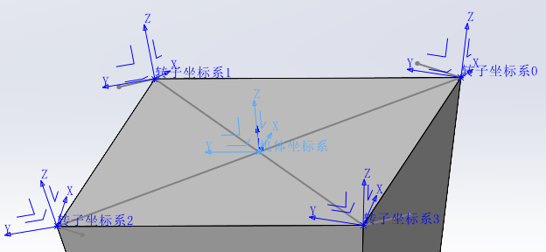
控制可以简化为，底面为长方形的四棱锥。每个螺旋桨产生的力/力矩的作用点位于长方形的四个顶点，转子坐标系的z轴和四棱锥的棱共线。机体坐标系原点位于长方形几何中心，xoy平面和长方形共面。
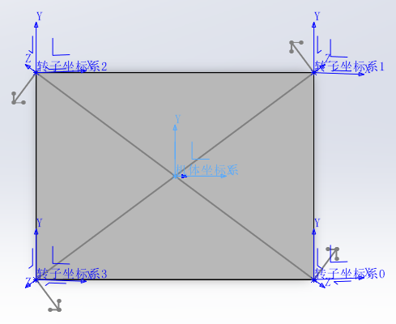
转轴单位向量公式（右手系，XY 平面内）：
$$\begin{matrix}u_{0}=\left(\frac{b}{\sqrt{a^{2}+b^{2}}},\frac{a}{\sqrt{a^{2}+b^{2}}},0\right) \\ u_{1}=\left(\frac{−b}{\sqrt{a^{2}+b^{2}}},\frac{a}{\sqrt{a^{2}+b^{2}}},0\right) \\ u_{2}=\left(\begin{matrix}\frac{−b}{\sqrt{a^{2}+b^{2}}},\frac{−a}{\sqrt{a^{2}+b^{2}}},0\end{matrix}\right) \\ u_{3}=\left(\frac{b}{\sqrt{a^{2}+b^{2}}},\frac{−a}{\sqrt{a^{2}+b^{2}}},0\right)\end{matrix}$$
各转子坐标系为标准坐标系绕各转轴旋转$θ$后的结果，转轴转角的Rodrigues公式为：
$$R\left(u,θ\right)=\left(\begin{matrix}u_{x}^{2}\left(1−cosθ\right)+cosθ & u_{x}u_{y}\left(1−cosθ\right)−u_{z}sinθ & u_{x}u_{z}\left(1−cosθ\right)+u_{y}sinθ \\ u_{y}u_{x}\left(1−cosθ\right)+u_{z}sinθ & u_{y}^{2}\left(1−cosθ\right)+cosθ & u_{y}u_{z}\left(1−cosθ\right)−u_{x}sinθ \\ u_{z}u_{x}\left(1−cosθ\right)−u_{y}sinθ & u_{z}u_{y}\left(1−cosθ\right)+u_{x}sinθ & u_{z}^{2}\left(1−cosθ\right)+cosθ\end{matrix}\right)$$
其中，$u={\left(u_{x},u_{y},u_{z}\right)}^{T}$，是单位向量。$θ$为转角。
首先，利用第一章中的公式来推导混控矩阵，可以列出以下关系：
$$\begin{matrix} & F_{0}=R_{0}{\left[0,0,f_{0}\right]}^{T}, M_{0}=R_{0}{\left[0,0,S_{0}kf_{0}\right]}^{T}, r_{0}={\left[\frac{a}{2},−\frac{b}{2},0\right]}^{T} \\ & F_{1}=R_{1}{\left[0,0,f_{1}\right]}^{T}, M_{1}=R_{1}{\left[0,0,S_{1}kf_{1}\right]}^{T}, r_{1}={\left[\frac{a}{2},\frac{b}{2},0\right]}^{T} \\ & F_{2}=R_{2}{\left[0,0,f_{2}\right]}^{T}, M_{2}=R_{2}{\left[0,0,S_{2}kf_{2}\right]}^{T}, r_{2}={\left[−\frac{a}{2},\frac{b}{2},0\right]}^{T} \\ & F_{3}=R_{3}{\left[0,0,f_{3}\right]}^{T}, M_{3}=R_{3}{\left[0,0,S_{3}kf_{4}\right]}^{T}, r_{3}={\left[−\frac{a}{2},−\frac{b}{2},0\right]}^{T} \\ & \\ & \\ & \\ & \end{matrix}$$
带入（1-4）可得：
$$\begin{matrix} & f=\sum_{i=0}^{n−1}{R_{i}{\left[0,0,1\right]}^{T}f_{i}} \\ & τ=\sum_{i=1}^{n−1}{{（r}_{i}}×R_{i}{\left[0,0,1\right]}^{T}+R_{i}{\left[0,0,1\right]}^{T}{S_{i}k）f}_{i}\end{matrix}$$

$$\left[\begin{matrix}f \\ τ\end{matrix}\right]=\left[ \begin{matrix}R_{0}{\left[0,0,1\right]}^{T} & R_{1}{\left[0,0,1\right]}^{T} \\ r_{0}×R_{0}{\left[0,0,1\right]}^{T}+R_{0}{\left[0,0,1\right]}^{T}S_{0}k & r_{1}×R_{1}{\left[0,0,1\right]}^{T}+R_{1}{\left[0,0,1\right]}^{T}S_{1}k\end{matrix} \begin{matrix}R_{2}{\left[0,0,1\right]}^{T} & R_{3}{\left[0,0,1\right]}^{T} \\ r_{2}×R_{2}{\left[0,0,1\right]}^{T}+R_{2}{\left[0,0,1\right]}^{T}S_{2}k & r_{3}×R_{3}{\left[0,0,1\right]}^{T}+R_{3}{\left[0,0,1\right]}^{T}S_{3}k\end{matrix}\right]\left[\begin{matrix}\begin{matrix}\begin{matrix}\begin{matrix}f_{0} \\ f_{1}\end{matrix} \\ f_{2}\end{matrix} \\ f_{3}\end{matrix}\end{matrix}\right]$$
所以：
$$\left[\begin{matrix}\begin{matrix}f_{x} \\ f_{y} \\ f_{z}\end{matrix} \\ \begin{matrix}τ_{x} \\ τ_{y} \\ τ_{z}\end{matrix}\end{matrix}\right]=\left[ \begin{matrix}\begin{matrix}\frac{a}{\sqrt{a^{2}+b^{2}}}sinθ \\ −\frac{b}{\sqrt{a^{2}+b^{2}}}sinθ \\ cosθ\end{matrix} & \begin{matrix}\frac{a}{\sqrt{a^{2}+b^{2}}}sinθ \\ \frac{b}{\sqrt{a^{2}+b^{2}}}sinθ \\ cosθ\end{matrix} \\ \begin{matrix}−\frac{b}{2}cosθ+\frac{S_{0}ka}{\sqrt{a^{2}+b^{2}}}sinθ \\ −\frac{a}{2}cosθ−\frac{S_{0}kb}{\sqrt{a^{2}+b^{2}}}sinθ \\ S_{0}kcosθ\end{matrix} & \begin{matrix}\frac{b}{2}cosθ+\frac{S_{1}ka}{\sqrt{a^{2}+b^{2}}}sinθ \\ −\frac{a}{2}cosθ+\frac{S_{1}kb}{\sqrt{a^{2}+b^{2}}}sinθ \\ S_{1}kcosθ\end{matrix}\end{matrix} \begin{matrix}\begin{matrix}−\frac{a}{\sqrt{a^{2}+b^{2}}}sinθ \\ \frac{b}{\sqrt{a^{2}+b^{2}}}sinθ \\ cosθ\end{matrix} & \begin{matrix}−\frac{a}{\sqrt{a^{2}+b^{2}}}sinθ \\ −\frac{b}{\sqrt{a^{2}+b^{2}}}sinθ \\ cosθ\end{matrix} \\ \begin{matrix}\frac{b}{2}cosθ−\frac{S_{2}ka}{\sqrt{a^{2}+b^{2}}}sinθ \\ \frac{a}{2}cosθ+\frac{S_{2}kb}{\sqrt{a^{2}+b^{2}}}sinθ \\ S_{2}kcosθ\end{matrix} & \begin{matrix}−\frac{b}{2}cosθ−\frac{S_{3}ka}{\sqrt{a^{2}+b^{2}}}sinθ \\ \frac{a}{2}cosθ−\frac{S_{3}kb}{\sqrt{a^{2}+b^{2}}}sinθ \\ S_{3}kcosθ\end{matrix}\end{matrix}\right]\left[\begin{matrix}\begin{matrix}\begin{matrix}\begin{matrix}f_{0} \\ f_{1}\end{matrix} \\ f_{2}\end{matrix} \\ f_{3}\end{matrix}\end{matrix}\right]$$
$$\left[\begin{matrix}\begin{matrix}f_{x} \\ f_{y} \\ f_{z}\end{matrix} \\ \begin{matrix}τ_{x} \\ τ_{y} \\ τ_{z}\end{matrix}\end{matrix}\right]=A\left[\begin{matrix}\begin{matrix}\begin{matrix}\begin{matrix}f_{0} \\ f_{1}\end{matrix} \\ f_{2}\end{matrix} \\ f_{3}\end{matrix}\end{matrix}\right]$$
对上式求伪逆可得到：
$$\left[\begin{matrix}\begin{matrix}\begin{matrix}\begin{matrix}f_{0} \\ f_{1}\end{matrix} \\ f_{2}\end{matrix} \\ f_{3}\end{matrix}\end{matrix}\right]=A_{ }^{+}\left[\begin{matrix}\begin{matrix}f_{x} \\ f_{y} \\ f_{z}\end{matrix} \\ \begin{matrix}τ_{x} \\ τ_{y} \\ τ_{z}\end{matrix}\end{matrix}\right]$$
其中$A_{ }^{+}$表示$A$的伪逆矩阵。
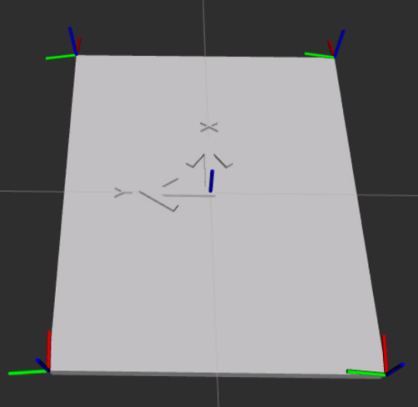
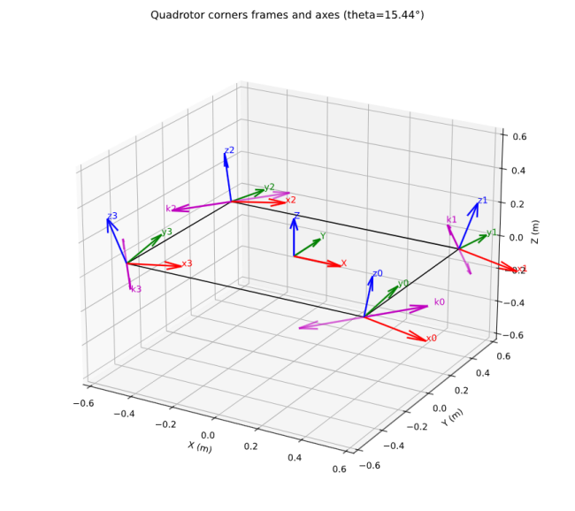
    - 耦合证明
$$\left[\begin{matrix}\begin{matrix}{\text{f}}_{\text{x}} \\ {\text{f}}_{\text{y}} \\ {\text{f}}_{\text{z}}\end{matrix} \\ \begin{matrix}{\text{τ}}_{\text{x}} \\ {\text{τ}}_{\text{y}} \\ {\text{τ}}_{\text{z}}\end{matrix}\end{matrix}\right]\text{=}\left[ \begin{matrix}\begin{matrix}\frac{\text{a}}{\sqrt{{\text{a}}^{\text{2}}\text{+}{\text{b}}^{\text{2}}}}\text{sinθ} \\ \text{−}\frac{\text{b}}{\sqrt{{\text{a}}^{\text{2}}\text{+}{\text{b}}^{\text{2}}}}\text{sinθ} \\ \text{cosθ}\end{matrix} & \begin{matrix}\frac{\text{a}}{\sqrt{{\text{a}}^{\text{2}}\text{+}{\text{b}}^{\text{2}}}}\text{sinθ} \\ \frac{\text{b}}{\sqrt{{\text{a}}^{\text{2}}\text{+}{\text{b}}^{\text{2}}}}\text{sinθ} \\ \text{cosθ}\end{matrix} \\ \begin{matrix}\text{−}\frac{\text{b}}{\text{2}}\text{cosθ+}\frac{{\text{S}}_{\text{0}}\text{k}\text{a}}{\sqrt{{\text{a}}^{\text{2}}\text{+}{\text{b}}^{\text{2}}}}\text{sinθ} \\ \text{−}\frac{\text{a}}{\text{2}}\text{cosθ−}\frac{{\text{S}}_{\text{0}}\text{k}\text{b}}{\sqrt{{\text{a}}^{\text{2}}\text{+}{\text{b}}^{\text{2}}}}\text{sinθ} \\ {\text{S}}_{\text{0}}\text{kcosθ}\end{matrix} & \begin{matrix}\frac{\text{b}}{\text{2}}\text{cosθ+}\frac{{\text{S}}_{\text{1}}\text{k}\text{a}}{\sqrt{{\text{a}}^{\text{2}}\text{+}{\text{b}}^{\text{2}}}}\text{sinθ} \\ \text{−}\frac{\text{a}}{\text{2}}\text{cosθ+}\frac{{\text{S}}_{\text{1}}\text{k}\text{b}}{\sqrt{{\text{a}}^{\text{2}}\text{+}{\text{b}}^{\text{2}}}}\text{sinθ} \\ {\text{S}}_{\text{1}}\text{kcosθ}\end{matrix}\end{matrix} \begin{matrix}\begin{matrix}\text{−}\frac{\text{a}}{\sqrt{{\text{a}}^{\text{2}}\text{+}{\text{b}}^{\text{2}}}}\text{sinθ} \\ \frac{\text{b}}{\sqrt{{\text{a}}^{\text{2}}\text{+}{\text{b}}^{\text{2}}}}\text{sinθ} \\ \text{cosθ}\end{matrix} & \begin{matrix}\text{−}\frac{\text{a}}{\sqrt{{\text{a}}^{\text{2}}\text{+}{\text{b}}^{\text{2}}}}\text{sinθ} \\ \text{−}\frac{\text{b}}{\sqrt{{\text{a}}^{\text{2}}\text{+}{\text{b}}^{\text{2}}}}\text{sinθ} \\ \text{cosθ}\end{matrix} \\ \begin{matrix}\frac{\text{b}}{\text{2}}\text{cosθ−}\frac{{\text{S}}_{\text{2}}\text{k}\text{a}}{\sqrt{{\text{a}}^{\text{2}}\text{+}{\text{b}}^{\text{2}}}}\text{sinθ} \\ \frac{\text{a}}{\text{2}}\text{cosθ+}\frac{{\text{S}}_{\text{2}}\text{k}\text{b}}{\sqrt{{\text{a}}^{\text{2}}\text{+}{\text{b}}^{\text{2}}}}\text{sinθ} \\ {\text{S}}_{\text{2}}\text{kcosθ}\end{matrix} & \begin{matrix}\text{−}\frac{\text{b}}{\text{2}}\text{cosθ−}\frac{{\text{S}}_{\text{3}}\text{k}\text{a}}{\sqrt{{\text{a}}^{\text{2}}\text{+}{\text{b}}^{\text{2}}}}\text{sinθ} \\ \frac{\text{a}}{\text{2}}\text{cosθ−}\frac{{\text{S}}_{\text{3}}\text{k}\text{b}}{\sqrt{{\text{a}}^{\text{2}}\text{+}{\text{b}}^{\text{2}}}}\text{sinθ} \\ {\text{S}}_{\text{3}}\text{kcosθ}\end{matrix}\end{matrix}\right]\left[\begin{matrix}\begin{matrix}\begin{matrix}\begin{matrix}{\text{f}}_{\text{0}} \\ {\text{f}}_{\text{1}}\end{matrix} \\ {\text{f}}_{\text{2}}\end{matrix} \\ {\text{f}}_{\text{3}}\end{matrix}\end{matrix}\right]$$
为了简化，假设旋转顺序为[+1,-1,+1,-1]。
$$\left[\begin{matrix}\begin{matrix}{\text{f}}_{\text{x}} \\ {\text{f}}_{\text{y}} \\ {\text{f}}_{\text{z}}\end{matrix} \\ \begin{matrix}{\text{τ}}_{\text{x}} \\ {\text{τ}}_{\text{y}} \\ {\text{τ}}_{\text{z}}\end{matrix}\end{matrix}\right]\text{=}\left[ \begin{matrix}\begin{matrix}\frac{\text{a}}{\sqrt{{\text{a}}^{\text{2}}\text{+}{\text{b}}^{\text{2}}}}\text{sinθ} \\ \text{−}\frac{\text{b}}{\sqrt{{\text{a}}^{\text{2}}\text{+}{\text{b}}^{\text{2}}}}\text{sinθ} \\ \text{cosθ}\end{matrix} & \begin{matrix}\frac{\text{a}}{\sqrt{{\text{a}}^{\text{2}}\text{+}{\text{b}}^{\text{2}}}}\text{sinθ} \\ \frac{\text{b}}{\sqrt{{\text{a}}^{\text{2}}\text{+}{\text{b}}^{\text{2}}}}\text{sinθ} \\ \text{cosθ}\end{matrix} \\ \begin{matrix}\text{−}\frac{\text{b}}{\text{2}}\text{cosθ+}\frac{\text{k}\text{a}}{\sqrt{{\text{a}}^{\text{2}}\text{+}{\text{b}}^{\text{2}}}}\text{sinθ} \\ \text{−}\frac{\text{a}}{\text{2}}\text{cosθ−}\frac{\text{k}\text{b}}{\sqrt{{\text{a}}^{\text{2}}\text{+}{\text{b}}^{\text{2}}}}\text{sinθ} \\ {\text{S}}_{\text{0}}\text{kcosθ}\end{matrix} & \begin{matrix}\frac{\text{b}}{\text{2}}\text{cosθ−}\frac{\text{k}\text{a}}{\sqrt{{\text{a}}^{\text{2}}\text{+}{\text{b}}^{\text{2}}}}\text{sinθ} \\ \text{−}\frac{\text{a}}{\text{2}}\text{cosθ−}\frac{\text{k}\text{b}}{\sqrt{{\text{a}}^{\text{2}}\text{+}{\text{b}}^{\text{2}}}}\text{sinθ} \\ {\text{S}}_{\text{1}}\text{kcosθ}\end{matrix}\end{matrix} \begin{matrix}\begin{matrix}\text{−}\frac{\text{a}}{\sqrt{{\text{a}}^{\text{2}}\text{+}{\text{b}}^{\text{2}}}}\text{sinθ} \\ \frac{\text{b}}{\sqrt{{\text{a}}^{\text{2}}\text{+}{\text{b}}^{\text{2}}}}\text{sinθ} \\ \text{cosθ}\end{matrix} & \begin{matrix}\text{−}\frac{\text{a}}{\sqrt{{\text{a}}^{\text{2}}\text{+}{\text{b}}^{\text{2}}}}\text{sinθ} \\ \text{−}\frac{\text{b}}{\sqrt{{\text{a}}^{\text{2}}\text{+}{\text{b}}^{\text{2}}}}\text{sinθ} \\ \text{cosθ}\end{matrix} \\ \begin{matrix}\frac{\text{b}}{\text{2}}\text{cosθ−}\frac{\text{k}\text{a}}{\sqrt{{\text{a}}^{\text{2}}\text{+}{\text{b}}^{\text{2}}}}\text{sinθ} \\ \frac{\text{a}}{\text{2}}\text{cosθ+}\frac{\text{k}\text{b}}{\sqrt{{\text{a}}^{\text{2}}\text{+}{\text{b}}^{\text{2}}}}\text{sinθ} \\ {\text{S}}_{\text{2}}\text{kcosθ}\end{matrix} & \begin{matrix}\text{−}\frac{\text{b}}{\text{2}}\text{cosθ+}\frac{\text{k}\text{a}}{\sqrt{{\text{a}}^{\text{2}}\text{+}{\text{b}}^{\text{2}}}}\text{sinθ} \\ \frac{\text{a}}{\text{2}}\text{cosθ+}\frac{\text{k}\text{b}}{\sqrt{{\text{a}}^{\text{2}}\text{+}{\text{b}}^{\text{2}}}}\text{sinθ} \\ {\text{S}}_{\text{3}}\text{kcosθ}\end{matrix}\end{matrix}\right]\left[\begin{matrix}\begin{matrix}\begin{matrix}\begin{matrix}{\text{f}}_{\text{0}} \\ {\text{f}}_{\text{1}}\end{matrix} \\ {\text{f}}_{\text{2}}\end{matrix} \\ {\text{f}}_{\text{3}}\end{matrix}\end{matrix}\right]$$
$$\left[\begin{matrix}\begin{matrix}{\text{f}}_{\text{x}} \\ {\text{f}}_{\text{y}} \\ {\text{f}}_{\text{z}}\end{matrix} \\ \begin{matrix}{\text{τ}}_{\text{x}} \\ {\text{τ}}_{\text{y}} \\ {\text{τ}}_{\text{z}}\end{matrix}\end{matrix}\right]\text{=}\left[ \begin{matrix}\begin{matrix}\frac{\text{a}}{\sqrt{{\text{a}}^{\text{2}}\text{+}{\text{b}}^{\text{2}}}}\text{sinθ} \\ \text{−}\frac{\text{b}}{\sqrt{{\text{a}}^{\text{2}}\text{+}{\text{b}}^{\text{2}}}}\text{sinθ} \\ \text{cosθ}\end{matrix} & \begin{matrix}\frac{\text{a}}{\sqrt{{\text{a}}^{\text{2}}\text{+}{\text{b}}^{\text{2}}}}\text{sinθ} \\ \frac{\text{b}}{\sqrt{{\text{a}}^{\text{2}}\text{+}{\text{b}}^{\text{2}}}}\text{sinθ} \\ \text{cosθ}\end{matrix} \\ \begin{matrix}\text{−}\text{（}\frac{\text{b}}{\text{2}}\text{cosθ−}\frac{\text{k}\text{a}}{\sqrt{{\text{a}}^{\text{2}}\text{+}{\text{b}}^{\text{2}}}}\text{sinθ}\text{）} \\ \text{−}\frac{\text{a}}{\text{2}}\text{cosθ−}\frac{\text{k}\text{b}}{\sqrt{{\text{a}}^{\text{2}}\text{+}{\text{b}}^{\text{2}}}}\text{sinθ} \\ {\text{S}}_{\text{0}}\text{kcosθ}\end{matrix} & \begin{matrix}\frac{\text{b}}{\text{2}}\text{cosθ−}\frac{\text{k}\text{a}}{\sqrt{{\text{a}}^{\text{2}}\text{+}{\text{b}}^{\text{2}}}}\text{sinθ} \\ \text{−}\frac{\text{a}}{\text{2}}\text{cosθ−}\frac{\text{k}\text{b}}{\sqrt{{\text{a}}^{\text{2}}\text{+}{\text{b}}^{\text{2}}}}\text{sinθ} \\ {\text{S}}_{\text{1}}\text{kcosθ}\end{matrix}\end{matrix} \begin{matrix}\begin{matrix}\text{−}\frac{\text{a}}{\sqrt{{\text{a}}^{\text{2}}\text{+}{\text{b}}^{\text{2}}}}\text{sinθ} \\ \frac{\text{b}}{\sqrt{{\text{a}}^{\text{2}}\text{+}{\text{b}}^{\text{2}}}}\text{sinθ} \\ \text{cosθ}\end{matrix} & \begin{matrix}\text{−}\frac{\text{a}}{\sqrt{{\text{a}}^{\text{2}}\text{+}{\text{b}}^{\text{2}}}}\text{sinθ} \\ \text{−}\frac{\text{b}}{\sqrt{{\text{a}}^{\text{2}}\text{+}{\text{b}}^{\text{2}}}}\text{sinθ} \\ \text{cosθ}\end{matrix} \\ \begin{matrix}\frac{\text{b}}{\text{2}}\text{cosθ−}\frac{\text{k}\text{a}}{\sqrt{{\text{a}}^{\text{2}}\text{+}{\text{b}}^{\text{2}}}}\text{sinθ} \\ −(−\frac{\text{a}}{\text{2}}\text{cosθ−}\frac{\text{k}\text{b}}{\sqrt{{\text{a}}^{\text{2}}\text{+}{\text{b}}^{\text{2}}}}\text{sinθ)} \\ {\text{S}}_{\text{2}}\text{kcosθ}\end{matrix} & \begin{matrix}\text{−}\text{（}\frac{\text{b}}{\text{2}}\text{cosθ−}\frac{\text{k}\text{a}}{\sqrt{{\text{a}}^{\text{2}}\text{+}{\text{b}}^{\text{2}}}}\text{sinθ}\text{）} \\ −(−\frac{\text{a}}{\text{2}}\text{cosθ−}\frac{\text{k}\text{b}}{\sqrt{{\text{a}}^{\text{2}}\text{+}{\text{b}}^{\text{2}}}}\text{sinθ)} \\ {\text{S}}_{\text{3}}\text{kcosθ}\end{matrix}\end{matrix}\right]\left[\begin{matrix}\begin{matrix}\begin{matrix}\begin{matrix}{\text{f}}_{\text{0}} \\ {\text{f}}_{\text{1}}\end{matrix} \\ {\text{f}}_{\text{2}}\end{matrix} \\ {\text{f}}_{\text{3}}\end{matrix}\end{matrix}\right]$$
定义 4 个与力和力矩有关的组合量：
$$\begin{matrix}S & =f_{0}+f_{1}+f_{2}+f_{3} \\ D_{x} & =f_{0}+f_{1}−f_{2}−f_{3} \\ D_{y} & =−f_{0}+f_{1}+f_{2}−f_{3} \\ Σ_{s} & =f_{0}−f_{1}+f_{2}−f_{3}\end{matrix}$$
为把矩阵中的几行写成：
$$\begin{matrix} & f_{x}=\frac{a}{\sqrt{a^{2}+b^{2}}}sinθD_{x} \\ & f_{y}=\frac{b}{\sqrt{a^{2}+b^{2}}}sinθD_{y} \\ & f_{z}=cosθS \\ & τ_{z}=kcosθΣ_{s}\end{matrix}$$
对于${\text{τ}}_{\text{x}}$和${\text{τ}}_{\text{y}}$：
$$\begin{matrix} & {\text{τ}}_{\text{x}}=(\frac{\text{b}}{\text{2}}cosθ−\frac{\text{k}\text{a}}{\sqrt{{\text{a}}^{\text{2}}\text{+}{\text{b}}^{\text{2}}}}sinθ)D_{y} \\ & {\text{τ}}_{\text{y}}=(−\frac{\text{a}}{\text{2}}cosθ−\frac{\text{k}\text{b}}{\sqrt{{\text{a}}^{\text{2}}\text{+}{\text{b}}^{\text{2}}}}sinθ)D_{x} \\ & \\ & \end{matrix}$$
所以：
$$\begin{matrix} & {\text{τ}}_{\text{x}}=(\frac{\text{b}}{\text{2}}cosθ−\frac{\text{k}\text{a}}{\sqrt{{\text{a}}^{\text{2}}\text{+}{\text{b}}^{\text{2}}}}sinθ)\frac{\sqrt{a^{2}+b^{2}}}{bsinθ}f_{y} \\ & {\text{τ}}_{\text{y}}=(−\frac{\text{a}}{\text{2}}cosθ−\frac{\text{k}\text{b}}{\sqrt{{\text{a}}^{\text{2}}\text{+}{\text{b}}^{\text{2}}}}sinθ)\frac{\sqrt{a^{2}+b^{2}}}{asinθ}f_{x} \\ & \\ & \end{matrix}$$

  - 长方形模型
    - 动力分配矩阵
令$θ=0$：
$$\left[\begin{matrix}\begin{matrix}f_{x} \\ f_{y} \\ f_{z}\end{matrix} \\ \begin{matrix}τ_{x} \\ τ_{y} \\ τ_{z}\end{matrix}\end{matrix}\right]=\left[ \begin{matrix}\begin{matrix}\frac{a}{\sqrt{a^{2}+b^{2}}}sinθ \\ −\frac{b}{\sqrt{a^{2}+b^{2}}}sinθ \\ cosθ\end{matrix} & \begin{matrix}\frac{a}{\sqrt{a^{2}+b^{2}}}sinθ \\ \frac{b}{\sqrt{a^{2}+b^{2}}}sinθ \\ cosθ\end{matrix} \\ \begin{matrix}−\frac{b}{2}cosθ+\frac{S_{0}ka}{\sqrt{a^{2}+b^{2}}}sinθ \\ −\frac{a}{2}cosθ−\frac{S_{0}kb}{\sqrt{a^{2}+b^{2}}}sinθ \\ S_{0}kcosθ\end{matrix} & \begin{matrix}\frac{b}{2}cosθ+\frac{S_{1}ka}{\sqrt{a^{2}+b^{2}}}sinθ \\ −\frac{a}{2}cosθ+\frac{S_{1}kb}{\sqrt{a^{2}+b^{2}}}sinθ \\ S_{1}kcosθ\end{matrix}\end{matrix} \begin{matrix}\begin{matrix}−\frac{a}{\sqrt{a^{2}+b^{2}}}sinθ \\ \frac{b}{\sqrt{a^{2}+b^{2}}}sinθ \\ cosθ\end{matrix} & \begin{matrix}−\frac{a}{\sqrt{a^{2}+b^{2}}}sinθ \\ −\frac{b}{\sqrt{a^{2}+b^{2}}}sinθ \\ cosθ\end{matrix} \\ \begin{matrix}\frac{b}{2}cosθ−\frac{S_{2}ka}{\sqrt{a^{2}+b^{2}}}sinθ \\ \frac{a}{2}cosθ+\frac{S_{2}kb}{\sqrt{a^{2}+b^{2}}}sinθ \\ S_{2}kcosθ\end{matrix} & \begin{matrix}−\frac{b}{2}cosθ−\frac{S_{3}ka}{\sqrt{a^{2}+b^{2}}}sinθ \\ \frac{a}{2}cosθ−\frac{S_{3}kb}{\sqrt{a^{2}+b^{2}}}sinθ \\ S_{3}kcosθ\end{matrix}\end{matrix}\right]\left[\begin{matrix}\begin{matrix}\begin{matrix}\begin{matrix}f_{0} \\ f_{1}\end{matrix} \\ f_{2}\end{matrix} \\ f_{3}\end{matrix}\end{matrix}\right]$$
$$\left[\begin{matrix}\begin{matrix}f_{x} \\ f_{y} \\ f_{z}\end{matrix} \\ \begin{matrix}τ_{x} \\ τ_{y} \\ τ_{z}\end{matrix}\end{matrix}\right]=\left[ \begin{matrix}\begin{matrix}0 \\ 0 \\ 1\end{matrix} & \begin{matrix}0 \\ 0 \\ 1\end{matrix} \\ \begin{matrix}−\frac{b}{2} \\ −\frac{a}{2} \\ S_{0}k\end{matrix} & \begin{matrix}\frac{b}{2} \\ −\frac{a}{2} \\ S_{1}k\end{matrix}\end{matrix} \begin{matrix}\begin{matrix}0 \\ 0 \\ 1\end{matrix} & \begin{matrix}0 \\ 0 \\ 1\end{matrix} \\ \begin{matrix}\frac{b}{2} \\ \frac{a}{2} \\ S_{2}k\end{matrix} & \begin{matrix}−\frac{b}{2} \\ \frac{a}{2} \\ S_{3}k\end{matrix}\end{matrix}\right]\left[\begin{matrix}\begin{matrix}\begin{matrix}\begin{matrix}f_{0} \\ f_{1}\end{matrix} \\ f_{2}\end{matrix} \\ f_{3}\end{matrix}\end{matrix}\right]$$
$$\left[\begin{matrix}\begin{matrix} \\ \\ f_{z}\end{matrix} \\ \begin{matrix}τ_{x} \\ τ_{y} \\ τ_{z}\end{matrix}\end{matrix}\right]=\left[ \begin{matrix}\begin{matrix} \\ \\ 1\end{matrix} & \begin{matrix} \\ \\ 1\end{matrix} \\ \begin{matrix}−\frac{b}{2} \\ −\frac{a}{2} \\ S_{0}k\end{matrix} & \begin{matrix}\frac{b}{2} \\ −\frac{a}{2} \\ S_{1}k\end{matrix}\end{matrix} \begin{matrix}\begin{matrix} \\ \\ 1\end{matrix} & \begin{matrix} \\ \\ 1\end{matrix} \\ \begin{matrix}\frac{b}{2} \\ \frac{a}{2} \\ S_{2}k\end{matrix} & \begin{matrix}−\frac{b}{2} \\ \frac{a}{2} \\ S_{3}k\end{matrix}\end{matrix}\right]\left[\begin{matrix}\begin{matrix}\begin{matrix}\begin{matrix}f_{0} \\ f_{1}\end{matrix} \\ f_{2}\end{matrix} \\ f_{3}\end{matrix}\end{matrix}\right]$$
平移和姿态耦合。
  - 加2垂直推进器4，5模型
    - 动力分配矩阵
位于4-[l,m,n],5-[l,-m,n]
$$\begin{matrix} & f=\sum_{i=0}^{n−1}{R_{i}{\left[0,0,1\right]}^{T}f_{i}} \\ & τ=\sum_{i=1}^{n−1}{{（r}_{i}}×R_{i}{\left[0,0,1\right]}^{T}+R_{i}{\left[0,0,1\right]}^{T}{S_{i}k）f}_{i}\end{matrix}$$
$$\begin{matrix} & R_{0−3}= I \\ & R_{4−5}= {Rot}_{y}(90)\end{matrix}$$
$$r_{0}={\left[\frac{a}{2},−\frac{b}{2},0\right]}^{T}r_{1}={\left[\frac{a}{2},\frac{b}{2},0\right]}^{T}r_{2}={\left[−\frac{a}{2},\frac{b}{2},0\right]}^{T}r_{3}={\left[−\frac{a}{2},−\frac{b}{2},0\right]}^{T}r_{4}={\left[l,m,n\right]}^{T}r_{5}={\left[l,−m,n\right]}^{T}$$
$$\left[\begin{matrix}f \\ τ\end{matrix}\right]=\left[ \begin{matrix}{\left[0,0,1\right]}^{T} & {\left[0,0,1\right]}^{T} \\ r_{0}×{\left[0,0,1\right]}^{T}+{\left[0,0,1\right]}^{T}S_{0}k & r_{1}×{\left[0,0,1\right]}^{T}+{\left[0,0,1\right]}^{T}S_{1}k\end{matrix} \begin{matrix}{\left[0,0,1\right]}^{T} & {\left[0,0,1\right]}^{T} \\ r_{2}×{\left[0,0,1\right]}^{T}+{\left[0,0,1\right]}^{T}S_{2}k & r_{3}×{\left[0,0,1\right]}^{T}+{\left[0,0,1\right]}^{T}S_{3}k\end{matrix} \begin{matrix}{Rot}_{y}(90){\left[0,0,1\right]}^{T} & {Rot}_{y}(90){\left[0,0,1\right]}^{T} \\ r_{4}×{Rot}_{y}(90){\left[0,0,1\right]}^{T}+{Rot}_{y}(90){\left[0,0,1\right]}^{T}S_{4}k & r_{5}×{Rot}_{y}(90){\left[0,0,1\right]}^{T}+{{Rot}_{y}(90)\left[0,0,1\right]}^{T}S_{5}k\end{matrix}\right]\left[\begin{matrix}\begin{matrix}{\text{f}}_{0} \\ {\text{f}}_{1} \\ {\text{f}}_{2}\end{matrix} \\ \begin{matrix}{\text{f}}_{3} \\ {\text{f}}_{4} \\ {\text{f}}_{5}\end{matrix}\end{matrix}\right]$$
$$M=\left[\begin{matrix}0 & 0 & 0 & 0 & 1 & 1 \\ 0 & 0 & 0 & 0 & 0 & 0 \\ 1 & 1 & 1 & 1 & 0 & 0 \\ −\frac{b}{2} & \frac{b}{2} & \frac{b}{2} & −\frac{b}{2} & S_{4}k & S_{5}k \\ −\frac{a}{2} & −\frac{a}{2} & \frac{a}{2} & \frac{a}{2} & n & n \\ S_{0}k & S_{1}k & S_{2}k & S_{3}k & −m & m\end{matrix}\right]$$
$$\left[\begin{matrix}f_{x} \\ f_{z} \\ τ_{x} \\ τ_{y} \\ τ_{z}\end{matrix}\right]=\left[\begin{matrix}0 & 0 & 0 & 0 & 1 & 1 \\ & & & & & \\ 1 & 1 & 1 & 1 & 0 & 0 \\ −\frac{b}{2} & \frac{b}{2} & \frac{b}{2} & −\frac{b}{2} & S_{4}k & S_{5}k \\ −\frac{a}{2} & −\frac{a}{2} & \frac{a}{2} & \frac{a}{2} & n & n \\ S_{0}k & S_{1}k & S_{2}k & S_{3}k & −m & m\end{matrix}\right]\left[\begin{matrix}f_{0} \\ f_{1} \\ f_{2} \\ f_{3} \\ f_{4} \\ f_{5}\end{matrix}\right]$$

  - SO3控制器
对于机器人位置：
$$F_{b}−F_{floating}+G=F_{d}$$
其中，$F_{b}$为世界系下作用到base_link的力，$F_{floating}$为浮力，$G$为重力，$F_{d}$为世界系下推进器期望的合力。
设计PD+前馈控制律为：
$$\begin{matrix} & e_{p}=x−x_{ref} \\ & e_{v}=v−v_{ref} \\ & F_{d}=−k_{p}e_{p}−k_{d}e_{v}+ma_{ref}−F_{floating}+mge_{z}\end{matrix}$$
对于机器人姿态动力学：
$$\dot{R}=R\hat{w}$$
$$J\dot{w}+w×\left(Jw\right)=τ$$
姿态误差:
$$e_{R}=\frac{1}{2}{\left(R_{d}^{⊤}R−R^{⊤}R_{d}\right)}^{∨}$$
角速度误差:
$$e_{w}=w−R_{d}^{⊤}R_{d}w_{d}$$
控制律:
$$τ=−k_{R}e_{R}−k_{Ω}e_{w}+w×\left(Jw\right)−J\left(\hat{w}R_{d}^{⊤}R_{d}w_{d}−R_{d}^{⊤}R_{d}\dot{w_{d}}\right)$$
所有都在机体坐标系下。

