# Project A: Rocket and Windmill

CS 351

Hao Zhang

hzj943

**Goal:**

The goal of this project is to moving and jointed 3D assemblies with WebGl. I fulfilled this goal by building a windmill and a rocket with four engines, which have four thrusters attached to the wings.

**Instruction:**

W, A, S, D, w, a, s, and D keys control the position of the windmill of the right part of canvas. W, w keys can move it up. S, s keys can move it down. A, a keys can move it left. D, d keys can move it right. Also drag mouse can rotate the windmill.

For the rocket on the left, ‘Pause/Start Rocket’ button can stop or start it moving upwards. ‘Pause/Start Engines’ button can stop or start the rotation of four engines attached to the rockets. ‘Pause/Start Thrusters’ button can stop or start the rotation of fours thrusters attached to the wings of four engines.

The flex angle of rocket is also user adjustable. Simply inputting the start angle and stop angle, the rocket will tilt between that range. Or user can just stop the tilting and reset it to straight by click ‘pause/resume tilting’ button, which can also start tilting.

**Results:**

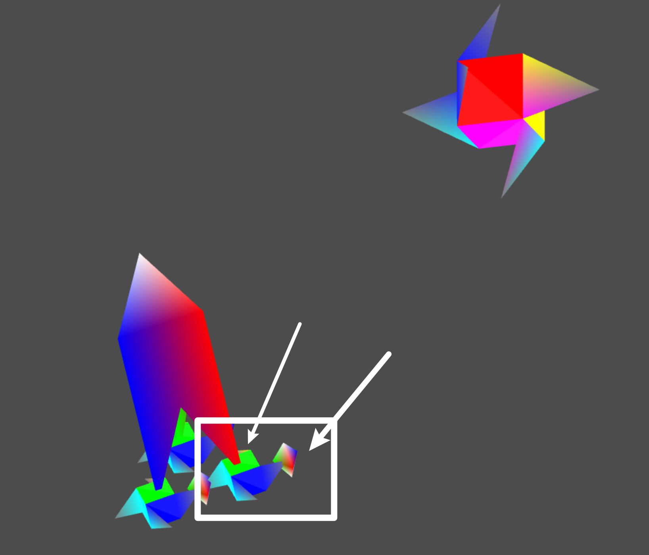

Figure 1 A rocket engine with a thruster.

The rocket is composited by its head, body, and three engines, each one of which has a attached thruster.

Figure 2 Rocket Flying out of the canvas.

The rocket fly from out of the canvas in the bottom to the top. Figure 2 shows when the rocket is about to fly out of the canvas to the top.

Figure 3 Rocket tilting within user adjustable flex angles.

The rocket can tilt within user adjustable angle range. Figure 3 shows rocket tilts to a user defined value and was about to tilt backwards.

Figure 4 Move windmill with keyboard and rotate it with mouse.

The windmill can be moved within in the canvas by press W, A, S, D, w, a, s, and D keys. Also, it can be rotated by dragging mouse. Figure 4 shows the windmill was moved to a position and rotated.