# （一）网页及其代码

## 一、酷狗首页

1、网页效果截屏

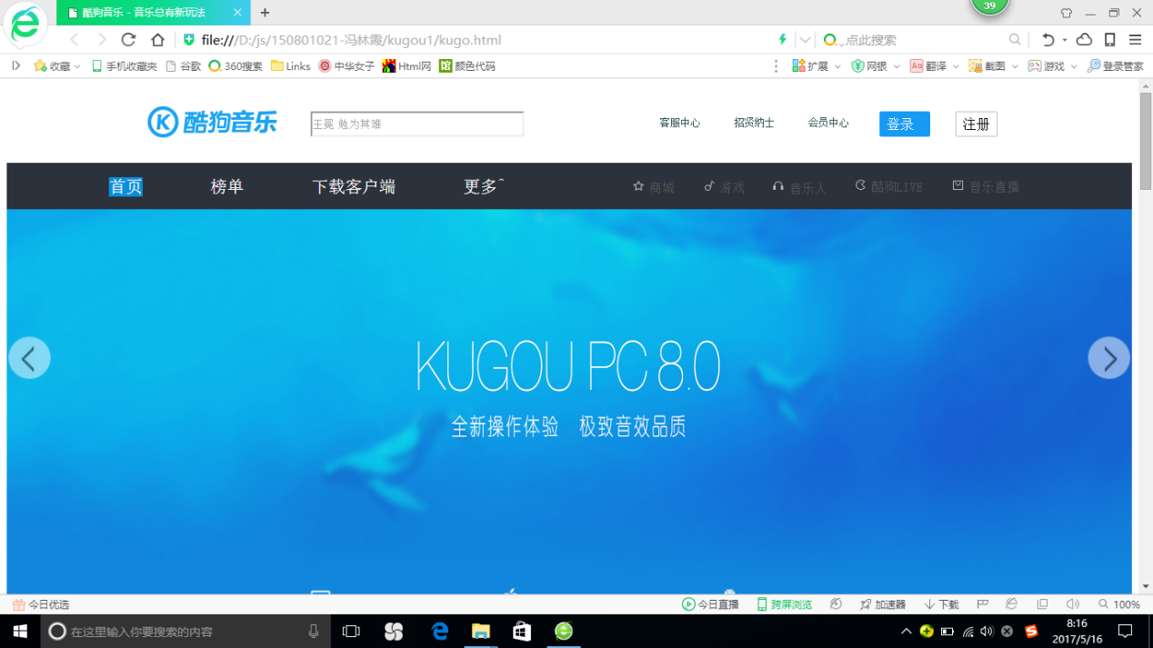

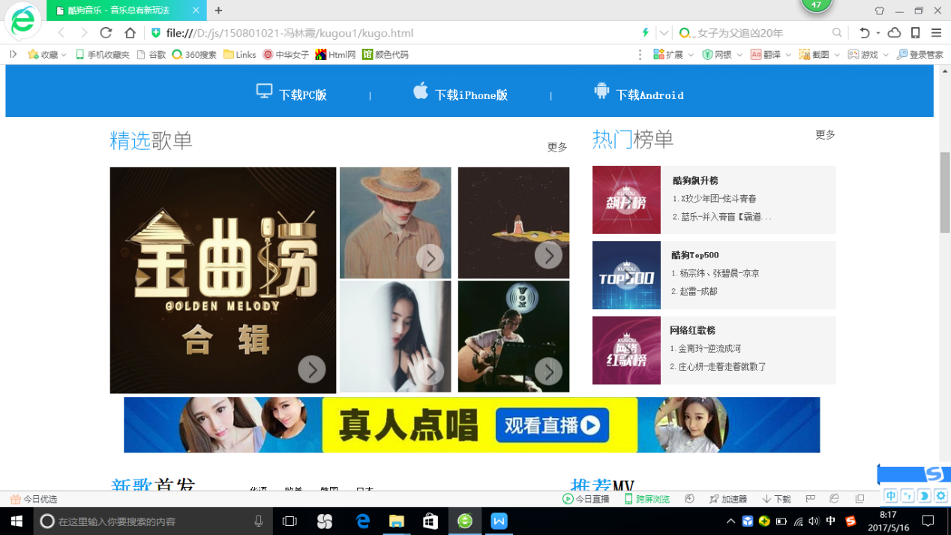

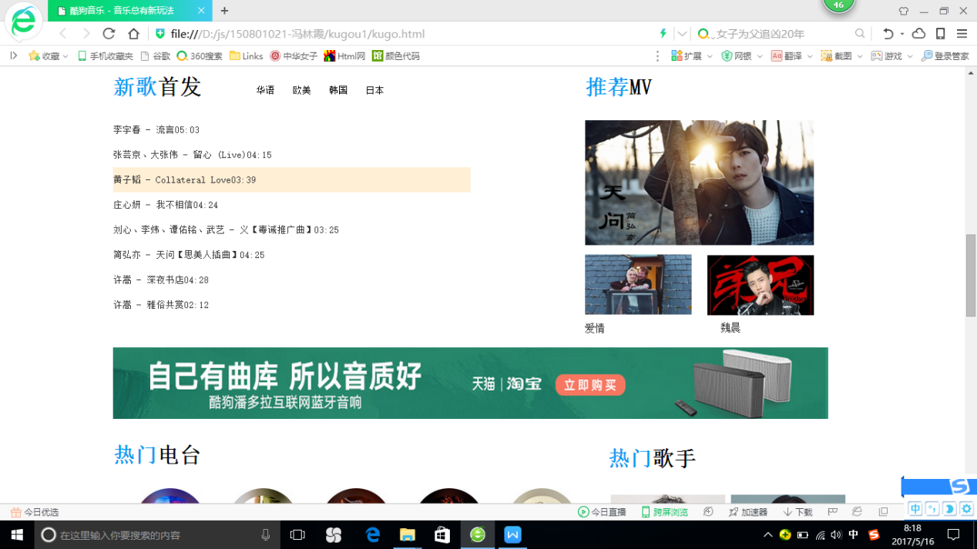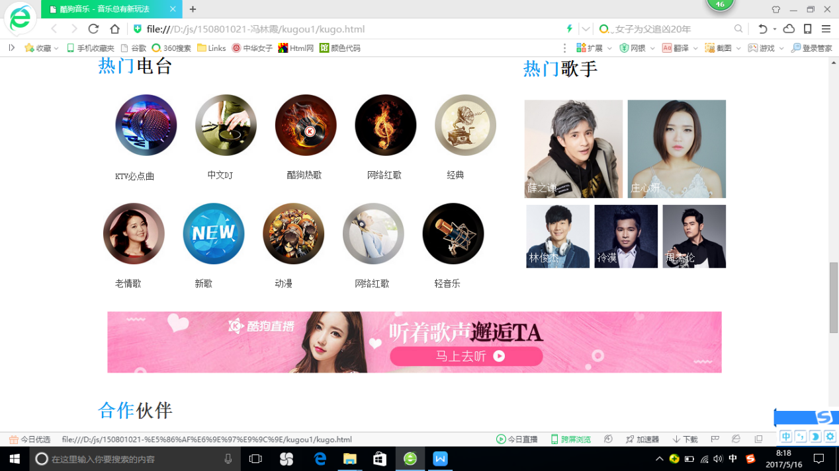

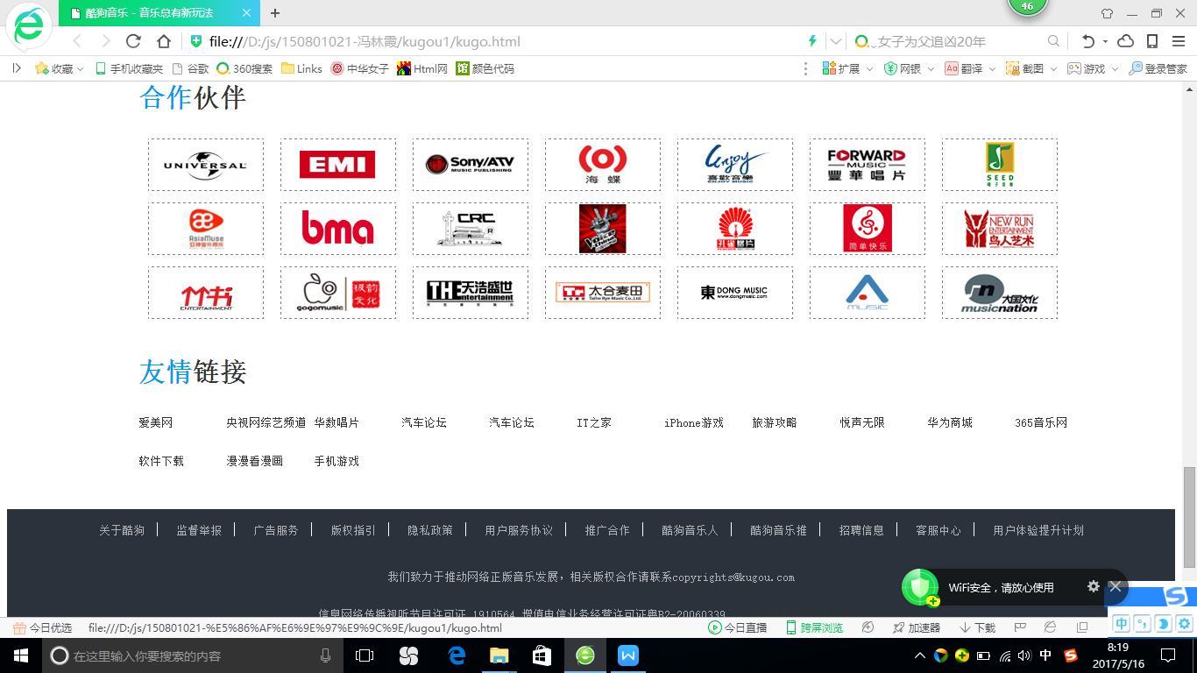

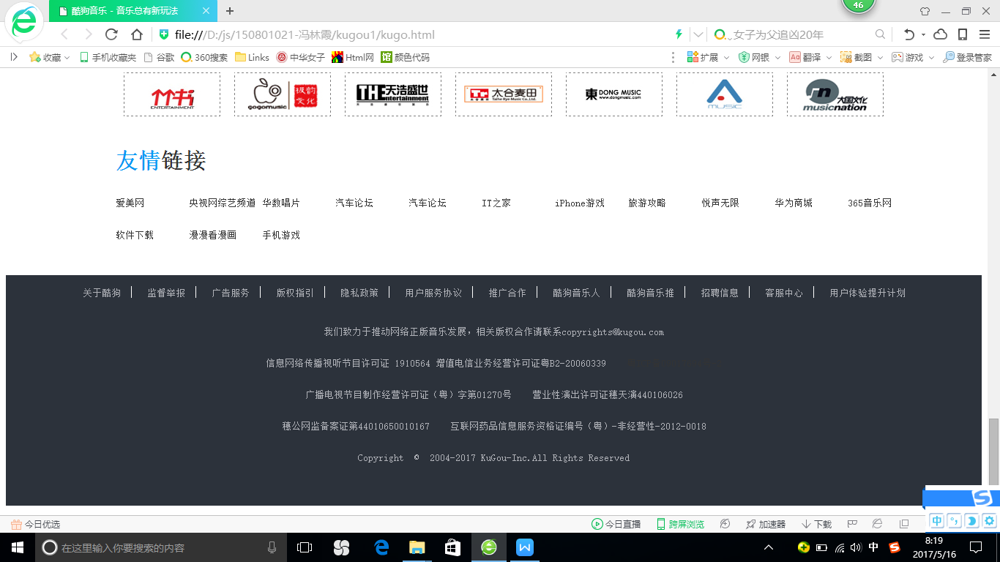

1. 首页代码
2. CSS样式

.main{width: 100%;

min-width: 1000px;

margin: 0 auto;

position: relative;

}

.dh:hover,.rm li:hover,#m2:hover{

color:rgb(22,154,243);

}

#m2{

float:right;

display: block;

width: 48px;

height: 28px;

line-height: 28px;

border: 1px solid #C0C0C0;

border-radius: 2px;

text-align: center;

}

#m1{

float:right;

display: block;

width: 48px;

height: 28px;

line-height: 28px;

border: 1px solid #169af3;

border-radius: 2px;

text-align: center;

color: #fff;

background-color: #169af3;

padding-right: 10px;

}

#search { background:url(images/ss.png) no-repeat center right #FFFFFF;

height:24px;

width:249px;

line-height: 24px;

color: #666;

}

.h{

float:left;

margin-left: 160px;

}

.wenben{

margin-left: 300px;

margin-top: 30px;

}

.header{

height:90px;

width: 100%;

border:1px solid #fff;

}

.nav li{

float:left;

font-size: 10px;

color:#2F4F4F;

}

.dh{

margin-left:40px;

}

.mid{

height:50px;

width: 340px;

float:right;

margin-right: 300px;

margin-top: -40px;

}

#submit{

height:40px;

width: 80px;

float:right;

margin-right: -400px;

margin-top: -30px;

}

#submit2{

height:40px;

width: 80px;

float:right;

margin-right: -480px;

margin-top: -30px;

}

.head1 {

position: relative;

z-index: 999;

width: 100%;

height: 55px;

background-color: #2c323b;

text-align: center;

}

.lm li{

float:left;

text-align:center;

list-style:none;

font-size:20px;

margin-left:80px;

}

.lm a{

color:#ccc;

text-decoration:none;

border-right:1px solid #ccc;

padding:0px 15px;

}

.lm li:hover{

background:#0c8ed9;

text-decoration:none;

color:#ccc;

}

.lm{

border:1px solid #2c323b;

height:50px;

width:600px;

color:#fff;

}

.xiala li{

display:block;

float:left;

padding:5px 2px;

text-align:center;

width:60px;

height:30px;

background-color:#2c323b;

margin: 0;

padding:0;

display:inline;

}

.xiala li:hover{

color:#999;

}

.xiala{

position:absolute;

margin:-1000px;

}

ul li:hover .xiala{

margin:auto;

display: block;

}

.rm li{

list-style:none;

float:left;

text-align:center;

float:right;

font-size: 15px;

margin-left:30px;

color:#545454 ;

}

.rm{

height:50px;

width:700px;

margin-left: 500px;

color:#fff;

margin-top: -200px;

}

#sy{

background:#0c8ed9;

}

#second{

height:300px;

width:100px;

border:1px solid #fff;

}

#bg1 {

width: 100%;

height: 500px;

}

#bg2 {

width: 100%;

height: 500px;

}

#bg3 {

width: 100%;

height: 500px;

}

#bg4 {

width: 100%;

height: 500px;

}

#bg2,#bg3,#bg4{

display:none;

}

#mid1{

width:50px;

height:50px;

position:absolute;

top:50%;

left:10px;

}

#mid2{width:50px;

height:50px;

position:absolute;

top:50%;

right:10px;

}

#download{

width:100%;

height:70px;

text-align: center;

margin-top: -72px;

}

#part3{

margin-top: 18px;

}

.c1{

margin-right: 50px;

color:#fff;

font-weight:bold

}

.c2{

color:#fff;

font-weight:bold

}

.x{

font-size: 3px;

color:#fff;

margin-right: 50px;

}

#top1{

margin-left: 200px;

}

#mm{

margin-bottom: 20px;

}

#more{

margin-left:500px;

color:#545454;

font-size: 15px;

}

#more2{

float:right;

margin-top: 20px;

color:#545454;

font-size: 15px;

}

#h1{

margin-left: 150px;

}

#h2{

margin-left: 0px;

margin-top: 20px;

margin-bottom: 20px;}

#max{

margin-left: 150px;

float:left;

width:330px;

height:330px;

}

#small{

width:350px;

height:330px;

margin-left: 460px;

}

#left1{

width:325px;

height:325px;

}

#i1{

width:160px;

height:160px;

}

#i2{

float:right;

width:160px;

height:160px;

}

#i3{

width:160px;

height:160px;

}

#i4{

float:right;

margin-top: -326px;

width:160px;

height:160px;

}

#right{

width:350px;

height:400px;

float:right;

margin-top: -405px;

margin-right: 140px;

}

#php1{

width:100%;

height:98px;

background: #F5F5F5;

}

#r1{

width:98px;

height:98px;

}

#php2{

width:100%;

height:98px;

background: #F5F5F5;

margin-top: 10px;

}

#r2{

width:98px;

height:98px;

}

#php3{

width:100%;

height:98px;

background: #F5F5F5;

margin-top: 10px;

}

#r3{

width:98px;

height:98px;

}

#right2{

float:right;

margin-top: -95px;

margin-right: 90px;

}

#right3{

clear:both;

float:right;

margin-top: -96px;

margin-right: 110px;

}

#right4{

clear:both;

float:right;

margin-top: -96px;

margin-right: 100px;

}

#h11{

font-size: 12px;

color:#333;

}

#p11{

font-size: 12px;

color:#555;

}

#theLast{

margin-left: 170px;

}

#bofang5,#bofang1,#bofang2,#bofang3,#bofang4,#bofang6,#bofang7,#bofang8{width:40px;height:40px;position:absolute;z-index:1;}

#bofang5{margin-top: 270px;margin-left: 270px;}

#bofang1,#bofang3{margin-top: 110px;margin-left: 110px;}

#bofang2{margin-top: 110px;margin-left: 280px;}

#bofang4{margin-top: -220px;margin-left: 280px;}

#bofang6,#bofang7,#bofang8{margin-top: 30px;margin-left: 30px;}

#xinge{padding-left: 150px;padding-right: 150px;}

#shou{float:left;}

#shou h3{font-size: 30px;}

#shou h3 span,#reMen h3 span{color: #009af3;}

#fa1{position:relative;left: 200px;top:-50px;font-size: 14px;margin-right: 20px;}

#fa1 span{font-size: 13px;margin-right: 18px;}

#fa1 span:hover{color:rgb(22,154,243);}

#fatu{margin-top: -370px;margin-left: 660px;}

#tu3{float: right;margin-top: -86px;}

#tu2{margin-top: 10px;}

#tuW2{margin-top:8px;font-size: 14px;}

#tuW3{margin-top:-17px;margin-left: 190px;font-size: 14px;}

#song ul li{height: 35px;width:500px;list-style: none;line-height: 35px;font-size: 13px;}

#song ul li:hover{background: #FFEFD5;}

a{text-decoration:none;color:#333;}

#song ul{margin-left: -40px;margin-top: -20px;}

.pict3{clear:both;padding-top: 20px;}

#reMen{padding:0px;margin:0px;padding-left: 150px;}

#reMen h3{font-size: 30px;}

#leibie ul{margin-left: -30px;}

#leibie ul li{list-style: none;}

#shang li{float:left; margin-right: 30px;}

#xia li{float:left;margin-right: 30px;}

#leibie ul li a{width: 100px;text-align: center;line-height: 20px;font-size: 14px;color:#333;margin-left:20px; }

#leibie ul li a:hover{color:#009af3;}

#songer{float:right;position: absolute;top:1660px;left:810px;}

#songer h3{font-size: 30px;padding-left: 40px;}

#songer h3 span{color:#009af3;}

#son1,#son2{float:right;padding:4px;}

#son3,#son4,#son5{float:right;padding:4px;margin-top: -50px;}

.sonWen1{position: relative;top:-45px;left:5px;color: white;}

#songer ul li{list-style: none;}

.pict4{text-align: center;line-height: 260px;}

#hezuo h3{font-size: 30px;}

#hezuo h3 span{color:#009af3;}

#hezuo{position:relative;margin-left: 150px;margin-top: -110px;}

#huo img{margin-bottom: 10px;margin-left:11px;border: 1px dashed gray;}

#you h3{color:#333;font-size: 30px;}

#you h3 span{color:#009af3;}

#you{padding-left:150px;}

#lian ul li{list-style: none;float:left;width: 140px;height: 24px;line-height: 24px;margin-bottom: 20px;color: #555;font-size:13px;margin-left: -40px;}

#lian a:hover{color: #009af3;}

#links a{color: #b1b3b9;font-size: 13px;padding-right:10px;padding: 10px;text-align: center;line-height: 50px;}

#links span{color:white;}

#links a:hover{color: #009af3;}

#links{margin-top: -100px;}

.footWen p{color: #b1b3b9;font-size: 13px;line-height: 30px;text-align: center;color: #b1b3b9;}

#footerWrapper{background-color: #2c323b;margin-top: 240px;}

.thelast{padding-bottom: 50px;}

（2）HTML代码

<!doctype html>

<html lang="en">

<head>

<meta charset="UTF-8">

<title>酷狗音乐 - 音乐总有新玩法</title>

<link href="css/main.css" rel="stylesheet" />

</head>

<body>

<div class="main">

<!--header开始-->

<div class="header">

<h1 class="h">

<img src="images/logo.png" alt="" />

</h1>

<div >

<div class="wenben">

<input id="search" placeholder="王冕 勉为其难" type="text">

</div>

</div>

<div class="mid">

<ul class="nav" type="none">

<li class="dh">客服中心</li>

<li class="dh">招贤纳士</li>

<li class="dh">会员中心</li>

</ul>

</div>

<div id="submit">

<div id="m1">登录</div>

</div>

<div id="submit2">

<div id="m2">注册</div>

</div>

</div>

<!--header结束-->

<!--搜索1开始-->

<div class="head1">

<div>

<div class="lm">

<ul>

<li id="sy">首页</li>

<li id="sy1">榜单</li>

<li id="sy2">下载客户端</li>

<li id="sy3">更多^

<ul class="xiala">

<li>电台</li>

<br><li>MV</li></br>

<li>歌手</li>

<br><li>歌单</li></br>

</ul></li>

</ul>

</div>

<!--二级菜单-->

<div class="rm">

<ul>

<li><img src="images/t11.png" alt="" />音乐直播</li>

<li><img src="images/t22.jpg" alt="" />酷狗LIVE</li>

<li><img src="images/t33.png" alt="" />音乐人</li>

<li><img src="images/t44.png" alt="" />游戏</li>

<li><img src="images/t55.png" alt="" />商城</li>

</ul>

</div>

</div>

</div>

</div>

<!--搜索1结束-->

<!--背景图开始-->

<div>

<img id="bg1" src="images/bg01.jpg" alt="" />

<img id="bg2" src="images/bg02.jpg" alt="" />

<img id="bg3" src="images/bg03.jpg" alt="" />

<img id="bg4" src="images/bg04.jpg" alt="" />

<img src="images/1.png" id="mid2" onclick="forward()">

<img src="images/2.png" id="mid1" onclick="back()">

</div>

<!--背景图结束-->

<!--菜单2开始-->

<div id="download">

<div id="part3">

<img src="images/pc.png" alt="" />

<span class="c1">下载PC版</span>

<span class="x">|</span>

<img src="images/mac.png" alt="" />

<span class="c1">下载iPhone版</span>

<span class="x">|</span>

<img src="images/andriod.png" alt="" />

<span class="c2">下载Android</span>

</div>

</div>

<!--菜单2结束-->

<div id="three">

<!--左侧歌单开始-->

<div id="left">

<div id="mm">

<img id="h1" src="images/selectlist.jpg" alt="" />

<span id="more">更多</span>

</div>

<div id="bottom1" >

<div id="max">

<div id="bf"onmouseover="display(this)" onmouseout="disappear(this)">

<img id="bofang5" src="images/1.png" alt="" />

<img id="left1" src="images/left.jpg" alt="" />

</div>

</div>

<div id="small">

<div id="bf"onmouseover="display(this)" onmouseout="disappear(this)">

<img id="bofang1" src="images/1.png" alt="" />

<img id="i1" src="images/as01.jpg" alt="" />

</div>

<div id="bf"onmouseover="display(this)" onmouseout="disappear(this)">

<img id="bofang2" src="images/1.png" alt="" />

<img id="i2" src="images/as02.jpg" alt="" />

</div>

<div id="bf"onmouseover="display(this)" onmouseout="disappear(this)">

<img id="bofang3" src="images/1.png" alt="" />

<img id="i3" src="images/as03.jpg" alt="" />

</div>

<div id="bf"onmouseover="display(this)" onmouseout="disappear(this)">

<img id="bofang4" src="images/1.png" alt="" />

<img id="i4" src="images/as04.jpg" alt="" />

</div>

</div>

</div>

</div>

<!--左侧歌单结束-->

<!--右侧歌单开始-->

<div id="right">

<div id="top2">

<img id="h2" src="images/hotlist.jpg" alt="" />

<span id="more2">更多</span>

</div>

<div id="bottom2">

<div id="php1">

<div id="left2">

<div id="bf"onmouseover="display(this)" onmouseout="disappear(this)">

<img id="bofang6" src="images/1.png" alt="" />

<img id="r1" src="images/right01.jpg" alt="" />

</div>

</div>

<div id="right2">

<h1 id="h11">酷狗飙升榜</h1>

<p id="p11">1.X玖少年团-炫斗青春</p>

<p id="p11">2.蓝乐-并入膏盲【霸道...</p>

</div>

</div>

<div id="php2">

<div id="left3">

<div id="bf"onmouseover="display(this)" onmouseout="disappear(this)">

<img id="bofang7" src="images/1.png" alt="" />

<img id="r2" src="images/right02.jpg" alt="" />

</div>

</div>

<div id="right3">

<h1 id="h11">酷狗Top500</h1>

<p id="p11">1.杨宗纬、张碧晨-凉凉</p>

<p id="p11">2.赵雷-成都</p>

</div>

</div>

<div id="php3">

<div id="left4">

<div id="bf"onmouseover="display(this)" onmouseout="disappear(this)">

<img id="bofang8" src="images/1.png" alt="" />

<img id="r3" src="images/right03.jpg" alt="" />

</div>

</div>

<div id="right4">

<h1 id="h11">网络红歌榜</h1>

<p id="p11">1.金南玲-逆流成河</p>

<p id="p11">2.庄心妍-走着走着就散了</p>

</div>

</div>

</div>

</div>

<!--右侧歌单结束-->

</div>

</div>

<div>

<img id="theLast" src="images/last.jpg" alt="" height:"80px" width:"1000px" />

</div>

<div id="xinge">

<div id="shou">

<h3><span>新歌</span>首发</h3>

<div id="fa1">

<span>华语</span>

<span>欧美</span>

<span>韩国</span>

<span>日本</span>

</div>

<div id="song">

<ul>

<li><a href="#">李宇春 - 流言<span>05:03</span></a></li>

<li><a href="#">张芸京、大张伟 - 留心 (Live)<span>04:15</span></a></li>

<li><a href="#">黄子韬 - Collateral Love<span>03:39</span></a></li>

<li><a href="#">庄心妍 - 我不相信<span>04:24</span></a></li>

<li><a href="#">刘心、李炜、谭佑铭、武艺 - 义【毒诫推广曲】<span>03:25</span></a></li>

<li><a href="#">简弘亦 - 天问【思美人插曲】<span>04:25</span></a></li>

<li><a href="#">许嵩 - 深夜书店<span>04:28</span></a></li>

<li><a href="#">许嵩 - 雅俗共赏<span>02:12</span></a></li>

</ul>

<div id="fatu">

<h3><span>推荐</span>MV</h3>

<div><a href="#"><img src="images/32.jpg" width="320" height="175" </a></div>

<div id="tu2"><a href="#"><img src="images/33.jpg" height="84"; </a></div>

<div id="tu3"><a href="#"><img src="images/34.jpg" height="84" </a></div>

<div id="tuW2">爱情</div>

<div id="tuW3">魏晨</div>

<div class="kong2"></div>

</div>

</div>

</div>

<div class="pict3"><a href="#"><img src="images/31.jpg" width="1000" height="100" /></a></div>

</div>

<div id="main1">

<div id="reMen">

<h3><span>热门</span>电台</h3>

<div id="leibie">

<ul id="shang">

<li><a href="#"><img src="images/35.jpg" width="100" height="100" alt="" /></a><br></br><a href="#">KTV必点曲</a></li>

<li><img src="images/36.jpg" width="100" height="100" alt="" /><br></br><a href="#">中文DJ</a></li>

<li><img src="images/37.jpg" width="100" height="100" alt="" /><br></br><a href="#">酷狗热歌</a></li>

<li><img src="images/38.jpg" width="100" height="100" alt="" /><br></br><a href="#">网络红歌</a></li>

<li><img src="images/39.jpg" width="100" height="100" alt="" /><br></br><a href="#">经典</a></li>

</ul>

<br style="clear:both"></br>

<ul id="xia">

<li><img src="images/40.jpg" width="100" height="100" alt="" /><br></br><a href="#">老情歌</a></li>

<li><img src="images/41.jpg" width="100" height="100" alt="" /><br></br><a href="#">新歌</a></li>

<li><img src="images/42.jpg" width="100" height="100" alt="" /><br></br><a href="#">动漫</a></li>

<li><img src="images/43.jpg" width="100" height="100" alt="" /><br></br><a href="#">网络红歌</a></li>

<li><img src="images/44.jpg" width="100" height="100" alt="" /><br></br><a href="#">轻音乐</a></li>

</ul>

</div>

<div id="songer">

<h3><span>热门</span>歌手</h3>

<ul id="son">

<li id="son1"><a href=""><img width="160" height="160" src="images/45.jpg"</a><p class="sonWen1">庄心妍</p></li>

<li id="son2"><a href=""><img width="160" height="160" src="images/46.jpg"</a><p class="sonWen1">薛之谦</p></li>

</ul>

<ul id="son11">

<li id="son3"><a href=""><img width="103" height="103" src="images/47.jpg"</a><p class="sonWen1">周杰伦</p></li>

<li id="son4"><a href=""><img width="103" height="103" src="images/48.jpg"</a><p class="sonWen1">冷漠</p></li>

<li id="son5"><a href=""><img width="103" height="103" src="images/49.jpg"</a><p class="sonWen1">林俊杰</p></li>

</ul>

</div>

</div>

<div class="kong2"></div>

<div class="pict4"><img src="images/51.jpg" width="1000" height="100" /></div>

<div id="hezuo">

<h3><span>合作</span>伙伴</h3>

<div id="huo">

<a href=""><img src="images/p01.jpg"</a>

<a href=""><img src="images/p02.jpg"</a>

<a href=""><img src="images/p03.jpg"</a>

<a href=""><img src="images/p04.jpg"</a>

<a href=""><img src="images/p05.jpg"</a>

<a href=""><img src="images/p06.jpg"</a>

<a href=""><img src="images/p07.jpg"</a>

<a href=""><img src="images/p08.jpg"</a>

<a href=""><img src="images/p09.jpg"</a>

<a href=""><img src="images/p10.jpg"</a>

<a href=""><img src="images/p11.jpg"</a>

<a href=""><img src="images/p12.jpg"</a>

<a href=""><img src="images/p13.jpg"</a>

<a href=""><img src="images/p14.jpg"</a>

<a href=""><img src="images/p15.jpg"</a>

<a href=""><img src="images/p16.jpg"</a>

<a href=""><img src="images/p17.jpg"</a>

<a href=""><img src="images/p18.jpg"</a>

<a href=""><img src="images/p19.jpg"</a>

<a href=""><img src="images/p20.jpg"</a>

<a href=""><img src="images/p21.jpg"</a>

</div>

</div>

<div id="you">

<h3><span>友情</span>链接</h3>

<div id="lian">

<ul>

<li><a href="#">爱美网</a></li>

<li><a href="#">央视网综艺频道</a></li>

<li><a href="#">华数唱片</a></li>

<li><a href="#">汽车论坛</a></li>

<li><a href="#">汽车论坛</a></li>

<li><a href="#">IT之家</a></li>

<li><a href="#">iPhone游戏</a></li>

<li><a href="#">旅游攻略</a></li>

<li><a href="#">悦声无限</a></li>

<li><a href="#">华为商城</a></li>

<li><a href="#">365音乐网</a></li>

<li><a href="#">软件下载</a></li>

<li><a href="#">漫漫看漫画</a></li>

<li><a href="#">手机游戏</a></li>

</ul>

</div>

<div class="kong3"></div>

</div>

</div>

<div id="footerWrapper">

<div id="footer">

<center>

<div id="links">

<a href="#">关于酷狗</a><span>|</span>

<a href="#">监督举报</a><span>|</span>

<a href="#">广告服务</a><span>|</span>

<a href="#">版权指引</a><span>|</span>

<a href="#">隐私政策</a><span>|</span>

<a href="#">用户服务协议</a><span>|</span>

<a href="#">推广合作</a><span>|</span>

<a href="#">酷狗音乐人</a><span>|</span>

<a href="#">酷狗音乐推</a><span>|</span>

<a href="#">招聘信息</a><span>|</span>

<a href="#">客服中心</a><span>|</span>

<a href="#">用户体验提升计划</a>

</div>

<div class="footWen">

<p>我们致力于推动网络正版音乐发展，相关版权合作请联系copyrights@kugou.com</p>

<p>信息网络传播视听节目许可证 1910564 增值电信业务经营许可证粤B2-20060339 &nbsp;&nbsp;&nbsp;<a href="">粤ICP备09017694号-2</a></p>

<p>广播电视节目制作经营许可证（粤）字第01270号&nbsp;&nbsp;&nbsp;&nbsp;营业性演出许可证穗天演440106026</p>

<p>穗公网监备案证第44010650010167&nbsp;&nbsp;&nbsp;&nbsp;互联网药品信息服务资格证编号（粤）-非经营性-2012-0018</p>

<p class="thelast">Copyright&nbsp;&nbsp;&copy;&nbsp;&nbsp;2004-2017 KuGou-Inc.All Rights Reserved</p>

</div>

</center>

</div>

</div>

</body>

</html>

<script>

var m=2;

function forward(){

for(var i=1;i<=4;i++){

var img = document.getElementById("bg"+i);

if(i == m){

img.style.display = "block";

}else{

img.style.display = "none";

}

}

m++;

if(m==5){

m=1;

}

}

var n=4;

function back(){

for(var i=1;i<5;i++){

var img = document.getElementById("bg"+i);

if(i == n){

img.style.display = "block";

}else{

img.style.display = "none";

}

}

n--;

if(n==0){

n=4;

}

}

</script>

## 二、列表页

1. 网页效果截屏

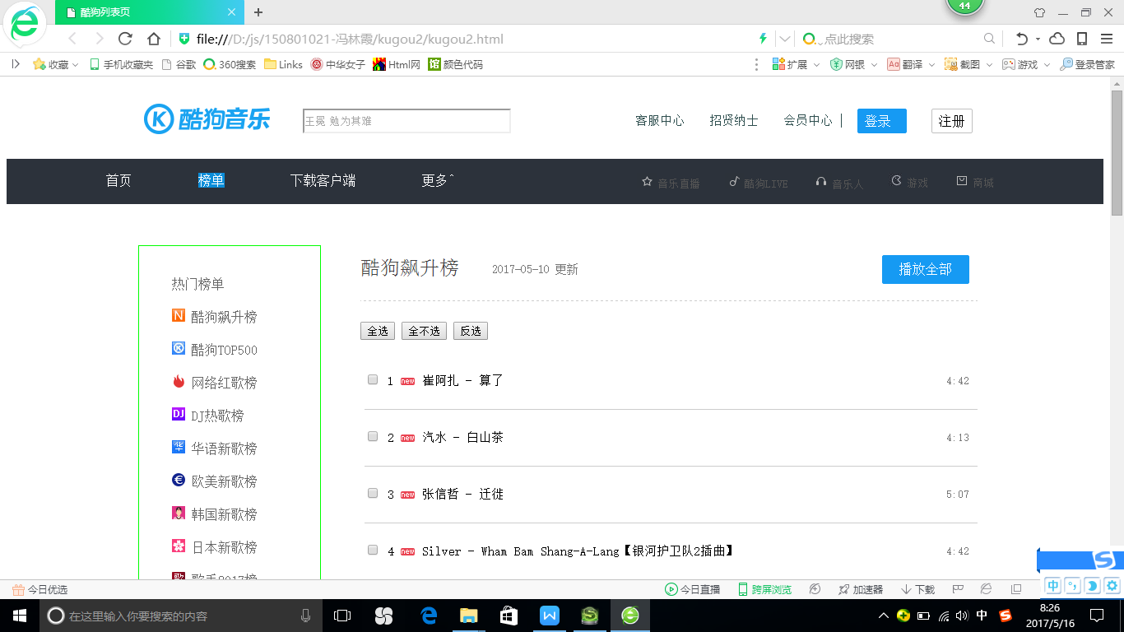

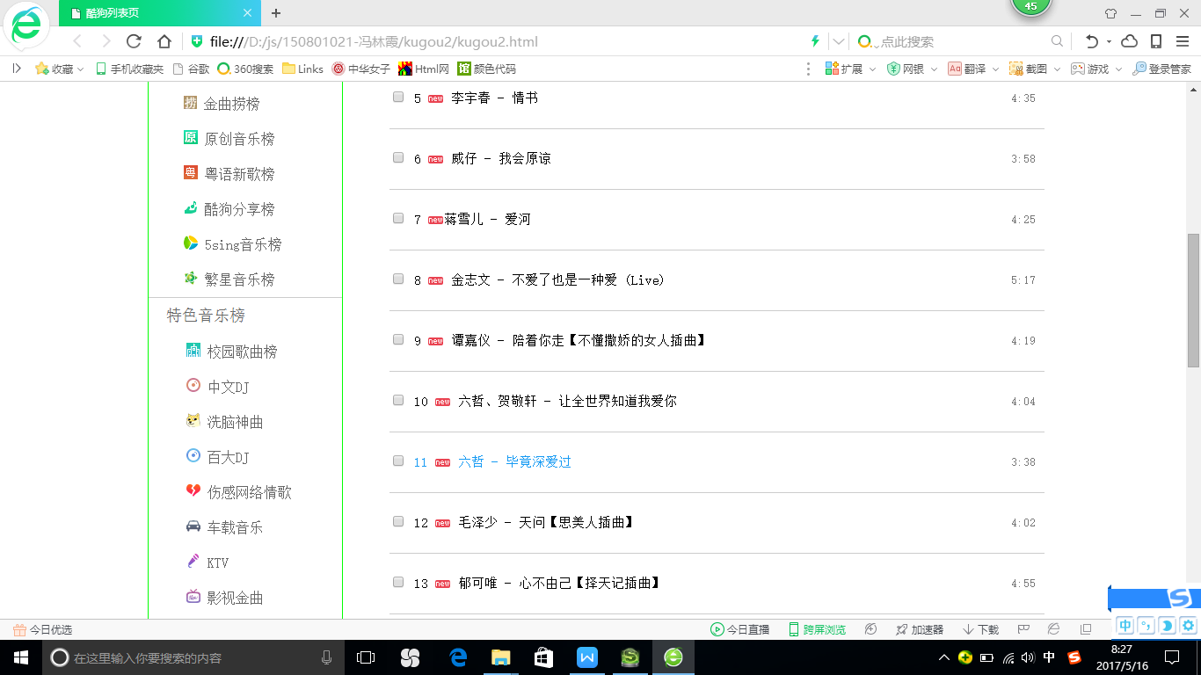

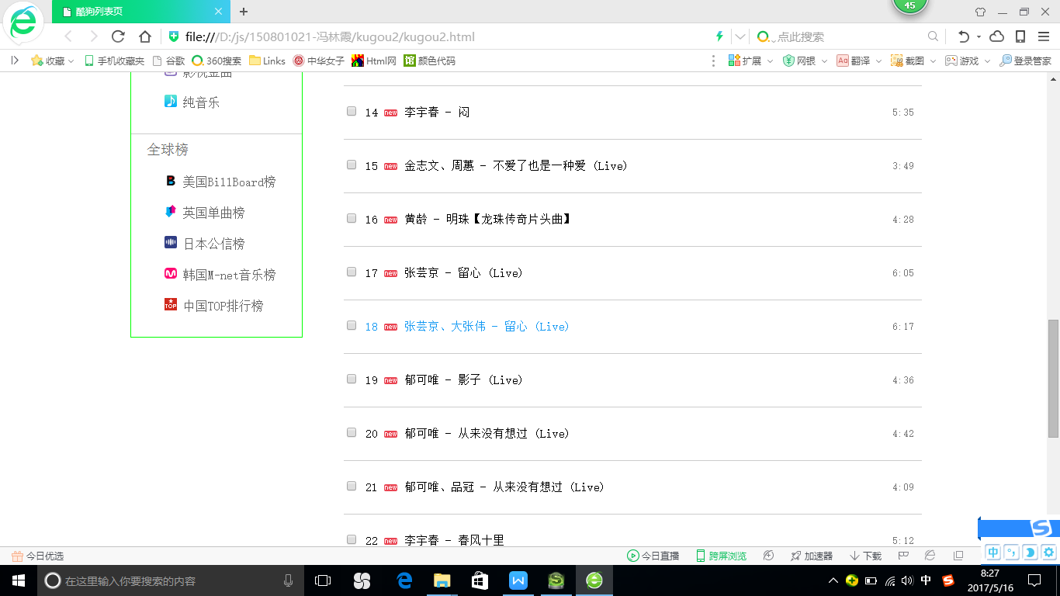

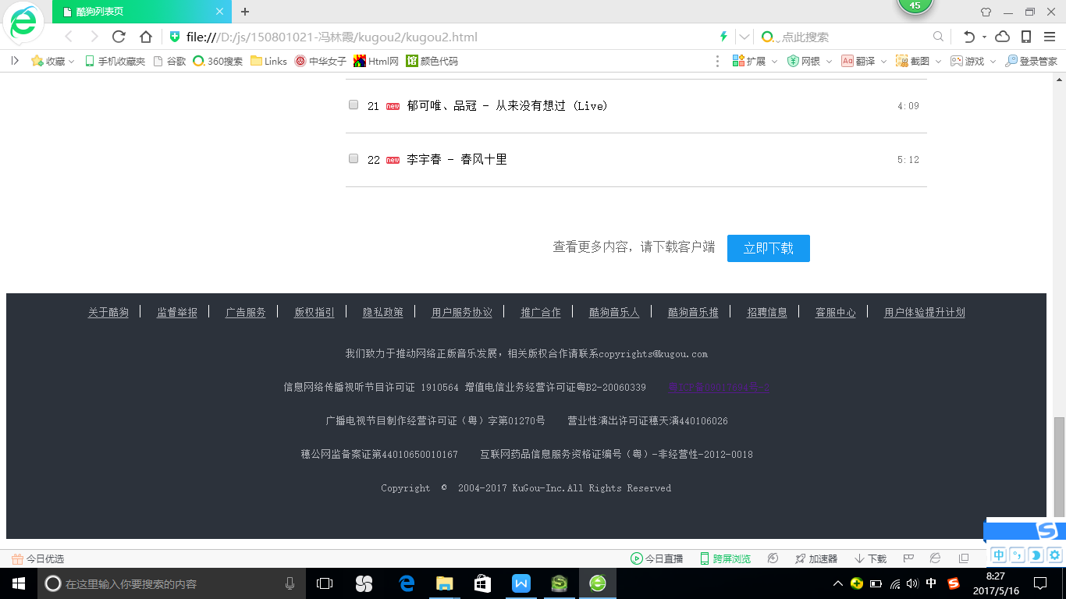

1. 网页代码
2. CSS样式

.main{width: 100%;min-width: 1000px;margin: 0 auto;position: relative;}

#m2{

float:right;

display: block;

width: 48px;

height: 28px;

line-height: 28px;

border: 1px solid #C0C0C0;

border-radius: 2px;

text-align: center;

}

#m1{

float:right;

display: block;

width: 48px;

height: 28px;

line-height: 28px;

border: 1px solid #169af3;

border-radius: 2px;

text-align: center;

color: #fff;

background-color: #169af3;

padding-right: 10px;

}

#search {

background:url(images/ss.png) no-repeat center right #FFFFFF;

height:24px;

width:249px;

line-height: 24px;

color: #666;

}

.h{

float:left;

margin-left: 160px;

}

.wenben{

margin-left: 300px;

margin-top: 30px;

}

.header{

height:90px;

width: 100%;

border:1px solid #fff;

}

.nav li{

float:left;

font-size: 10px;

color:#2F4F4F;

}

.mid ul li{

margin-left:30px;

font-size: 15px;

}

.mid{

height:50px;

width: 340px;

float:right;

margin-right: 300px;

margin-top: -40px;

}

.dh1{

padding-right: 10px;

border-right: 1px solid #2F4F4F;

}

#submit{

height:40px;

width: 60px;

float:right;

margin-right: -400px;

margin-top: -30px;

}

#submit2{

height:40px;

width: 80px;

float:right;

margin-right: -480px;

margin-top: -30px;

}

.head1 {

position: relative;

z-index: 999;

width: 100%;

height: 55px;

background-color: #2c323b;

text-align: center;

}

.lm li{

float:left;

text-align:center;

list-style:none;

font-size:16px;

margin-left:80px;

}

.lm a{

color:#ccc;

text-decoration:none;

border-right:1px solid #ccc;

padding:0px 15px;

}

.lm li:hover{

background:#0c8ed9;

text-decoration:none;

color:#ccc;

}

.lm{

border:1px solid #2c323b;

height:50px;

width:600px;

color:#fff;

}

.rm li{

list-style:none;

float:left;

text-align:center;

float:right;

font-size: 13px;

margin-left:30px;

color:#545454 ;

}

.rm{

height:50px;

width:700px;

margin-left: 500px;

color:#fff;

margin-top: -200px;

}

#sy1{

background:#0c8ed9;

}

#banner{

min-height: 1000px;

width: 100%;

}

.side{

width: 220px;

height: 1350px;

float: left;

margin-top: 50px;

margin-left: 160px;

border: 1px solid #00ff00

}

.hot li{

width: 130px;

float: left;

list-style: none;

margin-top: 10px;

margin-left: 20px;

font-size: 18px;

color: #555;;

}

.hotlist ul li{

float: left;

width: 150px;

margin-top: 20px;

margin-right: 70px;

list-style: none;

font-size: 16px;

line-height: 20px;

color: #666666;

}

.hot1{

width: 200px;

float: left;

list-style: none;

margin-top: 10px;

margin-bottom: 20px;

font-size: 18px;

color: #666666;

border-top: 1px solid #ccc;

padding-top: 10px;

padding-left: 20px;

}

.hotlist1 ul li{

float: left;

width: 150px;

margin-bottom: 20px;

margin-left: 3px;

list-style: none;

font-size: 16px;

line-height: 20px;

color: #666666;

}

.hot2{

width: 200px;

float: left;

list-style: none;

margin-top: 10px;

margin-bottom: 20px;

font-size: 18px;

color: #666666;

border-top: 1px solid #ccc;

padding-top: 10px;

padding-left: 20px;

}

.hotlist2 ul li{

float: left;

width: 150px;

margin-bottom: 20px;

margin-left: 3px;

list-style: none;

font-size: 16px;

line-height: 20px;

color: #666666;

}

#clear{clear:both;}

.banner{

float: left;

margin-left: 400px;

margin-top: -1350px;

padding-left: 30px;

position: relative;

width: 750px;

min-height: 500px;

}

.title{

width: 750px;

height: 50px;

margin-top: 5px;

}

.timu li{

float: left;

margin-top: 10px;

list-style: none;

font-size: 24px;

line-height: 20px;

color: #444444;

}

#gengxin{

float: left;

margin-left: 40px;

margin-top: 14px;

font-size: 14px;

color: #777777;

list-style: none;

}

#bofang{

float: right;

margin-top: 5px;

margin-right: 10px;

}

#m3{

float:right;

display: block;

width: 70px;

height: 25px;

line-height: 25px;

border: 1px solid #169af3;

border-radius: 2px;

text-align: center;

color: #fff;

background-color: #169af3;

padding: 4px 17px 4px 17px;

}

.checkall{

margin-top: 10px;

border-top: 1px dashed #ccc;

padding-top: 25px;

}

.checkall ul li{

font-size: 15px;

line-height: 34px;

border-bottom: 1px solid #ccc;

padding-bottom: 17px;

padding-top: 17px;

list-style: none;

margin-left: -35px;

}

.checkall ul li span{

font-size: 13px;

float: right;

margin-right: 10px;

color: #777777;

}

.bottom{

list-style: none;

height: 120px;

line-height: 120px;

text-align: center;

font-size: 16px;

color: #666;

}

#m4{

margin-top: -75px;

margin-right: 150px;

float:right;

display: block;

width: 70px;

height: 25px;

line-height: 25px;

border: 1px solid #169af3;

border-radius: 2px;

text-align: center;

color: #fff;

background-color: #169af3;

padding: 4px 17px 4px 17px;

}

.xiala li{

display:block;

float:left;

padding:5px 2px;

text-align:center;

width:60px;

height:30px;

background-color:#2c323b;

margin: 0;

padding:0;

display:inline;

}

.xiala li:hover{

color:#999;

}

.xiala{

position:absolute;

margin:-1000px;

}

ul li:hover .xiala{

margin:auto;

display: block;

}

.dh1:hover,.dh:hover,.rm li:hover,#m2:hover{

color:rgb(22,154,243);

}

.hotlist li:hover,.hotlist1 li:hover,.hotlist2 li:hover,.checkall li:hover{

color:rgb(22,154,243);

}

#links a{color: #b1b3b9;font-size: 13px;padding-right:10px;padding: 10px;text-align: center;line-height: 50px;}

#links span{color:white;}

#links a:hover{color: #009af3;}

#links{margin-top: -100px;}

.footWen p{color: #b1b3b9;font-size: 13px;line-height: 30px;text-align: center;color: #b1b3b9;}

#footerWrapper{background-color: #2c323b;margin-top: 100px;}

.thelast{padding-bottom: 50px;}

1. HTML代码

<!doctype html>

<html lang="en">

<head>

<meta charset="UTF-8">

<title>酷狗列表页</title>

<link href="css/main.css" rel="stylesheet" />

</head>

<body>

<div class="main">

<!--header开始-->

<div class="header">

<h1 class="h">

<img src="images/logo.png" alt="" />

</h1>

<div >

<div class="wenben">

<input id="search" placeholder="王冕 勉为其难" type="text">

</div>

</div>

<div class="mid">

<ul class="nav" type="none">

<li class="dh">客服中心</li>

<li class="dh">招贤纳士</li>

<li class="dh1">会员中心</li>

</ul>

</div>

<div id="submit">

<div id="m1">登录</div>

</div>

<div id="submit2">

<div id="m2">注册</div>

</div>

</div>

<!--header结束-->

<!--搜索1开始-->

<div class="head1">

<div>

<div class="lm">

<ul>

<li id="sy">首页</li>

<li id="sy1">榜单</li>

<li id="sy2">下载客户端</li>

<li id="sy3">更多^

<ul class="xiala">

<li>电台</li>

<br><li>MV</li></br>

<li>歌手</li>

<br><li>歌单</li></br>

</ul></li>

</ul>

</div>

<!--二级菜单-->

<div class="rm">

<ul>

<li><img src="images/t11.png" alt="" />商城</li>

<li><img src="images/t22.jpg" alt="" />游戏</li>

<li><img src="images/t33.png" alt="" />音乐人</li>

<li><img src="images/t44.png" alt="" />酷狗LIVE</li>

<li><img src="images/t55.png" alt="" />音乐直播</li>

</ul>

</div>

</div>

</div>

</div>

<!--搜索1结束-->

<div id="banner">

<!--侧边栏-->

<div class="side">

<!--热门歌单开始-->

<div class="hot">

</div>

<div class="hotlist">

<ul>

<li>热门榜单</li>

<li><img src="images/a.png" alt="" / > 酷狗飙升榜</li>

<li><img src="images/b.png" alt="" /> 酷狗TOP500</li>

<li><img src="images/c.png" alt="" /> 网络红歌榜</li>

<li><img src="images/d.jpg" alt="" /> DJ热歌榜</li>

<li><img src="images/e.png" alt="" /> 华语新歌榜</li>

<li><img src="images/f.png" alt="" /> 欧美新歌榜</li>

<li><img src="images/g.png" alt="" /> 韩国新歌榜</li>

<li><img src="images/h.png" alt="" /> 日本新歌榜</li>

<li><img src="images/i.png" alt="" /> 歌手2017榜</li>

<li><img src="images/j.jpg" alt="" /> 金曲捞榜</li>

<li><img src="images/k.png" alt="" /> 原创音乐榜</li>

<li><img src="images/l.png" alt="" /> 粤语新歌榜</li>

<li><img src="images/m.png" alt="" /> 酷狗分享榜</li>

<li><img src="images/n.png" alt="" /> 5sing音乐榜</li>

<li><img src="images/o.png" alt="" /> 繁星音乐榜</li>

</ul>

</div>

<div class="hot1">

<li>特色音乐榜</li>

</div>

<div class="hotlist1">

<ul>

<li><img src="images/aa.png" alt="" / > 校园歌曲榜</li>

<li><img src="images/bb.png" alt="" /> 中文DJ</li>

<li><img src="images/cc.png" alt="" /> 洗脑神曲</li>

<li><img src="images/dd.png" alt="" /> 百大DJ</li>

<li><img src="images/ee.png" alt="" /> 伤感网络情歌</li>

<li><img src="images/ff.png" alt="" /> 车载音乐</li>

<li><img src="images/gg.png" alt="" /> KTV</li>

<li><img src="images/hh.png" alt="" /> 影视金曲</li>

<li><img src="images/ii.png" alt="" /> 纯音乐</li>

</ul>

</div>

<div class="hot2">

<li>全球榜</li>

</div>

<div class="hotlist2">

<ul>

<li><img src="images/jj.png" alt="" / > 美国BillBoard榜</li>

<li><img src="images/kk.png" alt="" /> 英国单曲榜</li>

<li><img src="images/ll.png" alt="" /> 日本公信榜</li>

<li><img src="images/mm.png" alt="" /> 韩国M-net音乐榜</li>

<li><img src="images/nn.png" alt="" /> 中国TOP排行榜</li>

</ul>

</div>

</div>

<div id="clear"></div>

<!--歌曲列表-->

<div class="banner">

<div class="title">

<div class="timu">

<li>酷狗飙升榜</li>

</div>

<div id="gengxin">

<li>2017-05-10 更新</li>

</div>

<div id="bofang">

<div id="m3">播放全部</div>

</div>

</div>

<div class="checkall">

<button onclick="doSelect(1);">全选</button>

<button onclick="doSelect(2);">全不选</button>

<button onclick="doSelect(3);">反选</button>

<ul>

<li><input type="checkbox" name="uid" check/> 1 <img src="images/new.png"> 崔阿扎 - 算了 <span>4:42</span></li>

<li><input type="checkbox" name="uid" check/> 2 <img src="images/new.png"> 汽水 - 白山茶<span>4:13</span></li>

<li><input type="checkbox" name="uid" check/> 3 <img src="images/new.png"> 张信哲 - 迁徙<span>5:07</span></li>

<li><input type="checkbox" name="uid" check/> 4 <img src="images/new.png"> Silver - Wham Bam Shang-A-Lang【银河护卫队2插曲】<span>4:42</span></li>

<li><input type="checkbox" name="uid" check/> 5 <img src="images/new.png"> 李宇春 - 情书<span>4:35</span></li>

<li><input type="checkbox" name="uid" check/> 6 <img src="images/new.png"> 威仔 - 我会原谅<span>3:58</span></li>

<li><input type="checkbox" name="uid" check/> 7 <img src="images/new.png">蒋雪儿 - 爱河<span>4:25</span></li>

<li><input type="checkbox" name="uid" check/> 8 <img src="images/new.png"> 金志文 - 不爱了也是一种爱 (Live)<span>5:17</span></li>

<li><input type="checkbox" name="uid" check/> 9 <img src="images/new.png"> 谭嘉仪 - 陪着你走【不懂撒娇的女人插曲】<span>4:19</span></li>

<li><input type="checkbox" name="uid" check/> 10 <img src="images/new.png"> 六哲、贺敬轩 - 让全世界知道我爱你<span>4:04</span></li>

<li><input type="checkbox" name="uid" check/> 11 <img src="images/new.png"> 六哲 - 毕竟深爱过<span>3:38</span></li>

<li><input type="checkbox" name="uid" check/> 12 <img src="images/new.png"> 毛泽少 - 天问【思美人插曲】<span>4:02</span></li>

<li><input type="checkbox" name="uid" check/> 13 <img src="images/new.png"> 郁可唯 - 心不由己【择天记插曲】<span>4:55</span></li>

<li><input type="checkbox" name="uid" check/> 14 <img src="images/new.png"> 李宇春 - 闷 <span>5:35</span></li>

<li><input type="checkbox" name="uid" check/> 15 <img src="images/new.png"> 金志文、周蕙 - 不爱了也是一种爱 (Live) <span>3:49</span></li>

<li><input type="checkbox" name="uid" check/> 16 <img src="images/new.png"> 黄龄 - 明珠【龙珠传奇片头曲】<span>4:28</span></li>

<li><input type="checkbox" name="uid" check/> 17 <img src="images/new.png"> 张芸京 - 留心 (Live) <span>6:05</span></li>

<li><input type="checkbox" name="uid" check/> 18 <img src="images/new.png"> 张芸京、大张伟 - 留心 (Live) <span>6:17</span></li>

<li><input type="checkbox" name="uid" check/> 19 <img src="images/new.png"> 郁可唯 - 影子 (Live) <span>4:36</span></li>

<li><input type="checkbox" name="uid" check/> 20 <img src="images/new.png"> 郁可唯 - 从来没有想过 (Live) <span>4:42</span></li>

<li><input type="checkbox" name="uid" check/> 21 <img src="images/new.png"> 郁可唯、品冠 - 从来没有想过 (Live) <span>4:09</span></li>

<li><input type="checkbox" name="uid" check/> 22 <img src="images/new.png"> 李宇春 - 春风十里 <span>5:12</span></li>

</ul>

</div>

<div class="bottom">

<li>查看更多内容，请下载客户端 </li>

<li id="m4">立即下载</li>

</div>

</div>

<div style="clear:both"></div>

<div id="footerWrapper">

<div id="footer">

<center>

<div id="links">

<a href="#">关于酷狗</a><span>|</span>

<a href="#">监督举报</a><span>|</span>

<a href="#">广告服务</a><span>|</span>

<a href="#">版权指引</a><span>|</span>

<a href="#">隐私政策</a><span>|</span>

<a href="#">用户服务协议</a><span>|</span>

<a href="#">推广合作</a><span>|</span>

<a href="#">酷狗音乐人</a><span>|</span>

<a href="#">酷狗音乐推</a><span>|</span>

<a href="#">招聘信息</a><span>|</span>

<a href="#">客服中心</a><span>|</span>

<a href="#">用户体验提升计划</a>

</div>

<div class="footWen">

<p>我们致力于推动网络正版音乐发展，相关版权合作请联系copyrights@kugou.com</p>

<p>信息网络传播视听节目许可证 1910564 增值电信业务经营许可证粤B2-20060339 &nbsp;&nbsp;&nbsp;<a href="">粤ICP备09017694号-2</a></p>

<p>广播电视节目制作经营许可证（粤）字第01270号&nbsp;&nbsp;&nbsp;&nbsp;营业性演出许可证穗天演440106026</p>

<p>穗公网监备案证第44010650010167&nbsp;&nbsp;&nbsp;&nbsp;互联网药品信息服务资格证编号（粤）-非经营性-2012-0018</p>

<p class="thelast">Copyright&nbsp;&nbsp;&copy;&nbsp;&nbsp;2004-2017 KuGou-Inc.All Rights Reserved</p>

</div>

</center>

</div>

</div>

<script type="text/javascript">

function doSelect(b){

var list=document.getElementsByTagName("input");

for(var i=0;i<list.length;i++){

switch(b){

case 1:list[i].checked=true;break;

case 2:list[i].checked=false;break;

case 3:list[i].checked=!list[i].checked;break;

}

}

}

</script>

</body>

</html>

## 三、详情页

1. 网页效果截屏

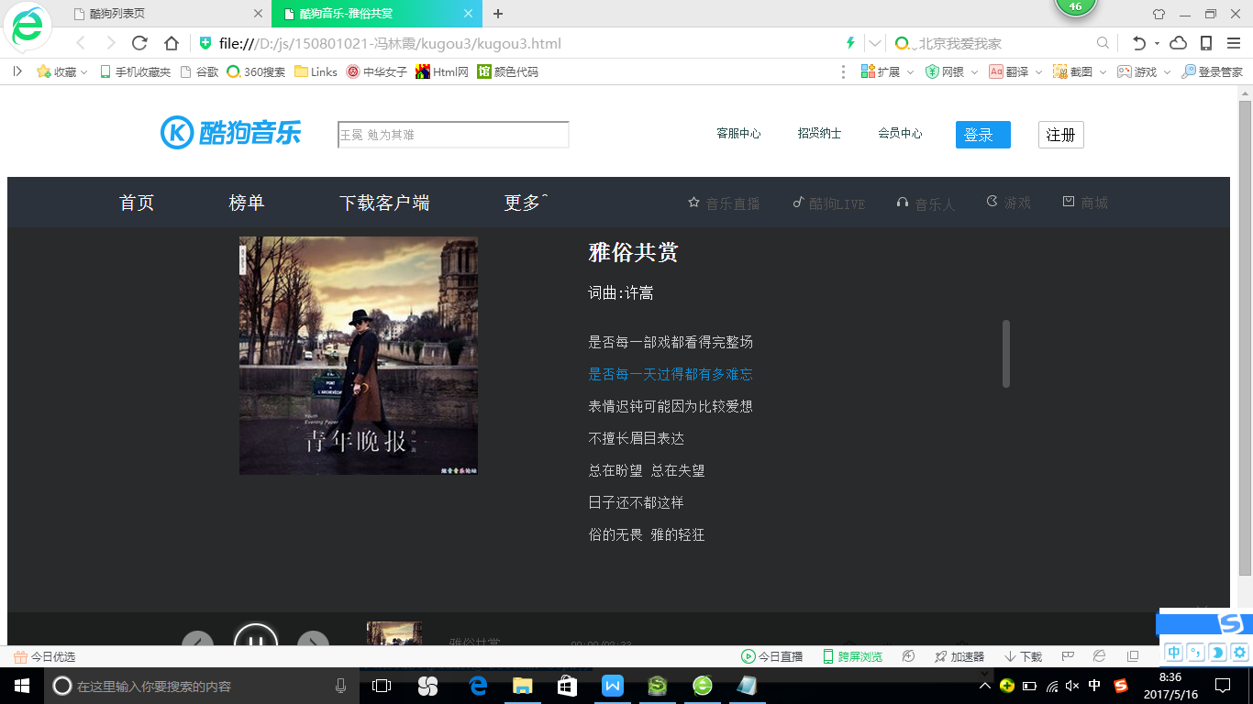

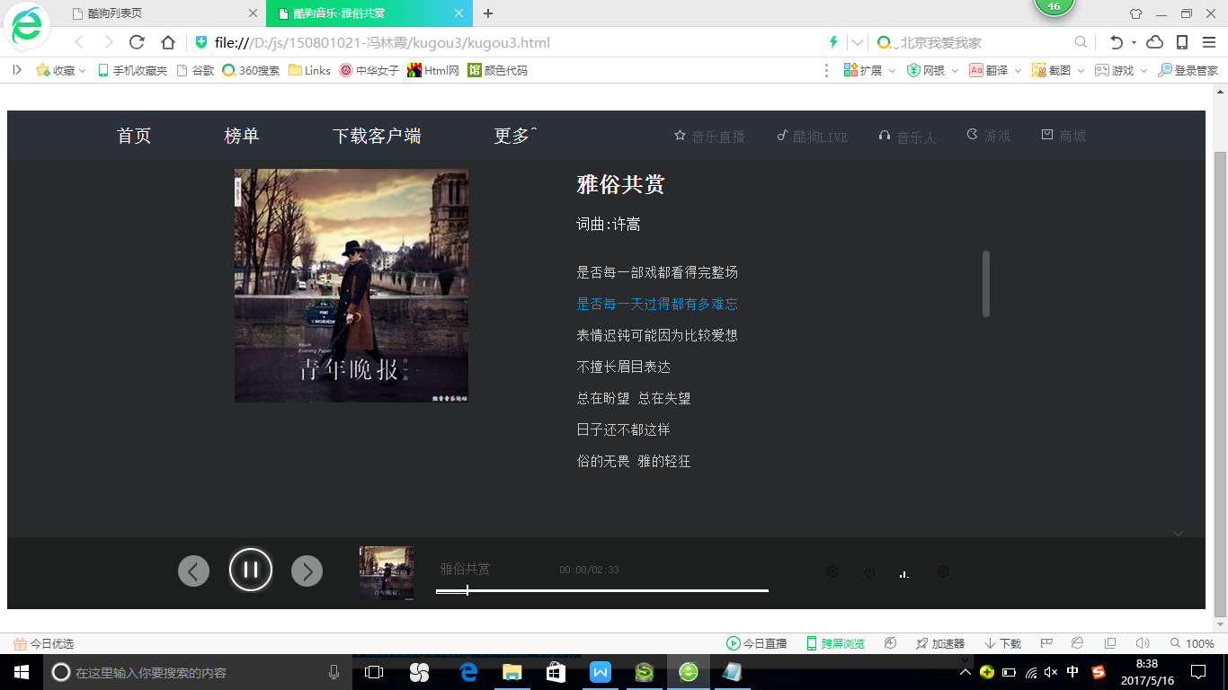

1. 网页代码
2. 、CSS样式

.title{width: 100%;min-width: 1000px;margin: 0 auto;position: relative;}

.dh:hover,.rm li:hover,#m2:hover{color:rgb(22,154,243);}

#m2{float:right;display: block;width: 48px;height: 28px;line-height: 28px;border: 1px solid #C0C0C0;border-radius: 2px;text-align: center;}

#m1{float:right;display: block;width: 48px;height: 28px;line-height: 28px;border: 1px solid #169af3;border-radius: 2px;text-align: center;color: #fff;background-color: #169af3;padding-right: 10px;}

#search { background:url(images/ss.png) no-repeat center right #FFFFFF;height:24px;width:249px;line-height: 24px;color: #666;}

.h{float:left;margin-left: 160px;}

.wenben{margin-left: 300px;margin-top: 30px;}

.header{height:90px;width: 100%;border:1px solid #fff;}

.nav li{float:left;font-size: 10px;color:#2F4F4F;}

.dh{margin-left:40px;}

.dh1{margin-left:40px;}

.mid{height:50px;width: 340px;float:right;margin-right: 300px;margin-top: -40px;}

#submit{height:40px;width: 80px;float:right;margin-right: -400px;margin-top: -30px;}

#submit2{height:40px;width: 80px;float:right;margin-right: -480px;margin-top: -30px;}

.head1 {position: relative;z-index: 999;width: 100%;height: 55px;background-color: #2c323b;text-align: center;}

.lm li{float:left;text-align:center;list-style:none;font-size:20px;margin-left:80px;}

.lm a{color:#ccc;text-decoration:none;border-right:1px solid #ccc;padding:0px 15px;}

.lm li:hover{background:#0c8ed9;text-decoration:none; color:#ccc;}

.lm{border:1px solid #2c323b;height:50px;width:600px;color:#fff;}

.xiala li{display:block;float:left;padding:5px 2px;text-align:center;width:60px;height:30px;background-color:#2c323b;margin: 0;padding:0;display:inline;}

.xiala li:hover{color:#999;}

.xiala{position:absolute;margin:-1000px;}

ul li:hover .xiala{margin:auto;display: block;}

.rm li{list-style:none;float:left;text-align:center;float:right;font-size: 15px;margin-left:30px;color:#545454 ;}

.rm{height:50px;width:700px;margin-left: 500px;color:#fff;margin-top: -200px;}

/*标题结束*/

/*正文开始*/

.page{width:100%;height:500px;background:#292a2b;position:relative;}

.main{width:840px;height:490px;position:absolute;top:10px;left:19%;}

.sing{width:460px;float:right;margin-top: -280px;font-weight:lighter;line-height: 20px;color:white;}

#did p{font-size: 15px;}

h3{font-size: 24px;}

.singer a{text-decoration: none;color:white;}

.text{margin-top:20px;width:460px;height:260px;overflow:hidden;position:relative;}

.scroll{position:absolute;top:0px;right:0px;width:8px;height:232px;}

#sc{position:absolute;top:0px;right:0px;width:8px;height:74px;background:white;border-radius:8px;opacity:0.2;}

#sf{width:26px;height:16px;display:block;position:absolute;bottom:80px;right:-230px;opacity:0.3;}

.bottom,.bkg{width:100%;height:80px;position:absolute;left:0px;bottom:0px;}

.bkg{background:black;opacity:0.3;}

.now{width:60px;height:60px;float:left;margin:9px 0 0 15px;}

.now img{margin-left: 5px;}

.next{width:36px;height:36px;display:block;float:left;margin:20px 0 0 15px;}

.before{width:36px;height:36px;display:block;float:left;margin:20px 0 0 190px;}

.before:hover{background-position:-36px -143px;}

.next:hover{background-position:-180px -143px}

.img{float:left;margin:10px 0 0 40px;}

.pb{width:374px;height:42px;float:left;color:#555555;margin:10px 0 0 25px;}

.pb p{font-size: 12px;padding:5px 0 18px 5px;}

.bgleft,.bgright,.bgmiddle{margin-top: -15px;}

.bgleft,.bgright{width:2px;height:3px;display:block;background-color: #fff;float:left;}

.bgmiddle{width:370px;height:3px;display:block;background-color: #fff;float:left;position:relative;}

.bgright{background-position:-237px -200px;}

#bar{width:0px;height:3px;border:1px solid #fff;position:absolute;display:block;left:0px;top:0px;}

#circle{width:2px;height:12px;background-color: #fff;position:absolute;display:block;left:0px;top:-5px;}

.tubiao{width:260px;float:left;margin:30px 0 0 60px;}

#voice,#cycle,.share,.la,.ls{width:16px;height:16px;display:block;float:left;}

#cycle{background-position:-64px -179px;margin-left:25px;}

.la{background-position:-240px -32px;margin-left:25px;}

.share{background-position:-240px 0px;margin-left:25px;}

.pp{position:absolute;right:16px;top:2px;color:white;}

#voice:hover{background-position:-80px -195px;}

#cycle:hover{background-position:-80px -179px;}

.la:hover{background-position:-256px -32px;}

.share:hover{background-position:-256px 0px;}

.ls:hover{background-position:-61px -120px;}

.ls:hover .pp{color:#169af3;}

1. 、HTML代码

<!doctype html>

<html lang="en">

<head>

<meta charset="UTF-8">

<title> 酷狗音乐-雅俗共赏</title>

<link href="css/main.css" rel="stylesheet" />

</head>

<body>

<div class="title">

<!--header开始-->

<div class="header">

<h1 class="h">

<img src="images/logo.png" alt="" />

</h1>

<div >

<div class="wenben">

<input id="search" placeholder="王冕 勉为其难" type="text">

</div>

</div>

<div class="mid">

<ul class="nav" type="none">

<li class="dh">客服中心</li>

<li class="dh">招贤纳士</li>

<li class="dh1">会员中心</li>

</ul>

</div>

<div id="submit">

<div id="m1">登录</div>

</div>

<div id="submit2">

<div id="m2">注册</div>

</div>

</div>

<!--header结束-->

<!--搜索1开始-->

<div class="head1">

<div>

<div class="lm">

<ul>

<li id="sy">首页</li>

<li id="sy1">榜单</li>

<li id="sy2">下载客户端</li>

<li id="sy3">更多^

<ul class="xiala">

<li>电台</li>

<br><li>MV</li></br>

<li>歌手</li>

<br><li>歌单</li></br>

</ul></li>

</ul>

</div>

<!--二级菜单-->

<div class="rm">

<ul>

<li><img src="images/t11.png" alt="" />商城</li>

<li><img src="images/t22.jpg" alt="" />游戏</li>

<li><img src="images/t33.png" alt="" />音乐人</li>

<li><img src="images/t44.png" alt="" />酷狗LIVE</li>

<li><img src="images/t55.png" alt="" />音乐直播</li>

</ul>

</div>

</div>

</div>

<div style="clear:both"></div>

<!--正文开始-->

<div class="page">

<!--main开始-->

<div class="main">

<div class="image">

<img src="images/vae+.jpg" width="260" height="260">

</div>

<!--sing开始-->

<div class="sing">

<h3>雅俗共赏</h3>

<div class="singer">

<p>词曲:<a href="#">许嵩</a></p>

</div>

<!--text开始-->

<div class="text">

<div id="did">

<p>是否每一部戏都看得完整场</p>

<p>是否每一天过得都有多难忘 </p>

<p>表情迟钝可能因为比较爱想 </p>

<p>不擅长眉目表达 </p>

<p>总在盼望 总在失望</p>

<p>日子还不都这样</p>

<p>俗的无畏 雅的轻狂</p>

</div>

<span class="scroll"></span>

<span id="sc"></span>

</div>

<!--text结束-->

</div>

<!--sing结束-->

<span id="sf"><img src="images/arrowMored.png" alt="" /></span>

</div>

<!--main结束-->

<!--bm开始-->

<div id="bm">

<span class="bkg"></span>

<!--bottom开始-->

<div class="bottom">

<span class="before"><img src="images/2.png" alt="" /></span>

<span class="now"><img src="images/btn2.png" alt="" /></span>

<span class="next"><img src="images/1.png" alt="" /></span>

<div class="img">

<img src="images/vae+.jpg" width="60" height="60">

</div>

<div class="pb">

<p><a style="font-size:14px">雅俗共赏 </a>

<a style="padding-left:70px;">00:00</a>/<a>02:33</a></p>

<span class="bgleft"></span>

<span class="bgmiddle">

<span id="bar"></span>

<span id="circle"></span>

</span>

<span class="bgright"></span>

</div>

<div class="tubiao">

<span id="voice"><img src="images/user_icon1.png" alt="" /></span>

<span id="cycle"><img src="images/user_icon2.png" alt="" /></span>

<span class="la"><img src="images/voice.gif" alt="" /></span>

<span class="share"><img src="images/user_icon1.png" alt="" /></span>

</div>

</div>

<!--bottom结束-->

</div>

<!--bm结束-->

</div>

<!--page结束-->

<embed src="video/vae.mp3" hidden="true" autostart="true" loop="true">

</body>

</html>

<script>

//滚动放映

var j=0;

var t=0;

var width=0;

var did=document.getElementById("did");

var list=did.getElementsByTagName("p");

var time;

function running(){

time=setInterval(function(){

for(var i=0;i<list.length;i++){

if(i==j){

list[i].style.color="#0c8ed9";

}else{

list[i].style.color="#ccc";

}

}

j++;

if(j==list.length){

j=0;

}

<!--歌词结束-->

<!--滚动条开始-->

width+=17;

document.getElementById("bar").style.width=width+"px";

document.getElementById("circle").style.left=width+"px";

if(width>370){

clearInterval(time);

}

},2000)

}

running();

</script>

# 感想

1. 经过这次大作业的锻炼，我发现在很多方面，我的能力不足，js特效不是很会用，意识到这个问题后，我会加强在这方面的能力。而且在页面的排版上，也不是很规范。
2. 这次的大作业，我们都花了非常多的时间和精力去做，希望能让自己让老师满意。在做完三个网页后，很有成就感。