Title: Understanding Organisational Participation and Success in IETF Standardisation

Research Aim: This project aims to investigate organisational participation in the IETF standardisation process and analyse the factors associated with the successful publication of Internet-Drafts as RFCs using the IETF Datatracker database.

Introduction: The IETF is the primary organisation responsible for developing Internet standards. Through the Internet-Draft and RFC publication process, thousands of organisations contribute to Internet technologies. However, it remains unclear which organisational factors influence successful standardisation. Therefore, this project aims to analyse IETF Datatracker data to better understand organisational participation and RFC success.

1.What questions do you want to answer?（main questions）

RQ1：Which organisations contribute the most Internet-Drafts within the IETF?
RQ2：What organisational factors influence the successful conversion of Internet-Drafts into RFCs?
RQ3：How has organizational participation and success changed over time?

2.Why are these interesting?

For RQ1：Organizations play an important role in Internet standardisation.
For RQ2：Participation does not necessarily lead to successful standardisation.
For RQ3：The IETF has evolved over several decades.

3.How will you answer them?
RQ1：Which organisations contribute the most Internet-Drafts within the IETF?
Dataset：IETF Datatracker archive (SQLite database provided by the supervisor)
Analysis Method：Count Internet-Drafts and RFC contributions by organisation.

RQ2: Which organizations are most successful in converting Internet-Drafts into RFCs?
Dataset：Internet-Drafts and RFC metadata

Analysis Method: Calculate Draft-to-RFC rate
RQ3: How has organizational participation and success changed over time?
Dataset： Publication dates
Document history
Organisation information

Analysis Method: Time-series analysis
4.Subquestion（key points）

RQ1 Which organizations participate the most?
├── SQ1.1 Which companies participate most?
├── SQ1.2 Which universities or research institutions participate most?
└── SQ1.3 Which countries are most represented?

RQ2 Participation does not necessarily lead to successful standardisation.
├── SQ2.1 Which organisations have the highest Draft-to-RFC success rate?
├── SQ2.2 Does success differ by technical area, such as Routing, Security, or Transport?
└── SQ2.3 Are high-participation organisations also high-success organisations?
RQ3 How has organizational participation and success changed over time?
├── SQ3.1 How has participation changed from 2000 to 2025?
├── SQ3.2 Have some organisations become more influential over time?
└── SQ3.3 Did Huawei’s participation or collaboration change after the 2019 Entity List?

5.Expected Contributions
Understand organisational participation.
Measure organisational success.
Reveal long-term evolution of Internet standardisation.
Provide evidence for future studies using mailing list analysis.

6.Folder Structure
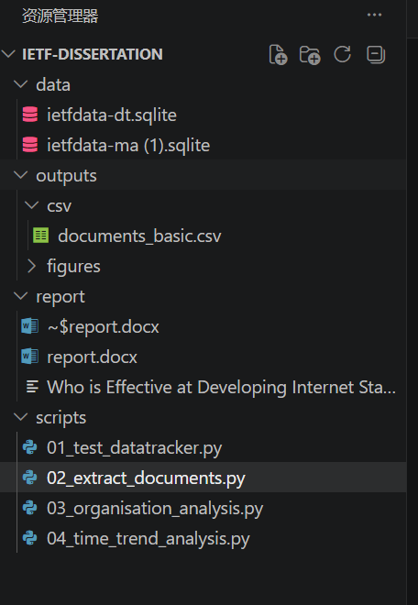
Script | Purpose
01_test_datatracker.py | Verify that the database can be accessed
02_extract_documents.py | Extract Internet-Draft metadata
03_organisation_analysis.py | Analyse organisational participation
04_time_trend_analysis.py | Analyse long-term publication trends

