## Raster

Addition formulas：



2D rotate:



Right rotate 90 degrees:



Vector v1 on the right side of v0:



(x,y) on the right side of (x0,y0)->(x1,y1):



In opengl, default visible faces are counter-clockwise. With counter-clockwise left side of three edges form the triangle area.

## Cross product

Cross product definition differs in right-hand coordinate system and left-hand coordinate system, ensuring that:



From this property:



## Coordinate System Transform

Describe (u,v,w) space axis in (x,y,z) space:



**P** converts a vector from (u,v,w) space to (x,y,z) space; Inv(**P**) converts a vector from (x,y,z) space to (u,v,w) space:



For points transform:

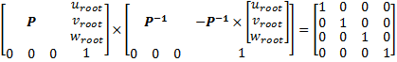

## Tangent Space

Triangle ABC in (x, y, z) space and (t, b, n) space:



For 2 edges of triangle:



Then

