A2 Assumption:

1. The “userName” of the user is unique because it could be used to log in.
2. The information about “hasOnSiteBooking”, “hasOnSiteTest”, “waitingTimes(min)”, “facilityType” are in the additionalInfo field of Testing Site.

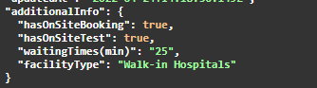

1. Users can pass the PIN Code to the on-site staff(receptionist) to check their booking, then the system displays the status the booking. The status includes customer info, testing info, created time and testing site info etc.
2. Every user is a customer (isCustomer: true), but whether he/she is a receptionist(isReceptionist) or healthcare worker(isHealthcareWorker) can only be set and updated within the system (Security Issue).
3. Assuming Home Booking won’t consume the waiting time.
4. Assuming there are fields called “isHomeBooking” and “isOnsiteBooking” in Booking’s additionalInfo field, we can use it to distinguish between homeBooking and some else type.
5. We assume that the unique QR code will be generated by the third party system. And we just use UUID in Java to emulate the QR code. And the unique url is generate by **“[https://Dummy](https://dummy) URL /… - “ + uuid**. Please refer to the following code: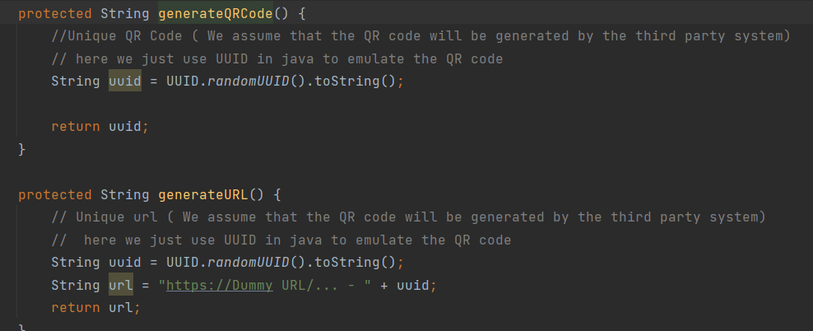
6. For “an interface for the facility staff can be developed to scan the QR code and update the system that the users have received the RAT kit from the facility”

We assume that scanning QR code is a process/operation to get all necessary information and set “hasRATKit” to true. As we use UUID to emulate the QR code, so scanning QR code is the same as the process/operation of inputting UUID to the system.

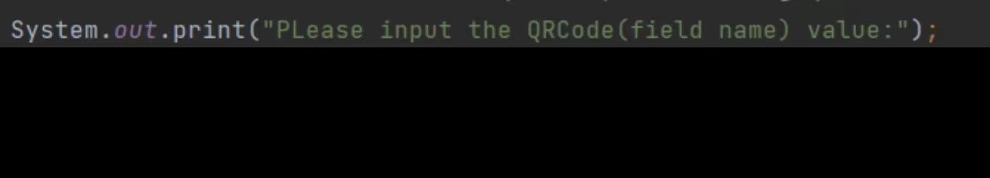

1. For the HomeBooking, we assume only administrators are able to QR code actions and receptionists are administrators.

A3 Assumption:

For 1.1:

1. We assuming the startTime field in booking is the time that users want to set/choose when they book for CovidTest. And we also use this field to judge if the booking is expired or not.

1652688085(1)

1. We assuming there is a field in booking to help us to judge the booking’s type(on site or home)

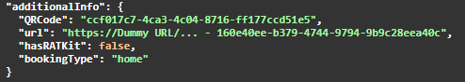(home booking)

1652838480(1)(on site booking)

Note For 1.1

1. profile中只显示没有过期的booking, 过期了的会被自动过滤掉（不显示）
2. residents在通过bookingID搜索booking的时候，也是自动过滤时间过期的booking