Metal 3D printing preprocessing optimization

# Authors

P. Stastny, S. J. Vijay

# Abstract

*What is this paper about and what are outcomes of my work*

This work was done with focus on selective laser melting (SLM) method, but results are generally applicable for other 3D printing methods as for example fused deposition modeling (FDM) or stereolitography (SLA).

# Introduction

## Motivation

The drive of this work is to make metal 3D printing technology more effective and affordable to broader spectrum of potential customers. One of barriers for broader usage of metal 3D printing are still relatively high costs of purchasing and operation of this technology. These costs consist mainly of machine purchase and maintenance, input material, labor, energy demand, post processing. By increasing efficiency, we can more or less influence all of them. Another barrier for implementation is need for highly qualified personal for operating this technology. These barriers significantly slows down application of these technologies in developing countries for whose the price is simply too high.

By automizing pre-processing part of the process can use less material more effectively, increase reliability of process. Simply make things faster and with no need for iterative remaking. This saves money and makes the whole process work better. Another advantage of automizing pre-processing is that we don't need super-special people to do this work anymore so anyone can use this technology.

## Process of component design and manufacturing using SLM

The process of component manufacturing starts with idea of designer who using computer-aided design (CAD) software creates 3D model of component. To ensure printability of component, designer should have basic knowledge of whole 3D printing process with its benefits and limitations.

Designed component data are prepared and converted to machine instructions, typically in particular machine specialized software. This pre-processing procedure consist of few steps: orientation optimization, support design and optimization and machine toolpath generation (slicing). (See Figure 1)

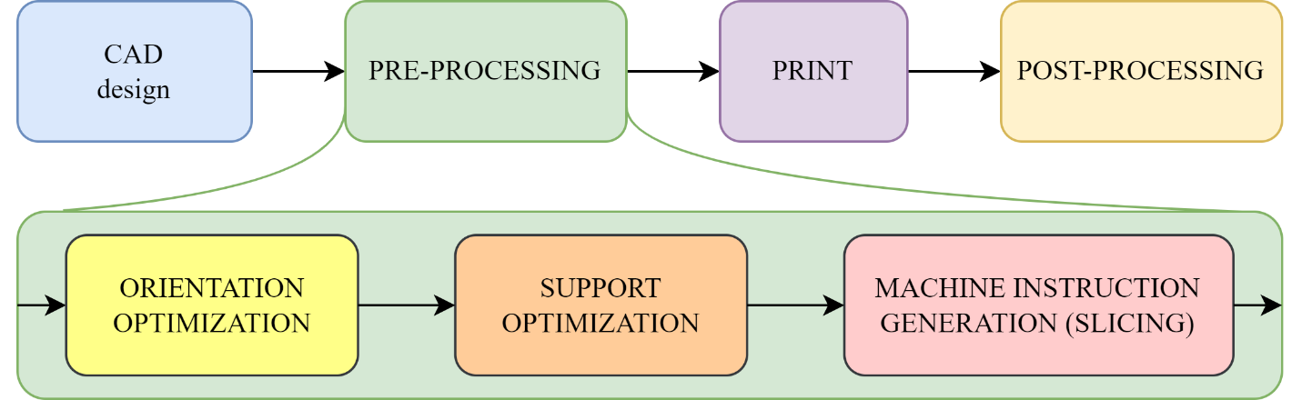

Figure Process of component design and manufacturing using 3D print.

First problem, this work is dealing with is a component orientation optimization. Orientation has big influence on amount of supports needed, printing time and mechanical properties of component. Function of supports in case of SLM is not only static mechanical supporting printed object but also supports works as thermal conductors. This is very important because during the process of printing component is loaded with very steep thermal gradients made by local melting and solidification of material. This load results non-homogenity of microstructure[1], residual stresses and distortion of whole component [2].

This hardly predictable very nonlinear behavior requires highly experienced and qualified operators to determine best print orientation and design support structure which ensure reliable “first try” good quality print. Otherwise, process leads to iterative repeating and parameters tuning. This dramatically increases time, material, work cost of a printed component (mainly in small batches of prototyping). As mentioned earlier, the aim of this work is to find way how to reduce an amount of manual inputs and operator knowledge needed, and make process of orientation optimization and support design more automized and more reliable.

# Part orientation optimization

Research in area of 3D printing part orientation optimization (3D print or layered manufacturing in general, not specifically SLM) came with multiple approaches to find best component orientation. Most common is optimization based on minimizing form error and minimizing support structure volume [3]–[5].

Figure Form error using FDM 3D print technology. [5]

From error becomes more significant with bigger layer heights *t*, typically with FDM where layer height is typically in range 0.1 – 0.3 mm. In case of SLM layer height is usually in interval 20-50 µm. Another reason why form error doesn’t have so high importance with SLM is the fact that laser melts not only volume of one layer, but re-melts also previous layers, this ensures surface smoothness and relatively small form error.

Form errors occurring in SLM are typically not typically on layer height size but bigger scale body distortions due to residual stresses. These stresses is almost impossible predict analytically, hence FEM simulation of whole 3D printing process is required. This simulation is high computational power demanding.

The most sensitive to thermal affected distortions are parts where one or two dimensions is significally smaller than others (thin or long). Optimizing component orientation by minimizing support volume this problematics solves automatically, because it automatically pushes thin dimensions out from Z direction.

Method used in this work is based on minimizing support structure volume.

## Optimization process

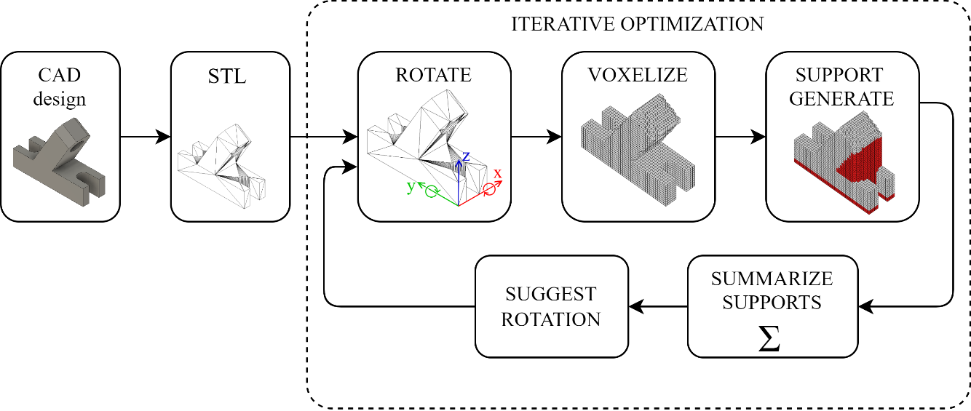

Figure Optimization process

Support volume which we are minimizing is function of exact body geometry and two angles of rotation:

Equation Function of support volume.

,

Where *B* represents body.

Optimization process shown in Figure 3 consists of several steps:

1. **Body import**

First step is import part designed in CAD software in general triangulation representation (STL file format).

1. **Rotate STL**

To ensure all possible orientations, imported part could be rotated by 2 axes (*x* and *y*). Rotation by *z* axis would not bring any information in sense of support volume.

Intervals of rotation are:

1. **Voxelize**

Part in particular rotation is cut by cubic grid. One cell of this grid is named as voxel. Voxel size could be an object of research. Our testing showed, that if of largest dimension, behavior of this method is stable.

1. **Generate supports and count supports volume**

Supports are generated for all component overhang voxels and simply counted. This simplification of generating supports for all downfacing surfaces smooths function *Vsupport* . Which makes next step - easier.

1. **Orientation optimization**

Function of volume support dependent on two rotation angles is shown Figure 5. This function corresponds to a body show in Figure 3. This body has multiple right angles and parallel faces, function due to this has periodic look with sharp changes in gradient. Due to this fact, simple gradient descent could not lead to globally optimal solution. The result of gradient descend is highly dependent on initial estimate. To ensure better general behavior, combination of grid search and gradient descent is used.

* 1. **Grid search**

Support volume is initially calculated in set of 25 positions separated by as shown in Figure 5. This step covers all “right angled” rotations. Orientation from this set with smallest support volume is output for further orientation fine tuning with gradient descent method.

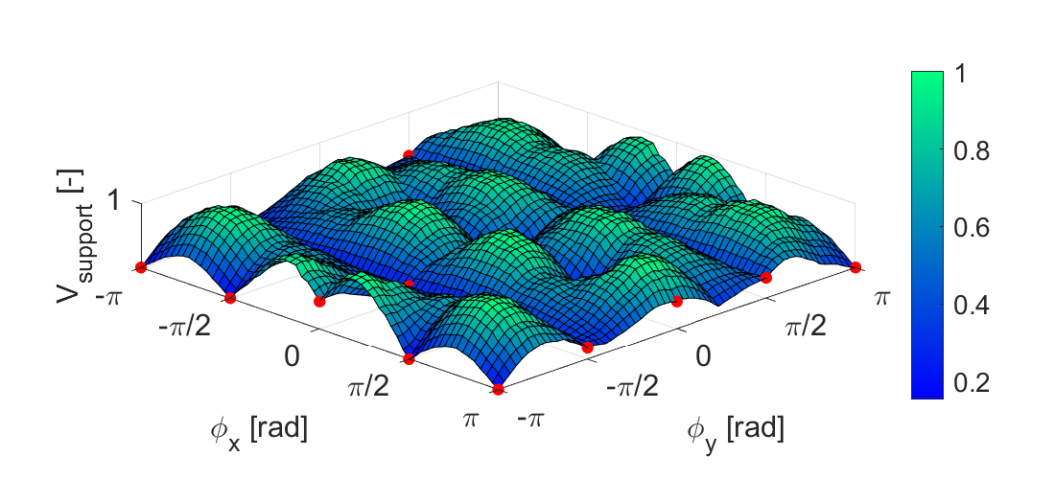

Figure Support volume Vsupport dependency on angles of rotation ∅x and ∅y of test body

* 1. **Gradient descent**

In general case grid search with this coarse span in-between point won’t give optimal orientation. To search minimum of support volume function (see Equation 1) iterative gradient descent method [6] is used. Initial point of gradient descent is output of grid search.

Orientation of rotation given by two angles and in next *n+1th* iteration is calculated according to formula:

Equation Iteration of gradient descent

,

Where are predicted next iteration angles, are actual angles, is dumping coefficient and is gradient of function in actual angles position. This leads to convergence to position of where support volume is smallest.

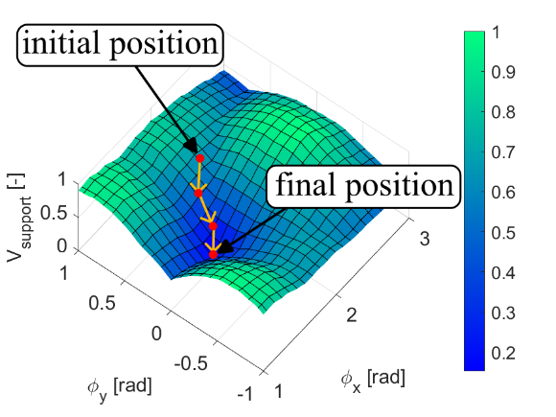

Figure Gradient descent

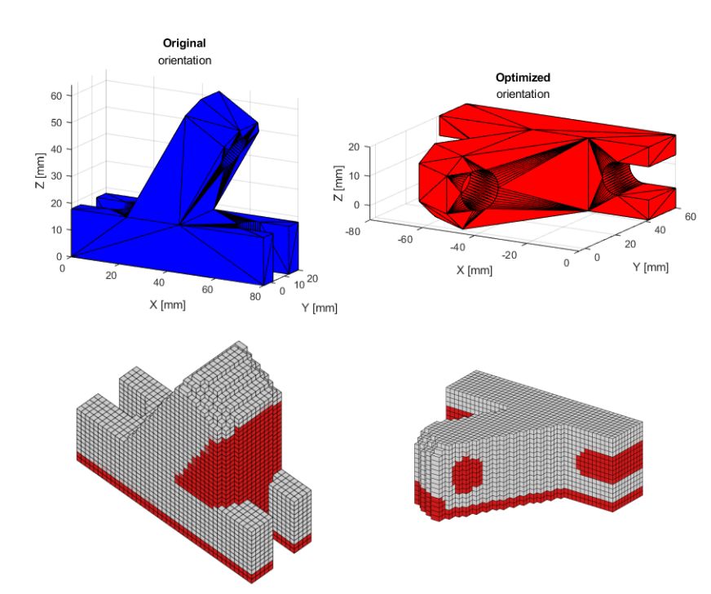

Figure Optimized orientation, a) STL bodies, b) voxelized with supports

# Feature detection

1. Whole body symmetry check

2. Feature shape classification from cut sections

3. Feature size evaluation

4. Feature eccentricity - how thin feature is?

5. Feature surrounding analysis - how much material is in surrounding?

6. Check if supports are standing on base or on the top of another feature

7. Based on basic shapes dataset trained dataset classify feature support parameters ()

# Support pattern prediction

## Dataset library

1. Basic shapes of bodies
2. Simulation of process in F360 with Additive manufacturing Extension
3. Parameters of bodies which will vary:
   1. Support height
   2. Overhang height
   3. Count of supported sides
   4. Feature XY Size
4. Parameters / support of print which will vary
   1. Support pattern list (max 3)
   2. Support density from – to

## Support prediction

Based on

* + 1. **performance of support - max distortion**
    2. (Print time)
    3. Support volume
    4. Support density

# Conclusion

* What are outcomes of this work
* What are limitations
* Future work – how should continue

# Acknowledgment

IAESTE

IIT Pallakkad

# References

# Shortcuts

|  |  |
| --- | --- |
| SLM | Selective laser melting |
| SLA | Stereolithography (3D printing method) |
| FDM | fused deposition modeling |
| CAD | Computer-Aided Design |
| FEM | Final element method |
| STL | Stereolitography (3D object representation) |
|  |  |
|  |  |
|  |  |
|  |  |
|  |  |
|  |  |
|  |  |
|  |  |