# Authors

# Abstract

# Introduction

* Motivation – why we are optimizing and trying to automize
  + Reduce costs and time by optimizing orientation and support structures
  + Eliminate print fails
  + No need for qualified operator
* Intro into process of component design and manufacturing using SLM 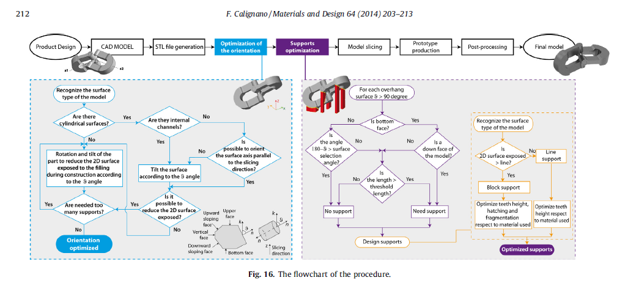

Figure 1 Design optimization of supports for overhanging structures in aluminum

* *Introduce problematics of support structure design*
  + *Need for experienced operator*
  + *Sometimes process is iterative because of fails*
  + *That leads to ineffectivity of process – if this process should be deployed in broader amount of businesses this ineffectivity needs to be eliminated*

# Part orientation

1. Body import
2. **Iterational - Orientation optimization based on minimizing support volume**
   1. Rotate STL
   2. Voxelize
   3. Calculate support volume
   4. **Decide where to move -> grid or gradient descent**
3. Export final body orientation to STL

# Feature identification

1. Whole body symmetry check
2. Feature shape classification from cut sections
3. Feature size evaluation
4. Feature eccentricity - how thin feature is?
5. Feature surrounding analysis - how much material is in surrounding?
6. Check if supports are standing on base or on the top of another feature
7. Based on basic shapes dataset trained dataset classify feature support parameters ()

# Dataset library

1. Basic shapes of bodies
2. Simulation of process in F360 with Additive manufacturing Extension
3. Parameters of bodies which will vary:
   1. Support height
   2. Overhang height
   3. Count of supported sides
   4. Feature XY Size
4. Parameters / support of print which will vary
   1. Support pattern list (max 3)
   2. Support density from - to

Prediction of supports

* 1. Based on
     1. **performance of support - max distortion**
     2. (Print time)
     3. Support volume
     4. Support density

# Conclusion

* What are outcomes of this work
* What are limitations
* Future work – how should continue

# Acknowledgment

IAESTE

IIT Pallakkad

# References