Metal 3D print preprocessing automatization

# Authors

P. Stastny, S. J. Vijay

# Abstract

In the last decade, 3D metal printing technology has experienced a big boom and is becoming a frequent tool in prototyping but also in the production of shape-complex components. The key step for successful printing is setting the printing orientation of the part and design of the structure and density of the supports. Both part orientation and support design require high experienced operator. this fact is against the availability of this technology especially for developing countries. Automizing these procedures could significantly help to adoption of this technology. An algorithm for autonomous part orientation based on minimizing support structure volume is proposed in this work. Oriented part is then autonomously analyzed for detecting features and identifying its parameters which are important for support design.

This work was done with focus on selective laser melting (SLM) method, but chassis of algorithms could be generally applicable for other 3D printing methods as for example fused deposition modeling (FDM) or stereolithography (SLA).

# Introduction

## Motivation

The drive of this work is to make metal 3D printing technology more effective and affordable to broader spectrum of potential customers. One of barriers for broader usage of metal 3D printing are still relatively high costs of purchasing and operation of this technology. These costs consist mainly of machine purchase and maintenance, input material, labor, energy demand, post processing. By increasing efficiency, we can more or less influence all of them. Another barrier for implementation is need for highly qualified personal for operating this technology. These barriers significantly slow down application of these technologies in developing countries for whose the price is simply too high.

By automizing pre-processing part of the process can use less material more effectively, increase reliability of process. Simply make things faster and with no need for iterative remaking. This saves money and makes the whole process work better. Another advantage of automizing pre-processing is that we don't need super-special people to do this work anymore so anyone can use this technology.

## Process of component design and manufacturing using SLM

The process of component manufacturing starts with idea of designer who using computer-aided design (CAD) software creates 3D model of component. To ensure printability of component, designer should have basic knowledge of whole 3D printing process with its benefits and limitations.

Designed component data are prepared and converted to machine instructions, typically in particular machine specialized software. This pre-processing procedure consist of few steps: orientation optimization, support design and optimization and machine toolpath generation (slicing). (See Figure 1)

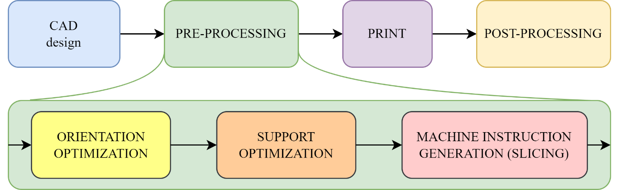

Figure Process of component design and manufacturing using 3D print.

First problem, this work is dealing with is a component orientation optimization. Orientation has big influence on amount of supports needed, printing time and mechanical properties of component. Function of supports in case of SLM is not only static mechanical supporting printed object but also supports works as thermal conductors. This is very important because during the process of printing component is loaded with very steep thermal gradients made by local melting and solidification of material. This load results non-homogeneity of microstructure[1], residual stresses and distortion of whole component [2].

This hardly predictable very nonlinear behavior requires highly experienced and qualified operators to determine best print orientation and design support structure which ensure reliable “first try” good quality print. Otherwise, process leads to iterative repeating and parameters tuning. This dramatically increases time, material, work cost of a printed component (mainly in small batches of prototyping). As mentioned earlier, the aim of this work is to find way how to reduce an amount of manual inputs and operator knowledge needed and make process of orientation optimization and support design more automized and more reliable.

# Part orientation optimization

Research in area of 3D printing part orientation optimization (3D print or layered manufacturing in general, not specifically SLM) came with multiple approaches to find best component orientation. Most common is optimization based on minimizing form error and minimizing support structure volume [3]–[5].

Figure Form error using FDM 3D print technology. [5]

From error becomes more significant with bigger layer heights *t*, typically with FDM where layer height is typically in range 0.1 – 0.3 mm. In case of SLM layer height is usually in interval 20-50 µm. Another reason why form error doesn’t have so high importance with SLM is the fact that laser melts not only volume of one layer, but re-melts also previous layers, this ensures surface smoothness and relatively small form error.

Form errors occurring in SLM are typically not typically on layer height size but bigger scale body distortions due to residual stresses. These stresses is almost impossible predict analytically, hence FEM simulation of whole 3D printing process is required. This simulation is high computational power demanding.

The most sensitive to thermal affected distortions are parts where one or two dimensions is significantly smaller than others (thin or long). Optimizing component orientation by minimizing support volume this problematic solves automatically, because it automatically pushes thin dimensions out from Z direction.

Method used in this work is based on minimizing support structure volume.

## Optimization process

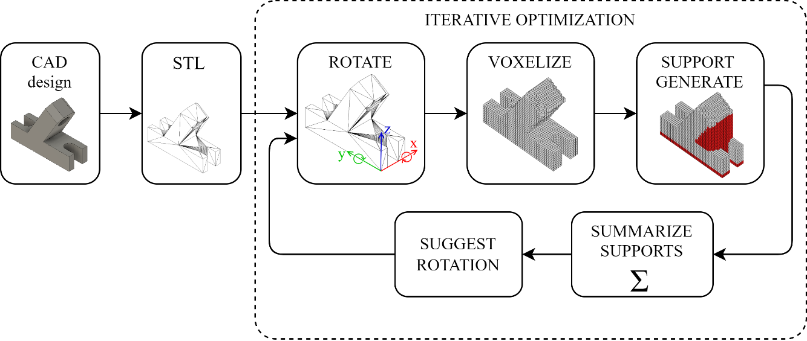

Figure Optimization process

Support volume which we are minimizing is function of exact body geometry and two angles of rotation:

Equation Function of support volume.

,

Where *B* represents body.

Optimization process shown in Figure 3 consists of several steps:

* **Body import**

First step is import part designed in CAD software in general triangulation representation (STL file format).

* **Rotate STL**

To ensure all possible orientations, imported part could be rotated by 2 axes (*x* and *y*). Rotation by *z* axis would not bring any information in sense of support volume.

Intervals of rotation are:

* **Voxelization**

Part in particular rotation is cut by cubic grid. One cell of this grid is named as voxel. Voxel size could be an object of research. Our testing showed, that if of largest dimension, behavior of this method is stable. [6]

* **Generate supports and count supports volume**

Supports are generated for all component overhang voxels and simply counted. This simplification of generating supports for all downfacing surfaces smooths function *Vsupport* . Which makes next step - easier.

* **Orientation optimization**

Function of volume support dependent on two rotation angles is shown Figure 4. This function corresponds to a body show in Figure 3. This body has multiple right angles and parallel faces, function due to this has periodic look with sharp changes in gradient. Due to this fact, simple gradient descent could not lead to globally optimal solution. The result of gradient descend is highly dependent on initial estimate. To ensure better general behavior, combination of grid search and gradient descent is used.

* + **Grid search**

Support volume is initially calculated in set of 25 positions separated by as shown in Figure 4. This step covers all “right angled” rotations. Orientation from this set with smallest support volume is output for further orientation fine tuning with gradient descent method.

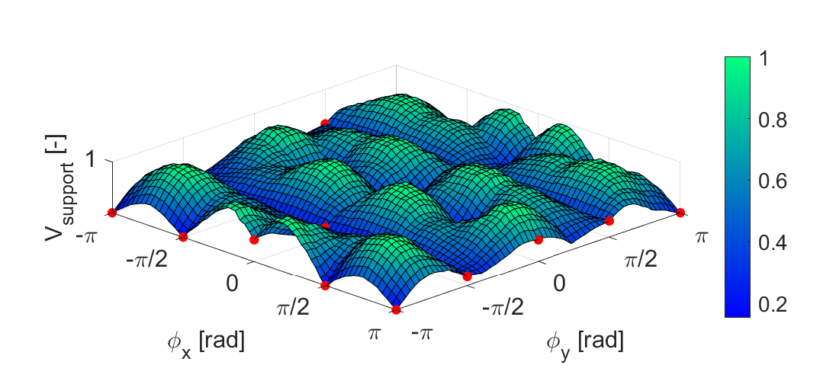

Figure Support volume Vsupport dependency on angles of rotation ∅x and ∅y of test body

* + **Gradient descent**

In general case grid search with this coarse span in-between point won’t give optimal orientation. To search minimum of support volume function (see Equation 1) iterative gradient descent method [7] is used. Initial point of gradient descent is output of grid search.

Orientation of rotation given by two angles and in next *n+1th* iteration is calculated according to formula:

Equation Iteration of gradient descent

,

Where are predicted next iteration angles, are actual angles, is dumping coefficient and is gradient of function in actual angles position. This leads to convergence to position of where support volume is smallest.

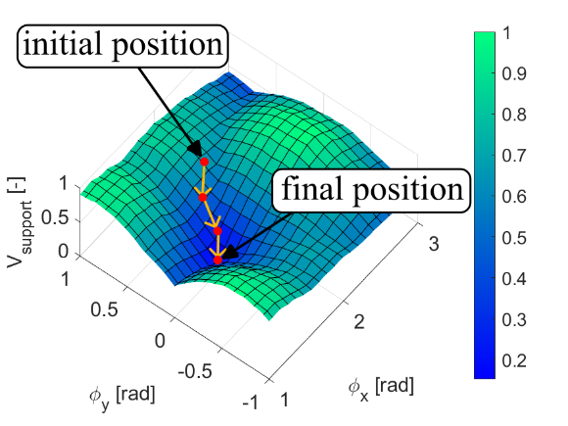

Figure Gradient descent

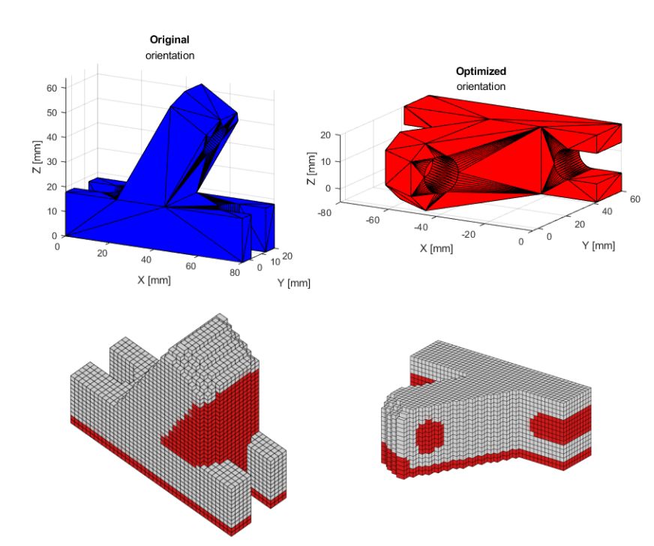

Figure Optimized orientation, a) STL bodies, b) voxelized with supports

# Feature detection

Figure Feature detection flowchart

* **Body import**

First step of body feature detection is import and voxelization of body (optimized orientation from previous step). Also, from STL wireframe is imported. Wireframe consists of all edges between neighboring edges whose mutual normal vectors and forms angle is bigger than threshold angle

Equation Angle between two face normals

* **Downfacing points extract**

Downfacing points are extracted from voxelized object as positions of all voxels which need to be supported. For first layer point is considered default support pattern, so first layer points are filtered out.

* **Filtering wireframe points**

Situation when two neighboring features share same edge (edge of wireframe) could be problematic for automatically distinguish between them one from other. This problem solves filtering point which are close to wireframe which acts like border of features.

With this step some information about small features could be lost. This could be problem for thin, needle like, features, which stands alone in “in air” and doesn’t have any support around. For features which has any other structures around themselves this should not be such big problem. Mistake made by this information lost is not crucial, because since these features are in comparison to neighbors small, temperature affection and residual stresses created by these features would be negligible.

* **Clustering points to features**

Points near to each other are compounded into groups (clusters) by searching nearest neighbor. This distinguishes features from each other. [8]

* **Feature parameters**

For each feature are determined parameters which are later used for feature type identification:

* Point clouds of overhang and support bottom
* Position of center and size of feature in X, Y and Z coordinates
* Cut in X, Y and Z plane. Tight cut for identification of feature type and extended cut which is used for analysis of features sides.

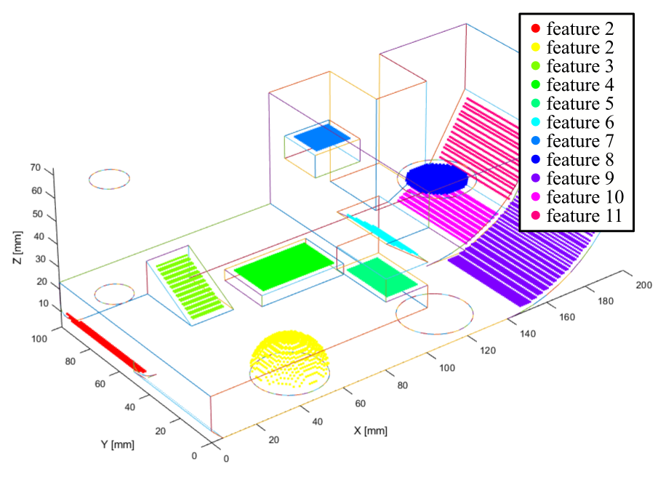

Figure Clustered features downfacing points, near wireframe points filtered out.

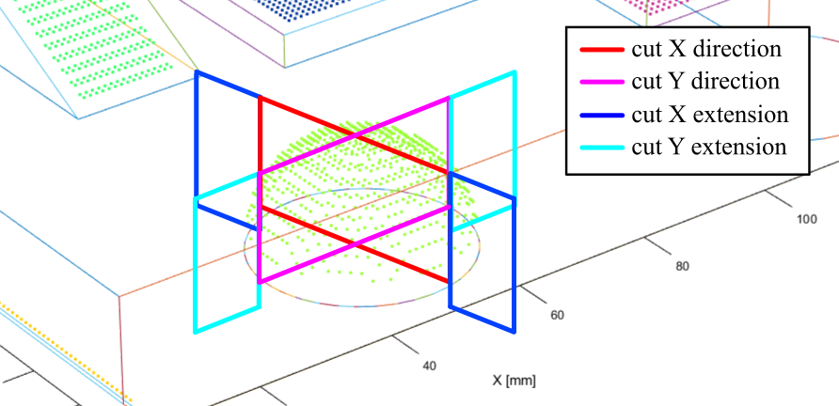

Figure Cut section detail.

# Feature parameters categories

For support design is crucial to determine geometrical parameters of features which can affect behavior of feature during SLM 3D printing process.

This work suggests considering these parameters:

* **Basic shape**

Basic shape is detected from X, Y, Z tight cuts by correlation with tight cuts of dataset. Feature cut is stretched/compressed to fit accurately dataset cut. This stretch is allowed because aim of this step is only detecting basic shape category not its dimensions. Basic body shapes dataset is shown in Table 1.

Table Basic body shapes.

|  |  |  |  |  |
| --- | --- | --- | --- | --- |
| 1- Block | 2- Circular rod | 3- Slope | 4- Inner radius | 5- Inner full radius |
|  |  |  |  |  |
| 6- Inner sphere | 7- Outer radius | 8- Outer radius full | 9- Outer sphere |  |
|  |  |  |  |  |

Figure Example of feature cuts in comparison with dataset.

* **Size**

X, Y size of feature and height.

* **Surrounding density**

Surrounding density express rate how much is feature, in particular direction, supported. This parameter is important information for prediction of feature behavior. Features which are supported on one side will tend to distort in different way than two side supported features or all side supported features. This would lead to different requirements of supports.

Figure Example of cuts with analyzed surroundings.

Density of feature surrounding is evaluated based on basic X, Y cut extensions which covers height from bottom of feature supports to top of feature overhang and width of 50% of feature size (with maximum width 15mm). Surrounding density of one direction is then percentual ratio of filled pixels to number of all pixels.

* **Overhang height, supports height**

Overhang height is calculated as difference between mean feature height and mean height of overhang top.

Supports height is calculated as difference between mean feature height and mean height of supports bottom.

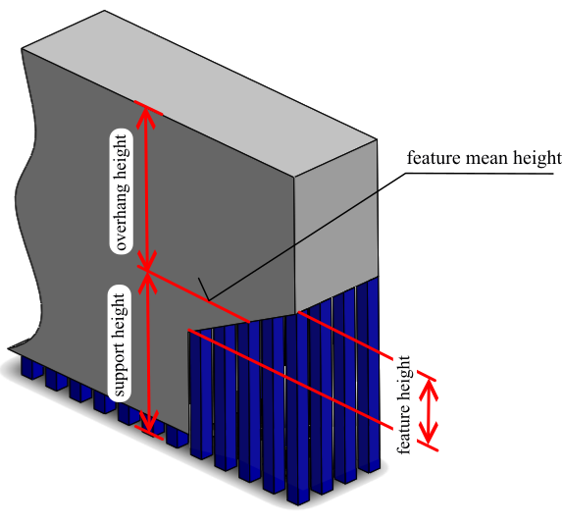

Figure Support height, overhang height.

* **Supports bottom surface**

Binary value which expresses if supports are standing on machine build plate or on another up facing feature.

Table Feature parameters overview.

|  |  |  |  |
| --- | --- | --- | --- |
| Category | Category label | Subcategories | Description |
| Basic shape | BS | {1,2,3,4,5,6,7,8,9} | 9 basic shapes |
| Size X direction | SX |  |  |
| Size Y direction | SY |  |  |
| Density of feature surroundings   |  |  |  |  | | --- | --- | --- | --- | | Density X positive | DXP |  | Unsupported  Partially supported  Supported | | Density X negative | DXN |  | Unsupported  Partially supported  Supported | | Density Y positive | DYP |  | Unsupported  Partially supported  Supported | | Density Y negative | DYN |  | Unsupported  Partially supported  Supported | | | | |
| Overhang height | OH |  |  |
| Support height | SH |  |  |
| Bottom support surface | BS | 0 - Buildplate   1. - Another feature |  |

# Conclusion

In this paper first the problematics of metal 3D printing is introduced, with accent for support design and related affordability of this technology. Process of metal 3D printing consists of several steps and as shown in between preprocessing are highly complicated and require high experienced operator. This fact creates an ample room for automatization and optimization of this process.

In reaction of this fact algorithm for automizing preprocessing was developed. Algorithm consists of these steps:

* **Part orientation** which considers as main criteria support structure volume minimization. Two approaches of optimization algorithm were involved: grid search for initial search and iterative method which use gradient descent for fine position tuning.
* **Feature detection** based on analysis of voxelized component. Algorithm autonomously detects features on component and determines its parameters as: basic shape, size, density of surrounding, overhang height, support height and determinates if potential supports will stand on build plate or on another up facing feature.

Algorithm provides reliable analysis for basis shapes of features.

Future work in this topic should provide design of support structure and density for particular combination of feature parameters. Followed with simulation analysis and which verify designed support structure and density.

# Acknowledgment

I would like to express my heartfelt gratitude to my supervisor, Mr. S. J. Vijay, for his support and valuable guidance throughout the course of this research project. Mr. Vijay's insightful advice and constructive feedback have been pivotal shaping the direction and quality of this work.

I am also deeply thankful to the International Association for the Exchange of Students for Technical Experience (IAESTE) for providing me with the incredible opportunity to work on this project. Their support, both logistical and financial, allowed me to embark on this research journey, fostering international collaboration and cultural exchange.

# References

[1] M. Schmidt, S. Greco, D. Müller, B. Kirsch, and J. C. Aurich, ‘Support Structure Impact in Laser-Based Powder Bed Fusion of AlSi10Mg’, in *Procedia CIRP*, Elsevier B.V., 2022, pp. 88–93. doi: 10.1016/j.procir.2022.03.019.

[2] F. Calignano, ‘Design optimization of supports for overhanging structures in aluminum and titanium alloys by selective laser melting’, *Mater Des*, vol. 64, 2014, doi: 10.1016/j.matdes.2014.07.043.

[3] R. Paul and S. Anand, ‘Optimization of layered manufacturing process for reducing form errors with minimal support structures’, *J Manuf Syst*, vol. 36, pp. 231–243, 2015, doi: 10.1016/j.jmsy.2014.06.014.

[4] R. Vaidya and S. Anand, ‘Optimum Support Structure Generation for Additive Manufacturing Using Unit Cell Structures and Support Removal Constraint’, in *Procedia Manufacturing*, Elsevier B.V., 2016, pp. 1043–1059. doi: 10.1016/j.promfg.2016.08.072.

[5] L. Di Angelo, P. Di Stefano, and E. Guardiani, ‘Search for the optimal build direction in additive manufacturing technologies: A review’, *Journal of Manufacturing and Materials Processing*, vol. 4, no. 3. MDPI Multidisciplinary Digital Publishing Institute, Jul. 01, 2020. doi: 10.3390/JMMP4030071.

[6] Adam H. Aitkenhead, ‘Mesh voxelisation - MATLAB’.

[7] ‘Gradient descent’. Accessed: Oct. 17, 2023. [Online]. Available: https://en.wikipedia.org/wiki/Gradient_descent

[8] ‘Point Cloud Processing’. Accessed: Oct. 18, 2023. [Online]. Available: https://www.mathworks.com/help/vision/point-cloud-processing.html?s_tid=CRUX_lftnav

# Shortcuts

|  |  |
| --- | --- |
| SLM | Selective laser melting |
| SLA | Stereolithography (3D printing method) |
| FDM | fused deposition modeling |
| CAD | Computer-Aided Design |
| FEM | Final element method |
| STL | Stereolithography (3D object representation) |