OS Simulator

By: Erik Hattervig, Jonathan Tomes, Alex Wulf

Division of Effort: Erik Hattervig: 30%, Jonathan Tomes: 30%, Alex Wulf: 40%

GUI Description:

Our GUI is quite simple. The main window will appear when you start our program. On it will be a series of buttons as shown below.

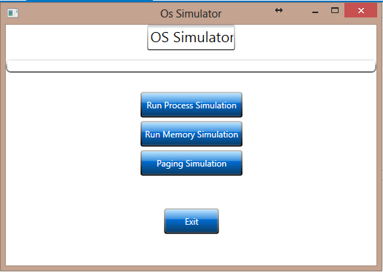

Run Process Simulation runs the process simulation and will display a Column Graph of the different algorithms and their turnaround times and wait times.

Run Memory Simulation runs simulation for memory handlers. It will also display a column graph of the various algorithms that shows the percentage page faults and external fragmentation.

Paging Simulation runs the simulation for paging. It will display a column graph with a single column per algorithm that shows the percentage of page faults from the resulting algorithm.

All the simulations can take some time so we added a progress bar that shows the progress of the simulation. It is displayed above the buttons.

Exit button is untested. May result in destruction of all things.