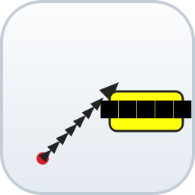
Interactive Ruler
User Manual
Plugin version 1.17 | November 2026
A drag-and-click measuring tool for QGIS 3.x

In this manual:
1. About the Interactive Ruler 3
2. Requirements and Installation 3
2.1 Requirements 3
2.2 Installing the plugin 3
3. Quick Start 4
4. The Launcher Dialog 4
4.1 Measurement modes 4
4.2 Layer name 5
4.3 Ruler style section 5
5. Measuring 5
5.1 Straight lines (I-Ruler) 5
5.2 Paths (I-Ruler Path) 5
5.3 What gets saved 6
6. Styling Your Rulers 6
6.1 Dark, light and red themes 6
6.2 Sliders 7
6.3 Restyling existing lines with the sliders 7
6.4 Typical workflow: restyle an existing line 8
6.5 Where the settings are stored 8
6.6 Changing the color of an existing line 8
7. Settings Reference 9
8. Tips and Troubleshooting 9
9. Version History 10

1. About the Interactive Ruler
The Interactive Ruler plugin turns the QGIS map canvas into a quick measuring device. Drag with the mouse to measure a straight line, or click point after point to measure a path. While you measure, a small balloon next to the cursor shows the azimuth and the live distance – no need to look down at the status bar.
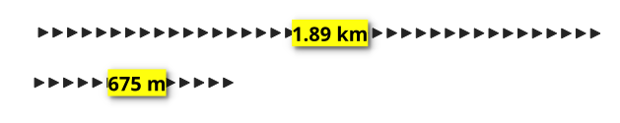
Figure 1 – A saved ruler: arrow line with the length label “675 m” and “1.89 km” (dark theme).
Key features
- Straight-line measurement (drag) and multi-point path measurement (click).
- Live azimuth and distance balloon that follows the cursor.
- Distances measured on the WGS84 ellipsoid in the project CRS.
- Automatic unit switching: meters below 1,000 m, kilometers above.
- Direction arrows and yellow length labels along every saved line.
- Dark (black), light (white) and red (#e31a1c) themes chosen for each line in a small popup – the light theme is made for dark basemaps such as Google Satellite; existing lines keep their color and are never recolored.
- Label font size and line width sliders: with a Ruler layer or group selected in the Layers panel they restyle it, otherwise they set the default for new measurements.
- Every finished measurement becomes its own layer, named after its result and grouped under the layer name (SITE A 1.82 km).
- Layer-name box: type or paste a site name before measuring; the name is remembered between QGIS sessions.

2. Requirements and Installation

2.1 Requirements
- QGIS 3.0 or newer (tested with QGIS 3.44 LTR).
- No other software or accounts needed – all styles are created in code.

2.2 Installing the plugin
- Copy the interactive ruler plugin folder into your QGIS profile plugins directory (in QGIS: Settings ▸ User Profiles ▸ Open Profile Folder, then Python\Plugins).
- Start QGIS and open Plugins ▸ Manage and Install Plugins.
- Select “Installed” and enable Interactive-Ruler.
- The I-Ruler button appears in the toolbar.
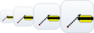
Figure 2 – The plugin icon at 16, 24, 32 and 40 px (toolbar sizes).
To remove the plugin, disable or uninstall it in the plugin manager. Ruler layers you have already drawn stay in your projects.

3. Quick Start
- Click the I-Ruler button in the toolbar. The Interactive Ruler dialog opens.
- Type a site name in the Layer name box (for example SITE A) and press I-Ruler.
- Press the left mouse button on the map, drag, and watch the balloon next to the cursor – it shows the azimuth and the growing distance.
- Release the mouse button. A small window asks for the theme of this line – Dark, Light or Red – then the line is saved with its length label.
That is all there is to it. The following chapters describe each feature in detail.

4. The Launcher Dialog
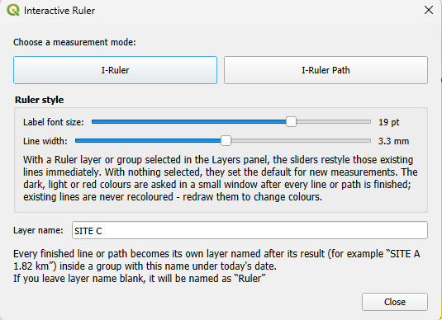
Figure 3 – The Interactive Ruler dialog in version 1.17.

4.1 Measurement modes
Button | How to measure | How to finish
I-Ruler | Press and drag in one movement | Release the mouse button
I-Ruler Path | Click point after point; the total path length grows with every click | Right-click or double-click

Both modes can be cancelled at any time with Esc or a right-click (in straight mode).

4.2 Layer name
The Layer name box sets where new measurements are saved. Type or paste a name before you start – for example SITE A. Every finished line or path becomes its own layer inside a group with that name under today’s date, and the layer is named after its result (SITE A 1.82 km). The name is remembered between QGIS sessions; leave it blank to use the default name Ruler.

4.3 Ruler style section
The Ruler style group contains the two sliders. The dark or light color is not chosen here: it is asked in a small popup after each line is finished. With a Ruler layer or group selected in the Layers panel the sliders restyle those existing lines; with nothing selected they only set the default for new measurements. Chapter 6 covers styling in detail.

5. Measuring

5.1 Straight lines (I-Ruler)
- Open the dialog and choose I-Ruler. The mouse cursor changes to a cross on the map.
- Press the left mouse button where the measurement should start. A red rubber band follows the cursor.
- Drag. The balloon next to the cursor shows Azimuth (direction clockwise from north) and Distance (live length).
- Release the mouse button. A small window asks for the theme of this line. After you choose Dark, Light or Red, the measurement is saved with its length label and the tool is ready for the next measurement.
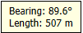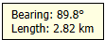
Figure 4 – The live balloon while dragging.
- Distances are calculated on the WGS84 ellipsoid in the current project CRS.
- Below 1,000 m the balloon shows meters (e.g. “507 m”); above it shows kilometers (e.g. “2.82 km”).
- The balloon flips to the other side of the cursor automatically when the cursor approaches the edge of the map canvas.
- Press Esc or right-click to cancel the current drag.

5.2 Paths (I-Ruler Path)
- Open the dialog and choose I-Ruler Path.
- Click once for every corner of the path. The rubber band shows the path so far, and the balloon shows the live total length including the segment to the cursor.
- Finish with a right-click or a double-click. The whole path is saved as one line with the total length as its label, and a small window asks for its theme.
A single click that lands exactly on the previous point is ignored, so small mouse slips do not create zero-length segments.

5.3 What gets saved
- Every finished line or path becomes its own memory layer, inside a group named after the Layer name box (for example SITE A).
- The groups sit under a group named after the current date (for example 10-Nov-2026), so projects stay organized: 10-Nov-2026 ▸ SITE A.
- Each layer is named after its result: SITE A 1.82 km. A duplicate name gets a number (SITE A 1.82 km 2).
- Every feature carries its formatted length in the Length field, is drawn as a chain of direction arrows, and shows the length in a yellow label in the middle of the line.
- The layers are normal vector layers, so they can be re-labelled, exported or styled further like any QGIS layer.
Projections and distance
Distances are always geodesic measurements on the WGS84 ellipsoid, reported in meters or kilometers – never in the project’s map units. A line drawn on a Web Mercator, UTM or other projected map therefore shows the real ground length even where the projection distorts distance. It can differ slightly from a planar grid measurement when the project CRS uses a datum-shift grid, typically by about 0.01%.
The project must have a CRS. If none is set, the ruler does not measure and warns “Set a project CRS before measuring (Project ▸ Properties ▸ CRS).” Set a CRS in Project ▸ Properties ▸ CRS, then draw again. Geographic, projected and compound 2-D CRSs all work; geocentric or 3-D-only CRSs such as EPSG:4978 are not meaningful on the 2-D map canvas.

6. Styling Your Rulers

6.1 Dark, light and red themes
Each finished line or path is drawn in one of three color themes:
Theme | Line and arrows | Best used on
Dark | Black (#232323) | Light basemaps – imagery with bright terrain, OSM, cadaster
Light | White (#FFFFFF) | Dark basemaps – Google Satellite, dark imagery, hill shade
Red | Red (#e31a1c) | Most basemaps – a strong color that stands out on both light and dark imagery

The yellow label with black text stays the same in all three themes because it is readable on light and dark backgrounds alike.
How the theme choice works:
The popup opens after every line or path and is already set to the theme you chose last time. Press Enter or click OK to accept the pre-selected theme, or choose another radio button and click OK.
- The choice applies only to the line that was just finished.
- Existing lines are never recolored. Each saved line keeps its color, so different sites can use different themes in the same project.
- The last choice is saved in QGIS settings and pre-selected the next time you draw.
- To change the color of an existing line, delete it and draw it again (section 6.6).
The popup looks like this:
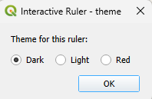
Figure 5 – The theme popup after a finished line. The last choice is pre-selected.
The light theme is made for dark basemaps (Figure 6):
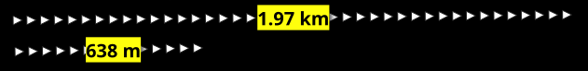
Figure 6 – The light theme (white arrows) on a dark satellite-like basemap.

6.2 Sliders
Slider | Range | Default | What it changes
Label font size | 6 – 24 pt | 12 pt | Text size of the yellow length labels
Line width | 0.5 – 6.0 mm | 2.0 mm | Size of the direction arrows; the arrow spacing scales with it so the dashed-arrow look is preserved
The two sliders set the label font size and the arrow line width. Their ranges are shown above; section 6.3 explains which lines they change.

6.3 Restyling existing lines with the sliders
Every Ruler layer keeps its own theme, font size and line width, stored with the layer. The selection in the Layers panel decides what the sliders change when the dialog opens (the dialog is modal, so the selection cannot change while it is open):
Selection in the Layers panel | What the sliders change
Nothing | Only the default style for new measurements. Existing layers keep their styles.
One or more Ruler layers | Those layers. Font size and line width change live; every layer keeps its own theme.
A group (site or day group) | Every Ruler layer inside it, including nested groups. Their themes are kept.

The sliders only change the font size and line width – never the dark, light or red color. What they restyle is taken from the Layers panel selection. The theme is chosen per line in the popup (section 6.1).
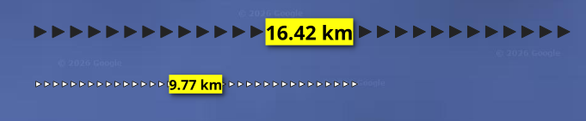
Figure 7 – Two Ruler layers in one project, each with its own theme, font size and line width.

6.4 Typical workflow: restyle an existing line
- In the QGIS Layers panel, select the Ruler layer or the group you want to change – for example SITE A.
- Open the I-Ruler dialog. The sliders start at the style of the first selected layer.
- Move the sliders – the selected lines update immediately. Their dark or light color does not change.
- Close the dialog. The new font size and line width are stored with each layer.

6.5 Where the settings are stored
- Per-layer styles: layer custom properties (theme, font size, line width), saved inside the project file (.qgz/.qgs).
- Layer name and the last theme choice: QGIS settings (QSettings), shared across projects.

6.6 Changing the color of an existing line
The plugin never recolors a saved line: there is no recolor button or menu entry, and colors are fixed when a line is finished.
To change a color, draw the line again:
- Delete the old layer (right-click it in the Layers panel and choose Remove Layer), or delete just its feature.
- Draw the measurement again with the same Layer name, so it is grouped with the other lines for that site.
- Pick Dark, Light or Red in the popup. The last choice is pre-selected, so you only click another radio button when you want a different theme.
If you only want a different font size or line width, do not redraw: select the layer or group and use the sliders (section 6.3).

7. Settings Reference
Setting | Stored in | Default | Range
Layer name | QSettings | Ruler | any text
Theme (last choice) | per layer + QSettings | dark | dark / light / red
Label font size | per layer + QSettings | 12 pt | 6 – 24 pt
Line width | per layer + QSettings | 2.0 mm | 0.5 – 6.0 mm

Out-of-range values are clamped automatically, so values written by older plugin versions can never break the style.

8. Tips and Troubleshooting
Situation | What happens / what to do
The balloon disappears when you leave the map window | Normal – the balloon is hidden while the cursor is outside the canvas and returns when you continue.
The ruler does not measure and warns about the project CRS | The project has no CRS. Set one in Project ▸ Properties ▸ CRS, then draw again. Without a CRS the canvas has no meaningful units, so the ruler refuses to measure.
Distance shows NaN | The project has no usable ellipsoid or the CRS is invalid. Set a proper project CRS (Project ▸ Properties ▸ CRS).
You change the project CRS while measuring | The tool notices the change, keeps finished measurements untouched and starts a fresh Ruler layer in the new CRS.
Ruler layers made by plugin versions older than 1.5 | They are recognized by their Length field. Select them (or their group) and use the sliders to restyle font size and line width.
Labels are hard to read at a small map scale | Select the Ruler layer or group in the Layers panel, then increase the label font size with the slider (section 6.3).
Black lines are invisible on my dark imagery | Delete the line and draw it again with the Light theme. An existing line keeps the color it was drawn with (section 6.6).
I want my existing lines in the other theme | Redraw them: delete the old layer (or feature), measure again with the same Layer name, and pick the other theme in the popup (section 6.6).
I measured by mistake | Press Esc before finishing, or right-click to cancel. Finished lines can be deleted like any feature: select the Ruler layer, activate a digitizing tool and delete the feature, or remove the whole layer.
The theme popup appears after every line | By design: each line stores its own color. Press Enter to keep the pre-selected theme, or click the other radio button for this line.
My measurements went into the wrong group | Type the site name in the Layer name box before measuring. The name is remembered for the next session.

9. Version History
Version | Changes
1.17 | Added a Red theme (#e31a1c) alongside Dark and Light. The rubber band shown while dragging is now always red, so the preview stays visible with the Light theme too. The theme popup has three radio buttons.
1.16 | The ruler refuses to measure when the project has no CRS and shows a warning instead (“Set a project CRS before measuring”). Previously the canvas units were treated as metres and produced a meaningless length. No pending layer is created until a project CRS is set.
1.15 | Fixed a RuntimeError when the pending (empty) ruler layer was deleted outside the plugin – for example removed in the Layers panel or the project closed – and the tool was deactivated. Drawing after such a deletion starts a fresh layer, and an empty name group is still cleaned up.
1.14 | Dark / light is asked in a small window after every finished line or path, pre-selected with the last choice. The theme radios, “Apply style to” selector, Recolor button and Layers panel recolour entries were removed; existing lines are never recoloured. The sliders still restyle the selected layers or groups.
1.13 | Theme switching recoloured only the selection in the Layers panel; with nothing selected it recoloured every Ruler layer. (Superseded by 1.14.)
1.12 | Theme switching recoloured all Ruler layers immediately, without the message bar confirmation. (Superseded by 1.13 and 1.14.)
1.11 | Measurements are grouped by the typed name under the date group, and every layer is named after its distance (SITE C 1.82 km). Empty pending layers and groups are cleaned up.
1.10 | Layer-name box replaces the “Ask for a Ruler layer name” checkbox: type the name before measuring, and every measurement gets its own layer.
1.9 | Recolor existing rulers without redrawing: a “Recolor existing layers” button in the dialog, a message bar prompt after a theme change, and Layers panel right-click entries; recoloring changes only the theme and keeps each layer’s label font size and line width.
1.8 | Theme switching now always targets the default style for new measurements: the Dark/Light radio buttons reset the “Apply style to” selector to “New measurements (default style)” and reload the default slider values; existing layers are left untouched.
1.7 | New SVG plugin icon; user manual added.
1.6 | Per-layer ruler styles: theme, label font size and line width are stored on each Ruler layer; “Apply style to” can restyle the selected layer, all layers, or only the default for new measurements.
1.5 | Dark/Light theme radio buttons plus label font size and line width sliders; live restyling of existing Ruler layers.
1.4 | Live azimuth/distance balloon next to the cursor while dragging; the status bar no longer shows the live distance.
1.3 | Launcher dialog and optional Ruler layer naming after each measurement.
1.2 | Arrow-line style with length labels, m/km auto-switching, path mode.
1.0 | First version: straight-line measuring.

Interactive Ruler is free to use and modify. The plugin consists of interactive_ruler.py, icon.svg and this manual.

