获取智能管控系统token

POST:: <http://IP:PORT/auth/oauth/token>

入参：

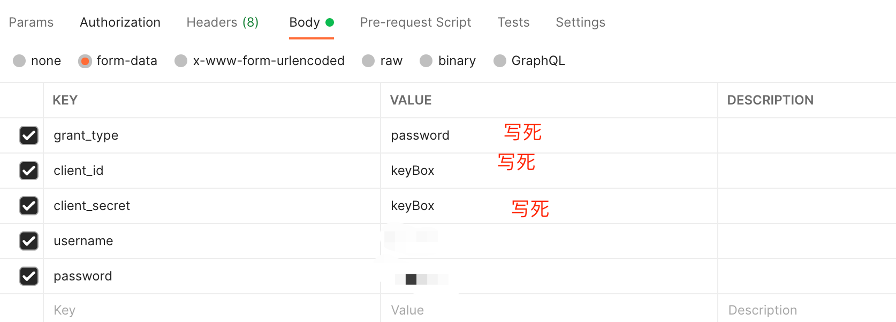

出参：

|  |
| --- |
| {  "access_token": "",  "token_type": "bearer",  "expires_in": 1799,  "scope": "read write",  "tenantId": 0,  "fullName": "钥匙柜系统",  "refresh_interval": 1200000,  "tenantSchema": "april",  "userId": 1602224750738341889,  "phone": "13512341234",  "jti": "c8045606-f7dd-4a20-baa4-8f8a07a62795"  } |