Great—this is the core landscape of modern diffusion models. I’ll explain each one clearly, then connect them mathematically and practically.

🧠 Big Picture First
All three are about the same idea:
Start from noise → gradually denoise → get an image
But they differ in how the reverse process is done and how efficient it is.

1️⃣ DDPM (Denoising Diffusion Probabilistic Models)
🔹 What it is
The original diffusion model (Ho et al., 2020)
🔹 Key idea
- Reverse process is stochastic (random)
- Each step adds some randomness
🔹 Sampling rule
xt−1=μθ(xt,t)+σtz,z∼N(0,I)x_{t-1} = \mu_\theta(x_t, t) + \sigma_t z, \quad z \sim \mathcal{N}(0,I)xt−1​=μθ​(xt​,t)+σt​z,z∼N(0,I)
👉 Noise is added at every step

🔹 Properties
- ✔️ Very high quality
- ✔️ Strong theoretical grounding (ELBO)
- ❌ Slow (1000 steps typical)

🔹 Intuition
DDPM is like carefully sculpting a statue, adding a tiny bit of randomness each time.

2️⃣ DDIM (Denoising Diffusion Implicit Models)
🔹 What it is
A deterministic version of DDPM (Song et al., 2021)
🔹 Key idea
Remove randomness:
xt−1=deterministic function of xtx_{t-1} = \text{deterministic function of } x_txt−1​=deterministic function of xt​
No sampling noise.

🔹 Sampling rule (simplified)
xt−1=αˉt−1x^0+1−αˉt−1ϵθ(xt,t)x_{t-1} = \sqrt{\bar{\alpha}_{t-1}} \hat{x}_0 + \sqrt{1-\bar{\alpha}_{t-1}} \epsilon_\theta(x_t,t)xt−1​=αˉt−1​​x^0​+1−αˉt−1​​ϵθ​(xt​,t)

🔹 Properties
- ✔️ Much faster (20–50 steps)
- ✔️ Deterministic (same input → same output)
- ❌ Slightly less diverse

🔹 Intuition
DDIM follows a straight path from noise → image instead of wandering randomly.

🔥 Key insight
DDPM = random walk
DDIM = straight trajectory

3️⃣ Stable Diffusion
🔹 What it is
A practical large-scale system built on diffusion ideas.
Key innovation:
Do diffusion in latent space instead of pixel space

🔹 Architecture components
(A) VAE (compression)
- Image → latent space
- Smaller representation
(B) U-Net (diffusion model)
- Works in latent space
(C) Text encoder (CLIP)
- Converts prompt → embedding

Visual pipeline
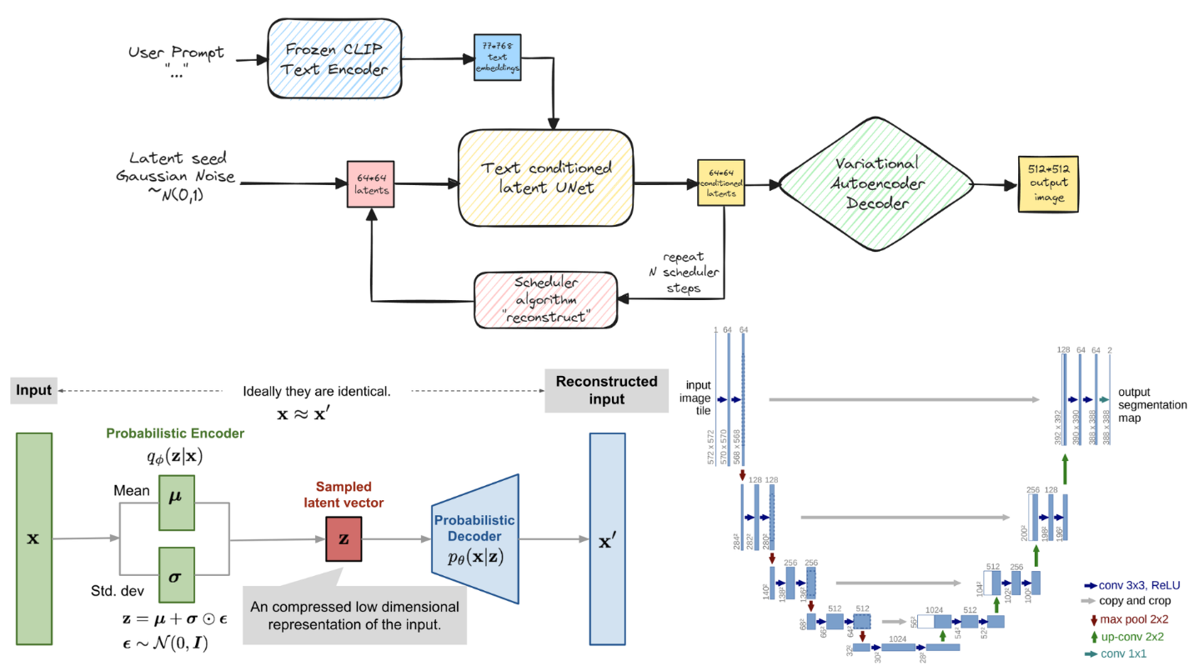
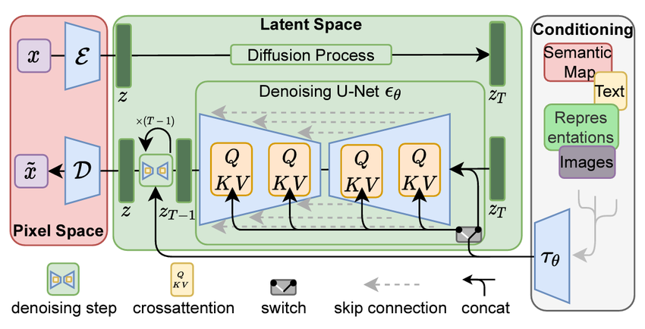

4

🔹 Process
- Text → embedding
- Start with latent noise
- U-Net denoises with conditioning
- Decode latent → image

🔹 Why latent space?
- Pixel images are huge (e.g., 512×512×3)
- Latent is much smaller (e.g., 64×64×4)
👉 So:
- ⚡ Faster
- 💾 Less memory
- 🎨 Still high quality

⚙️ 4️⃣ Mathematical Connection
All three share the same core:
ϵθ(xt,t)\epsilon_\theta(x_t,t)ϵθ​(xt​,t)
The difference is in how we step backward.

DDPM (stochastic)
xt−1=μθ(xt,t)+σtzx_{t-1} = \mu_\theta(x_t,t) + \sigma_t zxt−1​=μθ​(xt​,t)+σt​z

DDIM (deterministic)
xt−1=f(xt,ϵθ)x_{t-1} = f(x_t, \epsilon_\theta)xt−1​=f(xt​,ϵθ​)
(no noise)

Stable Diffusion
Same as DDIM/DDPM but:
xt∈latent spacex_t \in \text{latent space}xt​∈latent space
and conditioned on text:
ϵθ(xt,t,text)\epsilon_\theta(x_t,t, \text{text})ϵθ​(xt​,t,text)

🆚 5️⃣ Side-by-side comparison
Feature | DDPM | DDIM | Stable Diffusion
Reverse process | Stochastic | Deterministic | Usually DDIM-like
Speed | Slow | Fast | Fast
Space | Pixel | Pixel | Latent
Conditioning | Optional | Optional | Core feature
Use case | Theory | Fast sampling | Real-world generation

🧠 6️⃣ Deeper Insight
Why DDIM works
DDIM corresponds to solving the probability flow ODE instead of SDE:
- DDPM → stochastic differential equation
- DDIM → deterministic ODE
👉 Same distributions, different paths

🚀 7️⃣ Practical takeaway
- DDPM → foundation, theory
- DDIM → fast sampler
- Stable Diffusion → scalable system

🧠 8️⃣ One-sentence summary
DDPM defines the original stochastic diffusion process, DDIM provides a faster deterministic sampling path, and Stable Diffusion applies these ideas in a compressed latent space with text conditioning for real-world image generation.

