Great question—this is where diffusion models become practical.
The U-Net is the neural network that actually performs the denoising step.
Let’s explain it clearly, then rigorously connect it to the math you just saw.

🧠 1. What role does U-Net play?
In diffusion, we need a function:
ϵθ(xt,t)\epsilon_\theta(x_t, t)ϵθ​(xt​,t)
👉 This is exactly what the U-Net implements.
So:
U-Net = the function that predicts the noise (or score) from a noisy image

🏗️ 2. Why U-Net specifically?
We need a network that:
- understands local details (edges, textures)
- understands global structure (objects, layout)
- preserves spatial resolution
👉 U-Net does all three.

🔁 3. U-Net Structure (Intuition)
A U-Net has three parts:
(A) Downsampling path (Encoder)
- gradually reduces resolution
- extracts high-level features
(B) Bottleneck
- deepest representation
(C) Upsampling path (Decoder)
- reconstructs image
(D) Skip connections
- connect encoder ↔ decoder

Visual intuition
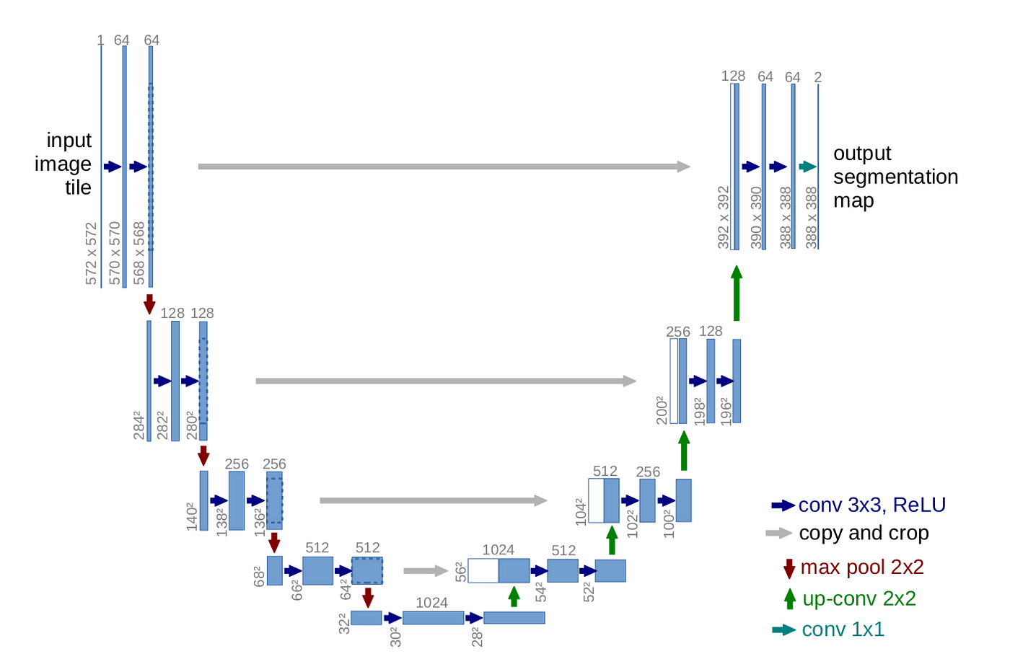
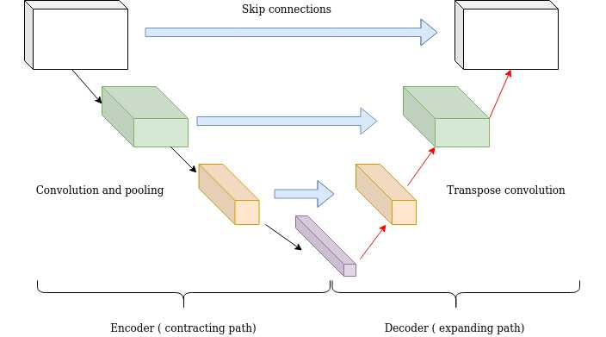
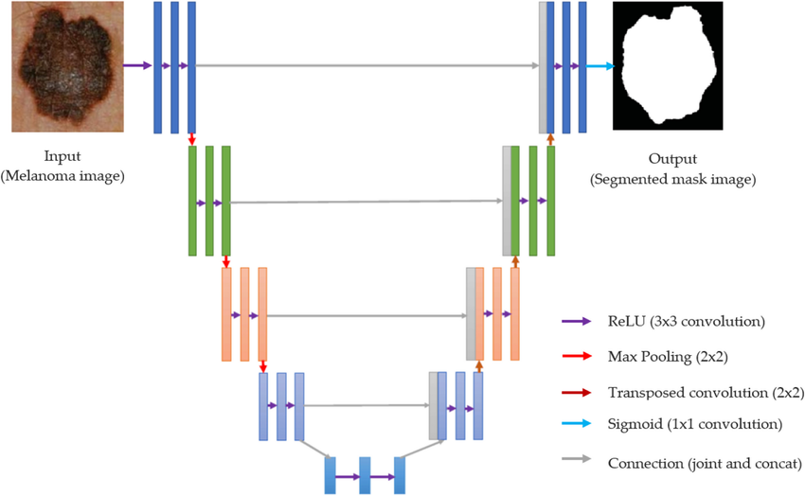
4
👉 The “U” shape comes from going down then up.

⚙️ 4. What goes INTO the U-Net?
At training time, the U-Net receives:
Input:
- noisy image xtx_txt​
- timestep ttt
Output:
- predicted noise ϵθ(xt,t)\epsilon_\theta(x_t, t)ϵθ​(xt​,t)

🧮 5. Mathematical role
Recall the key formula:
xt=αˉtx0+1−αˉtϵx_t = \sqrt{\bar\alpha_t} x_0 + \sqrt{1-\bar\alpha_t}\epsilonxt​=αˉt​​x0​+1−αˉt​​ϵ
We train:
ϵθ(xt,t)≈ϵ\epsilon_\theta(x_t,t) \approx \epsilonϵθ​(xt​,t)≈ϵ
👉 U-Net is just a parameterization of this function.

🧩 6. How timestep ttt is used
The model must know how noisy the image is.
So we embed ttt into a vector:
t→embedding(t)t \rightarrow \text{embedding}(t)t→embedding(t)
Then inject it into the network (usually via addition in layers).

Sinusoidal embedding (typical)
Similar to transformers:
Embed(t)=(sin⁡(⋅),cos⁡(⋅))\text{Embed}(t) = (\sin(\cdot), \cos(\cdot))Embed(t)=(sin(⋅),cos(⋅))
This lets the model understand time continuously.

🔧 7. Inside the U-Net (more precise)
Each block typically contains:
- Conv layers
- GroupNorm / BatchNorm
- Activation (SiLU / ReLU)
- Residual connections
Modern diffusion U-Nets are actually:
Residual U-Nets with attention

🧠 8. Attention in U-Net
To capture global structure, we add:
- self-attention layers at some resolutions
This helps with:
- long-range dependencies
- object coherence

🧾 9. Full computation pipeline
At each step ttt:
- Sample noise ϵ\epsilonϵ
- Construct:
xt=αˉtx0+1−αˉtϵx_t = \sqrt{\bar\alpha_t}x_0 + \sqrt{1-\bar\alpha_t}\epsilonxt​=αˉt​​x0​+1−αˉt​​ϵ
- Feed into U-Net:
ϵθ=U-Net(xt,t)\epsilon_\theta = \text{U-Net}(x_t, t)ϵθ​=U-Net(xt​,t)
- Compute loss:
∥ϵ−ϵθ∥2\|\epsilon - \epsilon_\theta\|^2∥ϵ−ϵθ​∥2

🎨 10. During sampling
At generation time:
- Start with noise xTx_TxT​
- Repeat:
  - feed into U-Net
  - predict noise
  - compute denoised estimate
- gradually get image
👉 U-Net is called hundreds of times per image.

🔍 11. Why skip connections matter
Without skip connections:
- you lose fine details
With skip connections:
- early layer details are reused
👉 This is crucial for:
- sharp images
- textures

🆚 12. Why not use a simple CNN or Transformer?
CNN only:
- loses global structure
Transformer only:
- expensive for images
U-Net:
- best of both worlds:
  - local + global
  - efficient
  - stable

🧠 13. Key insight (important)
The U-Net does NOT generate images directly.
It learns:
noisy image→what noise to remove\text{noisy image} \rightarrow \text{what noise to remove}noisy image→what noise to remove
That’s why diffusion works so well:
- each step is simple
- but repeated many times → complex generation

🚀 14. One-line summary
In diffusion models, the U-Net is a multi-scale denoising function that predicts noise at every timestep using both local features and global context.

