Code Review

Introduction
The papers-prototype implements a pipeline that converts PDF files into DOCX, extracts text, performs Named Entity Recognition (NER) with spaCy, and stores results into an SQLite database for later query via an interactive command-line interface.

While the prototype demonstrates the feasibility of the pipeline, several issues remain. A key concern is compatibility: some required packages (e.g., pdf2docx, spacy) fail to install across Python versions 3.6–3.11 when run under Anaconda 2.5 and Jupyter notebooks. This raises the risk that the program may need partial rewriting or dependency substitution to ensure broader portability.

Readability/Comprehension
From observation alone, the code contains multiple functions that are implemented in varying locations, it makes it more comprehensible and readable to me if all functions are implemented in the same location making them stand out and to prevent a stop-start feel to the code. For example the first function is called on line 13 then the remaining two are called on lines 135 and 156. The functions should remain in the same order,due to the build_and_cases function called within build_query.

Variable names like wb_obj were initially hard to understand, naming these variables like workbook instead will be more obvious that it relates to the excel document. Similarly, I had to research the .cursor() method to understand that the cur object was used to execute SQL commands, if this variable was named SQL_obj it would be more obvious. The important query_string variable could also be changed to Paper_query to make it obvious that this is where the objective of the program is carried out and assigned its variable.

Adding more blank spaces between code that isn't directly related for example, there is no breathing room from lines 71 to 128, the first two lines are the initialisation of empty arrays which is easily separated form the for loop that follows, within which there are two more for loops which could be separated for an easier read.

Documentation/Comments
All three functions declared in the code are not described using python docstrings which provide information on the variable inputs the return value, for example the first function on line 13; get_connection(db_file) is described as creating a connection with a SQL database without mentioning the argument and argument type and the return value. Correction with the first function example;

def get_connection(db_file: str) -> sqlite3.Connection:
"""
Create a database connection to a SQLite database.

Parameters:
db_file (str): Path to the SQLite database file.

Returns:
sqlite3.Connection: connection object to the SQLite database.
"""

The remaining two functions contain no definition, argument types or return types information in a docstring format.

The # Ignore Header Row comment is not needed as min_row 2 already tells us that the for loop is missing out the first row. Much like the comments on rows 82 and 84 that interrupt instructions that would be easier to comprehend if they were next to each other.

An initial comment with a brief description of what the code is doing would be helpful i.e
“Given a paper to search the program will find the associated papers with and their file type e.g JSON”

Adding comments explaining what each of the modules and methods contained within each of the imported libraries do would also be beneficial.

Structure/Design
The code contains multiple functions that are implemented in varying locations, it makes it more comprehensible and readable to me, if all functions are implemented in the same location making them stand out and to prevent a stop-start feel to the code. For example the first function is called on line 13 then the remaining two are called on lines 135 and 156. The functions should remain in the same order, due to the build_and_cases function being called within build_query.

The file path variables later used for concatenation and therefore storage can be moved to the top of the code for easy readability rather than being put between where a headers array is initialised and printed, as these are connected they should be connected in the code as well.

The first if statement on line 75 is an exceptional circumstance statement therefore would make more sense as an else statement or flagged somewhere else so there isn’s lots of if statements and for loops within the elif statement itself on line 77.

It would make the code more cohesive for the four modules imported from prompt_toolkit to be done at the top rather than on lines 130 onwards.

Don’t know if the elif statement on line 171 is used correctly and therefore required as the following comparisons with equal indentation are made with if.

Testing the function declared on line 13 with conn = get_connection("data/test_db.sqlite") on line 200 seems unstructured and confusing, as this was already done on line 41 along with creating the cursor object cur which has also been repeated.

Useability

The prototype demonstrates a functional end-to-end pipeline, but its usability can be evaluated in terms of both user-facing functionality and practical limitations.

Basic functionality:

Reads metadata from index.xlsx (columns paper_pdf, paper_name); Converts PDFs to DOCX using pdf2docx, with a fallback to PyMuPDF when conversion fails; Extracts paragraphs from DOCX and writes them to JSON; Runs Named Entity Recognition (NER) with spaCy (en_core_web_sm). And stores results in an SQLite database with three tables (papers, entities, papers_have_entities).In the same time, provides an interactive command-line query interface using prompt_toolkit.

Observed behaviour:
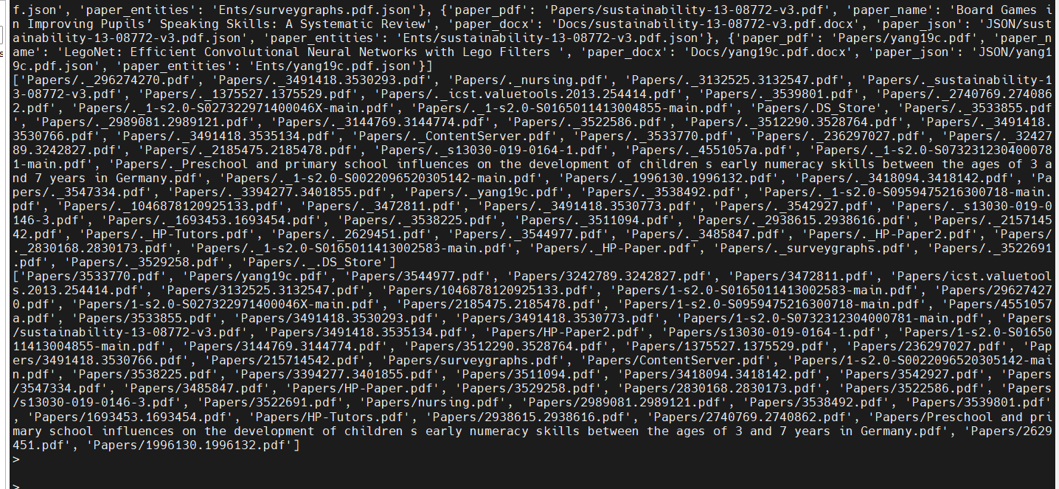
Figure 1 shows that after reading index.xlsx, the system constructs a processing dictionary mapping each PDF to corresponding DOCX, JSON, and entity files. This confirms that input metadata is correctly interpreted and required paths are prepared.
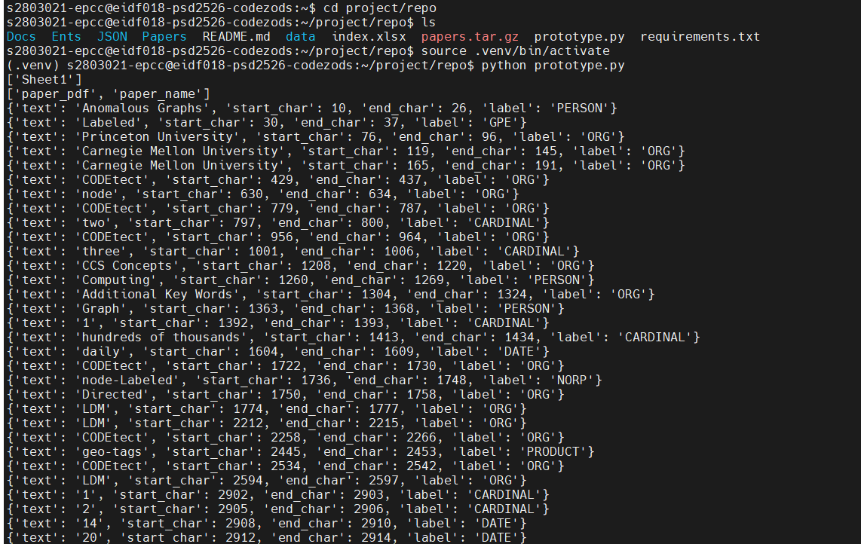
Figure 2 demonstrates console output after execution. The prototype successfully processes PDFs and identifies entities, reporting text spans, offsets, and labels.

For example:
"Princeton University" recognised as ORG.
"Anomalous Graphs" recognised as PERSON (incorrect, but demonstrates extraction).
"daily" recognised as DATE.

Input/output consistency:
for input Papers/1996130.1996132.pdf, the system generates:

Docs/1996130.1996132.pdf.docx (DOCX).

Miscellaneous
Automated build tools are not required since the project is in Python.
A complementary unit test suite would help validate correctness and prevent regressions during refactoring.

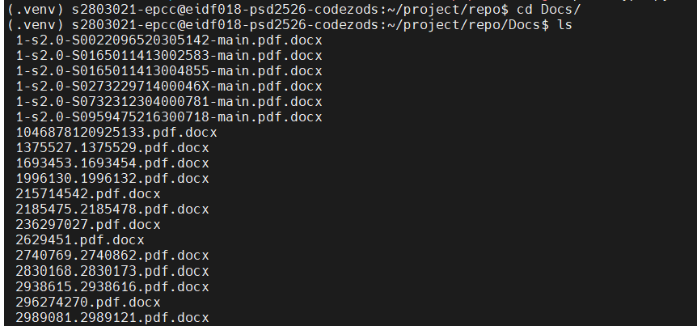

JSON/1996130.1996132.pdf.json (paragraph text).
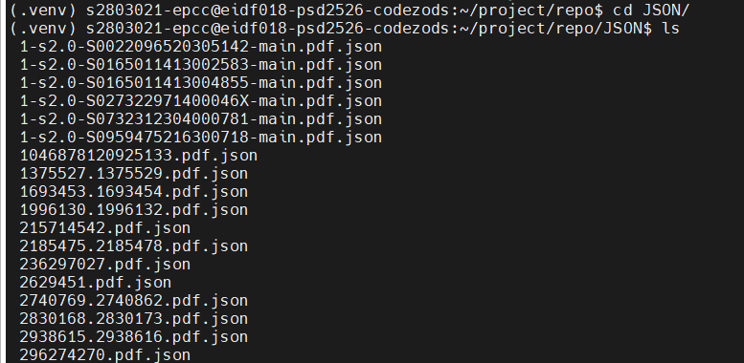

Ents/1996130.1996132.pdf.json (NER results).
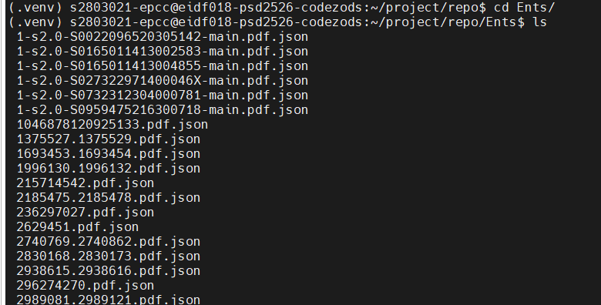

Usability issues:
by Adam:
When running, the code currently displays a paper title along with its file structure as such:
(52, 'Testing and Debugging Exascale Applications by Mocking MPI ', 'Papers/2830168.2830173.pdf', 'Docs/2830168.2830173.pdf.docx', 'JSON/2830168.2830173.pdf.json', 'Ents/2830168.2830173.pdf.json')
There is clearly a bug from these outputs as a file cannot have both json and pdf files.

Dependency compatibility:
Installation of pdf2docx and spacy failed in multiple environments (Python 3.6–3.11, macOS Monterey, Anaconda 2.5). This represents a practical usability issue for end users who may run the software in diverse environments.

Provide human-readable error messages, currently the program produces no error messages.
This could be corrected for example on line 75;
if len(find_file) == 0:
unprocessed.append(os.path.join(source_path, path))
Checks for an erroneous file, but just sends the file to a separate array which is then printed without comments.

Implement a -h|--help command-line parameter so the user can get information on what the program does and how to use it.

by Boyang:
Conversion reliability: The original implementation using pdf2docx frequently crashed ('Rect' object has no attribute 'get_area'). The fallback with PyMuPDF improves robustness but introduces inconsistencies in formatting.

File handling: When conversions fail, the code previously attempted to open missing .docx files, raising PackageNotFoundError. This caused abrupt termination rather than graceful error handling.

Text integrity: PyMuPDF sometimes extracted NULL or control characters, leading to ValueError: All strings must be XML compatible. This reduced usability, as users were met with cryptic errors.

Query system limitations: The CLI only supports exact entity matches. From a user perspective, the lack of fuzzy or full-text search makes queries less natural and less useful.

Error messages: Current outputs are low-level Python exceptions rather than human-readable guidance. For usability, the system should provide clear explanations, e.g., [ERROR] Missing DOCX file for input PDF.

Fixes introduced:

Added pdf_to_docx_with_fallback: if pdf2docx fails, PyMuPDF extracts plain text and saves it into a DOCX file, ensuring every PDF produces some usable output.

Implemented clean_text(): strips illegal characters before writing XML, preventing crashes.

Added lightweight logging messages ([INFO], [WARN]), improving user understanding of program status.

