Generated Examples that Showcases the Ability of an “AI HR”

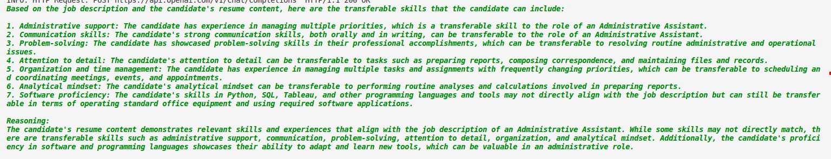
This generated answer to transferable skills of someone with software engineering background on matching to an administration assistant position showcases the importance of delving deeper into the resume and recognizing that there are skills that can be carried over and applied to specific job duties. A human HR may not give these things enough consideration.

