Software Installations 1

MacOS (only 10.8 and 10.9) 1

Installing Software: Python SDK 1

Python 2.7 1

Naoqi 1

Installing Software: OpenCV 2

numpy 1.10 2

matplotlib: 2

OpenCV for python 2

Windows 3

Installing Software: Python and Naoqi 3

Python 2.7 3

Naoqi 3

Installing Software: OpenCV 3

numpy 1.10 4

matplotlib 4

OpenCV for python 4

Creating Animations 4

Exporting to Python or C++ 5

Troubleshooting 5

Software Installations

# MacOS (only 10.8 and 10.9)

## Installing Software: Python SDK

To use Python with Nao independent of Choregraphe, we need to install the following:

1. Python 2.7
2. Pynaoqi

See http://doc.aldebaran.com/2-1/dev/python/install_guide.html for instructions

### Python 2.7

* MacOSX:
  + Comes preinstalled on MacOS X.
  + Aldebaran says to not use naoqi with Python versions downloaded from Python.org.

### Naoqi

* Available from https://community.aldebaran.com.
* Instructions available at http://doc.aldebaran.com/2-1/dev/python/install_guide.html
* You **must** be signed-in with an account connected to a robot to download it.
* Download the sdk and then add the path to the sdk to the PYTHONPATH by entering the following in a Terminal:

export PYTHONPATH=${PYTHONPATH}:/path/to/python-sdk

export DYLD_LIBRARY_PATH=${DYLD_LIBRARY_PATH}:/path/to/python-sdk

## Installing Software: OpenCV

OpenCV is a helpful library for vision analysis. There are packages for facial recognition, feature detection, filtering, etc. This requires installing the following for Python.

1. Numpy 1.10
2. Matplotlib (optional)
3. OpenCV

Nao comes with numpy and OpenCV installed, so you do not have to install any software on the robot.

### numpy 1.10

* http://www.numpy.org/.
* Can be installed using Python’s package manager. Enter the following in terminal:

pip install numpy

**I had to use sudo pip install numpy

* Can also be installed using Homebrew or Macports:

sudo port install py27-numpy

brew install numpy

### matplotlib:

* http://matplotlib.org/.
* This is not required, but this lets you display images, which is nice.

pip install numpy

### OpenCV for python

* http://opencv.org/
* Source code available at https://github.com/Itseez/opencv/
* Has to be built from binaries…there is no installer.
* There are a lot blog posts about doing this, so I will not duplicate that work, e.g.,
  + http://www.pyimagesearch.com/2015/06/15/install-opencv-3-0-and-python-2-7-on-osx/
  + http://www.learnopencv.com/install-opencv-3-on-yosemite-osx-10-10-x/
  + http://blogs.wcode.org/2014/10/howto-install-build-and-use-opencv-macosx-10-10/
  + …
* To use OpenCV, use the import statement (even for OpenCv 3.x):

import cv2

# Windows

## Installing Software: Python and Naoqi

To use Python with Nao, we need to install the following:

1. Python 2.7
2. Pynaoqi

### Python 2.7

* Available using a package manager like Anaconda, Homebrew, Macports,etc or from https://www.python.org/downloads/.
* Later, you will have to install numpy and matplotlib (which are part of the ScyPy stack), but this can be avoid if you obtain a distribution of python that comes with the ScyPy stack already installed. I have not tested this, so I am not sure how installing OpenCV or the naoqi will work if one of these distributions is used.
  + Anaconda Continuum.io, https://www.continuum.io/downloads
  + Enthought Canopy, https://www.enthought.com/products/canopy/
  + Python(x,y), http://python-xy.github.io/
  + WinPython, http://winpython.github.io/
* To add python to the environment path…so the system can find python and use pip:
  + Open control panel
  + Choose system
  + Choose advanced system settings
  + Choose environment variables
  + Select Path under System variables. Click Edit button.
  + Add C:\Python27 to the beginning of the variable value.
  + Click OK
  + Click Ok on the Environment Variables window

### Naoqi

* Available from https://community.aldebaran.com. You **must** be signed-in with an account connected to a robot to download it.
* Instructions available at http://doc.aldebaran.com/2-1/dev/python/install_guide.html
* Basically, download and run the installer.

## Installing Software: OpenCV

OpenCV is a helpful library for vision analysis. There are packages for facial recognition, feature detection, filtering, etc. This requires installing the following for Python.

1. Numpy 1.10
2. Matplotlib (optional)
3. OpenCV

Nao comes with numpy and OpenCV installed, so you do not have to install any software on the robot.

### numpy 1.10

* http://www.numpy.org/.
* Option 1:
  + Go to https://sourceforge.net/projects/numpy/files/NumPy/1.10.2/
  + Select download numpy-1.10.2-win32-superpack-python2.7.exe
  + Run installer
* Option 2:
  + Download the unofficial, prebuilt binaries appropriate for your computer from http://www.lfd.uci.edu/~gohlke/pythonlibs/#numpy
  + Move the downloaded file to: C:\Python27\Scripts
  + Then open Command Prompt. Navigate to C:\Python27\Scripts and use the following command:

pip install <name-of-file.whl>

* OpenCV will not work if it is an older version of numpy.
  + Naoqi appeared to install an older version of numpy, so make sure if you already had numpy installed, you are using Numpy 1.10. I had to reinstall/update numpy after installing naoqi.

### matplotlib

* http://matplotlib.org/
* This is not required, but this lets you display images, which is nice.
* Using the Python package manager:

pip install matplotlib

* Or, download an installer from https://pypi.python.org/pypi/matplotlib

### OpenCV for python

* Available at http://opencv.org/downloads.html
* OpenCv’s instructions work great, so follow those: http://opencv-python-tutroals.readthedocs.org/en/latest/py_tutorials/py_setup/py_setup_in_windows/py_setup_in_windows.html
* The above instructions worked on Windows 7
* to use OpenCV, use the import statement (even for OpenCv 3.x):

import cv2

Creating Animations

You can “train” Nao to do just about any sequence of movements you want. The instructions for doing this in the textbook do not work for NAO qi 2.1.x. The correct instructions are available at http://doc.aldebaran.com/2-1/software/choregraphe/animation_mode.html. The difference from the instructions in the textbook are:

* Turn off autonomous life by click the heart button. The heart is filled when autonomous life is turned on and the heart is empty when autonomous life is turned off.
* Click the wake up button (the shape burst button next to the heart button)
* Put NAO in animation mode by clicking the animation button (the button next to the heart button that has a human figure on it). This button will be green when animation mode is OFF and it will be red when animation is ON.
* Creating animations is otherwise the same except some of the wording on the buttons has changed (but they are in the same location, so it is easy to figure out what to do).
* Click the animation mode button again to remove NAO from animation mode when you are finished.

# Exporting to Python or C++

If you are creating a program using Python or C++, you can export a keyframe to Python or C++. In the timeline view, right click on the keyframe you want to export. From the menu, hover over “export motion to clipboard” and choose Python or C++. The code is now in your clipbard. Open the file you want to insert the movement into and paste the code where you want it.

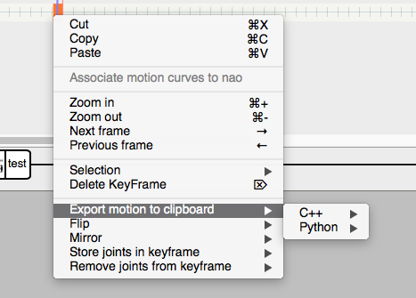

Troubleshooting

* When you open Choregraphe that bin/naoqi.exe has stopped working:
  + You can only have one instance of Choregraphe open at a time. This seems to only be a problem in Windows.
  + Windows:
    - Use Task Manager to kill all Choregraphe processes.
    - Reopen Choregraphe.

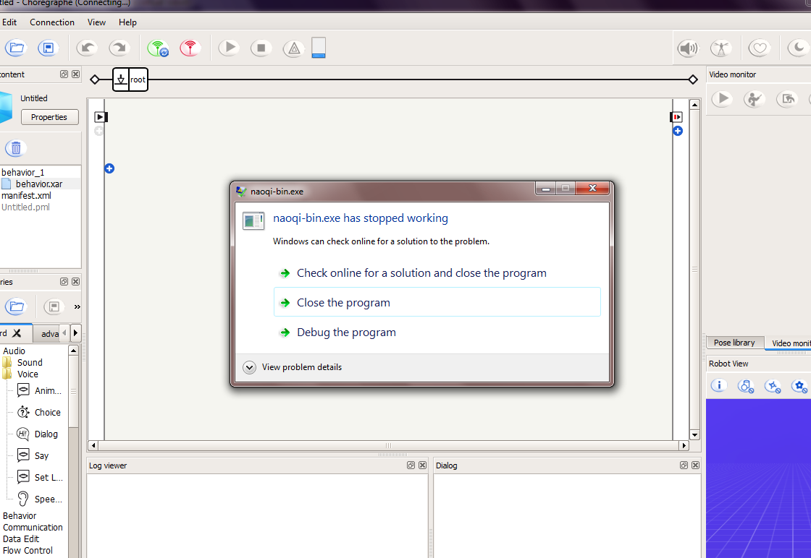

* + When you hover over Choregraphe in the Taskbar, you should only see one window. It should not look like the below:

