Smart Air Quality Monitoring and Prediction System
A Low-Cost, Open-Data Approach for Dhaka Using Deployed IoT Monitors (OpenAQ) and Machine Learning
A Project Report submitted in partial fulfillment of the requirements for the degree of
[Degree - e.g., B.Sc. in Computer Science & Engineering]
Submitted by
Lutful Ahmed Nadim
Mysha Maliha
Jannatun Nayem Aurpy
Alvee Ahnaf
Meher Nigar Anonna
Raisul Islam
Abdullah Al Yamin
Tahmid Alam
[Student IDs / Roll Numbers]
Supervised by
[Supervisor Name and Designation]
[Department Name]
[University / Institution Name]
June 2026

Abstract
Dhaka is consistently ranked among the most polluted cities in the world, with annual fine-particulate (PM2.5) concentrations many times higher than the World Health Organization guideline of 5 ug/m3 [1]. Reliable, real-time, and predictive air-quality information is therefore a public-health priority. This project designs and implements a Smart Air Quality Monitoring and Prediction System for Dhaka. The original specification called for custom IoT sensor nodes (ESP32 with PM2.5/CO2/temperature/humidity sensors); because purpose-built, well-calibrated hardware proved expensive, the team adopted an equivalent open-data alternative: hourly readings from already-deployed, commercial low-cost monitors are obtained through the OpenAQ v3 API [4]. The data pipeline cleans the series, computes the Air Quality Index from PM2.5 using the U.S. EPA 2024 breakpoints [2], engineers time and lag features, and trains machine-learning models to nowcast the next-hour PM2.5 and AQI. On a time-ordered hold-out test set of 4,256 hourly samples, Linear Regression was the best model, achieving a PM2.5 mean absolute error of 7.45 ug/m3 and a coefficient of determination (R2) of 0.74, narrowly outperforming a Random Forest. A Flask web dashboard with Chart.js and Leaflet presents the live multi-pollutant city sensor network on a map, colour-coded AQI, historical trends, the model's actual-versus-predicted performance, and a short recursive forecast. The result is a low-cost, reproducible, end-to-end system demonstrating that open monitoring data and lightweight machine learning can deliver actionable air-quality intelligence for a megacity without bespoke hardware.
Keywords: air quality, PM2.5, Air Quality Index, OpenAQ, machine learning, Random Forest, Linear Regression, nowcasting, IoT, Dhaka, dashboard.

Acknowledgements
We express our sincere gratitude to our supervisor, [Supervisor Name], for continuous guidance, constructive feedback, and encouragement throughout this project. We thank the [Department Name] and [University / Institution Name] for providing the academic environment and resources that made this work possible.
We gratefully acknowledge OpenAQ and the operators of the air-quality monitors across Dhaka, whose commitment to open environmental data allowed us to build and validate this system without prohibitively expensive instrumentation. Finally, we thank our families, friends, and peers for their support and patience during the course of this work.

Table of Contents
Right-click here and choose Update Field to build the table of contents.

(In Microsoft Word: press Ctrl+A then F9, or right-click the line above -> Update Field -> Update entire table, to populate page numbers automatically.)

List of Figures
Figure 3.1 Revised system architecture (deployed monitors -> OpenAQ -> ML -> dashboard)
Figure 4.1 Exploratory data analysis: PM2.5 over time and average PM2.5 by hour of day
Figure 4.2 Test set - actual vs. predicted PM2.5
Figure 4.3 Test set - actual vs. predicted AQI
Figure 4.4 Predicted vs. actual scatter (PM2.5 and AQI)

List of Tables
Table 3.1 Core tools and technologies
Table 4.1 Dataset summary
Table 4.2 Model performance comparison (hold-out test set)
Table C.1 U.S. EPA Air Quality Index categories (2024 PM2.5 breakpoints)
Table A.1 Backend REST API endpoints
Table B.1 Team members and functional roles

List of Abbreviations
Abbreviation | Meaning
AQI | Air Quality Index
PM2.5 | Particulate Matter <= 2.5 um
PM10 / PM1 | Particulate Matter <= 10 um / <= 1 um
WHO | World Health Organization
EPA | U.S. Environmental Protection Agency
NAAQS | National Ambient Air Quality Standards
API | Application Programming Interface
IoT | Internet of Things
ML | Machine Learning
LR / RF | Linear Regression / Random Forest
MAE | Mean Absolute Error
RMSE | Root Mean Squared Error
R2 | Coefficient of Determination
EDA | Exploratory Data Analysis
CSV | Comma-Separated Values
ug/m3 | Micrograms per cubic metre

Chapter 1: Introduction

1.1 Background and Context
Air pollution is among the most serious environmental health risks of our time. Fine particulate matter (PM2.5) - particles 2.5 micrometres in diameter or smaller - penetrates deep into the lungs and bloodstream and is linked to respiratory and cardiovascular disease and premature death. In 2021 the World Health Organization tightened its recommended annual PM2.5 limit from 10 to 5 ug/m3 (and the 24-hour limit to 15 ug/m3) [1]. Dhaka, the capital of Bangladesh, routinely records annual average PM2.5 around 68-78 ug/m3 - roughly fifteen times the WHO guideline - placing it among the most polluted cities in the world, with pollution peaking in the dry winter months [5][6].

1.2 Problem Statement
Despite the severity of the problem, citizens and decision-makers in Dhaka lack affordable, real-time, and forward-looking air-quality information at neighbourhood scale. Building a dense network of custom IoT sensor nodes is technically attractive but expensive once reliable sensors, calibration, enclosures, power, and connectivity are accounted for. The central problem this project addresses is therefore: how can a low-cost, end-to-end system continuously monitor air quality across a city, compute a standard health index, and predict short-term pollution trends, without depending on costly bespoke hardware?

1.3 Objectives
- Acquire real, continuous, hourly air-quality data for multiple locations across Dhaka.
- Compute the Air Quality Index from PM2.5 using a recognised international standard (U.S. EPA 2024).
- Develop and compare machine-learning models that nowcast the next-hour PM2.5 and AQI.
- Evaluate the models with standard regression metrics (MAE, RMSE, R2) on unseen data.
- Deliver an interactive web dashboard that visualises live readings, trends, validation, and a short forecast.
- Demonstrate a reproducible, low-cost alternative to custom IoT hardware using open monitoring data.

1.4 Significance of the Study
The system shows that open air-quality data and lightweight machine learning can together deliver actionable, city-scale intelligence at near-zero hardware cost. Because every component is built from open data and open-source software, the approach is reproducible and transferable to other data-scarce cities. For residents, the dashboard converts raw pollutant readings into an easily understood, colour-coded health index and a short-term outlook.

1.5 Scope and Limitations
The study focuses on Dhaka and on particulate pollution (PM2.5 as the primary pollutant, with PM10, PM1, temperature, and humidity where reported). Gaseous pollutants (NO2, SO2, O3, CO) and CO2 are out of scope because the low-cost monitors aggregated by OpenAQ report particulates and environment only; the AQI engine is nonetheless designed to incorporate gases when reference-station data are added. Prediction is a short-horizon nowcast rather than a multi-day air-quality forecast, and the web application is a development-grade demonstrator rather than a hardened production service.

1.6 Organisation of the Report
Chapter 2 reviews air-quality standards, the situation in Dhaka, open-data platforms, and machine learning for pollution prediction. Chapter 3 details the system architecture and methodology. Chapter 4 presents the results. Chapter 5 discusses their interpretation and limitations, and Chapter 6 concludes with recommendations and future work.

Chapter 2: Literature Review

2.1 Particulate Pollution and Health
PM2.5 is widely regarded as the air pollutant most consequential for human health. The WHO 2021 Global Air Quality Guidelines synthesise the epidemiological evidence and set the annual PM2.5 guideline at 5 ug/m3 and the 24-hour guideline at 15 ug/m3, a substantial tightening of the 2005 values that reflects health effects observed at low concentrations [1].

2.2 Air-Quality Indexing and the EPA AQI
To make pollutant concentrations interpretable, agencies map them onto an Air Quality Index. The U.S. EPA AQI converts PM2.5 concentration into a 0-500 index divided into colour-coded categories from Good to Hazardous. In February 2024 the EPA strengthened the annual PM2.5 standard from 12.0 to 9.0 ug/m3 and revised the AQI breakpoints accordingly, so that an AQI of 50 now corresponds to 9.0 ug/m3 [2][3]. Where several pollutants are measured, the reported AQI is the maximum of the individual pollutant sub-indices (the dominant-pollutant rule), which this project adopts.

2.3 Air Quality in Dhaka
Multiple assessments place Dhaka among the world's most polluted cities. International air-quality reports record annual PM2.5 averages of roughly 68-78 ug/m3 in recent years, with strong winter peaks driven by brick kilns, road and construction dust, vehicle exhaust, and household combustion [5][6]. This persistent, source-rich pollution motivates localised, neighbourhood-level monitoring rather than a single city-wide value.

2.4 Open Air-Quality Data and Low-Cost Sensors
OpenAQ is a non-profit platform that aggregates and harmonises open air-quality data from government reference monitors and low-cost sensors worldwide; by 2025 it hosted more than two billion measurements from over 20,000 locations across 134 countries [4]. Reference monitors are the accuracy gold standard, while low-cost sensors trade some accuracy for spatial density. By consuming existing OpenAQ-listed monitors through the v3 API, a project can obtain real, multi-location data immediately, sidestepping the cost and calibration burden of building its own sensor network - the key design decision in this work.

2.5 Machine Learning for PM2.5 and AQI Prediction
Data-driven models are widely used to predict PM2.5 and AQI. Ensemble tree methods such as Random Forest [7] are popular for their robustness and ability to capture non-linear relationships, and comparative studies routinely benchmark Linear Regression, Decision Trees, Random Forest, gradient boosting, and deep models such as LSTM, with reported accuracies varying by dataset and feature set [14]. A recurring finding is that recent (lagged) pollutant values are the strongest predictors of the next observation, which underpins the lag-feature design used here. Standard open-source libraries - scikit-learn [8], pandas [9], and NumPy [10] - make such pipelines reproducible.

2.6 Research Gap
While air-quality standards, open data, and prediction methods each exist independently, few low-cost student-scale systems integrate them end-to-end for a specific data-scarce megacity. This project fills that gap by combining open OpenAQ data for Dhaka, EPA-standard AQI computation, machine-learning nowcasting, and an interactive dashboard in a single reproducible system.

Chapter 3: Methodology

3.1 System Architecture
The architecture follows the data flow shown in Figure 3.1. Rather than custom sensor nodes, the system treats already-deployed low-cost monitors across Dhaka as its sensing layer and reads them through the OpenAQ v3 API. A Python data pipeline cleans the readings, computes AQI, engineers features, and trains the prediction model; a Flask backend serves the processed data and model outputs to a browser dashboard.
Deployed IoT monitors (Dhaka) -> OpenAQ v3 API -> Python pipeline (clean -> AQI -> features) -> ML model (train/predict) -> Flask API -> Web dashboard
Figure 3.1 Revised system architecture: the costly custom-hardware sensing layer is replaced by open data from monitors already deployed across the city.

3.2 Hardware Substitution Rationale
The original Project-01 specification required a working sensor node (ESP32/Arduino with PM2.5, CO2, temperature, and humidity sensors), a circuit diagram, and a calibration report. Reliable, well-calibrated particulate sensors and the supporting enclosure, power, and connectivity are expensive, and uncalibrated hobby sensors would have undermined data quality. The team therefore substituted the sensing layer with real readings from commercial low-cost monitors already operating in Dhaka and exposed through OpenAQ. This preserves the project's data-to-dashboard learning objectives while removing hardware cost and calibration risk.

3.3 Data Acquisition
Hourly observations are retrieved from several monitoring nodes across Dhaka via the OpenAQ v3 API. For each node the pipeline pulls every parameter the node exposes - PM2.5 plus, where available, PM10, PM1, temperature, and humidity - and stores a live multi-pollutant city snapshot (network.json) alongside the historical training series. A primary node (Uttara) provides the continuous PM2.5 series used for modelling, enriched with the node's PM1, temperature, and humidity channels.

3.4 Data Cleaning and Preprocessing
- Parse timestamps to a regular hourly index and sort chronologically.
- Remove null and physically implausible readings and obvious noise/outliers.
- Align multi-channel readings to a common hourly grid for the primary node.

3.5 AQI Computation
AQI is computed from PM2.5 using the U.S. EPA 2024 breakpoints with the standard piecewise-linear interpolation formula [2]. For nodes reporting multiple pollutants, each pollutant's sub-index is computed and the node's headline AQI is the worst (maximum) sub-index, with the driving pollutant labelled - the EPA dominant-pollutant rule.

3.6 Feature Engineering
Inputs to the model are derived from the cleaned series: calendar/time features (hour of day, day of week) and lagged PM2.5 values (recent past readings). Lag features capture the strong temporal autocorrelation of pollution, which is the dominant signal for a one-hour-ahead nowcast.

3.7 Model Development
The data are split by time - the earlier portion for training and the most recent, unseen tail for testing - to avoid look-ahead leakage and to imitate real deployment. Two models are trained and compared: Linear Regression as an interpretable baseline and a Random Forest regressor [7][8]. After modelling, 4,256 hourly samples were available. The best model is serialised (aqi_model.joblib) and consumed by the dashboard backend.

3.8 Evaluation Metrics
Model quality is measured with Mean Absolute Error (MAE), Root Mean Squared Error (RMSE), and the coefficient of determination (R2), reported for both predicted PM2.5 and the derived AQI on the hold-out test set.

3.9 Dashboard and Tools
The Flask backend exposes JSON endpoints (summary, network, history, predictions, forecast) that the frontend renders with Chart.js charts and a Leaflet map. The forecast is produced recursively from the latest readings for the next 12/24/48 hours. Table 3.1 lists the core technologies.
Table 3.1 Core tools and technologies.
Layer | Technology
Language | Python 3, JavaScript (ES6)
Data / ML | pandas, NumPy, scikit-learn, joblib
Data source | OpenAQ v3 REST API
Backend | Flask (REST API + template rendering)
Frontend | HTML5, CSS3, Chart.js, Leaflet (map)
Standard | U.S. EPA 2024 AQI breakpoints

Chapter 4: Results

4.1 Dataset Overview
After acquisition and cleaning, the modelling dataset comprised 4,256 hourly observations of PM2.5 (with derived AQI) for the primary Dhaka node, enriched with PM1, temperature, and humidity channels, plus a live multi-node city snapshot for the dashboard.
Table 4.1 Dataset summary.
Item | Value
Study area | Dhaka, Bangladesh (multiple monitoring nodes)
Primary pollutant | PM2.5 (AQI derived via EPA 2024)
Additional channels | PM10, PM1, temperature, humidity (where reported)
Temporal resolution | Hourly
Modelling samples | 4,256
Data source | OpenAQ v3 API

4.2 Exploratory Data Analysis
Exploratory analysis (Figure 4.1) shows the PM2.5 time series and a clear diurnal pattern in the average PM2.5 by hour of day, confirming the temporal structure the lag features exploit.
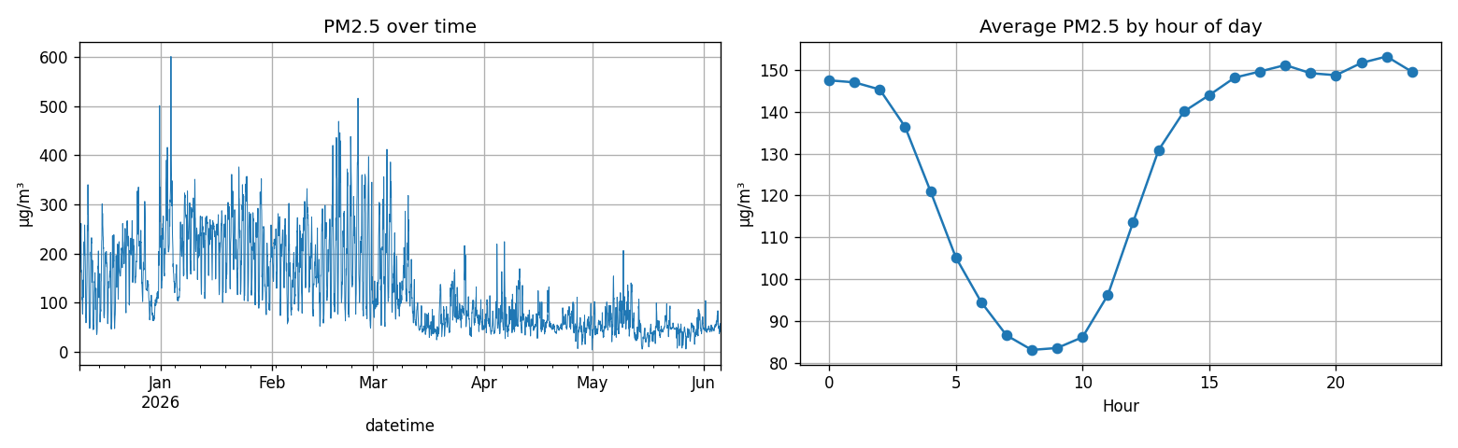
Figure 4.1 PM2.5 over time (left) and average PM2.5 by hour of day (right).

4.3 Model Performance
On the time-ordered hold-out test set, Linear Regression was the best model, achieving a PM2.5 MAE of 7.45 ug/m3 and R2 of 0.74, slightly ahead of the Random Forest on every metric. Table 4.2 reports the full comparison; Figures 4.2-4.4 show the fit on unseen data.
Table 4.2 Model performance comparison (hold-out test set).
Model | PM2.5 MAE | PM2.5 RMSE | PM2.5 R2 | AQI MAE | AQI RMSE
Linear Regression (best) | 7.454 | 11.883 | 0.738 | 11.729 | 17.029
Random Forest | 8.050 | 12.530 | 0.708 | 12.474 | 17.971

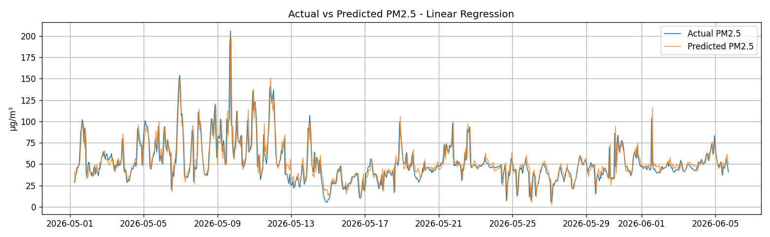
Figure 4.2 Test set: actual vs. predicted PM2.5.
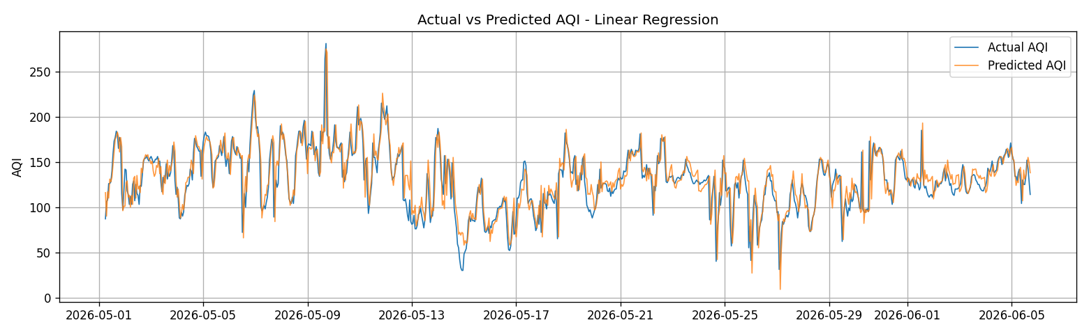
Figure 4.3 Test set: actual vs. predicted AQI.
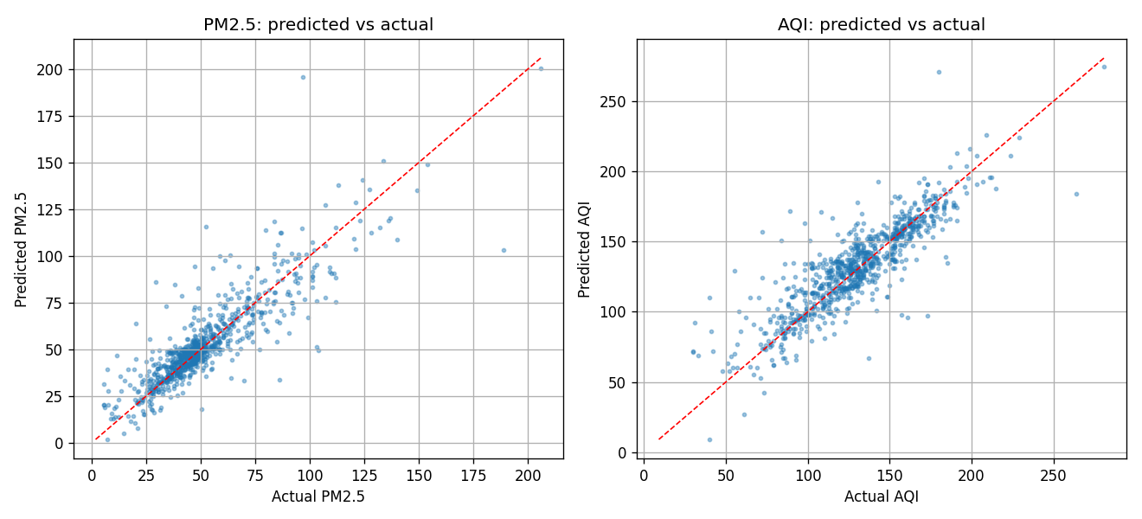
Figure 4.4 Predicted vs. actual scatter for PM2.5 and AQI.

4.4 Dashboard
The Flask + Chart.js + Leaflet dashboard renders: a colour-coded current-AQI indicator with the latest PM2.5; a live city sensor network on a map, each node showing every channel it measures and its worst-pollutant AQI; a per-pollutant area comparison of 30-day daily means; 7-day/30-day/1-year trend views; the model's actual-vs-predicted validation chart; and a 12/24/48-hour recursive forecast. The dashboard meets and exceeds the Phase-6 specification, which listed the map and forecast as optional/advanced features.

Chapter 5: Discussion

5.1 Interpretation of Results
An R2 of 0.74 for one-hour-ahead PM2.5 indicates the model explains most of the short-term variance, and a MAE of about 7.5 ug/m3 is small relative to Dhaka's typical PM2.5 range. That a simple Linear Regression slightly outperformed the Random Forest is consistent with the dominance of lagged PM2.5: when the next value is largely a near-linear function of the most recent values, a linear model captures the relationship with less risk of over-fitting than a high-variance ensemble on a moderate-sized dataset. This is a useful reminder that model complexity should be justified by the data, not assumed.

5.2 Comparison with the Literature
The results sit comfortably within the range reported in comparative PM2.5/AQI studies, where linear and tree-based models often perform similarly and lagged concentrations are the strongest predictors [7][14]. The project does not claim state-of-the-art accuracy; rather, it demonstrates that a competitive nowcast is achievable with open data and a lightweight pipeline.

5.3 The OpenAQ Substitution
Replacing custom hardware with OpenAQ data removed cost and calibration risk and provided immediate, multi-location, professionally maintained readings. The trade-offs are reduced control over sensor placement and a dependence on third-party data availability and channel coverage. On balance, for a time-bounded student project targeting a data-rich city, the substitution was clearly advantageous.

5.4 Limitations
- Pollutant coverage: the aggregated low-cost monitors report particulates and environment only, so CO2 and gaseous pollutants (NO2, SO2, O3, CO) required by the original brief are absent; the AQI engine supports them once reference-station data are added.
- No physical sensor node: the hardware deliverables (sensor node, circuit diagram, calibration report) are intentionally out of scope under the substitution.
- Short horizon: the model nowcasts one hour ahead; longer horizons would need weather inputs and a different formulation.
- Single city and development server: results are specific to Dhaka and the app is a demonstrator, not a hardened production deployment.

5.5 Unexpected Outcomes
The most notable surprise was the baseline Linear Regression edging out the Random Forest. Rather than a defect, this is an informative outcome about the near-linear, autocorrelated nature of the short-term signal, and it motivates testing gradient-boosting and sequence models on larger, multi-feature datasets in future work.

Chapter 6: Conclusion and Recommendations

6.1 Conclusion
This project delivered a complete, low-cost Smart Air Quality Monitoring and Prediction System for Dhaka. By substituting expensive custom IoT hardware with open data from deployed monitors via OpenAQ, the team built an end-to-end pipeline that acquires hourly readings, computes EPA-standard AQI, nowcasts the next hour with machine learning (best model: Linear Regression, PM2.5 R2 = 0.74, MAE = 7.45 ug/m3), and presents everything through an interactive Flask dashboard with a live city map, trends, validation, and a short forecast. All core software and analytical objectives of the original specification were met, and several optional dashboard features were exceeded.

6.2 Recommendations and Future Work
- Add gaseous pollutants (NO2, SO2, O3, CO) and CO2 by including reference-station location IDs, enabling a true multi-pollutant AQI.
- Optionally deploy a small number of the team's own calibrated low-cost nodes to complement OpenAQ and recover the hands-on hardware learning objective.
- Benchmark gradient-boosting (XGBoost/LightGBM) and sequence models (LSTM) on a larger, multi-feature dataset.
- Extend prediction to multi-hour and multi-day horizons using forecast weather inputs.
- Add health alerts (SMS/email/push) and a mobile-friendly interface.
- Harden and containerise the application for reliable public deployment.

References
[1] World Health Organization, "WHO global air quality guidelines: particulate matter (PM2.5 and PM10), ozone, nitrogen dioxide, sulfur dioxide and carbon monoxide," WHO, Geneva, Switzerland, 2021. [Online]. Available: https://www.who.int/publications/i/item/9789240034228
[2] U.S. Environmental Protection Agency, "Final Updates to the Air Quality Index (AQI) for Particulate Matter," Fact Sheet, EPA, Feb. 2024. [Online]. Available: https://www.epa.gov/system/files/documents/2024-02/pm-naaqs-air-quality-index-fact-sheet.pdf
[3] U.S. Environmental Protection Agency, "Reconsideration of the National Ambient Air Quality Standards for Particulate Matter," Final Rule, Federal Register, Mar. 6, 2024.
[4] OpenAQ, "OpenAQ Data Platform: Providing Air Quality Data," OpenAQ (non-profit), 2024. [Online]. Available: https://openaq.org
[5] IQAir, "Dhaka Air Quality Index (AQI) and Bangladesh Air Pollution," IQAir, 2026. [Online]. Available: https://www.iqair.com/bangladesh/dhaka/dhaka
[6] The Business Standard, "Bangladesh's air remains the second-worst globally in 2025," Dhaka, Bangladesh, 2025. [Online]. Available: https://www.tbsnews.net
[7] L. Breiman, "Random forests," Machine Learning, vol. 45, no. 1, pp. 5-32, 2001.
[8] F. Pedregosa et al., "Scikit-learn: Machine learning in Python," Journal of Machine Learning Research, vol. 12, pp. 2825-2830, 2011.
[9] W. McKinney, "Data structures for statistical computing in Python," in Proc. 9th Python in Science Conf. (SciPy), 2010, pp. 56-61.
[10] C. R. Harris et al., "Array programming with NumPy," Nature, vol. 585, pp. 357-362, 2020.
[11] Pallets Projects, "Flask Documentation," 2024. [Online]. Available: https://flask.palletsprojects.com
[12] Chart.js, "Chart.js - Open source HTML5 charts." [Online]. Available: https://www.chartjs.org
[13] Leaflet, "Leaflet - an open-source JavaScript library for interactive maps." [Online]. Available: https://leafletjs.com
[14] "PM2.5 concentration prediction using machine learning algorithms: an approach to virtual monitoring stations," Scientific Reports, vol. 15, 2025. [Online]. Available: https://www.nature.com/articles/s41598-025-92019-3

Appendices

Appendix A: Backend REST API Endpoints
Table A.1 Backend REST API endpoints (Flask).
Endpoint | Purpose
/ | Renders the dashboard (index.html)
/api/summary | Latest PM2.5 + current AQI and category
/api/meta | Model card / provenance and feature list
/api/network | Live multi-pollutant city snapshot (all nodes)
/api/history | Historical pollutant/environment series
/api/predictions | Test-set actual vs. predicted PM2.5 / AQI
/api/forecast | Recursive next 12/24/48-hour forecast

Appendix B: Team Members and Functional Roles
Functional areas follow the original five-lead structure of Project 01; responsibilities were shared across the eight-member team. Assignments below are indicative.
Table B.1 Team members and functional roles (indicative).
Member | Primary functional area
Lutful Ahmed Nadim | Data source & API integration (OpenAQ)
Mysha Maliha | Data pipeline & cloud/backend communication
Jannatun Nayem Aurpy | Data analytics & preprocessing (EDA)
Alvee Ahnaf | Machine-learning modelling & evaluation
Meher Nigar Anonna | Machine-learning modelling & evaluation
Raisul Islam | Web dashboard (frontend) development
Abdullah Al Yamin | Backend / API & deployment
Tahmid Alam | Documentation, testing & presentation

Appendix C: U.S. EPA Air Quality Index Categories
PM2.5 24-hour breakpoints per the EPA 2024 update [2]. Concentrations in ug/m3.
Table C.1 EPA AQI categories (2024 PM2.5 breakpoints).
AQI category | AQI range | PM2.5 (ug/m3)
Good | 0-50 | 0.0-9.0
Moderate | 51-100 | 9.1-35.4
Unhealthy for Sensitive Groups | 101-150 | 35.5-55.4
Unhealthy | 151-200 | 55.5-125.4
Very Unhealthy | 201-300 | 125.5-225.4
Hazardous | 301-500 | 225.5-325.4+

Appendix D: Repository Structure
dataset/ training_data.csv (hourly PM2.5 + AQI)
ml_model/ notebooks (clean + executed), add_pollutants.py, gen_predictions.py,
gen_model_card.py, aqi_model.joblib, metrics.json, predictions CSV
backend/ app.py (Flask API), gen_network.py, dashboard_data.csv, network.json
frontend/ templates/index.html, static/app.js, static/style.css
documentation/ STRUCTURE.md, figures/*.png
requirements.txt, README.md

