**High-Level Steps for building the CRM**

Contents

Create a WordPress blog EC2 instance via CloudFormation 1

Go into the stack in CloudFormation and visit the WordPress blog; set-up initial credentials via the WordPress interface; add a file upload plug-in 2

Connect to EC2 instance via command line; install AWS CLI 2

Add a shell file that can transfer a file from the EC2 instance to S3 3

Create two Lambda functions—one that can execute the shell script (give the function a security policy access to S3 and SSM); and one that sends emails from the file transferred to S3 (give the function a security policy access to S3 and SES) 3

Verify the email addresses to be used in SES 4

Schedule the two Lambda functions with EventBridge 5

# Create a WordPress blog EC2 instance via CloudFormation

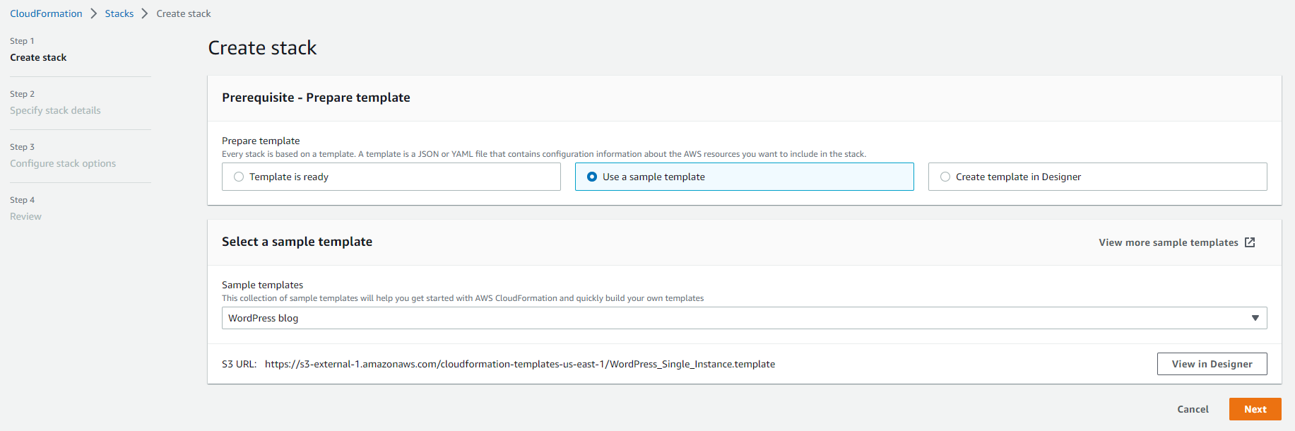

# Go into the stack in CloudFormation and visit the WordPress blog; set-up initial credentials via the WordPress interface; add a file upload plug-in

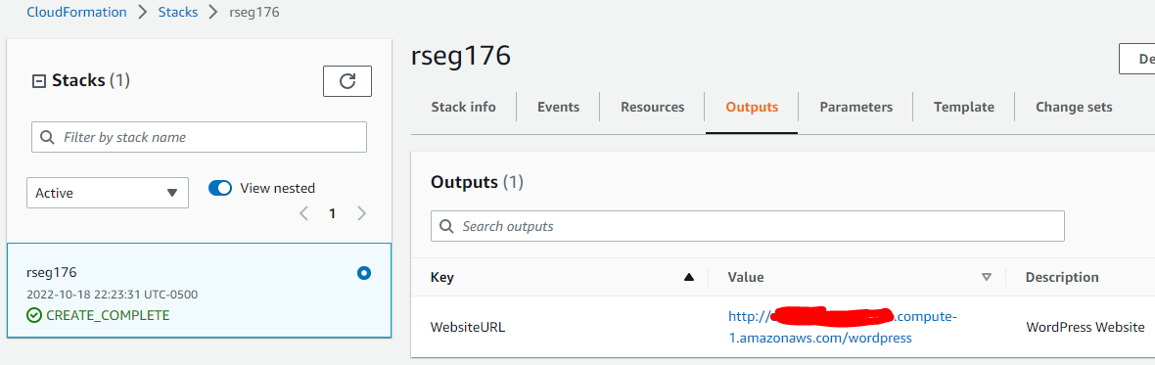

# Connect to EC2 instance via command line; install AWS CLI

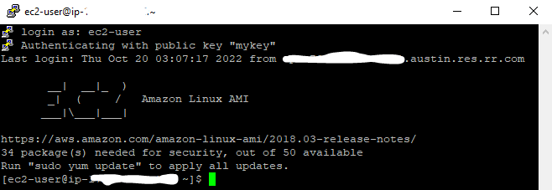

# Add a shell file that can transfer a file from the EC2 instance to S3

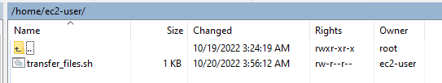

# Create two Lambda functions—one that can execute the shell script (give the function a security policy access to S3 and SSM); and one that sends emails from the file transferred to S3 (give the function a security policy access to S3 and SES)

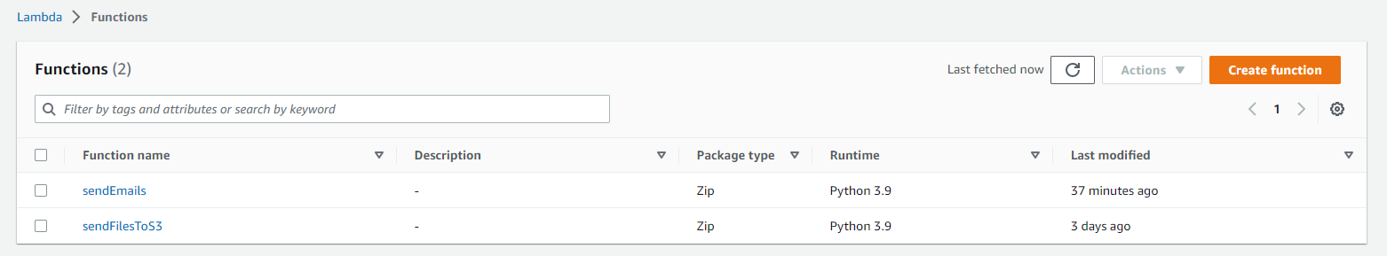

# Verify the email addresses to be used in SES

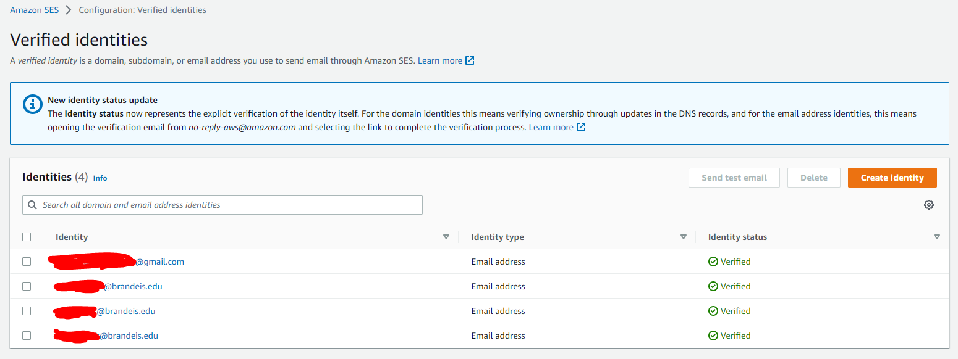

# Schedule the two Lambda functions with EventBridge

