Sales and Demand Forecasting
Using Time Series Analysis
MINI PROJECT REPORT
Submitted in partial fulfilment of the requirement for the award of the degree of Bachelor of Technology
in
Computer Science and Engineering
Data Science
Submitted to
DR. A.P.J. ABDUL KALAM TECHNICAL UNIVERSITY, UTTAR PRADESH,
LUCKNOW

Submitted by  Name: Happy  Roll No: 2301531540016  Semester: 7th Section: E | Under the Supervision of  Dr. Alankrita Agarwal  Professor

Department of Computer Science & Engineering & Allied Branches
Lloyd Institute of Engineering & Technology
Plot No. 3, Knowledge Park II, Greater Noida, Uttar Pradesh 201306

Session: 2026–27

CERTIFICATE
This is to certify that the Mini Project Report entitled Sales and Demand Forecasting Using Time Series Analysis is submitted by Happy, Roll No 2301531540016, in partial fulfilment of the requirements for the award of the degree of Bachelor of Technology in Computer Science and Engineering Data Science during the academic session 2026–27, Seventh Semester, at Lloyd Institute of Engineering and Technology, Greater Noida.
_____________________  Project Guide  Dr. Alankrita Agarwal  Professor | _____________________  Project Coordinator  Mr. Vishal Gupta  Assistant Professor | _____________________  Head of Department  Dr. Alankrita Agarwal  Professor
The work is submitted for examination under the supervision of Dr. Alankrita Agarwal, Professor. The project and this report are subject to verification and approval by the undersigned institutional authorities.

Date: 24/10/2026
Place: Greater Noida

DECLARATION
I hereby declare that the Mini Project Report entitled “Sales and Demand Forecasting Using Time Series Analysis” submitted to the Department of Computer Science and Engineering [Data Science], Lloyd Institute of Engineering and Technology , in partial fulfilment of the requirements for the degree of B.Tech Data Computer Science and Engineering [Data Science]is a record of original work carried out by me under the guidance of Dr. Alankrita Agarwal, Professor.
I further declare that this report has not been copied from any other source, and that all references, data and material taken from other sources have been duly acknowledged. The similarity index of this report, as checked using [Turnitin / Grammarly / Institution tool], is % (excluding references, code and standard boilerplate text), which is below the permitted limit of 20%.

Signature: ____________________
Name: Happy
Roll No.: 2301531540016
Date: 24/10/2026

ACKNOWLEDGEMENT
I would like to express my gratitude to my project guide, Dr. Alankrita Agarwal, Professor , Department of Computer Science and Engineering and Allied Branches, for the guidance and feedback associated with this mini project.
I thank Mr. Vishal Gupta, Project Coordinator, and Dr. Alankrita Agarwal Head of Department, for their academic support. I also thank Lloyd Institute of Engineering and Technology for the learning environment in which this work is submitted.
I acknowledge the developers and maintainers of Python, Pandas, NumPy, Matplotlib, Plotly, statsmodels, scikit-learn and Streamlit. Their software makes the analytical workflow and presentation interface possible. The UCI Online Retail schema and the forecasting resources listed in the references provide context for the project.
I am also thankful to my family, friends and classmates for their encouragement during my studies.
Happy
BTech Computer Science and Engineering Data Science
Seventh Semester Session 2026–27

ABSTRACT
This project implements a daily sales forecasting workflow that converts retail transactions into analytical outputs and a thirty-day forecast. The system validates required fields, removes selected invalid records, calculates transaction revenue, aggregates daily sales and produces exploratory charts. A chronological split compares a Naive baseline, ARIMA(1,1,1) and SARIMA(1,1,1)(1,0,1,7) using mean absolute error, root mean squared error and mean absolute percentage error. The selected method is refitted on the complete history, and a Streamlit dashboard presents saved results through six tabs.
The reported experiment uses 13,089 synthetic transactions covering 1,096 days from January 2022 to December 2024. Retained revenue totals £548,324.51. SARIMA records the lowest validation MAE of £205.82, compared with £213.85 for Naive and £221.07 for ARIMA. It generates forecasts for January 2025, although the final fit emits a convergence warning. Twelve focused checks produce ten passes and expose two input-validation defects.
The project demonstrates an inspectable analytical pipeline rather than verified commercial forecasting performance. Its target is monetary sales, which differs from product demand in units. Stronger validation, rolling backtests, convergence diagnostics and real-data evaluation are required before operational use.
Keywords: sales forecasting, time series, ARIMA, SARIMA, synthetic data, Streamlit.

Certificate i
Declaration ii
Acknowledgement iii
Abstract iv
List of Figures viii
List of Tables ix
List of Abbreviations x
CHAPTER 1 INTRODUCTION 1
1.1 Background and project purpose 1
1.2 Problem statement 2
1.3 Objectives and deliverables 3
1.4 Scope and boundaries 4
1.5 Value and appropriate use 5
1.6 Organisation of the report 6
CHAPTER 2 LITERATURE REVIEW AND EXISTING SYSTEM 7
2.1 Forecasting foundations 7
2.2 Existing manual and spreadsheet approaches 8
2.3 Naive and moving average methods 9
2.4 ARIMA model 10
2.5 Seasonal ARIMA and weekly structure 11
2.6 Data source and software background 12
2.7 Research gap and selected approach 13
2.8 Revenue and unit demand as separate targets 14
2.9 Fixed origin and rolling origin evaluation 15
2.10 Model complexity and evidence requirements 16
CHAPTER 3 SYSTEM ANALYSIS AND DESIGN 17
3.1 Functional requirements 17
3.2 Quality requirements and feasibility 18
3.3 System architecture 19
3.4 Data flow and processing stages 20
3.5 Input data dictionary 21
3.6 Output data relationships 22
3.7 Chronological evaluation design 23
3.8 Forecast uncertainty design 24
3.9 Design risks and controls 25
3.10 Worked transaction to daily sales example 26
3.11 Data quality rules and audit trail 27
3.12 Module contracts and failure boundaries 28
3.13 Requirements traceability and review procedure 29
CHAPTER 4 IMPLEMENTATION 30
4.1 Project structure and execution environment 30
4.2 Input loading and schema checks 31
4.3 Filtering and sales amount calculation 32
4.4 Daily series construction 33
4.5 Exploratory analysis implementation 34
4.6 Stationarity and decomposition implementation 35
4.7 Model fitting and comparison 36
4.8 Error metrics and selection rule 37
4.9 Thirty day forecast generation 38
4.10 Dashboard implementation 39
4.11 Pipeline control sequence 40
4.12 Reproducibility and version management 41
4.13 Dashboard refresh and presentation checks 42
CHAPTER 5 TESTING 43
5.1 Testing strategy and evidence 43
5.2 Input and preprocessing test cases 44
5.3 Validation defects and proposed corrections 45
5.4 Temporal and numerical tests 46
5.5 Integration outputs and convergence warning 47
5.6 Acceptance criteria and remaining tests 48
5.7 Boundary test design for future hardening 49
5.8 Regression checks after code changes 50
CHAPTER 6 RESULTS AND DISCUSSION 51
6.1 Dataset and cleaning results 51
6.2 Daily sales and long term movement 52
6.3 Monthly and weekly seasonal patterns 53
6.4 Product and country contributions 54
6.5 Stationarity and decomposition results 55
6.6 Model comparison and interpretation 56
6.7 Thirty day forecast results 57
6.8 Discussion and limits of the findings 58
6.9 Forecast output audit 59
6.10 Monthly sales across the three sample years 60
6.11 Forecast detail for January eight to nineteen 61
6.12 Forecast detail for January twenty to thirty 62
CHAPTER 7 CONCLUSION AND FUTURE SCOPE 63
7.1 Conclusion 63
7.2 Limitations 64
7.3 Future scope and development priorities 65
REFERENCES 66
APPENDIX A Reproduction instructions 67
APPENDIX B Selected source code 68
APPENDIX C Submission completion 69

LIST OF FIGURES
Fig. 3.1 File based system architecture...............................................................................19
Fig. 3.2 Analysis and forecast data flow.............................................................................20
Fig. 3.3 Training validation and final forecast timeline......................................................23
Fig. 6.1 Daily synthetic sales and thirty day rolling mean..................................................52
Fig. 6.2 Monthly synthetic sales totals................................................................................53
Fig. 6.3 Product revenue contribution in the synthetic sample...........................................54
Fig. 6.4 Additive decomposition with a seven day period..................................................55
Fig. 6.5 MAE and RMSE comparison on synthetic validation data...................................56
Fig. 6.6 Thirty day sales forecast and nominal model bounds............................................57

LIST OF TABLES
Table 1.1 Objectives and corresponding deliverables...........................................................3
Table 2.1 Comparison of analytical approaches...................................................................8
Table 3.1 Functional requirements and implementation.....................................................17
Table 3.2 Transaction input dictionary...............................................................................21
Table 3.3 Generated data products......................................................................................22
Table 3.4 Design risk assessment........................................................................................25
Table 3.5 Worked aggregation fixture................................................................................26
Table 3.6 Preparation audit fields.......................................................................................27
Table 3.7 Requirement verification matrix.........................................................................29
Table 4.1 Modules and responsibilities...............................................................................30
Table 4.2 Metric interpretation............................................................................................37
Table 4.3 Dashboard tabs and content................................................................................39
Table 5.1 Verification scope...............................................................................................43
Table 5.2 Preparation test results........................................................................................44
Table 5.3 Failed boundary checks.......................................................................................45
Table 5.4 Temporal and metric test results.........................................................................46
Table 5.5 Acceptance assessment.......................................................................................48
Table 5.6 Proposed boundary tests not yet executed..........................................................49
Table 6.1 Sample dataset summary.....................................................................................51
Table 6.2 Forecast errors on the validation segment...........................................................56
Table 6.3 First seven exported forecast days......................................................................59
Table 6.4 Monthly synthetic revenue by calendar year......................................................60
Table 6.5 Exported forecast continuation...........................................................................61
Table 6.6 Exported forecast continuation...........................................................................62
Table 7.1 Prioritised future work........................................................................................65

LIST OF ABBREVIATIONS
Abbreviations used in the report
Abbreviation | Full form
ADF | Augmented Dickey Fuller
ARIMA | Autoregressive Integrated Moving Average
CSV | Comma Separated Values
DFD | Data Flow Diagram
EDA | Exploratory Data Analysis
IEEE | Institute of Electrical and Electronics Engineers
MAE | Mean Absolute Error
MAPE | Mean Absolute Percentage Error
RMSE | Root Mean Squared Error
SARIMA | Seasonal Autoregressive Integrated Moving Average
SARIMAX | Seasonal ARIMA with Exogenous Regressors
UCI | University of California Irvine
UI | User Interface

CHAPTER 1 INTRODUCTION

1.1 Background And Project Purpose
Retail invoices record individual purchases, but planning usually requires a view of sales over time. A transaction table can answer which item was sold and at what price; it does not immediately show the expected level of sales next week. This project connects these two views by converting transactions into a continuous daily series and applying statistical forecasting methods.
The implemented system contains a Python analysis pipeline and a Streamlit dashboard. The pipeline cleans input records, calculates sales amounts, produces exploratory charts, compares three forecasting methods and exports a thirty-day forecast. The dashboard reads those exported files and presents results through six tabs. The project therefore demonstrates a complete workflow from data preparation to presentation.
The numerical target is daily sales revenue, calculated as quantity multiplied by unit price. Although the project title refers to demand, revenue is only an indirect indicator of demand. Changes in price or product mix can alter revenue without the same change in units sold. The report uses the term sales forecast when describing the implemented target and reserves unitdemand forecasting for future development.
The experiment uses the bundled synthetic dataset covering 2022 to 2024. It demonstrates execution and method comparison; it does not establish accuracy for a real retailer. This distinction is central to interpreting the findings in Chapter 6. The forecasting workflow follows the general sequence of understanding the series, establishing a baseline, evaluating predictions and interpreting uncertainty [1].

1.2 Problem Statement
The central problem is to transform dated retail transactions into an interpretable estimate of future aggregate sales. Invoice-level records may contain cancellations, invalid dates and unusable prices. Dates may be absent entirely. Without a defined preparation process, these conditions can produce inconsistent totals and misleading forecasts.
Manual inspection also becomes difficult when transactions span several years. A user needs to see daily variation, monthly totals, the relative contribution of products and countries, and the performance of competing forecast methods. A single chart cannot answer all these questions. The system therefore separates preparation, exploratory analysis, modelling and presentation while connecting them through saved output files.
The analytical problem can be expressed as follows. Given historical daily sales y1 through yT, generate forecasts for yT+1 through yT+30 using only observations available at the forecasting origin. Evaluate candidate methods on a later chronological segment before refitting the selected method on the complete series. This preserves the direction of time and creates an explicit selection rule.
Several limits are part of the problem definition. The application does not receive stock availability, promotions, marketing spend or future price information. It cannot infer lost sales during stock-outs or recommend a purchase order directly. Its output is a statistical estimate that supports planning discussion. The appropriate success criterion is a reproducible workflow with transparent errors and limitations, rather than a claim of guaranteed commercial benefit.

1.3 Objectives And Deliverables
The first objective is to prepare a consistent daily sales series. Preparation includes requiredcolumn validation, date and numeric conversion, cancellation filtering, removal of selected invalid records, revenue calculation and calendar completion. The resulting series provides the common input for both exploratory charts and forecasting.
The second objective is to make historical behaviour understandable. Daily and monthly charts show sales movement, product and country charts show contribution, and a rolling mean reduces short-term visual noise. Weekly decomposition and an augmented Dickey–Fuller test provide additional descriptive information about temporal structure.
The third objective is to compare a simple Naive forecast with ARIMA and seasonal ARIMA. The comparison uses a chronological split and reports MAE, RMSE and MAPE. The method with the lowest reported MAE is used to produce a thirty-day future forecast. The fourth objective is to present these outputs in a dashboard and retain downloadable daily data.
Table 1.1 maps the objectives to concrete files or behaviours. It also makes an important distinction between a completed implementation feature and evidence of forecast quality. A forecast file confirms that execution completed; its existence alone does not prove that the forecast is reliable.
Table 1.1 Objectives and corresponding deliverables
Objective | Deliverable
Prepare transactions | cleaned_transactions.csv and daily_sales.csv
Explain historical sales | Six EDA charts and weekly decomposition
Compare forecast methods | model_comparison.csv with three error metrics
Estimate future sales | Thirty dated rows in future_forecast.csv
Present analysis | Six Streamlit tabs and daily CSV download

1.4 Scope And Boundaries
The system accepts UCI-style transaction data in CSV or spreadsheet form. Required columns identify invoices, products, descriptions, quantities, dates, prices and countries. CustomerID is optional for processing, although the bundled sample includes it. The modelled series is the sum of valid sales amounts across all products and countries for each calendar day.
The temporal scope is daily aggregation with a fixed thirty-day future horizon. The statistical comparison includes a last-observation Naive baseline, ARIMA(1,1,1) and SARIMA(1,1,1) (1,0,1,7). Model orders are fixed in the source code. There is no automated search over alternative seasonal periods, external variables or model families.
The dashboard is a local analytical interface. It displays stored outputs rather than fitting models interactively. Data replacement is performed by rerunning the command-line pipeline. The application does not include user accounts, access roles, a transactional database, online data ingestion or an inventory ordering integration. These omissions keep the academic implementation understandable and limit deployment claims.
The report covers the supplied code, a reproducible run on the bundled sample, additional focused checks and interpretation of generated artefacts. It includes design diagrams that describe the implemented file-based architecture. It does not present an invented production deployment, a completed plagiarism assessment or signed institutional approval. These submission activities require the appropriate student and institutional processes.

1.5 Value and appropriate use
A useful contribution of the project is the connection between model output and the data preparation choices that produced it. The same transaction set is used for summary values, daily aggregation and forecast evaluation. This makes it possible to trace a surprising chart or error metric back to the underlying records instead of treating the forecast as an isolated number.
The comparison also illustrates why a simple baseline matters. A statistical model has more parameters and requires numerical fitting. It should earn that complexity through measured performance. In the sample run, ARIMA does not outperform the Naive baseline by MAE. Reporting that result is more informative than assuming that every advanced model must be superior.
For an academic user, the exported files make the workflow inspectable. Cleaned transactions can be compared with the raw input, daily totals can be recalculated, and model rankings can be checked from a compact metrics table. The dashboard then provides an accessible presentation layer for discussion and demonstration.
For a business user, the project would be an initial analytical prototype. Before operational use, it would require verified business data, stronger validation, repeated historical backtests and a clear relationship between forecast uncertainty and decisions. Revenue forecasts could assist budget discussion, but replenishment would require product quantities, lead times and servicelevel assumptions. The project is most valuable when used within these limits rather than as a complete inventory-management solution.

1.6 Organisation Of The Report
Chapter 2 explains the forecasting concepts and existing approaches relevant to the implementation. It distinguishes a conceptual literature review from an empirical comparison: the report runs three implemented models, while additional methods are discussed only as context or future alternatives.
Chapter 3 translates the project objectives into requirements, a file-based architecture, dataflow descriptions, a data dictionary and a chronological evaluation design. It explains why there is no database entity relationship model in the current application and instead documents the relationships between exported files.
Chapter 4 describes the actual modules and their execution sequence. It covers preprocessing, daily aggregation, exploratory analysis, stationarity testing, model fitting, metric calculation, future forecast generation and the dashboard. Implementation details are linked to named source files so that the report can be checked against the project.
Chapter 5 reports the testing approach and observed outcomes. Normal cases, error handling and boundary cases are separated. Failed validation checks and the convergence warning remain visible because they affect the strength of the final conclusions.
Chapter 6 presents the sample data summaries, charts, model comparison and thirty-day forecast. It distinguishes observed results from interpretation and describes why synthetic patterns cannot establish real-world demand behaviour. Chapter 7 states the completed contribution, remaining limitations and a prioritised development path. References use numbered IEEE-style entries, and the appendix provides reproduction instructions, selected code and a submission-completion checklist.

CHAPTER 2 LITERATURE REVIEW AND EXISTING SYSTEM

2.1 Forecasting Foundations
Time-series forecasting estimates future observations from data ordered in time. The order is essential because nearby observations may be related and the distribution can change. A retail series may contain an overall level, gradual trend, repeated seasonal behaviour and irregular variation. Identifying these components helps determine which methods are plausible and what information a forecast can capture.
A forecast must always be associated with an origin and a horizon. The origin is the latest observation available when the prediction is produced. The horizon is the distance into the future. An estimate one day ahead and an estimate thirty days ahead are different tasks even when they use the same model. Error often changes with horizon, so one aggregate error value cannot describe every future date equally well.
The project uses daily revenue as the observation and thirty days as the final horizon. Its validation window is longer than thirty days, which means the historical comparison and final use case are not perfectly matched. This is a design limitation to consider when interpreting the ranking.
The broader forecasting literature recommends exploring the data, understanding its structure and evaluating forecasts on observations not used for fitting [1]. These principles are more important than selecting a complicated algorithm. A method can reproduce training behaviour and still fail when seasonal patterns or business conditions change. The project applies the basic temporal separation principle, while repeated rolling evaluation remains future work.

2.2 Existing Manual And Spreadsheet Approaches
A manual sales review typically begins with transaction totals, recent averages or a spreadsheet chart. These methods are accessible and can be adequate when data volumes are small. A manager can inspect unusual transactions, apply business knowledge and revise an expectation in response to known events. The weakness is that the process may be inconsistent across users and difficult to reproduce.
A spreadsheet can automate aggregation and a moving average, but complex cleaning rules and several model comparisons become harder to audit as formulas spread across sheets. A change in the source range or an accidentally unsorted date column can alter results without a clear execution history. These are process risks rather than an assertion that spreadsheets are unsuitable for all forecasting tasks.
The proposed pipeline makes the sequence explicit in source files and writes outputs to predictable locations. This improves repeatability and supports a compact dashboard. It does not remove the need for user judgement: unusual business events and data-quality problems still need interpretation.
Table 2.1 compares the approaches at the level relevant to this project. The table describes capabilities of the design rather than measured operational savings. No user study or timesaving experiment was conducted.
Table 2.1 Comparison of analytical approaches
Approach | Strength | Limitation
Manual review | Business context and flexibility | Depends on consistent judgement
Spreadsheet analysis | Accessible summaries and formulas | Complex logic can become difficult to trace
Current Python pipeline | Explicit reusable processing steps | Requires a supported Python environment
Current dashboard | Accessible view of generated results | Does not retrain from the interface

2.3 Naive And Moving Average Methods
The Naive method predicts that the most recently observed value will persist. For a training series ending at time T, every future prediction equals yT. This creates an inexpensive reference point. If a more complex model cannot improve on it, the additional estimation effort may not be justified for that dataset and evaluation window.
The supplied implementation repeats the final training value across the complete held-out period. It does not update the forecast after each test observation. The historical experiment is therefore a fixed-origin multi-step comparison rather than a rolling one-day forecast. This distinction affects the expected behaviour of the baseline and the interpretation of its errors.
A moving average serves a different role in the project. The thirty-day rolling mean is used for visual smoothing, with shorter windows allowed at the start of the series. It is not included as a forecast competitor. A smoothed line summarises recent historical observations and should not be described as an independent prediction for future dates.
A useful extension would be a seasonal Naive method that repeats the observation from the same weekday in the previous week. Because the sample generator explicitly creates stronger Friday and Saturday activity, this would be a particularly relevant benchmark. It has not been implemented or evaluated in the supplied comparison. Adding it would test whether the SARIMA improvement comes mainly from recognising a simple weekly repetition [1].

2.4 ARIMA Model
ARIMA combines autoregressive terms, differencing and moving-average terms. The autoregressive component relates the current value to past values. Differencing models changes instead of raw levels when the series has a changing mean. The moving-average component relates the current value to past forecast disturbances. The notation ARIMA(p,d,q) records the respective orders.
The implemented model is ARIMA(1,1,1). It takes one difference and fits one autoregressive and one moving-average term through the statsmodels ARIMA class. The order is fixed rather than selected from an information-criterion search. This keeps the code small and explainable, but it also means the model may be poorly matched to some datasets.
The model is fitted on the training segment and produces predictions for the whole test segment. If selected, a new model with the same order is fitted on the complete daily series for the final thirty-day forecast. Training for evaluation and refitting for deployment are separate steps and use different amounts of historical information.
ARIMA does not receive product identifiers, country labels, prices or quantities as independent predictors. Those fields affect the aggregated revenue series indirectly. It also has no explicit weekly seasonal terms in this configuration. A weakness against a weekly series is therefore plausible, but the report relies on measured errors rather than assuming the result in advance. The model should be treated as a compact candidate whose suitability is determined empirically [1].

2.5 Seasonal ARIMA And Weekly Structure
Seasonal ARIMA extends the non-seasonal model with repeating lag structure. The notation (p,d,q)(P,D,Q,s) includes seasonal autoregressive and moving-average orders, seasonal differencing and a seasonal period. For daily data with a weekly cycle, a period of seven is a natural candidate when the series supports it.
The source uses SARIMAX with non-seasonal order (1,1,1) and seasonal order (1,0,1,7). Despite using the SARIMAX class, no exogenous predictor matrix is supplied. The implemented method is therefore a seasonal univariate model. Calling it a promotion-aware or price-aware model would be inaccurate.
The seasonal differencing order is zero. The model contains weekly lag terms but does not take an additional seasonal difference. Both stationarity and invertibility enforcement are disabled in the constructor. This can make estimation more permissive, but it increases the importance of checking convergence, fitted parameters and residual behaviour before interpreting the output [3].
The synthetic generator increases expected quantities on Fridays and Saturdays and in November and December. A weekly model can represent part of that design, while the annual peak is not explicitly represented by a second seasonal period. The presence of both structures explains why a low MAE ranking does not establish that every relevant pattern has been captured. The final fit also emitted a convergence warning, which is reported with the results rather than hidden.

2.6 Data Source And Software Background
The project recommends the UCI Online Retail dataset as an external input source. Its documented schema contains invoice identifiers, stock codes, descriptions, quantities, timestamps, unit prices, customer identifiers and countries. The real dataset and the bundled synthetic sample are separate resources. The experiment in this report uses only the bundled sample; the UCI source provides schema and domain context [2].
Pandas provides the tabular operations used in the pipeline, including date conversion, grouping, resampling and CSV export. NumPy supports array operations and the deterministic sample generator. Matplotlib saves analytical figures, while Plotly provides interactive dashboard charts. Statsmodels supplies decomposition, stationarity testing and ARIMA-family estimation.
Scikit-learn supplies MAE and mean-squared-error calculations. Streamlit supplies the presentation framework, tabs, tables and download control. The dashboard loads artefacts generated by the separate command-line pipeline. This separation is consistent with Streamlit being used as a Python data application framework [4].
The requirements file specifies minimum package versions rather than a fully locked environment. A reproducible report should therefore record the versions actually used. Small numerical differences across library releases or optimisers are possible, especially where fitting has not converged. The report includes the run environment in Chapter 4 and avoids presenting the metrics as universal properties of the source code.

2.7 Research Gap And Selected Approach
The immediate gap addressed by this mini project is practical integration. The source package combines transaction preparation, sales visualisation, a small statistical comparison and a dashboard in a single understandable workflow. It does not claim a new forecasting algorithm or a novel theoretical result. Its academic contribution is the design, implementation and evaluation of that workflow.
The selected approach uses a simple benchmark and two related statistical models. This creates a manageable comparison that can be explained in a viva and reproduced from the source. MAE is the selection criterion because it remains in the same units as the target and is straightforward to interpret as average absolute daily revenue error.
The approach also leaves clear gaps. One validation segment is used for both comparison and selection, and there is no additional untouched test set. The final horizon differs from the validation length. A seasonal Naive method, repeated rolling evaluation and residual diagnostics would strengthen the evidence before introducing additional complex models.
These gaps guide the rest of the report. The design chapter documents the current system as implemented; the testing chapter checks its actual behaviour; and the discussion separates measured outcomes from proposed improvements. This prevents a common reporting error in which planned features are described as completed capabilities. The strongest conclusion supported here is that the workflow runs on the sample and yields an inspectable comparison, subject to the documented validation and estimation limitations.

2.8 Revenue And Unit Demand As Separate Targets
The target variable determines what a forecasting result can answer. In the current implementation, each transaction contributes quantity multiplied by unit price. The daily target is the sum of these contributions. A forecast in pounds therefore estimates monetary sales under the price and product mix patterns represented in the history.
Consider two days with the same ten units sold. If the average realised price changes from five pounds to eight pounds, revenue increases from fifty pounds to eighty pounds while total unit demand remains unchanged. Conversely, a shift towards lower-priced products can reduce revenue even when more units are sold. These examples explain why aggregate revenue and demand should not be used interchangeably.
The daily output already retains Quantity alongside SalesAmount. This provides a starting point for a separate quantity model, but the supplied forecasting functions are called only with SalesAmount. A quantity extension would need its own evaluation, selection and output labels. Merely relabelling the current forecast as units would be incorrect.
Product-level replenishment introduces another distinction. An aggregate quantity forecast combines different products whose inventory cannot necessarily substitute for one another. A useful operational extension would preserve StockCode as the forecasting level and reconcile those estimates with an overall view. Such an extension should first define the decision, the unit of measurement and the cost of over- and under-prediction.

2.9 Fixed Origin And Rolling Origin Evaluation
A fixed-origin experiment fits a model once and predicts a complete later sequence. The supplied project uses this approach. All 165 validation predictions originate at the end of the training segment, so the prediction for the last validation day is much farther ahead than the prediction for its first day.
A rolling-origin experiment repeats the procedure at several dates. At each origin, only data available by that date is used, and a specified future horizon is predicted. A thirty-day rolling design would more closely match the final thirty-day use case. It would also expose variation between quiet periods and seasonal transitions.
There are several choices within a rolling design. An expanding window keeps all earlier observations, while a sliding window retains a fixed recent history. Origins can be separated by one day, one week or one month. Closely spaced origins create overlapping target periods, so resulting errors are related and should not be presented as independent experiments.
The current report does not substitute hypothetical rolling scores for the executed fixed-origin results. The proposed design is an evaluation extension. It should use the same preparation rules, compare identical dates across methods and record failures as well as errors. A final untouched period would still be needed if the rolling results are used to tune configurations or choose among many candidates.

2.10 Model Complexity And Evidence Requirements
The comparison has a deliberately small candidate set. Naive requires no estimated time-series parameters, while ARIMA and SARIMA estimate statistical relationships from the training sequence. The more complex methods can represent additional structure, but additional flexibility does not guarantee better predictions on later observations.
The sample results illustrate this distinction. ARIMA has higher MAE than Naive, while SARIMA has a modest improvement over Naive. The appropriate conclusion concerns this dataset and evaluation window. It does not establish that one model family is always superior or that a fixed order is appropriate for every retail application.
Searching more orders would create another source of selection uncertainty. If many models are evaluated on the same segment, the smallest observed error can partly reflect chance. The evaluation design must therefore grow with the number of modelling decisions. A separate final period becomes especially important when parameters, transformations or seasonal periods are selected after inspecting validation errors.
A useful improvement sequence begins with input correctness and stronger baselines, then repeated evaluation, and only then a wider candidate set. This ordering makes any later improvement easier to attribute. It also provides a practical stopping rule: a model that is harder to fit and explain should provide a meaningful, reproducible benefit for the intended horizon before it replaces a simpler alternative.

CHAPTER 3 SYSTEM ANALYSIS AND DESIGN

3.1 Functional Requirements
Functional requirements describe what the program must do with a valid input and how it should respond when a required resource is absent. The source implements a batch workflow: one command reads a dataset, generates all analytical outputs and reports the selected model. A separate command starts the dashboard.
The input requirement is a table containing seven required columns. The preparation requirement is to calculate transaction revenue and a complete daily index. The analysis requirement is to generate descriptive charts and time-series diagnostics. The modelling requirement is to compare the implemented methods on a later segment and produce a thirtyday forecast from the lowest-MAE method.
The presentation requirement is to expose the stored data and results through six dashboard tabs. Missing essential processed files must produce a helpful message. Missing forecast artefacts should produce a warning in the relevant tab. The requirements do not include editing raw transactions from the dashboard.
Table 3.1 connects the main requirements with their implementation location. It can also serve as a guide when the project is demonstrated or reviewed. Satisfaction of a requirement is assessed from execution and source inspection, with boundary defects reported separately in Chapter 5.
Table 3.1 Functional requirements and implementation
ID | Requirement | Source location
FR1 | Read CSV or spreadsheet input | data_preprocessing.py
FR2 | Clean and aggregate daily sales | data_preprocessing.py
FR3 | Save charts and summary values | eda.py and main.py
FR4 | Compare three forecast methods | forecasting.py and evaluation.py
FR5 | Export thirty future dates | forecasting.py
FR6 | Display results and download data | app.py

3.2 Quality Requirements And Feasibility
The primary quality requirement is traceability. Users should be able to connect dashboard values with the exported tables and connect those tables with the source data and processing rules. File names and module responsibilities provide the current trace. A stronger production design would add input hashes, timestamps and a run manifest.
Usability is addressed through named tabs, summary indicators, charts and explanatory messages. Maintainability is addressed by separating preparation, exploratory analysis, forecasting and evaluation into modules. Reliability is partly addressed by input checks and model-level exception handling, although the tests reveal validation gaps and the pipeline can stop before modelling on some unsuitable series.
The implementation is technically feasible on an ordinary computer capable of running the listed Python libraries. No specialised accelerator is required by the code. Resource use depends on transaction count and seasonal model fitting. The often-stated four-gigabyte laptop recommendation in the source draft is a suggested starting point, not a measured minimum established by a benchmark.
Economic feasibility is limited to the software architecture: the project uses commonly available open-source libraries and local files. No cost-benefit calculation, hosting quotation or measured business return was performed. Operational feasibility depends on a user supplying correctly structured data and rerunning the pipeline when it changes. This makes the current system suitable for an academic demonstration and exploratory analysis, with additional controls needed for recurring business use.

3.3 System Architecture
The architecture has three logical layers. The input layer contains the raw transaction file and the optional sample-data generator. The processing layer contains the command-line controller and four analysis modules. The presentation layer contains exported artefacts and the Streamlit interface. The layers are linked through the file system rather than a service API.
main.py controls the batch sequence. It calls preprocessing, creates daily data, saves EDA outputs, runs stationarity analysis, evaluates methods and writes the final forecast. app.py does not call the model-fitting functions. It loads the exported CSV files and creates dashboard views from them.
Figure 3.1 shows the implemented direction of information flow. The dashboard is downstream of the pipeline. A changed source dataset will not affect the dashboard until the corresponding outputs are regenerated. Cached dashboard data may also need to be refreshed when files are replaced.
This architecture is simple to inspect and demonstrate, but output files can become inconsistent after a failed or interrupted run. An atomic output directory per execution and a manifest identifying the dataset would be useful improvements. They are design recommendations, not features present in the supplied code.

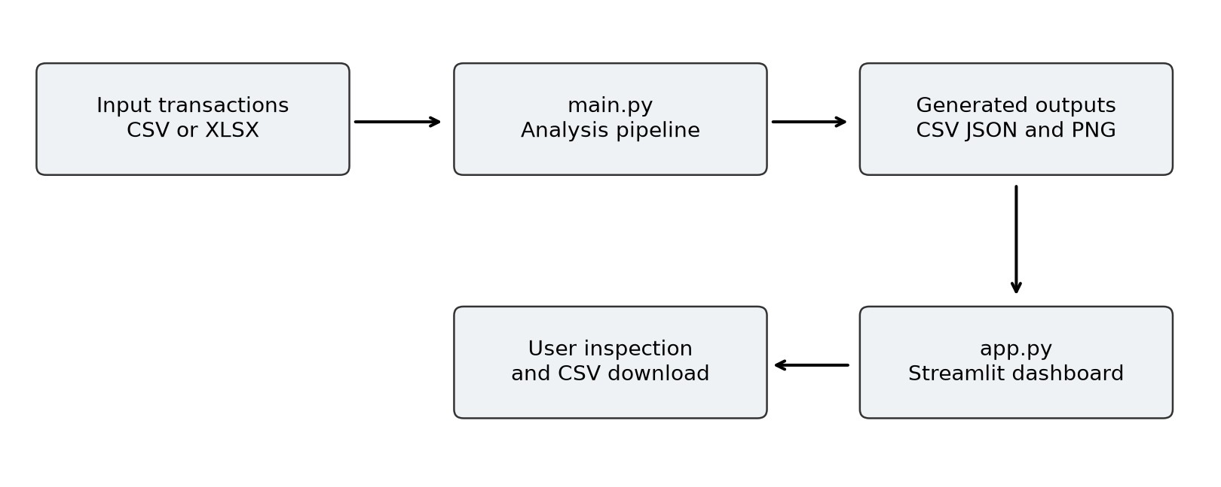
Fig. 3.1 File based system architecture

3.4 Data Flow And Processing Stages
At the context level, the external user supplies a transaction dataset and starts the analysis. The system returns cleaned data, summaries, charts, model errors and future sales estimates. The same user can then open the dashboard to inspect the outputs and download daily sales. There is no separate administrator or authenticated customer role in the implemented application.
At the processing level, data passes through validation, conversion, filtering and revenue calculation before aggregation. The daily series feeds both descriptive analysis and forecasting. Historical predictions feed the error calculations, and the sorted comparison identifies the method used for future forecasting.
The distinction between historical prediction and future forecasting is important in the data flow. Historical test values exist and can be compared with predictions. Future observations do not yet exist at the forecast origin, so the final forecast file has dates, point estimates and bounds but no realised error values.
The flow also identifies where a failure can interrupt execution. Missing columns stop preprocessing, while an ADF or decomposition error can stop the pipeline before model comparison. Within comparison, individual model errors are caught so other methods can continue. The current exception handling is therefore local rather than a complete transactionstyle recovery mechanism. Chapter 5 tests selected normal and failure paths and explains which were only inspected in source.
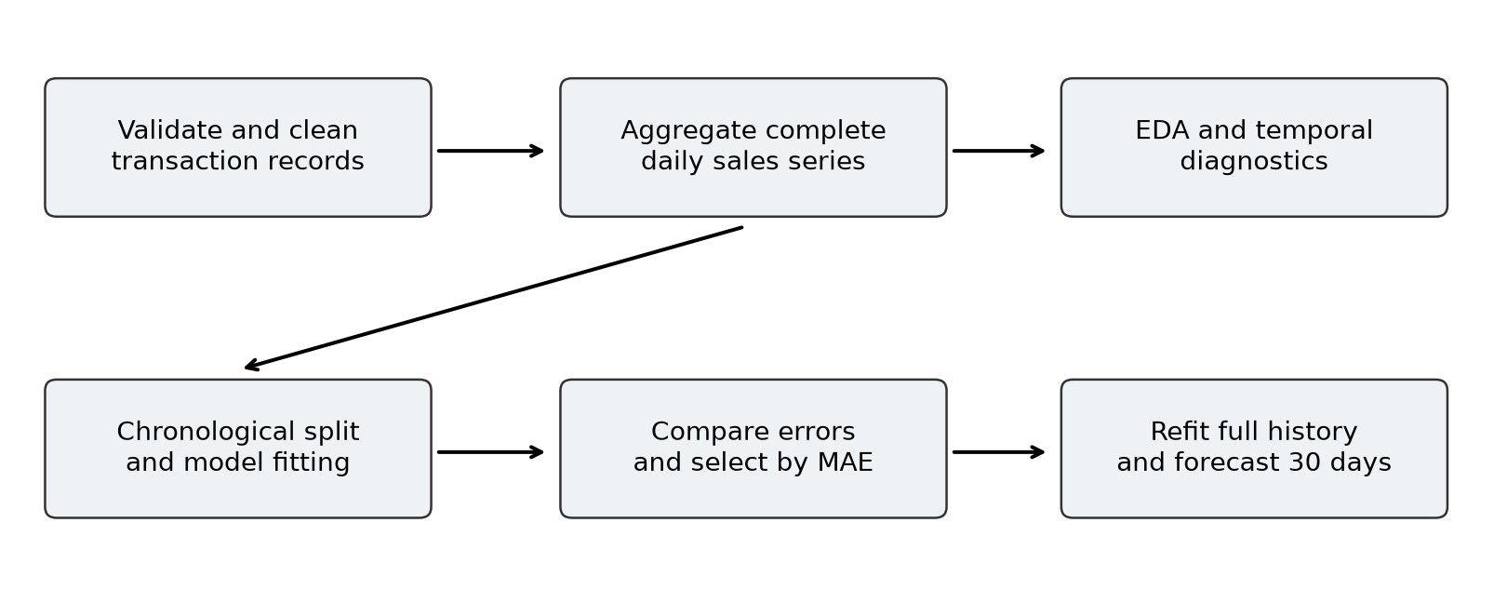
Fig. 3.2 Analysis and forecast data flow

3.5 Input Data Dictionary
The required schema follows a retail transaction representation. InvoiceNo identifies an invoice; StockCode identifies a product; Description is the human-readable product label. Quantity and UnitPrice determine the monetary amount, and InvoiceDate determines the daily grouping. Country is retained for geographical analysis.
CustomerID is used to count distinct customers when present, but the preprocessing module does not require it. A missing CustomerID column therefore does not by itself make the input invalid. The sample contains all eight fields and no missing values before conversion.
Table 3.2 documents the expected role of each field. Types describe intended meaning rather than a strict schema enforced at import. The code converts dates and selected numerics after reading the file. It does not comprehensively validate identifier uniqueness, text completeness or every numeric missing-value condition.
The monetary unit in the charts is pounds sterling. The synthetic prices are interpreted consistently with those labels. A new dataset using another currency would require the labels and reporting assumptions to be updated; the code does not perform currency conversion. In the UCI schema, unit prices are documented in sterling [2].
Table 3.2 Transaction input dictionary
Field | Meaning | Requirement
InvoiceNo | Invoice identifier and cancellation marker | Required
StockCode | Product identifier | Required
Description | Product name | Required
Quantity | Units on a transaction line | Required
InvoiceDate | Transaction timestamp | Required
UnitPrice | Monetary amount per unit | Required
Country | Customer country | Required
CustomerID | Customer identifier | Optional

3.6 Output Data Relationships
The current application stores analytical artefacts as CSV, JSON and image files. It does not implement a relational database. For that reason, the useful design model is a relationship between data products rather than an entity relationship diagram suggesting tables and constraints that do not exist.
cleaned_transactions.csv contains retained source fields and SalesAmount. daily_sales.csv contains Date, SalesAmount, Quantity and Transactions. Date is unique in the daily file because grouping and reindexing produce one row per calendar day. The number of transactions is the distinct invoice count within that day, not necessarily the number of transaction lines in a general retail dataset.
model_comparison.csv contains a row per successfully evaluated method and columns for MAE, RMSE and MAPE. future_forecast.csv contains a date, point forecast, lower bound and upper bound for each future day. The selected model name is inferred from the sorted comparison file rather than written into each forecast row.
The files are linked by a common execution, but the source does not persist a run identifier. A user can accidentally mix daily data from one input with metrics from an earlier input if a run fails partway. A manifest and atomic publication step would make the relationships explicit.
These improvements would also help reproduce a report when the raw dataset is replaced.
Table 3.3 Generated data products
File | Granularity | Main use
cleaned_transactions.csv | Transaction line | Audit and descriptive analysis
daily_sales.csv | Calendar day | Charts and model input
data_summary.json | Analysis run | Preparation counts and totals
model_comparison.csv | Successful model | Ranking and error reporting
future_forecast.csv | Future calendar day | Thirty-day sales estimate

3.7 Chronological Evaluation Design
The daily series is sorted and split at floor(0.85N), where N is the number of observed calendar days after completion. The earlier segment trains the methods; the later segment evaluates them. With 1,096 days in the sample, this produces 931 training observations and 165 held-out observations.
Training ends on 19 July 2024 and evaluation begins on 20 July 2024. All three methods receive the same training values and forecast the same 165 dates. Test observations are not incrementally fed back into the models. This preserves a common fixed-origin comparison but creates a long multi-step evaluation window.
Figure 3.3 illustrates the split and the subsequent refit. Once the lowest-MAE model is chosen, it is fitted to all 1,096 daily values. The final forecast then starts on 1 January 2025. The January dates are future relative to the dataset endpoint, regardless of the calendar date when the software is executed.
The held-out window also acts as the model-selection set. It is therefore more precise to call it a validation segment than an independent final test of the selected model. A later untouched segment or repeated rolling origins would provide stronger evidence. The report retains the source terminology test where discussing variables, while explaining this methodological distinction.
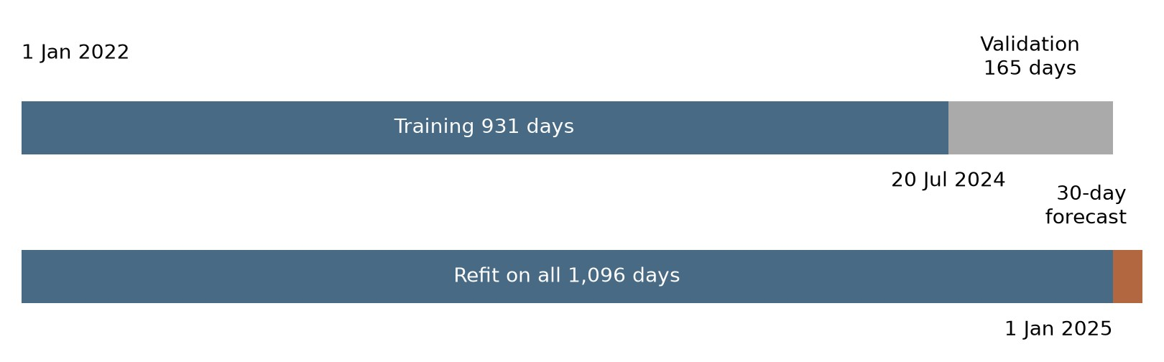
Fig. 3.3 Training validation and final forecast timeline

3.8 Forecast Uncertainty Design
A point forecast is a single estimated future value. The ARIMA-family implementations also request forecast bounds from statsmodels. In the standard library configuration, these are nominal 95 percent intervals. They express model-based uncertainty conditional on the fitted specification and its assumptions; they are not guarantees that every future observation will lie inside the band.
The future_forecast function clips the point estimate and both bounds at zero. This avoids negative displayed sales, but it changes the statistical interval when an unmodified bound is negative. Coverage should therefore be assessed on the exported values before they are used operationally. The project does not measure empirical interval coverage.
For the Naive option, lower and upper bounds are set equal to the repeated final value. These are degenerate placeholders rather than a calibrated uncertainty interval. If Naive were selected on another dataset, the dashboard would still display these columns, so the user should not infer certainty from the zero-width band.
The sample run selected SARIMA, and the exported bounds are positive. However, the final refit emitted a convergence warning. The resulting interval is therefore best described as provisional model output. Residual checks, optimisation review and repeated backtesting should precede any planning decision based on its nominal confidence level. The source design supports displaying uncertainty but does not establish that it is well calibrated.

3.9 Design Risks And Controls
The most significant data risk is interpreting a missing date as a true zero-sales day. The current reindexing operation fills absent dates with zero. This is a clear and reproducible rule, but it may be wrong when a day is absent because of a collection failure. The distinction requires source-system knowledge that is not available from the transaction table alone.
A second risk is treating positive sales as net business revenue. Cancellations and nonpositive quantity or price records are removed. Depending on the source, returns and refunds can be legitimate negative transactions. Removing them changes the accounting meaning of the target. The report therefore describes the result as retained positive sales under the implemented filters.
Model risk arises from fixed orders, one comparison window and suppressed fitting warnings inside comparison functions. Presentation risk arises when cached or partially regenerated outputs are displayed together. Neither risk invalidates the educational workflow, but both limit the strength of its conclusions.
Table 3.4 summarises the controls already present and the next control needed. A clear distinction between current and proposed controls prevents the architecture description from overstating the implementation.
Table 3.4 Design risk assessment
Risk | Current control | Recommended extension
Invalid records | Required fields and selected filters | Explicit finite-value and type checks
Missing dates | Complete daily index | Distinguish outages from true zeros
Model failure | Per-method exception handling | Persist convergence diagnostics
Mixed output files | Predictable output paths | Run manifest and atomic outputs
Overstated accuracy | Three error metrics | Rolling validation and final test

3.10 Worked Transaction To Daily Sales Example
A small worked example makes the aggregation contract explicit. Suppose three retained transaction lines occur on 1 January. Two belong to invoice A and one belongs to invoice B. Their quantities are two, one and three, and their unit prices are five, eight and four pounds.
The line revenues are ten, eight and twelve pounds.
The expected daily SalesAmount is thirty pounds and daily Quantity is six units. Transactions is two because the implementation counts distinct InvoiceNo values rather than rows. This distinction matters for an external retail dataset where one invoice can contain several products. The sample generator uses a unique invoice number for each row, so the distinction is not visible from its totals alone.
If the next retained transaction occurs on 3 January, calendar completion inserts 2 January with zero revenue, zero quantity and zero transactions. That inserted day is a processing assumption. It does not establish whether the business was closed or whether records were lost.
Table 3.5 provides the numerical example. It is an explanatory fixture rather than a claim about the measured sample. It can be used in a demonstration to show how record-level calculations connect to the modelled series and why invoice count must be defined separately from transaction-line count.
Table 3.5 Worked aggregation fixture
Line | Invoice | Quantity | Unit price £ | Revenue £
1 | A | 2 | 5 | 10
2 | A | 1 | 8 | 8
3 | B | 3 | 4 | 12
Daily total | 2 distinct | 6 | Not additive | 30

3.11 Data Quality Rules And Audit Trail
A preparation audit should explain both what was retained and what was removed. The current summary records original rows, missing cells before conversion, cancellations removed, invalid rows removed and clean rows. These counters provide a useful overview, but they do not preserve the identity or exact exclusion reason of every rejected record.
A stronger audit would assign each input row a stable source position and record a reason code before filtering. For example, a row could fail date conversion, quantity validation or cancellation handling. Multiple conditions may apply simultaneously. The audit design should decide whether to retain all applicable reasons or use an explicit precedence rule for mutually exclusive counts.
A before-and-after reconciliation should also distinguish missing cells before parsing from missing values created by parsing. The confirmed nonnumeric quantity defect demonstrates why these are different measurements. A source string can be nonmissing at import and become unusable only after numeric conversion.
Table 3.6 distinguishes existing counters from proposed additions. The additions are design recommendations rather than artefacts generated by the supplied pipeline. Implementing them would make future reports easier to reproduce and would help users understand why a changed dataset produces a different total.
Table 3.6 Preparation audit fields
Field group | Current implementation | Recommended extension
Input counts | Rows and missing cells | Input hash and file timestamp
Conversions | Dates and numerics converted | Counts of new parsing failures
Exclusions | Two aggregate removal counters | Row identifiers and reason codes
Reconciliation | Clean row count and sales totals | Explicit retained plus rejected balance

3.12 Module Contracts And Failure Boundaries
Each module has an informal contract defined by its arguments and return values. load_and_clean_data returns a cleaned DataFrame and a summary dictionary. create_daily_sales returns one row per calendar day. create_eda_outputs returns descriptive totals while saving image files. These return values and side effects are both part of the workflow.
The forecasting module expects a regular numeric series with adequate history. Its comparison function returns two mappings: method names to prediction series and method names to metric dictionaries. The evaluation module transforms the metric mapping into a sorted table. The controller relies on a nonempty table when reading the first model name.
Failure handling crosses these boundaries unevenly. Input existence and required columns are checked early, individual candidate failures are caught in comparison, and the controller catches a final exception only to print a message and re-raise it. Diagnostic failures before comparison can therefore stop all later stages.
A future contract should specify empty-input behaviour, accepted dtypes, required index order, finite-value requirements and minimum history. It should also distinguish a candidate failure from a pipeline failure. These definitions would support tests that verify meaningful behaviour at module boundaries instead of only checking that a particular function name exists. The present source is small enough to inspect directly, making this a practical maintenance improvement.

3.13 Requirements Traceability And Review Procedure
Requirements traceability connects a user-facing capability with a source location and a verification step. It prevents a feature described in a project proposal from being mistaken for a completed implementation. In this project, the clearest evidence comes from the executed pipeline, exported files and focused function checks.
The matrix in Table 3.7 complements the functional requirements table by identifying how each capability can be reviewed. A source inspection can establish that a tab is declared, while a live acceptance session is needed to establish that its interactive behaviour works in the intended environment. These are different levels of evidence.
During review, the examiner can start from an output and work backwards. A forecast row should be linked to the input endpoint, chosen model and comparison table. A daily total should be linked to retained transaction values. An error message should be linked to an invalid-input check. This makes the demonstration concrete and reduces reliance on unsupported verbal claims.
The matrix is also useful after changes. If the quantity target or cancellation rules are modified, the affected checks and report sections can be identified immediately. A traceable maintenance process makes the document and code easier to keep consistent across later project revisions.
Table 3.7 Requirement verification matrix
Capability | Review evidence | Relevant report section
Prepare valid sales | Cleaning fixtures and reconciliation | 4.2 to 4.4 and 5.2
Handle malformed input | Passed and failed boundary checks | 5.2 and 5.3
Compare methods | Generated metric table | 4.7 4.8 and 6.6
Produce future dates | Forecast file structure audit | 4.9 and 6.9
Present results | Dashboard source and pending UI checks | 4.10 and 5.6

CHAPTER 4 IMPLEMENTATION

4.1 Project Structure And Execution Environment
The source package separates execution, analysis and presentation. main.py is the pipeline entry point and app.py is the dashboard entry point. The src directory contains data_preprocessing.py, eda.py, evaluation.py and forecasting.py. The data directory contains the sample generator and input documentation. The outputs directory contains generated data products and figures.
The report run used Python 3.12 with Pandas 3.1.0, NumPy 2.5.4, Matplotlib 3.11.2, SciPy 1.18.1, statsmodels 0.15.0 and scikit-learn 1.9.1. These packages were used to execute the original analysis pipeline without changing its model code. The dashboard was reviewed from source; interactive UI acceptance was not performed.
The supplied requirements file specifies lower bounds such as Pandas 2.0 and statsmodels 0.14. It does not fix exact versions. The observed results belong to the recorded environment and sample input. Repeating the analysis with another compatible environment may produce small numerical differences, particularly for numerical optimisation.
A practical reproduction procedure creates a virtual environment, installs requirements, runs main.py from the project root and starts Streamlit. Running from the root is important because main.py writes relative output paths. app.py resolves files relative to its own location. Executing the pipeline from another working directory can therefore create outputs somewhere the dashboard does not read. The appendix supplies commands and a verification checklist.
Table 4.1 Modules and responsibilities
Module | Responsibility
main.py | Orchestrate complete analysis
data_preprocessing.py | Load clean aggregate and save
eda.py | Generate descriptive figures and totals
forecasting.py | Split fit compare and forecast
evaluation.py | Calculate and rank error metrics
app.py | Read outputs and render dashboard

4.2 Input Loading And Schema Checks
load_and_clean_data first constructs a filesystem path and checks that it exists. If the path is missing, it raises FileNotFoundError with a message pointing to the data instructions. A dataset is read using read_excel for xlsx or xls suffixes and read_csv otherwise. The input option is passed through the command line as --input.
After loading, the function compares the available columns with the required-column set. If any required columns are absent, it raises ValueError listing the missing names. This is a useful early check because later operations depend on consistent field names. It does not automatically rename variations such as invoice_date or unit_price.
The function records the original row count and the total number of missing cells before type conversion. InvoiceDate is converted with invalid entries coerced to missing timestamps. Quantity and UnitPrice are converted with invalid entries coerced to missing numeric values. This makes malformed strings visible as missing values, but the subsequent invalid mask does not fully handle those numeric missing values.
The xls suffix is recognised by the code, but support still depends on an appropriate spreadsheet engine. requirements.txt includes openpyxl, which supports xlsx input; it does not establish legacy xls support by itself. For a reliable demonstration, the bundled CSV or an xlsx file is the clearest supported path. Extension recognition and successful parser support should not be treated as equivalent.

4.3 Filtering And Sales Amount Calculation
The cancellation mask converts InvoiceNo to text and checks whether it begins with uppercase C. The invalid mask checks for a missing parsed date, a nonpositive quantity or a nonpositive unit price. Rows covered by either mask are excluded. Cancellation and invalid-removal counts are calculated separately so that an uppercase cancellation is not also counted as an invalid removal.
For each retained row, SalesAmount equals Quantity multiplied by UnitPrice. The retained rows are sorted by InvoiceDate. The function returns both the cleaned table and a summary dictionary. The pipeline later merges this dictionary with EDA totals and writes data_summary.json.
Two limitations were confirmed by focused tests. A nonnumeric Quantity becomes NaN during conversion, but comparisons such as NaN less than or equal to zero are false. It can therefore survive the current mask. Likewise, a lowercase c-prefixed invoice does not match the uppercase-only cancellation rule. These are implementation defects on boundary inputs, even though they do not affect the supplied clean sample.
A proposed correction would explicitly reject missing or nonfinite numeric values and normalise invoice case before cancellation detection. It should also record the reason for each exclusion and clarify how returns are treated. The report documents this recommendation without representing it as an implemented change. The original project code was retained for the reported experiment.

4.4 Daily Series Construction
create_daily_sales normalises each transaction timestamp to its calendar date, groups the cleaned records by date and calculates three aggregates. SalesAmount is summed, Quantity is summed and Transactions is the count of distinct invoice numbers. These fields are saved together so that users can inspect the relationship between monetary activity, units and invoice counts.
The function then creates a full daily date range from the first retained date to the last. Reindexing inserts absent dates and fills their aggregate values with zero. Finally, the date index is returned to a Date column and sorted. This gives the forecasting code a regular calendar sequence rather than a collection of only the dates on which transactions appear.
In the supplied sample, all 1,096 dates from 1 January 2022 to 31 December 2024 are represented. The daily sum reconciles with the cleaned transaction revenue of £548,324.51. This reconciliation is useful because a forecast model cannot compensate for an incorrect target series.
The function assumes that at least one valid dated transaction remains. If all rows are removed, the minimum and maximum date do not define a usable range. The code also does not distinguish a genuine closure from missing data. These conditions should be validated before daily construction in a stronger implementation. The sample run does not exercise them, so successful execution should not be generalised to every structurally valid input.

4.5 Exploratory Analysis Implementation
create_eda_outputs receives cleaned transactions and daily sales. It saves daily sales, monthly trend, monthly bars, product contribution, country contribution and a thirty-day rolling-average figure. The helper save_plot uses consistent image dimensions, titles, monetary axes and a fixed image resolution. Monthly totals are calculated from transaction timestamps using month-start resampling.
The product chart groups by Description, sums SalesAmount, selects the largest ten values and plots them in sorted order. The sample has six products, so all six appear despite the title referring to a top ten. Grouping by description can merge distinct stock codes if they share a label or split one product if its description changes. Product identity is therefore an important consideration for real data.
The country chart similarly groups and ranks revenue. The daily rolling average uses rolling(30, min_periods=1). The earliest plotted values use fewer than thirty observations and should not be interpreted as full-window means. The chart is descriptive and is not used as a model feature.
The function also returns total sales, total quantity, unique products, optional unique customers and distinct invoices. These summary values are merged with preparation counts. Visual results are discussed in Chapter 6 rather than treated as proof that the models fit well. The EDA stage describes the input; forecast quality still requires comparison against later observations.

4.6 Stationarity And Decomposition Implementation
main.py converts the daily SalesAmount column to a dated series and assigns daily frequency. It then calls adfuller and writes the statistic, p-value and a simple interpretation to adf_result.csv. The significance threshold is 0.05. A low p-value is interpreted as evidence against a unit root under the test assumptions.
In the sample run, the p-value is approximately 0.123. At the chosen threshold, the unit-root null is not rejected. This does not prove nonstationarity or identify the correct differencing order. The ARIMA-family models use d equal to one regardless of the test result, so the test is descriptive rather than an automated configuration rule.
When at least twenty-one observations exist, the pipeline performs additive decomposition with period seven. The decomposition separates a trend estimate, repeated weekly component and residual variation. It is a descriptive analysis of the complete historical series. Its result is saved as weekly_decomposition.png and is not used to estimate the training models.
The current minimum-length condition applies to decomposition, but the ADF test runs earlier and can fail on very short or constant series. The pipeline therefore needs stronger suitability checks for arbitrary inputs. The source also uses a simple additive decomposition even though the sample generator applies multiplicative seasonal factors to expected quantity. This does not invalidate the chart as a descriptive aid, but the decomposition should not be presented as a verified generative model.

4.7 Model Fitting And Comparison
chronological_split calculates an integer split position from 85 percent of the series length and returns the earlier and later slices. run_model_comparison then iterates over a dictionary containing Naive, ARIMA(1,1,1) and SARIMA(1,1,1)(1,0,1,7). Each method receives the same training and test series.
The Naive function repeats the last training value. The ARIMA function fits the stated nonseasonal order and forecasts the test length. The seasonal function fits SARIMAX with the stated weekly configuration and forecasts the same number of observations. Predictions are assigned the test index before metrics are calculated.
Each method is wrapped in a try block. If fitting or evaluation raises an exception, that method is omitted and a message is printed. If all methods fail, the function raises RuntimeError. If only one method succeeds, it becomes the available comparison winner; the output does not separately record which methods failed or why.
Warnings are suppressed inside the ARIMA and SARIMA validation helpers. This includes potentially useful information about convergence. The later full-series forecast fit does not suppress the same warning, which is why the sample execution exposed a final convergence issue. A robust comparison should persist success status, warning messages and convergence indicators alongside errors. A ranking based solely on metrics can otherwise conceal an unstable estimation process.

4.8 Error Metrics And Selection Rule
calculate_metrics converts actual and predicted values to floating-point arrays. MAE is the mean absolute difference, RMSE is the square root of mean squared error, and MAPE is the mean absolute percentage difference over observations whose actual value is not zero. Each returned metric is rounded to two decimal places.
MAE = sum of absolute errors divided by n. RMSE = square root of the mean squared error. MAPE = 100 times the mean of absolute error divided by absolute actual value over nonzero actuals. MAE and RMSE are in pounds for this project, while MAPE is a percentage. They answer related but different questions about error.
comparison_table creates one row per successful method and sorts ascending by MAE. main.py selects the model name in the first row. Because rounding occurs before sorting, very close methods could become tied after rounding. The current source has no explicit secondary tie rule or unrounded selection score.
MAPE excludes zeros rather than assigning an infinite percentage. This is practical but changes the subset being evaluated. When all actuals are zero, MAPE becomes NaN. The current report sample has strictly positive daily sales, so no dates are excluded on that basis. The chosen MAE ranking avoids selecting directly from percentage errors, but does not resolve limitations of a single temporal validation segment.
Table 4.2 Metric interpretation
Metric | Unit | Interpretation
MAE | Pounds per day | Typical absolute revenue error
RMSE | Pounds per day | Error measure emphasising large misses
MAPE | Percent | Relative error on nonzero actual days

4.9 Thirty Day Forecast Generation
After selection, future_forecast creates thirty daily dates immediately after the last observed date. The selected method is fitted again using the complete historical series. This refit is necessary because the final deployment origin has more information than the earlier validation origin.
For ARIMA and SARIMA, get_forecast returns the predicted mean and model-based confidence bounds. The function extracts the first and second bound columns and clips point values and limits at zero. For Naive, all three numerical columns contain the repeated final observation. The returned DataFrame is saved as future_forecast.csv.
In this run, the future period is 1 to 30 January 2025 because the input ends on 31 December 2024. It is a historical demonstration forecast relative to that dataset endpoint. It should not be described as a forecast for the thirty days following the report preparation date.
The controller also saves forecast_result.png, combining training values, actual validation sales, the selected method’s validation predictions and final future forecasts. These curves refer to different fitting stages. The historical prediction is generated from the training segment, while the final forecast uses the full series. A viewer should not infer that the future line was produced by the same fitted object as the held-out prediction. Chapter 6 interprets the forecast with this distinction and the observed convergence warning.

4.10 Dashboard Implementation
app.py configures a wide Streamlit page and defines a cached CSV loader. Essential daily and transaction files are checked before the interface proceeds. If they are absent, an error message directs the user to run main.py. Forecast and comparison files are optional for loading and lead to tab-specific warnings when missing.
The Overview tab displays total revenue, units, product count and invoice count, followed by a daily chart. Sales Analysis contains monthly, product and country charts. Time-Series Analysis displays the daily series and rolling average with a short explanation. Forecasting displays the three forecast columns and a table. Model Performance displays the comparison table, while Data displays daily values and offers a CSV download.
The dashboard does not display the saved ADF result or decomposition figure. It also does not let the user upload data, change model orders or start training. These distinctions matter when preparing a demonstration: the dashboard shows generated results, while data processing and fitting occur through the command line.
The implementation uses @st.cache_data without a file modification timestamp as an explicit input. Replacing a file may therefore require cache clearing or an application restart to ensure fresh values. The report does not include invented screenshots of a running interface. The sixtab behaviour described here was verified from source, while interactive UI testing remains a separate acceptance step [4].
Table 4.3 Dashboard tabs and content
Tab | Displayed content
Overview | Summary indicators and daily line
Sales Analysis | Monthly product and country charts
Time-Series Analysis | Daily values and rolling average
Forecasting | Point estimates bounds and table
Model Performance | Sorted error comparison
Data | Daily table and CSV download

4.11 Pipeline Control Sequence
The controller begins by creating output subdirectories, then loads and cleans the input. It builds the daily series and saves processed data before generating descriptive figures and the merged summary. Diagnostics, model comparison and future forecasting run only after those earlier steps complete.
This ordering explains why the presence of some outputs does not establish a successful full run. A failure during ADF testing can leave fresh cleaned files but no fresh model comparison. A failure during the final refit can leave a new comparison table alongside an old future forecast. The current source does not remove earlier artefacts at the beginning of an execution.
A robust extension would separate computation from publication. The controller could write all outputs into a new run directory, validate them and then make that directory available to the dashboard. Failed runs would remain available for diagnosis without replacing the last complete result. This is a proposed design and was not used to change the reported model calculations.
For the current implementation, the practical control is to review the terminal completion message and inspect output modification times together. The report experiment was executed from a temporary project root with its outputs reviewed as one run. Keeping the input, package versions and execution log together remains important when the same project is rerun on a different dataset.

4.12 Reproducibility And Version Management
The sample generator creates its random-number generator with seed forty-two. This gives the generator a repeatable starting point under a compatible numerical environment. The experiment uses the CSV already present in the archive rather than replacing it with newly generated transactions before analysis.
Reproducibility requires more than a seed. It also depends on the exact input bytes, library versions, model settings, working directory and fitting behaviour. The requirements file gives minimum dependency versions, so it describes a range of environments rather than an exact executable specification. The environment recorded in Section 4.1 provides the versions used for these reported results.
For future releases, an environment lock and a run manifest should accompany the outputs. The manifest could contain a source-data hash, source-code revision, package versions, commandline arguments, start time, completion status and candidate diagnostics. These fields would make it possible to distinguish a genuine model change from a dependency or data change.
Version management also applies to the report. If the input is replaced, the descriptive totals, date ranges, plots and model comparison must all be regenerated. Editing only the selectedmodel name would leave an inconsistent document. The most reliable workflow treats the report, its input and its generated outputs as a single documented experiment.

4.13 Dashboard Refresh And Presentation Checks
The dashboard reads generated CSV files through a cached helper. The helper returns None when a requested path is absent. Essential daily and transaction files cause an early error message if missing, while forecast-related tabs show warnings when optional analysis files are unavailable.
A demonstration should begin by confirming that the displayed total agrees with the current transaction file. After a pipeline rerun, the presenter should clear cached data or restart the application and verify that the new date range appears. This avoids presenting cached values while discussing a newly generated forecast.
The forecast tab plots point estimates and two bound columns as lines. The lower and upper curves should be explained as model-based limits, with the special caveat that the Naive implementation produces equal values in all three columns. The model performance table should be introduced using the metric definitions and selection rule rather than described as a percentage accuracy score.
A live acceptance procedure should also verify browser rendering, tab navigation, table scrolling and the downloaded daily CSV. These interactions were not executed in the report experiment, so they remain pending UI checks. The source inspection confirms the declared interface structure, while the proposed acceptance procedure defines the evidence needed before claiming a fully tested presentation layer.

CHAPTER 5 TESTING

5.1 Testing Strategy And Evidence
Testing was organised around the implemented workflow rather than a claim that every possible input is supported. The full pipeline was executed on the bundled sample, generated outputs were inspected, and twelve focused checks exercised preparation, temporal splitting, baseline behaviour and metric arithmetic. Dashboard behaviour was inspected in source and was not accepted through a live browser session.
The focused checks used small constructed transaction tables with known expected outcomes. This makes it possible to test cancellation handling, numeric conversion and calendar completion without relying on a large dataset to happen to contain an edge case. Expected failures were recorded instead of silently changing the source code before reporting.
The pipeline experiment provides integration evidence: preprocessing, EDA, diagnostics, three models and final forecast export all completed. It does not establish that every branch of each function is correct. The synthetic sample has no missing values or cancellation rows, so targeted checks are needed to investigate those behaviours.
Ten of the twelve focused checks passed and two exposed defects. The full pipeline also emitted a convergence warning during the final SARIMA fit. These findings are reported in the following sections. They support a qualified conclusion: the sample workflow is executable, but input validation and estimation diagnostics should be strengthened before wider use. The report deliberately avoids describing the project as fully tested or production ready.
Table 5.1 Verification scope
Area | Evidence type | Status
Complete sample pipeline | Executed original main.py | Completed with fit warning
Core and boundary functions | Twelve focused checks | Ten pass two fail
Generated files | Data and numerical inspection | Present and reconciled
Dashboard interaction | Source review | Live UI not tested
Commercial accuracy | No real-data backtest | Not established

5.2 Input And Preprocessing Test Cases
The first group of tests verifies behaviour at the preparation boundary. A missing file must raise FileNotFoundError. An input missing required columns must raise ValueError. A valid transaction with quantity two and unit price three must produce SalesAmount equal to six.
These checks passed.
A cancellation test adds a second invoice whose identifier begins with uppercase C and confirms that it is removed. Another test adds an invalid date, zero quantity and negative price and confirms that only the valid transaction remains. These checks also passed and match the explicit source masks.
The calendar test uses valid transactions on 1 January and 3 January. The expected daily output includes 2 January with zero sales. The resulting three-row series confirms the implemented gap-filling rule. This verifies software behaviour, while the appropriateness of interpreting every gap as zero remains a business assumption.
Table 5.2 reports the passed preparation tests. The two boundary defects are separated on the next page because a successful sample run would otherwise hide them. Small controlled fixtures are especially useful here: they distinguish an implementation rule from accidental properties of the bundled clean dataset.
Table 5.2 Preparation test results
Case | Expected outcome | Observed
P1 Missing input | FileNotFoundError | Pass
P2 Missing columns | ValueError listing fields | Pass
P3 Valid transaction | 2 × 3 = 6 revenue | Pass
P4 Uppercase C invoice | Cancellation excluded | Pass
P5 Invalid date or nonpositive value | Invalid rows excluded | Pass
P6 Missing calendar date | Inserted zero-sales day | Pass

5.3 Validation Defects And Proposed Corrections
The nonnumeric quantity test supplies the string bad in a Quantity cell. pd.to_numeric converts it to NaN. The invalid mask checks whether quantity is nonpositive but does not check isna. The row remains in the cleaned table, causing the expected rejection check to fail. The same pattern can affect UnitPrice.
This failure matters because later aggregation can hide the malformed row. Pandas sums may skip NaN values, so a transaction can remain present while contributing no revenue or quantity. A clean row count alone would then overstate the number of usable records. Validation should explicitly test numeric completeness and finiteness after conversion.
The lowercase cancellation test supplies an invoice beginning with c. The source checks startswith uppercase C, so the row survives. A case-normalised comparison would recognise both forms. Whether lowercase identifiers should count as cancellations must follow the source convention; the UCI field description itself refers to a c prefix [2].
Table 5.3 records the observed failures and proposed remedies. The supplied code was not modified for this report. Correcting the project and rerunning the same fixtures would be a separate implementation step, followed by a new full analysis. The clean synthetic sample is unaffected by these two cases, but that does not remove their relevance to external data.
Table 5.3 Failed boundary checks
Case | Observed behaviour | Proposed correction
P7 Nonnumeric quantity | NaN quantity row retained | Reject missing and nonfinite numerics
P8 Lowercase c invoice | Cancellation row retained | Normalise identifier case before matching

5.4 Temporal and numerical tests
The split check creates one hundred ordered observations and applies the default split function. The expected result is eighty-five training values and fifteen later values, with every training index preceding the test indices. This passed and verifies the arithmetic of the default chronological cut.
The Naive check uses training values one, two and three, then requests two predictions. Both predictions must equal three. This passed and confirms the repeated-last-value definition. It does not evaluate whether that method is accurate on a particular retail series.
The metric check uses actual values ten and twenty with predictions twelve and sixteen. Absolute errors are two and four, so MAE is three. Mean squared error is ten, giving RMSE 3.16 after rounding. Both percentage errors are twenty percent, so MAPE is twenty. The implementation returned those values.
A separate MAPE check uses one zero actual and one nonzero actual. The zero is excluded from the percentage calculation while still contributing to MAE and RMSE. The result matches the documented rule. These tests verify calculation semantics and avoid confusing a mathematically correct metric implementation with sufficient evaluation design. Repeated backtesting and a final untouched comparison period are still needed to assess generalisation.
Table 5.4 Temporal and metric test results
Case | Expected result | Observed
P9 Chronological split | 85 earlier and 15 later values | Pass
P10 Naive prediction | Repeat final training value | Pass
P11 Metric arithmetic | MAE 3 RMSE 3.16 MAPE  20 | Pass
P12 Zero actual MAPE | Exclude zero from percentage mean | Pass

5.5 Integration Outputs And Convergence Warning
The complete pipeline was run from the extracted project root using the original sample CSV. It reported SARIMA(1,1,1)(1,0,1,7) as the lowest-MAE method. The expected cleaned transaction file, daily file, summary, ADF result, model comparison and thirty-row future forecast were produced. EDA, decomposition and combined forecast figures were also generated.
The cleaned transaction count is 13,089 and the daily series contains 1,096 unique consecutive dates. Summed daily revenue agrees with summed transaction SalesAmount at £548,324.51. The forecast contains thirty consecutive dates beginning one day after the historical endpoint. These checks establish internal consistency of the sample outputs.
The final full-series SARIMA fit emitted a Maximum Likelihood optimisation failed to converge warning. The pipeline did not stop and still exported predictions. A returned forecast therefore does not imply that the numerical optimiser reached a satisfactory solution. The metric helpers suppress warnings during comparison, so the validation CSV alone cannot show whether a similar issue occurred there.
The appropriate next step is to inspect optimiser return information, examine parameter estimates and residuals, and try controlled fitting settings before accepting the final model. Any alternative fit should be evaluated again rather than selected merely because it avoids a warning.
The reported metrics remain the observed values from this run, with this limitation attached.

5.6 Acceptance Criteria And Remaining Tests
For an academic demonstration, the current sample meets several concrete criteria: the batch workflow completes, totals reconcile, outputs are dated correctly, three methods are compared and the forecast is exported. The source contains the required six-tab interface. These achievements are sufficient to demonstrate the basic project concept, subject to the documented caveats.
Broader acceptance is not yet established. The input layer should be tested with empty data, allinvalid rows, constant series, short series, nonfinite numeric values, mixed date formats and repeated invoice lines. Spreadsheet parser support should also be tested explicitly for each promised format. These are proposed tests rather than reported passes.
The dashboard needs a live acceptance run covering missing files, successful loading, navigation, plot rendering, downloads and cache refresh after new outputs. Forecast validation needs rolling origins aligned to a thirty-day horizon, a seasonal Naive benchmark, residual diagnostics and interval coverage checks. A final real-data experiment would be needed before discussing retail accuracy.
Table 5.5 summarises the readiness assessment. It distinguishes conditions met by the current sample from work still required. This makes the final conclusion useful for project improvement as well as submission review.
Table 5.5 Acceptance assessment
Criterion | Assessment
Sample pipeline execution | Met with convergence warning
Reconciled sales totals and dated outputs | Met
Core and boundary checks | Partly met two defects remain
Live dashboard acceptance | Pending
Robust forecast evaluation | Pending rolling and final tests
Real retailer validation | Pending suitable real dataset

5.7 Boundary Test Design For Future Hardening
The twelve executed checks cover selected behaviours, but they do not exhaust the input space. Additional tests should focus on conditions that can break the target series before forecasting. Empty input, all-invalid rows and a constant series are especially important because the current pipeline can fail before the per-model exception handling is reached.
Table 5.6 specifies proposed cases with observable expectations. These are test designs rather than reported successful executions. They should be run after the input contract is strengthened and retained as regression checks. A clear expected outcome is preferable to a test that merely verifies that no exception occurred.
The nonfinite-value case should include positive infinity, negative infinity and missing numeric values. The date case should distinguish an unparseable timestamp from a timezone or format mismatch. The invoice case should use several product rows under one identifier so that distinct-invoice counting is exercised independently of line counting.
Each added test should also verify the audit summary where relevant. A rejected record should change the correct exclusion counter, and the remaining revenue should reconcile. This connects error handling with analytical correctness and makes it harder for a malformed row to disappear silently inside a later sum.
Table 5.6 Proposed boundary tests not yet executed
Case | Expected controlled behaviour
Empty or all-invalid input | Reject before daily date-range construction
Short or constant series | Explain diagnostic or fitting unsuitability
Nonfinite numeric values | Reject and record exclusion reason
Several lines per invoice | Sum revenue and count invoice once per day
Legacy spreadsheet format | Confirm required engine or reject clearly

5.8 Regression Checks After Code Changes
A code correction should be evaluated against both the defective fixture and the normal workflow. For example, normalising invoice case should make the lowercase cancellation test pass without changing the valid uppercase case. Explicit missing-numeric rejection should remove malformed quantities while preserving the valid revenue calculation.
The next step is a full sample rerun. Because the bundled data has no invalid or cancelled rows under these rules, a preparation-only correction should preserve its row count and retained sales total. Any changed sample total would need investigation rather than automatic acceptance. Forecast metrics might still vary if dependencies or fitting settings change at the same time, so those changes should be kept traceable.
A regression review should compare file structure as well as numerical values. The daily file must remain chronologically ordered, the model table must use the stated metric columns and the future file must preserve thirty consecutive dates. The dashboard should still read the resulting schema and provide a usable download.
The report should then be updated from the new execution rather than carrying forward old metric values. Passed and failed checks, warnings and environment details should be recorded together. This process provides a practical route from the current prototype to a more dependable version without hiding the limitations found during the original analysis.

CHAPTER 6 RESULTS AND DISCUSSION

6.1 Dataset And Cleaning Results
The sample file contains 13,089 generated transaction rows across 1 January 2022 to 31 December 2024. The preparation summary reports zero missing cells before conversion, zero removed uppercase cancellations and zero invalid rows removed by the implemented mask. All 13,089 rows remain after cleaning.
The retained data contains six stock codes, five countries and 501 customer identifiers. Invoice numbers are unique in this sample, so the invoice count equals the row count. This equality is a property of the generator and should not be assumed for a real invoice dataset containing several product lines per invoice.
The total quantity is 46,796 units and total retained revenue is £548,324.51. The completed daily series contains 1,096 days. Mean daily revenue is £500.30, while the median is £459.96. The mean exceeding the median is consistent with higher-sales days pulling the average upward.
Table 6.1 summarises the run. These numbers describe synthetic data generated for testing. They are not evidence about the actual UCI retailer, customer preferences or national retail markets. The sample provides a repeatable setting for demonstrating calculations and model behaviour, while real-world conclusions require a verified external dataset and a separate analysis.
Table 6.1 Sample dataset summary
Measure | Observed value
Original and cleaned rows | 13,089
Historical period | 1 Jan 2022 to 31 Dec 2024
Daily observations | 1,096
Products countries customers | 6 products 5 countries 501 customers
Total quantity | 46,796 units
Total revenue | £548,324.51
Mean and median daily revenue | £500.30 and £459.96

6.2 Daily Sales And Long Term Movement
Daily sales fluctuate substantially across the sample. The smallest daily total is £100.13 and the largest is £1,404.60. The sample standard deviation is £215.57. These descriptive values show why a single average cannot represent the entire series and why a forecast can miss individual days even when its overall level appears plausible.
Figure 6.1 presents daily values together with the thirty-day rolling mean. The smoother line makes gradual movement and late-year peaks easier to see, while the daily line preserves shortterm variability. The rolling mean is descriptive and uses only the values in each historical window.
Annual revenue increases from £166,255.98 in 2022 to £184,498.14 in 2023 and £197,570.39 in 2024. The generator deliberately introduces a rising factor, so this growth should be interpreted as a known sample property rather than discovered business performance.
The chart also shows why extrapolation needs care. A forecast fitted at a high late-year level may carry that level into January even when the generator’s annual factor falls after December. The fixed weekly SARIMA specification does not explicitly represent annual seasonality. This provides a concrete reason to review forecast plausibility beyond the aggregate validation score.
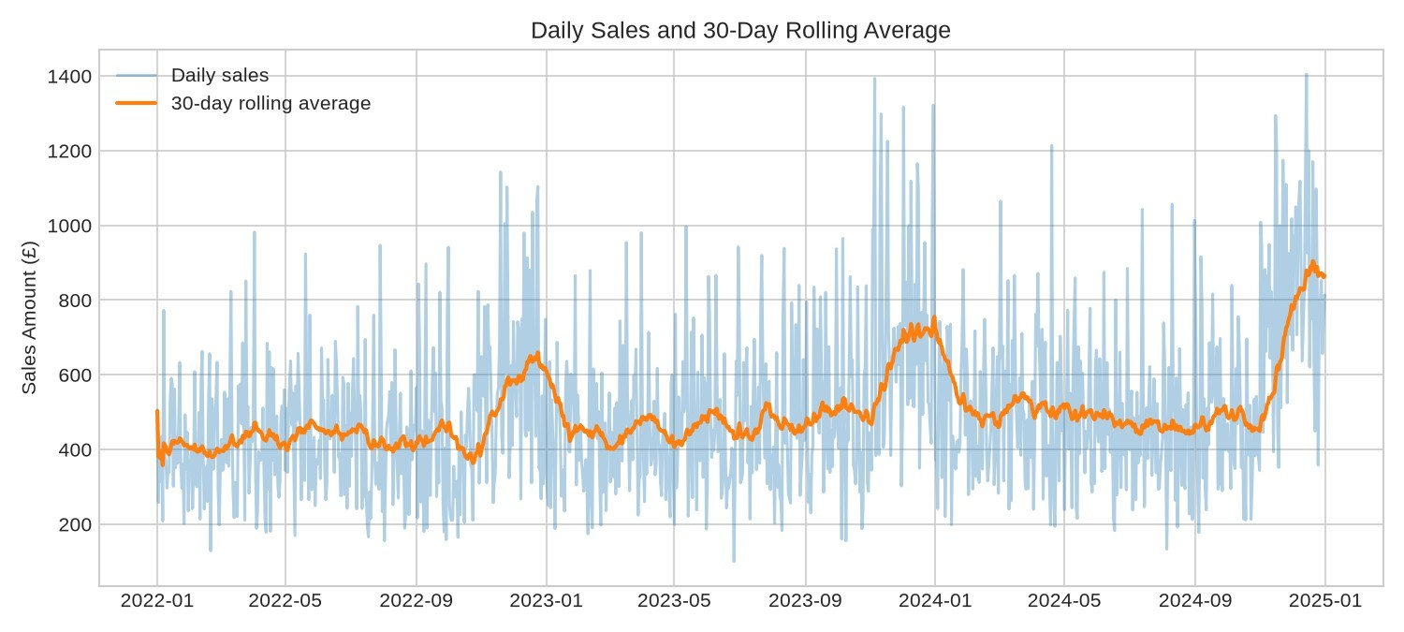
Fig. 6.1 Daily synthetic sales and thirty day rolling mean

6.3 Monthly And Weekly Seasonal Patterns
Monthly totals help separate the broad sales level from daily noise. Figure 6.2 shows the monthly aggregation of retained revenue. Late-year peaks are expected because the generator multiplies expected quantity by 1.45 in November and December. The pattern is therefore useful for testing whether an analytical workflow exposes known structure.
Average daily sales also vary by weekday. Friday averages £622.95 and Saturday £668.14, compared with Monday £426.08 and Thursday £430.34. These differences match the generator’s stronger Friday and Saturday quantity factor. They justify considering a seven-day seasonal period in the candidate model.
Monthly totals should not be confused with average daily sales: months have different lengths, and February differs between leap and non-leap years. Likewise, weekday averages are descriptive summaries over the whole sample. They are not independent causal estimates of a day-of-week effect.
The combination of a weekly pattern, a late-year factor and gradual growth creates more structure than a single weekly model explicitly represents. It is therefore plausible for SARIMA to improve on a level-only baseline while still leaving material error. A future evaluation should compare a seasonal Naive method and models that can account for multiple seasonal patterns without assuming that additional complexity will necessarily improve performance.
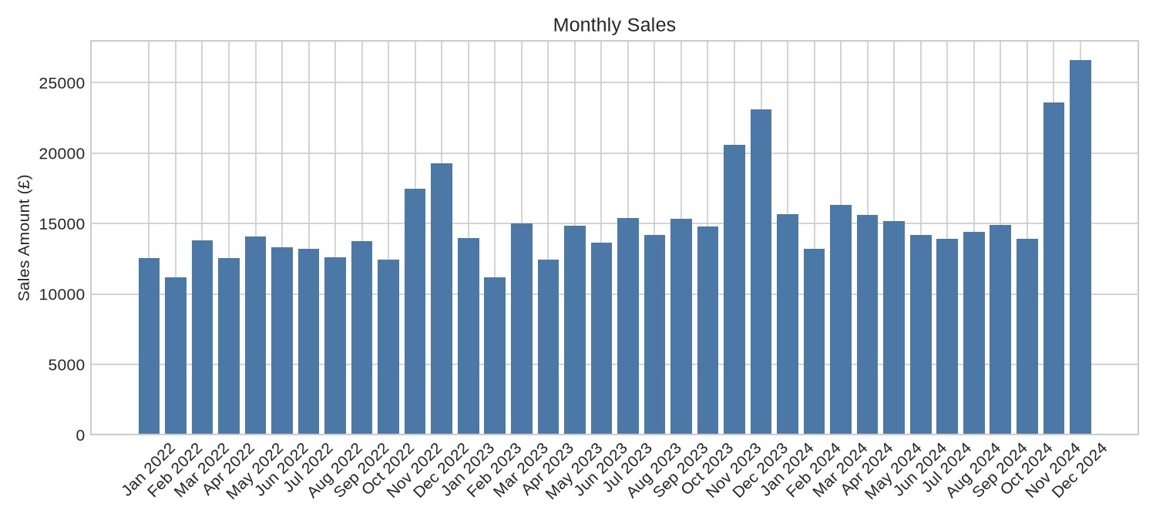
Fig. 6.2 Monthly synthetic sales totals

6.4 Product And Country Contributions
Wireless Headphones contribute the largest revenue total at £171,873.34, followed by Desk Lamp at £144,267.26. USB Cable has the smallest revenue total at £35,404.25. These comparisons reflect both unit quantities and the different base prices assigned by the generator.
They do not measure popularity in units or profitability.
Figure 6.3 displays the product totals. Because the sample contains only six products, every product is shown. A higher-priced item can contribute more revenue even when its unit count is similar to another item. A demand-oriented extension should therefore report units separately and model product quantities rather than interpreting revenue rank as demand rank.
The United Kingdom contributes £299,416.70, followed by France £67,152.50, Germany £64,004.25, the Netherlands £61,742.79 and Spain £56,008.27. The generator samples the United Kingdom with probability 0.55 and the other countries with lower probabilities. The observed concentration is consequently an expected sample design feature.
These charts demonstrate the dashboard’s descriptive capabilities. They do not support marketentry recommendations or claims about actual customer behaviour. For a real dataset, differences in coverage, prices, currencies, returns and business operations would need to be understood before interpreting geographical or product contribution.
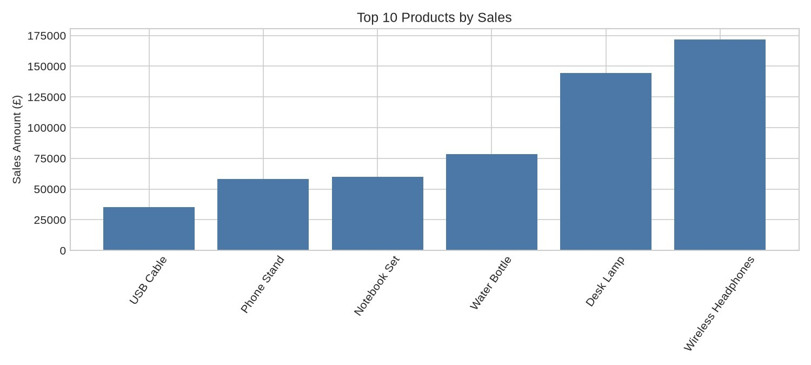
Fig. 6.3 Product revenue contribution in the synthetic sample

6.5 Stationarity And Decomposition Results
The ADF statistic is approximately -2.46993 and the p-value is 0.12296. With a threshold of 0.05, the test does not reject the unit-root null. The source labels this as likely nonstationary and uses first differencing in both ARIMA-family candidates. The p-value should not be read as the probability that the series is nonstationary.
Figure 6.4 shows the additive weekly decomposition. It provides an interpretable separation of the historical series into a smoothed trend, repeated seven-day component and residual. The decomposition is calculated on the full series for description, not used as a fitted forecast component in the validation experiment.
The weekly component is consistent with the known weekday factor, while the trend component follows broader changes including the late-year lift. Residual variation remains because transaction counts, product selection, quantities, prices and customer countries are sampled. The decomposition alone does not establish that residuals satisfy the assumptions of the forecasting models.
Model adequacy would require examining fitted-model residual autocorrelation, distribution and stability. Those diagnostics are not exported by the current pipeline and were not completed as part of the reported run. The ADF result and decomposition therefore provide context for modelling, not a certificate that the selected seasonal specification is correct.
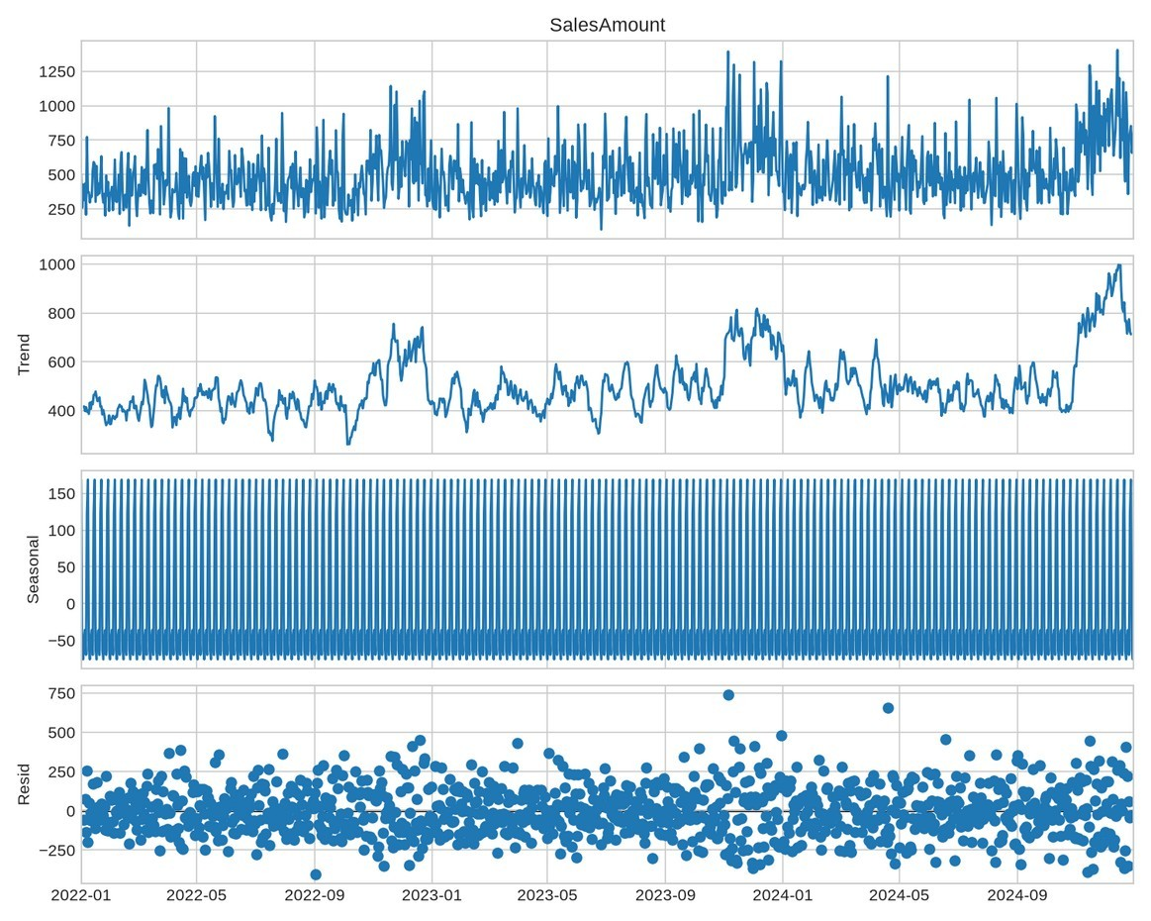
Fig. 6.4 Additive decomposition with a seven day period

6.6 Model Comparison And Interpretation
Table 6.2 reports the errors from the 165-day chronological validation segment. SARIMA has the lowest MAE at £205.82 per day and the lowest RMSE at £272.59. Naive has MAE £213.85 and ARIMA has MAE £221.07. The source therefore selects SARIMA for the final full-history refit.
SARIMA improves MAE over Naive by £8.03 per day, approximately 3.75 percent relative to the Naive MAE. This is a measured improvement on one segment, not evidence of a statistically established or universal advantage. The difference is modest enough that repeated origins and alternative baselines would be valuable.
ARIMA performs worse than Naive by MAE despite having additional fitted parameters. This illustrates why the baseline is necessary. SARIMA also has the lowest reported MAPE at 34.84 percent, but that percentage is not an accuracy score of 65.16 percent. Error metrics should be interpreted according to their definitions rather than converted into unsupported accuracy claims.
The comparison uses a fixed origin and a 165-day horizon, while the final forecast covers thirty days. It also lacks an independent final test after selecting the model. These limitations and suppressed validation warnings mean the ranking is useful as a demonstration result, while stronger evaluation is needed before operational selection.

Table 6.2 Forecast errors on the validation segment
Model | MAE £ | RMSE £ | MAPE %
SARIMA (1,1,1)  (1,0,1,7) | 205.82 | 272.59 | 34.84
Naive | 213.85 | 275.97 | 39.96
ARIMA (1,1,1) | 221.07 | 293.05 | 37.61
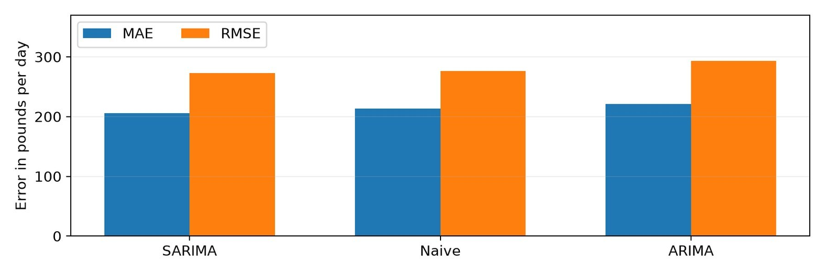
Fig. 6.5 MAE and RMSE comparison on synthetic validation data

6.7 Thirty Day Forecast Results
The selected SARIMA configuration was refitted to the complete daily series and produced forecasts for 1 to 30 January 2025. The sum of its point estimates is approximately £24,499.96. Daily point forecasts range from £738.52 to £1,011.11. The forecast retains a visible weekly pattern in the generated values.
Figure 6.6 presents the final thirty-day estimates and exported bounds. The first day is £769.69, with lower and upper bounds of £430.13 and £1,109.25. On 4 January the point estimate is £999.98, with bounds £655.17 and £1,344.78. These are model outputs rather than observed sales.
The relatively high January level deserves scrutiny because the generator’s November– December factor ends after December. The selected model represents weekly structure but has no explicit annual factor. The final fit also emitted a convergence warning. Both facts limit confidence in extrapolating the high recent level.
No actual January 2025 observations are included in the supplied input, so this report cannot measure error for the final forecast. The forecast should be used as an illustration of output generation and uncertainty presentation. Before practical use, the fitting issue should be resolved and thirty-day rolling backtests should examine performance across seasonal transitions.
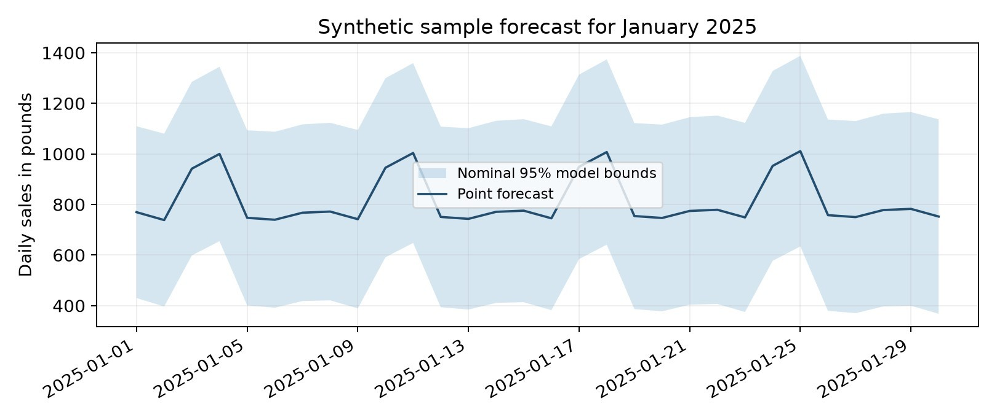
Fig. 6.6 Thirty day sales forecast and nominal model bounds

6.8 Discussion And Limits Of The Findings
The results establish that the implemented workflow can transform the bundled transactions into a daily series, produce descriptive outputs, compare three methods and export a future forecast. The totals reconcile and the model ranking follows the programmed MAE rule. These are concrete implementation achievements.
The results also show that working software and reliable forecasting are different standards. Synthetic weekly structure favours a model with weekly terms, yet the measured improvement over Naive is modest and the final optimiser warning remains unresolved. A successful file export should not be interpreted as validation of the fitted parameters or forecast intervals.
The revenue target limits demand interpretation. Product mix and price changes can move total revenue independently of unit demand. The preprocessing filters also exclude cancellations and nonpositive transactions, so the series represents retained positive sales rather than a complete net-revenue accounting measure. Real retail decisions require those definitions to be agreed explicitly.
The next evaluation should address the largest uncertainties before adding new algorithms. It should repair numeric and cancellation validation, record warnings, align backtests to thirty days, include a seasonal Naive method and use real data with known provenance. Only then would it be meaningful to assess additional business variables or more complex models. The present evidence supports an academic prototype and a clear improvement plan, with no claim of production readiness or realised financial benefit.

6.9 Forecast Output Audit
A forecast export should be checked as a data product as well as interpreted as a model result.
The sample output has thirty rows, thirty distinct consecutive dates and four expected columns. Its first date follows the final historical date by one day. Every point estimate and bound is finite and nonnegative in the reported run.
Table 6.3 provides the first seven exported days, rounded to two decimals for readability. The dated values make the weekly pattern visible and allow a reviewer to compare the report with the forecast CSV. The table is a record of generated predictions, not a record of actual sales or a second accuracy experiment.
For each exported day, the lower bound is below the point estimate and the upper bound is above it. The sum of daily point estimates is £24,499.96. Summing daily lower and upper bounds would not by itself produce a valid 95 percent interval for the thirty-day total, because forecast errors across dates may be dependent.
These checks confirm file structure and basic numerical ordering. They do not resolve the final fit warning or establish interval calibration. The separation is useful in practice: an output can be structurally valid while its statistical reliability remains uncertain. Both levels of checking should be retained when the pipeline is extended.
Table 6.3 First seven exported forecast days
Date | Forecast £ | Lower £ | Upper £
2025-01-01 | 769.69 | 430.13 | 1109.25
2025-01-02 | 738.52 | 396.75 | 1080.30
2025-01-03 | 941.77 | 598.47 | 1285.07
2025-01-04 | 999.98 | 655.17 | 1344.78
2025-01-05 | 747.38 | 401.08 | 1093.68
2025-01-06 | 739.80 | 392.01 | 1087.59
2025-01-07 | 767.57 | 418.30 | 1116.85

6.10 Monthly Sales Across The Three Sample Years
Table 6.4 reorganises the daily data into a month-by-year comparison. Each cell is the sum of retained synthetic sales for that calendar month. This view makes it possible to compare the same month across years without relying on a long chronological bar chart.
The comparison should account for the construction of the sample. A gradual quantity factor increases over the three-year period, while November and December receive a separate higher seasonal factor. Variation remains because the generator samples transaction counts, products, quantities and prices. Individual monthly totals are therefore not expected to increase in exactly the same proportion.
The table reports monthly revenue rather than revenue per trading day. February 2024 includes an additional calendar day, and months differ in length. These differences should be considered before treating every change as a change in underlying daily intensity. The figures describe the sample and do not measure commercial growth.
Table 6.4 Monthly synthetic revenue by calendar year
Month | 2022 £ | 2023 £ | 2024 £
January | 12,554.83 | 13,970.32 | 15,684.74
February | 11,166.61 | 11,167.02 | 13,199.98
March | 13,796.47 | 15,003.66 | 16,327.35
April | 12,565.35 | 12,447.05 | 15,633.53
May | 14,088.84 | 14,853.73 | 15,186.90
June | 13,324.81 | 13,669.97 | 14,181.11
July | 13,203.40 | 15,374.23 | 13,895.54
August | 12,610.52 | 14,184.84 | 14,388.16
September | 13,751.60 | 15,334.30 | 14,896.05
October | 12,430.22 | 14,765.74 | 13,941.46
November | 17,482.53 | 20,599.31 | 23,607.36
December | 19,280.80 | 23,127.97 | 26,628.21

6.11 Forecast Detail For January Eight To Nineteen
The dates in Table 6.5 continue the first-week values reported in Table 6.3. Every value comes from the same full-history SARIMA refit. No extra model was fitted to produce this expanded table, and no future actual observations are available for an error calculation.
The alternating level across weekdays reflects the weekly structure carried into the forecast. The bounds describe the model’s nominal uncertainty, conditional on its assumptions and estimated parameters. Their numerical ordering was checked, but empirical coverage was not established.
The final optimisation warning applies to these values as well as the first week. The table is included to make the generated output inspectable. It should be read together with the model comparison and the discussion of the high January level, rather than treated as a separate validation result.
Table 6.5 Exported forecast continuation
Date | Forecast £ | Lower £ | Upper £
2025-01-08 | 772.13 | 421.04 | 1,123.23
2025-01-09 | 741.98 | 389.38 | 1,094.58
2025-01-10 | 945.43 | 591.33 | 1,299.52
2025-01-11 | 1,003.69 | 648.10 | 1,359.27
2025-01-12 | 750.88 | 393.81 | 1,107.94
2025-01-13 | 743.29 | 384.75 | 1,101.83
2025-01-14 | 771.09 | 411.07 | 1,131.10
2025-01-15 | 775.65 | 413.84 | 1,137.46
2025-01-16 | 745.47 | 382.17 | 1,108.77
2025-01-17 | 949.09 | 584.31 | 1,313.87
2025-01-18 | 1,007.40 | 641.14 | 1,373.65
2025-01-19 | 754.37 | 386.65 | 1,122.10

6.12 Forecast Detail For January Twenty To Thirty
Table 6.6 completes the exported thirty-day horizon. The file ends on 30 January 2025 because the function requests thirty periods after the 31 December 2024 historical endpoint. It does not generate the whole calendar month, which contains thirty-one days.
These later dates are farther from the forecasting origin than the first-week values. They remain predictions from one fitted object rather than a sequence of daily refits. The supplied program does not incorporate new January observations between the forecast dates.
A useful operational extension would compare realised values with the saved forecast as they arrive, while preserving the original forecast for evaluation. Replacing it silently with a new forecast would make retrospective error measurement ambiguous. The current sample contains no such realised January data, so the table provides reproducible forecast detail without claiming achieved accuracy.
Table 6.6 Exported forecast continuation
Date | Forecast £ | Lower £ | Upper £
2025-01-20 | 746.78 | 377.59 | 1,115.97
2025-01-21 | 774.60 | 403.95 | 1,145.24
2025-01-22 | 779.16 | 406.74 | 1,151.59
2025-01-23 | 748.97 | 375.06 | 1,122.87
2025-01-24 | 952.76 | 577.38 | 1,328.13
2025-01-25 | 1,011.11 | 634.28 | 1,387.95
2025-01-26 | 757.87 | 379.58 | 1,136.16
2025-01-27 | 750.27 | 370.53 | 1,130.02
2025-01-28 | 778.12 | 396.93 | 1,159.30
2025-01-29 | 782.69 | 399.73 | 1,165.64
2025-01-30 | 752.46 | 368.04 | 1,136.88

CHAPTER 7 CONCLUSION AND FUTURE SCOPE

7.1 Conclusion
This mini project implements an end-to-end workflow for daily sales forecasting. It loads transaction data, applies documented cleaning rules, constructs a regular daily series, produces visual summaries, compares Naive, ARIMA and SARIMA methods, and exports a thirty-day forecast. A Streamlit application provides six views of the generated data and results.
The sample experiment contains 13,089 synthetic transactions and 1,096 daily observations. Total retained revenue is £548,324.51. On the chronological validation segment, SARIMA achieves the lowest MAE of £205.82, compared with £213.85 for Naive and £221.07 for ARIMA. The pipeline consequently selects the seasonal model and generates January 2025 forecast artefacts.
These outcomes meet the main demonstration objectives, but the evaluation has material limits. The sample is synthetic, the comparison uses one segment, the final horizon differs from the validation horizon and the final SARIMA fit raises a convergence warning. Focused checks also expose missing numeric rejection and lowercase cancellation handling defects.
The supported conclusion is that the project offers a reproducible and understandable analytical prototype. Its strongest contribution is the connection between data preparation, forecast comparison and accessible presentation. The next development stage should improve validation and statistical evaluation before extending functionality or claiming real-world forecasting reliability. Revenue forecasts should remain clearly distinguished from forecasts of product demand in units.

7.2 Limitations
The first limitation is data representativeness. The sample generator explicitly creates trend, weekly variation and a late-year factor. It does not represent a verified retailer’s demand process, operational disruptions or customer behaviour. A model performing well on this structure may behave differently on real transactions.
The second limitation is validation design. A single 85/15 chronological split is used to rank three fixed configurations. The later segment is both the comparison set and the selection set, with no additional untouched assessment. There are no repeated origins, seasonal Naive comparison, significance analysis or reported residual checks.
The third limitation is numerical and software robustness. Validation helpers suppress fitting warnings, the final fit warns about convergence, and two boundary checks fail. Empty, constant and short series can also interrupt earlier diagnostics. Output files have no common run identifier or atomic update process, and cached dashboard results can require refresh.
The fourth limitation is decision scope. The implemented target is aggregate revenue. The system does not forecast stock-keeping-unit quantities, model stock-outs, include promotions or translate intervals into inventory decisions. Naive bounds are degenerate, and ARIMAfamily intervals are clipped at zero without coverage testing. These limits should remain visible when demonstrating the project so that the scope of the completed work is accurately understood.

7.3 Future Scope And Development Priorities
The first priority is reliable preparation. Numeric fields should be explicitly checked for missing and nonfinite values, cancellation identifiers normalised, and empty or unsuitable series rejected with clear messages. Removal reasons should be recorded so users can distinguish returns, invalid records and genuine zero activity.
The second priority is stronger evaluation. A seasonal Naive benchmark and rolling origins aligned to a thirty-day horizon would make the comparison more relevant. An untouched final segment, stored convergence diagnostics, residual checks and empirical interval coverage would improve confidence in the selected method.
The third priority is modelling business demand more directly. Product-level quantity forecasts could be combined with prices and lead times for planning. Holidays, promotions and availability could be considered where reliable historical and future values exist. More advanced methods should be evaluated against the strengthened baselines rather than assumed to improve performance.
The fourth priority is controlled delivery. A run manifest, locked environment, atomic output publication and dashboard refresh controls would support reproducibility. A live UI acceptance test should precede any deployment. Table 7.1 orders the changes by their effect on trustworthiness rather than visual novelty.
Table 7.1 Prioritised future work
Priority | Change | Expected benefit
1 | Repair validation and suitability checks | Prevent malformed model input
2 | Rolling backtests and convergence logs | Improve selection evidence
3 | Real data and unit-demand targets | Increase practical relevance
4 | Run manifests and atomic outputs | Keep artefacts consistent
5 | Live UI tests and deployment controls | Support dependable presentation

REFERENCES
- R. J. Hyndman and G. Athanasopoulos, Forecasting Principles and Practice, 3rd ed.
Melbourne, Australia: OTexts, 2021. [Online]. Available: https://otexts.com/fpp3/. [Accessed:
Oct. 22, 2026].
- D. Chen, Online Retail, UCI Machine Learning Repository, 2015, doi:
10.24432/C5BW33. [Online]. Available: https://archive.ics.uci.edu/dataset/352/online+retail.
[Accessed: Oct. 22, 2026].
- Statsmodels Developers, statsmodels.tsa.statespace.sarimax.SARIMAX, statsmodels documentation. [Online]. Available:
https://www.statsmodels.org/stable/generated/statsmodels.tsa.statespace.sarimax.SARIMAX. html. [Accessed: Oct. 22, 2026].
- Streamlit, Streamlit documentation. [Online]. Available: https://docs.streamlit.io/.
[Accessed: Oct. 22, 2026].

Project source material
The implemented behaviour and sample experiment are documented from the accompanying sales demand forecasting mini project package, including main.py, app.py, src modules, data/create_sample_data.py, README.md, PROJECT_REPORT.md and SYNOPSIS.md.
Charts in Chapter 6 were regenerated from the included sample; the design diagrams describe the supplied implementation.

APPENDIX A Reproduction instructions
Extract the supplied source archive into a project folder. Use a supported Python installation and run the following commands from that folder. The commands illustrate an isolated environment; activate it using the command appropriate to the operating system.
python -m venv .venv
Windows: .venv\Scripts\activate Linux or macOS: source .venv/bin/activate pip install -r requirements.txt python main.py streamlit run app.py
To analyse a different dataset, place a compatible CSV or xlsx file in the data directory and pass its path explicitly. For example: python main.py --input "data/Online Retail.xlsx". The UCI dataset is an optional external input and is not included as the measured dataset in this report.

Verification after execution
Confirm that daily_sales.csv has one row per calendar date, daily revenue reconciles with cleaned transaction revenue, model_comparison.csv includes successful methods, and future_forecast.csv contains thirty dates immediately after the data endpoint. Review the terminal for fit warnings. Clear the dashboard cache or restart the app after regenerating outputs.
Keep the original input, exact dependency versions, terminal log and generated outputs together. A new dataset or model change requires a new analysis and updated report metrics. The two validation defects and convergence issue documented in Chapters 4 and 5 should be addressed before treating new outputs as operational forecasts.

APPENDIX B Selected source code
The following excerpts identify the daily target construction and temporal split. The complete implementation remains in the accompanying project archive. These excerpts are provided for explanation rather than as a replacement for the runnable source.
def chronological_split(series, train_fraction=0.85): split_index = int(len(series) * train_fraction) return series.iloc[:split_index], series.iloc[split_index:]
# Transaction revenue
clean["SalesAmount"] = clean["Quantity"] * clean["UnitPrice"]
# Daily aggregation in create_daily_sales daily = clean_data.assign(
Date=clean_data["InvoiceDate"].dt.normalize()
).groupby("Date", as_index=False).agg(
SalesAmount=("SalesAmount", "sum"),
Quantity=("Quantity", "sum"),
Transactions=("InvoiceNo", "nunique")
)
# Candidate configurations
ARIMA(train, order=(1, 1, 1)).fit()
SARIMAX(train, order=(1, 1, 1), seasonal_order=(1, 0, 1, 7), enforce_stationarity=False, enforce_invertibility=False).fit(disp=False)
The metric implementation excludes zero actuals only from MAPE and rounds all metrics to two decimals before ranking. The recommended changes discussed in the report are not included in these source excerpts.

APPENDIX C Submission completion
Complete the identity fields on the cover, certificate and declaration before submission. Obtain institutional signatures and the required similarity assessment. A similarity percentage has not been asserted in this report and must be entered only after checking with the approved tool.
Submission completion checklist
Item | Action required
Student details | Verify Happy and complete university roll number and section
Supervision details | Enter guide name designation coordinator and HOD
Certificate and declaration | Review wording date and obtain required signatures
Similarity assessment | Run approved check enter verified result and attach report
Source code | Include the supplied runnable project ZIP or approved repository link
Soft copy | Submit final PDF and source code as required
Physical copy | Arrange the prescribed soft-bound spiral copy
The stated fourth-year minimum is satisfied by seventy-six pages before these appendices when the unnumbered cover is excluded. Appendix pages and the selected code listing are additional. The report uses A4 pages, prescribed margins, Times New Roman body text, chapter-wise captions and separate preliminary and main page numbering.

