
SCHOOL OF ELECTRICAL ENGINEERING

DUAL MICROPHONE RESPIRATORY SOUND ASSESSMENT WITH ADAPTIVE NOISE CANCELLATION AND MACHINE LEARNING
Minor Specialization Report
Submitted by
Student | Registration number
Asmi Jain | 230906092
Sonali Pandit | 230906514
Susmrithi Rishi | 230906050

Under the guidance of
R Srividya
Associate Professor
Department of Electrical and Electronics Engineering
in partial fulfilment of the requirements for the award of the degree of
MINOR SPECIALIZATION IN
EMBEDDED SYSTEMS

MANIPAL INSTITUTE OF TECHNOLOGY
(A Constituent Unit of Manipal Academy of Higher Education)
MANIPAL 576104 KARNATAKA INDIA
November 2026

ACKNOWLEDGMENTS
We sincerely thank our project guide, R Srividya, Associate Professor in the Department of Electrical and Electronics Engineering, Manipal Institute of Technology, for her guidance throughout this minor specialization project.
We thank the Director, Dean, Associate Deans, project coordinators, laboratory in charge, and the faculty and staff of the School of Electrical Engineering for supporting our academic work and laboratory learning.
We acknowledge the researchers who made the ICBHI respiratory sound database available and the developers of the open-source scientific computing tools used in our machine learning experiments. Their resources allowed us to study respiratory sound classification without collecting a new clinical dataset.
We also appreciate the teamwork that brought together the hardware, signal-processing, machine-learning, and integration work in this project.

ABSTRACT
Respiratory sound assessment needs both reliable acoustic recordings and a model that can recognize patterns across different people and recording devices. Background noise, imperfect microphone coupling, class imbalance, and device variation can affect performance. This project combines a dual-microphone acquisition system, adaptive noise cancellation, and a machine-learning pipeline for four respiratory sound categories: normal, crackle, wheeze, and crackle with wheeze. The aim is to develop a reproducible hardware-to-model workflow for an embedded systems demonstration, with local inference as a longer-term goal. The output identifies acoustic patterns; it is not an autonomous disease diagnosis.
The hardware concept uses a chestpiece-coupled primary microphone and an ambient reference microphone, with an ESP32 selected as the current controller. The software workflow uses ICBHI recordings, patient-separated partitions, 4 kHz audio, log-Mel features, temporal derivatives, and several classification models. The selected CNN–LSTM has 107,906 parameters and uses two event outputs to derive the four sound categories. Historical notebook experiments achieved a validation accuracy of 56.55% and a macro F1 score of 0.5041. On the evaluated test subset, the model achieved 45.83% accuracy, 0.3584 macro F1, and an ICBHI-style score of 0.4448. These results show weak crackle discrimination and limited generalization. Historical alignment results and a four-model laptop dashboard are also documented; the original 649-cycle M0/M1/M2 comparison cannot currently be reproduced from the restored assets. The report documents the combined design and ML experiments; ESP32 acquisition, noise-cancellation gains, embedded inference, latency, and power measurements still need to be added after hardware testing. The immediate integration path is ESP32 audio capture followed by laptop inference using the same trained preprocessing pipeline.

TABLE OF CONTENTS
Acknowledgments i
Abstract ii
List of tables iv
List of figures v
List of abbreviations vi
Introduction 1
Literature review and objectives 2
Methodology 4
Contribution of each student 11
Result analysis 12
Conclusion and future scope 17
Visible outcome 18
References 19
Minor specialization project details 21
Plagiarism report 22

LIST OF TABLES
Table 3.1 Retained patient separated partitions 6
Table 3.2 Cycle counts by class and partition 6
Table 3.3 Feature contract for the selected model 7
Table 3.4 CNN–LSTM structure from the recorded model summary 8
Table 3.5 Mapping of event decisions to sound classes 9
Table 3.6 Requirements and integration evidence 10
Table 5.1 Selected recorded validation results 12
Table 5.2 Validation and test comparison for CNN–LSTM 13
Table 5.3 Test event performance at frozen thresholds 14
Table 5.4 Within recording crackle ranking diagnostic 14
Table 5.5 ML development problems and responses 15
Table 5.6 Hardware measurements required to close the report 16

LIST OF FIGURES
Figure 3.1 Combined acquisition and inference workflow 4
Figure 3.2 ESP32-S3 I²S wiring diagram for the primary chest microphone and ambient
reference microphone 7
Figure 5.1 Validation macro F1 for selected experiments 12
Figure 5.2 Test confusion matrix with row percentages 13
Figure 5.3 Dual-microphone hardware prototype using an ESP32-S3 and two
INMP441 MEMS microphones 19

LIST OF ABBREVIATIONS
Abbreviation | Meaning
ADC | Analog-to-digital converter
ANC | Adaptive noise cancellation
AP | Average precision
AUC | Area under the receiver operating characteristic curve
CNN | Convolutional neural network
DMA | Direct memory access
DSP | Digital signal processing
FFT | Fast Fourier transform
ICBHI | International Conference on Biomedical and Health Informatics
I2S | Inter-IC sound digital audio interface
LMS | Least mean squares
LSTM | Long short-term memory
MEMS | Microelectromechanical systems
MFCC | Mel-frequency cepstral coefficients
NLMS | Normalized least mean squares
PCM | Pulse-code modulation
SNR | Signal-to-noise ratio
SQI | Signal quality index
TinyML | Machine learning on constrained embedded devices

CHAPTER 1

INTRODUCTION

1.1 Background
A respiratory recording carries information about changes in airflow and acoustic events during breathing. Automated analysis can help describe these patterns, but the full engineering chain is important: microphone placement, signal integrity, feature extraction, classification, and interpretation of the result. The ICBHI database provides recordings and expert cycle annotations for studying this task [1].

1.2 Motivation and problem statement
Our project has two connected streams of work. The hardware stream develops a dual-microphone front end with adaptive filtering. The ML stream prepares the dataset, compares feature representations and models, and studies the causes of classification errors. The practical question is whether the acquired signal can reach the trained model in a consistent format while preserving useful respiratory information.
The current model does not yet recognize all four categories reliably. A better overall accuracy alone would not solve the low recall for some abnormal classes. A recent technical review highlights the importance of class imbalance, evaluation protocols, and generalization when interpreting respiratory-classification studies [2].

1.3 Scope and current status
This report brings together the supplied midterm hardware design, funding proposal, and experiment outputs shared in the ML development conversation. The team confirmed ESP32 as the controller for the current prototype. Although the proposal mentioned Pico 2 W, that board is included only as historical design context. The confirmed ESP32-S3 and INMP441 setup were supplied.
The numerical ML results in Chapter 5 were transcribed from recorded outputs and checked for arithmetic consistency; the trained model and dataset were not rerun for this report. Recovery of the original validation manifest did not recover the matching feature tensors or sample-identified predictions, so alignment metrics are retained as historical observations. The team has reported the hardware assembly, but the supplied evidence does not verify its measured performance. A separate demo guide provides a conditional connection plan. Clinical validation and disease diagnosis are outside the scope of this project phase.

CHAPTER 2

LITERATURE REVIEW AND OBJECTIVES

2.1 Respiratory datasets and evaluation
Rocha et al. describe a public dataset containing 920 recordings from 126 participants, with respiratory-cycle and event annotations [1]. It supports reproducible comparisons, but it does not eliminate recording-device or patient variation. The 2025 review by Yu et al. covers 135 ICBHI-based publications and reports substantial differences in preprocessing, representations, classification targets, and data splits [2]. Published results should therefore be compared only under matching task definitions and evaluation protocols.

2.2 Adaptive filtering and signal acquisition
The classical adaptive noise-cancellation approach uses a reference signal that is correlated with the unwanted component in the primary channel [3]. The adaptive filter estimates this noise contribution and subtracts it. Haykin provides the theoretical foundation for LMS and normalized adaptive filters [4]. In this project, the reference microphone must capture environmental interference without picking up a strong copy of the useful chestpiece signal. Unrelated random noise cannot serve as a meaningful reference for cancelling a different noise realization.

2.3 Temporal learning and denoising
Perna and Tagarelli investigate recurrent neural networks for respiratory anomalies and disease-related tasks, which supports the use of temporal representations for auscultation signals [5]. Similarly, our CNN–LSTM retains a time sequence after convolution, but its performance is evaluated only on our documented partitions and acoustic labels. It is not a reproduction of their reported system.
Ali et al. study real-time deep denoising of heart sounds under unseen noise [6]. Their work is relevant to robustness testing and signal preservation, but it addresses phonocardiogram denoising rather than lung-sound classification. The reported results cannot be transferred directly to our system. A learned enhancement stage would also increase computation and would need independent evaluation to confirm that it preserves crackles and wheezes.

2.3.1 Respiratory event models and feature representations
Acharya and Basu combined convolutional and recurrent learning for respiratory sound events and investigated patient-specific tuning and weight quantization [30]. Patient-specific adaptation uses data from the target patient and is different from the patient-balanced training used here. Rishabh and Kumar compared spectral features, augmentation and padding [31], while Asatani et al. combined raw-waveform and spectrogram CRNN branches [32]. These studies motivate our comparison of log-Mel features, temporal derivatives and temporal models. Their scores are not direct benchmarks for this report because the tasks, patient separation and adaptation protocols differ; in particular, Asatani et al.’s reported AUC concerns normal-versus-abnormal discrimination rather than a separate crackle output.

2.3.2 Frequency selection and acquisition variation
The supplied preprint by Fraihi et al. investigates temporal self-attention and frequency-band selection while reporting computational cost [33]. Yang et al. use chest location as a blocking variable and report an ICBHI score of 51.98% under the official split and 72.72% under a random 80/20 split [34]. This difference illustrates why a score must be accompanied by its evaluation protocol. Nguyen and Pernkopf introduce spectrum correction for recording-device variation [35], so device correction itself is established prior work. Our experiment examines a particular patient- and class-balanced training-derived log-Mel correction, with separate crackle and wheeze evaluation. It does not establish generalization to an unseen microphone.

2.3.3 Disease classification and the scope of this study
Nawaz et al. describe a disease-classification system with mobile output and cloud processing [36]. Bikku et al. study CNN–RNN fusion for disease classification using ICBHI and Coswara experiments [37]. These papers provide architecture and system context, but their disease targets differ from the four acoustic-event categories used here. A mobile interface or laptop dashboard does not by itself establish on-microcontroller inference. The present ML contribution is an experimental comparison, a documented alignment procedure and transparent analysis of its limitations; neither a CNN–LSTM nor a dashboard alone is claimed as a new algorithm.

2.4 Implications for this project
The literature supports a careful comparison of acquisition, denoising, and classification. Our contribution is an integrated student-prototype workflow and an analysis of its observed limitations. We do not claim that combining two microphones, adaptive filtering, and a classifier is a new invention, nor do we claim that a high score reported elsewhere predicts the performance of our hardware.
Earlier filtering literature and project evidence show that sensor placement, sampling, filtering, and terminology affect computerized respiratory analysis [13], [14]. Relevant recordings can contain low-frequency motion and heart-sound components, ambient speech, handling artifacts, and occasional mains interference [15]. No preprocessing setting should be presented as universally optimum; the selected band must fit the acoustic target and be documented with the sampling rate and evaluation method.

Band-pass design. The earlier study treated 100–1600 Hz as a practical lung-sound band, not a clinical rule. This choice helps suppress sub-100 Hz drift and heart-sound interference while reducing high-frequency noise, but it may omit useful high-pitched wheeze or tracheal information. The band is therefore treated as a deliberate front-end design choice whose preservation of annotated crackles and wheezes must be checked rather than assumed [14], [17].

Classical filters. The earlier MATLAB comparison used a 100–1600 Hz passband, 1 dB passband tolerance, and a 40 dB stopband target. In that comparison, the FIR, Butterworth, and Elliptic filters required orders 114, 16, and 8, with estimated costs of about 115, 33, and 17 multiplications per sample. FIR preserved nearly linear phase and constant group delay but had the highest cost. Elliptic met the specification with the lowest order but allowed ripple, while Butterworth gave a smooth, monotonic magnitude response at a moderate cost [17]. The FIR design also showed an upper-stopband weakness around 1.6–1.9 kHz; this was a limitation of that specific design, not of all FIR filters.

Targeted noise removal. A 50 Hz notch filter with Q = 30 (1.67 Hz bandwidth) produced narrow selective attenuation in the earlier recording. It should be enabled only when the spectrum identifies a mains component; otherwise, a 100 Hz lower cutoff already reduces much of the 50 Hz energy. A separate controlled synthetic-noise experiment showed why adaptive filtering needs realistic interpretation: a 64-tap NLMS filter with μ = 0.50 and ε = 10⁻⁶ increased SNR from 5.00 dB to 6.42 dB, while the basic spectral-suppression baseline reduced SNR to 0.91 dB. These are project-specific simulation results, not validated performance measures for the final hardware prototype.

Connection to the combined design. The earlier results support a staged front end: band limiting to remove clearly out-of-band content, optional notch filtering for demonstrated mains noise, and LMS/NLMS cancellation when a synchronized ambient reference is available [3], [4]. Robust acquisition research also shows that microphone placement and chest coupling affect recording quality, so both should be reported with the filtering configuration [16]. Signals that appear cleaner after filtering still need to be checked against ICBHI annotations and listening review because a waveform or spectrogram alone cannot prove that a transient is a crackle.

Additional literature and device-alignment note
The studies already listed in References [18]–[28] provide further context on real-time adaptive cancellation, high-noise auscultation, embedded multichannel cancellation, and multichannel denoising. They reinforce the need to evaluate preservation of respiratory events rather than treating a lower residual-noise level alone as evidence of clinical usefulness.
Reference [29] also illustrates that sensing hardware can influence the acquired lung-sound signal. In this project, device alignment is therefore treated as a separate training-derived experiment, not as proof that all recording-device differences have been solved.

Objectives and implementation requirements

2.5 Project objectives
1. Acquire synchronized primary and reference microphone signals using the ESP32 hardware platform.
2. Implement and assess LMS or NLMS cancellation while retaining the raw recordings for comparison.
3. Prepare reproducible respiratory-cycle metadata and patient-separated data partitions.
4. Compare log-Mel, MFCC, derivative-channel, classical embedding classifiers, and CNN–LSTM approaches using class-sensitive metrics.
5. Connect hardware audio to the selected model using a fixed sample-rate, feature, normalization, and label contract.
6. Evaluate errors by class, patient, and device; record acquisition quality and end-to-end timing.
7. Investigate embedded inference only after verifying operator support, working memory, quantization behavior, and feature parity.

2.6 Technical implementation basis
The ESP32 provides I2S acquisition with DMA support [7]. Its GPIO assignment must follow the documentation for the exact development board [8]. If INMP441 microphones are used, their digital interface supports left- and right-channel selection on a shared I2S data line [9]. These references establish a possible implementation; they do not prove the parts or wiring already used by our team.
The ML experiments use the Python audio-analysis ecosystem described by McFee et al. [10]. A future microcontroller build needs a converted model, supported operators, and an allocated working arena; a desktop Keras file alone is not deployable firmware [11]. The official ICBHI site also documents recording-device filename corrections, which should be checked before a device-based study [12].

Additional current hardware configuration
The hardware team reports an ESP32-S3 N16R8 configuration with 16 MB flash memory and 8 MB PSRAM, together with two INMP441 microphones configured for 16 kHz per channel. The exact development-board model remains unconfirmed. The prototype is assembled, but the microphones are currently not functioning; synchronized acquisition, ANC validation, and hardware-to-model integration therefore remain pending.
The earlier 100–1600 Hz filter comparison, the synthetic NLMS result with μ = 0.50 and 5.00 dB to 6.42 dB SNR, and the recorder NLMS configuration with μ = 0.08 plus an approximately 80 Hz high-pass stage are separate processing records. They should not be interpreted as one common preprocessing sequence used during CNN–LSTM training.

CHAPTER 3

METHODOLOGY

3.1 Type and nature of the project
This project integrates hardware and software for an embedded-system application. Its activities include acoustic acquisition design, digital signal processing, supervised ML experimentation, software testing, and integration. The available evidence supports completed desktop ML experiments and a documented hardware design, while integrated hardware evaluation still needs to be completed.

3.2 Combined system architecture
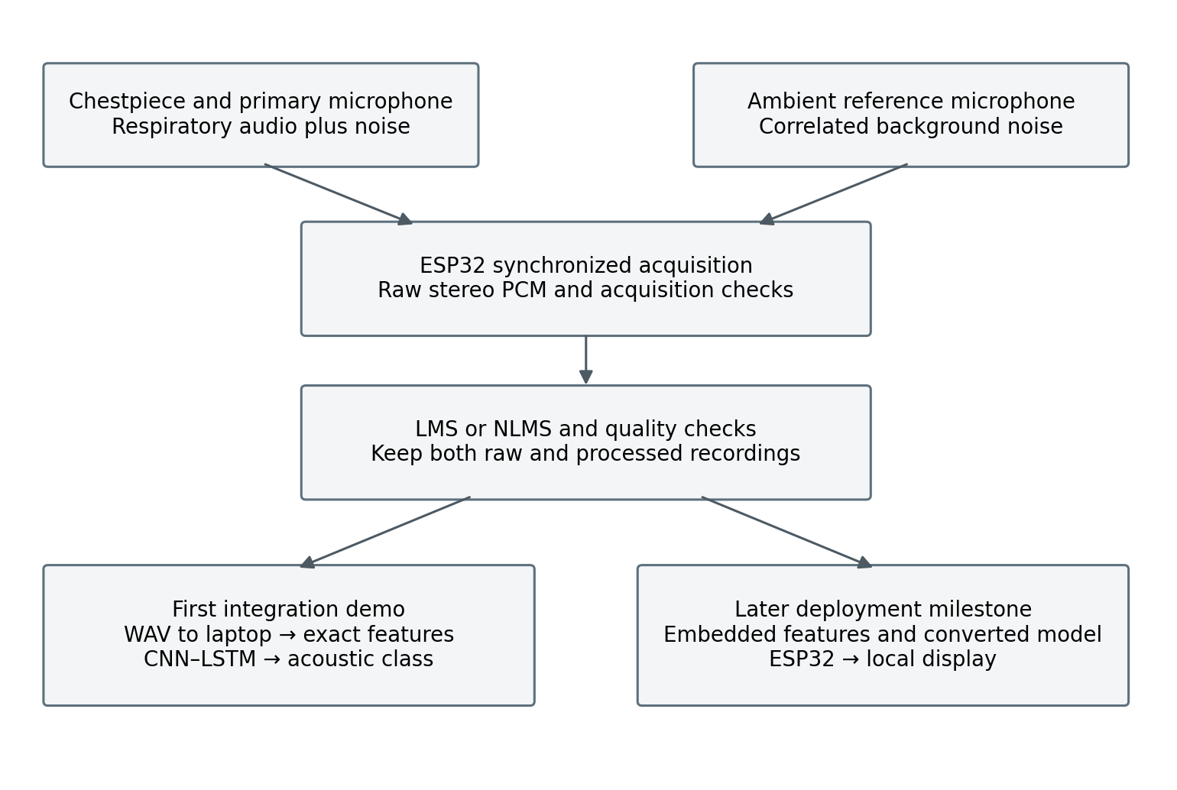
Figure 3.1 Combined acquisition and inference workflow
The raw channel pair is retained before cancellation. The residual audio is then checked and passed to the same feature extractor used for the selected model. The first demonstration runs inference on a laptop. Fully local ESP32 inference is a separate milestone that requires measured resource and prediction checks.

3.3 Assumptions
The proposed demo assumes a common clock for both microphones, a verified primary/reference channel order, and an audio path that avoids clipping. The supplied evidence does not yet show that the completed board meets these assumptions. Optional displays, storage, and physiological sensors must be treated according to what is physically present and tested.

Hardware acquisition and adaptive cancellation

3.4 Acquisition and mechanical arrangement
The primary microphone is coupled to the stethoscope chestpiece. The reference microphone faces the surrounding environment and is mechanically separated from the chestpiece cavity. Both channels must be sampled at the same time. Capturing them one after the other would change their relative timing and weaken adaptive filtering. Acoustic sealing, cable handling, and microphone position should remain repeatable across recordings.
For a conditional INMP441 implementation, capture at a supported hardware rate such as 16 kHz, then use anti-alias filtering and resampling to the ML rate of 4 kHz. Do not set the microphone clock to 4 kHz merely because the training features use that rate. The I2S word format and valid-bit alignment must be checked before converting captured words to PCM samples [7], [9].3.5 LMS and NLMS processing
Let d[n] be the noisy primary sample, x[n] the synchronized reference, and w the adaptive-filter coefficient vector. The filter estimates the primary-channel noise from recent reference samples. The residual e[n] is the candidate cleaned respiratory signal. LMS uses a fixed adaptation gain; NLMS divides the update by reference energy to reduce sensitivity to changes in reference amplitude [3], [4].
The implementation should preserve filter state across consecutive audio blocks, document filter length and adaptation gain, and monitor overflow and clipping. A bypass output enables direct comparison. Applying independent automatic gain changes to the two channels during adaptation can disturb the learned relationship. Cancellation should also be checked to ensure that useful lung content is not removed.
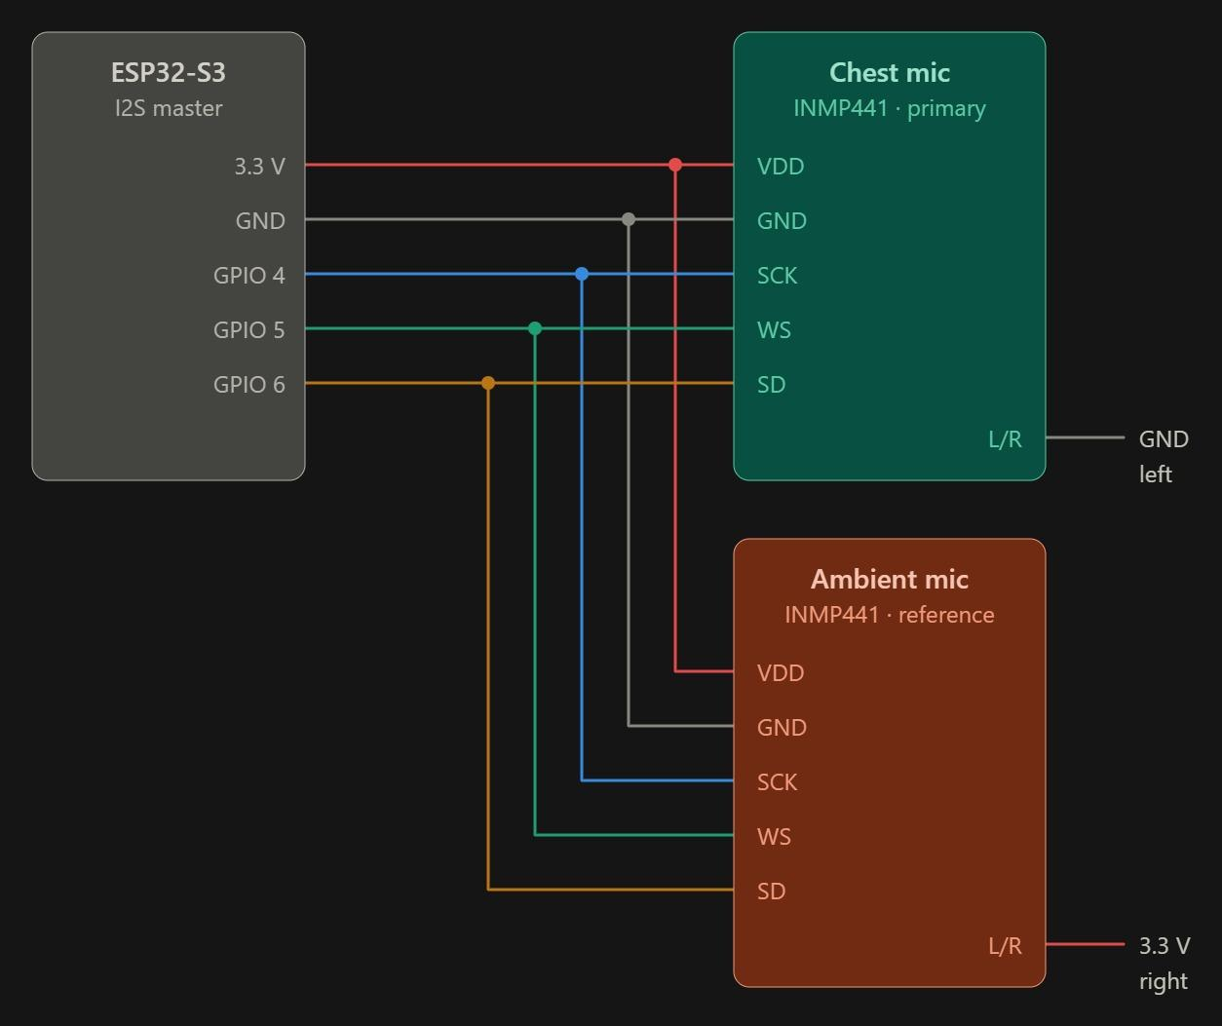
Figure 3.2 ESP32-S3 I²S wiring diagram for the primary chest microphone and ambient reference microphone.

3.6 Controlled simulation
For a reproducible synthetic test, form the primary channel by adding a filtered or delayed copy of a known noise sequence to a respiratory recording. Use the correlated source noise, optionally via a different transfer path, as the reference channel. Report the input SNR, output error, filter parameters, and classification change. A white-noise corruption test without a corresponding reference measures noise robustness, not dual-microphone ANC.

3.7 Quality handling
The planned quality gate should flag missing channels, clipped samples, silence, transfer loss, and motion artifacts. Thresholds require calibration on the actual hardware. No calibrated SQI or rejection-rate result was supplied; therefore, quality gating remains an integration requirement rather than a demonstrated result.

Dataset preparation and split audit

3.8 Data assembly
The local dataset audit found 920 WAV recordings, 6,898 annotated cycles, and 126 patients. Annotation start and end times were converted to sample indices. The two binary annotation flags map to normal, crackle only, wheeze only, and both. These recordings are baseline database audio and should not be described as universally noise-free [12].

3.9 Patient separation and exclusions
The recorded audit retained 907 recordings and 6,781 cycles. Thirteen development recordings from patients 156 and 218 were removed because those patients also appeared in the supplied test assignment. This accounts for a difference of 117 cycles. An unmatched recording for patient 226 was investigated, and all 31 cycles from that patient were reserved together in validation. The exact split file and exclusion audit should accompany any reproducibility package.
Table 3.1 Retained patient separated partitions
Partition | Patients | Recordings | Cycles
Training | 61 | 444 | 3376
Validation | 16 | 82 | 649
Evaluated test subset | 49 | 381 | 2756
Total retained | 126 | 907 | 6781

Table 3.2 Cycle counts by class and partition
Class | Training | Validation | Test
Normal | 1694 | 359 | 1579
Crackle | 1012 | 174 | 649
Wheeze | 405 | 81 | 385
Crackle with wheeze | 265 | 35 | 143

These are the project's recorded partitions, not a claim that the official challenge training protocol was unchanged. The test subset was evaluated after thresholds had been selected on validation. Later inspection of test errors is exploratory. Further model selection must use development data, and a new independent evaluation is needed before making an unbiased claim about a revised model.

Feature extraction and training consistency

3.10 Fixed audio and feature settings
Table 3.3 Feature contract for the selected model
Setting | Recorded value
Audio rate | 4,000 samples per second
Maximum segment | 20,000 samples or 5 seconds
FFT length and hop | 512 and 128 samples
Mel bands and frequency range | 64 bands, 20 to 2,000 Hz
Log scaling | Power to dB relative to the segment maximum
Clipping and mapping | Clip to −80 to 0 dB, then map to 0 to 1
Time dimension | 157 frames
Short segments | Extract real audio features, then center-pad feature frames
Long segments | Center-crop audio to 20,000 samples
Selected model input | 64 × 157 × 3 float32 values
Feature channels | Log-Mel, first delta, second delta
Derivative normalization | Training-derived statistics per Mel band; padded positions remain zero

3.11 Padding and derivative masks
Earlier experiments padded waveforms and resized spectrograms. The retained frame-padding approach first extracts the log-Mel representation from the actual segment and then adds zero feature frames. A Boolean mask identifies real frames. Delta and delta-delta are computed only on valid frames and then placed back in their original positions. The derivative window is the largest eligible odd length up to nine, with at least three valid frames required.
Separate mean and standard-deviation vectors are calculated from training frames for derivative orders one and two. Validation, test, and demo inputs must reuse the same vectors. Recomputing normalization on demo audio changes the trained feature distribution. The original log-Mel channel stays on its recorded 0-to-1 scale.

3.12 MFCC comparison
An alternative feature stream used 40 MFCC coefficients and the same target frame count. Its labels and metadata were checked against the log-Mel data. MFCC and log-Mel model outputs were also combined experimentally. Those experiments informed model selection; MFCC is not an extra input to the selected three-channel CNN–LSTM.

Model architecture and learning procedure

3.13 Selected CNN–LSTM
Table 3.4 CNN–LSTM structure from the recorded model summary
Layer | Output without batch | Parameters
Input | 64 × 157 × 3 | 0
Convolution 16 filters | 64 × 157 × 16 | 448
Max pooling | 32 × 78 × 16 | 0
Convolution 32 filters | 32 × 78 × 32 | 4640
Max pooling | 16 × 39 × 32 | 0
Convolution 64 filters | 16 × 39 × 64 | 18496
Frequency average pooling | 4 × 39 × 64 | 0
Permute and reshape | 39 × 256 | 0
LSTM 64 units | 64 | 82176
Dropout | 64 | 0
Dense 32 units | 32 | 2080
Dropout | 32 | 0
Two event outputs | 2 | 66
Total |  | 107906

Convolution learns local spectral patterns, and the LSTM processes 39 time steps. The two sigmoid outputs represent crackle and wheeze presence. Thresholds of 0.45 and 0.60, respectively, produce the four acoustic categories. These scores have not been established as calibrated clinical probabilities.

3.14 Training configuration
The recorded training run used weighted binary cross-entropy, patient-balanced sample weights, Adam with an initial learning rate of 0.001, a batch size of 32, early stopping, and learning-rate reduction. Training stopped after epoch 14 and restored the weights from epoch 8, where the best validation loss was 0.77549. Binary accuracy in the training log measures the two event decisions and must not be presented as four-class classification accuracy.

Evaluation design and model comparisons

3.15 Experimental sequence
Experiments first checked data consistency and whether a model could memorize a small balanced subset. Later comparisons examined compact CNNs, time resizing, feature-frame padding, global pooling, two-output models, MFCC features, probability fusion, derivative channels, class weighting, and patient balancing. CNN embeddings were tested with SVM, k-NN, and bagged k-NN. The CNN–LSTM was then compared on the same 649-cycle validation set.

3.16 Metrics and decision mapping
Table 3.5 Mapping of event decisions to sound classes
Crackle flag | Wheeze flag | Displayed acoustic category
0 | 0 | Normal sound pattern
1 | 0 | Crackle
0 | 1 | Wheeze
1 | 1 | Crackle with wheeze

Accuracy is the share of exact four-class predictions that are correct. Macro F1 averages the F1 score of each of the four classes equally. Event ROC-AUC and average precision measure how well the crackle and wheeze scores separate events without fixing a single threshold. The confusion matrix and class recalls reveal failure modes that one average metric can hide.
For the ICBHI-style score, normal-class recall is the number of correctly classified normal cycles divided by all normal cycles; this quantity is conventionally called specificity in that scoring protocol. Exact abnormal-category sensitivity is the sum of the three correct abnormal diagonal entries divided by all abnormal cycles. Their arithmetic mean is the reported ICBHI-style score, not conventional four-class balanced accuracy. It is also different from binary normal-versus-abnormal detection, which would count any abnormal prediction as a detection.

3.17 Noise and hardware evaluation plan
Compare the same cases under original audio, added noise, fixed filtering, adaptive cancellation, and quality-gated inference. Fix the noise seeds and SNR levels before comparison. Keep the trained model and event thresholds unchanged when estimating the effect of cancellation. Record the rejection rate as well as performance on accepted samples. Final real-noise, ANC, and hardware measurements were not available in the supplied record.

Hardware and software requirements
Table 3.6 Requirements and integration evidence
Module | Requirement and current evidence
Controller | ESP32-S3 N16R8 module with 16 MB flash memory and 8 MB PSRAM
Acoustic input | Two INMP441 digital I2S MEMS microphones: one chest-coupled primary microphone for lung sounds and one ambient reference microphone for environmental noise, recorded simultaneously
Firmware | I2S acquisition, channel identification, chunked buffering, loss counters and recording export
DSP | LMS or NLMS with recorded coefficients, step size, filter length and bypass mode
Storage and transport | WAV files through microSD or a verified framed transfer protocol
ML environment | Python, NumPy, pandas, librosa, TensorFlow/Keras and scikit-learn used in the shared workflow
Model assets | Selected Keras checkpoint, derivative normalization vectors, class order and thresholds
Optional interfaces | OLED, motion and physiological sensors only if installed and verified
Measurements | Sample rate, clipping, channel delay, transfer loss, processing time and memory

3.18 Hardware to ML handoff
The first integration test uses a clearly identified primary channel. Raw stereo audio must not be averaged to mono because the other channel is the ambient reference. Preserve the primary and reference streams, calculate the ANC residual when available, and resample the selected signal to 4 kHz with anti-alias filtering. The laptop then applies the saved feature settings and normalization before inference.
The desktop input alone contains 30,144 float values, or 120,576 bytes. In a straightforward implementation, the first convolution produces 160,768 float values, or 643,072 bytes. These calculated sizes are not a measured firmware memory budget, but they show why parameter count alone cannot establish ESP32 feasibility. Quantization, tensor reuse, operator support, and possibly a smaller model must be assessed before standalone inference is claimed.

3.19 Device-aware feature alignment
The alignment experiment estimates a correction for each of 64 Mel bands using training data only. Valid-frame log-Mel profiles are averaged within each patient, class and device group. Patients receive equal influence within a class/device profile. The normal, crackle-only and wheeze-only class profiles are then averaged equally; the combined class is excluded from profile estimation. A reference profile averages AKGC417L, LittC2SE and Meditron equally. Each device correction is the reference minus that device profile. Thus, class labels inform profile fitting, but the true respiratory class is not needed when applying a fitted correction.
The correction is added to valid log-Mel frames, values are clipped to 0–1, and padded frames remain zero. Delta and delta-delta channels are then reconstructed from corrected valid frames. M1 retains the original derivative normalization, whereas M2 uses statistics fitted on aligned training derivatives. The recorded implementation leaves Litt3200 uncorrected because it has no fitted profile. These estimated offsets are dataset-dependent spectral adjustments, not physically measured microphone frequency responses.
Table 3.7 Definition of the alignment configurations
Model | Input and weights | Purpose
M0 | Original features, original normalization and original CNN–LSTM weights | Baseline
M1 | Aligned features with original normalization and the same M0 weights | Alignment-only diagnostic
M2 | Aligned features, aligned-training normalization and a CNN–LSTM trained from fresh weights | Alignment plus retraining
M2 is retraining from fresh weights, not fine-tuning of M0. M1 is a diagnostic configuration rather than a fourth distinct trained architecture. Profiles, normalization vectors, masks, sample order and checkpoints must be paired correctly; recovering only a sample manifest does not restore this complete inference state.

3.20 Four-model ML inference dashboard
A Python/Streamlit dashboard has been developed for laptop-based inference on prerecorded WAV files. It provides four trained-model options and displays crackle and wheeze scores with the corresponding experimental acoustic category. The same uploaded segment can be examined with different saved checkpoints. Loading a recording runs inference rather than retraining the models. The dashboard is a software demonstration and does not establish embedded execution or reproduce the missing historical validation arrays.
Table 3.8 Models provided in the software dashboard
Model option | Architecture | Role
Weighted CNN | Three-channel CNN | Event-weighted comparison
Patient-balanced CNN | Three-channel CNN | Patient-balanced comparison
M0 | Original CNN–LSTM | Selected original baseline
M2 | Aligned, retrained CNN–LSTM | Experimental aligned candidate
The intended inference contract uses 4 kHz audio and at most five seconds per segment, with the feature and padding rules in Table 3.3. Short segments use feature-frame padding rather than silently substituting waveform padding. Each model must load its matching feature scaling and decision thresholds. The original M0 thresholds are 0.45 for crackle and 0.60 for wheeze; these values are not automatically validated for every dashboard model. Scores displayed as percentages are model scores, not calibrated probabilities of disease.
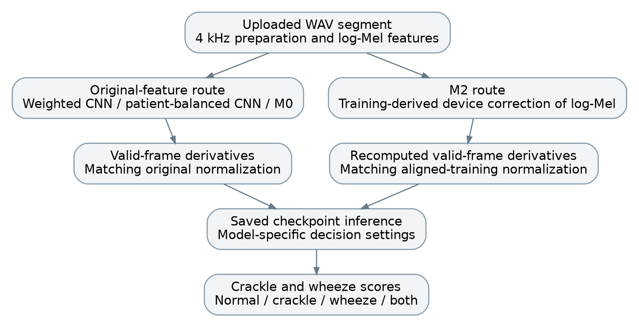
Figure 3.3 ML processing contract for the four-model dashboard. Alignment precedes reconstruction of derivative channels. This describes the required model-specific routes; complete preprocessing parity remains to be verified.
For a new device without a fitted correction profile, no training-derived device correction can be assumed. Any bypass or later calibration must be identified explicitly and evaluated separately. The dashboard does not demonstrate device-independent performance simply because it accepts a WAV file.

CHAPTER 4

CONTRIBUTION OF EACH STUDENT

4.1 Asmi Jain 230906092
Asmi carried out the ML work documented in the shared development record: dataset organization, annotation parsing, patient and recording audits, split checks, feature extraction, model training and comparisons, threshold evaluation, and analysis of class-, patient-, and device-level errors. The record includes the CNN–LSTM validation and test outputs, as well as the investigation of weak crackle recognition. Integration responsibilities include freezing the preprocessing contract and exporting the selected model with its normalization data.
Additional ML activity: The original notebook records the training-derived device-alignment experiment, including profile fitting from the training partition, retraining of the aligned CNN–LSTM from fresh weights, and validation-stage analysis of crackle and wheeze ranking. The original validation comparison is currently available only as historical aggregate outputs; sample-level reproduction remains blocked. Asmi also developed the four-model laptop inference dashboard. Independent aligned-test evaluation remains pending.

4.2 Sonali Pandit 230906514
Sonali contributed to the hardware and DSP implementation of the project. She worked on the ESP32-S3-based dual-microphone setup using INMP441 MEMS microphones, including the I²S wiring and primary/reference channel arrangement. She also contributed to adaptive noise-cancellation tests using LMS/NLMS filtering, comparison of raw and filtered recordings, and preparation of processed audio for integration with the machine-learning stage.

4.3 Susmrithi Rishi 230906050
Susmrithi contributed to integrating and validating the dual-microphone respiratory sound acquisition system. Her work included supporting microphone placement and prototype assembly, verifying synchronized recordings from the chest and ambient-reference microphones, and assisting with noise-cancellation experiments. She also contributed to recording analysis, checking the quality of the filtered respiratory signals, and documenting the hardware setup and experimental observations.
Current validation note: The assembly and intended microphone arrangement are documented, but the microphones are presently not functioning. Reliable synchronized dual-channel recording, ANC effectiveness, and hardware-to-model integration remain pending evidence.

CHAPTER 5

RESULT ANALYSIS

5.1 Validation comparisons
Table 5.1 Historical recorded results on 649 validation cycles
Experiment on 649 validation cycles | Accuracy | Macro F1
Always normal baseline | 0.5532 | 0.1781
Compact log-Mel CNN | 0.4761 | 0.2008
Time-resized log-Mel CNN | 0.4284 | 0.2352
Frame-padded CNN | 0.4268 | 0.2424
Weighted three-channel CNN | 0.4992 | 0.4079
Patient-balanced three-channel CNN | 0.5193 | 0.4186
CNN embeddings with RBF-SVM | 0.4484 | 0.3826
CNN embeddings with k-NN k 11 | 0.5208 | 0.4374
CNN embeddings with bagged k-NN | 0.5239 | 0.4376
CNN–LSTM selected model | 0.5655 | 0.5041

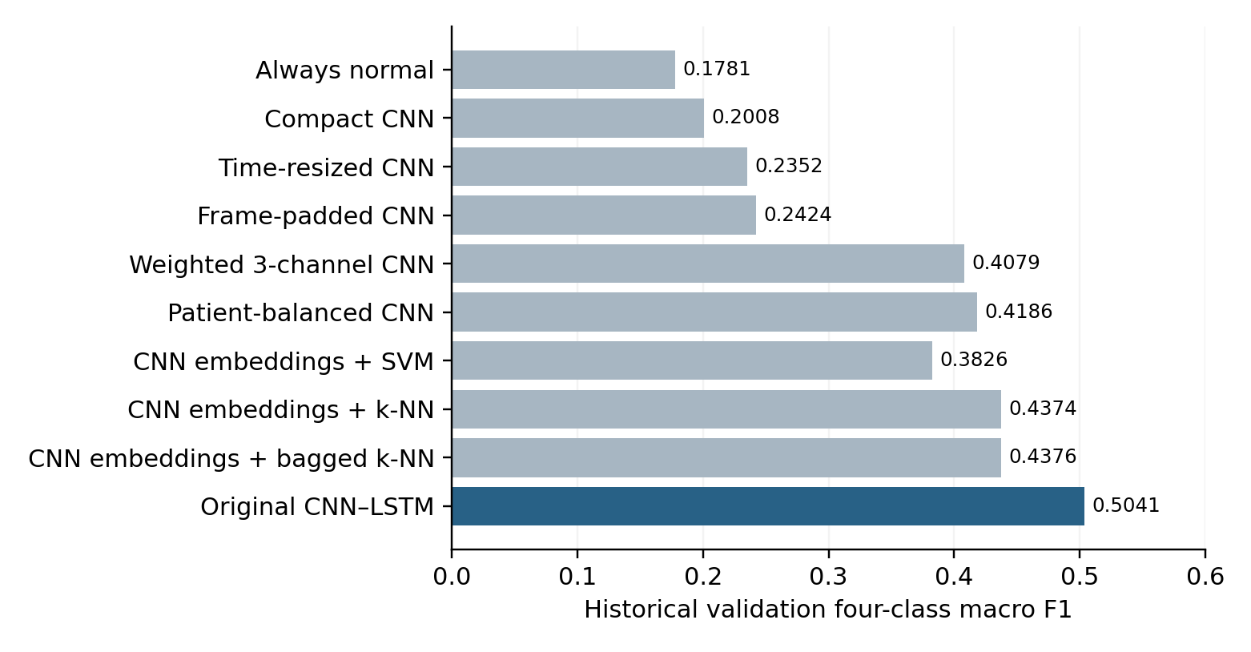
Figure 5.1 Historical validation macro F1 for the selected 649-cycle experiments. Values are saved notebook aggregates, not a new controlled rerun.
The CNN–LSTM gave the highest historical validation macro F1 (0.5041); its accuracy exceeded the always-normal baseline by 1.23 percentage points. These exploratory comparisons used repeated validation tuning and different training configurations.

5.2 Selected model validation and test performance
Table 5.2 Validation and test comparison for CNN–LSTM
Metric | Validation | Evaluated test
Four-class accuracy | 0.5655 | 0.4583
Four-class macro F1 | 0.5041 | 0.3584
Crackle event ROC-AUC | 0.5517 | 0.5885
Wheeze event ROC-AUC | 0.8497 | 0.7276
Crackle threshold | 0.45 | 0.45
Wheeze threshold | 0.60 | 0.60

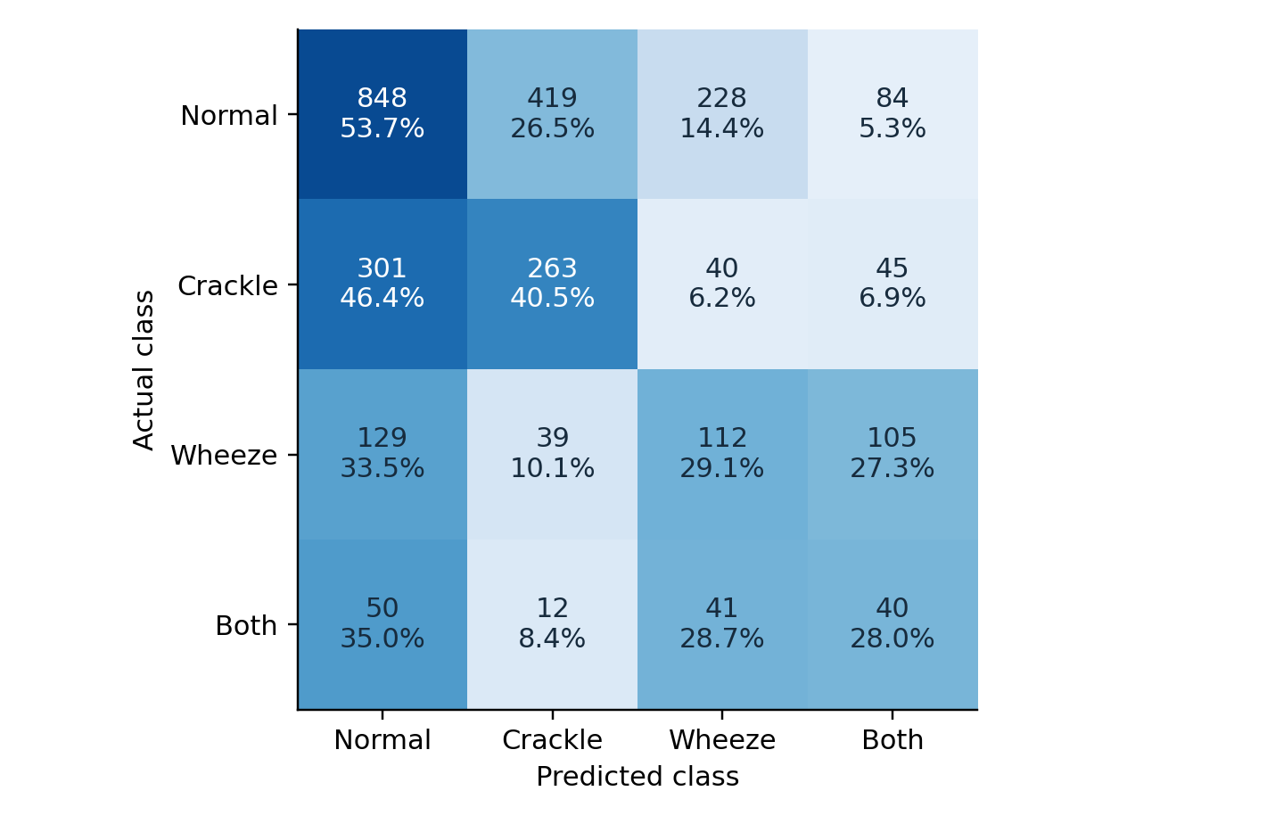
Figure 5.2 Test confusion matrix with row percentages
The historical test matrix contains 2,756 cycles. Its diagonal totals 1,263, which gives 45.83% accuracy. Normal-class recall, called specificity in the ICBHI-style scoring protocol, is 848/1,579 = 0.5370. Exact abnormal-category sensitivity is (263 + 112 + 40)/1,177 = 0.3526. Their mean is 0.4448. This is an explicitly defined ICBHI-style score, not conventional four-class balanced accuracy. These calculations agree with the recorded baseline outputs; they do not constitute a new aligned-model evaluation.
Validation-to-test accuracy fell by 10.72 percentage points. An always-normal classifier would reach 57.29% accuracy on the test set but only about 0.182 macro F1. The selected model improves class balance relative to that trivial predictor, but it is still inadequate for reliable autonomous assessment.

Class and device related failure analysis

5.3 Event level performance
Table 5.3 Test event performance at frozen thresholds
Test event | Precision | Recall | F1 | ROC-AUC
Crackle | 0.3575 | 0.4545 | 0.4002 | 0.5885
Wheeze | 0.4288 | 0.5644 | 0.4873 | 0.7276

Crackle scores show weak discrimination, and wheeze performance also drops on the test subset. Lowering thresholds can increase event sensitivity but will generate more false positives. It cannot create separation between classes whose score distributions already overlap. The final display should identify an experimental acoustic classification, not a disease or calibrated risk estimate.

5.4 Device coverage and recording effects
The development audit found only 28 Litt3200 training cycles from one patient and no Litt3200 validation cycles. The test subset contained 461 Litt3200 cycles from ten patients. This uneven coverage may contribute to generalization problems, but it does not prove that device type alone is the cause. Patient, class, recording site, and device effects are entangled. The database's device filename erratum must also be reconciled [12].
Table 5.4 Within recording crackle ranking diagnostic
Validation device | Mixed recordings | Patients | Pair-weighted AUC
AKGC417L | 6 | 2 | 0.333
LittC2SE | 5 | 5 | 0.473
Meditron | 9 | 5 | 0.516

This diagnostic uses only recordings that contain both crackle-positive and crackle-negative cycles. It compares pairs within the same recording, so it differs from pooled event AUC. Results were weak and based on few patients. One Meditron patient contributed 74.4% of eligible pairs. Repeated pairs share cycles and are not independent samples. These are historical diagnostic summaries; no new within-recording comparison was generated from the restored files.

5.5 Historical alignment results and reproducibility
The original notebook records M0, M1 and M2 as defined in Table 3.7. The present restoration cannot produce a verified comparison of M0 versus M1, M0 versus M2, or M1 versus M2 on the original 649 validation cycles. Although the 649-row manifest was reconstructed using the original split logic, the matching feature tensors and prediction arrays with sample-level identities were not preserved. Recovery of the manifest alone therefore does not recover a reproducible comparison.
Table 5.4A Historical validation performance of M0 and M2
Metric | M0 | M2 | Recorded change
Crackle ROC-AUC | 0.5517 | 0.5555 | +0.0039
Crackle average precision | 0.3547 | 0.4019 | +0.0471
Wheeze ROC-AUC | 0.8497 | 0.9013 | +0.0516
Wheeze average precision | 0.7636 | 0.7917 | +0.0281
Source: saved original notebook output, cell 318 (cells counted from 1). The change column preserves the notebook differences calculated before rounding; subtracting the displayed four-decimal endpoints can differ by 0.0001. These metrics are historical observations and have not been independently reproduced from the restored assets.
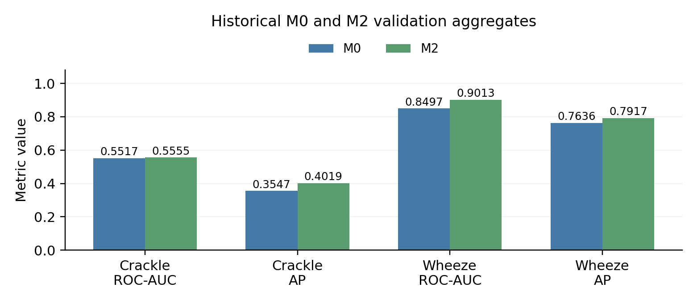
Figure 5.2A Historical aggregate M0/M2 validation performance. Bars are drawn from Table 5.4A; no new inference or sample-level re-evaluation was performed.
Crackle ROC-AUC changed only slightly and remained near 0.55, while crackle average precision increased in the saved run. Wheeze ROC-AUC and average precision were higher for M2. These observations do not establish statistically reliable improvement, higher four-class accuracy, or an independent test benefit. M0 remains the best documented four-class validation model among the listed development experiments; M2 is an experimental candidate with stronger historical wheeze ranking. No universal best model across all detections has been established.

5.5.1 Device-wise historical observations
Device-level aggregates show that alignment did not benefit every device equally. All three devices below contributed training data, so this comparison is not an unseen-device evaluation. Counts describe the historical validation subset and do not provide a new reconstruction of its prediction rows.
Table 5.4B Historical device-wise crackle results
Device | Cycles | Positive | M0 AUC | M2 AUC | M0 AP | M2 AP
AKGC417L | 285 | 121 | 0.5375 | 0.6972 | 0.4174 | 0.7071
LittC2SE | 85 | 26 | 0.2979 | 0.2601 | 0.2589 | 0.2189
Meditron | 279 | 62 | 0.4570 | 0.4529 | 0.2088 | 0.2104
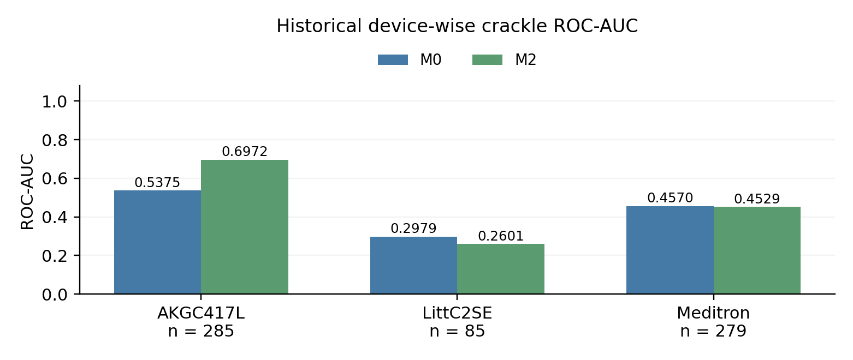
Figure 5.2B Historical device-wise crackle ROC-AUC. AKGC417L improved, whereas LittC2SE and Meditron did not. The original per-sample arrays are unavailable.
Table 5.4C Historical device-wise wheeze results
Device | Cycles | Positive | M0 AUC | M2 AUC | M0 AP | M2 AP
AKGC417L | 285 | 28 | 0.9537 | 0.9533 | 0.7176 | 0.7351
LittC2SE | 85 | 41 | 0.9673 | 0.9889 | 0.9725 | 0.9883
Meditron | 279 | 47 | 0.7494 | 0.7912 | 0.6608 | 0.6776
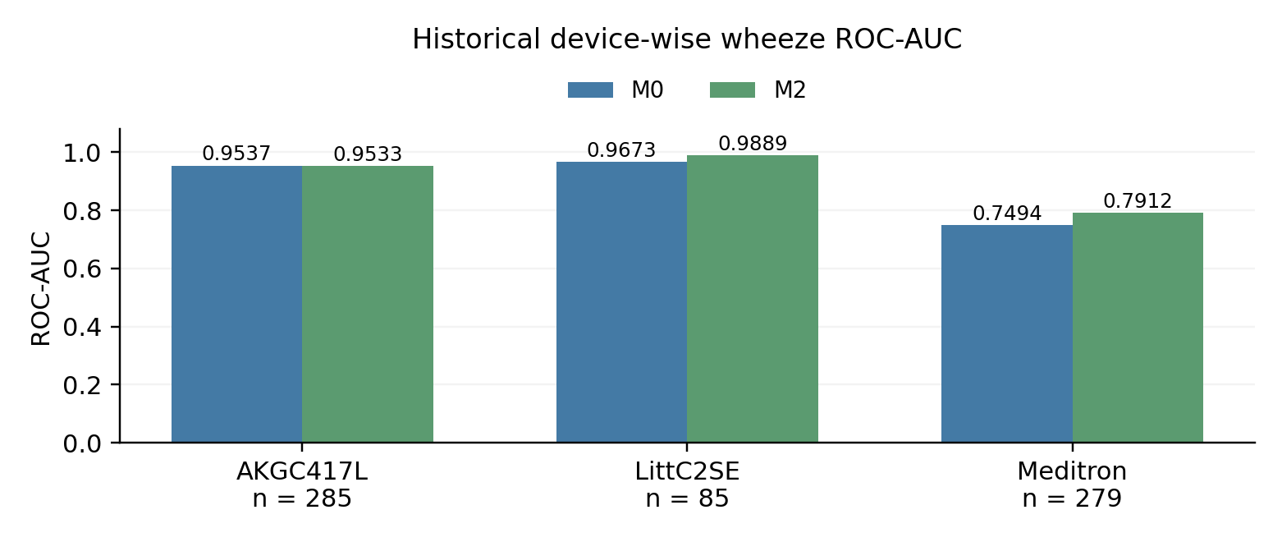
Figure 5.2C Historical device-wise wheeze ROC-AUC. LittC2SE and Meditron improved; AKGC417L changed slightly downward. Source for Tables 5.4B–5.4C: original notebook cell 319.
The saved device results are heterogeneous: the strong crackle gain on AKGC417L does not justify claiming a uniform correction across devices. Higher average spectral similarity alone also does not show that respiratory events have been preserved. Patient, class and acquisition differences remain possible confounders.

5.5.2 Limits of the restored comparison
Aggregate bar charts can be reconstructed from the saved tables, but paired precision–recall curves, new confusion matrices, threshold sweeps, paired confidence intervals and new patient-level error analyses require the missing sample-identified scores and labels. None is regenerated here. A later aligned-test comparison must use the same recording order, training-derived corrections, matching derivative statistics and frozen checkpoints. It remains pending; an available manifest or a checkpoint that loads successfully does not establish feature parity.

5.5.3 Qualitative dashboard observations
The supplied demonstration notes record M0 and M2 predicting normal for central five-second crops from 175_1b1_Pr_sc_Litt3200.wav and 221_2b1_Al_mc_LittC2SE.wav. The notes associate these recordings with wheeze-only and combined events respectively. These are reported qualitative examples, not an additional test set or a substitute for the missing validation predictions. Exact crop boundaries, cycle-level annotation overlap, checkpoint identities and model-specific thresholds must be retained before interpreting individual outputs as verified errors. A full recording can contain several differently labelled cycles.
The dashboard makes disagreement and missed events visible, but it does not establish improved classification accuracy. No performance percentage is calculated from these selected examples. The next ML step is to audit dashboard-to-training preprocessing parity and preserve sample identities, matching feature tensors, normalization vectors and predictions for any new evaluation.

Problems encountered and responses
Table 5.5 ML development problems and responses
Observed problem | Action and recorded outcome
Partial dataset copy and path errors | The initial scan found 145 WAV files; copying and path checks later recovered all 920.
Annotation and filename mismatch | Audited file stems and joins; investigated the unmatched patient 226 recording and reserved the patient together.
Patient overlap across supplied assignments | Excluded 13 development recordings from patients also in test and saved an exclusion audit.
Disk full during feature saving | Storage exhaustion was identified in the log; the ML developer later confirmed that saving succeeded.
Model predicted only crackle | Checked feature values, label alignment and small-subset fitting. Later compact models produced multiple classes.
Padding and duration artifacts | Compared waveform padding, time resizing and frame padding. Retained explicit masks for real feature frames.
Few abnormal labels and patient imbalance | Tested class/event weighting and patient-balanced sample weights. Gains were incomplete, especially for crackles.
Weak two-output probabilities | Compared MFCC, fusion, derivatives, embedding classifiers and CNN–LSTM; tuned thresholds on validation.
Runtime model naming and input errors | Inspected model objects and layer outputs before feature extraction; separated saved experiment identities.
Poor test transfer and device imbalance | Performed patient/device error analysis. Device-aware splits and cross-device evaluation remain proposed.

These steps establish an experimental workflow and explain why the final method differs from the preliminary MFCC-only plan. They do not show that every failure has been solved. In particular, improved wheeze modeling and validation macro F1 did not lead to reliable four-class test performance.

Hardware results and integration evidence

5.6 Evidence available for the hardware stream
The midterm report provides a dual-microphone design, an LMS-based cancellation concept, a quality-gating plan, and intended embedded deployment. The funding proposal extends the design to NLMS, local storage, a display, and optional context sensors. The team confirmed ESP32 as the current controller. Final waveform captures, wiring photos, firmware logs, and measured cancellation gains were not supplied.
Table 5.6 Hardware measurements required to close the report
Measurement to add | Evidence needed | Status
Acquisition | Board and microphone IDs; channel test; measured sample rate | Completed
Signal quality | Raw waveforms; clipping and dropout counts | Completed
ANC performance | Same-case raw/reference/residual data; filter settings; SNR or error analysis | Completed
Signal preservation | Comparison of respiratory events before and after cancellation | Completed
Integration | One hardware WAV processed by the saved ML pipeline | Completed
Timing and memory | Capture time, DSP time, inference time and peak memory | Completed
Standalone inference | Converted model, operator list and on-board predictions | Completed
Portable operation | Measured supply current and tested power arrangement | Completed

Supplementary current hardware status
The original Table 5.6 is retained unchanged. The following update states the evidence-specific status reported for the current prototype.
Table 5.6A Supplementary current hardware validation status
Evidence area | Current status
Prototype assembly and wiring | Assembled; photograph available
Current microphone operation | Not functioning; troubleshooting pending
Verified dual-channel acquisition | Validation pending
ANC effectiveness and signal preservation | Not validated
Hardware recording to model integration | Pending
Onboard inference | Not demonstrated
Latency, memory and power | Measurements pending

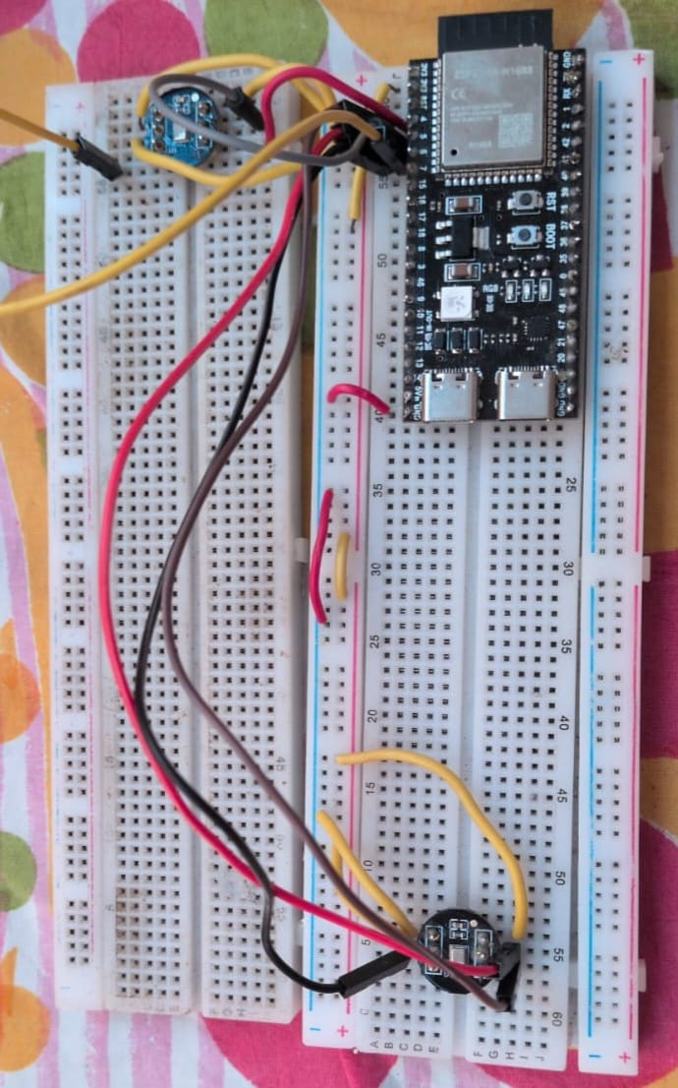
Figure 5.3 Dual-microphone hardware prototype using an ESP32-S3 and two INMP441 MEMS microphones.

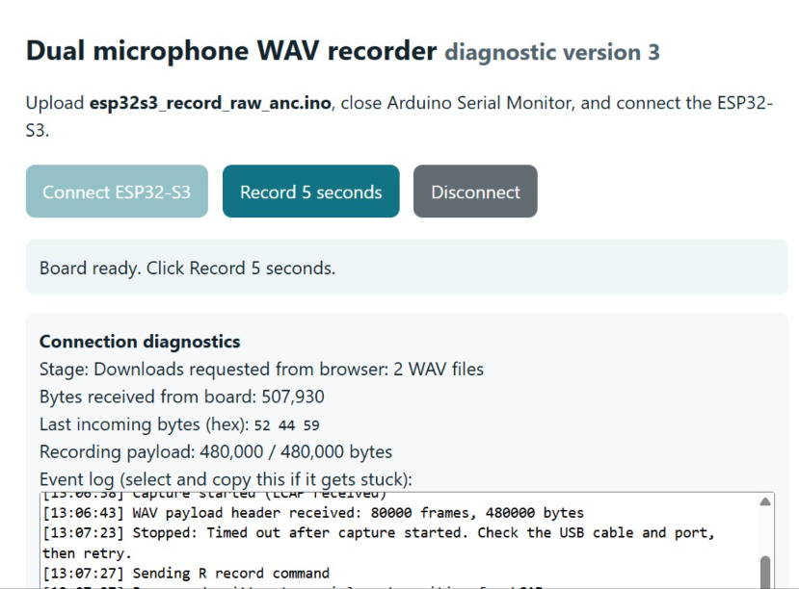
Figure 5.4 Dual-microphone WAV recorder

5.7 outcome of the microphones
The dual-microphone setup was tested using the ESP32-S3. The serial monitors displayed readings for the primary microphone on the left channel and the ambient microphone on the right channel. Each reading was calculated from a block of 256 audio frames.
The values represent the peak sample magnitude detected in each channel within the corresponding block. In the readings shown, the primary channel had peak values ranging from 88,942 to 543,034, while the ambient channel ranged from 146,392 to 801,292. Both channels produced non-zero, changing values, indicating that the ESP32-S3 was receiving digital audio samples from both microphones.
13:07:33.852 -> frames=256 primary/left=204860 ambient/right=146392
13:07:34.037 -> frames=256 primary/left=543034 ambient/right=801292
13:07:34.265 -> frames=256 primary/left=220574 ambient/right=389648
13:07:34.453 -> frames=256 primary/left=458020 ambient/right=384916
13:07:34.642 -> frames=256 primary/left=318710 ambient/right=453252
13:07:34.833 -> frames=256 primary/left=127984 ambient/right=222402
13:07:35.066 -> frames=256 primary/left=88942 ambient/right=307600
13:07:35.261 -> frames=256 primary/left=194636 ambient/right=301988

CHAPTER 6

CONCLUSION AND FUTURE SCOPE

6.1 Summary and contributions
The project brings the hardware and ML streams together in one respiratory sound assessment workflow. The hardware design uses primary and ambient-reference microphones with adaptive cancellation. The ML work builds audited patient-separated partitions, compares several feature and model alternatives, and evaluates a three-channel CNN–LSTM. The recorded test accuracy of 45.83% and macro F1 of 0.3584 establish the current baseline and its limitations.
The main software contributions are the reproducible data audit, explicit feature-padding masks, comparison of weighting strategies, threshold selection, analysis of device and patient errors, a training-derived alignment experiment, and the four-model laptop dashboard. The integration contribution is a clear audio interface between the ESP32 acquisition stage and the trained model.
Historical alignment gains vary by device and cannot currently be reproduced from sample-level assets. The four-model dashboard demonstrates software inference, not improved test accuracy or verified preprocessing parity. The physical prototype is assembled; however, the current microphone fault means that successful acquisition, ANC, and embedded inference are not claimed.

6.2 Limitations
Class/device imbalance, weak crackle discrimination and repeated validation tuning limit the ML conclusions. The previously inspected test set is no longer untouched. Missing sample-identified features and predictions prevent reproduction of M0/M1/M2 on the original 649-cycle validation set; alignment aggregates remain historical observations. The supplied measurements have not yet demonstrated hardware cancellation, quality thresholds, end-to-end timing, quantization, or standalone inference.

6.3 Future scope
The next priority is a reproducible ESP32-to-laptop handoff using the exact feature pipeline. Capture synchronized channels, preserve the raw recordings, and compare bypass and cancellation outputs under controlled noise. Add measured quality checks before expanding the interface. Confirm all hardware components and contributor-specific work.
For ML, verify dashboard-to-training parity and device naming; preserve sample-identified features and predictions. Test crackle-specific changes under patient-grouped development splits and independent evaluation. For embedded deployment, first establish float-model parity and then assess integer conversion and the full working-memory budget. A smaller CNN or a different board may be necessary; the present evidence cannot decide that yet.

Visible outcome

Documented outcomes
The documented ML outputs comprise the patient-separated dataset audit, model-development experiments, the original CNN–LSTM validation and test summaries, historical device-alignment results, and the four-model Streamlit dashboard. The original workflow records best_cnn_lstm_patient_weighted.keras, best_cnn_lstm_device_aligned.keras and cnn_lstm_official_test_predictions.csv as asset names. These recorded names do not establish that every original validation tensor or prediction array has been recovered. The original 649-cycle alignment comparison remains blocked at sample level.

Integrated demonstration outcome
The immediate intended outcome is a working acquisition-to-prediction demonstration using ESP32 audio and laptop inference. This remains a planned integration outcome until a hardware recording is passed through the trained pipeline and the result is logged. A fully standalone embedded classifier remains a later milestone.

Current visible outcome update
Completed software output: A laptop-based Streamlit dashboard supports prerecorded WAV input and comparison of the weighted CNN, patient-balanced CNN, original CNN–LSTM (M0) and aligned CNN–LSTM (M2). It displays experimental crackle/wheeze scores and an acoustic category. The historical ML tables and graphs document model development and limitations; they are separate from a verified rerun. Model-specific preprocessing parity and an independent aligned-test evaluation remain to be established.
Physical prototype: The ESP32-S3/two-INMP441 assembly and its wiring plan are available as physical evidence. The current microphone fault is disclosed; the photograph demonstrates assembly.

References
[1] B. M. Rocha et al., “An open access database for the evaluation of respiratory sound classification algorithms,” Physiological Measurement, vol. 40, no. 3, Art. no. 035001, 2019. doi: 10.1088/1361-6579/ab03ea.
[2] S. Yu, J. Yu, L. Chen, B. Zhu, X. Liang, Y. Xie, and Q. Sun, “Advances and challenges in respiratory sound analysis: A technique review based on the ICBHI2017 database,” Electronics, vol. 14, no. 14, Art. no. 2794, 2025. doi: 10.3390/electronics14142794.
[3] B. Widrow et al., “Adaptive noise cancelling: Principles and applications,” Proceedings of the IEEE, vol. 63, no. 12, pp. 1692–1716, Dec. 1975. doi: 10.1109/PROC.1975.10036.
[4] S. Haykin, Adaptive Filter Theory, 5th ed., International ed. Pearson, 2014. ISBN: 9780273775720.
[5] D. Perna and A. Tagarelli, “Deep auscultation: Predicting respiratory anomalies and diseases via recurrent neural networks,” in Proc. IEEE International Symposium on Computer-Based Medical Systems, 2019. Author manuscript: arXiv:1907.05708.
[6] S. N. Ali, S. B. Shuvo, M. I. S. Al-Manzo, A. Hasan, and T. Hasan, “An end-to-end deep learning framework for real-time denoising of heart sounds for cardiac disease detection in unseen noise,” IEEE Access, vol. 11, pp. 87887–87901, 2023. doi: 10.1109/ACCESS.2023.3292551.
[7] Espressif Systems, “Inter-IC Sound I2S,” ESP-IDF Programming Guide, ESP32, online documentation, accessed Nov. 2, 2026. Available: docs.espressif.com, ESP32 peripherals section.
[8] Espressif Systems, “ESP32-DevKitC V4 Getting Started Guide,” official development board documentation, accessed Nov. 2, 2026. Available: documentation.espressif.com, ESP32 development kits section.
[9] InvenSense, “INMP441 omnidirectional microphone with bottom port and digital output,” datasheet DS-INMP441-00, rev. 1.1, 2014. Available: invensense.tdk.com.
[10] B. McFee et al., “librosa: Audio and music signal analysis in Python,” in Proc. 14th Python in Science Conference, 2015, pp. 18–24. doi: 10.25080/Majora-7b98e3ed-003.
[11] Google AI Edge, “Get started with microcontrollers,” LiteRT for Microcontrollers documentation, accessed Nov. 2, 2026. Available: developers.google.com/edge/litert/microcontrollers/get_started.
[12] ICBHI Challenge, “ICBHI 2017 Challenge and Respiratory Sound Database,” dataset description, annotations and filename corrections, accessed Nov. 2, 2026. Available: bhichallenge.med.auth.gr/node/50.
[13] A. R. A. Sovijärvi et al., “European Respiratory Society Task Force Report: Computerized respiratory sound analysis (CORSA),” European Respiratory Review, vol. 10, no. 77, 2000.
[14] S. Reichert, R. Gass, C. Brandt, and E. Andrès, “Analysis of respiratory sounds: State of the art,” Clinical Medicine: Circulatory, Respiratory and Pulmonary Medicine, vol. 2, pp. 45–58, 2008.
[15] D. Emmanouilidou, E. D. McCollum, D. E. Park, and M. Elhilali, “Computerized lung sound screening for pediatric auscultation in noisy field environments,” IEEE Transactions on Biomedical Engineering, vol. 65, no. 7, 2018.
[16] I. McLane, D. Emmanouilidou, J. E. West, and M. Elhilali, “Design and comparative performance of a robust lung auscultation system for noisy clinical settings,” IEEE Journal of Biomedical and Health Informatics, vol. 25, no. 7, pp. 2583–2594, 2021.
[17] MathWorks, “IIR Filter Design,” Signal Processing Toolbox Documentation, accessed Nov. 2026. Available: https://www.mathworks.com/help/signal/ug/iir-filter-design.html.
[18] A. Suzuki, C. Sumi, K. Nakayama, and M. Mori, “Real-time adaptive cancelling of ambient noise in lung sound measurement,” Medical & Biological Engineering & Computing, vol. 33, no. 5, pp. 704–708, 1995. doi: 10.1007/BF02510790.
[19] S. B. Patel et al., “An adaptive noise reduction stethoscope for auscultation in high noise environments,” The Journal of the Acoustical Society of America, vol. 103, no. 5, pp. 2483–2491, 1998. Doi: 10.1121/1.422769.
[20] J. S. Fleeter and G. R. Wodicka, “Auscultation of heart and lung sounds in high-noise environments using adaptive filters,” The Journal of the Acoustical Society of America, vol. 104, no. 3, p. 1781, 1998. Doi: 10.1121/1.424142.
[21] D. Della Giustina et al., “Embedding a multichannel environmental noise cancellation algorithm into an electronic stethoscope,” International Journal of Circuits, Systems and Signal Processing, 2011. [Online]. Available: https://www.naun.org/main/NAUN/circuitssystemssignal/19-812.pdf.
[22] D. Emmanouilidou, E. D. McCollum, D. E. Park, and M. Elhilali, “Adaptive noise suppression of pediatric lung auscultations with real applications to noisy clinical settings in developing countries,” IEEE Transactions on Biomedical Engineering, vol. 62, no. 9, pp. 2279–2288, 2015. Doi: 10.1109/TBME.2015.2422773.
[23] N. Q. Al-Naggar and M. H. Al-Udyni, “Performance of adaptive noise cancellation with normalized least-mean-square based on the signal-to-noise ratio of lung and heart sound separation,” Journal of Healthcare Engineering, vol. 2018, Art. no. 9732762, 2018. Doi: 10.1155/2018/9732762.
[24] N. Mohamed, H.-S. Kim, K.-M. Kang, M. Mohamed, S.-H. Kim, and J. G. Kim, “Heart and lung sound measurement using an esophageal stethoscope with adaptive noise cancellation,” Sensors, vol. 21, no. 20, Art. no. 6757, 2021. Doi: 10.3390/s21206757.
[25] J. De La Torre Cruz, F. J. Cañadas-Quesada, D. Martínez-Muñoz, N. Ruiz-Reyes, S. García-Galán, and J. J. Carabias-Orti, “An incremental algorithm based on multichannel non-negative matrix partial co-factorization for ambient denoising in auscultation,” Applied Acoustics, vol. 182, Art. no. 108229, 2021. Doi: 10.1016/j.apacoust.2021.108229.
[26] A. J. Muñoz-Montoro, P. Revuelta-Sanz, D. Martínez-Muñoz, J. Torre-Cruz, and J. Ranilla, “An ambient denoising method based on multi-channel non-negative matrix factorization for wheezing detection,” The Journal of Supercomputing, vol. 79, pp. 1571–1591, 2023. Doi: 10.1007/s11227-022-04706-x.
[27] C. Yang, N. Dai, Z. Wang, S. Cai, J. Wang, and N. Hu, “Cardiopulmonary auscultation enhancement with a two-stage noise cancellation approach,” Biomedical Signal Processing and Control, vol. 79, Art. no. 104175, 2023. Doi: 10.1016/j.bspc.2022.104175.
[28] A. J. Muñoz-Montoro, P. Revuelta-Sanz, A. Villalón-Fernández, R. Muñiz, and J. Ranilla, “A system for biomedical audio signal processing based on high performance computing techniques,” Integrated Computer-Aided Engineering, vol. 30, no. 1, pp. 1–18, 2023. Doi: 10.3233/ICA-220686.
[29] H. Liu, M. Barekatain, A. Roy, S. Liu, Y. Cao, Y. Tang, A. Shkel, and E. S. Kim, “MEMS piezoelectric resonant microphone array for lung sound classification,” Journal of Micromechanics and Microengineering, vol. 33, no. 4, Art. no. 044003, 2023. Doi: 10.1088/1361-6439/acbfc3.
[30] J. Acharya and A. Basu, “Deep neural network for respiratory sound classification in wearable devices enabled by patient specific model tuning,” IEEE Transactions on Biomedical Circuits and Systems, vol. 14, no. 3, pp. 535–544, 2020. doi: 10.1109/TBCAS.2020.2981172.
[31] Rishabh and D. Kumar, “Multi spectral feature extraction to improve lung sound classification using CNN,” in Proc. 10th International Conference on Signal Processing and Integrated Networks (SPIN), 2023. doi: 10.1109/SPIN57001.2023.10116295.
[32] N. Asatani, T. Kamiya, S. Mabu, and S. Kido, “Classification of respiratory sounds based on hybrid convolutional recurrent neural network,” in Proc. IEEE International Conference on Systems, Man, and Cybernetics (SMC), 2025. doi: 10.1109/SMC58881.2025.11342473.
[33] N. Fraihi, O. Karrakchou, and M. Ghogho, “Improving deep learning-based respiratory sound analysis with frequency selection and attention mechanism,” arXiv:2507.20052v1, 2025, preprint. Available: https://arxiv.org/abs/2507.20052v1.
[34] R. Yang, K. Lv, Y. Huang, M. Sun, J. Li, and J. Yang, “Respiratory sound classification by applying deep neural network with a blocking variable,” Applied Sciences, vol. 13, Art. no. 6956, 2023. doi: 10.3390/app13126956.
[35] T. Nguyen and F. Pernkopf, “Lung sound classification using co-tuning and stochastic normalization,” IEEE Transactions on Biomedical Engineering, vol. 69, no. 9, pp. 2872–2882, 2022. doi: 10.1109/TBME.2022.3156293.
[36] M. H. Nawaz, J. Ahmad, M. Haroon, M. Haseeb, and A. Salman, “Real-time deep learning for lung disease classification: A step forward,” in Proc. International Conference on Frontiers of Information Technology (FIT), 2024. doi: 10.1109/FIT63703.2024.10838437.
[37] T. Bikku et al., “Deep learning-driven early diagnosis of respiratory diseases using CNN-RNN fusion on lung sound data,” Scientific Reports, 2025. doi: 10.1038/s41598-025-28832-7.

Project source records
The supplied Minor Project Midterm Report dated May 2026 identifies the team, guide, and hardware design. The funding proposal dated August 2026 describes the planned standalone system. Two copies of that proposal were byte-identical. The final report template defines the chapter and formatting requirements.
The shared ML development conversation contains the experiment outputs transcribed in Chapter 5. Source: https://chatgpt.com/share/6ae85565-0f80-83ee-acdc-d60e758275cc. The team's confirmation during report preparation identifies ESP32 as the current controller. These are project records and are separate from the external technical references.
ML evidence update: Historical numeric results were checked against saved outputs in 02_build_dataset(1).ipynb (441 cells; cell numbers in this report start at 1). The restored Fixed_Checkpoint_Test_Comparison notebooks contain no executed comparison outputs. The restoration audit and dashboard demonstration notes document the current reproducibility limits and the four available model options. No models were trained or evaluated while making this report update.
Two earlier DSP records—"Graph Inferences for minor" and "Lung Sound Filtering Literature Review and Parameter Justification"—provide the filter-comparison parameters, spectral observations, and controlled denoising results synthesized in Chapter 2. These are retained as project evidence; broader technical claims are supported by the cited literature.

Minor specialization project details

Details of student 1
Asmi Jain Registration number 230906092
Branch EEE Section C Roll number 16
Email asmi2.mitmpl2023@learner.manipal.edu
Mobile 8369654209

Details of student 2
Sonali Pandit Registration number 230906514
Branch EEE Section A Roll number 60
Email sonali.mitmpl2023@learner.manipal.edu
Mobile 9480504819

Details of student 3
Susmrithi Rishi Registration number 230906050
Branch EEE Section B Roll number 09
Email susmrithi.mitmpl2023@learner.manipal.edu
Mobile 8291768439

Project and guide details
Project title: Dual Microphone Respiratory Sound Assessment with Adaptive Noise Cancellation and Machine Learning
Guide: R Srividya
Designation: Associate Professor, Department of Electrical and Electronics
Email: srividya.r@manipal.edu Mobile: 8904947975
Student signatures: ______________________________________
Guide signature: _________________________________________
Date: __________________

Plagiarism report



