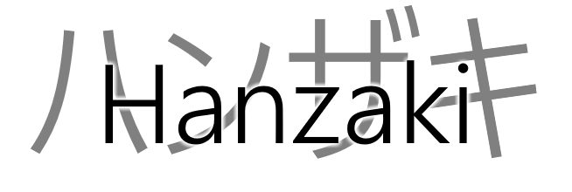Game Design Document

* Game Info Document
* Functional Design Document
* Graphical Design Document
* Technical Design Document

Producer**:** Alieke  
Lead-Dev**:** Jordi  
Lead-Artist**:** Rilana  
Level Design**:** Sascha  
UX**:** Marc  
QA**:** Janneke  
Planning Manager**:** Arne

Contents

Intro 5

Game Info Document

# Intro

balbla