PERIPHERALS PLUS

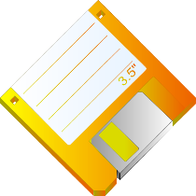

(646)-898-6789

136-06 35th Avenue, Flushing, NY 11354

September 26, 2016

Mr. Fred Jones

ABC Products

234-15 56 Avenue

Bayside, NY 11364

Dear Mr. Jones:

We would like to take this opportunity to thank you got your recent floppy disk order. We are happy to welcome you as a new customer to Peripherals Plus.

At PERIPHERALS Plus we hope to meet all your computer input, output, and storage device needs. If you ever have any comments or questions, please feel free to contact your service representative, at 800-555-1234.

Sincerely,

Helen Zhou

President