CIRCUIT ANALYSIS COURSE

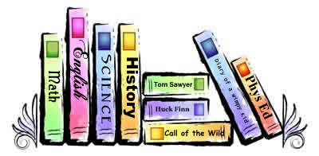

(646)-898-6789

136-06 35th Avenue, Flushing, NY 11354

September 26, 2016

Mr. Stu Asser

Queensborough Community College

222-05 56 Avenue

Bayside, NY 11364

Dear Mr. Asser:

I really enjoy my lab and lecture class for ET110- Circuit Analysis. The way Professor Wu and Professor Birchfield makes their class is very enjoyable. The way they teach and explain is very easy for me to understand. Even if I do not understand, they are so willing to explain to us when we go to their office ours. I would recommend them to any students who are planning to take ET110- Circuit Analysis.

Sincerely,

Helen Zhou

Student