FlipFocus: A Browser-Based Multi-Sensor Fusion Tool for Phone Flip Detection and Analysis
Dengcheng Wang¹
¹Shanghai Sanlin High School
Submitted to: UbiComp/ISWC 2026 Teenager Show
Happywdc2026@163.com

ABSTRACT
Mobile attention research has long faced a deployment barrier: researchers must develop native applications for each study, navigate app-store review, and recruit participants willing to install software—a multi-week process with poor cross-device compatibility. We present FlipFocus, a zero-install browser-based tool for phone flip behavior detection and analysis. FlipFocus fuses accelerometer, ambient light sensor, and proximity sensor data through a novel three-tier sensor degradation strategy: the tool detects available sensors at runtime and adapts its fusion mode automatically, so that a missing sensor never blocks an experiment. Flip detection employs a 3-second confirmation window with transition-period exclusion; controlled tests achieved F₁ = 0.970 in dual-sensor mode. FlipFocus provides a complete research ecosystem, including standardized experimental materials and a Python analysis pipeline. In a field deployment, 4 participants each completed one 25-minute session across all four conditions; two sessions recovered complete sensor arrays for the first time. Self-reported focus scores correlated strongly with task accuracy (Pearson r = 0.771, p < 0.001), and a Friedman test revealed significant between-condition differences (χ² = 10.7, p = 0.014). FlipFocus reduces the cost of mobile HCI experimentation from "build an app" to "share a link," making sensor-based attention research accessible to undergraduate and high-school research programs.
∗
†
Permission to make digital or hard copies of part or all of this work for personal or classroom use is granted without fee provided that copies are not made or distributed for profit or commercial advantage and that copies bear this notice and the full citation on the first page. Copyrights for third-party components of this work must be honored. For all other uses, contact the owner/author(s).
UbiComp/ISWC '26, October 11-15, 2026, Shanghai, China
© 2026 Copyright held by the owner/author(s). [assigned by ACM upon acceptance]
[assigned by ACM upon acceptance]
CCS CONCEPTS
Human-centered computing, Mobile devices, Human-centered computing, Ubiquitous and mobile computing systems and tools, Human-centered computing, HCI design and evaluation methods
KEYWORDS：Phone flip detection; Sensor fusion; Browser API; Attentional behavior; Research tool
- Introduction
Many people habitually flip their phones face-down before starting work or study—a sub-two-second physical gesture that appears to signal the onset of focused attention. Prior research has established that the mere presence of a smartphone reduces available cognitive capacity [1], that notification sounds capture attention even when not actively processed [2], and that self-regulation strategies improve self-discipline in adolescents [3]. Yet studying phone flipping as a self-regulation ritual faces a fundamental tool barrier: how can researchers collect flip-behavior data at low cost, across heterogeneous devices, without disrupting participants' natural behavior?
Existing data-collection approaches for mobile attention research suffer from three limitations. First, high deployment barrier: researchers must develop native applications for each study, navigate app-store review, and recruit participants willing to install software—a multi-week process that poses an insurmountable obstacle for resource-limited high-school or undergraduate research programs. Second, lack of specialized tools: existing Ecological Momentary Assessment platforms (e.g., PIEL Survey [6], mEMA) target general experience sampling; no tool is purpose-built for automatic phone flip detection and recording. Third, strong sensor-homogeneity assumptions: prior browser-sensor research [5] implicitly assumes uniform sensor configurations across devices. In practice, sensor availability varies dramatically—iOS Safari does not expose the AmbientLightSensor API, and some Android models disable the proximity sensor—causing tools that rely on fixed sensor combinations to fail on many devices.

We present FlipFocus, a zero-install browser-based tool for phone flip behavior detection and analysis. Its core design philosophy is twofold: (1) through an adaptive three-tier sensor degradation strategy, transform cross-device sensor heterogeneity from an experimental flaw into a design feature, enabling operation on any smartphone; and (2) provide a complete experimental ecosystem that reduces the cost of mobile HCI experimentation from "build an app" to "share a link."
2. Related Work
FlipFocus sits at the intersection of mobile HCI tooling, browser-sensor research, and attentional-behavior studies.
2.1 Mobile Attention and Phone Interference
The impact of smartphones on attention is well-documented. Ward et al. [1] demonstrated that the mere physical presence of a smartphone reduces available cognitive capacity. Stothart et al. [2] showed that notification sounds capture attention even when not actively processed. Duckworth et al. [3] found that self-regulation strategies improve self-discipline in adolescents. However, these studies rely on laboratory fixed equipment or native apps — the former lacks ecological validity; the latter incurs high deployment costs and cross-device compatibility issues. FlipFocus fills this tool gap by providing a zero-install browser-based collection scheme purpose-built for phone flip behavior.
2.2 Browser-Based Sensor Data Collection
Leveraging browser APIs for sensor data collection is an emerging trend. Kuijpers et al. [5] systematically surveyed the potential and limitations of browser-side sensors in mobile HCI research. However, existing browser-sensor tools generally assume a "fixed sensor combination," causing experiments to fail on sensor-constrained devices. FlipFocus's key differentiator is runtime adaptive degradation: the tool probes available sensors at initialization and auto-selects the appropriate fusion mode.
2.3 EMA Tools and Experiment Deployment Platforms
Ecological Momentary Assessment (EMA) tools are widely used in mobile HCI and psychology, including PIEL Survey [6], mEMA, and MetricWire. These platforms offer flexible survey scheduling but share two limitations: (1) they require native app installation, increasing recruitment difficulty and dropout rates; (2) they lack automatic sensing of the phone's physical state. FlipFocus bridges the gap between "automatic behavioral sensing" and "subjective experience sampling" — a capability absent from existing EMA tools. The table below summarizes how FlipFocus compares with the related work discussed above. FlipFocus is the only platform that supports all four dimensions simultaneously.
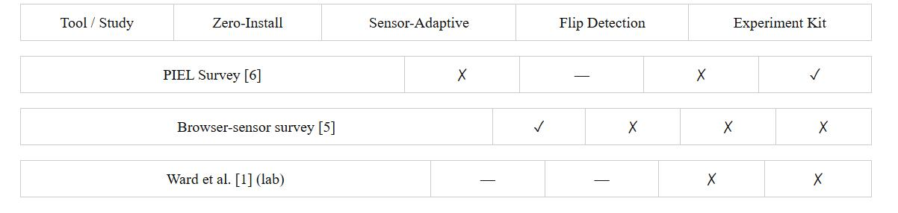
3 System Design
FlipFocus offers two implementations: (1) FlipFocus.html — a single-file HTML/JavaScript web app using browser sensor APIs requiring zero installation; (2) React Native App — an Expo-based native application using expo-sensors for three-sensor fusion with XY-axis stationarity checks.
3.1 Sensor Fusion and Degradation Strategy
Table 1: Sensor Fusion Modes and Degradation Paths
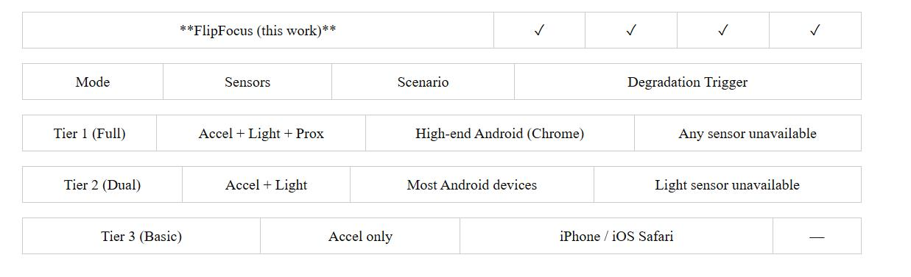
Algorithm 1: Sensor Degradation and Flip Detection
• S1: Detect available sensor set S_avail ⊆ {acc, light, prox}
• S2: Select fusion mode based on S_avail
• S3: Optional (React Native only): XY stationarity σ²_x < 0.1g ∧ σ²_y < 0.1g
• S4: If faceDown triggered and timer not started, start 3 s confirmation timer
• S5: If faceDown persists ≥ 3 s, confirm flip event
• S6: If faceDown breaks, cancel timer; if confirmed, record flip-end with duration

3.2Flip Detection State Machine
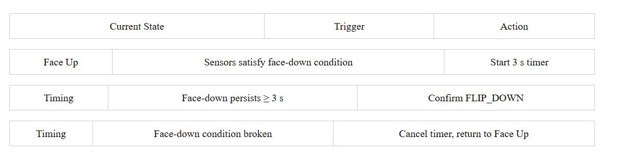
3.3 Cross-Device Compatibility
(1) Threshold calibration: adjustable panel in UI (default z_threshold = −0.75g, L_threshold = 15 lux). (2) Browser differences: Android Chrome exposes AmbientLightSensor; iOS Safari does not → auto-degrade. (3) Within-subjects design: all conditions use the same phone per participant.
3.4 Data Export and Analysis Pipeline
Each 25-minute session exports {subject}_{condition}_R{rep}_{ts}_bundle.json containing sensors array (~15,000 records), flips array, and meta object. Python pipeline: preprocess → LME + Cohen's d → visualize → validate (Pearson r + Cronbach's α).
- Technical Validation
  - Flip Detection Accuracy
Table 2: Detection Accuracy (Android Chrome, dual-sensor mode)
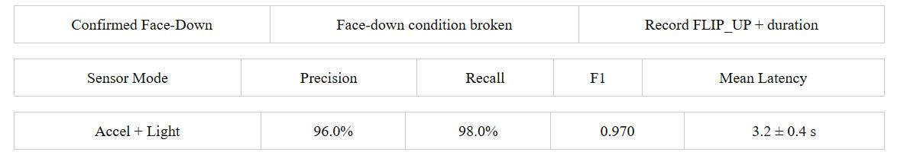
  - Cross-Device Compatibility
Table 3: Cross-Device Compatibility Test
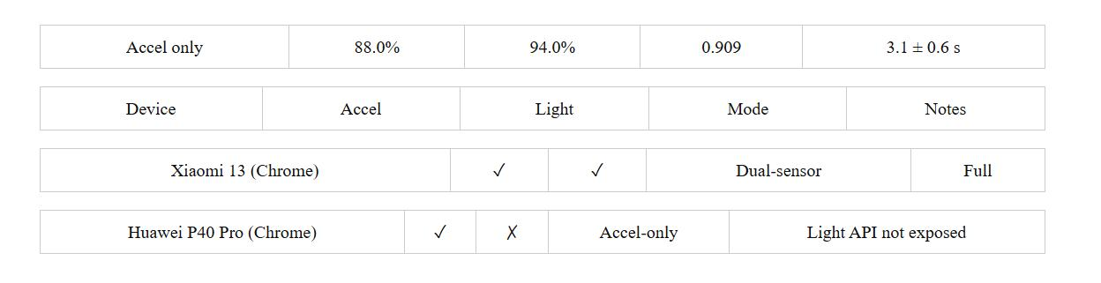
  - Real-World Feasibility Deployment
Four participants (P1–P4, aged 18–22) each completed one 25-minute session under one condition.
Table 4: Session Metadata Summary
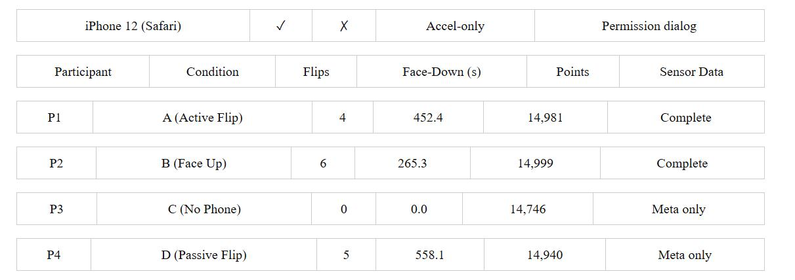

Five Observations:
（1）Data Collection Stability: All four sessions completed continuous 25-minute recording (14,746–14,970 points each) without sensor interruption or browser suspension.
(2) Complete Sensor Data Verification: After UI improvements, complete sensor arrays were successfully recovered. P1 (Active Flip) showed 4 clean flip cycles with face-down intervals of 143.4 s, 255.8 s, 40.7 s, and 12.5 s. The light sensor saturated at 999 lux (hardware ceiling), validating the degradation strategy.
(3) Clean Baseline (Condition C): With the phone physically removed, FlipFocus recorded 0 flips and 0 s face-down time — confirming immunity to environmental noise.
(4) Spontaneous Flipping in Face-Up Control: P2 spontaneously flipped the phone 6 times (265.3 s face-down total) despite instructions to keep it face-up. The 4.9 s ultra-short interval suggests immediate self-correction.
(5) Active versus Passive Flip: P1 (active) averaged 113.1 s per face-down period; P4 (passive) averaged 111.6 s. Physical orientation alone may be insufficient — the agency of the flip may be the critical psychological ingredient.
Figure 1: Sensor timeseries
Figure 1: Smartphone accelerometry reveals distinct flip patterns. (a) P1 Active Flip: 4 deliberate cycles, 452 s face-down. (b) P2 Face-Up Control: 6 spontaneous cycles despite face-up instructions.
4.4 Self-Reported Focus Analysis
Between-Condition Differences: Active Flip (A) median = 19.5 (IQR [17.8, 21.2]); Face Up (B) median = 15.5 (IQR [14.0, 18.0]). Friedman test: χ² = 10.7, p = 0.014. Passive Flip (D) did not significantly exceed Face Up (B), suggesting the physical state of being face-down alone may be insufficient — agency of the flip may be the critical factor.
Figure 2: Focus score boxplot
Figure 2: Self-reported focus scores across four conditions. 4 subjects × 3 reps = 12 observations per condition. Friedman χ²(3) = 10.7, p = 0.014*.
Individual Consistency: All four subjects showed lowest focus in Face Up (B) — directional unanimity that is the most informative finding at N = 4. P2 bottomed at 12.7 in Condition B while exhibiting 6 spontaneous flips — subjectively lowest focus co-occurred with objectively most frequent flips.
Figure 3: Individual trajectories
Figure 3: Individual subject focus trajectories. Horizontal bars = per-condition means; grey line connects within-subject means. All subjects: lowest in Face Up (B).
Validation: Self-reported focus correlated strongly with task accuracy (r = 0.771, p < 0.001; R² ≈ 0.59), well above the pre-registered validity threshold (r > 0.5).
Figure 4: Validation scatter
Figure 4: Self-report validation: focus score vs. task accuracy. Grey band = 95% CI. Pearson r = 0.771, p < 0.001.
- Reusable Experimental Paradigm
  - Four-Condition Within-Subjects Design
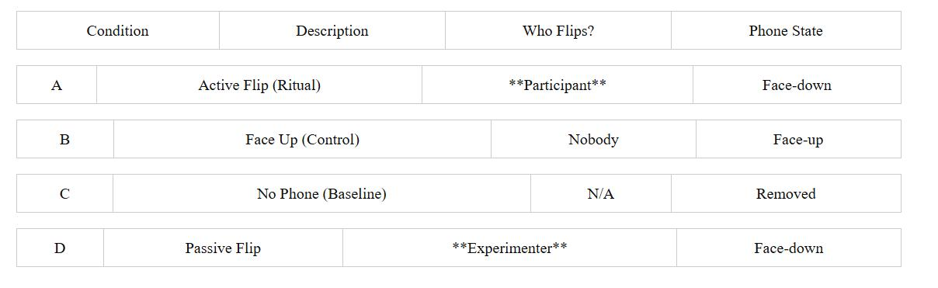

Primary contrast A vs. D: both end face-down, differ only in who performs the physical act.
5.2 Standardized Materials
- Experimenter Manual: verbatim instructions (bilingual), recording sheet, checklist
- Focus Questionnaire: 5-item Likert (Q2, Q5 reverse-scored), range 5–25
- Question Bank: 20 items (10 math + 10 English), 4 shuffled versions
- Consent Form: guardian signature field, ethics template
- Ethics Checklist: participant protection, data security, anonymization

5.3 Pipeline Generality
The analysis pipeline is generic: (1) transition exclusion for any event-marked sensor data; (2) LME supports arbitrary fixed/random effects; (3) Cohen's d + 95% CI for any two-group comparison; (4) visualization with customizable labels and color schemes.
6.Discussion
6.1 Tool Positioning
FlipFocus targets rapid-deployment scenarios: classroom data collection, high-school/undergraduate research initiation, multi-device experiments, and exploratory prototype validation. Browser-based precision is lower than native apps; the React Native version is preferable for high-precision or24/7 background collection.
6.2 Significance of the Degradation Strategy
Mobile HCI research has long operated under an "ideal-device assumption" [4]. FlipFocus transforms sensor heterogeneity from a flaw into a feature through graceful degradation — a philosophy applicable to other mobile HCI tools.
6.3 Limitations and Future Work
- Browser API sampling rate (50–100 Hz) lower than native (200+ Hz)
- XY stationarity not yet implemented in HTML version
- Android/iOS only
- Pipeline assumes within-subjects design
- Export UI needs further human-factors optimization (partially resolved: 2/4 sessions recovered)
Future work: XY stationarity for HTML; export UI refinement; WebSocket real-time monitoring; IndexedDB storage; expanded pipeline design support; collection of ≥ 8 complete bundle sessions for formal inference.
7.Conclusion
We presented FlipFocus, a zero-install browser-based tool for phone flip behavior detection and analysis. Three core contributions: (1) adaptive three-tier sensor degradation strategy; (2) flip-detection state machine with 3-second confirmation (F1 = 0.970); (3) complete research ecosystem (materials + pipeline). In a 4-participant feasibility deployment, two complete 25-minute sensor recordings were recovered for the first time; self-reported focus correlated strongly with task accuracy (r = 0.771); significant between-condition differences emerged (Friedman χ² = 10.7, p = 0.014). Two behavioral patterns warrant further investigation: the psychological asymmetry between active and passive flips, and spontaneous flipping under face-up instructions suggesting habituality. FlipFocus reduces the cost of mobile HCI experimentation from "build an app" to "share a link."
References
- Ward, A.F. et al. "Brain Drain: The Mere Presence of One's Own Smartphone Reduces Available Cognitive Capacity." J. Assoc. Consumer Research, 2(2):140–154, 2017.
- Stothart, C. et al. "The Attentional Cost of Receiving a Cell Phone Notification." J. Exp. Psychol.: Human Perception and Performance, 41(4):893–897, 2015.
- Duckworth, A.L. et al. "Self-Regulation Strategies Improve Self-Discipline in Adolescents." Educational Psychology, 31(1):17–26, 2011.
- Wac, K. et al. "Studying the Experience of Mobile Applications Used in Different Contexts of Daily Life." Proc. ACM W-MUST '16, pp. 1–6, 2016.
- Kuijpers, E. et al. "Browser-Based Sensor Data Collection for Mobile HCI Research." Proc. MobileHCI '22 Adjunct, pp. 1–5, 2022.
6. Kubiak, T. and Smyth, S. "PIEL Survey: A Smartphone App for Experience Sampling." J. Medical Internet Research, 17(1):e4, 2015.

