# Intellij Idea git切换远程分支

## 描述

最近项目建了分支，在并行开发，需要切换远程分支，在网上找了很多资料都不行。远程分支代码始终更新的是其他分支。

## 解决方案

话不多说，直接看图。

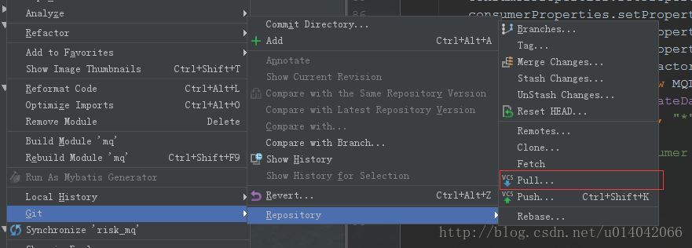

选择相关分支   
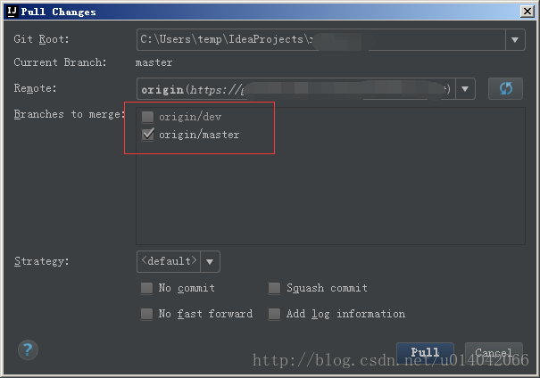

操作上述之后，开始pull下远程代码，完毕后也可发现分支发生变化   
这里写图片描述

## 说明

以上只在2016.1.3上验证。

# IDEA中配置Tomcat

在IDEA中配置Tomcat后，会在

C:\Users\WH\.IntelliJIdea2017.3\system\tomcat中生成，当前配置Tomcat的镜像备份。

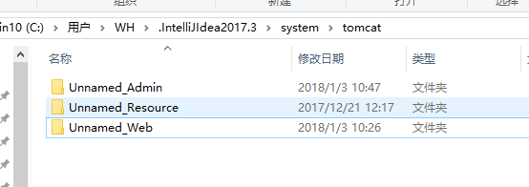

镜像Tomcat的内容。

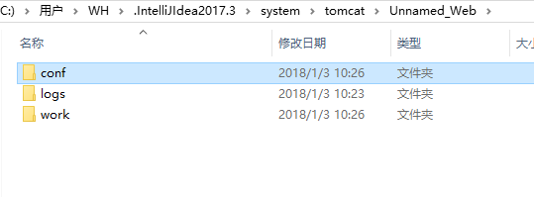

## 每日提示

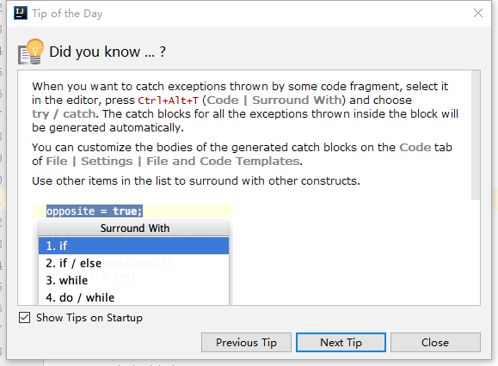

When you want to catch exceptions thrown by some code fragment, select it in the editor, press Ctrl+Alt+T (Code | Surround With) and choose try / catch. The catch blocks for all the exceptions thrown inside the block will be generated automatically.

You can customize the bodies of the generated catch blocks on the Code tab of File | Settings | File and Code Templates.

Use other items in the list to surround with other constructs.

# Mac安装MarIDB

首先安装brew, 这个就不在这赘述了. 安装教程一搜一大把

自行Google: "brew mac"

**brew配置正常后输入命令:**

brew install mariadb

显示如下则等待下载完成,自动安装即可

==> Downloading https://homebrew.bintray.com/bottles/mariadb-10.0.21.el_capitan.bottle.1.tar.gz

######################################################################## 100.0%

==> Pouring mariadb-10.0.21.el_capitan.bottle.1.tar.gz

==> /usr/local/Cellar/mariadb/10.0.21/bin/mysql_install_db --verbose --user=wangyu --basedir=/usr/local/Cellar/mariadb/10.0.21 --datadir=/usr/local

==> Caveats

如果提示以下则说明安装成功了

A "/etc/my.cnf" from another install may interfere with a Homebrew-built

server starting up correctly.

To connect:

mysql -uroot

To have launchd start mariadb at login:

ln -sfv /usr/local/opt/mariadb/*.plist ~/Library/LaunchAgents

Then to load mariadb now:

launchctl load ~/Library/LaunchAgents/homebrew.mxcl.mariadb.plist

Or, if you don't want/need launchctl, you can just run:

mysql.server start

大致意思是你可以利用上面的命令, 来设置自启动服务.

如果你不需要自启动, 可以用mysql.server start来启动

本人是不喜欢自启动的, 所以就用mysql.server start

➜ ~ mysql.server start

Starting MySQL

. SUCCESS!

➜ ~

提示如下的话, 说明启动成功了!下面开始操作数据库

➜ ~ mysql -uroot

Welcome to the MariaDB monitor. Commands end with ; or \g.

Your MariaDB connection id is 3

Server version: 10.0.21-MariaDB Homebrew

Copyright (c) 2000, 2015, Oracle, MariaDB Corporation Ab and others.

Type 'help;' or '\h' for help. Type '\c' to clear the current input statement.

MariaDB [(none)]>

MariaDB [(none)]> show databases;

+--------------------+

| Database |

+--------------------+

| information_schema |

| mysql |

| performance_schema |

| test |

+--------------------+

4 rows in set (0.00 sec)

MariaDB [(none)]> exit

Bye

➜ ~

至此,MariaDB就可以正常用了.

*MariaDB跟MySQL用起来是一样一样的, 好久没有大量操作数据库, 这次想自己搞个东西, 可能以后会遇到很多坑, 这里也提醒自己到时候要及时记录下来.*

**最后**

➜ ~ mysql.server stop

Shutting down MySQL

.. SUCCESS!

➜ ~

关闭数据库

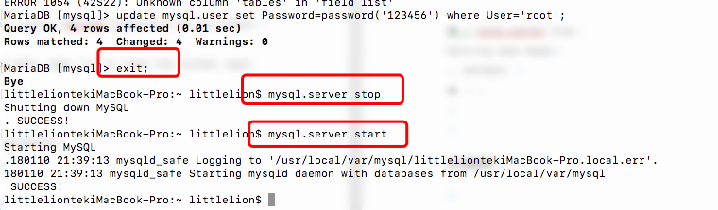  
  
作者：码农老王  
链接：https://www.jianshu.com/p/a340614040fe  
來源：简书  
著作权归作者所有。商业转载请联系作者获得授权，非商业转载请注明出处。

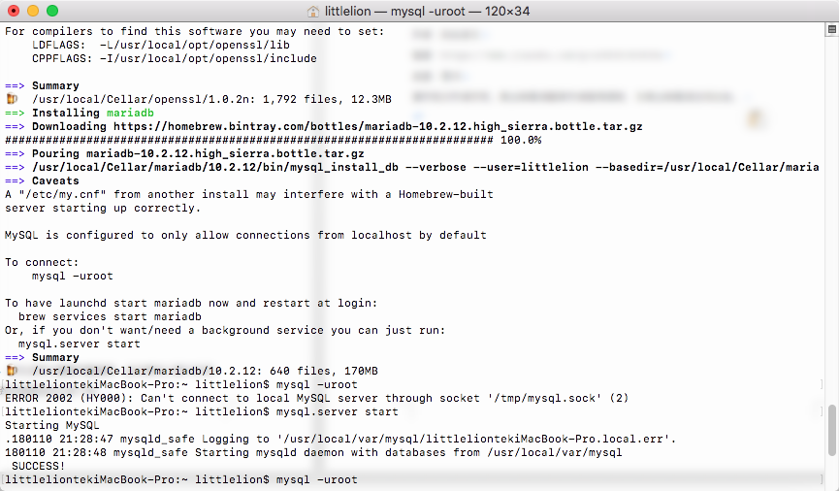

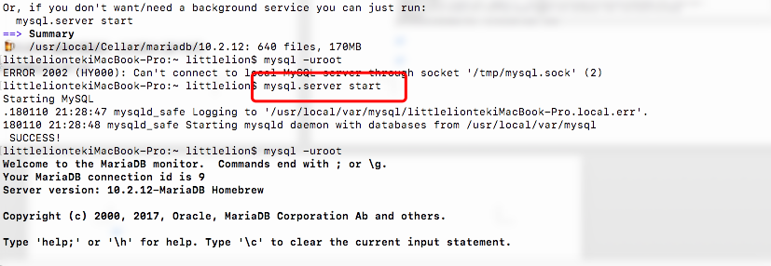

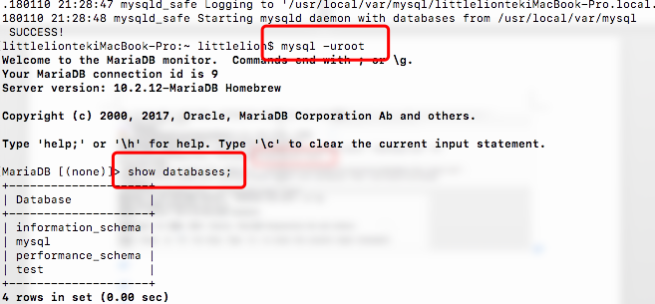

修改默认密码

use mysql;

update mysql.user set Password=password('123456') where User='root';