Bug 1:   
Title: Error message is not displayed

Description:

Given I am an Demo user and lands on user Dashboard

And I am presented with search widget

When I click on [Search] button

Then

Expected: Error message should be presented

Actual: Searching symbol (2 moving dots) start appearing on screen and same appear on different tab of Car, Boats etc.

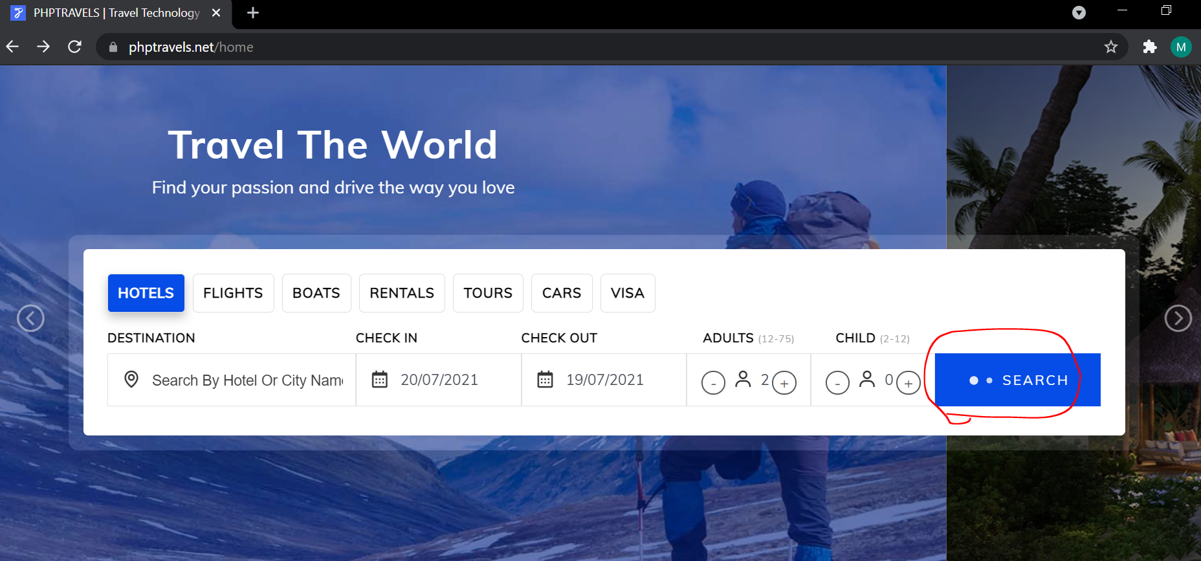

Bug 2:

Title: Not able to Search HOTEL.

Description:

Given I am a Demo user

And I want to book something HOTEL

When I submit valid details in the search widget

Then

Expected: I should be presented with list of option to continue my booking

Actual: Error message is displayed as ***“hotels.phptravels.net’s server IP address could not be found.”*** and search can’t be continue.

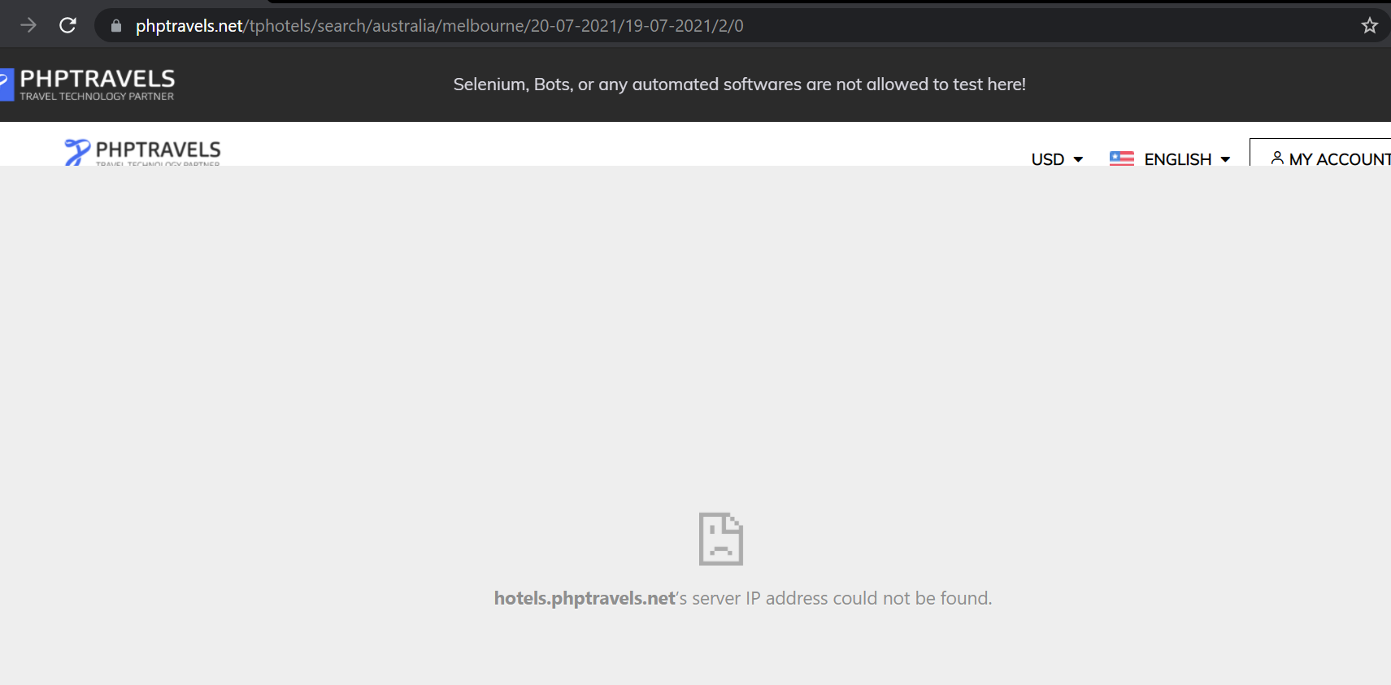

Bug 4:

Title: TAB navigation is not working in Flight Search widget.

Description:

Given I am a Demo user

And I want to book something Flight

When I submit valid Source Port ID and click TAB

Then I am not presented where I am focused at that moment.

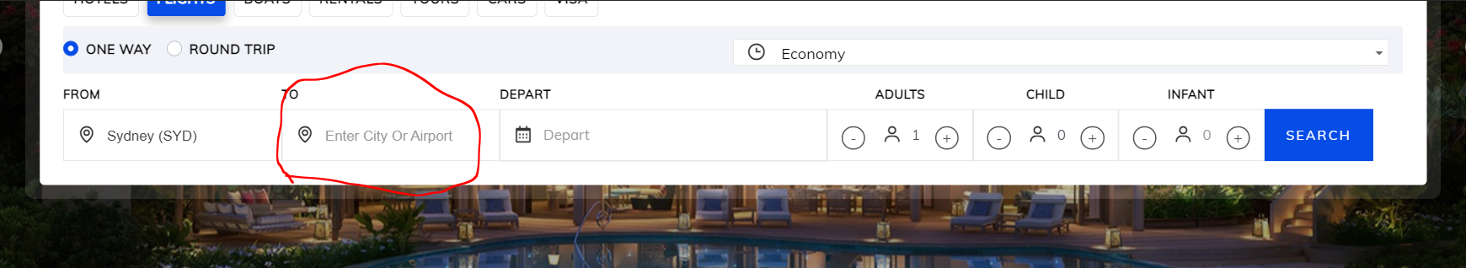

Bug 3: Element identifier for Flight Source edit box and Flight Destination edit box are same

