Create Job in Jenkins:

Click on New Item:

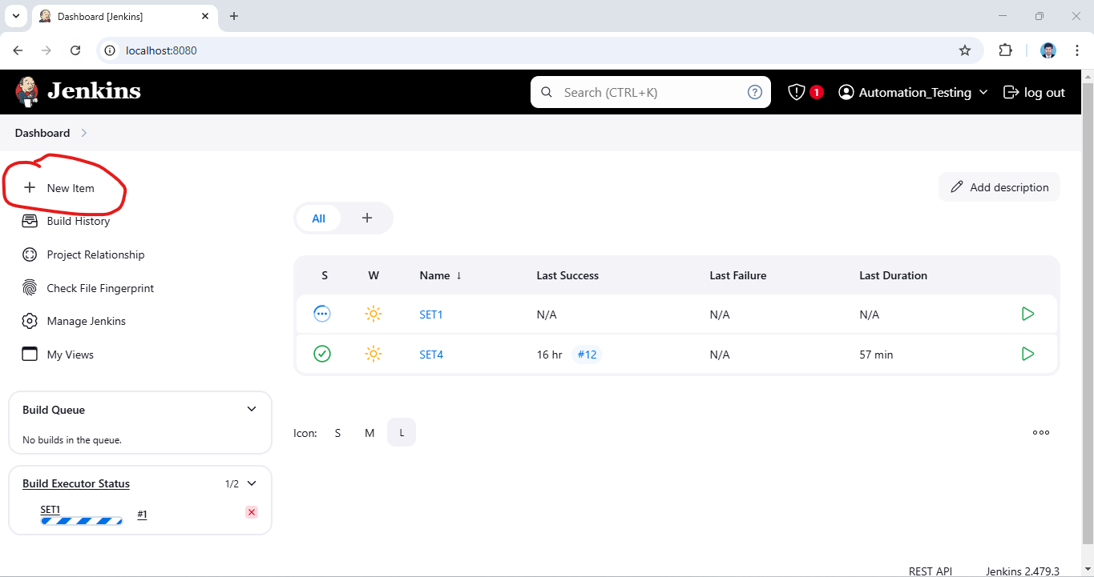

Enter Item Name & Click on Maven and Click on OK:

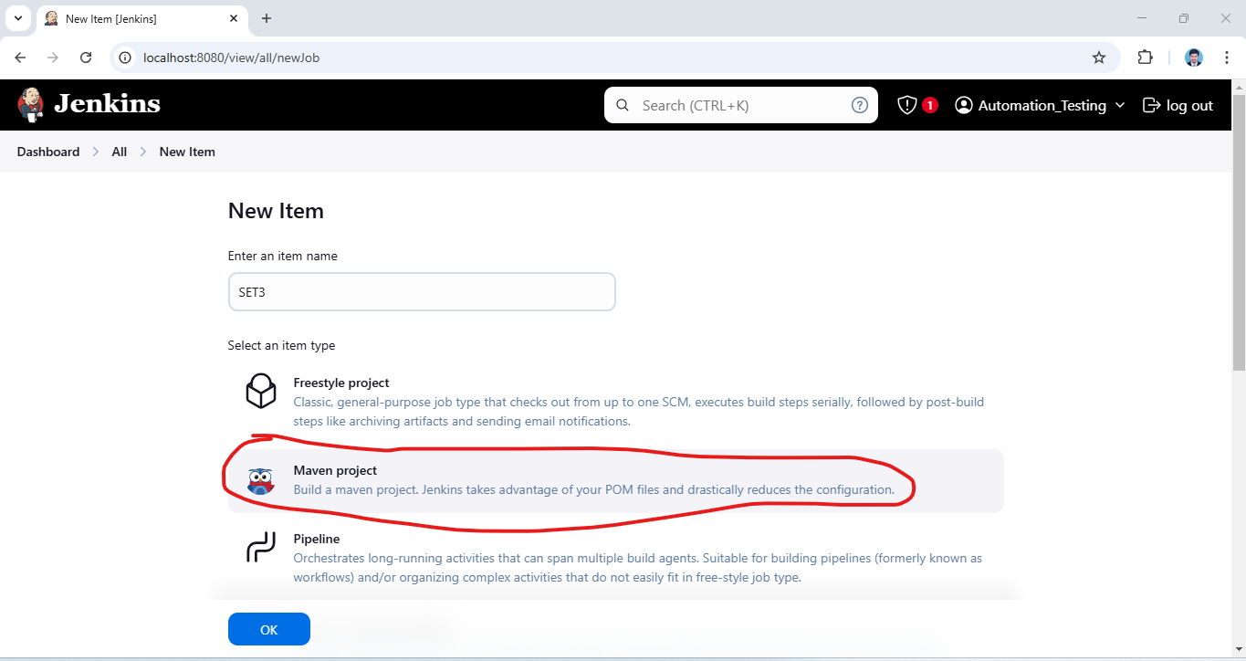

Click on Project Parameterized and click on Choice Parameter:

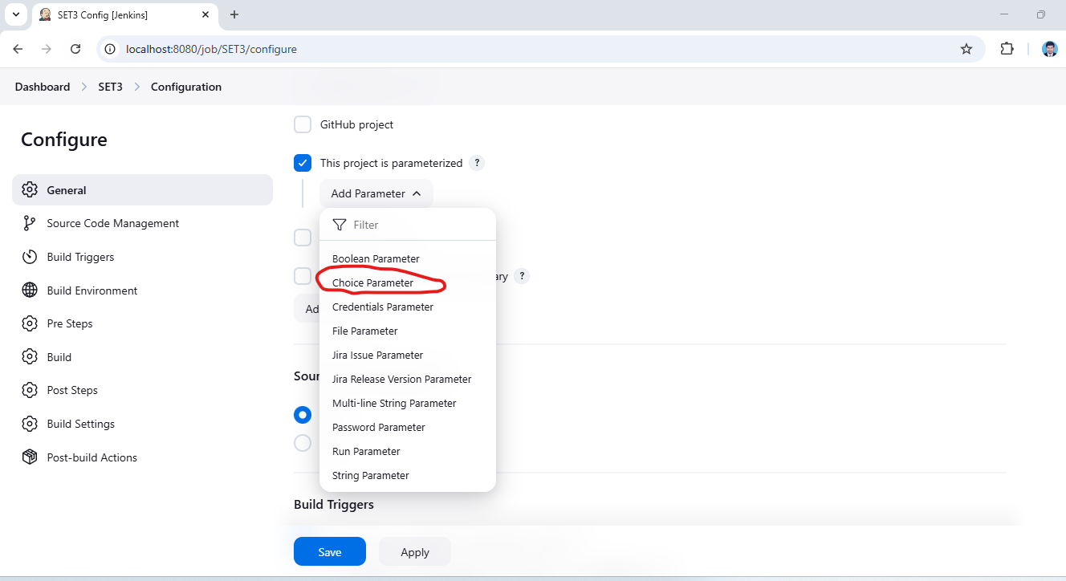

Project Parameterized 🡪 Choice Parameter 🡪 Add URL

URL

https://mme.benefitalign.com/mme/

https://ce-uat.benefitalign.com/mme/

https://mme.brokerengage.net/mme/

https://ce-qa.benefitalign.com/mme/

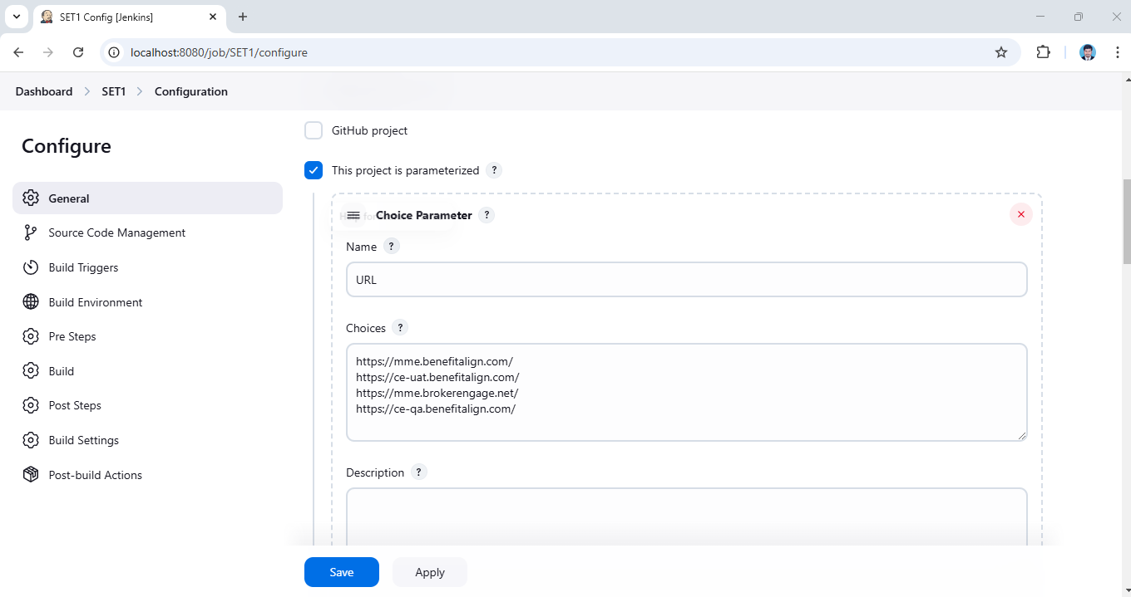

Add Parameterized 🡪 Choice Parameter 🡪Add Browser

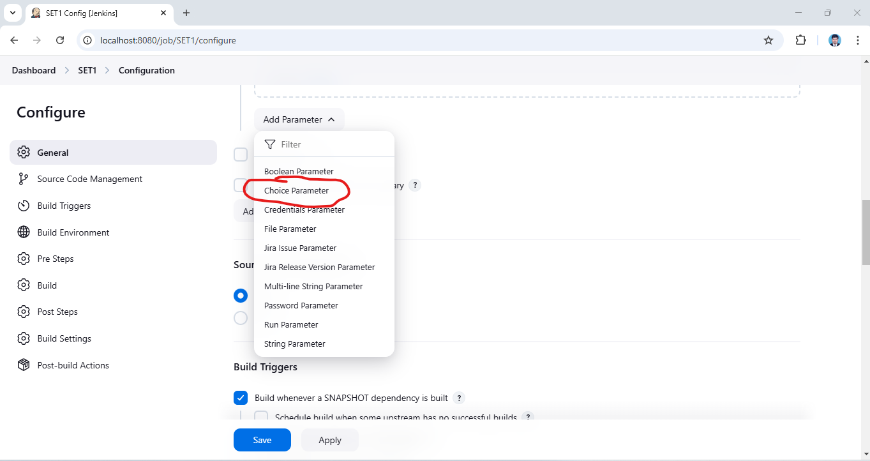

BROWSER

Chrome

Edge

Firefox

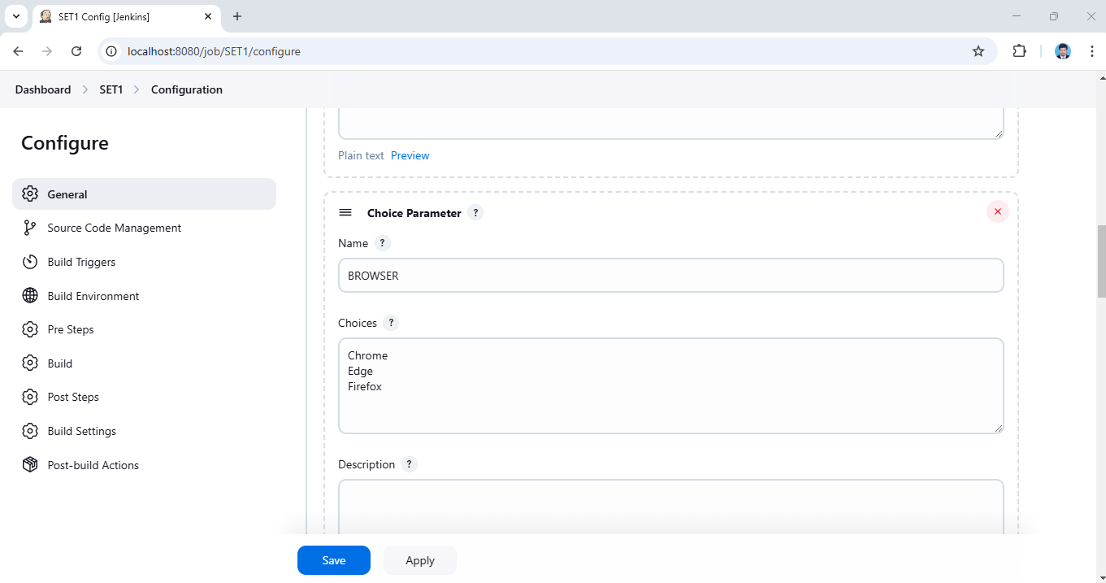

Build Periodically 🡪 Automatically Build Trigger 🡪 Based on Comments

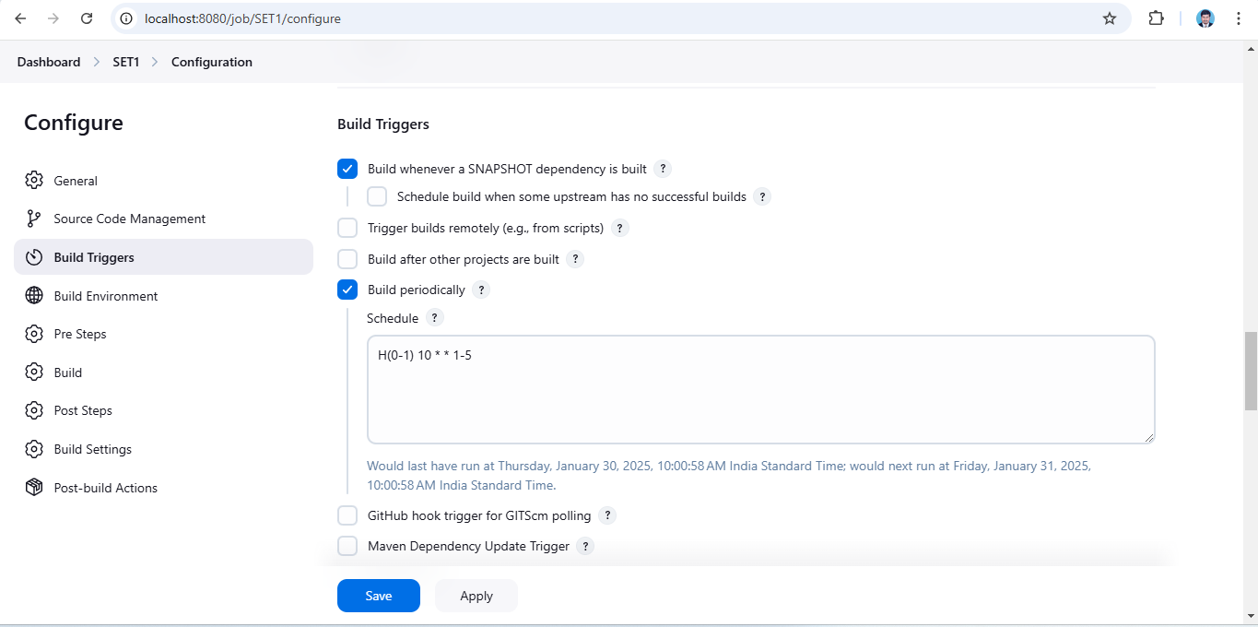

Pom SET UP Based on Project Pom file path & Goals and Options:

test -DsuiteXmlFile="testng.xml" -DBROWSER=${BROWSER} -DURL=${URL}

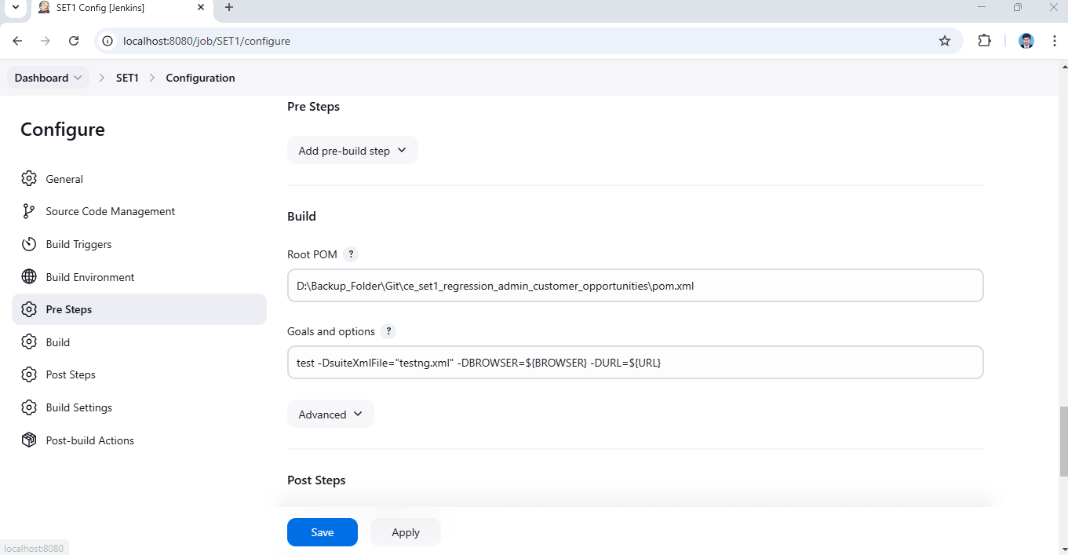

Pre steps:

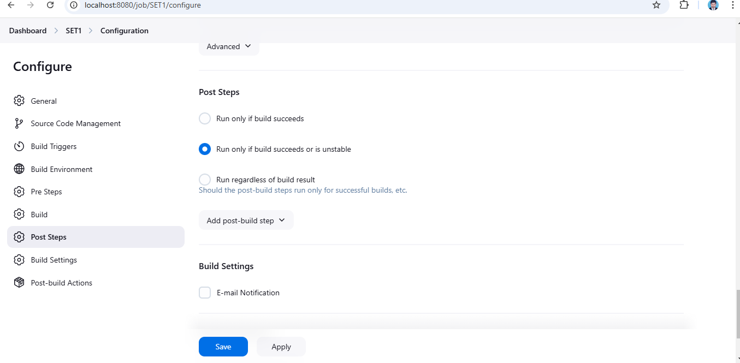

Post Build Action Click on Add:

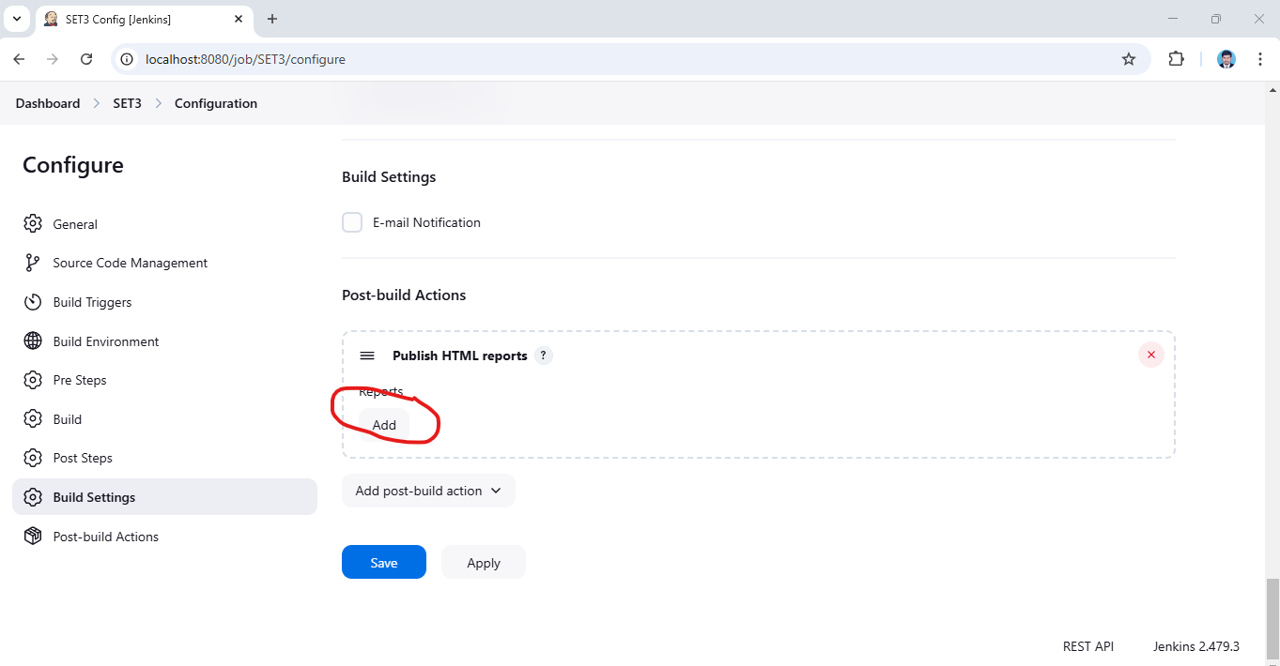

Post Build Actions Publish HTML Reports:

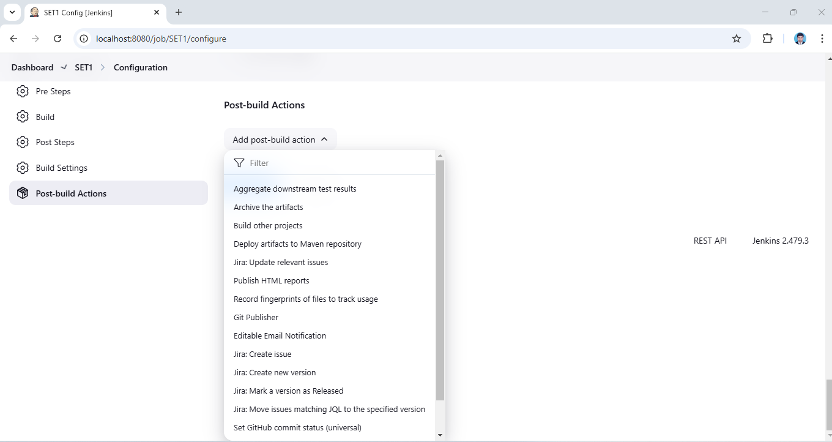

HTML Report File path & Apply and Save:

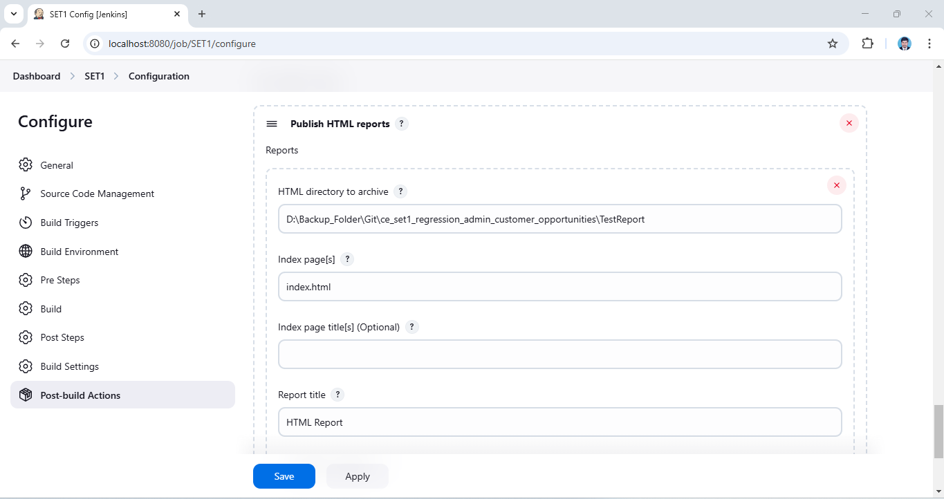

Jenkins Server:

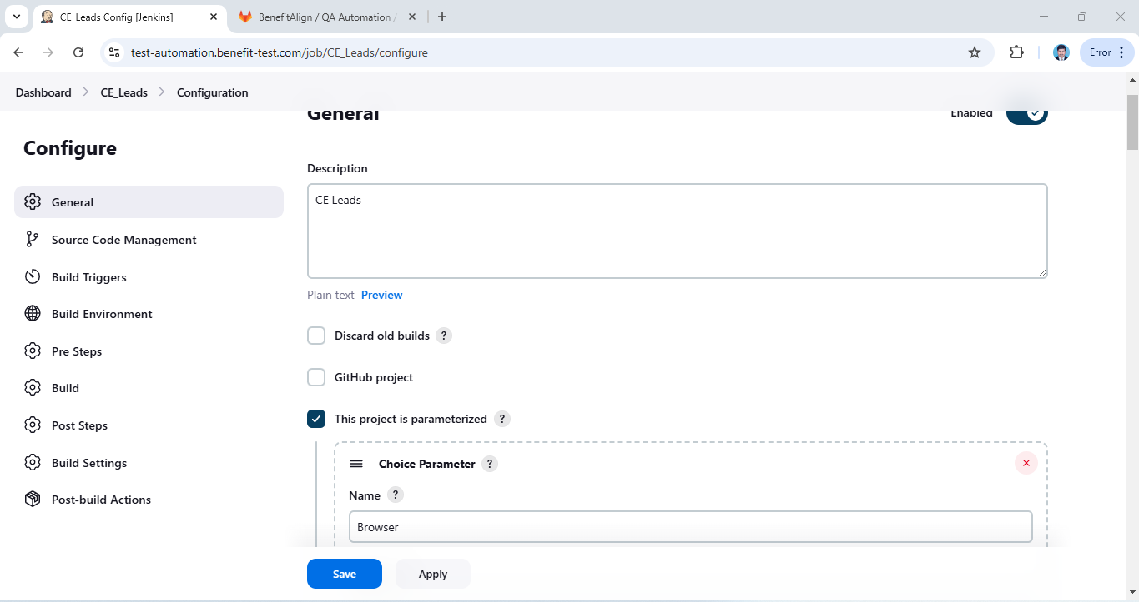

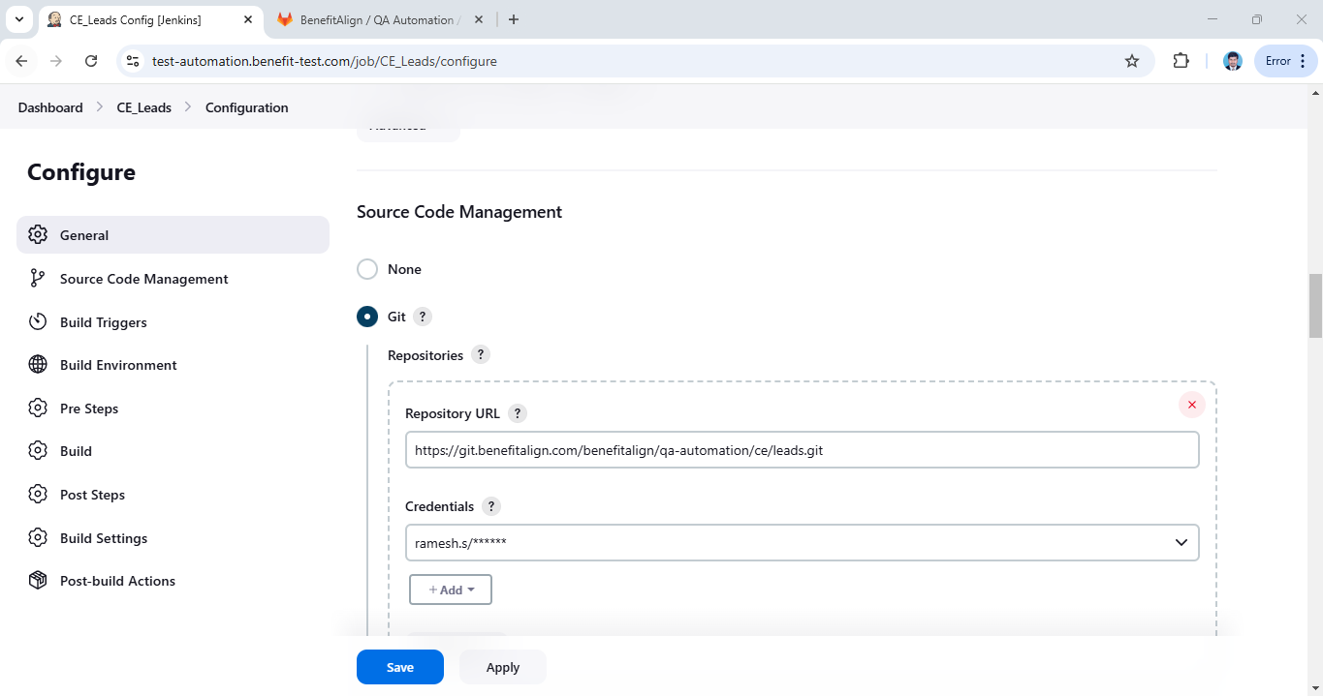

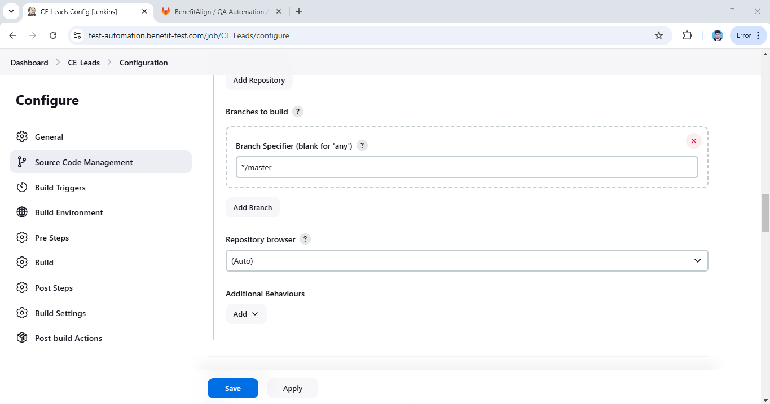

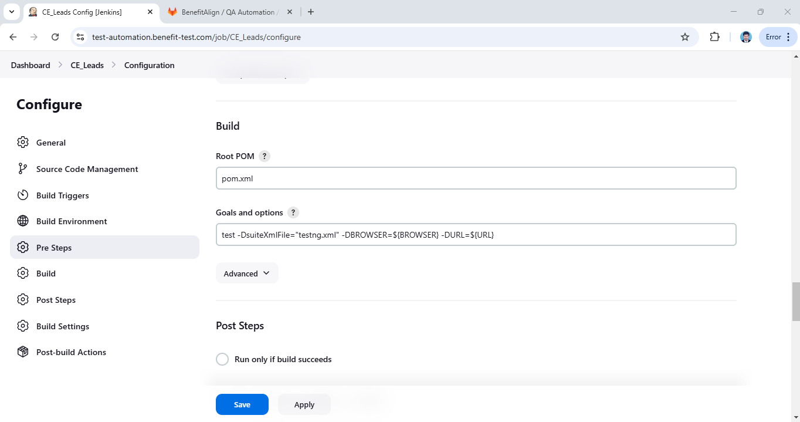

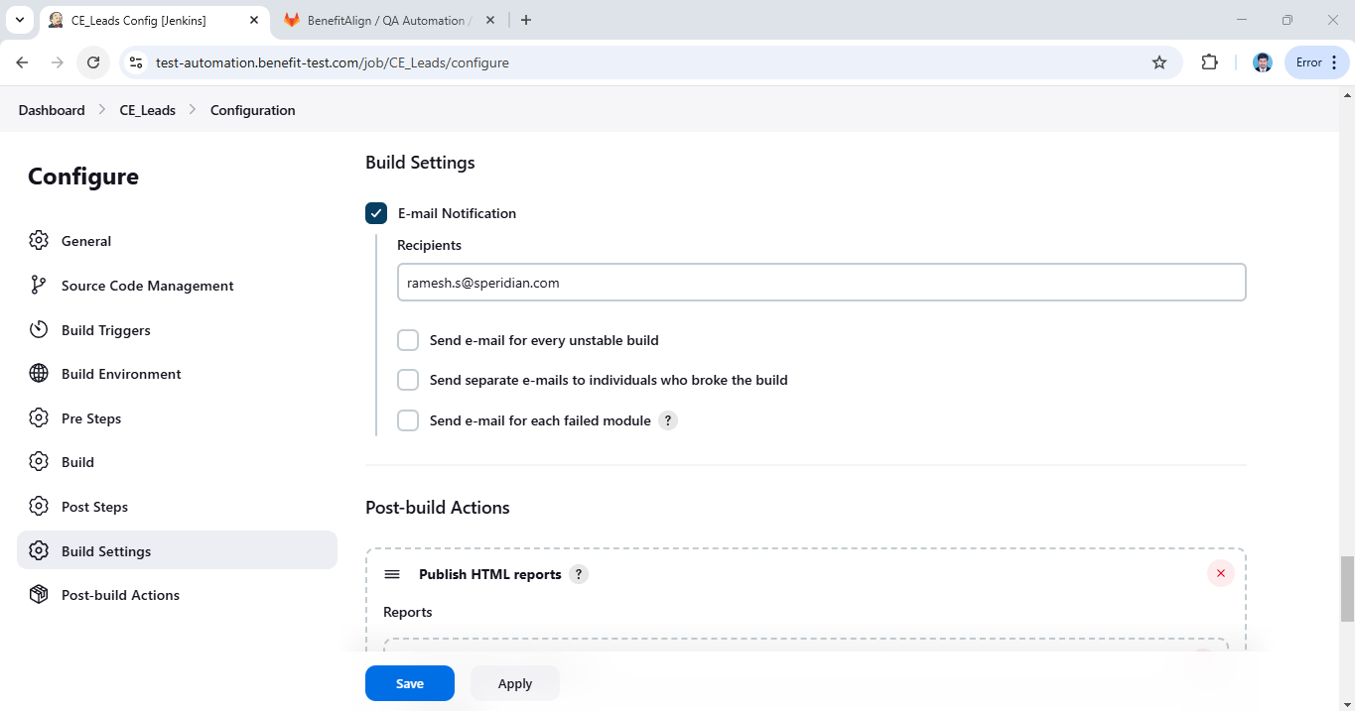

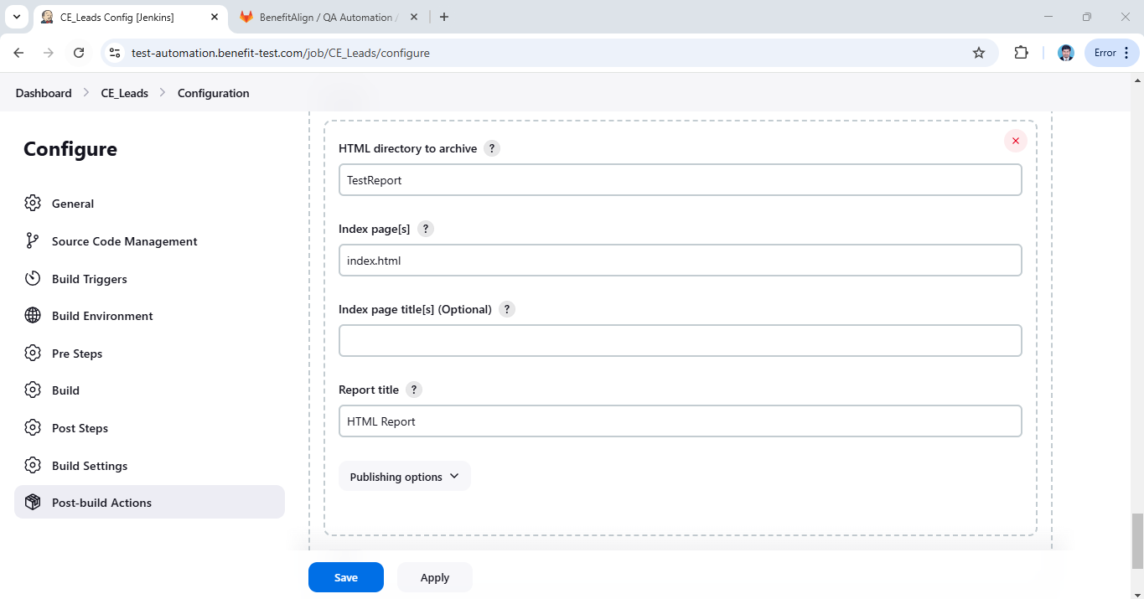

Git Credentials:

