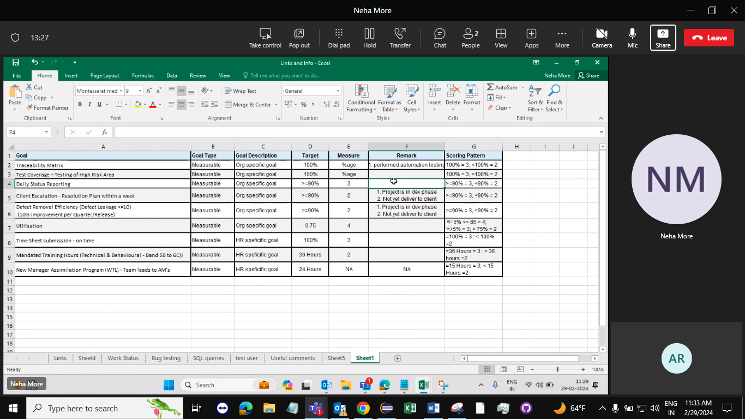

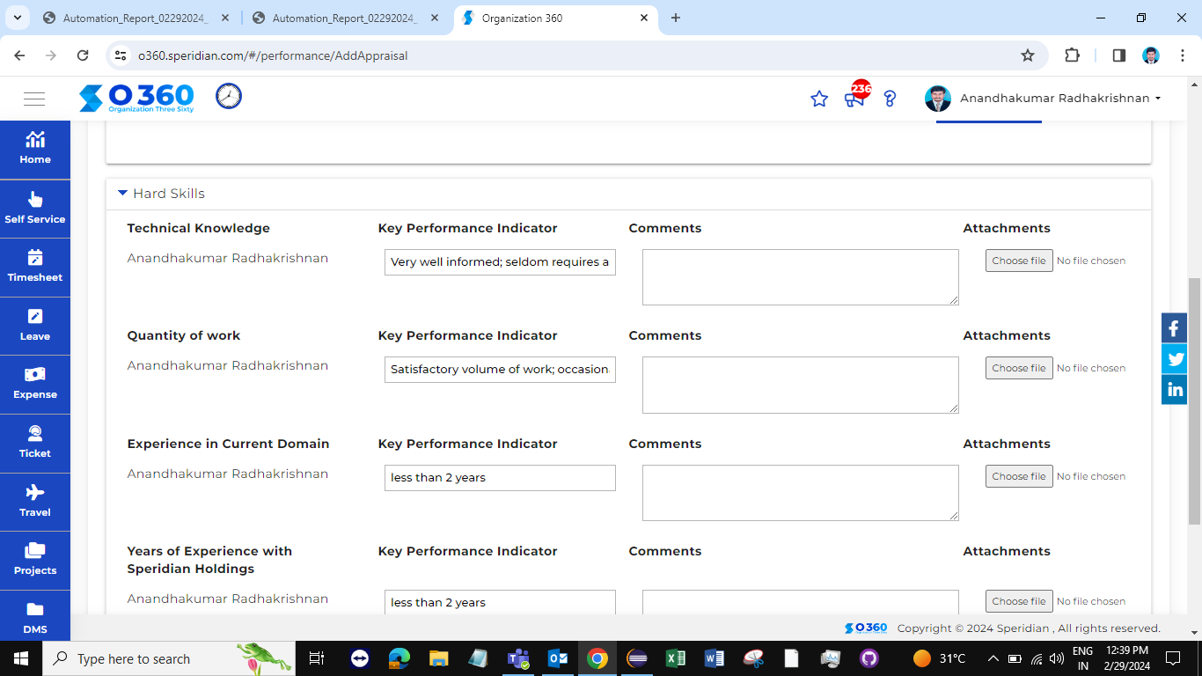

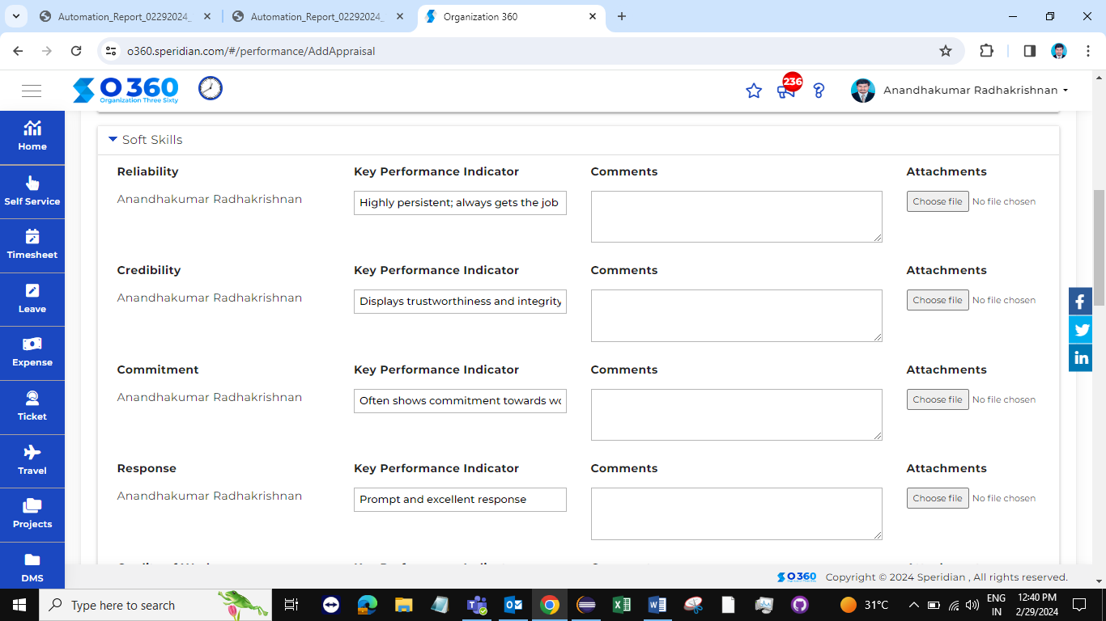

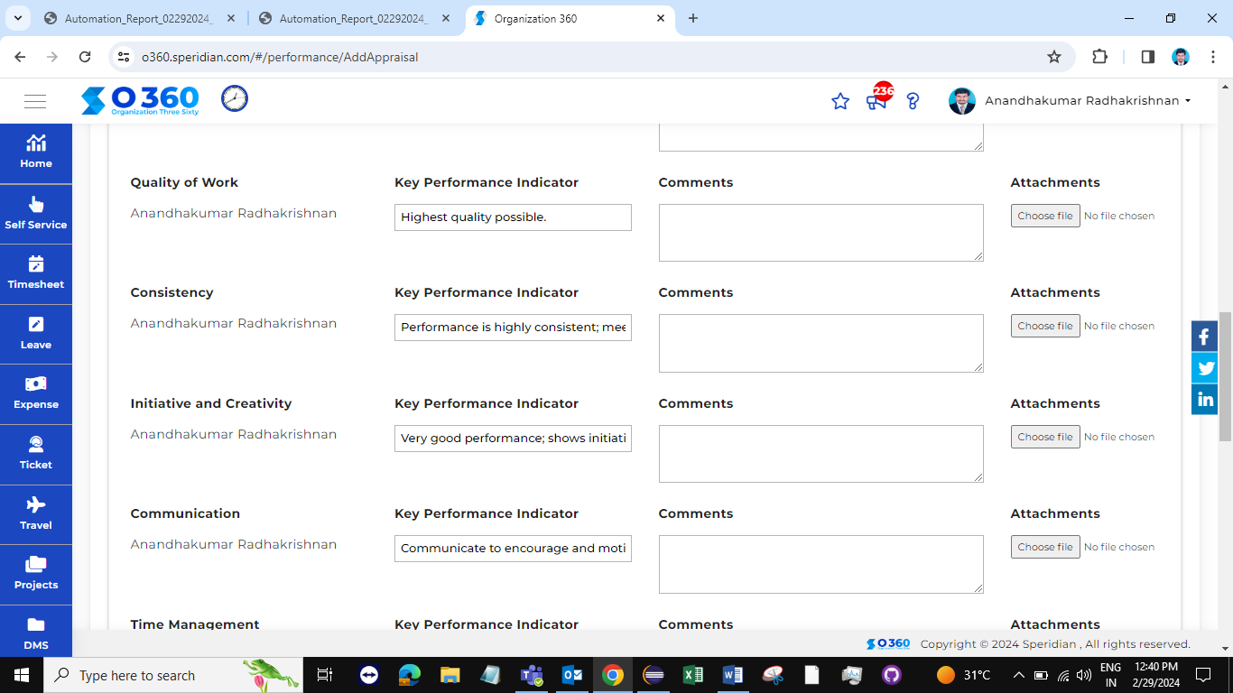

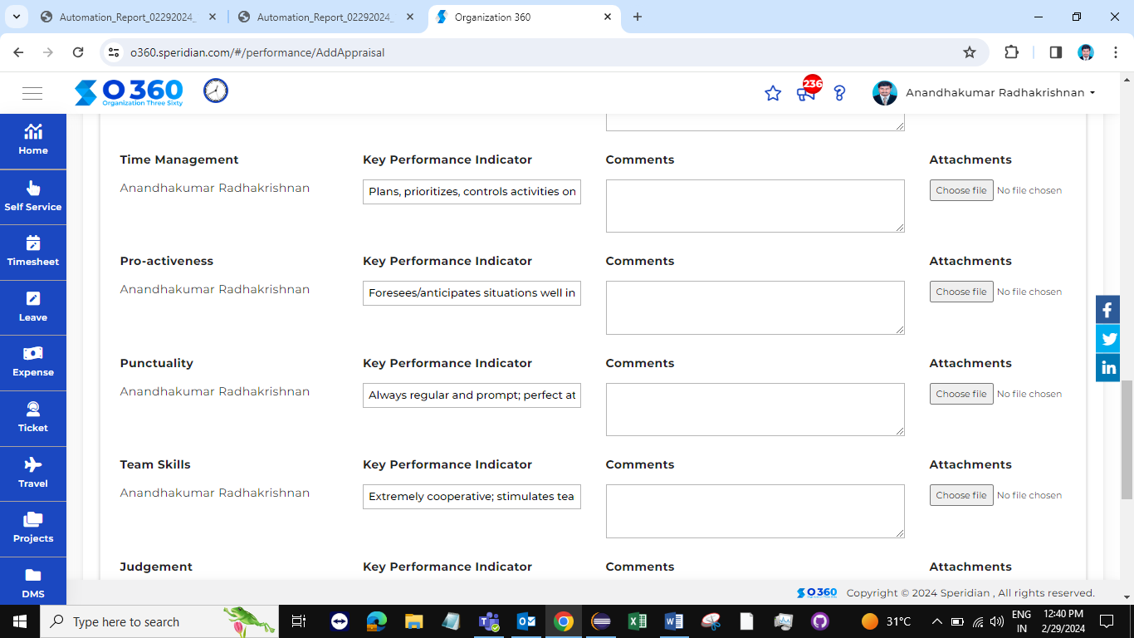

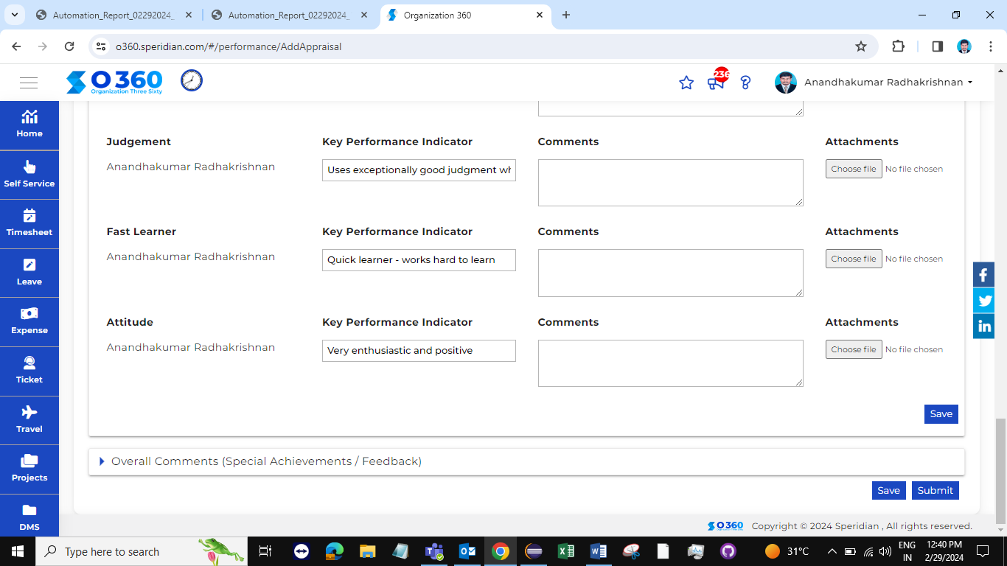

**ESP Training Programs**  
   > Successfully completed all 7 ESP training programs for the year 2023-24 as part of KPI's.  
   > Includes 5 Behavioural Programs & 2 communication programs.  
   > All are completed on or before 3rd July 2023.

**IHA EE Solution and Support - BenifitAlign FFM Portal :**

* Understanding the Requirements and Functional specifications of the Application,  and used Redmine for defect tracking, reporting and managing bug life cycle during the testing process.
* Working with different stakeholders, which includes Business Analyst, QA Team, Developers.
* Developed functional scripts and rerunning those scripts again at the time of Regression testing.
* Adept in scripting using Java-Selenium and POM automation framework, designing and implementing Selenium with TDD framework.
* Good Understanding of requirements and peer review.
* Involved in defining test strategies and creating comprehensive test plans.
* Attended Daily Stand-ups on Task status updates.
* Experienced in creating and maintaining automation scripts using Selenium with Java.
* Performing different types of testing like Functional, Regression testing.

**ESP Training Programs**

* Completed 5 ESP training programs for the year 2024 as part of KPI's.
* All 5 ESP Behavioural are completed within 27th February 2024

**Conclusion**

* Helped to Enhance skill and Override the Mistakes

**BA Tech – Quality Assurance:**

1. Understanding the Requirements and Functional specifications of the Application,  and used Redmine for defect tracking, reporting and managing bug life cycle during the testing process.  
2. Attended Daily Standups on Task status updates.  
3. Working with different stakeholders, which includes Business Analyst, QA Team, Developers.  
4. Involved in Developed functional scripts and re-running those scripts again at the time of Regression testing.  
5. Involved in Writing Testscript using Java-Selenium and Designing POM Page and Updating the Functional Scripts.  
6. Performing different types of Manual testing like Functional, Sanity Testing, Integration Testing, If in case of Testscript failed.

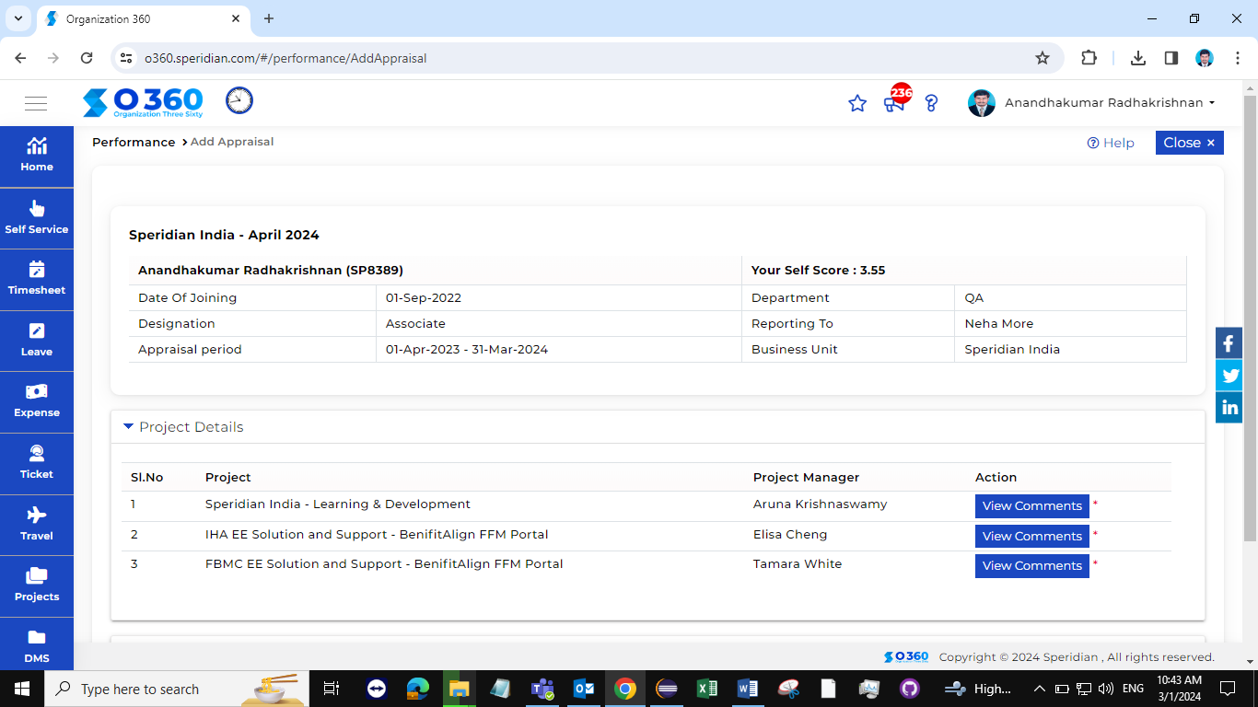

Final Feedback form:

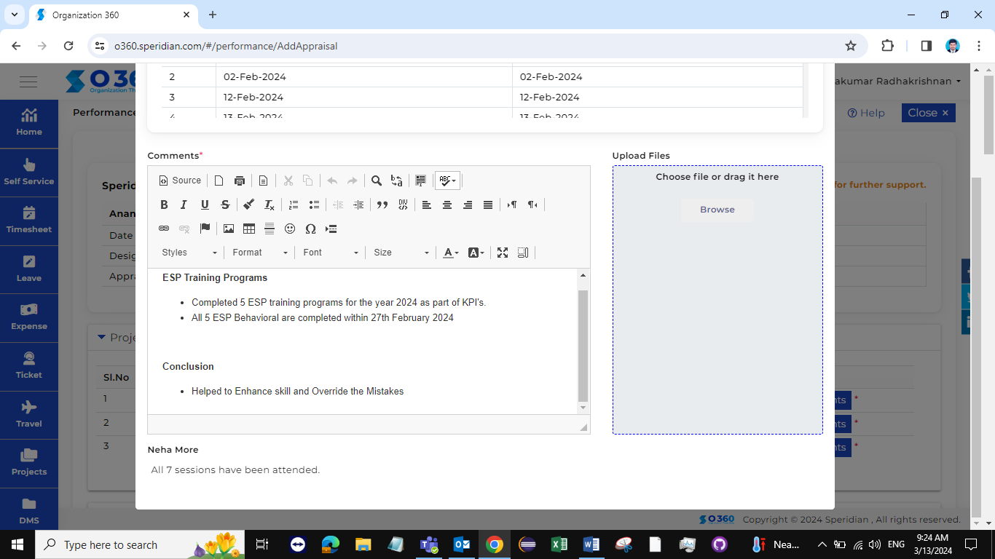

**IHA EE Solution and Support - BenifitAlign FFM Portal :**

* Understanding the Requirements and Functional specifications of the Application,  and used Redmine for defect tracking, reporting and managing bug life cycle during the testing process.
* Working with different stakeholders, which includes Business Analyst, QA Team, Developers.
* Developed functional scripts and rerunning those scripts again at the time of Regression testing.
* Adept in scripting using Java-Selenium and POM automation framework, designing and implementing Selenium with TDD framework.
* Good Understanding of requirements and peer review.
* Involved in defining test strategies and creating comprehensive test plans.
* Attended Daily Standups on Task status updates.
* Experienced in creating and maintaining automation scripts using Selenium with Java.
* Performing different types of testing like Functional, Regression testing.

