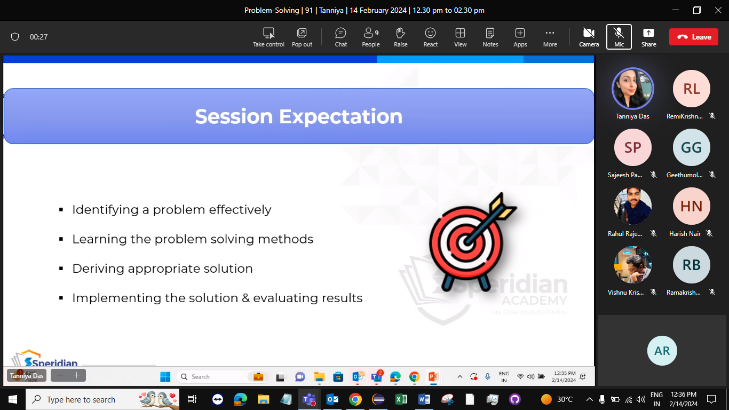

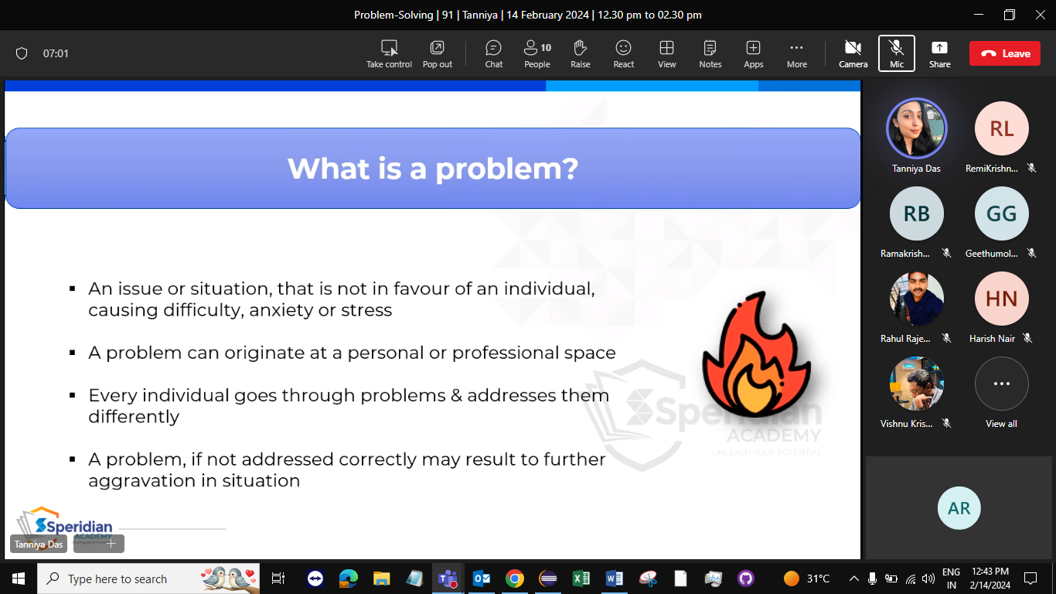

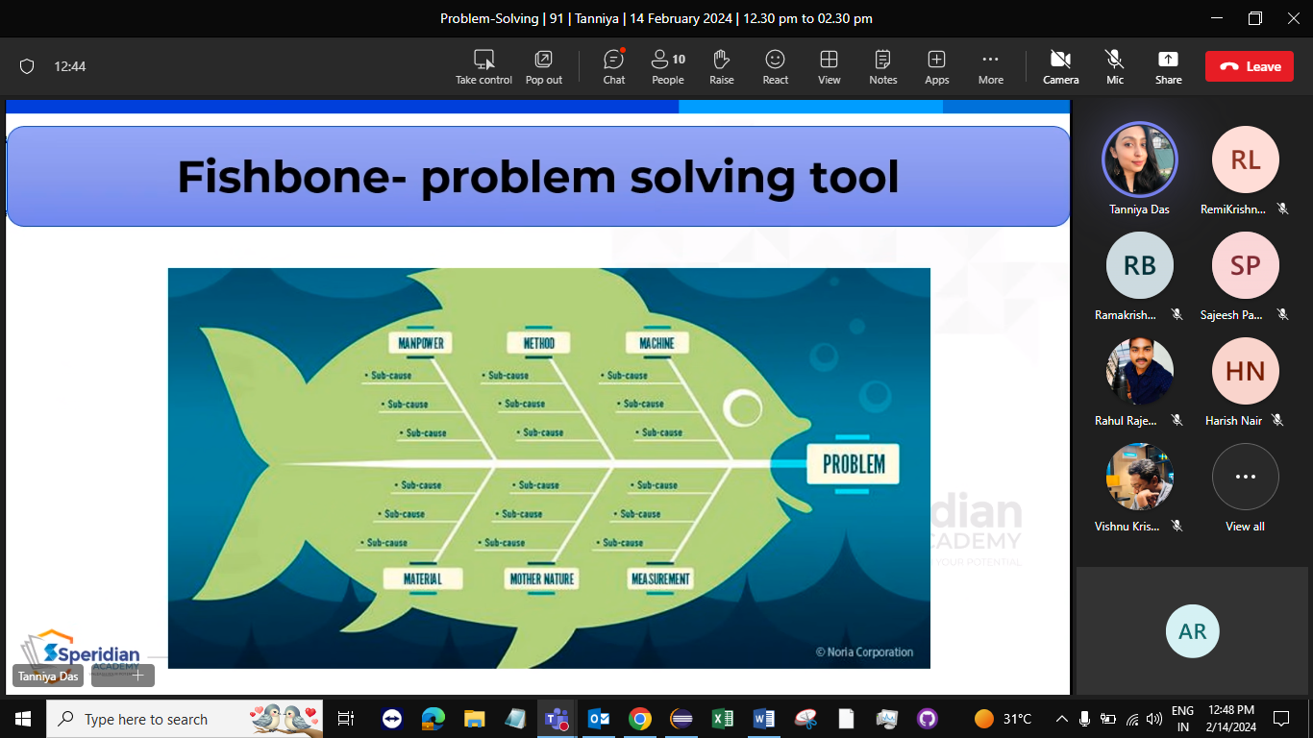

1. Traffic
2. Poor road construction
3. Poor garbage management
4. Pollution
5. Corruption
6. Water issues
7. Crimes
8. Health care