**ESP Training Programs :**

1. I have completed all ESP training programs for the year 2024-25.  
2. Helped to Enhance skill and Override the Mistakes.

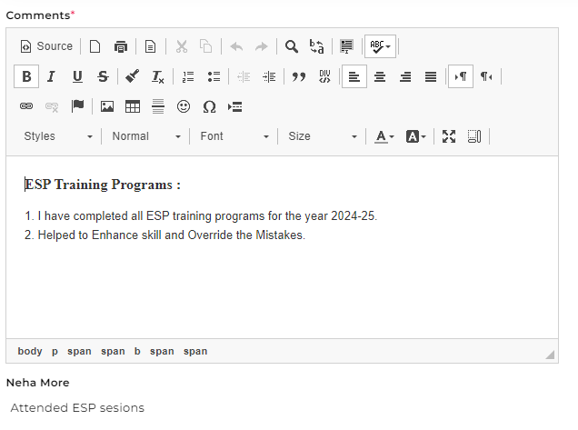

**BA Tech – Quality Assurance:**

1. Understanding the Requirements and Functional specifications of the Application,  and used Redmine for defect tracking, reporting and managing bug life cycle during the testing process.  
2. Attended Daily Standups on Task status updates.  
3. Working with different stakeholders, which includes Business Analyst, QA Team, Developers.  
4. Involved in Developed functional scripts and re-running those scripts again at the time of Regression testing.  
5. Involved in Writing Testscript using Java-Selenium and Designing POM Page and Updating the Functional Scripts.  
6. Performing different types of Manual testing like Functional, Sanity Testing, Integration Testing, If in case of Testscript failed.

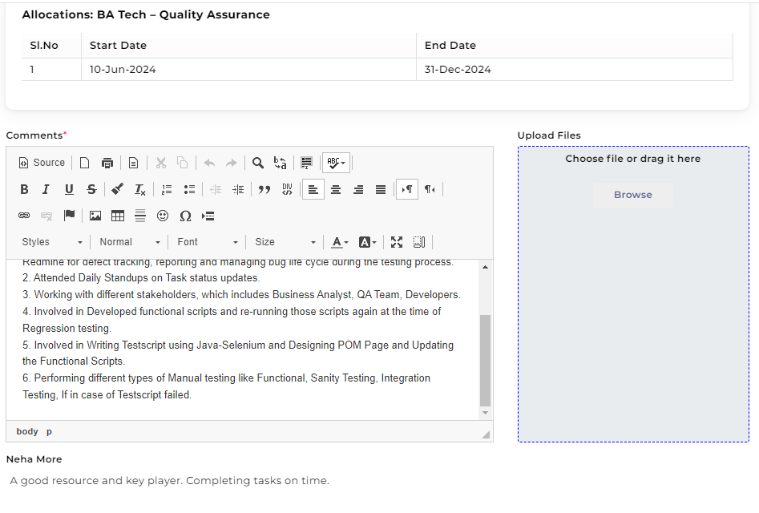

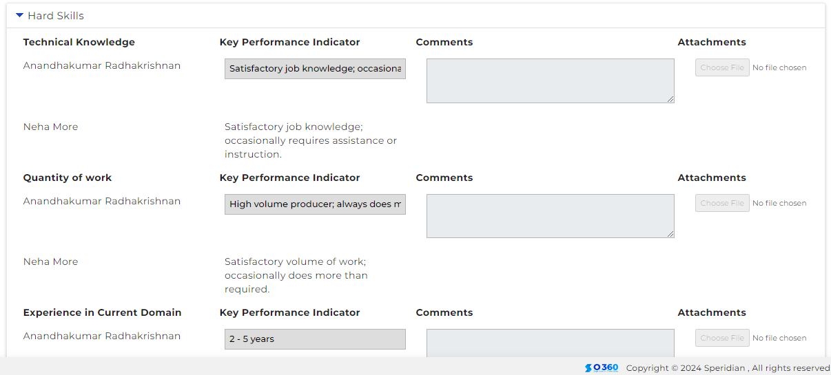

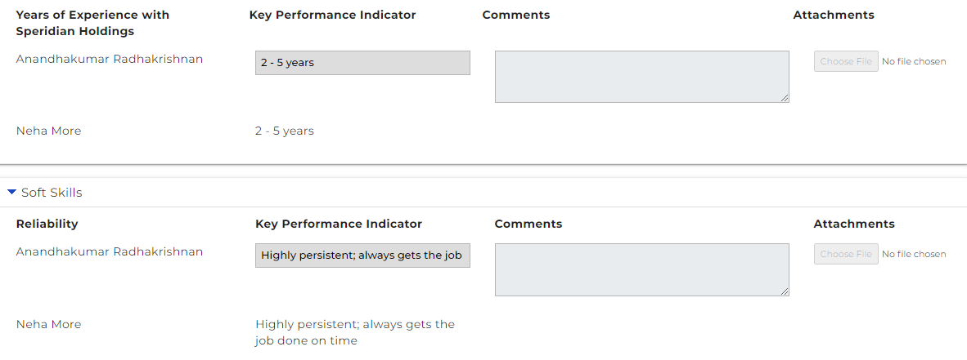

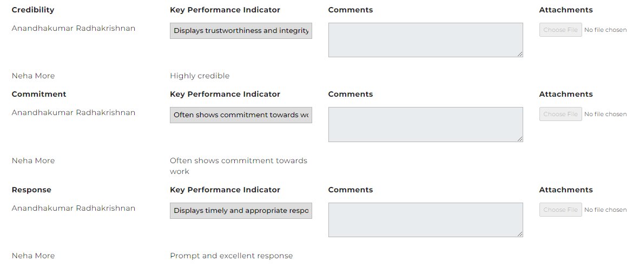

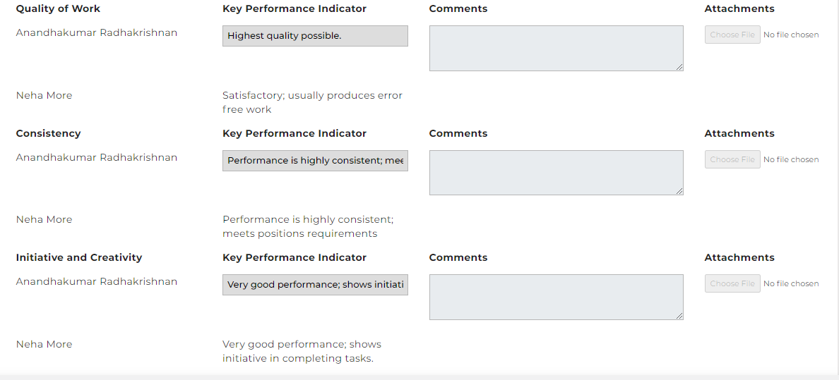

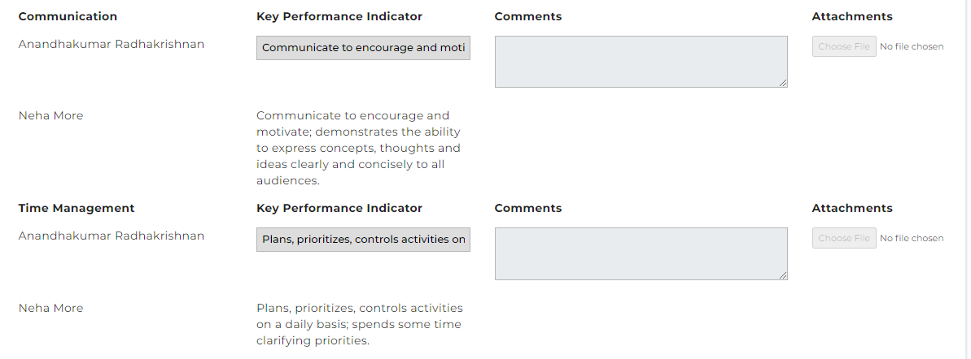

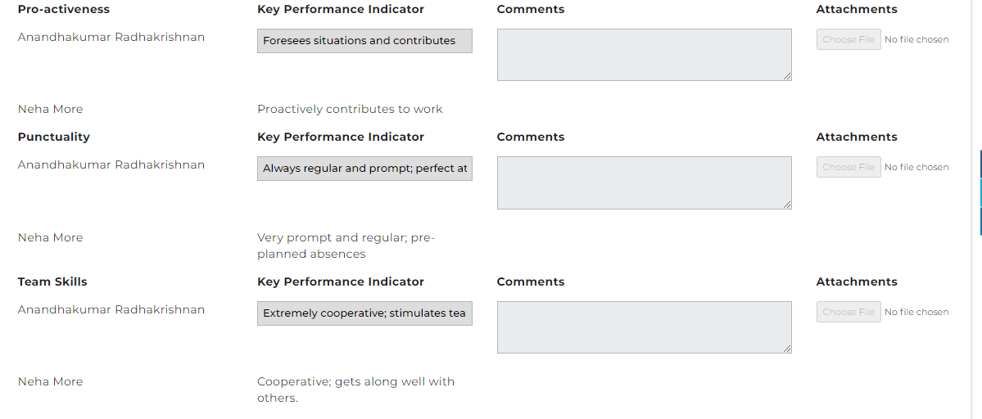

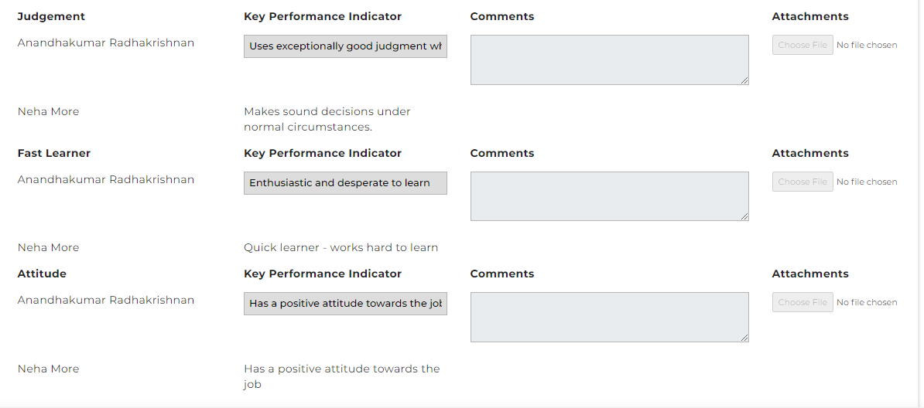

Please refer to the attached KPI spreadsheet.

**Learning:**

Jenkins

