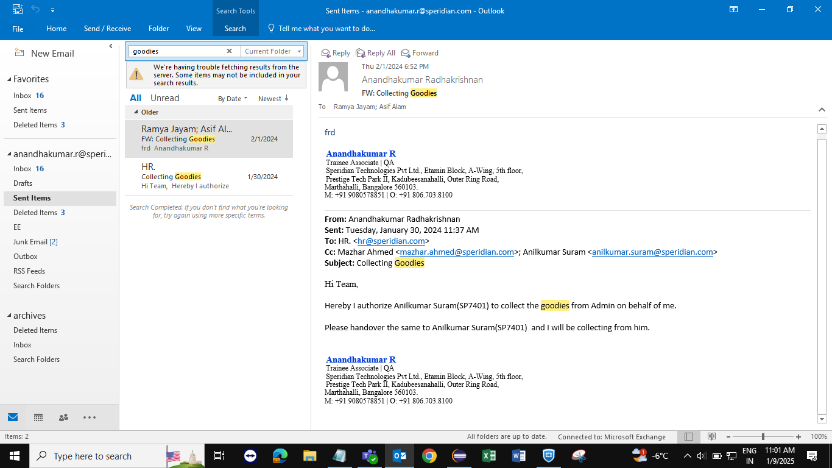

Subject : Collecting Goodies

Hi Team,

Hereby I authorize Gopinath Elumalai(SP7401) to collect the T-Shirts from Admin on behalf of me.

Please handover the same to Gopinath Elumalai (SP7401) and I will be collecting from him.