My Appointments Text Wrongly Updated:
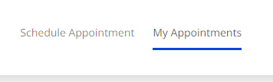

My Appointments not updated:

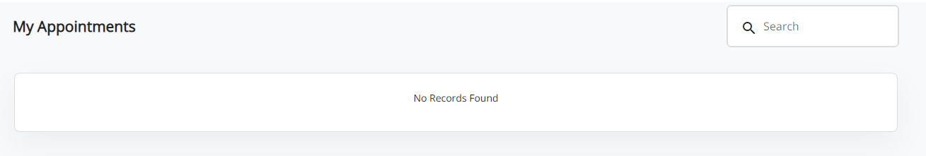

Click on Delete icon.it is not working:
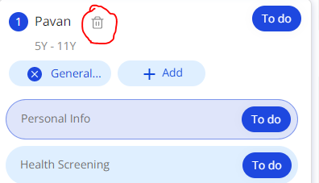

Medical Care is missing:
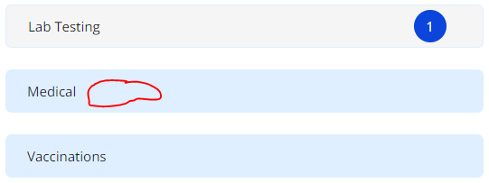

Time Not Displayed Personal Info Page:
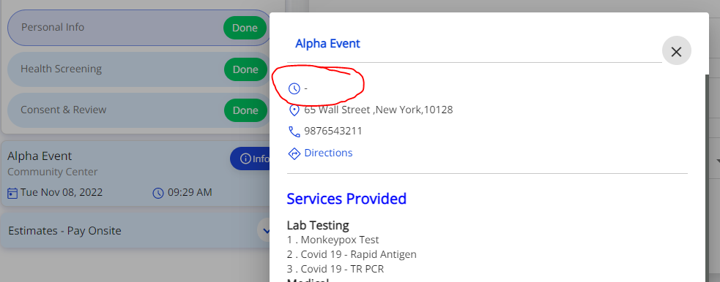

State Dropdown Missing:

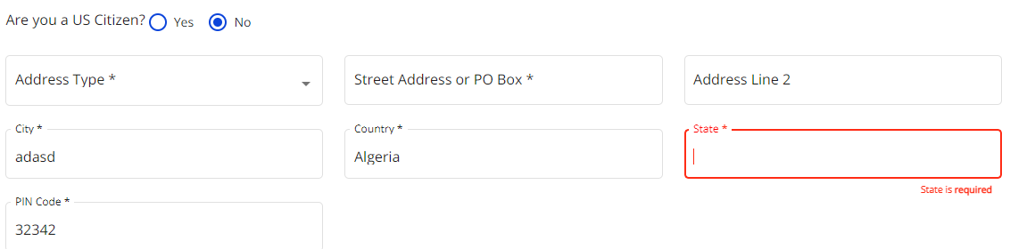

Distance Not Mentioned:

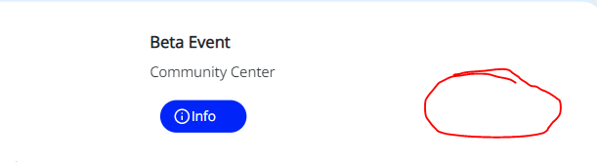

Some Categories Missing:

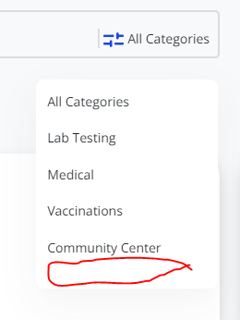

It is not a mandatory field:
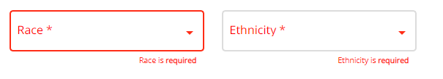

Click on any one of the page it will not switch that page:

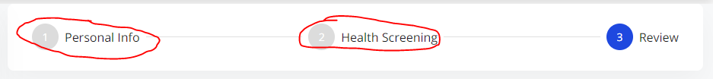

Scroll down Not There in Personal info and Review page:

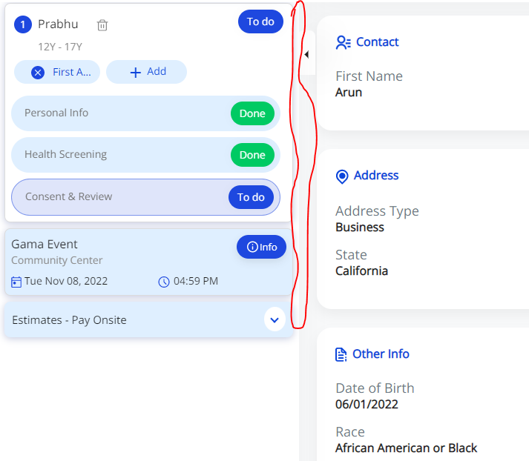

Deleted Message Displayed but still details visible:
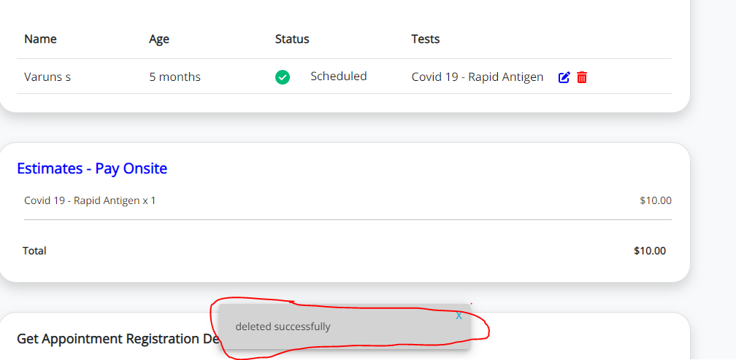

Invalid Email Accepted Here:

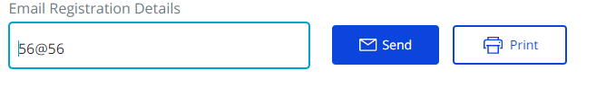
Cancel Icon Not Working:
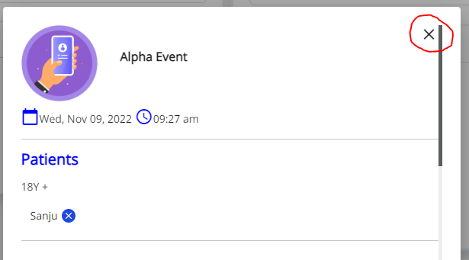

Registration Emailed to Invalid Email Address:

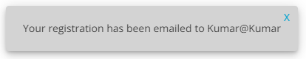

Time not displayed Confirmation Page:

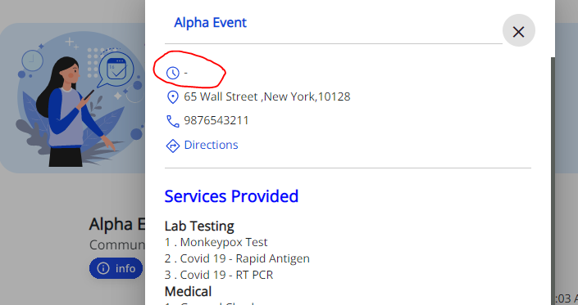
PIN Code text field More than Five numbers Accepted:
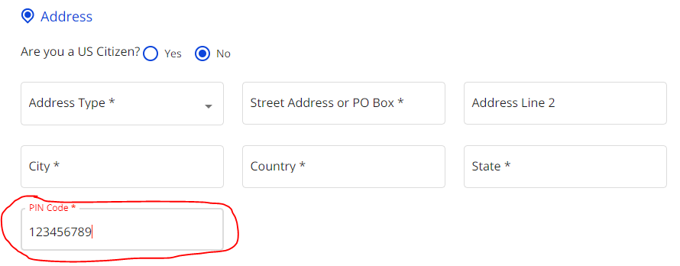

Mandatory if Patient is below 18 Years of age Or Signer Type is Surrogate Guardian, Interpreter but it will shows like all the options:
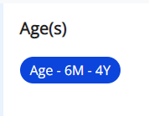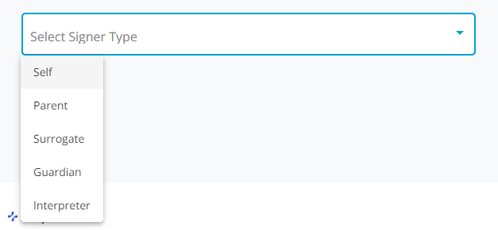

Selected Slot is full :
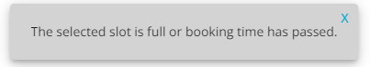

Cancel icon shows like Delete icon:
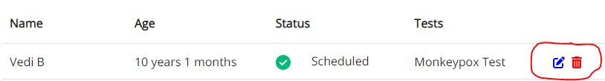

Interchanged Edit and Remove icons:

Images Not Displayed:

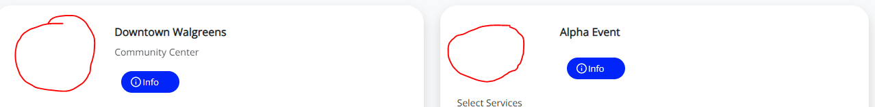

Save Button Missing in Health Screening Page:

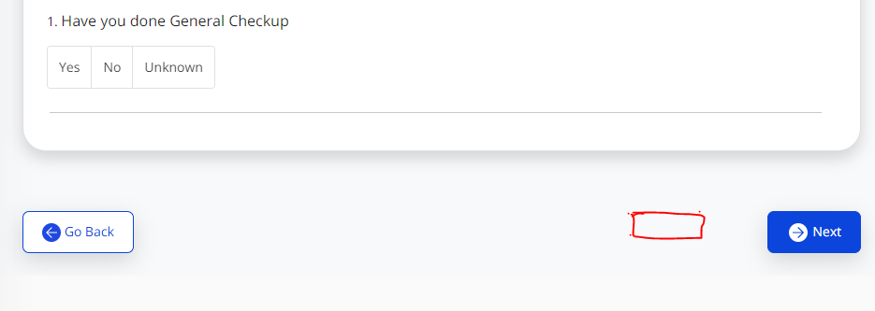

Save Button Missing in Personal Info Page:

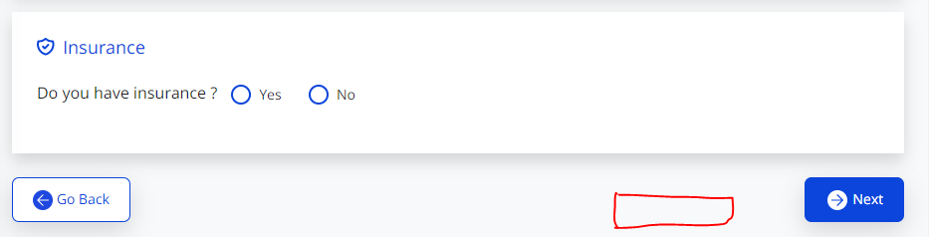

Missing Checkbox field I agree to Terms & Conditions:

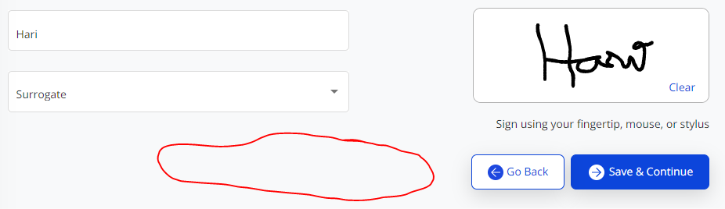

Printed Name Text field Accepted Special Characters:
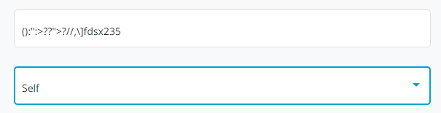

Images Not Displayed:

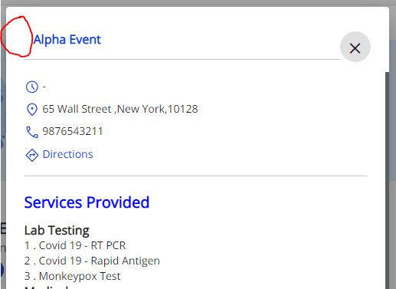

It is not a Good UI Design:

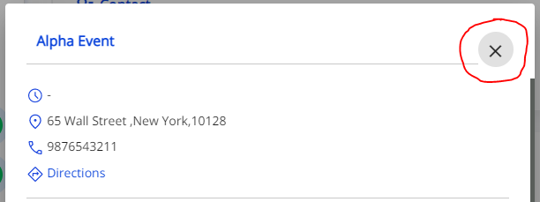

This Optional Message Not Displayed Health Screening page:

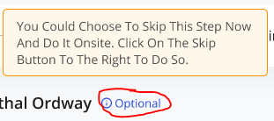

Reset Button Not Working:

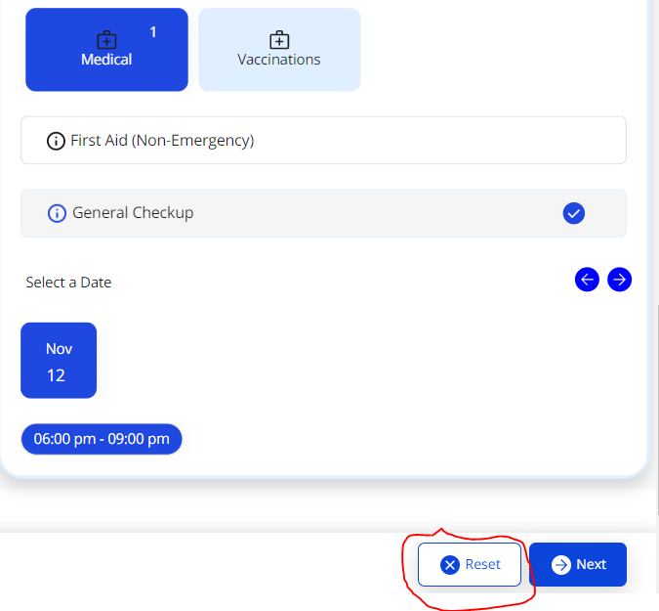

It will shows like 1, 2, 3 but 01, 02, 03:

Suffix, Preferred Name, Mother’s Maiden Name Not in Figma Link:
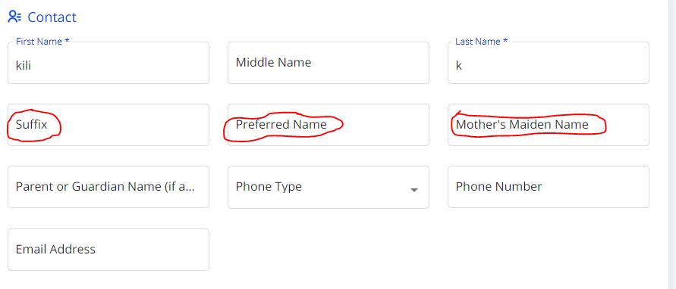

Select is shows like Search and Placeholder not present:

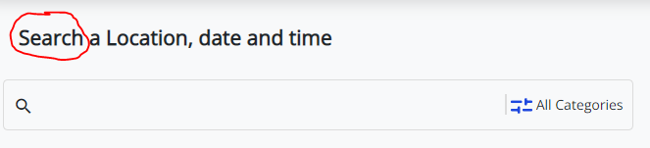
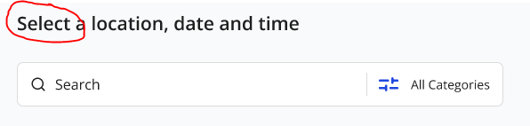
Default Selected New York Location:
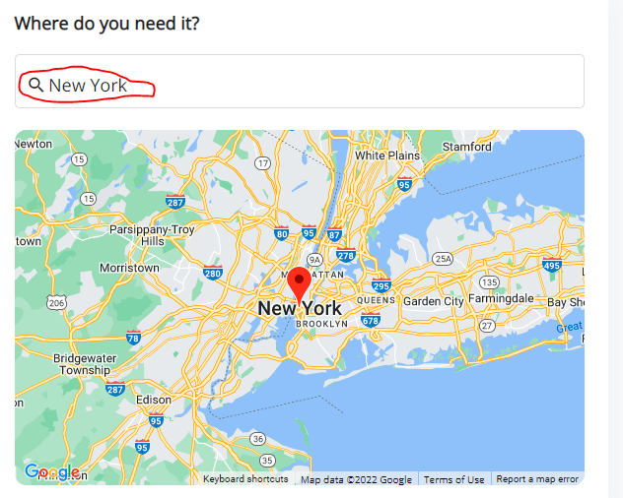

Forward and Backward Buttons not there if I try to select 1990:

