Confirmation Code Not Visible:

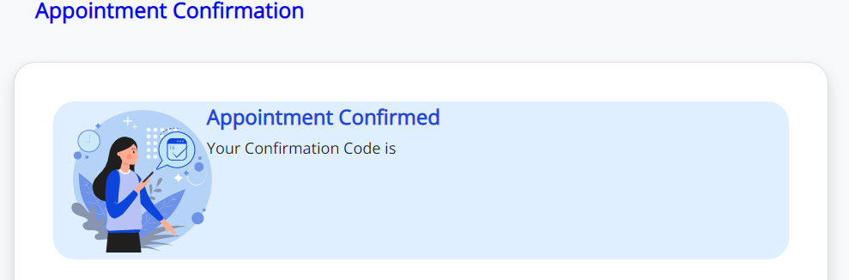

Date and Time Alignment Issue:

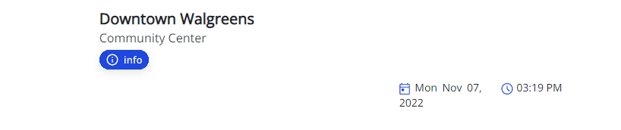

(Name, Age, Status, Tests) Details are not displayed:

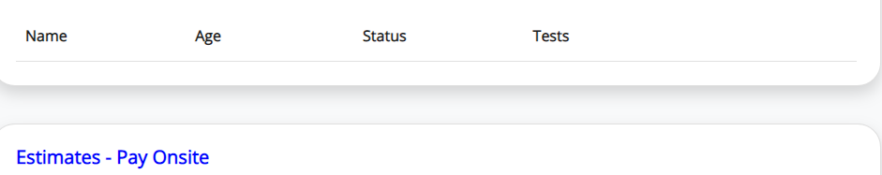

My Appointments Text Wrongly Updated:
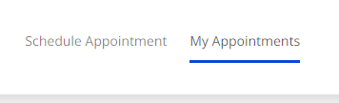
My Appointments not updated:

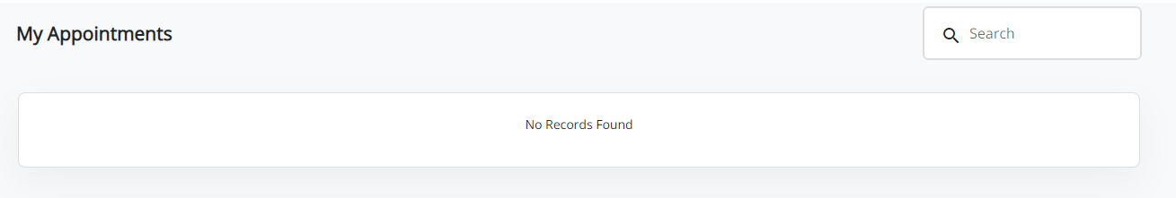

Confirmation Details Completely not downloaded:

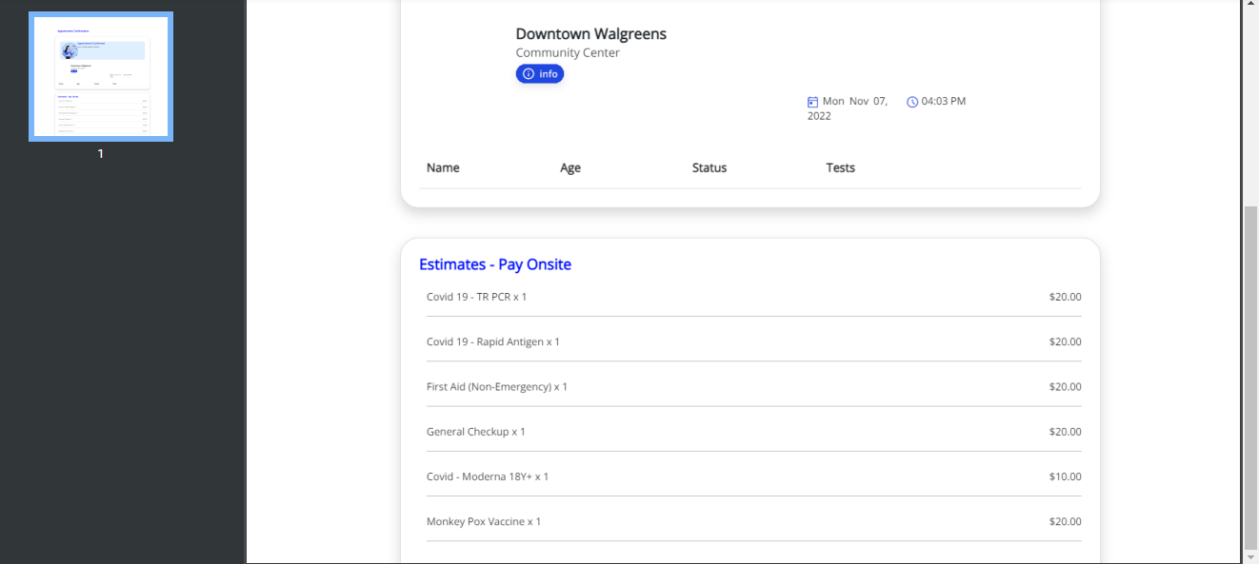

Click on Delete icon.it is not working:

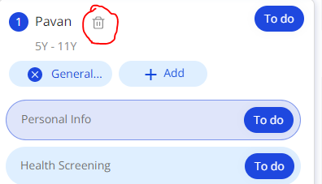
Appointment Confirmation Font Colour Black:

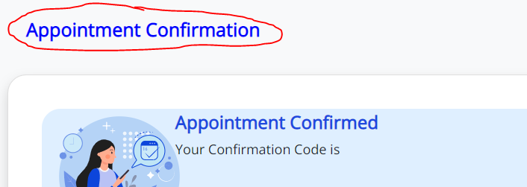

Alignment Issue:

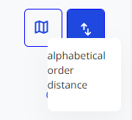

Time Not Displayed:

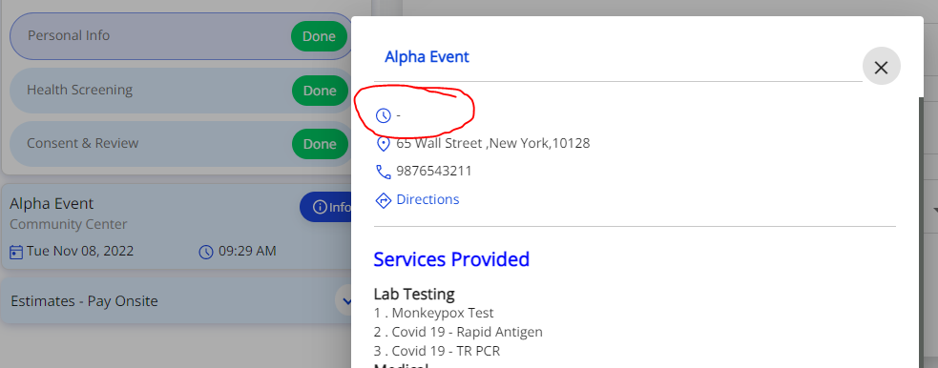
Deleted Message Displayed but still details visible
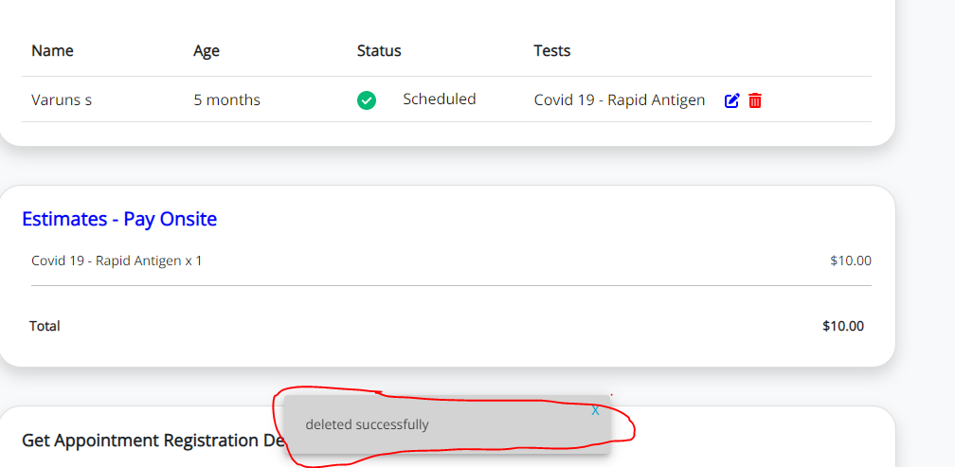

Selected Slot is full :
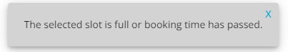

Appointment Confirmed Alignment Issue:


Cancel icon shows like Delete icon:
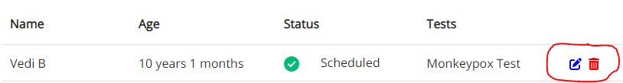

Interchanged Edit and Remove icons:

Time not displayed:

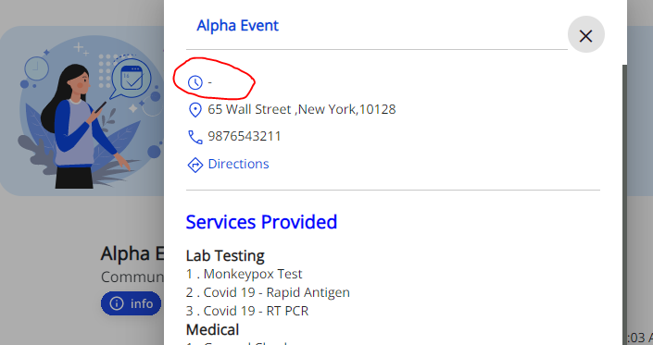

Overlapping after Language changes:

Images Not Displayed:

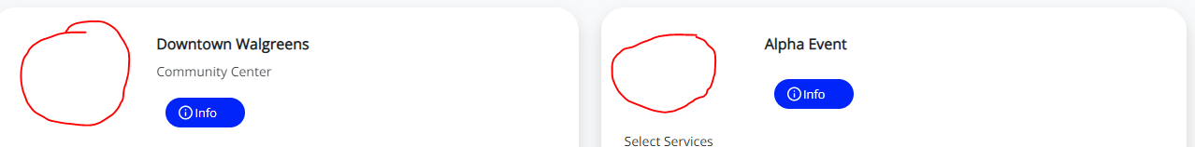
Save Button Missing in Health Screening Page:

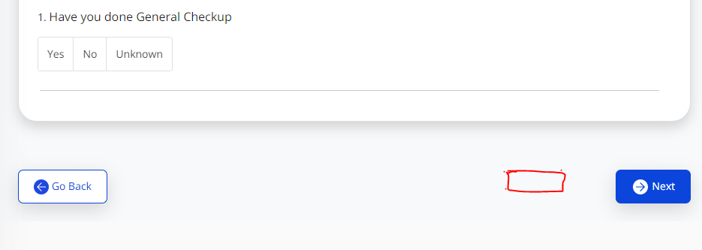

Save Button Missing in Personal Info Page:

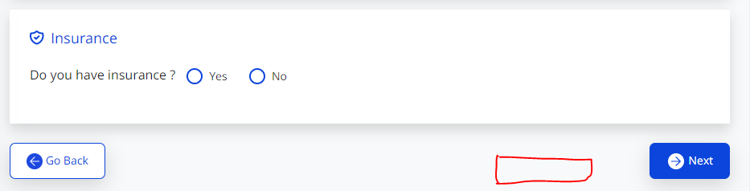

Missing Checkbox field I agree to Terms & Conditions:

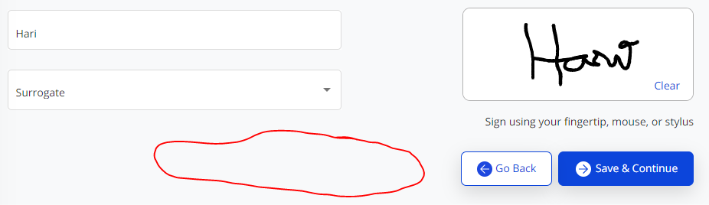

Where do you need them?

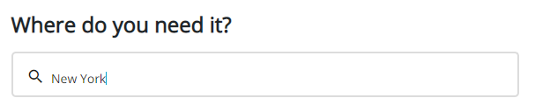

Medical Care is missing:
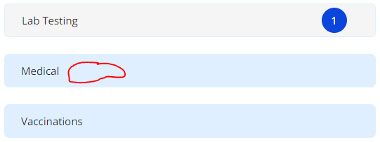

Distance Not Mentioned:

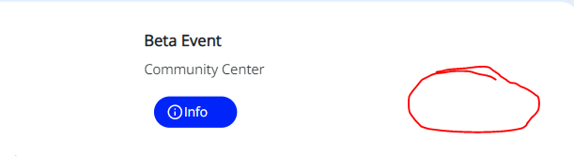

Some Categories Missing:

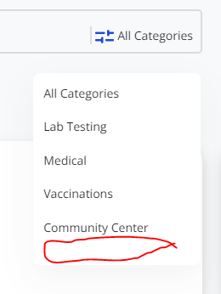

It is not a mandatory field:
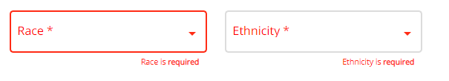

Click on any one of the page it will not switch that page:

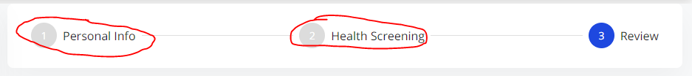

Scroll down Not There in Personal info and Review page:

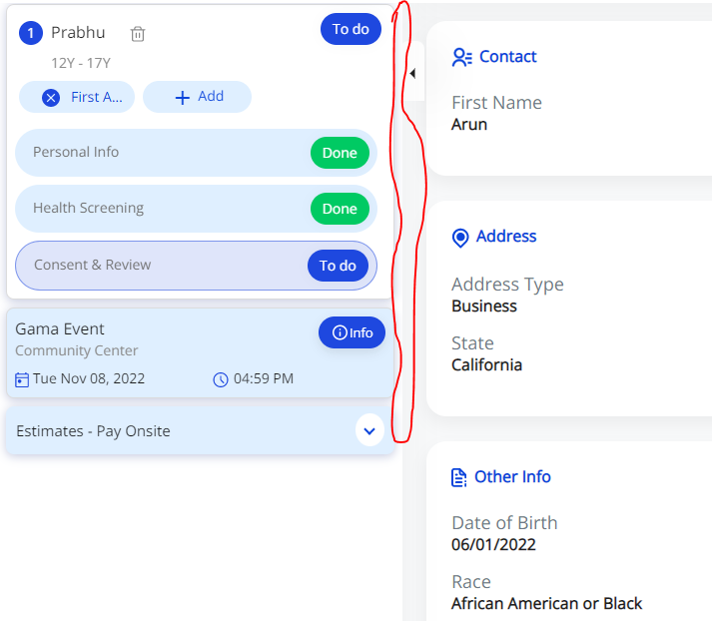

Age Extra field updated here:

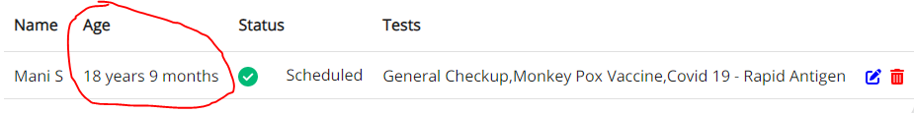

Images Not Displayed:

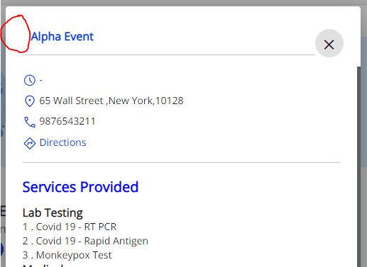

It is not a Good UI Design:

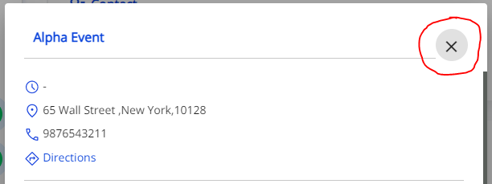

Properly not printed:

