FBMC_Business_Automation_Rules

Passed - 6 flows
FBMC_TerminatePolicy_DualCounty_turns65 - Pass
FBMC_TerminatePolicy_DualCounty_turns65_onSep30 - Pass
FBMC_TerminatePolicy_JacksonHealthSystem_Turns65 - Pass
FBMC_TerminatePolicy_Manatee_Sarasota_BasicAD_D_turns70 - Pass
FBMC_TerminatePolicy_LakeSumter_BasicADandD_Turns70 - Pass
FBMC_Florida_ChangeRate_turns_70or75 - Pass

Failed - 5 flows

FBMC_Flagler_ChangeBenifitamt_turns_70or75 - Facing Application issue
FBMC_TerminatePolicy_previousmonth_spouse70 - Select Plan Issue only one Plan is there under Medical
FBMC_Daytona_Coverageamt_ChangeLifeBenefitReduction_turns_70or75 - Date Issue Verify Termination Date method
FBMC_Terminate_stateofwest_Nondisabledchild_turn26 - element click intercepted: Element is not clickable at point
FBMC_Terminate_DuvalCounty_Nondisabledchild_turn26 - Termination Date Issue

FBMC_Flagler_ChangeBenifitamt_turns_70or75 - Facing Application issue

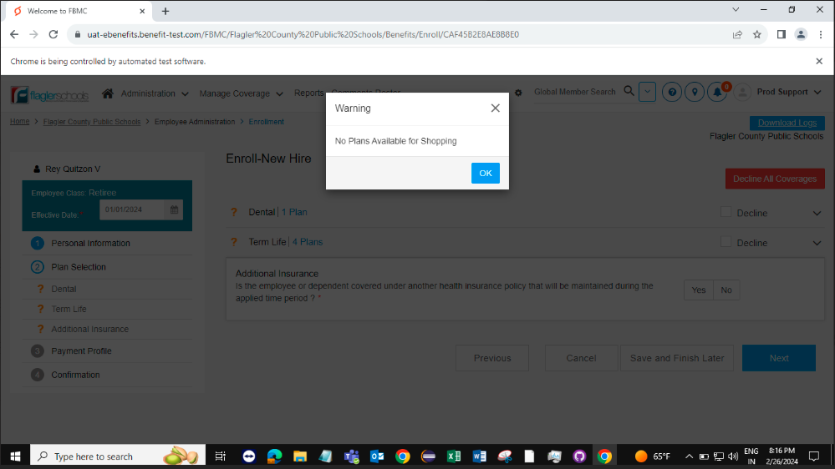
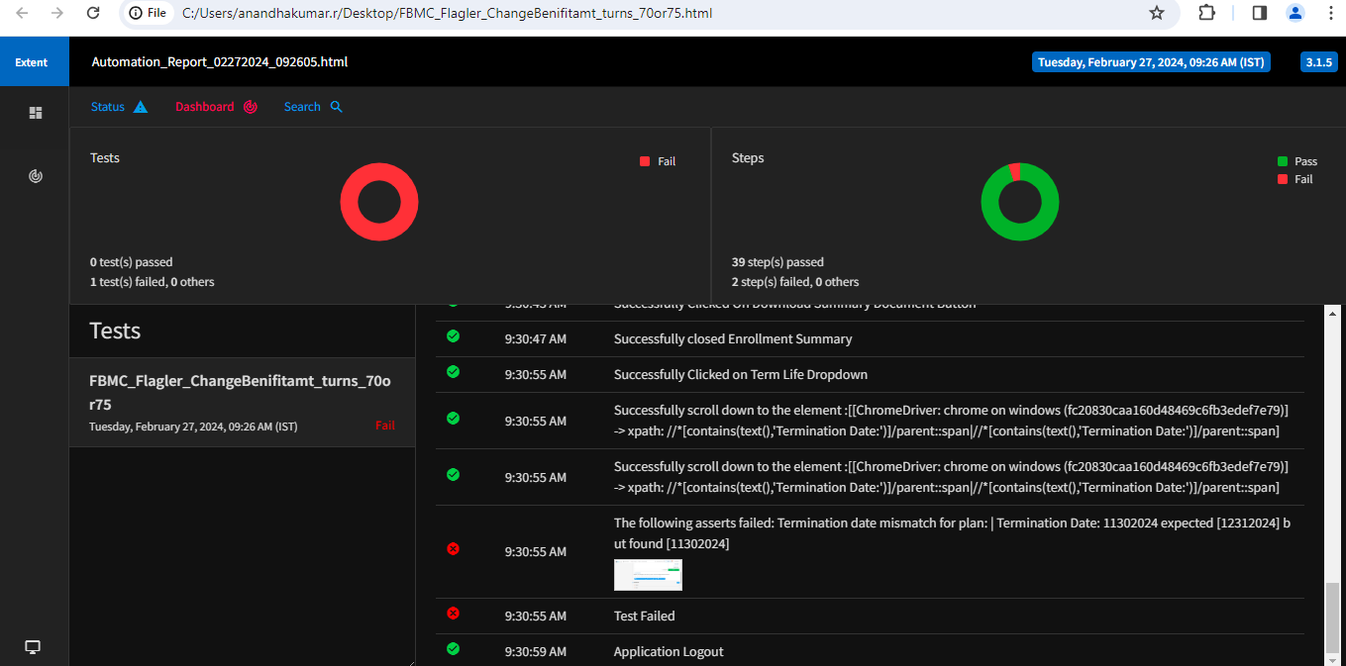

FBMC_TerminatePolicy_previousmonth_spouse70 - Select Plan Issue only one Plan is there under Medical
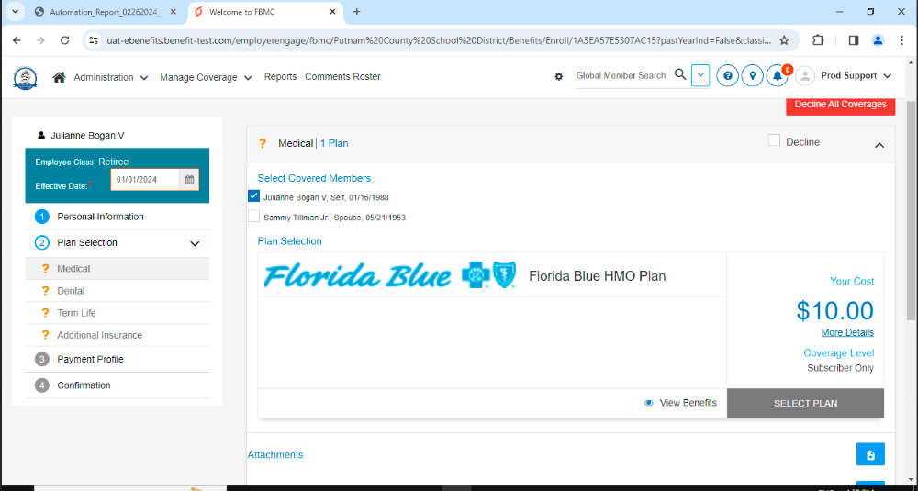
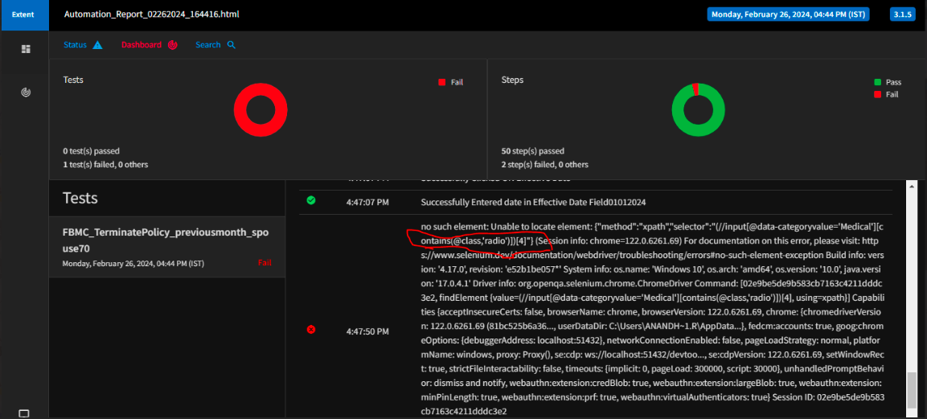
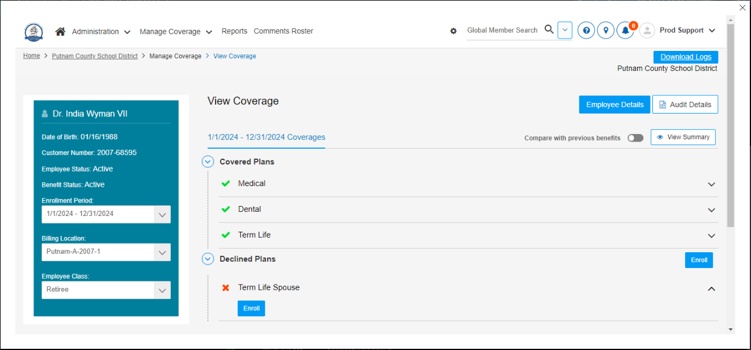
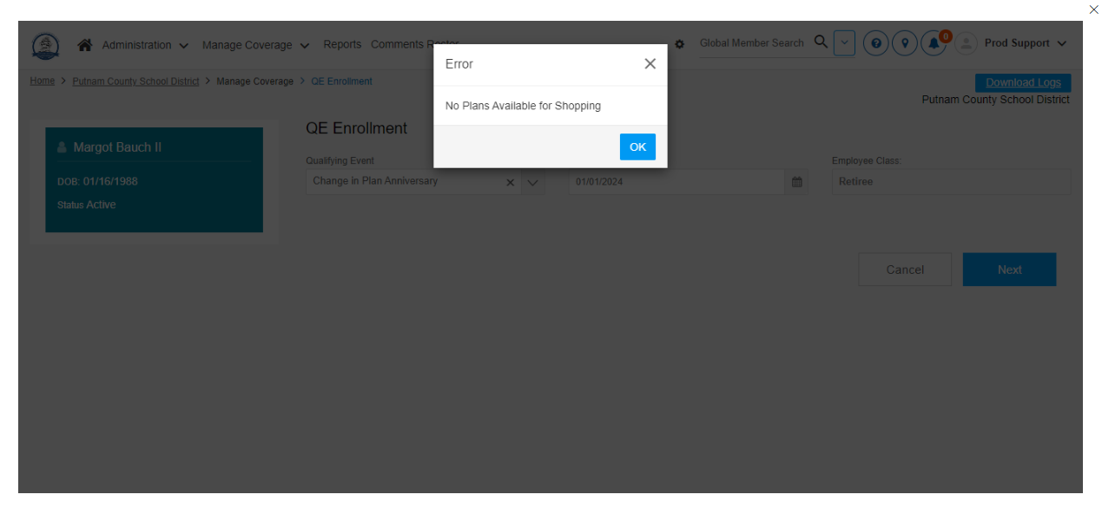

FBMC_Daytona_Coverageamt_ChangeLifeBenefitReduction_turns_70or75 - Date Issue Verify Termination Date method

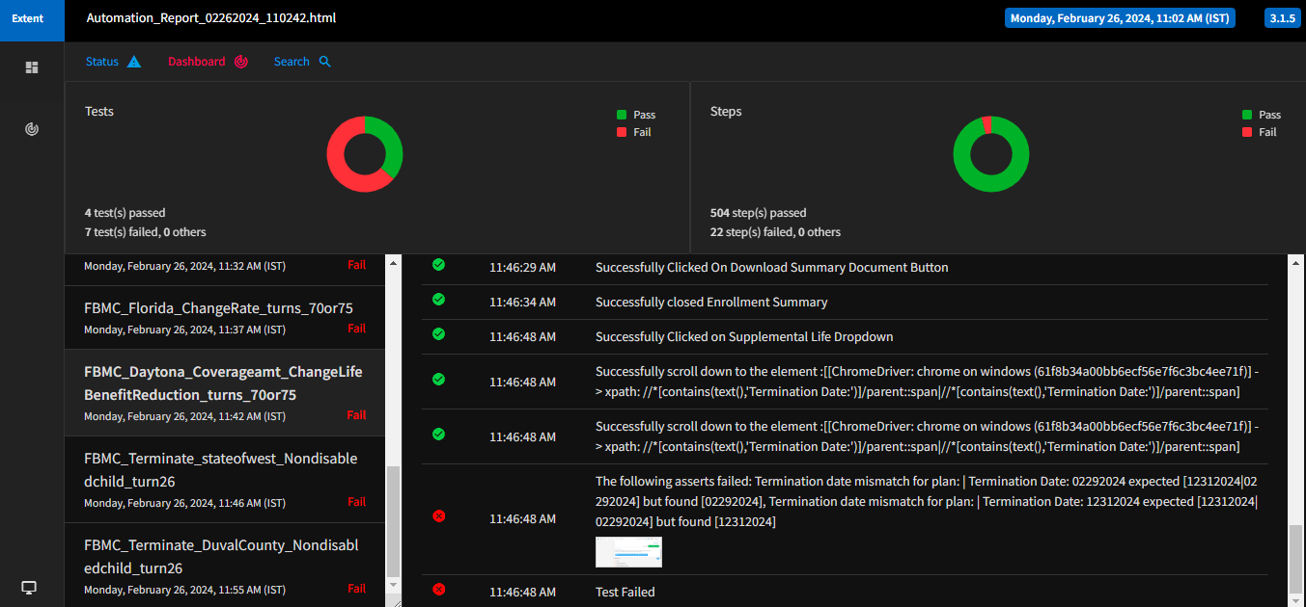
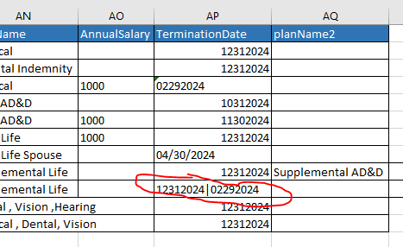
FBMC_Terminate_stateofwest_Nondisabledchild_turn26 - element click intercepted: Element is not clickable at point
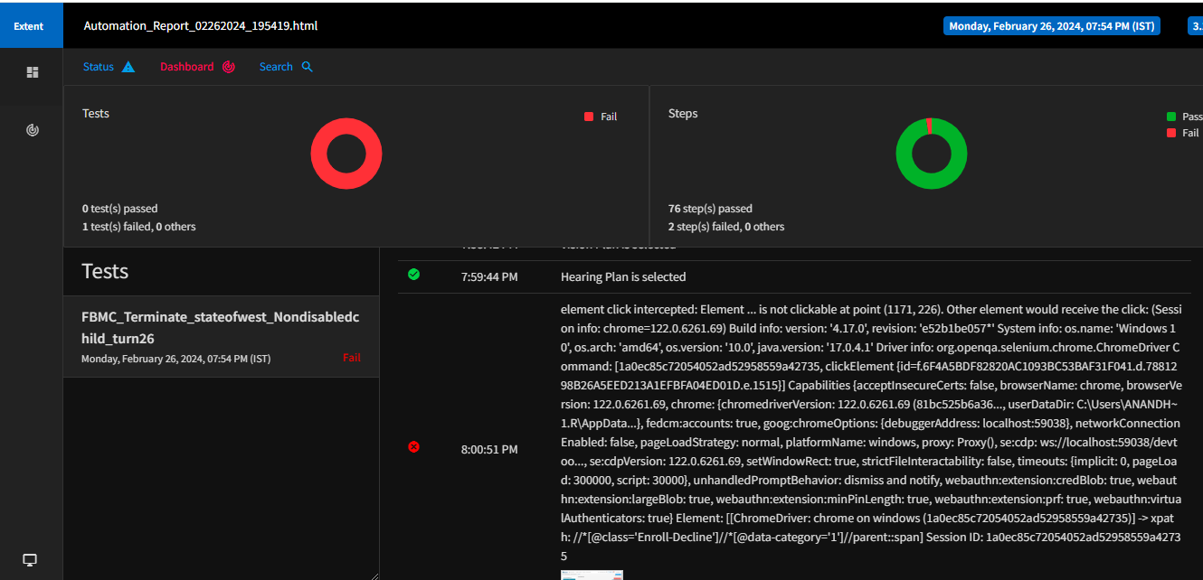
FBMC_Terminate_DuvalCounty_Nondisabledchild_turn26 - Termination Date Issue

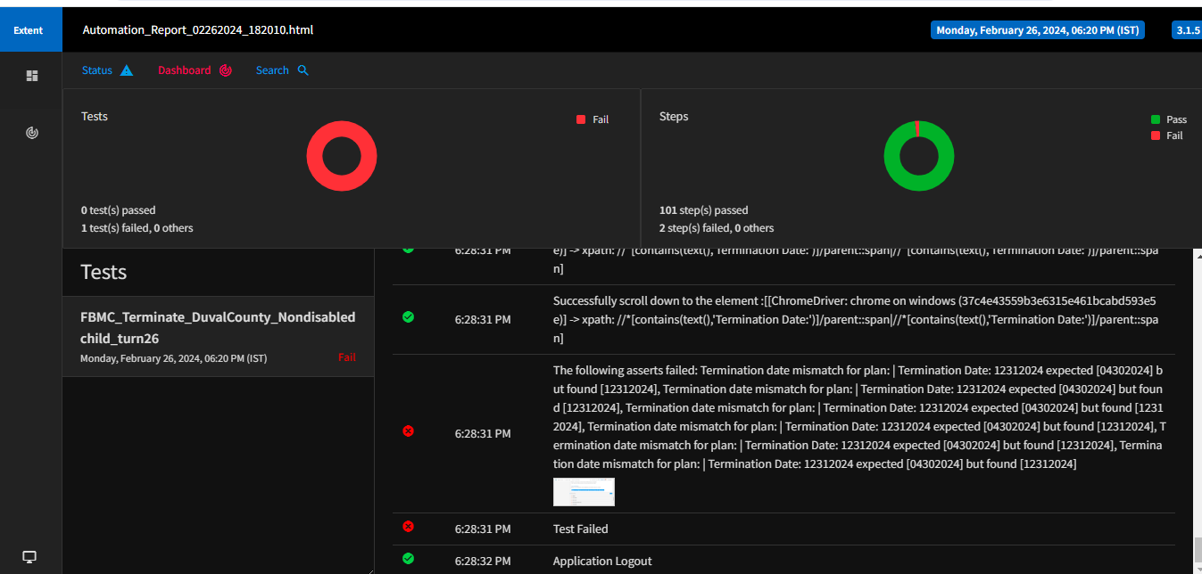
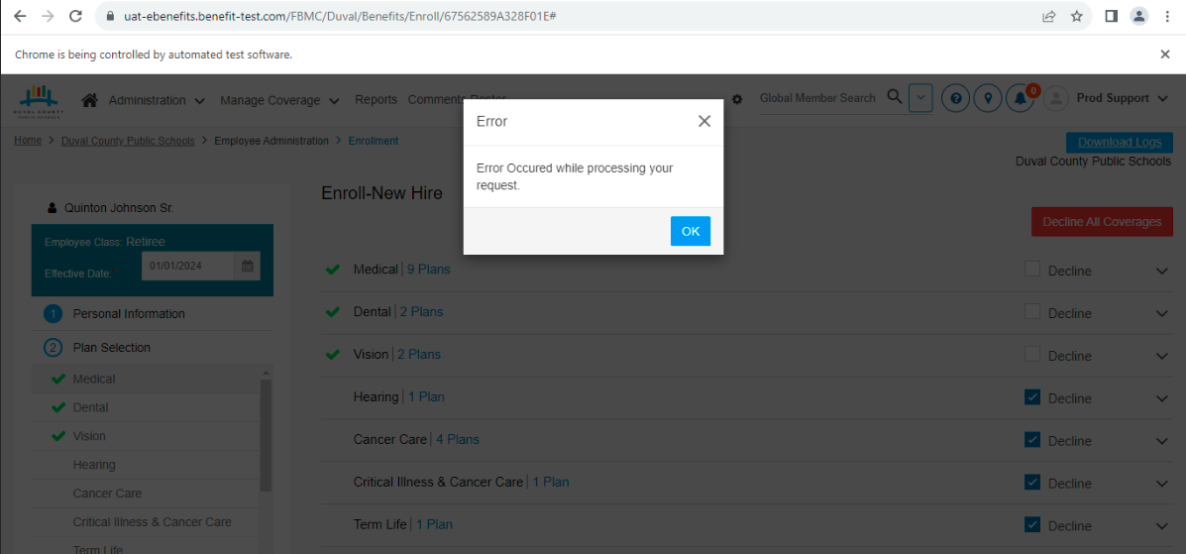
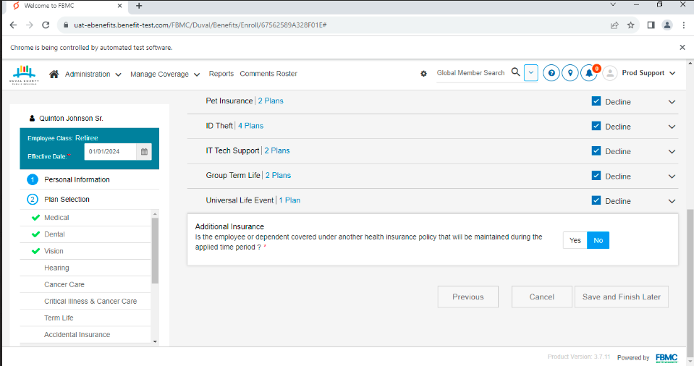

Note:
Passed TCs Mentioned in Green:
Failed TCs Mentioned in Red
