Author : Swetha Kotha

EE-BenefitAlign Framework Doc

- Installations
- Highlights
- Components
- Properties
- Design Pattern
- Standards
- Report Generation

Installations
- JDK 11
- Eclipse /Intellij IDEA Community Edition
- Allure Framework
- Download allure Framework using the below link
https://github.com/allure-framework/allure2
- Set the allure path under the system variables (Ex – Path= D:\allure-2.21.0\bin)

Highlights
- Logger
- Allure Report
- Test Data reading from the external Source
- Scripts separated from the Framework
- Cross-browser testing, supported for both chrome and Edge
- POM –Page object Model Design pattern

Components
Base
- Manages the selenium Web driver- creates on test start and teardown on test end
Listeners
- Loads the properties into the system
- Clean up the allure folder
- Attach the screenshots of Test failure
Utility
- Driver wrappers- Logging capability for each driver action
- Reads the CSV file and returns the object[][]
- Common functions across the application

Design Pattern
Page Object Model (POM)
Separate the actions based on pages. Create locators under the locator folder and actions under the actions folder.
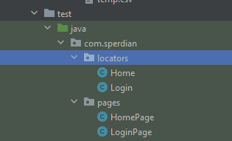

Properties
- Config.properties- Browser and Run related properties
- Data.properties- user login information
- Log4j.properties- Logger information

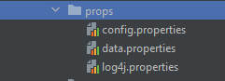
Standards
- All the Java coding standards to be followed while defining the variables, classes and methods
- Methods tagged with the step annotation only be appeared at the Allure Report. Tag all the methods for the detailed report.

Report Generation
Use follow commands to view the Report from the terminal
- Cd to the Project folder
- Allure serve

