Contact Management

Create a Contact

Click on Hamburger icon
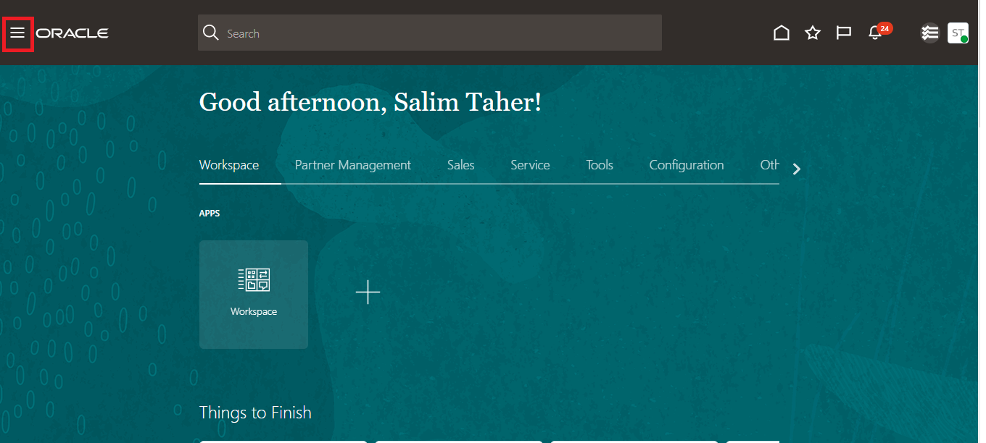
Click on sales > Contacts
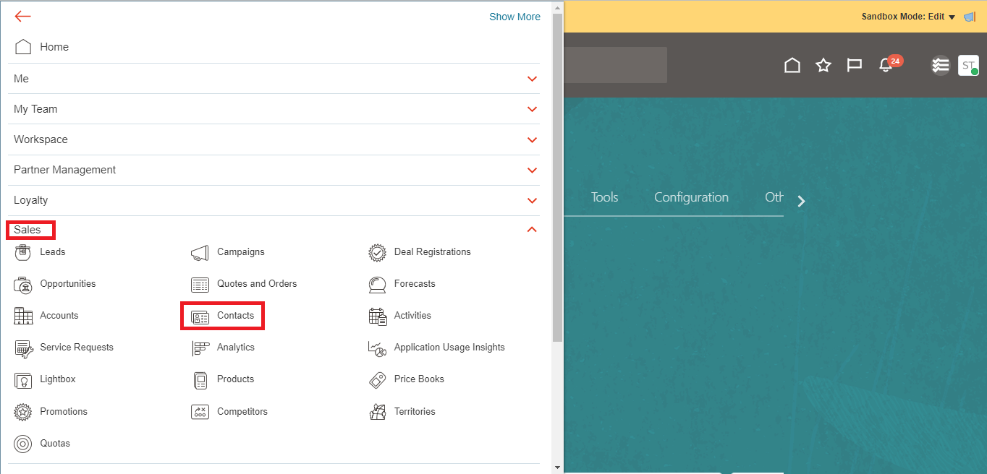
Click + icon
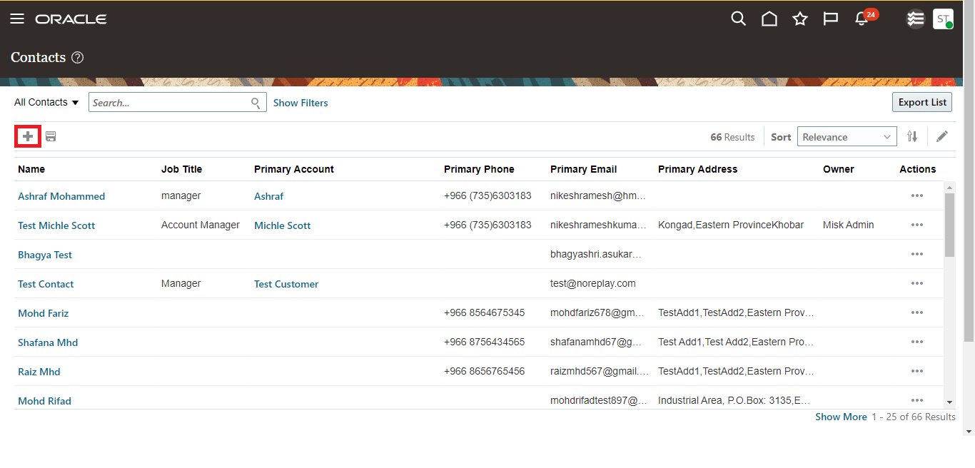
First Name in English, Last Name in English, City, and Address are Mandatory

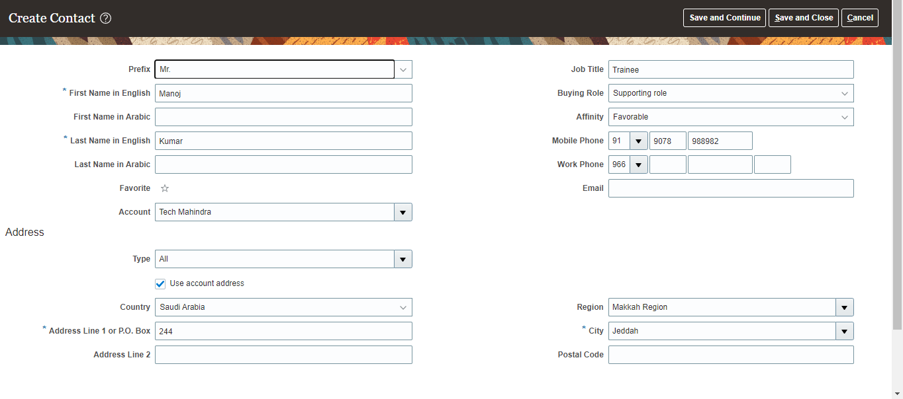
Click on save and Continue

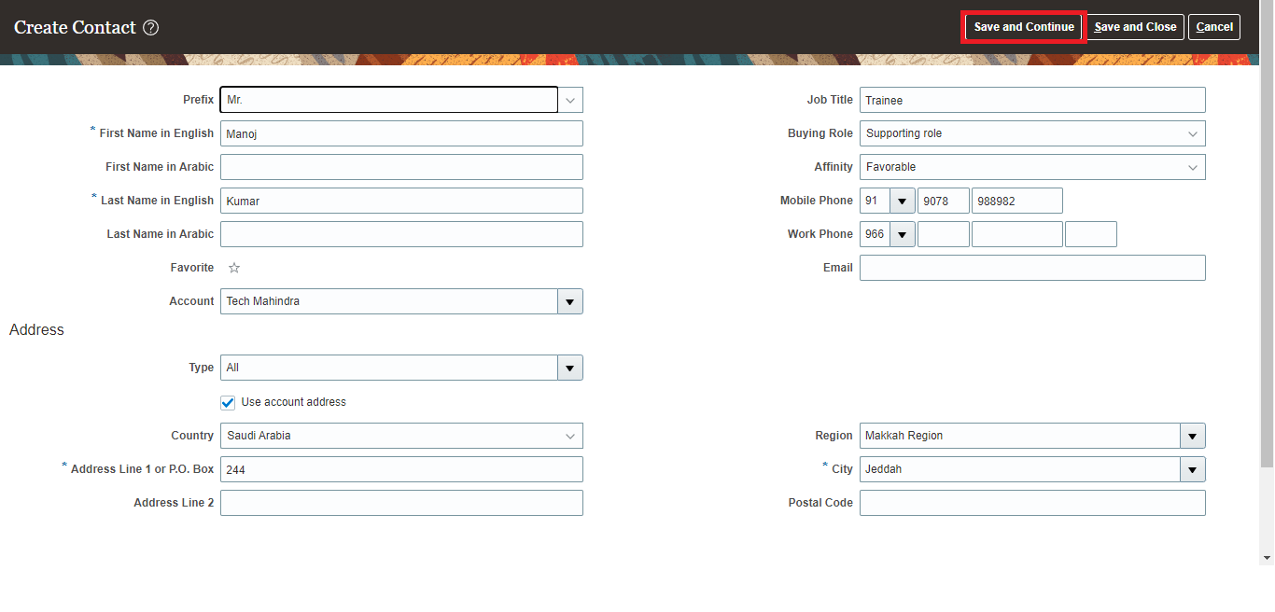

Edit existing Contact

Search for particular contact > select contact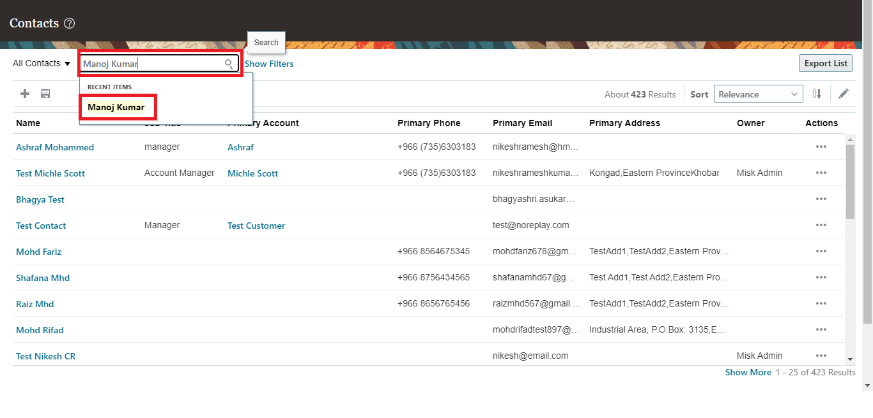
Click on profile

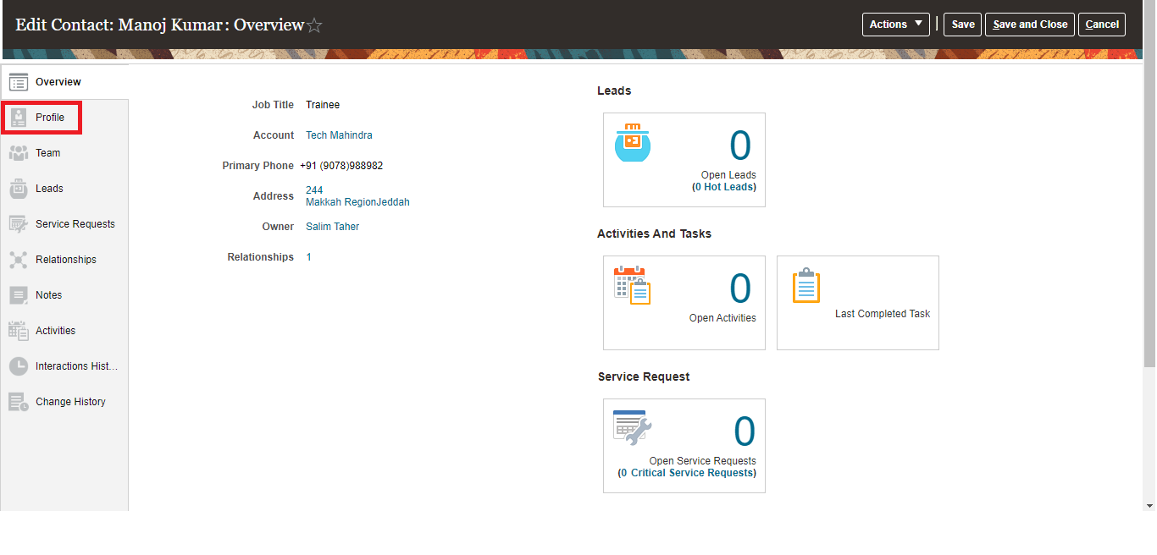
Edit Details and Click on Save
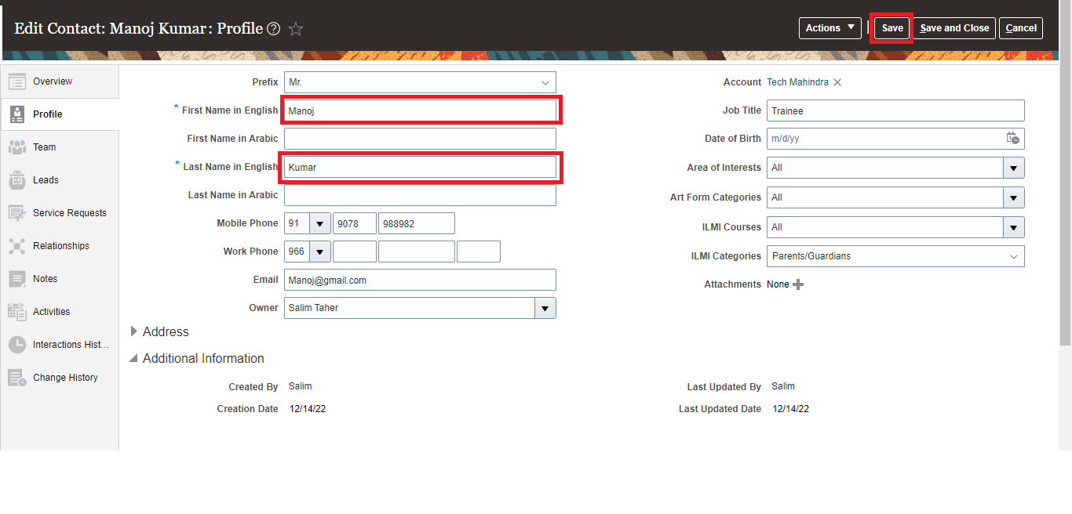

Partner Management

Create Partner

Click on Hamburger icon

Partner Managements > Partners

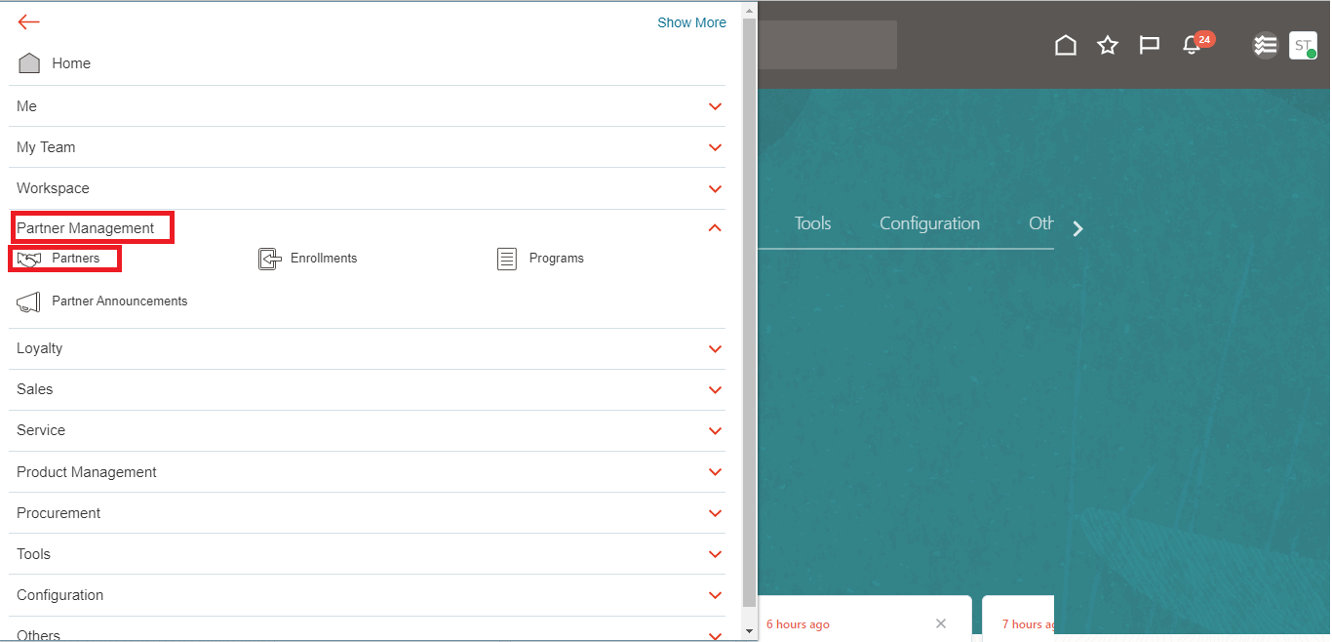

Click + icon

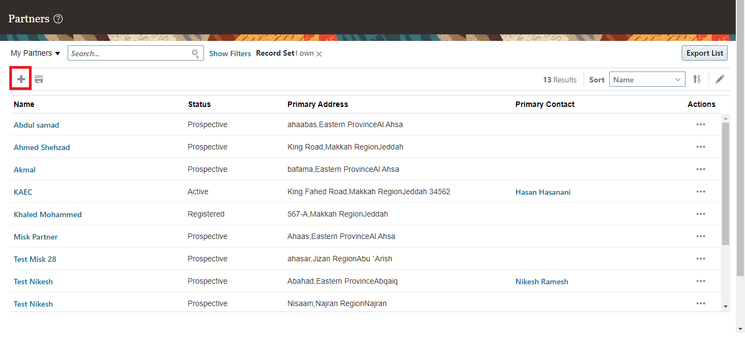
Name, City, Address are Mandatory

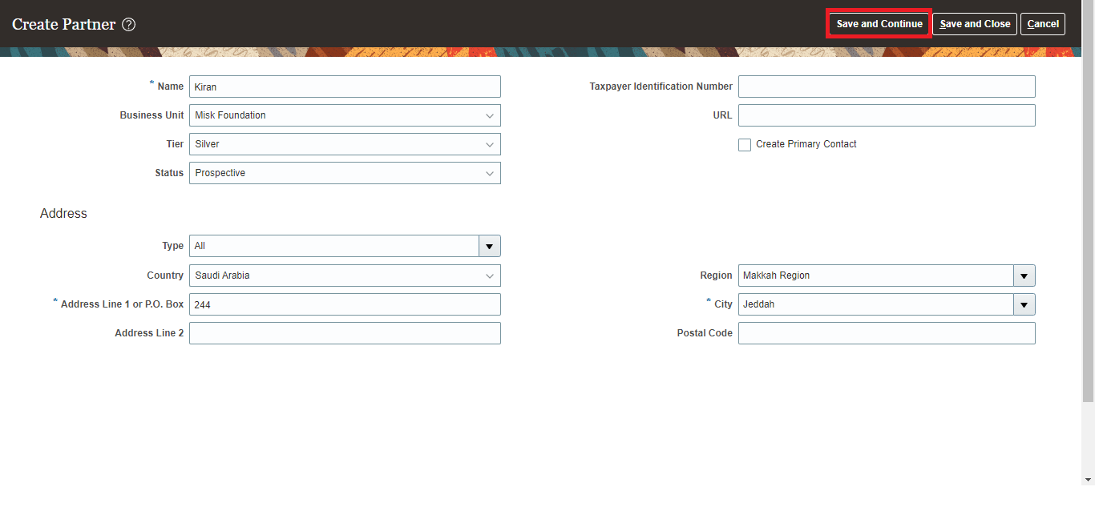
In Edit page, click on Partner contacts > create contacts First Name in English, Last Name in English, Email are Mandatory and Click on Save
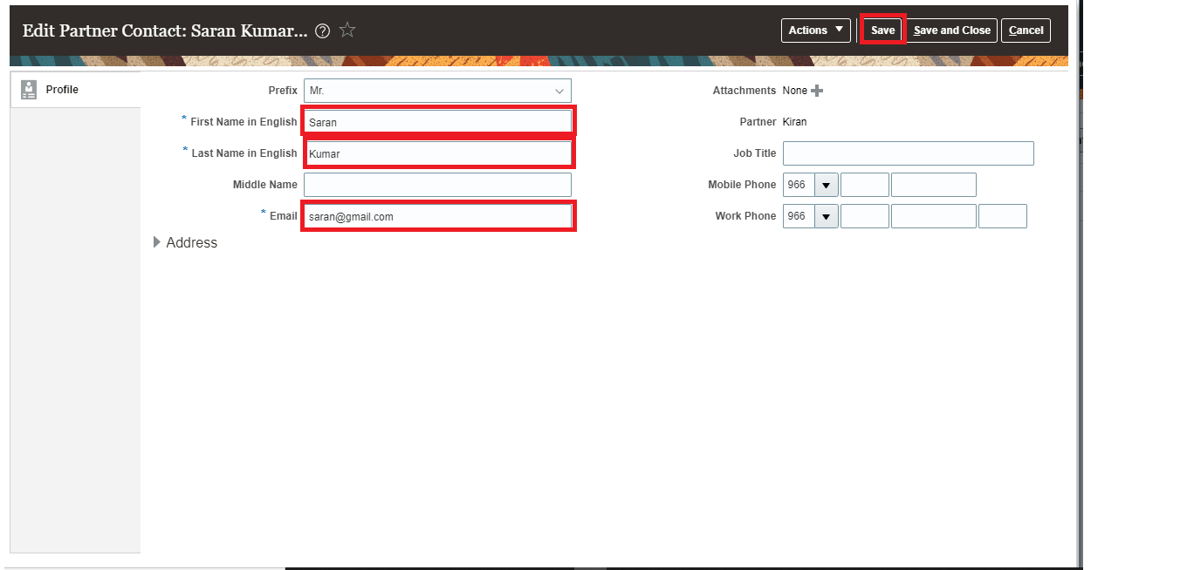

Edit existing Partner

Search for particular partner in search box and Select Partner
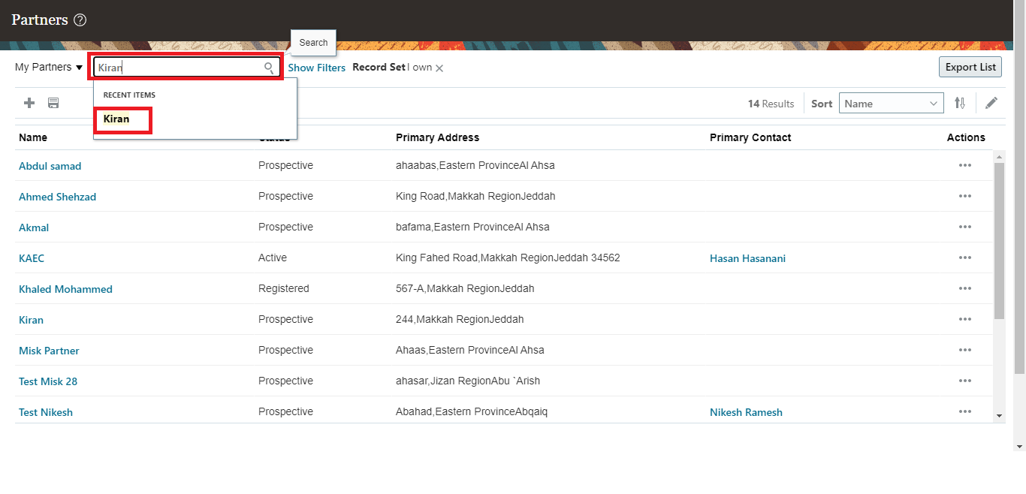
Edit existing Partner and Click on Save
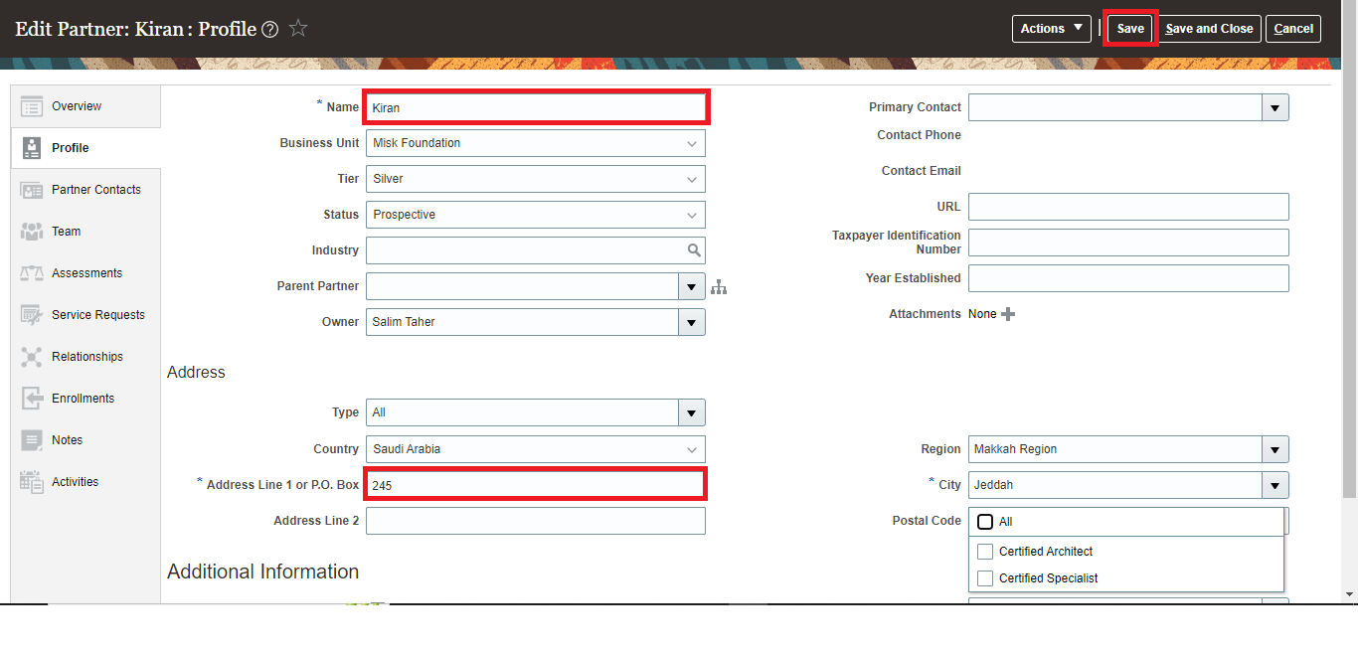
Click on Partner Contacts
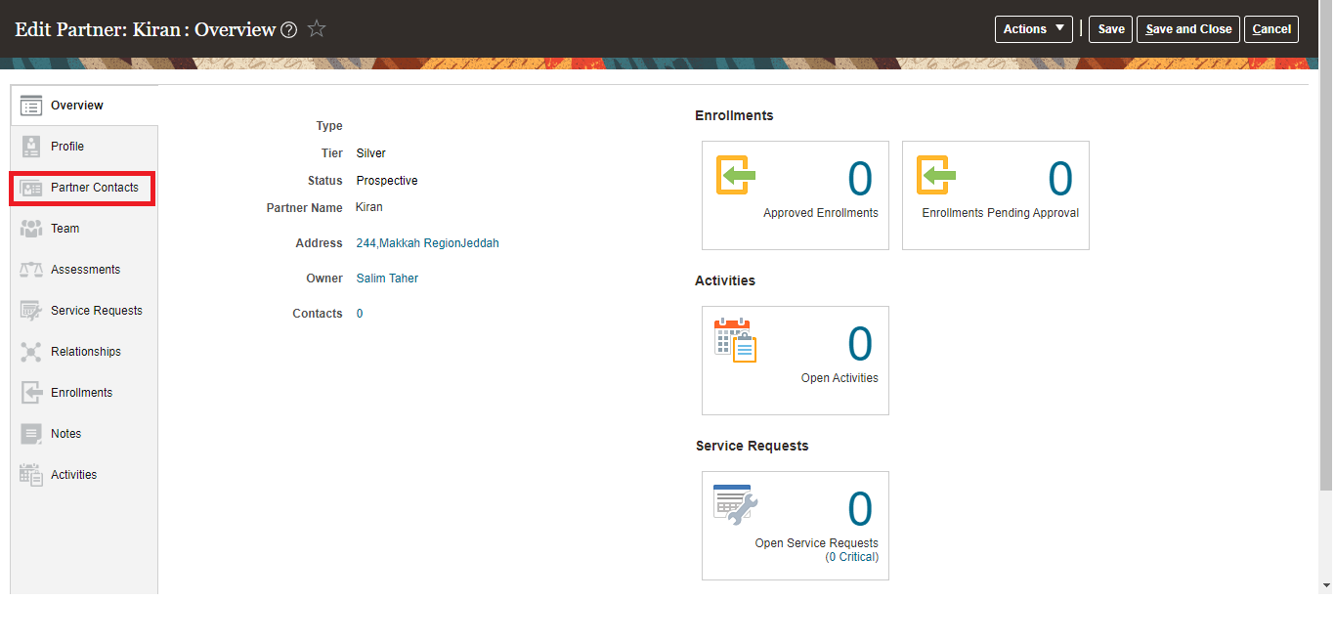
Click on Create Contact
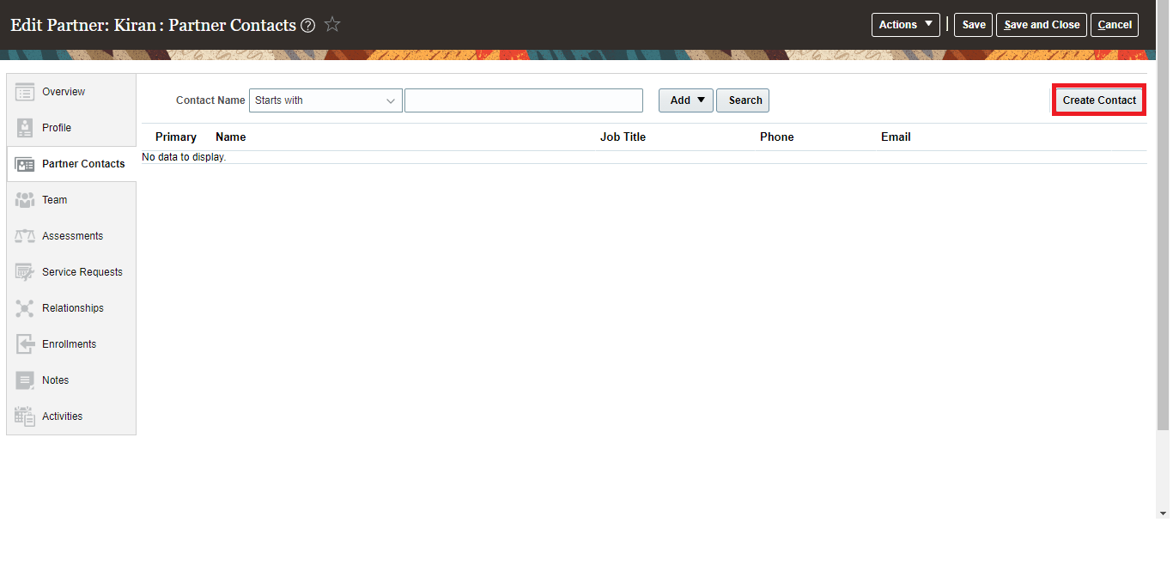
First Name in English, Last Name in English, Email, Partner are Mandatory and Click on save and continue

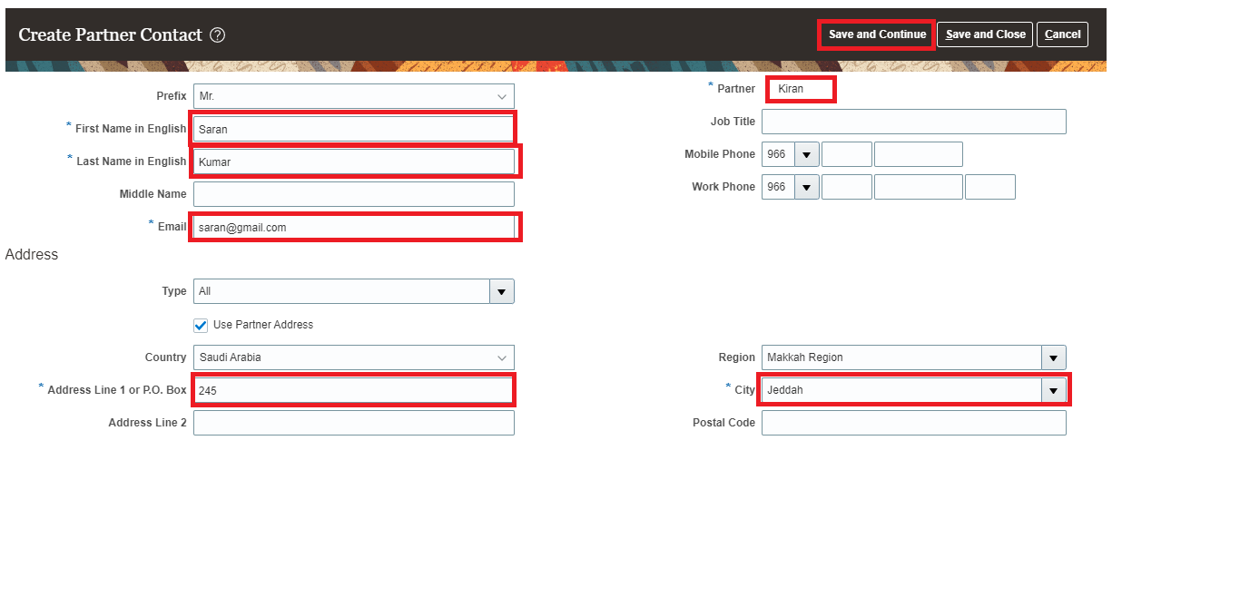
Click on Profile > status dropdown change to Registered and Click on Save
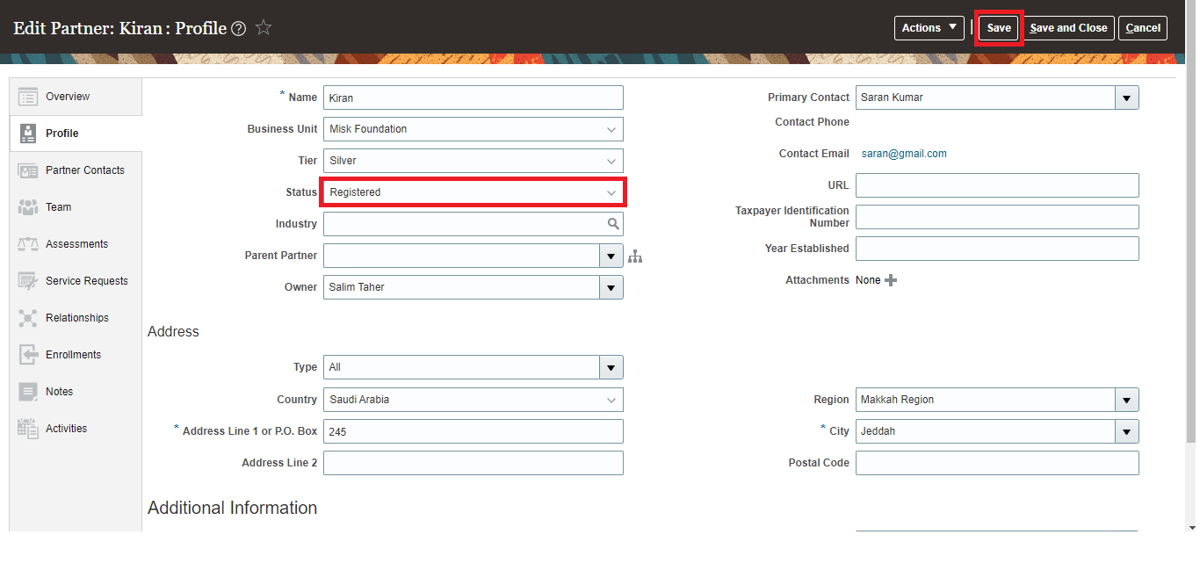
Click on Hamburger icon > Partner Managements > Programs > 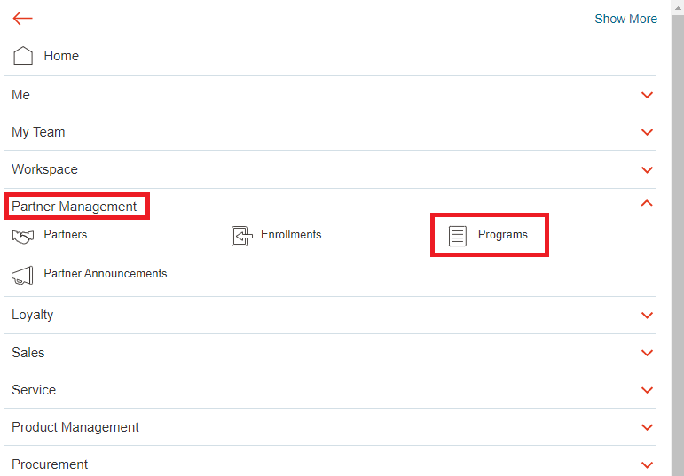
Click on Create Program
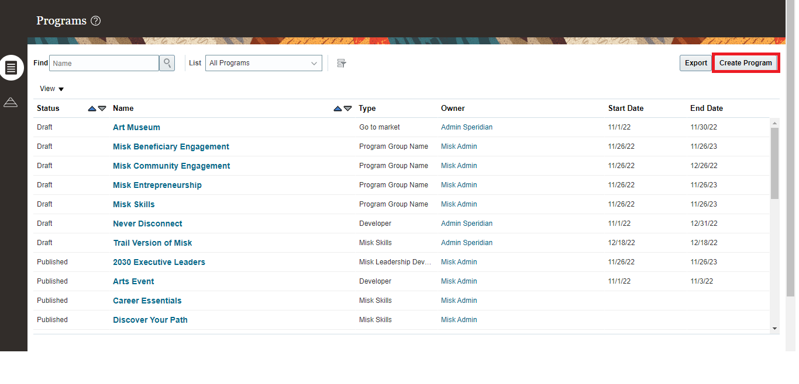
Name, Type, Owner are Mandatory and Click on save and continue
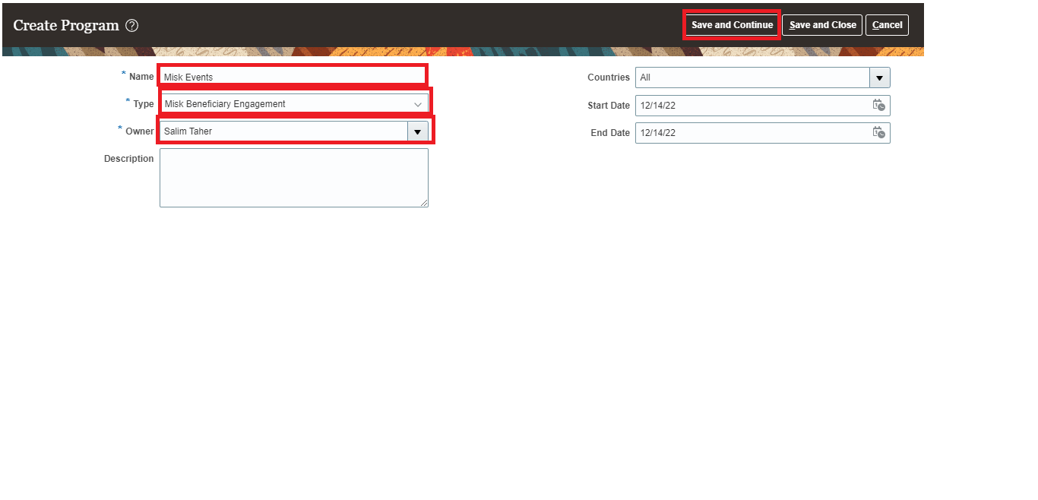

Misk Foundation

Create enrollments for partnership when partner contact is already exits

Click on Hamburger icon

Partner Managements > Entrollments
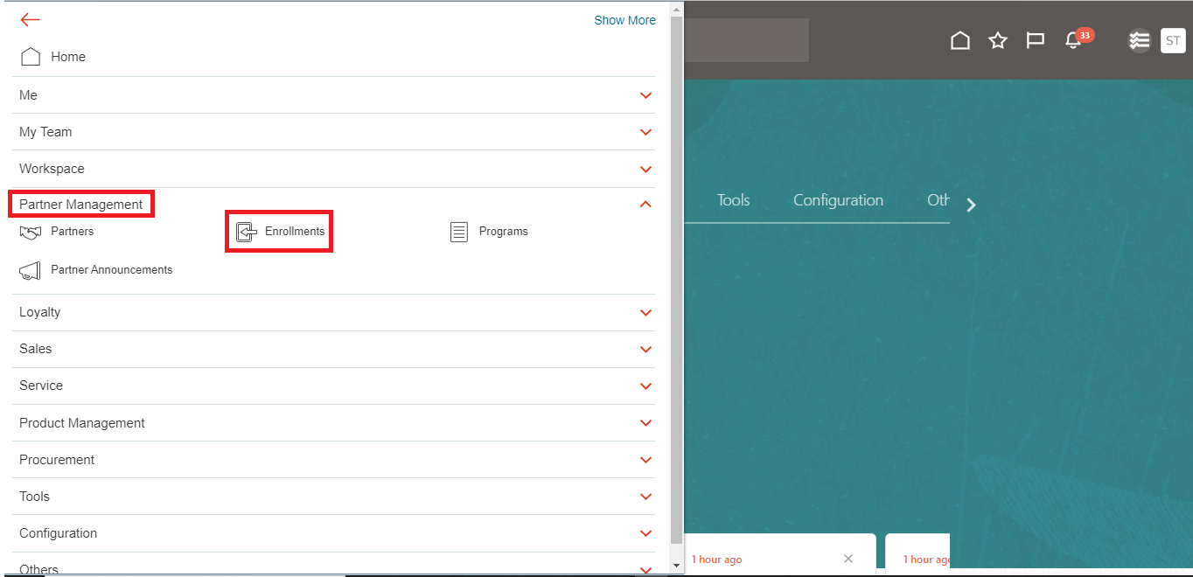
Click on Create Entrollment
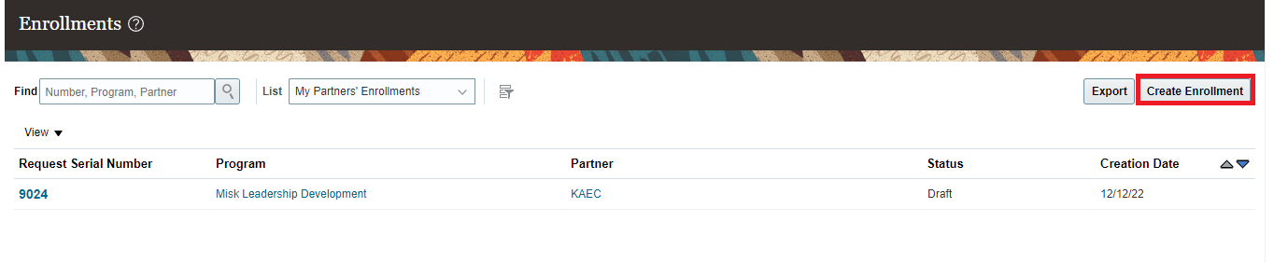
Partner,Business Unit, Program, Type, Stage are Mandatory and click on save

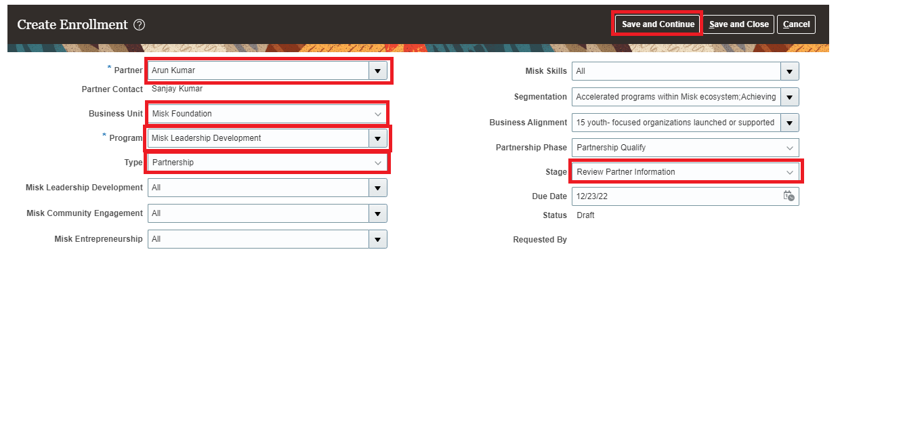

Create enrollments for sponsorship when partner contact is already exits

Click on Hamburger icon

Partner Managements > Enrollment’s > Create Enrollment’s
Click on Create Entrollment
Partner,Business Unit, Program, Type, Stage are Mandatory and click on save and continue
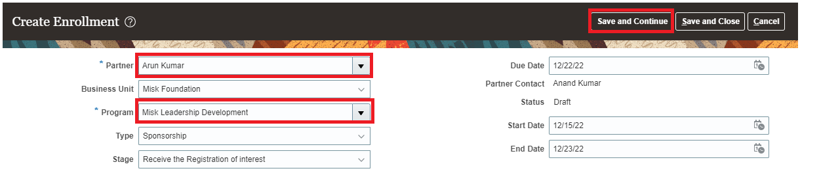

Misk Art

Create Proactive enrollment when partner contact is already exits

Click on Hamburger icon

Partner Managements > Entrollments
Click on Create Entrollment
Partner,Business Unit are Mandatory and click on save

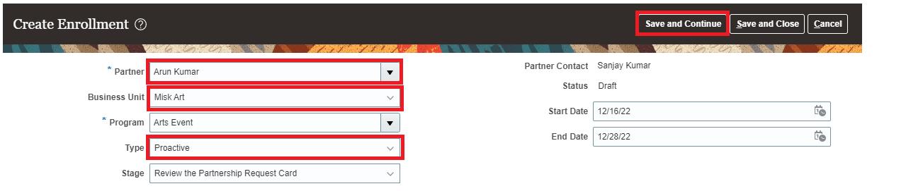

4.2 Create Reactive enrollment when partner contact is already exits

Click on Hamburger icon

Partner Managements > Entrollments
Click on Create Entrollment
Partner,Business Unit, Program, Type, Stage are Mandatory and click on save and continue

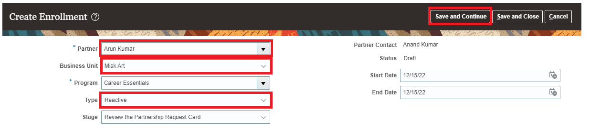

Service Request

Create service request from application

Click on Hamburger icon

Service > service request
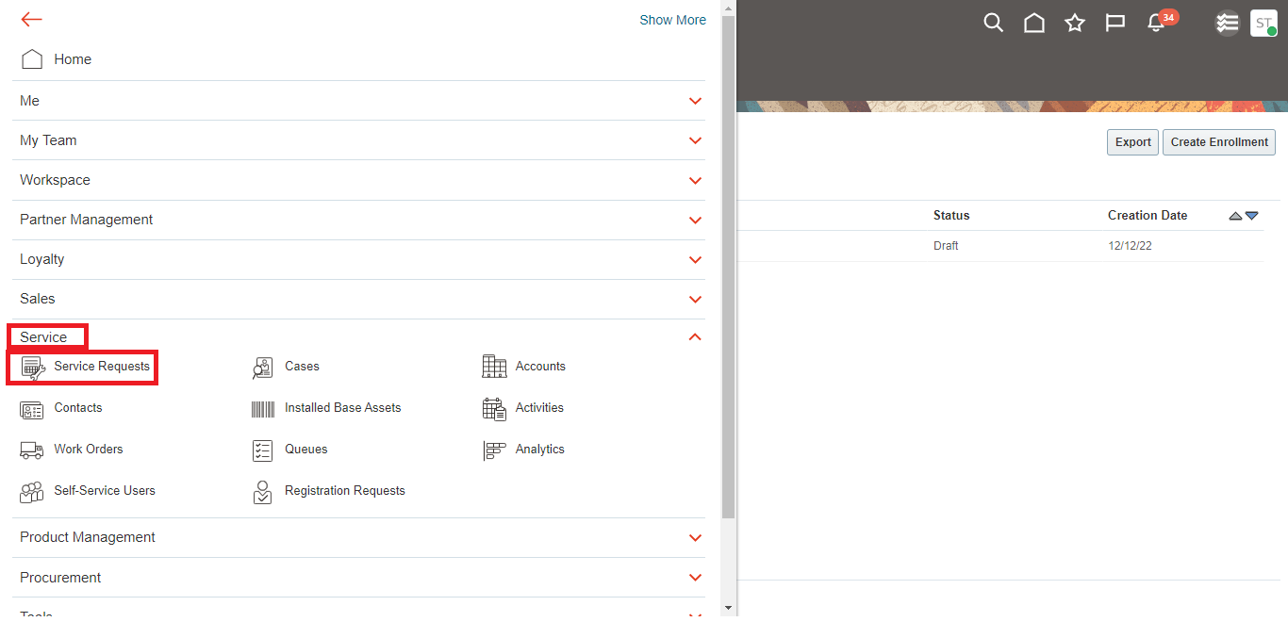

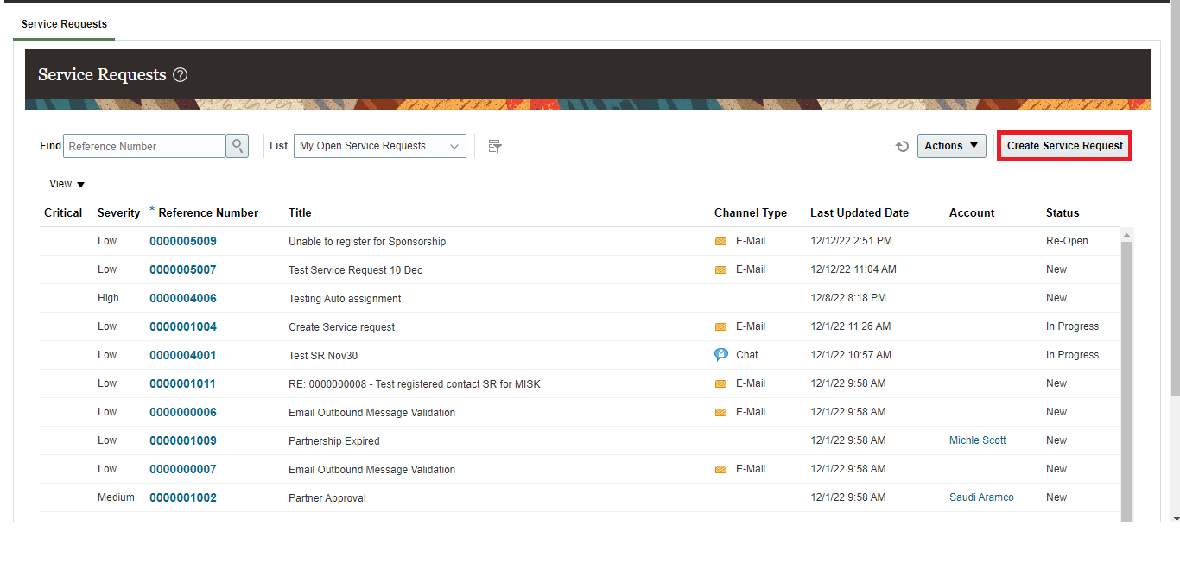

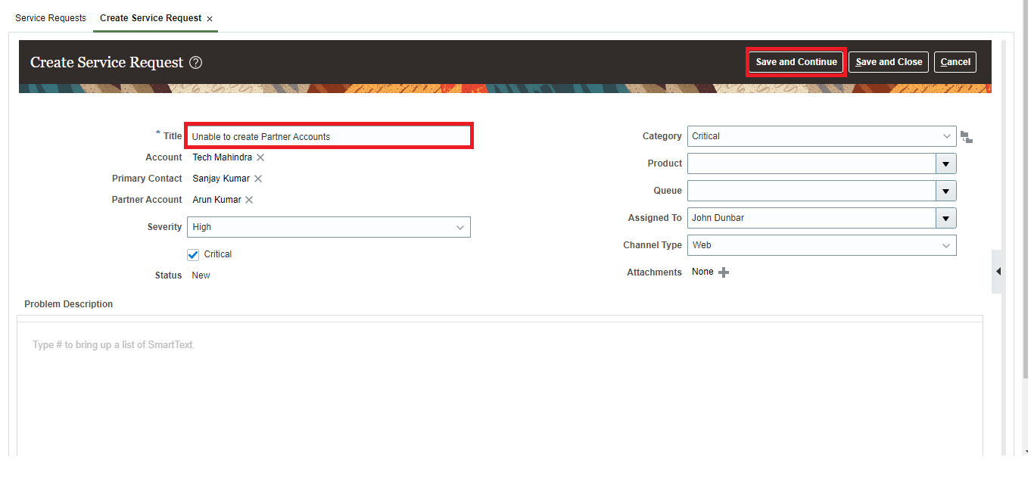

5.2 Edit service request from application

Service request landing page
Search SR by reference no.in search bar and Select SR

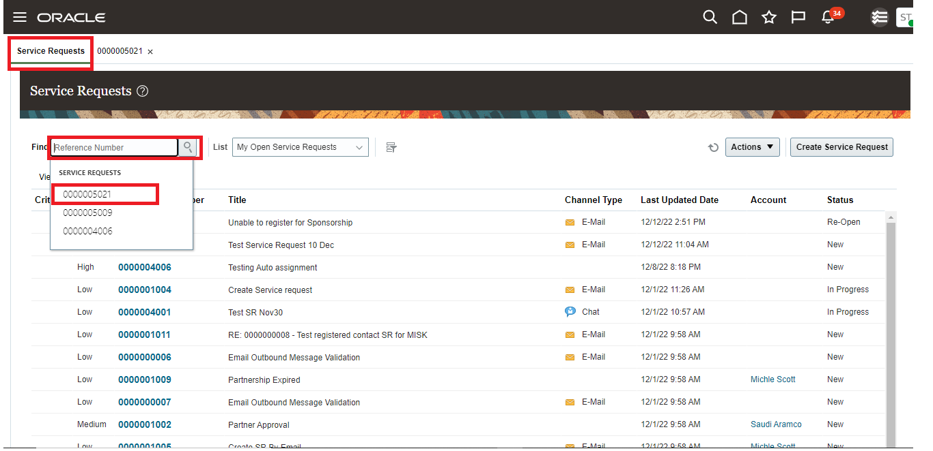

Edit details > save
